SpaceOps-2021,8,x1375

The CubeSat Communication Platform (CCP) – Mission Overview and ConOps

C. Vaskaª, J. Mulletª, J. Long^{b}, D. Thorsenª, O. Kegege^{b}, Y. Wong^{b}, Q. Luebke-Laroqueª, K. O’Neillª, C. Emersonª

ª University of Alaska Fairbanks, Fairbanks, AK, USA
^{b} National Aeronautics and Space Administration (NASA), USA

Abstract
This paper presents the CubeSat Communications Platform (CCP) mission concept, architecture, and development. The CCP is a CubeSat demonstration mission, being developed at the University of Alaska Fairbanks to improve satellite communication capabilities. The CCP payloads include a Software Defined Radio (SDR) with Variable Coded Modulation (VCM) protocols, and an S-band phased array antenna. The mission will test the performance of the VCM protocols versus conventional fixed modulation and coding schemes, relative to the percentage of the Shannon Channel Capacity that each scheme achieves over entire satellite passes. The mission will also test the performance of the phased array antenna, with regard to beamforming and interrogator scanning accuracy. The CCP Mission is collaborating with NASA's Near Space Network (NSN) to demonstrate DVB-S2 VCM and achievable maximum data rate in NASA S-band 5 MHz channel. NSN currently supports missions that communicate with fixed channel codes, modulations, and symbol rates, resulting in a constant data rate that does not adapt to the dynamic link margin. VCM adapts to the dynamics of the link to increase information throughput by changing modulation and coding when the signal-to-noise ratio (SNR) is high. The CCP will be the first mission to demonstrate VCM with NSN ground stations.

Keywords: phased array antenna, retrodirective, software-defined radio, DVB-S2, variable-coded modulation

Introduction
In the last two decades, CubeSat popularity has expanded to hundreds of launches per year [1]. The large volume of satellites sharing the same spectrum and the complexities of communications in Low-Earth Orbit (LEO) pose the challenge of how to downlink large volumes of data on a platform that is bandwidth, power, and time limited.
LEO satellites operate in a highly variable communications environment due to variations in inter-satellite or satellite-to-ground geometries, weather, and interference. Typical CubeSats use communication protocols with fixed coding, and modulation. This approach targets the worst-case channel conditions but never exploits the best case. In the highly variable LEO environment, the information throughput of these fixed systems is far below the theoretical maximum. Furthermore, the high-gain antennas currently available to CubeSats require precise attitude control or a complex gimbal, which adds to mission cost and may create operations challenges for spacecraft that need to be nadir or limb pointed.
The CubeSat Communications Platform (CCP) is a technology demonstration mission for two communication payloads: (a) a miniaturized S-band active phased array and (b) a Software Defined Radio (SDR) utilizing Variable Coded Modulation (VCM). The phased array (PA) subsystem, will demonstrate the operational advantages of beam forming to provide high gain without requiring strict satellite pointing capabilities. The CCP mission will demonstrate the ability to autonomously perform ground tracking with the phased array regardless of the attitude of the satellite itself. The SDR will use VCM to match the modulation and coding protocols with the channel characteristics for fixed symbol rates. When the Signal-to-Noise Ratio (SNR) is strong, the SDR will use a high bit rate modulation and coding. When the SNR is weak, the SDR will use a low bit rate modulation and coding to maintain link margin. A quasi Adaptive Coding Modulation (ACM) will be tested using ground commands which provide feedback to the satellite on measured SNR at the ground. The CCP mission seeks to characterize the performance of the two experimental technologies both jointly and independently as well as compare them to existing standards. The CCP mission is in collaboration with NASA’s Near Space Network (NSN), and will be the first mission to demonstrate the VCM capabilities of the NSN or a NSN Commercial Station (CS).

Mission Overview
The CCP mission will demonstrate the operational capabilities and performance of the PA and SDR payloads on orbit. To demonstrate the flexibility and autonomous beam-forming of the PA, the spacecraft will be put into various attitude control modes (nadir, limb, random tumble) during ground station passes. To demonstrate the improved information throughput capabilities of the VCM protocols, the spacecraft will perform downlinks with several fixed coding and modulation schemes, as well as the VCM modes. The total information throughput for each of these downlinks will be compared to the theoretical limits. These two technologies will first be demonstrated independently, and then tested concurrently. The experiments will be performed collaboratively with NSN to demonstrate both the NSN VCM capabilities and the compatibility of the payloads with the NSN.
The CCP spacecraft is a 3U (10 cm x10 cm x 30 cm) CubeSat consisting of standard commercial avionics and two technology demonstration payloads. Figure 1 shows the spacecraft Computer Aided Design (CAD) model, and Figure 2 shows the spacecraft system block diagram. The Attitude Determination and Control System (ADCS) and GPS are required for characterizing the performance of the PA. A UHF communication system (COMM) is used for command and telemetry. The Electrical Power System (EPS) provides 5 V and 3.3 V power rails used by the payloads and spacecraft. The Command and Data Handling (CDH) unit provides the standard spacecraft monitoring and control, as well as coordinating experiments between the payloads.

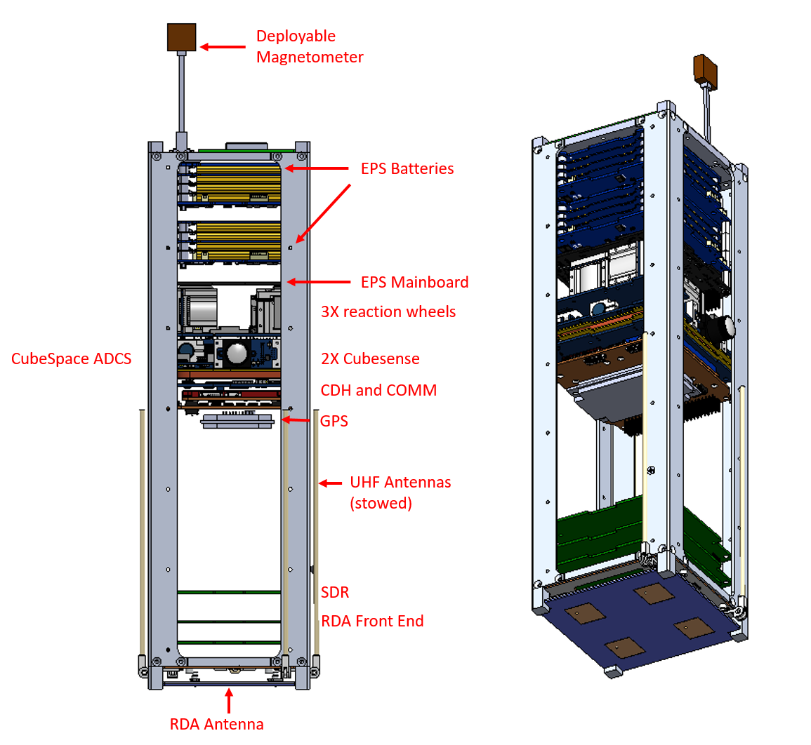
Figure 1: CCP spacecraft CAD model

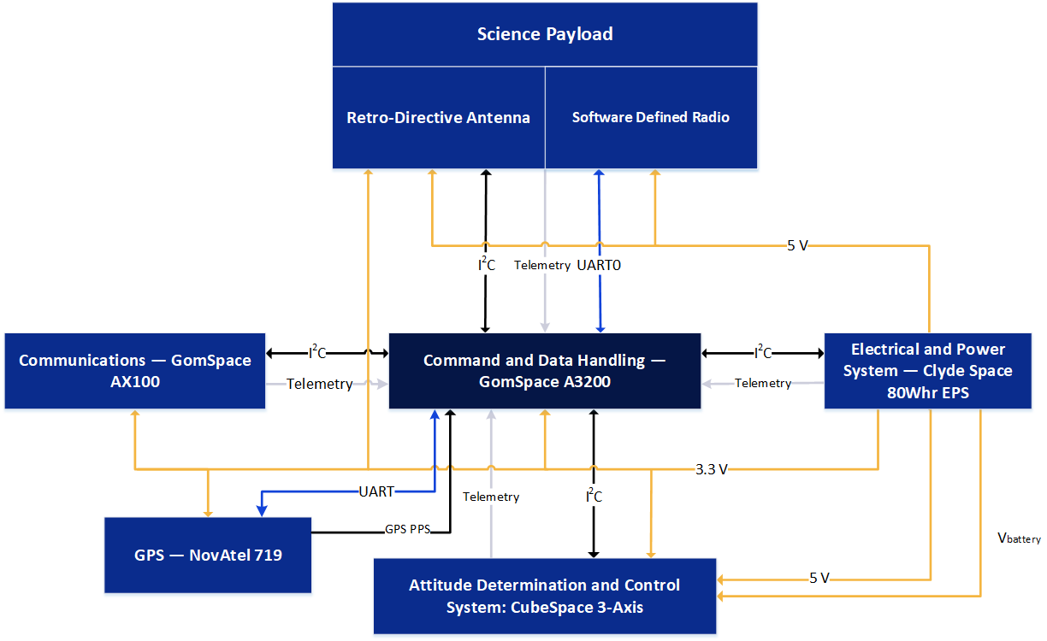
Figure 2: Spacecraft system block diagram

S-band active phased array (SPA)
The S-band active phased array (SPA) was developed in-house at the University of Alaska Fairbanks (UAF) [2]. The initial design included the ability to perform retrodirective power scanning techniques shown by Akagi et. al. [3] and null scanning techniques shown by Iwami [4]. These techniques both use an interrogating signal from the ground station. The phase array scans through the entire array while recording the power received thereby determining the angle of arrival of the interrogating signal. The separation in the downlink and uplink frequencies of the NSN is larger than can be accommodated by the bandwidth of our phased array. In the CCP mission the phased array ground tracking will be controlled by the CDH using positional information obtained from the GPS and ADCS. The motivation of this technology is to increase the antenna gain available on CubeSats, while minimizing the impact on the other spacecraft requirements such as attitude control, size, and number of deployables.
The SPA block diagram is shown in Figure 3. Wilkinson power dividers are used to separate the four array channels. Each channel has a phase shifter and a power amplifier. An MSP430 microcontroller is used to control the array and perform the beam forming. This microcontroller is also used to store and execute payload software, allowing autonomous operation of the SPA.
The SPA assembly is shown in Figure 4. The assembly consists of three pieces: a microcontroller board, an RF board, and an antenna board. The microcontroller board is a PC104 form factor board containing the microcontroller and related peripherals. Two header connectors provide digital logic control and power to the RF board, which contains all of the RF electronics on a dielectric controlled substrate. Coaxial RF connectors provide interface to the radio subsystem and the antenna board. The antenna board contains the four antenna elements on another dielectric controlled substrate bonded to an aluminum ground plane. The antenna board is mounted directly to the spacecraft structure via the aluminum ground plane.
The standard telemetry packet includes the current beamforming angle, temperature, and power measurements, the results of the array scanning, and general status with error flags. An I2C interface with the microcontroller is used to issue commands and request additional telemetry.

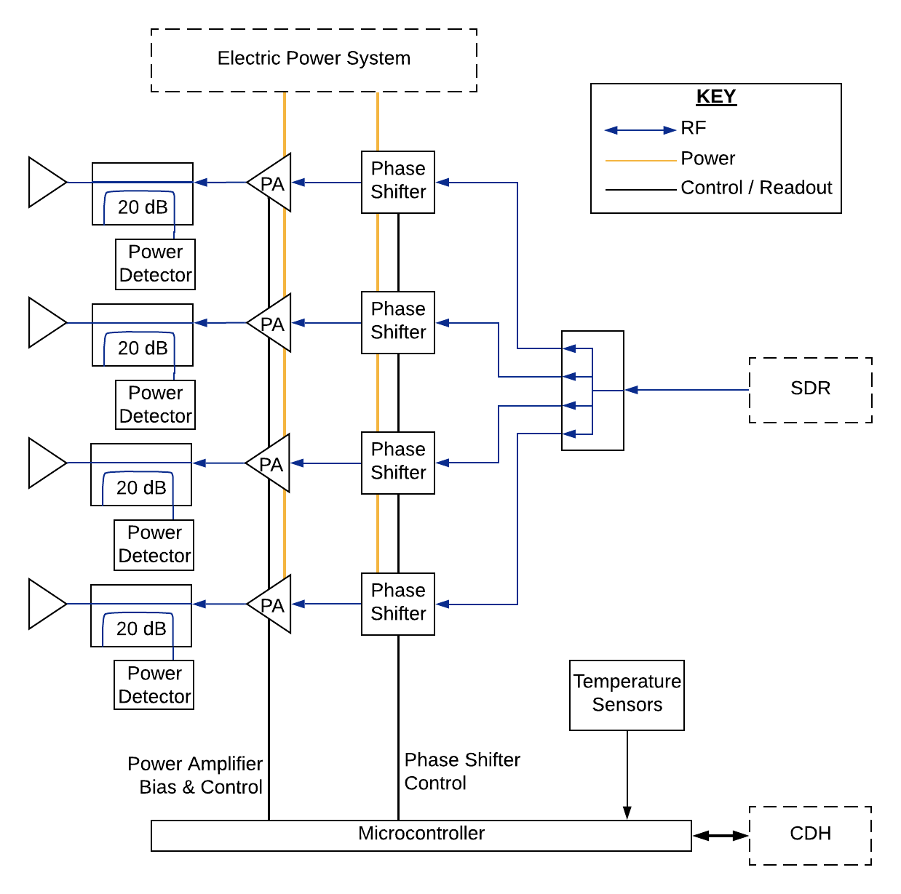
Figure 3: SPA Block Diagram

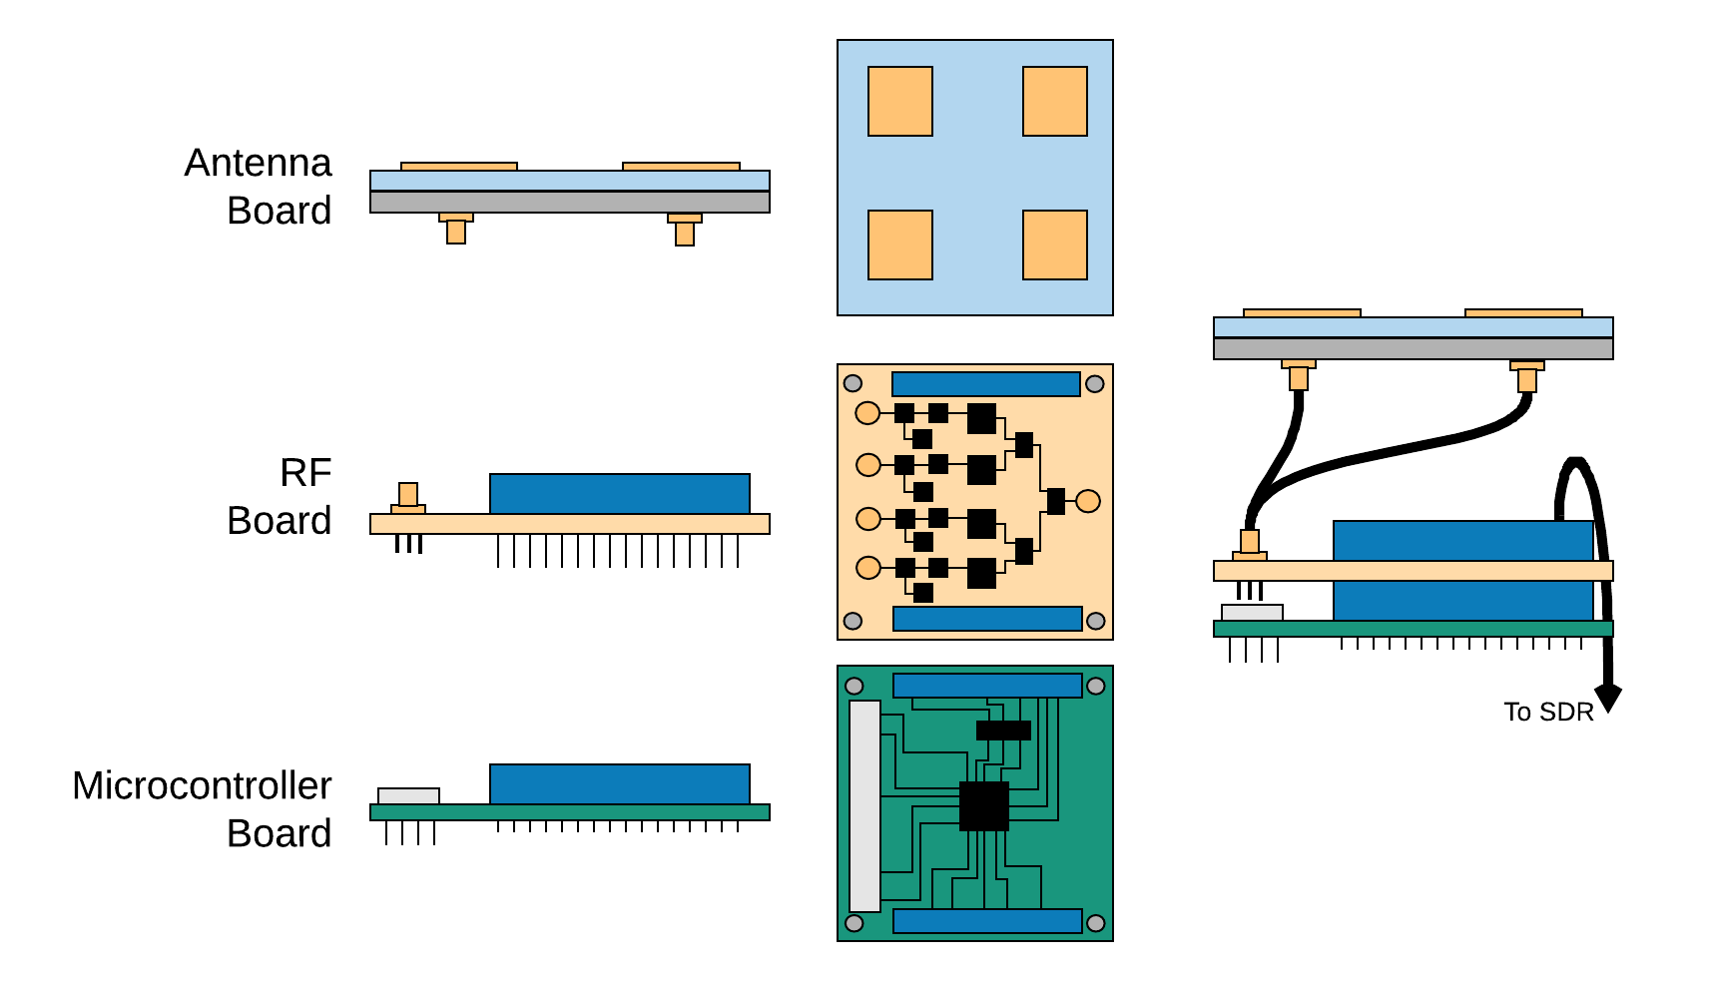
Figure 4: SPA Physical Design
The digital and RF electronics have been prototyped and tested to verify performance expectations. Design of the engineering development unit for the RF Board and Microcontroller board is currently in progress. The antenna elements have been simulated in HFSS for estimates of beam pattern and size. However, the current antenna element design is bandwidth limited, and further design work is being performed to increase the bandwidth. The simulated antenna gain is 8.1 dBi, with a fixed half-power beamwidth (HPBW) of 56°. With the use of scanning, the HPBW increases to 82°. The major limitation of the current antenna element design is bandwidth: 16 MHz at 2.2 GHz which precludes true retrodirectivity with the NSN ground stations. The scanning and beamforming accuracy of the system is expected to be less than 2°, based on measurements of the prototype. At a 1W transmit power, the system uses 5 V at 1 A and 3.3 V at 0.02 A, for a total power consumption of approximately 5 W. The SPA can transmit up to 2 W maximum power, a limit of the dielectric material of the antenna elements. The total electronics gain of the system is expected to be 27 dB. The SPA uses all commercial components, except for the custom antenna elements.

Software Defined Radio
The software defined radio (SDR) subsystem is a flexible radio transmitter capable of transmitting according to protocols defined by three unique standards: Digital Video Broadcasting-Satellite, Second Generation (DVB-S2), Consultative Committee for Space Data Systems (CCSDS), and VITAMIN (Variable-Coded Modulation to Maximize Information), a custom protocol developed at the University of Alaska Fairbanks [5]. The SDR is designed for flexibility to support the CCP mission to characterize the relative performances of the protocols with respect to Bit-Error Rate (BER) and Shannon Utilization Ratio to, ultimately, answer the question of how to maximize the information that can be downlinked from a CubeSat.
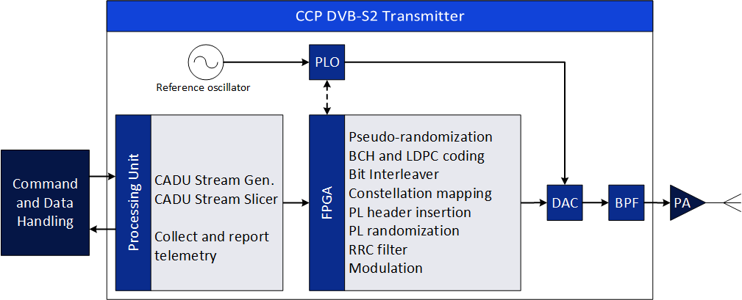
The CCP team has already developed and tested a VITAMIN transmitter and receiver using LabView and has tested a DVB-S2 transmitter in GNU Radio on the BeagleBone Black. In both test setups, the SDR is not capable of transmitting at the desired symbol rate of approximately 3.7 MSymbols/s. This issue is expected to be resolved after development on an FPGA. The DVB-S2 transmitter software modulator in GNU radio was tested in the NASA Goddard Space Flight Center (GSFC) Communication Standard and Test Laboratory (CSTL) with a Cortex High Data rate Receiver (HDR) in DVB-S2 mode. BER performance for modulations including QPSK, 8PSK and 16APSK with various coding rates such as 1/4, 3/4, 8/9, 9/10 were tested. The results indicate that the software modulator is coded correctly and compatible with the CCSDS over DVB-S2 standard. We are currently translating the GNU Radio code to MATLAB/Simulink HDL Coder for use with ADRV9361-Z7035 SDR. Figure 5 shows an SDR subsystem-level block diagram including showing the interfaces between the Command and Data Handling (CDH) and the Phased Array (SPA) subsystems.
CCP SDR
Figure 5: Prototype SDR block diagram

At a functional level, the software-defined radio will consist of three different VCM-capable communication protocols: DVB-S2, CCSDS, and VITAMIN. This a considerable task mitigated by the fact that the functional blocks are often similar or identical between each protocol which can be seen in Figure 6. Furthermore, VITAMIN is equivalent to that of CCSDS save one exception; the modulation and coding for CCSDS is signaled using a Frame Descriptor whereas VITAMIN uses unique physical layer frame lengths to convey that same information.

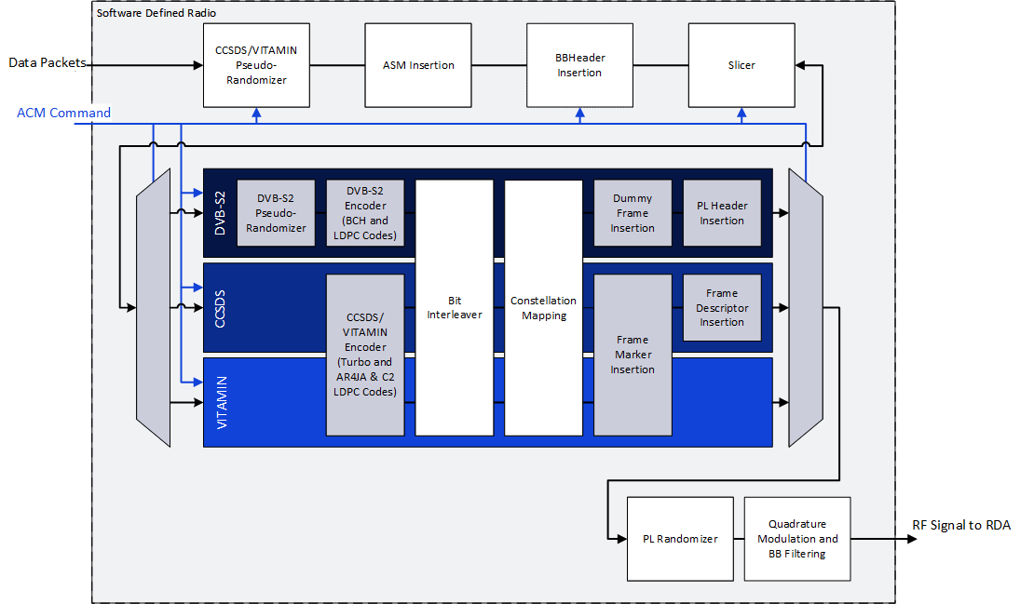
Figure 6: Functional blocks for VCM protocols: DVB-S2, CCSDS, and VITAMIN

Ground System
The mission plan calls for two ground stations: University of Alaska Fairbanks’ student ground station (SGS) and NASA’s Near Space Network (NSN). The SGS is responsible for basic telemetry and command as well as receiving experimental and decoding all packets up to 8PSK. The NSN ground station will be responsible for DVB-S2 experimental packets up to 16APSK. Experimental packets are to be transmitted at S-band and subsequent analysis for both ground stations assume a 5MHz bandwidth with a 0.35 filter roll-off. In order to determine the ability of the CCP to utilize VCM at a symbol rate of 3.7 MSymbols/s the CCP team performed a link analysis that determines link margins for each modulation and coding for each protocol for the duration of a satellite pass.
The University of Alaska student ground station is comprised of an S-band 1.2 m parabolic dish with gain-to-noise temperature of 2.48 dB/K. For the SGS, the SDR needs to be capable of achieving acceptable link margins to support modulations up to 8PSK. The link margins at the SGS for each modulation are shown in Figure 7. In the figure, each region is defined by the upper bound for a particular modulation and coding scheme and that of the next higher order modulation. A threshold of 6 dB is shown to offer a safe margin to account for stray losses and ensure the CCP can transmit at the necessary modulations.
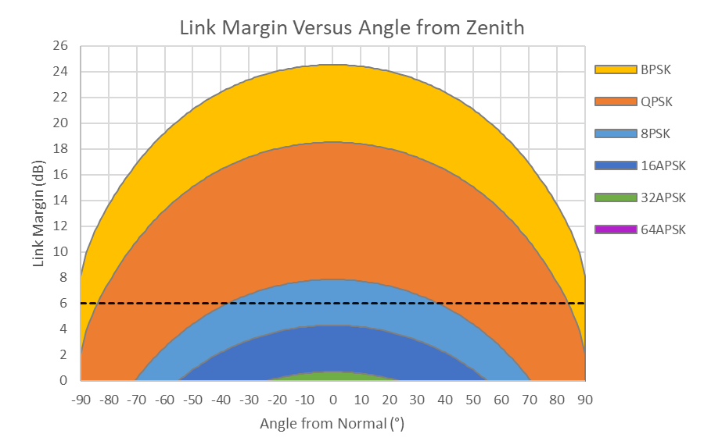
Figure 7: UAF SGS link margin
Based on estimates of the NSN ground station at Wallops, the link margins are more optimistic. Considering an 11 m parabolic dish with a gain-to-noise temperature of 23.21 dB/K and a symbol rate of 3.7 MSymbols/s, the same link analysis as for the UAF SGS yields the results shown in Figure 8.
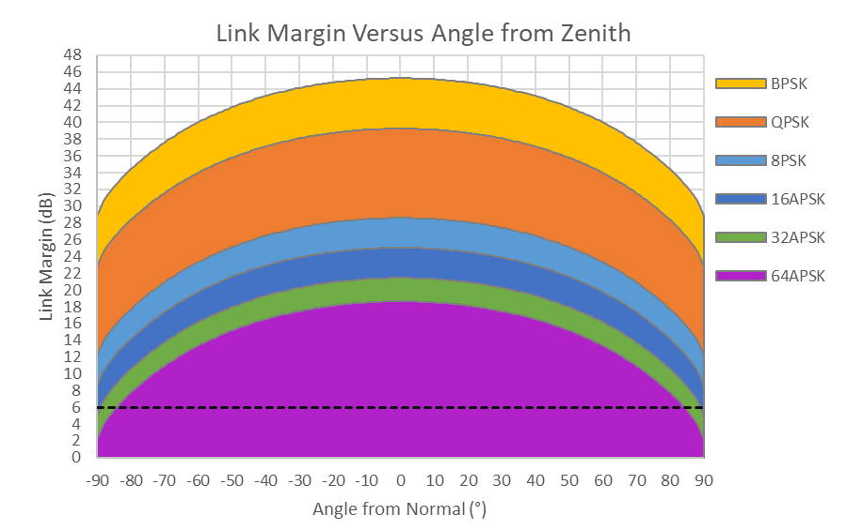
Figure 8: NSN link margin

Payload Operations
The CCP mission experiments are scheduled by ground command, and then executed and coordinated by the CDH subsystem. Each payload communicates solely with the CDH subsystem, there is no direct communication between the payloads. This simplifies the experiment operations by allowing the CDH subsystem to have absolute coordination of when the spacecraft should be in transmit or receive modes, and when and which experiment sequences should be executed.
The SPA payload performs beam forming and ground tracking on command from CDH. For the SDR operations, the VCM profile can either be pre-determined on the ground for upcoming passes and then transmitted to the spacecraft via command or can be quasi-adaptive with the ground command indicating the SNR of the received signal. Since command and telemetry is performed on a UHF system separate from the experimental payloads, downlink time is not wasted during these uplinks.

Compatibility Testing with NSN Ground Station
The compatibility of the DVB-S2 transmitter with NASA’s Near Space Network (NSN) ground station will be tested in three stages. Stage 1 is the test in the GSFC Communications, Standards, and Technology Laboratory (CSTL). Based on test results in CSTL, a prototype transmitter will be developed. Once the prototype is produced, it will be tested in the CubeSat testbed at Wallops Flight Facility in VA for stage 2. The testbed emulates NSN channel medium loop configuration containing an LNA, down converter and other components. An engineering unit will be developed based on test results in the CubeSat testbed. In stage 3, a formal compatibility test will be conducted with the flight version of the DVB-S2 transmitter in the Compatibility Test Lab (CTL) at GSFC. The transmitter parameters against those in the CCP RF ICD will be measured and verified during the test. The compatibility test report will be released after the test. This is the requirement for the certification of the compatibility of the DVB-S2 transmitter with NSN ground station.

Conclusion
Due to the increasing popularity of the CubeSat platform, methods for maximizing its potential become ever more significant. The inherent bandwidth, power, and time limited nature of the platform and the complexities of communication at LEO mean that technological advancements that allow a satellite to downlink more data with increased reliability can be crucial to the success of a mission. As has been shown, the CCP mission will demonstrate two potential strategies to improve the utility of the CubeSat. To accomplish this, the CCP improves the state-of-art for the CubeSat platform by demonstrating a miniature S-band phased array antenna, a VCM-capable SDR, and testing both technologies with the UAF SGS and NASA’s Near Space Network.

Acknowledgements

References

[1] E. Kulu, "Nanosatellite Database," 2019. [Online]. Available: http://www.nanosats.eu.
[2] J. Long, D. Thorsen and O. Kegege, "Retrodirective Phased Array Antenna for CubeSats," in IEEE Aerospace Conference Proceedings, 2019.
[3] J. Akagi, A. Zamora, M. Watanabe and W. Shiroma, "A Self-Steering Array Using Power Detection and Phase Shifting," IEEE MTT-S International Microwave Symposium Digest, pp. 1325-1328, 2008.
[4] R. Iwami, A. Zamora, T. Chun, M. Watanabe and W. Shiroma, "A retrodirective null-scanning array," in IEEE MTT-S International Microwave Symposium Digest, 2010.
[5] T. Sielicki, J. Hamkins and D. Thorsen, "Variable Coded Modulation software simulation," in IEEE Aerospace Conference Proceedings, 2013.

