Fundamental Satellite Precipitation Data Records
Chris Kidd¹², James Beachamp¹, Matthew Sapiano, Nai-Yu Wang^{1,3}
¹Earth System Science Interdisciplinary Center, University of Maryland, College Park, MD. USA,
²NASA/Goddard Space Flight Center, Greenbelt, MD. USA.
³NOAA, Silver Spring, MD. USA.

Abstract
The observation and measurement of precipitation across a range of temporal and spatial scales is of great importance for many user requirements and applications. Precipitation is a key component of the global energy and water cycle moving water, and its’ associated energy, through the Earth system at relatively fine spatial and temporal scales. At the societal level, precipitation provides fresh water and moderates our climate, but can also be destructive through storms, droughts and spreading diseases. Monitoring and measuring the distribution and quantities of precipitation, across the Earth’s surface is therefore crucial to physical and social applications, together with changes in precipitation over time. While conventional surface instruments provide a reasonably long record, these tend to be confined to well populated land surface areas: most ocean regions and sparsely populated regions have few measurements. Satellite-based precipitation products can provide global measurements, although the timespan of such products is limited and the data record is comprised of different instruments that operate over different periods of record. The challenge of any climate record is to provide a consistent product over the full period of record. Many satellite precipitation products incorporate ancillary data, such as surface gauge data or model data, which may limit their utility in the validation or verification of other climate data records.
This chapter provides a review of the importance of precipitation to the climate system, the basis of satellite precipitation retrievals, climate data records of satellite data for precipitation retrievals and the development of fundamental precipitation data records for climate applications.
Keywords: Climate data record, precipitation, rainfall, retrievals, errors and uncertainties

1 Introduction
Such fundamental questions such as “How often does it rain?” have been addressed by Sun et al. (2006) who used information from gauge data to assess global climate models in simulating the occurrence, intensity and number of rain-days. They found that while the overall precipitation totals were reasonable, the occurrence/intensity of precipitation was poor. While the studies by Sun et al. evaluated precipitation over land surfaces, over the oceans similar studies are difficult since few or no surface measurements are possible. Petty (1995) used ship-based weather reports (COADS) to generate seasonal maps of precipitation occurrence and intensity, although with gaps where few reports were available. Ellis et al. (2009) used observations made by the CPR on the CloudSat mission to calculate the frequency of precipitation over the ocean, showing good agreement with observations from island locations. Stephens et al. (2010) highlighted the problems relating to the representation of precipitation global models, particularly the characteristics of liquid precipitation over the oceans. They found that the differences between satellite observed and model precipitation were greater than those which could be attributed to the retrieval or sampling errors of the observations. Echoing the over-land results of Sun et al. (2006), could reproduce the total precipitation well, but the spatial patterns of the occurrence and intensity were poor, over-estimating the occurrence of light precipitation and underestimating heavy precipitation. A later study by Herold et al. (2016) noted that this was not confined to just the gauge-model data but also gauge-satellite data sets and concluded that the spatial scales of the observations, models and satellite data were a significant factor in discrepancies between the different data sites.
Changes in precipitation as a result of climate change have been highlighted by a number of key papers. Trenberth et al. (2003) noted that it is the characteristics of rain that are more likely to change as climate changes, leading to increases in floods and droughts rather than in the total precipitation, and the subsequent impact such an increase would have on agriculture, hydrology, and water resources. The source of enhanced moisture of this was investigated by Held and Soden (2006) who suggested that the observed increase in lower tropospheric moisture would lead to greater moisture transport and enhanced extreme precipitation (wet vs dry) conditions. Indeed, Alexander et al. (2006) showed that despite precipitation having less coherent changes (compared with those of temperature), changes in global precipitation were widespread with significant increases. More recently Donat et al. (2016), using observations and global climate models, showed increases in extreme daily precipitation over both wet and dry regions over the last six decades. Such changes are very much in line with the Clausius-Clapeyron constraint (Pall et al. 2007), with model simulations of future climate scenarios suggesting increases along the Tropics and at mid-latitudes, with reductions in precipitation in arid/semi-arid regions (Allen and Ingram, 2002). New et al. (2001) investigated trends in precipitation at the global scale using multi-sourced precipitation datasets, supporting some of the findings of the model simulations. Perhaps more crucially, since precipitation is a key part of the global energy and water cycle, the global water budget should be in balance: i.e. total evaporation should equal the precipitation. However, Trenberth et al. (2007) noted that model-simulated evaporation often exceeded that of precipitation, particularly in the lower latitudes.
Regional studies such as Simpson and Jones (2014) have shown changes in observed precipitation and extremes, particularly at regional seasonal scales over the UK, indicating wetter winters and drier summers. This study was echoed by Higgins and Kousky (2013) who showed that the return periods for both light and heavy precipitation had increased. Other regional studies include Maidment et al. (2015) who looked at recent changes over Africa while Chen et al. (2001) analysed a 50-year global gauge-based land surface data set. Pall et al. (2011) analysed the effect changes have on flood risk, which was further highlighted by Merz et al. (2014) who noted that assessing flood risks on global climate scale is crucial to better manage and mitigate the risks. Reed et al. (2015) demonstrated the case for satellite-based precipitation observations in managing floods on the global scale, and in particular, the need to frequent and regular observations. Importantly, as demands by society increases the management of water resources, further constraints of natural river flows (see Wisser et al. 2010) will necessitate improved monitoring and measurement of the whole regional water cycle.
Of course, it is not just rainfall per se that has been seen to change over the last few decades, but also snowfall which, due to a combination of rising temperatures and changes in precipitation patterns, has resulted in significant changes in regional snow packs as identified by Mote et al. (2018) over the mountainous regions of the western US. Such snow-covered regions are important for the storage and delivery (through melting) of fresh water to otherwise arid regions. Furthermore, the rising temperatures globally, and in particular in the polar regions is leading to changes in the phase of precipitation from snow to rain as noted by Bintanja and Andry (2017) with impacts across the water cycle of these regions (Vihma et al. 2016).
The measurement of precipitation and its characteristics is therefore of crucial importance in being able to assess its distribution across the globe, and importantly how it changes over time. As highlighted by Trenberth et al. (2003), these changes are likely to affect the intensity, occurrence and duration of precipitation events, characteristics that Stephens et al. (2010) noted were poorly represented within models. Furthermore, since precipitation characteristics are very much dependent upon the spatial and temporal resolution of the precipitation sampling, ensuring that precipitation is properly represented in retrievals both from satellite observations and from models is essential to ensure long-term assessments of precipitation characteristics.
Surface gauge data sets form the de facto reference data set for investigating global precipitation, at least over land (e.g. Jurković and Pasarić 2013). Regional data sets, such as the APHRODITE (Yatagai et al. 2012) and the GHCN (Menne et al. 2012) compile detailed data sets at regional and global scales. Perhaps the most comprehensive global gauge data set is that of the GPCC (Becker et al. 2013)) which draws on regional, national and international gauge networks to provide a comprehensive gauge data base and mapped products at various scales. However, gauge inter-comparisons highlighted variations between gauges and their associated measurement errors (Sevruk et al. 2009). Methods for improving gauge-based precipitation measurements were addressed by Strangeways (2004) noting, in particular, that there is not insignificant underestimation in the measurement of light precipitation using standard gauges. Gauge measurements are further complicated by having to relate point observations to spatial measurements particularly, for example, over complex terrain even in regions with high gauge densities (Dorninger et al. 2008).
Observations made by satellite sensors provide a global viewpoint, overcoming shortfalls in (primarily land-only) surface-based measurements (Kucera et al. 2013), and allows an additional independent source of information to provide the precipitation measurements needed for cross-disciplinary hydrological and land studies, climate and freshwater budgets, both aiding science and society.

2 Satellite precipitation estimates
Background to satellite precipitation measurements can be found in Kidd and Huffman (2011), Kidd and Levizzani (2011) and more recently in Kidd and Levizzani (2019). While IR-based techniques are able to exploit the frequent and regular observations that are made by the geostationary satellite sensors, such techniques rely upon indirect cloud-top to surface precipitation relationships. As a result, IR-based retrievals tend to vary in accuracy over time and location depending upon different meteorological and climatological regimes. More direct observations of the actual precipitation-sized particles are possible through the use of PMW observations: here it is the particles themselves (rather than the cloud tops) that provide the radiometric signal from which the retrieval can be made (see Figure 1). Techniques for the retrieval of precipitation have been built upon basic radiometric properties of the interaction of the precipitation-sized hydrometeors with the radiation sensed by the radiometer. Basic techniques have achieved a degree of success through linking this received radiation with the precipitation at the surface. However, providing an unambiguous retrieval of precipitation is often difficult due to the variability of the surface background, or the non-unique spectral signature to hydrometeor profile/surface rainfall relationships. This, together with a desire to provide vertical profiles of precipitation led to the development of physically-based precipitation retrieval schemes, as typified by the GPROF scheme (Kummerow et al., 2011, 2015). Ultimately many precipitation retrieval techniques need to seek a compromise between providing a physical correct and consistent retrieval and a reasonable estimate of surface precipitation within a set of developer and user requirements. The GPROF scheme utilizes model information and ancillary data sets to better constrain the set of possible precipitation retrievals, as well as to make the scheme more computationally efficient.

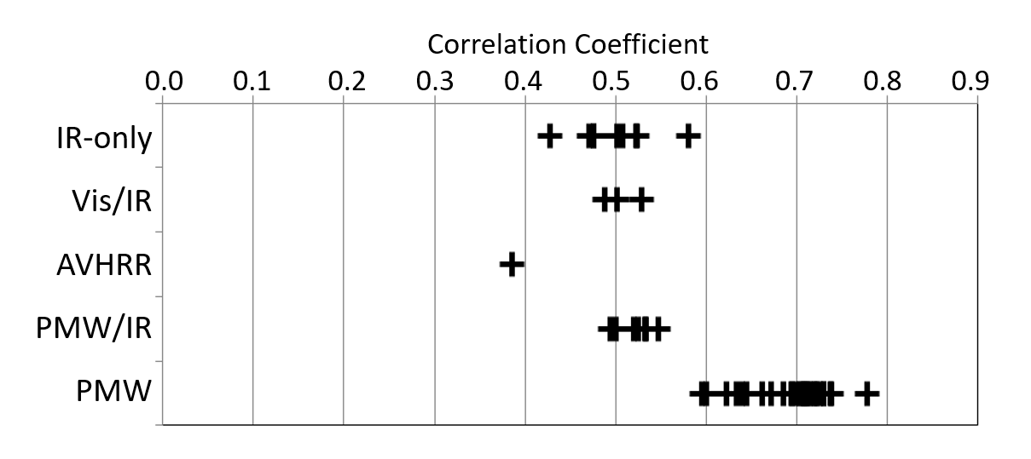
Figure 1: Correlations of instantaneous precipitation retrievals during the AIP-3 experiment, showing that the PMW retrievals are consistently better, at least over the AIP-3 region, for instantaneous precipitation estimates.

Consequently, passive microwave sensors have been developed over the last 40+ years to provide observations capable of being used for precipitation measurements (see Table 1). Over the course of these 40+ years, the number of satellites with these sensors has steadily increased and now amounts to about 10-12, many of which contribute to the GPM mission constellation (Hou et al., 2014). The GPM mission may be regarded as the current standard for measuring precipitation on a global scale, not least since it provides a focus for the precipitation research community and precipitation products for the user community (see (Kidd et al. 2020; Skofronick-Jackson et al. 2017). In addition, due to its low inclination orbit and highly calibrated instruments, GPM acts as a calibrator to the other precipitation-capable sensors (Wilheit et al. 2015). Algorithms and techniques have been further refined to take advantage of this intercalibrated set of observations, such as the GPROF scheme; (Kummerow et al. 2011, 2015; Randel et al. 2020) together with the techniques of EUMETSAT’s H-SAF (Mugnai et al. 1990, 2013).

Table 1: Passive microwave imaging radiometers commonly used for precipitation estimation; dates represent full extent of collected data. (SS=Sun Synchronous, NSS=Non-Sun Synchronous; CS=Conically Scanning, XT=cross-track; V=Vertical, H=Horizontal polarisation, number=number of channels; *resolution at nadir).
Sensor | Satellites | Dates | Orbit | Type | Frequency region (GHz) |  |  |  |  |  |  |  |  | Resolution (km)
 |  |  |  |  | 6.6 | 10.7 | 18 | 23 | 37 | 89 | 118 | 150 | 183 | Resolution (km)
SMMR | Seasat  Nimbus-7 | 1978-  1988 | SS | CS | VH | VH | VH | VH | VH
SSM/I | DMSP-F08,10,11  13,14,15 | 1987-present | SS | CS |  |  | VH | V | VH | VH
SSMIS | DMSP-F16,17,18,19 | 2003-present | SS | CS |  |  | VH | V | VH | VH |  | H | 2H
AMSR | AQUA  ADEOS-II | 2002-2011 | SS | CS | VH | VH | VH | VH | VH | VH
AMSR2 | GCOMW1 | 2012-present | SS | CS | VH | VH | VH | VH | VH | VH
TMI | TRMM | 1997-2015 | NSS | CS |  | VH | VH | V | VH | VH
GMI | GPM | 2015-present | NSS | CS |  | VH | VH | V | VH | VH |  | VH | 2V
MWRI | FY3C |  | SS | CS
AMSUB | NOAA-15,16,17 | 1998-2010 | SS | XT |  |  |  |  |  | V |  | V | 3V | 16x16*
MHS | NOAA-18,19  MetOpA,B,C | 2005-present | SS | XT |  |  |  |  |  | V |  | V | 2HV | 16x16*
ATMS | NOAA-20 NPP | 2011-present | SS | XT |  |  |  | V | V | V |  | H | 5H | 16x16*
SAPHIR | Megha-Tropiques | 2011-present | NSS | XT |  |  |  |  |  |  |  |  | 6H | 10x10*
MWHS | FY3C |  | SS | XT |  |  |  |  |  |  |  |  |  | 16x16*

Through the exploitation of the observations from multiple satellite sensors fine spatial and temporal resolution precipitation products are possible, typically around 10-km, 30-minute or finer. Some techniques rely upon relating IR observations to surface gauge measurements, such as CHIRPS (Funk et al. 2020) or TAMSAT (Maidment et al. 2015). Other techniques combine the more direct observations of the passive microwave observations, with the less direct but more frequent/regular infrared observations. This may be through the calibration of the IR observations by the PMW retrievals (e.g. PERSIANN, see Hsu et al. 2020), or through the morphing of PMW retrievals using IR (or model)-derived motion vectors, such as the CPC CMORPH technique (Joyce et al. 2004), the GPM IMERG technique (Huffman et al. 2020) or the GSMaP technique (Kubota et al. 2020). However, this latter group of techniques is very reliant upon the accuracy of the initial PMW retrievals, some of which are in turn tuned to the spaceborne precipitation radar with its own uncertainties. The use of the GPM DPR to ‘calibrate’ the constellation rainfall retrievals has shown that spaceborne precipitation radars are extremely valuable in such a role. However, uncertainties still exist in the radar-derived rainfall estimates due to the drop-size distribution to rain rate relationships, as outlined by Liao et al. (2014). Indeed, several studies have used other satellite data sets to verify the results derived from PMW and combined products, such as observations provided by the CloudSat mission (Stephens et al. 2018; Stephens et al. 2002). In particular, the greater sensitivity of the CloudSat CPR has highlighted the importance of light precipitation particularly at the higher latitudes and over the oceans (see Behrangi et al. 2014, 2016; Berg et al. 2010; Lebsock and L’Ecuyer 2011) as well as the capability for snowfall retrievals (see Panegrossi et al. 2017).
Many techniques that rely upon simple relationships between the satellites observations and surface precipitation are nevertheless still capable (Kidd et al. 2018); while not necessarily physically-based (i.e. reliant upon radiative transfer modelling), they do have a sound physical basis. For example, over the ocean, increases in the Tbs of the low frequency channels are strongly linked to increases in rainfall, while over land high frequency channels are linked to the precipitation-size ice in clouds. These basic criteria have been exploited by many techniques to provide a measure of precipitation at the surface. Critically, for long term precipitation data records, since these techniques are relatively simple, changes in the original satellite observations are much easier to trace, attribute and understand than changes in more complex retrieval schemes. In particular, the use of more ‘simple’ techniques allows not only changes in the input data sets to be checked, but also provides a forensic tool to be able to better understand changes in more complex schemes.

3 Satellite observational records
The observation, monitoring and measurement of precipitation on a global basis over a climate timescale is essential to understand changes in the Earth system. Establishing satellite data records for identified ECVs is examined by Hollmann et al. (2013) with satellite based ECV records (Bojinski et al. 2014). Further, Masó et al. (2020) highlighted the need for long term ECV-type data for sustainable development goals monitoring.
At the heart of any satellite precipitation product are the observations, the quality and consistency of which is paramount in being able to generate high quality precipitation retrievals. A number of FCDRs of PMW Tbs have been generated or are currently being generated. These climate data records provide a time series of measurements of sufficient length, consistency, and continuity, carefully developed to improve homogenization and inter-calibration of the Tbs to ensure long term stability of the FCDRs. The raw data records have been reprocessed to a common standard and have been calibrated to ensure a unified data record: new inter-calibration methodology includes scene dependent inter-satellite bias correction and a nonlinearity correction to the instrument calibration, while the data processing accounts for known issues such as calibration anomalies due to along scan inhomogeneity, moonlight intrusions, and sunlight intrusions. The satellite record and associated FCDRs are shown in Figure 2.

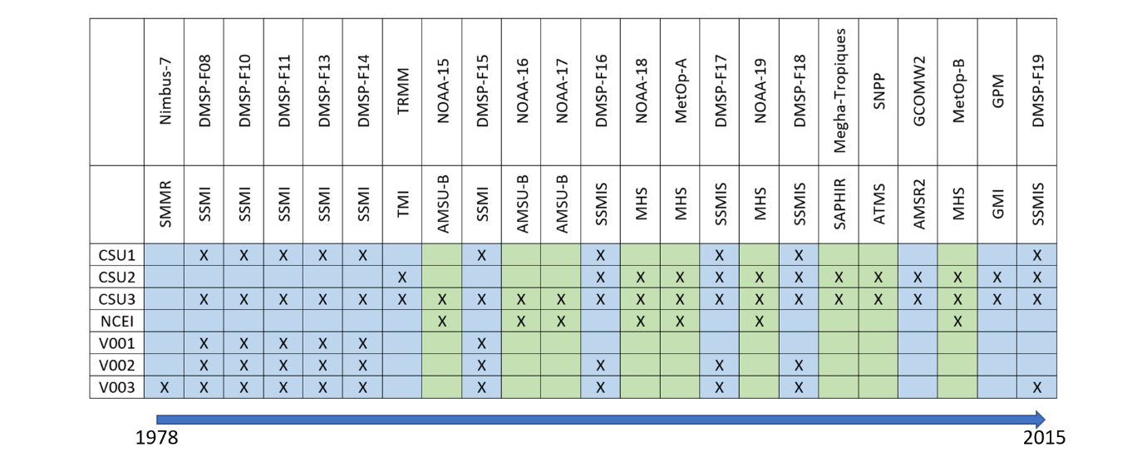
Figure 2: Schematic of sensors contributing to the current set of FCDRs Tb records from US/European/Japanese passive microwave sensors from 1978 to 2015. Blue shading indicates conical scanning radiometers (mostly imaging/window channels) while the green shading indicates the cross-track radiometers (primarily sounding channels). CSU=Colorado State University; NCEI=National Centers for Environmental Information (NOAA); V001-V003= CM-SAF versions.

A number of inter-calibrated radiometer data sets from the passive microwave instruments are available:
i) The NOAA/CSU FCDR is currently available (as of May 2017) from CSU and/or NOAA and comprises of data from all 10 DMSP 5D-2/3 SSM/I and SSMIS instruments from July 1987 to the present. This data set has been inter-calibrated to the DMSP F13 SSMI instrument, due its consistency and longevity (Berg et al. 2013; Sapiano et al. 2013).
ii) The second dataset covers the TRMM/GPM era Level 1C radiometer constellation and will be produced by the NASA/GSFC Precipitation Processing System (‘V05’) starting 1 October 2017. All of the TRMM/GPM constellation sensors are inter-calibrated to the GPM Microwave Imager (GMI). Note that this data set also contains all the sounder (MHS, ATMS, SAPHIR) instrument data (Berg et al. 2013; Semunegus et al. 2010; Wilheit et al. 2015).
iii) The third and final data set will extend the TRMM/GPM constellation record back to include the DMSP F08 SSM/I sensor; this data set is likely to be ready for release sometime during 2018 (Berg et al. 2018).
Alongside the NOAA/CSU FCDR for the SSMI and SSMIS data records, NOAA’s NCEI has been producing a FCDR for the sounding instruments as noted in Figure 2.
In parallel, the EUMETSAT Satellite Application Facility on Climate Monitoring (CM-SAF) currently develops, produces, archives and disseminates satellite-based products in support of climate monitoring. Of relevance here are three satellite observational data sets, namely the FCDR of SSM/I Tbs, FCDR of SSMI/SSMIS Tbs and FCDR of Microwave Imager Radiances, Edition 3 (see Table 2 below of details):

Table 2: Source of FCDR data sets for currently available multi-sensor together with DOIs.
Source | FCDR | Reference
NOAA/CSU | DMSP SSMI and SSMIS | DOI: 10.1109/TGRS.2012.2206601
NASA/CSU | TRMM/GPM constellation | DOI: 10.1175/JTECH-D-16-0100.1
NASA/CSU | Extended TRMM/GPM constellation | DOI: 10.1175/JTECH-D-16-0100.1
DWD/  CM-SAF | Fundamental Climate Data Record of SSM/I Brightness Temperatures | DOI:10.5676/EUM_SAF_CM/FCDR_SSMI/V001
DWD/  CM-SAF | Fundamental Climate Data Record of SSM/I / SSMIS Brightness Temperatures | DOI:10.5676/EUM_SAF_CM/FCDR_MWI/V002
DWD/  CM-SAF | Fundamental Climate Data Record of Microwave Imager Radiances, Edition 3 | DOI:10.5676/EUM_SAF_CM/FCDR_MWI/V003

i) The CM-SAF FCDR of SSM/I Tbs (V001) is available from July 1987 through to December 2008 for the six SSM/I passive microwave radiometers on the DMSP 5D2 series of satellites, namely the F08, F10, F11, F13, F14, and F15. The data files contain all available original sensor data and metadata to provide a completely traceable climate data record.
Additional layers are provided relating to inter-calibration and Earth incidence angle and their normalization offsets, together with radiometer sensitivities, quality flags and surface types (Fennig et al. 2013).
ii) The CM-SAF FCDR of SSM/I and SSMIS Tbs (V002) extends the above V001 data set to include the SSMIS sensors on board the F16, F17 and F18 satellites with the same processing strategy and data output as the V001 data set (Fennig et al. 2015).
iii) Finally, the CM-SAF FCDR of Microwave Imager Radiances (V003) provides inter-calibrated Tbs from the SMMR, SSM/I and SSMIS passive microwave radiometers from October 1978 to December 2015. This extends the data set back to the SMMR radiometer aboard Nimbus–7 satellite. It is noted that the corrections for SMMR are limited since raw data records for SMMR are not available, although the FCDR does include all available original SMMR Pathfinder Level 1b data (Fennig et al. 2020).
Despite the extensive work developing these Tb FCDRs, differences between these individual FCDRs are not insignificant.
Figure 3 below shows a comparison between the NASA PPS Tb records and those of the NCEI and the CM-SAF records. It can be noted that there are general systematic biases between the different channels for the same instruments. There are also shorter-term fluctuations apparent between the difference data sets, sometimes with varying degrees in magnitude, together with some significant spikes, likely to be related to bad or marginal data not being flagged.

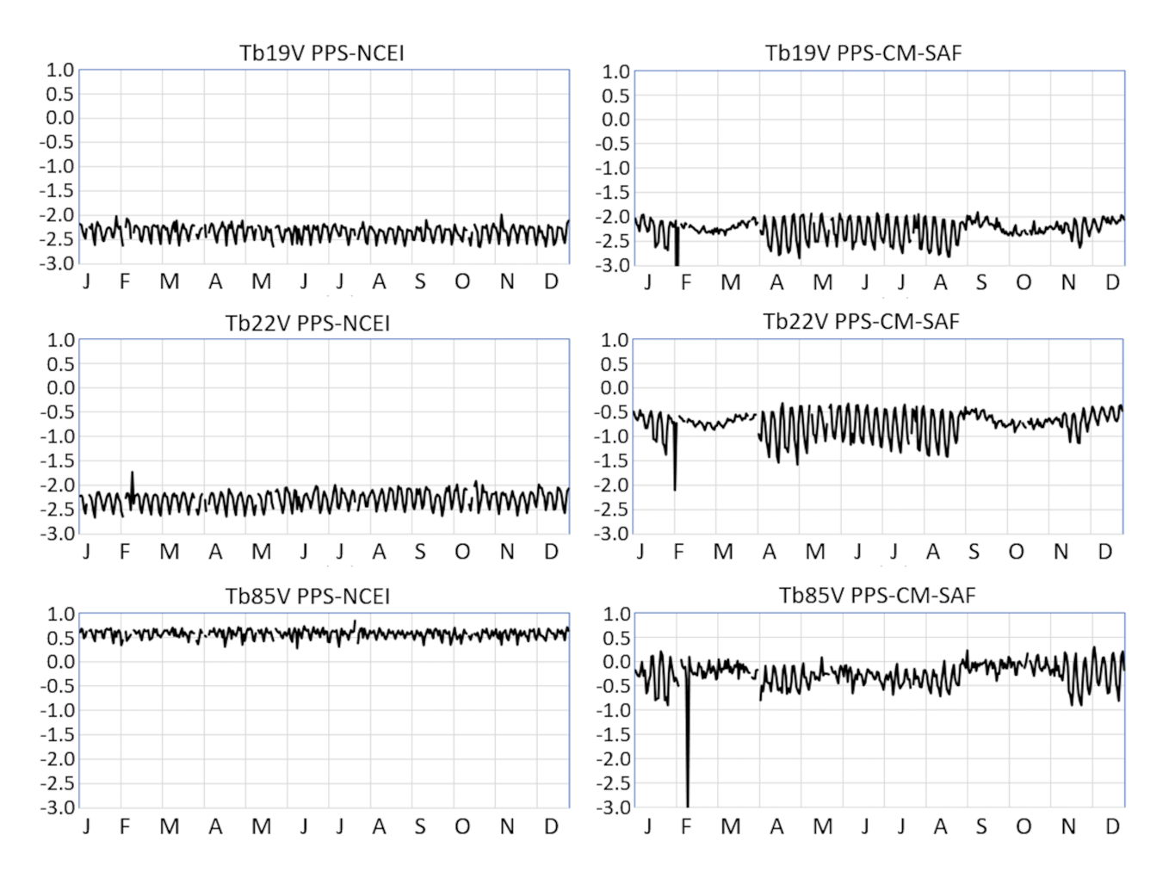
Figure 3: Differences between the NASA PPS Tb data record for the DMSP F14 SSMIS sensor for the 19V, 22V and 85V channels over the AIP-3 region (4°S-1°N, 153-158°E).

The consequence of this is clear when applying retrieval schemes to these different FCDRs: variations in any channel can led to differences in the retrieved rain rates: long term consistency of many precipitation products is problematic since small changes in the input data may be deemed significant. Changes in instrumentation, orbital parameters (affected local overpass times), channel selection and even the number of observations can be critical: even different footprint alignment schemes can alter the retrieved precipitation by as much as 4% (see Figure 4 and Table 3 below). Such variations may very similar to any long term trend in precipitation.

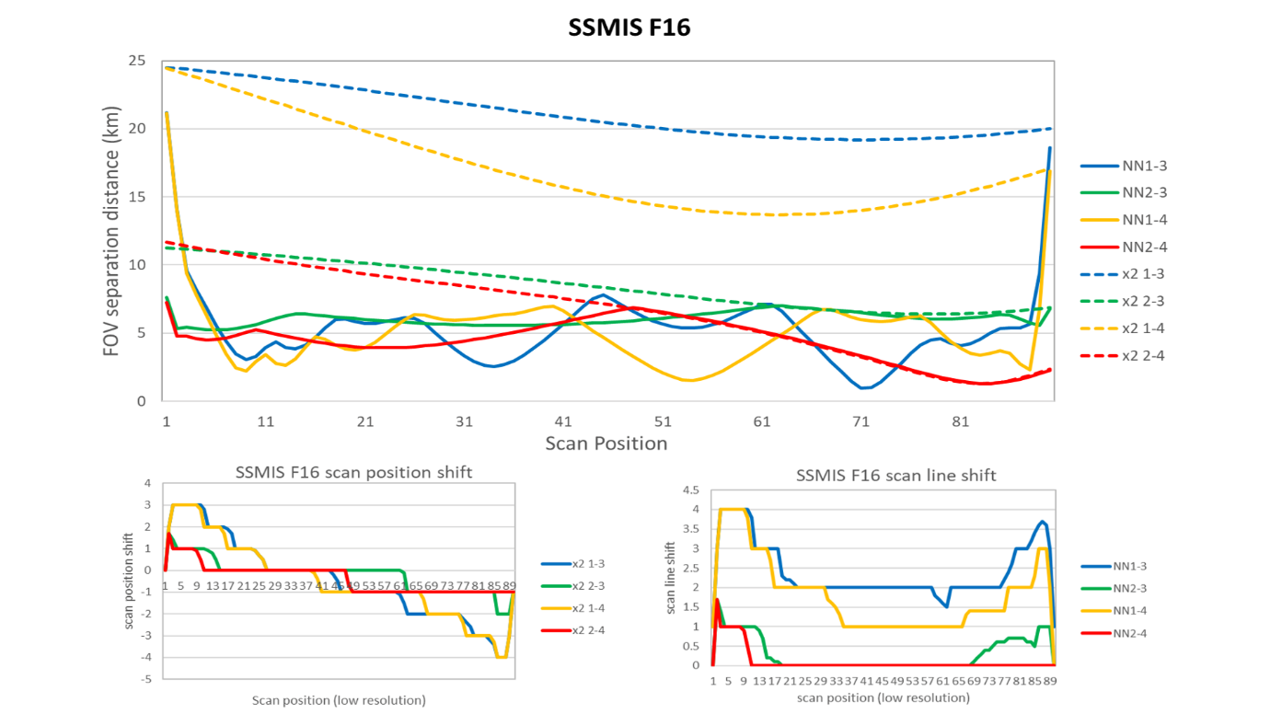
Figure 4: Nuances of how retrieval schemes handle different geolocation of footprints within their retrieval scheme. The upper figure shows the footprint separation distance if the scheme aligns the line/scan numbers (dashed lines), rather than the actual footprint location (solid line). The lower figures show the mean shift in scan position (left) and scan line(right) for each geolocation group for the SSMIS F16 sensor. Importantly, using the commonly-used matching of footprints by scan position can be 25 km astray, but using nearest, reduces this to about 5 km. Note also that these vary between different sensors of the same type. (NN=nearest scanline/scan-position; X2= scanline/scan-position based upon x2 line/position).

Table 3: Variations in estimated rainfall over the AIP-3 region based upon different sampling patterns.
Sampling scheme | BA1 (mm) | nobs | BA3 (mm) | nobs
All 180 scan positions | 9.127 | 189155 | 13.677 | 180342
Odd scan positions (1=1, 3=2, 5=3...) | 9.157 | 94521 | 13.721 | 95116
Even scan positions (2=1, 4=2, 6=3...) | 9.097 | 94521 | 13.634 | 95116
All 180 scan positions with closest low res scan positions | 9.241 | 189155 | 14.144 | 190342
Even scan positions with closest low res scan positions | 9.236 | 94521 | 14.187 | 95116
Odd scan positions with closest low res scan positions | 9.245 | 94634 | 14.102 | 95226

4 Precipitation climate data records
The range of users for satellite precipitation data products is extremely varied and consequently many satellite precipitation products are not necessarily aimed at climate-scale applications. Furthermore, those products that are climate-orientated often use external data sets, such as surface gauge data to adjust their products to remove any potential bias. While the latter is of use to particular users, it may also mask some underlying issues with the products themselves. Indeed, it many also introduce false confidence in the accuracy of the product since such products score highly when compared with surface data sets (the same data that bias-corrected the product in the first place), and the products are only corrected where surface data exists, so outside these regions their performance is relatively unknown. As noted above, many of the current satellite precipitation products are quite complex, incorporating many different satellite data sets and external data sets (such as model or gauge data) in various ways. Techniques typically try to homogenize the final products to ensure consistency over time: however, in doing so they could remove subtle and important variations in the precipitation record while also introducing unintended information. Crucially, the number of precipitation ECVs data sets (see http://climatemonitoring.info/ecvinventory) is small, and not necessarily related to a single product over the period of the whole product.
It is clear that variations occur in the observations made between different satellite sensors, whether these are from the actual sensors (e.g. channel frequencies, spatial resolution, sensitivity, etc) or from their orbital characteristics (e.g. altitude, overpass times, etc). Fundamentally, the differences between these observations and their retrieved precipitation needs to be examined so that they can be evaluated and properly corrected for, either within the retrieval scheme itself, or when the individual satellite products are combined into a precipitation climate data record.
Although there are, historically, a large number of precipitation retrieval schemes, the range of such schemes actively used has declined in recent years (e.g. 49 during the AIP-3 in 1996 (Ebert et al. 1996) falling to 29 for PIP-3 in 200). Today the number of techniques used to routinely provide estimates of rainfall from satellite observations is probably less than ten. While it is certain that some techniques have been discontinued due to inferior performance, other techniques have not been fully exploited due to funding or programmatic issues. However, a number of techniques performed extremely well in the above inter-comparisons which can be, and should be, exploited to provide a wider range of precipitation retrieval scenarios. Furthermore, these techniques are based upon basic, but sound, physical relationships between the precipitation-sized particles and the radiation stream. This latter point is important since if, as a consequence of climate change, changes in the characteristics of precipitation occurs, these simple techniques are likely to identify such changes more directly than the multi-satellite, multi-sourced retrievals, including changes in the satellite sensors, or from drifting orbits. In addition, the generation of errors and uncertainties is undoubtedly simpler for such techniques (see below). Examples of how different techniques, which produce similar monthly or annual precipitation totals, vary are shown here. Figure 5 shows the distribution of rain intensities generated by the AD1, BA1, BA3 (see Ebert et al. 1996), and GPROF (Kummerow et al. 2011) techniques from the DMSP SSMI F13, F14 and SSMIS F16 sensors over the tropical Atlantic Ocean for January 2007. It is clear that there are large differences between the different products in the precipitation intensities: the GPROF retrievals producing significantly more light precipitation than the other techniques, and the AD1 technique generating significantly higher precipitation intensities. However, although there are significant differences between the different techniques, the differences between the sensors are more subtle, with the F16 SSMIS tending to produce a higher occurrence of precipitation across all intensities except below about 0.025 mmh⁻¹ in the GPROF retrieval. The differences in the intensity distribution between these retrieval techniques is therefore of significant importance to evaluating the impact of climate change upon precipitation: as noted in the introduction, findings to date, as well as future projections, indicate that this will change precipitation intensities (rather than the precipitation total).
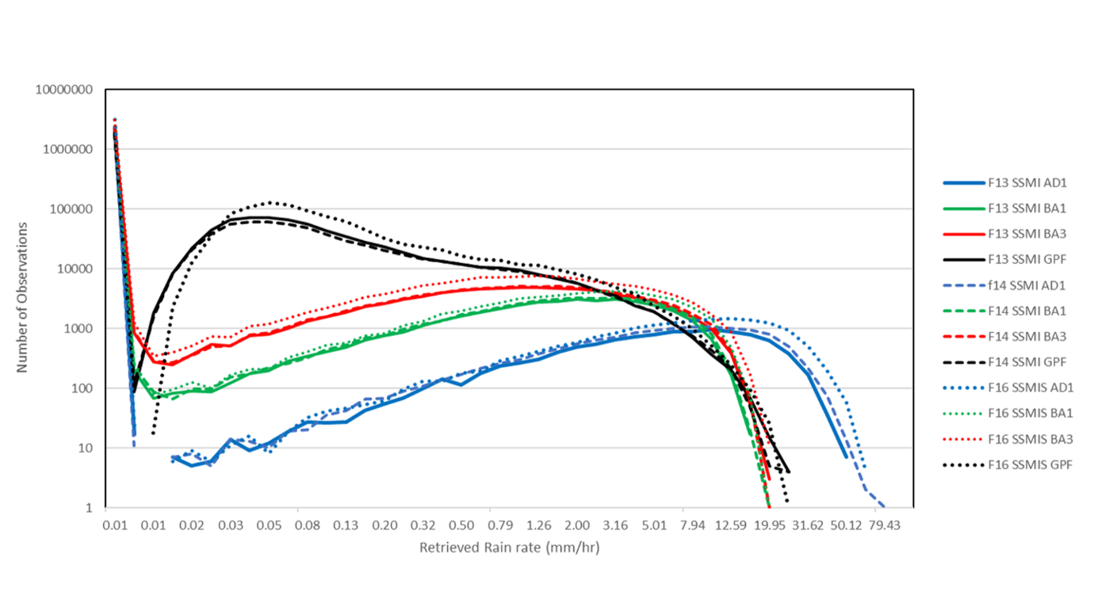
Figure 5: Variations between different precipitation retrieval schemes and different sensors for instantaneous retrievals over the tropical Atlantic Ocean for January 2007. All these schemes produce the roughly same total precipitation but show markedly different distributions in the intensities of the precipitation that make up these totals.

The differences in the intensity of the retrievals are significant, however, how do these different techniques vary over time? Figure 6 below show the retrievals from eight different techniques that were used in the AIP-3 study over the western Pacific Ocean. It can be seen that all the retrievals show similar variations in precipitation over time although there are some variations in their magnitudes. In particular, the period of low precipitation towards the end of 2010 is evident in all the techniques. Clearly, all techniques are able to capture the primary signal in the precipitation record, although subtleties in the characteristics of precipitation (such as correctly identifying warm rain), leads to differences in the final precipitation amounts.

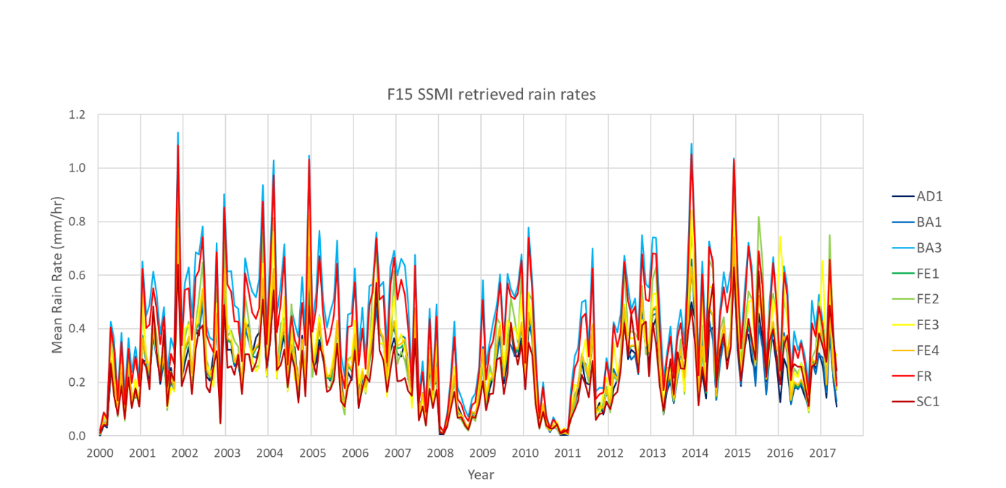
Figure 6: Monthly time series of mean daily precipitation from 8 basic retrieval schemes generated over the AIP-3 region of the western Pacific Ocean (4°S-1°N, 153-158°E).

The variations in the characteristics of precipitation, as noted above, is of great importance, and perhaps more crucially, how our observations (and model) relate to these changes. Figure 7 highlights this issue which shows the monthly precipitation estimates derived from GMI observations using the GPROF scheme and the PRPS (Kidd et al. 2016)), together with the near surface DPR retrieval and the ERA-5 numerical model product. The satellite retrievals from the GMI sensor are broadly in agreement, although subtle differences do occur. For example, the GPROF-GMI product is low relative to the PRPS-GMI product in 2015, but the reverse is true for 2017. More significantly, the DPR show less amplitude in its variations over time compared with the GMI retrievals and, somewhat perplexing, although the ERA-5 model agrees with the DPR results up to the middle of 2015, after than it produces less precipitation than the DPR up to the middle of 2017, then more than the DPR after that. Clearly, more research is required to elucidate the differences between these different products.

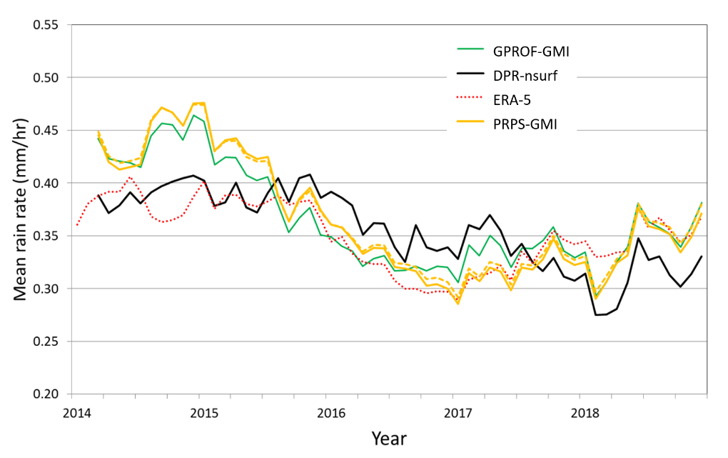
Figure 7: Comparison of precipitation products during the GPM era over AIP-3 region (4°S-1°N, 153-158°E).

5 Key questions
Throughout the satellite precipitation data record, it has become clear that no single precipitation product should be seen as being ‘correct’: each technique, scheme, and algorithm have errors and uncertainties associated with their precipitation products. Furthermore, the same is evident from the surface gauge data sets together with the output from numerical models. While the inter-comparison and validation of satellite (and other) precipitation products provides an insight into the performance of each technique, it is essential to start characterising the errors and uncertainties contained within each product. It is inevitable that any observational data set will have errors and uncertainties associated with it. This is particularly problematic for any satellite precipitation data sets where the instantaneous data is heavily skewed towards the modal rain rate value of zero. Accumulation of these instantaneous samples through time and space helps to ‘normalise’ the distribution, although other errors and uncertainties contribute, not least the representativeness of the samples that generate the accumulation.
At the very least, errors and uncertainties can be broken down into a number of identifiable sources:
Retrieval errors: any precipitation retrieval scheme will have varying degrees of error and uncertainty associated with them. This is essentially attributable to the directness of the observation to the retrieved parameters, such as the frequencies/channels utilized, the type of precipitation being observed, and the heterogeneity of the precipitation within the footprint of the sensor. For example, the frequency/channels used essentially determines the sensitivity to difference hydrometeors, i.e. ice above (any) freezing level and liquid water content (if any is present): more complex techniques may use combinations of channels/frequencies with different weightings thus changing retrieval errors associated with each individual observation. Retrieval errors and uncertainties are usually described through statistics scores through the comparison of the precipitation retrieval and a reference data set (e.g. surface gauge or radar). Studies such as those of the AIP-series (Ebert et al. 1996) and PIP-series (e.g. Adler et al. 2001) demonstrated, for example, that PMW techniques outperform the IR-only techniques, while studies such as Kidd et al. (2018) showed that retrieval schemes with greater channel diversity outperform those with fewer channels.
Sampling errors: The highly skewed distribution of instantaneous precipitation, together with the small occurrence of precipitation, impacts the sampling of precipitation events by satellite observing systems. Such sampling errors are greatest at the 1 hour to monthly scale; below that the spatial/temporal auto-correlation relationships are generally sufficient, while at or above the monthly scale sufficient samples are generally available to provide a reasonably robust estimate. The impact of sampling errors is usually determined by assuming a standard set of criteria for how often the precipitation is sampled within a certain time frame. A number of studies have attempted to quantify the uncertainties of satellite precipitation estimates through comparison surface rain gauges (Katsanos et al. 2004; Villarini et al. 2008), surface radar networks (Hossain and Anagnostou 2006; McConnell and North 1987; Nakamoto et al. 1990; North and Nakamoto 1989; Steiner et al. 2003) or multiple satellite estimates (Tian and Peters-Lidard 2010). However no over consensus is apparent since precipitation uncertainty tends to be dependent on region, season, and rain rate (Tian and Peters-Lidard 2010).
Diurnal sampling errors: Precipitation retrievals are largely based upon PMW observations made from low Earth orbiting satellites which provide only intermittent sampling, mostly at fixed time, although with some varying across different times of day. For regions that experience a strong diurnal cycle this has significant implications since satellite observations will sample different parts of the diurnal cycle. This is graphically illustrated in Figure 8 below where the ERA-5 modelled precipitation has been sampled at the overpass times of the difference sensors for the Amazon region. It can be seen that first, the magnitude of the final retrievals varies from about 0.16 to about 0.33 mmh⁻¹ while individual sensors, as their orbits drift through time, can vary nearly as much (c.0.18-0.33 mmh⁻¹). Clearly accounting for these differences is essential to ensure a robust precipitation climate data record.
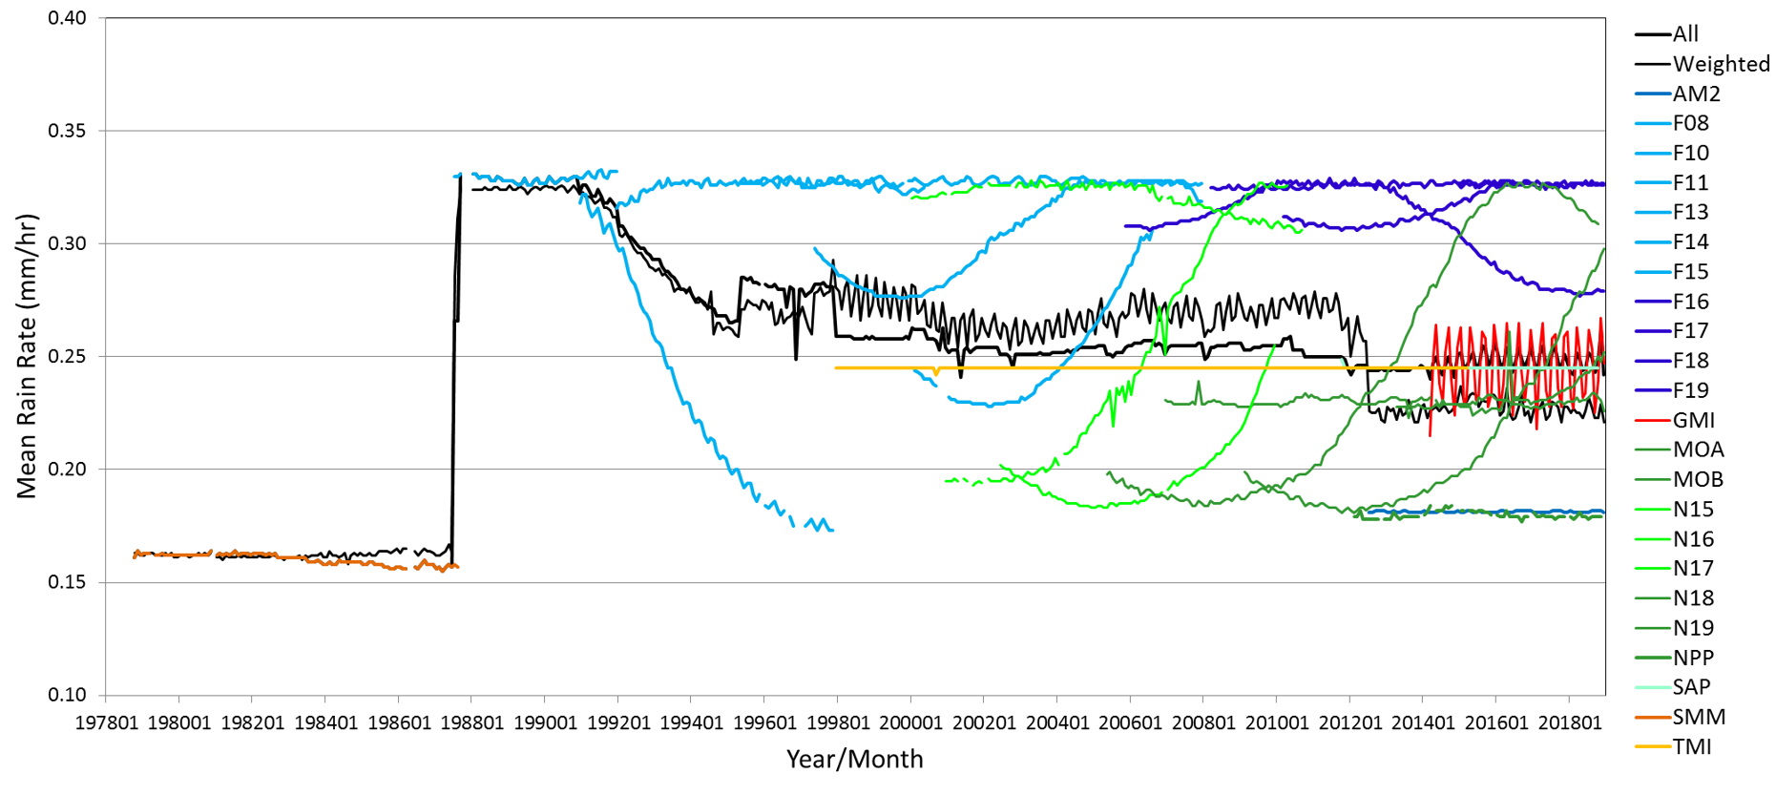
Figure 8: Effect of diurnal sampling by different satellite sensors: the ERA-5 model precipitation has been sampled at the times of each satellite overpass to replicate what each satellite estimate could be. Clearly, there are significant differences depending on where in the diurnal cycle the samples are taken.
6 Conclusions
Multi-instrument/multi-platform satellite data sets now available from the PMW radiometer FCDRs spanning the last 40 years that facilitate the production of a consistent observational record of global precipitation. Availability of such data permits multiple precipitation products to be generated from a single source, allowing a number of products to be generated, with the potential to provide measures of errors and uncertainties. The quality of the precipitation products has improved over time, not least for individual products. Combined products have exploited multi-satellite, multi-sensor data to allow the generation of fine scale precipitation products, although often masking some of the inter-satellite differences, as well as potential longer-term variations in the data record. Detailed information on the changes (either potential step-change or long-term trends) in the data sets needs to be further investigated and better understood. Furthermore, observation-only records are critical to provide a truly independent source of information on precipitation that can be fully utilized by, amongst others, the modelling community. In particular, the generation of multiple ensemble precipitation products is extremely valuable to better assess the variations in the precipitation retrievals, and to allow better integration of precipitation products on a climate timescale. At the very least, such a data set would provide a benchmark of precipitation products against which to assess the combined schemes.

Acknowledgements
Funding for this research has been provided through the NASA Earth Science Research Program, Making Earth System Data Records for Use in Research Environments (MEaSUREs) NNH17ZDA001N-MEASURES.

References
Adler, R. F., Kidd, C., Petty, G., Morissey, M., and Goodman, H. M. (2001). Intercomparison of global precipitation products: The third precipitation intercomparison project (PIP-3). Bulletin of the American Meteorological Society, 82(7), 1377–1396. https://doi.org/10.1175/1520-0477(2001)082<1377:IOGPPT>2.3.CO;2
Alexander, L. V., Zhang, X., Peterson, T. C., Caesar, J., Gleason, B., Klein Tank, A. M. G., Haylock, M., Collins, D., Trewin, B., Rahimzadeh, F., Tagipour, A., Rupa Kumar, K., Revadekar, J., Griffiths, G., Vincent, L., Stephenson, D. B., Burn, J., Aguilar, E., Brunet, M., … Vazquez-Aguirre, J. L. (2006). Global observed changes in daily climate extremes of temperature and precipitation. Journal of Geophysical Research Atmospheres, 111(5). https://doi.org/10.1029/2005JD006290
Allen, M. R., and Ingram, W. J. (2002). Constraints on future changes in climate and the hydrologic cycle. Nature, 419(6903), 224–232. https://doi.org/10.1038/nature01092
Becker, A., Finger, P., Meyer-Christoffer, A., Rudolf, B., Schamm, K., Schneider, U., and Ziese, M. (2013). A description of the global land-surface precipitation data products of the Global Precipitation Climatology Centre with sample applications including centennial (trend) analysis from 1901-present. Earth System Science Data, 5(1), 71–99. https://doi.org/10.5194/essd-5-71-2013
Behrangi, A., Christensen, M., Richardson, M., Lebsock, M., Stephens, G., Huffman, G. J., Bolvin, D., Adler, R. F., Gardner, A., Lambrigtsen, B., and Fetzer, E. (2016). Status of high-latitude precipitation estimates from observations and reanalyses. Journal of Geophysical Research, 121(9), 4468–4486. https://doi.org/10.1002/2015JD024546
Behrangi, A., Stephens, G., Adler, R. F., Huffman, G. J., Lambrigtsen, B., and Lebsock, M. (2014). An update on the oceanic precipitation rate and its zonal distribution in light of advanced observations from space. Journal of Climate, 27(11), 3957–3965. https://doi.org/10.1175/JCLI-D-13-00679.1
Berg, W., L’ecuyer, T., and Haynes, J. M. (2010). The distribution of rainfall over oceans from spaceborne radars. Journal of Applied Meteorology and Climatology, 49(3), 535–543. https://doi.org/10.1175/2009JAMC2330.1
Berg, W., Sapiano, M. R. P., Horsman, J., and Kummerow, C. (2013). Improved geolocation and earth incidence angle information for a fundamental climate data record of the SSM/I sensors. IEEE Transactions on Geoscience and Remote Sensing, 51(3), 1504–1513. https://doi.org/10.1109/TGRS.2012.2199761
Berg, Wesley, Kroodsma, R., Kummerow, C., and McKague, D. (2018). Fundamental Climate Data Records of Microwave Brightness Temperatures. Remote Sensing, 1306. https://doi.org/10.3390/rs10081306
Bintanja, R., and Andry, O. (2017). Towards a rain-dominated Arctic. Nature Climate Change, 7(4), 263–267. https://doi.org/10.1038/nclimate3240
Bojinski, S., Verstraete, M., Peterson, T. C., Richter, C., Simmons, A., and Zemp, M. (2014). The concept of essential climate variables in support of climate research, applications, and policy. Bulletin of the American Meteorological Society, 95(9), 1431–1443. https://doi.org/10.1175/BAMS-D-13-00047.1
Chen, M. Y., Xie, P. P., Janowiak, J. E., and Arkin, P. A. (2001). Global precipitation: A 50-year analysis based on interpolation and reconstruction of gauge observations. 12th Symposium on Global Change and Climate Variations (pp. 258–260).
Donat, M. G., Lowry, A. L., Alexander, L. V., O’Gorman, P. A., and Maher, N. (2016). More extreme precipitation in the worldâ €TM s dry and wet regions. Nature Climate Change, 6(5), 508–513. https://doi.org/10.1038/nclimate2941
Dorninger, M., Schneider, S., and Steinacker, R. (2008). On the interpolation of precipitation data over complex terrain. Meteorology and Atmospheric Physics, 101(3–4), 175–189. https://doi.org/10.1007/s00703-008-0287-6
Ebert, E. E., Manton, M. J., Arkin, P. A., Allam, R. J., Holpin, G. E., and Gruber, A. (1996). Results from the GPCP algorithm intercomparison programme. Bulletin of the American Meteorological Society, 77(12), 2875–2887. https://doi.org/10.1175/1520-0477(1996)077<2875:RFTGAI>2.0.CO;2
Ellis, T. D., L’Ecuyer, T., Haynes, J. M., and Stephens, G. L. (2009). How often does it rain over the global oceans? the perspective from CloudSat. Geophysical Research Letters, 36(3). https://doi.org/10.1029/2008GL036728
Fennig, K., Andersson, A., and Schröder, M. (2013). Fundamental Climate Data Record of SSM/I Brightness Temperatures. Satellite Application Facility on Climate Monitoring. https://doi.org/10.5676/EUM_SAF_CM/FCDR_SSMI/V001
Fennig, K., Schröder, M., and Andersson, A. (2015). Fundamental Climate Data Record of SSM/I / SSMIS Brightness Temperatures. Satellite Application Facility on Climate Monitoring. Earth Syst. Sci. Data, 12, 647–681. https://doi.org/10.5676/EUM_SAF_CM/FCDR_MWI/V002
Fennig, K., Schröder, M., Andersson, A., and Hollmann, R. (2020). A Fundamental Climate Data Record of SMMR, SSM/I, and SSMIS brightness temperatures. Earth System Science Data, 12(1), 647–681. https://doi.org/10.5194/essd-12-647-2020
Funk, C., Peterson, P., Landsfeld, M., Davenport, F., Becker, A., Schneider, U., Pedreros, D., McNally, A., Arsenault, K., Harrison, L., and Shukla, S. (2020). Algorithm and Data Improvements for Version 2.1 of the Climate Hazards Center’s InfraRed Precipitation with Stations Data Set. In Advances in Global Change Research (Vol. 67, pp. 409–427). Springer. https://doi.org/10.1007/978-3-030-24568-9_23
Held, I. M., and Soden, B. J. (2006). Robust responses of the hydrological cycle to global warming. Journal of Climate, 19(21), 5686–5699. https://doi.org/10.1175/JCLI3990.1
Herold, N., Alexander, L. V., Donat, M. G., Contractor, S., and Becker, A. (2016). How much does it rain over land? Geophysical Research Letters, 43(1), 341–348. https://doi.org/10.1002/2015GL066615
Higgins, R. W., and Kousky, E. V. (2013). Changes in Observed Daily Precipitation over the United States between 1950–79 and 1980–2009. Journal of Hydrometeorology, 105–121. https://doi.org/10.1175/JHM-D-12-062.1
Hollmann, R., Merchant, C. J., Saunders, R., Downy, C., Buchwitz, M., Cazenave, A., Chuvieco, E., Defourny, P., De Leeuw, G., Forsberg, R., Holzer-Popp, T., Paul, F., Sandven, S., Sathyendranath, S., Van Roozendael, M., and Wagner, W. (2013). The ESA climate change initiative: Satellite data records for essential climate variables. Bulletin of the American Meteorological Society, 94(10), 1541–1552. https://doi.org/10.1175/BAMS-D-11-00254.1
Hossain, F., and Anagnostou, E. N. (2006). A two-dimensional satellite rainfall error model. IEEE Transactions on Geoscience and Remote Sensing, 44(6), 1511–1522. https://doi.org/10.1109/TGRS.2005.863866
Hou, A. Y., Kakar, R. K., Neeck, S., Azarbarzin, A. A., Kummerow, C. D., Kojima, M., Oki, R., Nakamura, K., and Iguchi, T. (2014). The global precipitation measurement mission. Bulletin of the American Meteorological Society, 95(5), 701–722. https://doi.org/10.1175/BAMS-D-13-00164.1
Hsu, K. L., Karbalee, N., and Braithwaite, D. (2020). Improving PERSIANN-CCS Using Passive Microwave Rainfall Estimation. In Advances in Global Change Research (Vol. 67, pp. 375–391). Springer. https://doi.org/10.1007/978-3-030-24568-9_21
Huffman, G. J., Bolvin, D. T., Braithwaite, D., Hsu, K. L., Joyce, R. J., Kidd, C., Nelkin, E. J., Sorooshian, S., Stocker, E. F., Tan, J., Wolff, D. B., and Xie, P. (2020). Integrated Multi-satellite Retrievals for the Global Precipitation Measurement (GPM) Mission (IMERG). In Advances in Global Change Research (Vol. 67, pp. 343–353). Springer. https://doi.org/10.1007/978-3-030-24568-9_19
Joyce, R. J., Janowiak, J. E., Arkin, P. A., and Xie, P. (2004). CMORPH: A method that produces global precipitation estimates from passive microwave and infrared data at high spatial and temporal resolution. Journal of Hydrometeorology, 5(3), 487–503. https://doi.org/10.1175/1525-7541(2004)005<0487:CAMTPG>2.0.CO;2
Jurković, S. R., and Pasarić, Z. (2013). Spatial variability of annual precipitation using globally gridded data sets from 1951 to 2000. International Journal of Climatology, 33(3), 690–698. https://doi.org/10.1002/joc.3462
Katsanos, D., Lagouvardos, K., Kotroni, V., and Huffmann, G. J. (2004). Statistical evaluation of MPA-RT high-resolution precipitation estimates from satellite platforms over the central and eastern Mediterranean. Geophysical Research Letters, 31(6), L06116-4. https://doi.org/10.1029/2003gl019142
Kidd, C., and Huffman, G. (2011). Global precipitation measurement. Meteorological Applications, 18(3), 334–353. https://doi.org/10.1002/met.284
Kidd, C., and Levizzani. (2019). Extreme Hydroclimatic Events and Multivariate Hazards in a Changing Climate. https://doi.org/10.1016/B978-0-12-814899-0.00001-8
Kidd, C., and Levizzani, V. (2011). Status of satellite precipitation retrievals. Hydrology and Earth System Sciences, 15(4), 1109–1116. https://doi.org/10.5194/hess-15-1109-2011
Kidd, C., Matsui, T., Chern, J., Mohr, K., Kummerow, C., and Randel, D. (2016). Global precipitation estimates from cross-track passive microwave observations using a physically based retrieval scheme. Journal of Hydrometeorology, 17(1), 383–400. https://doi.org/10.1175/JHM-D-15-0051.1
Kidd, C., Takayabu, Y. N., Skofronick-Jackson, G. M., Huffman, G. J., Braun, S. A., Kubota, T., and Turk, F. J. (2020). The Global Precipitation Measurement (GPM) Mission. In Advances in Global Change Research (Vol. 67, pp. 3–23). Springer. https://doi.org/10.1007/978-3-030-24568-9_1
Kidd, C., Tan, J., Kirstetter, P. E., and Petersen, W. A. (2018). Validation of the Version 05 Level 2 precipitation products from the GPM Core Observatory and constellation satellite sensors. Quarterly Journal of the Royal Meteorological Society, 144, 313–328. https://doi.org/10.1002/qj.3175
Kubota, T., Aonashi, K., Ushio, T., Shige, S., Takayabu, Y. N., Kachi, M., Arai, Y., Tashima, T., Masaki, T., Kawamoto, N., Mega, T., Yamamoto, M. K., Hamada, A., Yamaji, M., Liu, G., and Oki, R. (2020). Global Satellite Mapping of Precipitation (GSMaP) Products in the GPM Era. In Advances in Global Change Research (Vol. 67, pp. 355–373). Springer. https://doi.org/10.1007/978-3-030-24568-9_20
Kucera, P. A., Ebert, E. E., Turk, F. J., Levizzani, V., Kirschbaum, D., Tapiador, F. J., Loew, A., and Borsche, M. (2013). Precipitation from space: Advancing earth system science. Bulletin of the American Meteorological Society, 94(3), 365–375. https://doi.org/10.1175/BAMS-D-11-00171.1
Kummerow, C. D., Randel, D. L., Kulie, M., Wang, N. Y., Ferraro, R., Joseph Munchak, S., and Petkovic, V. (2015). The evolution of the goddard profiling algorithm to a fully parametric scheme. Journal of Atmospheric and Oceanic Technology, 32(12), 2265–2280. https://doi.org/10.1175/JTECH-D-15-0039.1
Kummerow, C. D., Ringerud, S., Crook, J., Randel, D., and Berg, W. (2011). An observationally generated a priori database for microwave rainfall retrievals. Journal of Atmospheric and Oceanic Technology, 28(2), 113–130. https://doi.org/10.1175/2010JTECHA1468.1
Lebsock, M. D., and L’Ecuyer, T. S. (2011). The retrieval of warm rain from CloudSat. Journal of Geophysical Research Atmospheres, 116(20). https://doi.org/10.1029/2011JD016076
Liao, L., Meneghini, R., and Tokay, A. (2014). Uncertainties of GPM DPR rain estimates caused by DSD parameterizations. Journal of Applied Meteorology and Climatology, 53(11), 2524–2537. https://doi.org/10.1175/JAMC-D-14-0003.1
Maidment, R. I., Allan, R. P., and Black, E. (2015). Recent observed and simulated changes in precipitation over Africa. Geophysical Research Letters, 42(19), 8155–8164. https://doi.org/10.1002/2015GL065765
Masó, J., Serral, I., Domingo-Marimon, C., and Zabala, A. (2020). Earth observations for sustainable development goals monitoring based on essential variables and driver-pressure-state-impact-response indicators. International Journal of Digital Earth, 217–235. https://doi.org/10.1080/17538947.2019.1576787
McConnell, A., and North, G. R. (1987). Sampling errors in satellite estimates of tropical rain. Journal of Geophysical Research, 9567. https://doi.org/10.1029/jd092id08p09567
Menne, M. J., Durre, I., Vose, R. S., Gleason, B. E., and Houston, T. G. (2012). An overview of the global historical climatology network-daily database. Journal of Atmospheric and Oceanic Technology, 29(7), 897–910. https://doi.org/10.1175/JTECH-D-11-00103.1
Merz, B., Aerts, J., Arnbjerg-Nielsen, K., Baldi, M., Becker, A., Bichet, A., Blöschl, G., Bouwer, L. M., Brauer, A., Cioffi, F., Delgado, J. M., Gocht, M., Guzzetti, F., Harrigan, S., Hirschboeck, K., Kilsby, C., Kron, W., Kwon, H. H., Lall, U., … Nied, M. (2014). Floods and climate: Emerging perspectives for flood risk assessment and management. Natural Hazards and Earth System Sciences, 14(7), 1921–1942. https://doi.org/10.5194/nhess-14-1921-2014
Mote, P. W., Li, S., Lettenmaier, D. P., Xiao, M., and Engel, R. (2018). Dramatic declines in snowpack in the western US. Npj Climate and Atmospheric Science, 1(1). https://doi.org/10.1038/s41612-018-0012-1
Mugnai, A., Casella, D., Cattani, E., Dietrich, S., Laviola, S., Levizzani, V., Panegrossi, G., Petracca, M., Sanò, P., Di Paola, F., Biron, D., De Leonibus, L., Melfi, D., Rosci, P., Vocino, A., Zauli, F., Pagliara, P., Puca, S., Rinollo, A., … Gattari, F. (2013). Precipitation products from the hydrology SAF. Natural Hazards and Earth System Sciences, 13(8), 1959–1981. https://doi.org/10.5194/nhess-13-1959-2013
Mugnai, A., Cooper, H. J., Smith, E. A., and Tripoli, G. J. (1990). Simulation of microwave brightness temperatures of an evolving hailstorm at SSM/I frequencies. Bulletin - American Meteorological Society, 71(1), 2–13. https://doi.org/10.1175/1520-0477(1990)071<0002:SOMBTO>2.0.CO;2
Nakamoto, S., Valdes, J. B., and North, G. R. (1990). Frequency-wavenumber spectrum for GATE phase I rainfields. Journal of Applied Meteorology, 29(9), 842–850. https://doi.org/10.1175/1520-0450(1990)029<0842:FSFGPI>2.0.CO;2
New, M., Todd, M., Hulme, M., and Jones, P. (2001). Precipitation measurements and trends in the twentieth century. International Journal of Climatology, 21(15), 1889–1922. https://doi.org/10.1002/joc.680
North, G. R., and Nakamoto, S. (1989). Formalism for Comparing Rain Estimation Designs. Journal of Atmospheric and Oceanic Technology, 985–992. https://doi.org/10.1175/1520-0426(1989)006<0985:FFCRED>2.0.CO;2
Pall, P., Aina, T., Stone, D. A., Stott, P. A., Nozawa, T., Hilberts, A. G. J., Lohmann, D., and Allen, M. R. (2011). Anthropogenic greenhouse gas contribution to flood risk in England and Wales in autumn 2000. Nature, 470(7334), 382–385. https://doi.org/10.1038/nature09762
Pall, P., Allen, M. R., and Stone, D. A. (2007). Testing the Clausius-Clapeyron constraint on changes in extreme precipitation under CO2 warming. Climate Dynamics, 28(4), 351–363. https://doi.org/10.1007/s00382-006-0180-2
Panegrossi, G., Rysman, J. F., Casella, D., Marra, A. C., Sanò, P., and Kulie, M. S. (2017). CloudSat-based assessment of GPM microwave imager snowfall observation capabilities. Remote Sensing, 9(12). https://doi.org/10.3390/rs9121263
Petty, G. W. (1995). Frequencies and characteristics of global oceanic precipitation from shipboard present-weather reports. Bulletin - American Meteorological Society, 76(9), 1593–1616. https://doi.org/10.1175/1520-0477(1995)076<1593:FACOGO<2.0.CO;2
Randel, D. L., Kummerow, C. D., and Ringerud, S. (2020). The Goddard Profiling (GPROF) Precipitation Retrieval Algorithm. In Advances in Global Change Research (Vol. 67, pp. 141–152). Springer. https://doi.org/10.1007/978-3-030-24568-9_8
Reed, P. M., Chaney, N. W., Herman, J. D., Ferringer, M. P., and Wood, E. F. (2015). Internationally coordinated multi-mission planning is now critical to sustain the space-based rainfall observations needed for managing floods globally. Environmental Research Letters, 10(2). https://doi.org/10.1088/1748-9326/10/2/024010
Sapiano, M. R. P., Berg, W. K., McKague, D. S., and Kummerow, C. D. (2013). Toward an intercalibrated fundamental climate data record of the SSM/I sensors. IEEE Transactions on Geoscience and Remote Sensing, 51(3), 1492–1503. https://doi.org/10.1109/TGRS.2012.2206601
Semunegus, H., Berg, W., Bates, J. J., Knapp, K. R., and Kummerow, C. (2010). An extended and improved special sensor microwave imager (ssm/i) period of record. Journal of Applied Meteorology and Climatology, 49(3), 424–436. https://doi.org/10.1175/2009JAMC2314.1
Sevruk, B., Ondrás, M., and Chvíla, B. (2009). The WMO precipitation measurement intercomparisons. Atmospheric Research, 92(3), 376–380. https://doi.org/10.1016/j.atmosres.2009.01.016
Simpson, I. R., and Jones, P. D. (2014). Analysis of UK precipitation extremes derived from Met Office gridded data. International Journal of Climatology, 34(7), 2438–2449. https://doi.org/10.1002/joc.3850
Skofronick-Jackson, G., Petersen, W. A., Berg, W., Kidd, C., Stocker, E. F., Kirschbaum, D. B., Kakar, R., Braun, S. A., Huffman, G. J., Iguchi, T., Kirstetter, P. E., Kummerow, C., Meneghini, R., Oki, R., Olson, W. S., Takayabu, Y. N., Furukawa, K., and Wilheit, T. (2017). The global precipitation measurement (GPM) mission for science and Society. Bulletin of the American Meteorological Society, 98(8), 1679–1695. https://doi.org/10.1175/BAMS-D-15-00306.1
Steiner, M., Bell, T. L., Zhang, Y., and Wood, E. F. (2003). Comparison of two methods for estimating the sampling-related uncertainty of satellite rainfall averages based on a large radar dataset. Journal of Climate, 16(22), 3759–3778. https://doi.org/10.1175/1520-0442(2003)016<3759:COTMFE>2.0.CO;2
Stephens, G. L., L’Ecuyer, T., Forbes, R., Gettlemen, A., Golaz, J. C., Bodas-Salcedo, A., Suzuki, K., Gabriel, P., and Haynes, J. (2010). Dreary state of precipitation in global models. Journal of Geophysical Research Atmospheres, 115(24). https://doi.org/10.1029/2010JD014532
Stephens, G., Winker, D., Pelon, J., Trepte, C., Vane, D., Yuhas, C., L’Ecuyer, T., and Lebsock, M. (2018). Cloudsat and calipso within the a-train: Ten years of actively observing the earth system. Bulletin of the American Meteorological Society, 99(3), 569–581. https://doi.org/10.1175/BAMS-D-16-0324.1
Stephens, GL, Vane, D., Boain, R. J., Mace, G., Sassen, K., Wang, Z., Illingworth, A., Rossow, Durden, S., Miller, S., Austin, R., Benedetti, A., and Mitrescu, C. (2002). the CloudSat Science Team: The CloudSat mission and the A-Train: A new dimension of space-based observations of clouds and precipitation. Bull. Amer. Meteor. Soc, 83, 1771–1790. https://doi.org/10.1175/BAMS-83-12-1771
Strangeways, I. (2004). Improving precipitation measurement. International Journal of Climatology, 24(11), 1443–1460. https://doi.org/10.1002/joc.1075
Sun, Y., Solomon, S., Dai, A., and Portmann, R. W. (2006). How often does it rain? Journal of Climate, 19(6), 916–934. https://doi.org/10.1175/JCLI3672.1
Tian, Y., and Peters-Lidard, C. D. (2010). A global map of uncertainties in satellite-based precipitation measurements. Geophysical Research Letters, 37(24). https://doi.org/10.1029/2010GL046008
Trenberth, K. E., Dai, A., Rasmussen, R. M., and Parsons, D. B. (2003). The changing character of precipitation. Bulletin of the American Meteorological Society, 84(9), 1205–1161. https://doi.org/10.1175/BAMS-84-9-1205
Trenberth, K. E., Smith, L., Qian, T., Dai, A., and Fasullo, J. (2007). Estimates of the global water budget and its annual cycle using observational and model Data. Journal of Hydrometeorology, 8(4), 758–769. https://doi.org/10.1175/JHM600.1
Vihma, T., Screen, J., Tjernström, M., Newton, B., Zhang, X., Popova, V., Deser, C., Holland, M., and Prowse, T. (2016). The atmospheric role in the Arctic water cycle: A review on processes, past and future changes, and their impacts. Journal of Geophysical Research G: Biogeosciences, 121(3), 586–620. https://doi.org/10.1002/2015JG003132
Villarini, G., Mandapaka, P. V., Krajewski, W. F., and Moore, R. J. (2008). Rainfall and sampling uncertainties: A rain gauge perspective. Journal of Geophysical Research Atmospheres, 113(11). https://doi.org/10.1029/2007JD009214
Wilheit, T., Berg, W., Ebrahimi, H., Kroodsma, R., McKague, D., Payne, V., and Wang, J. (2015). Intercalibrating the GPM constellation using the GPM Microwave Imager (GMI). In International Geoscience and Remote Sensing Symposium (IGARSS) (Vols. 2015-, pp. 5162–5165). Institute of Electrical and Electronics Engineers Inc. https://doi.org/10.1109/IGARSS.2015.7326996
Wisser, D., Fekete, B. M., Vörösmarty, C. J., and Schumann, A. H. (2010). Reconstructing 20th century global hydrography: A contribution to the Global Terrestrial Network- Hydrology (GTN-H). Hydrology and Earth System Sciences, 14(1), 1–24. https://doi.org/10.5194/hess-14-1-2010
Yatagai, A., Kamiguchi, K., Arakawa, O., Hamada, A., Yasutomi, N., and Kitoh, A. (2012). Aphrodite constructing a long-term daily gridded precipitation dataset for Asia based on a dense network of rain gauges. Bulletin of the American Meteorological Society, 93(9), 1401–1415. https://doi.org/10.1175/BAMS-D-11-00122.1

