SpaceOps-2021,9,x1259
AMO-EXPRESS-2.5: Crew Autonomy Onboard the International Space Station
Brooke C. Allenª, Rush E. Elkins^{b} , Hassan Eslami^{c}, Jeremy D. Frank^{d}, Angie T. Haddock^{e},
Christopher D. Knight^{f}, Haifa R. Moses^{g}, Michael S. Scott^{h}, Keith J. Swanson^{i}, Lui Wang^{j}

ª ASO Human Factors Lead, NASA Marshall Space Flight Center, Huntsville, AL, brooke.allen@nasa
^{b} ISS Payload Rack Officer, Teledyne Brown Engineering, Huntsville, AL, rush.e.elkins@nasa
^{c} Computer Scientist, KBR Wyle Services, LLC, Moffett Field, CA, hassan.eslami@nasa.gov
^{d} ASO Project Lead, NASA Ames Research Center, Mountain View, CA, jeremy.d.franks@nasa
^{e} MSFC ASO Lead, NASA Marshall Space Flight Center, Huntsville, AL, angie.haddock@nasa.gov
^{f} Computer Scientist, NASA Ames Research Center, Mountain View, CA, christopher.d.knight@nasa.gov
^{g} ASO Human Factors, NASA Johnson Space Center, Houston, TX, haifa.r.moses@nasa
^{h} Computer Scientist, KBR Wyle Services, LLC, Moffett Field, CA, michael.s.scott@nasa.gov
^{i} Computer Scientist, NASA Ames Research Center, Mountain View, CA, keith.j.swanson@nasa
^{j} Computer Scientist, NASA Johnson Space Center, Houston, TX, lui.wang-1@nasa.gov

Abstract
NASA is committed to landing American astronauts, including the first woman and the next man, on the Moon by 2024. Currently, the crew cannot take on all functions performed by the ground today, so the future crews will need more automation to reduce the crew workload for future missions. Of significant importance for these missions is the balance between crew autonomy and vehicle automation. The Advanced Exploration Systems (AES) Autonomous Systems and Operations (ASO) Project has been investigating the ability to evaluate crew self-scheduling and activity monitoring for future space missions. The ASO project designed the Autonomous Mission and Operations- EXpedite the PRocessing of Experiments to Space Station Rack-2.5 (AMO-EXPRESS-2.5) payload to evaluate crew self-scheduling and activity monitoring. The AMO-EXPRESS-2.5 builds on the previous AMO-EXPRESS and AMO-EXPRESS-2.0 demonstrations on ISS. The AMO-EXPRESS-2.5 demonstration goals are to prove crew self-scheduling by planning through diagnosing systems expertise, failure detection, procedure recommendation and situational awareness. This paper will describe the development, test and execution results of the AMO-EXPRESS-2.5 demonstration, and will also outline the future planned development and operational efforts to enable autonomy for future deep space manned missions.
- Introduction
NASA is committed to landing American astronauts, including the first woman and the next man, on the Moon by 2024. Through the agency’s Artemis lunar exploration program, we will use innovative new technologies and systems to explore more of the Moon than ever before. In support of this vision, NASA plans to construct Gateway, a habitable spacecraft [1], in the vicinity of the Moon. Gateway consists of a Habitat, Airlock, Power and Propulsion Element (PPE), and Logistics module. The PPE provides orbital maintenance, attitude control, communications with Earth, space-to-space communications, and radio frequency relay capability in support of extravehicular activity (EVA) communications. The Habitat provides habitable volume and short-duration life support functions for crew in cislunar space, docking ports, attach points for external robotics, external science and technology payloads or rendezvous sensors, and accommodations for crew exercise, science/utilization and stowage. The Airlock provides capability to enable astronaut EVAs as well as the potential to accommodate docking of additional elements, observation ports, or a science utilization airlock. A Logistics module delivers cargo to the Gateway. NASA will collaborate with commercial and international partners to establish sustainable missions by 2028. NASA will use what we learn on and around the Moon to take the next giant leap - sending astronauts to Mars.
For over 50 years, NASA’s crewed missions have been confined to the Earth-Moon system, where speed-of-light communications delays between crew and ground are practically nonexistent. The close proximity of the crew to the Earth has enabled NASA to operate human space missions primarily from the ground. This “ground-centered” mode of operations has had several advantages: by having a large team of the people involved on the ground, the on-board crew could be smaller, the vehicles could be simpler and lighter, and the mission performed for a lower cost. Future exploration missions will be of much longer duration, and put crews much further from Earth, than today’s missions. The short duration of crewed visits to Gateway (30 days) put a premium on efficient operations. Accordingly, NASA’s Advanced Exploration Systems (AES) Program has recently funded a number of projects to develop and test autonomous concept of operations for these future missions. Of significant importance is the balance between crew autonomy and vehicle automation. Future crews need both the authority to make decisions without inefficient communication back and forth with ground-based mission control. They will also need sufficient information and vehicle capability to make, and implement, those decisions. However, small crews cannot take on all functions performed by ground today, and so vehicles must be more automated to reduce the number of tasks crews are responsible for.
This paper describes AMO-EXPRESS-2.5, a demonstration of crew autonomy to be performed onboard the International Space Station (ISS). AMO-EXPRESS-2.5 will demonstrate crew’s ability to change their daily schedule, and subsequently execute and monitor a complex system power-up and configuration task, demonstrating both crew autonomy and vehicle automation. AMO EXPRESS 2.5 demonstrates a transfer of authority from mission control to the crew. Specifically, we demonstrate the ability of an astronaut to power up and configure an EXPRESS rack, a payload-class facility onboard ISS. This demonstration follows previous AMO EXPRESS demonstrations, described in [2]. The demonstration in the current paper builds on previous work in two key ways. In earlier demonstrations, the exact time of the power-up and configuration was planned ahead of time, which is common practice. In the current work, the crew must schedule and perform the activity on the same day. We also introduce numerous simulated fault conditions, requiring the crew to understand the state of the activity and perhaps take action to respond. Both of these changes are enabled by simulating the rack, including fault conditions, in the ISS avionics.
AMO EXPRESS 2.5 builds on prior demonstrations of crew autonomy and automation. Previously executed crew autonomy experiments and demonstrations onboard ISS include:
- Crew Autonomous Procedures [3]; astronauts performed numerous human spaceflight procedures without assistance from Mission Control Center (MCC), resulting in guidelines on the writing of these procedures.
- The Autonomous Mission and Operations-Total Organic Carbon- Space Station Computer (AMO-TOCA-SSC) experiment [4]; an experiment in transitioning responsibility for two ISS subsystems (water quality analysis hardware and crew laptops) to astronauts, with the aid of software tools.
- Crew Self Scheduling [5]; an experiment to evaluate tools for astronauts to schedule their own daily activity plans.
Previous work in this area also includes automation of some ISS subsystems:
- Payload operations automation [6]; A variety of ISS payloads have been automated during its operational lifetime.
- Optimal Propellant Maneuvers and Zero Propellant Maneuvers [7]; a special trajectory accomplished only using ISS’ Control Moment Gyros (CMGs) was implemented using ground-based automation.
Our work represents a significant increase in demonstrated autonomy capability compared to previous work described above. A demonstration of crew autonomy was performed during the ISS Crew Autonomous Procedures experiment [3]. In this work, demonstration are conducted using systems with rich electronic command and telemetry interfaces, and also demonstrate how crews can autonomously respond to off-nominal scenarios. Our demonstration integrates the automation used in payload autonomous operations directly into our technology for use by the crew; the ISS Crew Autonomous Procedures demonstration changed the format and content of crew procedures, but did not employ new tools or technology. Crew self-scheduling demonstrations were performed as part of two previous demonstrations, AMO-TOCA-SSC [4] and Crew Autonomous Scheduling Test (CAST) [5]. Like the AMO-TOCA-SSC demonstration, the current work demonstrates crew self-scheduling of only one system (an EXPRESS Rack), while the CAST demonstration permitted crew to schedule an entire day of activity. Unlike previous work, the current demonstration integrates scheduling and procedure tools in a single application, and also features a complete end-to-end integration of scheduling, procedure display, and system automation. Also, unlike previous work, the AMO EXPESS 2.5 demonstration differs in its concept of operations, allowing the crew to schedule and perform activities on the same day. It is this ‘real-time’ flexibility in manipulating the daily activity plan that is a critical enabler of crew autonomy and has not previously been demonstrated in space.

- Operations Concept
AMO-EXPRESS- 2.5 is a software only payload designed to evaluate crew self-scheduling and activity monitoring for future exploration missions. It will be deployed on-board ISS, partly on the Operations LAN (OpsLAN), and partly in the Payload Multiplexer Demultiplexer (PLMDM). The software allows ISS crew to schedule and execute a simulated EXPRESS Rack power-on and power-off activity. AMO-EXPRESS-2.5 uses a simulated EXPRESS Rack, specifically, a simulation of EXPRESS Rack 7 (ER7), to reduce ISS risk and increase flexibility, making it easier to achieve the demonstration objectives. Both the simulation of ER7 and the automation controlling it are implemented as Timeliner bundles that run on the PLMDM.
The AMO-EXPRESS-2.5 objective is to evaluate crew self-scheduling and system awareness activities and monitoring capabilities. This operations concept will have the crew self-schedule a simulated ER7 powerup and configuration activity, possibly later in the day. The crew will later initiate and monitor this activity. Each simulated activity will exercise one of several different simulated ER7 scenarios, including a variety of off-nominal conditions, requiring different responses. The crew will evaluate and react to each scenario, and re-plan their activities as needed. The concept of operations for the demonstration is to select a day in advance that allows the crew time to schedule and execute the activity, but let the crew perform all other steps; select when to perform the powerup, initiate and monitor the activity, and respond as needed. Mission Control will only be on hand to ensure the demonstration goes smoothly. This demonstration will prove the crew’s ability to autonomously manage spacecraft systems without assistance from Mission Control. The successful demonstration of this concept will validate the ability of the crew to choose when to perform activities, as well as monitor their execution and to require the crew to respond to off-nominal situations.

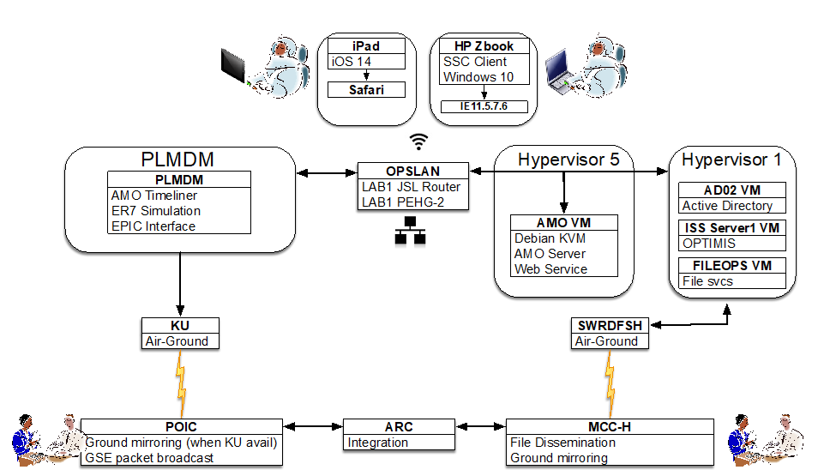
Fig 1. Software Architecture for AMO-EXPRESS-2.5
3. Design, Development, Test
Figure 1 describes the individual components of the AMO-EXPRESS-2.5 software, and how each component is integrated with each other, the on-board ISS environment, and Mission Control. The crew will interact with the AMO-EXPRESS-2.5 software and its user interface, which are deployed on the OpsLAN, the crew’s on-board support network (right). The software is deployed inside its own virtual machine (VM). This VM interacts with other ISS software components, including Operations Planning TIMeline Integration System (OPTIMIS), the crew’s daily planning system, file services, and file uplink-downlink. The other key part of AMO-EXPRESS-2.5 resides on the PLMDM, one of several avionics computers onboard the ISS (Right). These components are implemented as Timeliner bundles, and interact with the Timeliner engine inside the PLMDM [8]. These bundles both simulated ER7, including both nominal and off-nominal conditions, and the control of ER7. The automation and simulation communicate with the OpsLAN via the Enhanced Processor & Integrated Communications Card (EPIC) interface on the PLMDM, which provides an ethernet interface to the OpsLAN. File services to ground are provided via Software to Ready Data Files to Send Hastily (SWRDFSH) file transfer to Mission Control Center-Houston (MCC-H), and data services are provided to the Payload Operations Integration Center (POIC) via Ku-Band (bottom). The data are integrated into a single view at NASA Ames Research Center (ARC) for demonstration situational awareness.
The detailed operations flow, and in-depth explanation of the key components of AMO-EXPRESS-2.5, are described further below.
3.1 AMO-EXPRESS-2.5 Operations Flow
Figure 2 describes a notional day of execution activity flow for AMO-EXPRESS-2.5 operations. Each part of the execution flow is elaborated on further below.

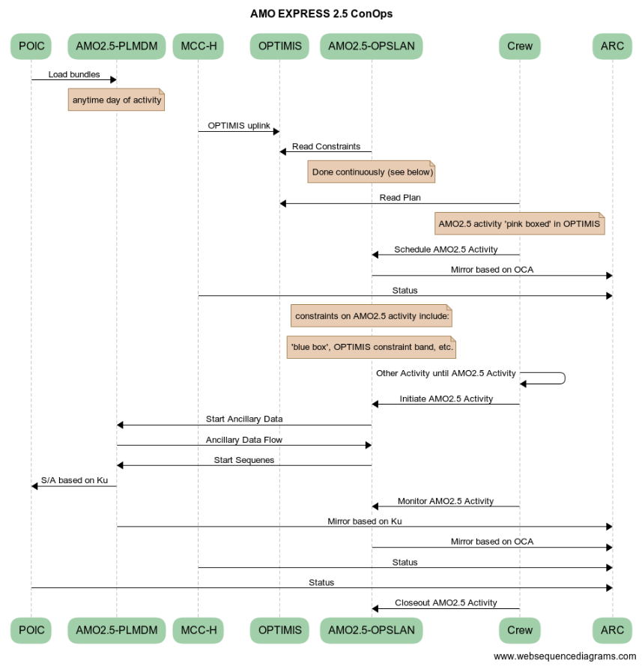
Figure 2. Operations Flow AMO-EXPRESS-2.5
POIC -> AMO2.5-PLMDM: Load Bundles
The POIC will load Timeliner bundles on day of execution to set up the day’s demonstration.

MCC-H -> OPTIMIS: OPTIMIS uplink
MCC-H uplinks the crew plan to OPTIMIS per.

AMO2.5-OPSLAN -> OPTIMIS: Read Constraints
The AMO-EXPRESS-2.5 software residing on the OpsLAN will programmatically read the OPTIMIS plan database and will reflect all constraints the crew will need to respect when scheduling the ER7 activity sequence.

Crew -> OPTIMIS: Read Plan
The crew will view the AMO-EXPRESS-2.5 payload activities

Crew -> AMO-EXPRESS-2.5 (AMO2.5)-OPSLAN: Schedule AMO2.5 Activity
The crew can perform the AMO-EXPRESS-2.5 activities anytime during the crew day. Details on how crew scheduling is performed are provided in Section 3.1.

Crew -> Crew: Other Activity until AMO2.5 Activity
The crew will schedule the activity first, and then perform other tasks during the crew day, before performing the simulated ER7 activity sequence. Notes:

- The AMO-EXPRESS-2.5 scheduling software will periodically receive an update from OPTIMIS, revise its constraints, and indicate if there are problems that may require crew to reschedule the ER7 activity.
- The AMO-EXPRESS-2.5 scheduling software will not write to OPTIMIS. This means the crew will need to check the AMO-EXPRESS-2.5 scheduler on the OpsLAN, not OPTIMIS, to see if the scheduled ER7 activity is still good to go prior to initiation, and perhaps reschedule.

POIC -> AMO2.5-PLMDM: Start Ancillary Data
The ancillary data is started to open data and request path between PLMDM and OpsLAN.

Crew -> AMO2.5-OPSLAN: Initiate AMO2.5 Activity
The crew will initiate the simulated ER7 activation or deactivation activity sequence.

AMO2.5-OPSLAN -> AMO2.5-PLMDM: Start Sequences
The EXPRESS Graphical User Interface (GUI) on the OpsLAN will initiate data flow over the EPIC interface between the OpsLAN and the PLMDM, and start Timeliner bundles on the PLMDM. The Timeliner bundles automatically perform the scheduled simulated ER7 activities.

AMO2.5-PLMDM -> POIC: S/A based on Ku
All PLMDM Timeliner data will flow over Ku to the POIC and be monitored by the Payload Rack Officer (PRO) and AMO software team.

AMO2.5-OPSLAN -> AMO2.5-PLMDM: Monitor AMO2.5 Activity
Critical data generated by the simulated ER7 and control functions on the PLMDM will be sent back to the OpsLAN as an ancillary data set, where it will be processed to populate a ‘cue-card’ like display for the crew monitoring the simulated ER7 activity.

AMO2.5-PLMDM -> ARC: Mirror based on Ku
All PLMDM Timeliner data will flow via POIC/Huntsville Operations Support Center (HOSC) services to the Ground version of the software for mirroring. This will provide ‘raw’ data that will be processed on the ground to replicate processing done on-board to drive the ‘cue card’. This data path does not provide crew activity schedule data to the Ground version of the software.

AMO2.5-OPSLAN -> ARC: Mirror based on Orbital Communications Adapter (OCA)
The software running on the OpsLAN will also send data to MCC-H via OCA and the Ground version of the software for mirroring. This data path provides crew activity schedule data and processed ‘cue card’ data, but not the raw PLMDM Timeliner data.

MCC-H -> ARC: Status
The ground version of the software will be hosted at NASA ARC. The MCC-H ops community can query the AMO-EXPRESS-2.5 software (via Web service) for status.

POIC -> ARC: Status
The ground version of the software will be hosted at NASA ARC. The POIC ops community can query the AMO-EXPRESS-2.5 software (via Web service) for status.

Crew -> AMO2.5-OPSLAN: Closeout
The crew will perform a final check on the status of the ER7 activity and do some closeout activities. This closeout status will be viewed on the ground via the Ku and OCA downlink.

POIC -> AMO2.5-PLDM: Stop Ancillary Data
The ancillary data is stopped.
3.1 Crew Self Scheduling
As described in Section 2, the crew’s first task is to choose when to perform the simulated ER7 power up and configuration activity. The crew will use the Scheduler to decide when the simulated ER7 activity will take place; they can perform it immediately following the current activity, or later during the crew day. The ER7 activity normally has a variety of constraints which must be respected. For this demonstration, the only constraints we enforce are the worst-case ER7 activity duration, including possible fault recovery, and that the crew can perform only one activity at a time. The worst-case ER7 activation time is 40 minutes. The Scheduler divides up the crew’s day into blocks of availability depending on the crew’s timeline. As described in Section 2, the Scheduler retrieves the crew activity timeline from OPTIMIS, and uses it to classify every block of time. The Scheduler will reason about all of the crew’s activities and activity status. Blocks of time will be color coded according to the following rules:
- Green = good: 'Available Time', empty block on the OPTIMIS schedule or OPTIMIS activity that was completed early.
- Yellow = 'Potential Conflict': overlaps with OPTIMIS activity that is 'scheduled enabled' but is not 'time critical'
- Grey = ’No-go’: overlaps with schedule enabled/time critical activity or overlaps with another previously scheduled ER7 activity. Any blocks of time labeled ‘no-go’ are accompanied by an explanation of why the block of time is not available.
The Scheduler GUI allows the crew to schedule the ER7 activity anywhere on the timeline, as long as the activity duration doesn’t overlap any ‘no-go’ block. The crew can schedule the activity to start in any 5 minute increment in each of the availability blocks. The Scheduler UI will provide feedback on that specific selected time slot in relation to any simultaneous activities on the timeline. The crew can reschedule the activity by drag-and-drop, or remove it altogether at any time prior to activation.

3.2 Autonomous Procedures
The AMO-EXPRESS-2.0 demonstration purpose was to show the crew could initiate and monitor the powerup of EXPRESS Rack 7 onboard ISS. As described in [2], this reduces impacts to flight controllers as the activation can take upwards of 40 minutes, three flight controllers (two at POIC and one at MCC-H), and nominally requires 57 commands. To do so, the Timeliner bundles controlling ER7 needed to be capable of interpreting and responding to telemetry via commands. For the AMO-EXPRESS-2.5 demonstration, we developed Timeliner bundles to simulate EXPRESS Rack 7 in the place of an actual piece of hardware. This approach has multiple benefits. The first is reducing the need to coordinate and schedule the use of commanding with ground controllers. POIC is still responsible for loading bundles on the day of execution and initiating data flow, but this burden is significantly reduced compared to prior demonstrations. The second benefit is the ability to introduce off-nominal ER7 scenarios in the on-orbit environment. Only a small number of previously demonstrated autonomy demonstrations explicitly include off-nominal responses; for example, the AMO-TOCA-SSC demonstration [4] depended on periodic, but unpredictable, occurring off-nominal situations. The advantage of simulating off-nominal cases is that they can be planned in advance, increasing predictability and ensuring adequate scenario coverage of the demonstrations.

AMO-EXPRESS-2.5 is divided into three Timeliner bundles: ASO SCENARIOS, AMO2.5 Payload Support System (PLSS) Simulation (SIM), and AMO2.5 RACK SIM. ASO SCENARIOS defines the conditions that AMO-EXPRESS-2.5 and the crew will encounter. The bundle populates a series of constants that will define the conditions for the activation. Certain constants generate off-nominal events that the activation script will navigate. The predefined scenarios are nominal activation, nominal deactivation, thermal flow error with recovery, thermal flow error with recovery and a failed auxiliary Rack Power Controller (RPC), thermal flow error without recovery, and a rack thermal error without recovery. The two bundles responsible for the simulation, PLSS SIM and RACK SIM, use the variables defined by SCENARIOS to emulate the activation sequence using the same commands, end items, and procedures that flight controllers would be utilizing. [2] The only changes made to the AMO-EXPRESS-2.5 are to reduce the number of messages generated by the PLMDM. This step was taken to decrease the amount of notifications that ground controllers receive. The ground controllers will receive a notification when the simulation begins and when it ends.
3.3 Payload Executive Processor Interface
The ASO EXPRESS 2.5 crew web UI is provided by a virtual machine on an SSC hypervisor system and this Virtual Machine (VM) needs to be able to request activation and deactivation sequences (both nominal and off-nominal) and receive telemetry to provide simulated status to the crew.

The previous iteration of this experiment required the crew’s use of software on a “Portable Computer System” (PCS) laptop able to communicate with the PLMDM directly. Since the Timeliner bundle that simulates ER7 is loaded on the PLMDM, initiating activation requires communication between the PLMDM and our software on the VM. The Payload Executive Processor (PEP) system has been enhanced with an Ethernet hardware interface that provides a Transmission Control Protocol (TCP) server endpoint [9]. This endpoint is accessible via the experiment’s VM over the payload Virtual Local Area Network (VLAN).

The experiment scheduling software, to coordinate components, utilizes a local software bus, Redis publish/subscribe bus. Scheduling requests and telemetry is bridged between this software bus and the PEP Ethernet interface via a standalone “bridge” component, also running on the VM. Access to PLMDM hardware with Ethernet capability is limited to integrated testing, the development team developed not only this bridge but also a simulator to simulate the Ethernet interface’s TCP service and to replay captured telemetry from lab experiments of the Timeliner bundle. The on-board ISS data flow is described in Figure 3.
Rack Sim
PEP Eth
Bridge
S/W Bus
Web Svr

Web UI

Fig. 3. PEP Interface for AMO-EXPRESS-2.5
3.4 User Interface
The design of the GUI for AMO-EXPRESS-2.5 focused on a set of goals established to ensure a human-centered and usable design. The goals of the GUI include learnability and memorability, efficiency, error tolerance, satisfaction, and situational awareness. These GUI goals also support the objectives of NASA’s future mission concepts, by designing a GUI that provides a balance between vehicle automation and crew autonomy while still providing adequate information for crew to make efficient decisions and effectively communicate with ground-based mission control.
Development of the GUI focused on two major components, crew self-scheduling and the ER7 simulation utilizing the autonomous procedures. The Overview page, seen in Figure 4, displays high-level information about both the crew self-scheduling and ER7 to provide crew with situational awareness of the activities without having to navigate to detailed information for each component. Providing this information in one location provides both situational awareness and efficiency for crew.
On the timeline in Figure 4, crew can see scheduled autonomous activities on both their timeline and the Autonomous System timeline. These autonomous activities appear on crew’s timeline because it requires crew initiation to begin AMO-EXPRESS-2.5 autonomous procedures. Once the crew press start, they can leave the system to run while focusing on other tasks. The Autonomous System timeline provides crew awareness when autonomous activities are occurring relative to other timeline activities. This is to ensure crew can find information on what autonomous systems are running within the vehicle if needed. Below the timeline is information relative to specific autonomous activities. On the left is where any recommended actions for crew populate in result of an autonomous activity. The right panel contains a status of actions completed by the autonomous system.
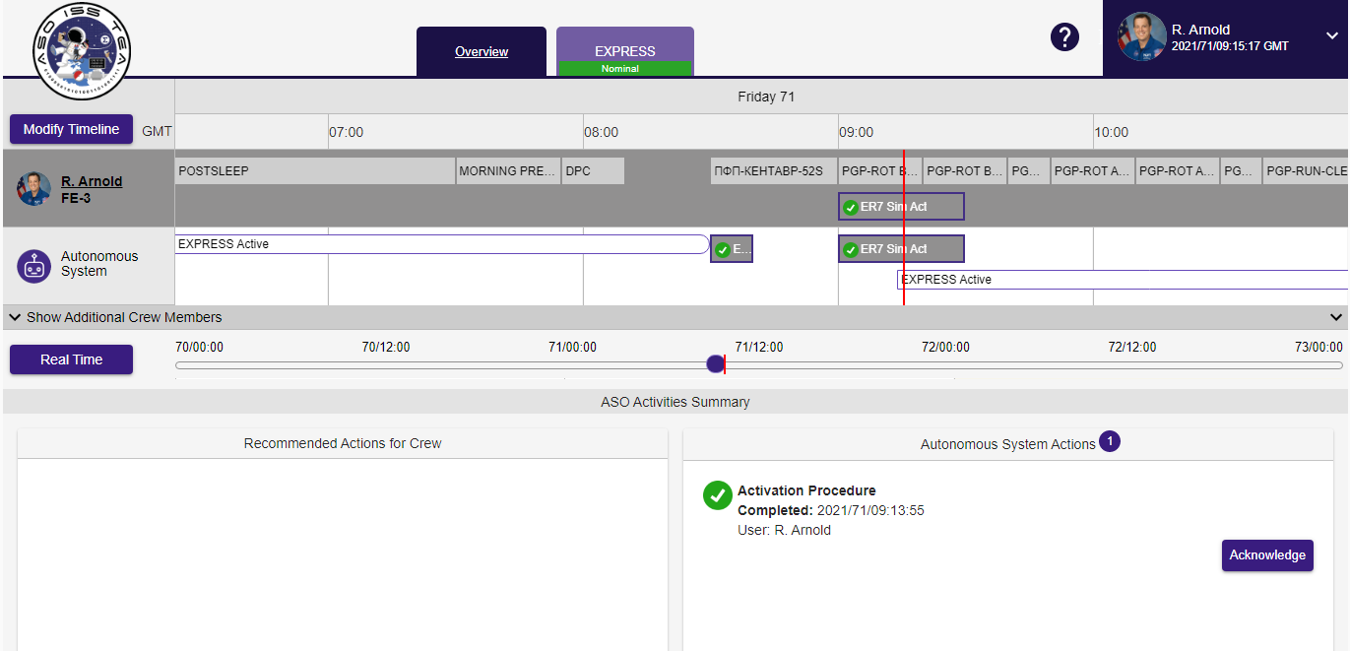Fig. 4. UI Overview tab for AMO-EXPRESS-2.5
On the timeline, as shown in Figure 5, the Modify Timeline button opens up a pop-up that allows crew to schedule activities as described in detail in section 3.1. On the left, crew can choose between an ER7 activation or ER7 deactivation procedure. To provide crew with flexibility in choosing how to manage their own activities, the self-scheduling tool provides color-coding to indicate what other types of activities might be occurring at that time if selected. Reiterating the descriptions from section 3.1, green indicates available time, yellow indicates that there are non-time-critical scheduled activities at this time, and dark grey indicate that there is a time critical activity at this time. When scheduling ER7 and other activities simultaneously, the left panel “Rationale (Potential Conflict)” will list the overlapping activities. If a time is selected that overlaps with a time critical activity, the GUI does not allow crew to proceed with scheduling by disabling the ‘save & close’ button.
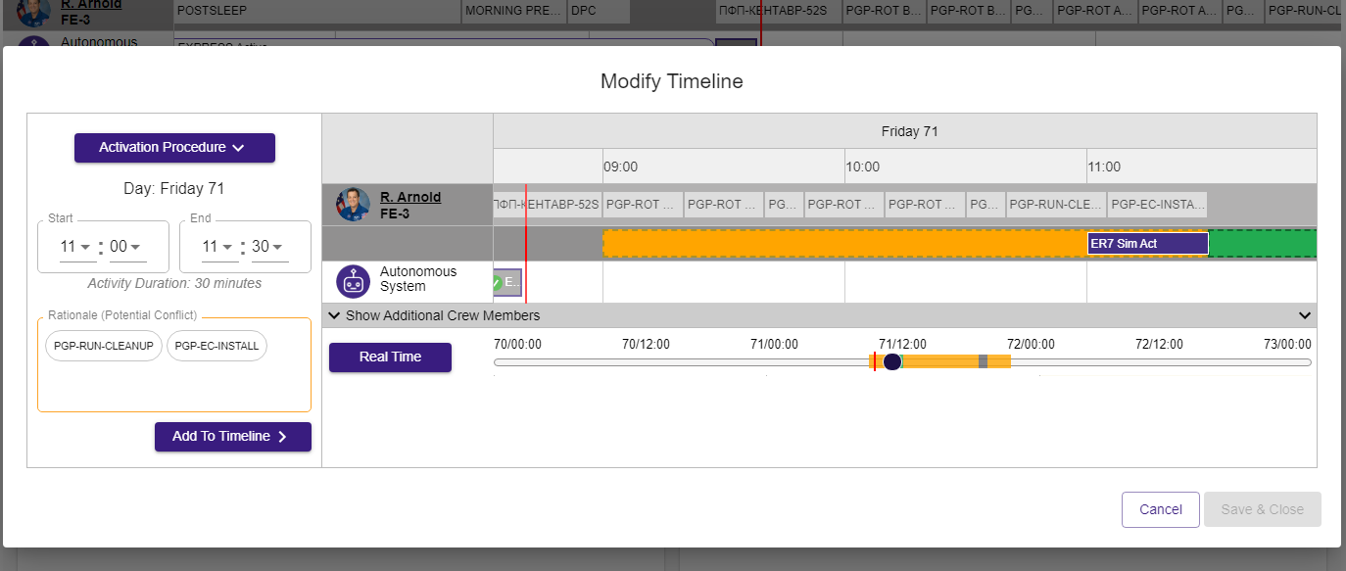Fig. 5. UI Overview tab with Modify Timeline pop-up for AMO-EXPRESS-2.5
The EXPRESS tab, shown in Figure 6, contains numerous subpages that allow the crew detailed insight into ER7 activities. Crew can provide detailed statuses for the procedure’s steps, a history of completed procedure activities, and detailed telemetry for potential in-depth troubleshooting. The EXPRESS page also reflects the same recommended crew actions and autonomous system actions shown on the home page. This information is shown in both locations to ensure visibility to crew.
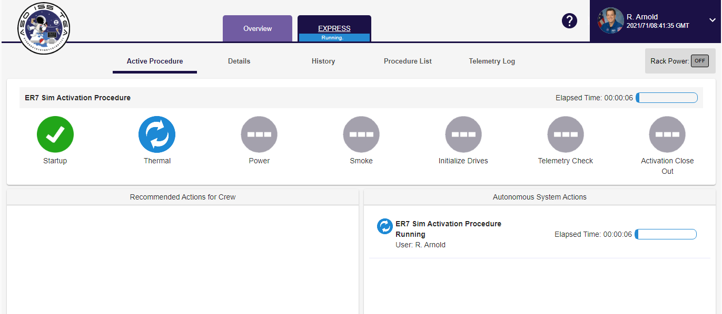 Fig. 6. UI EXPRESS tab for AMO-EXPRESS-2.5
When developing the GUI, the design focus was to allow crew to quickly process the visual information to allow them to take action. Crew are provided situational awareness to support them making their own decisions related to both the ER7 activities and when they wanted to complete them. The design of GUIs that enable crew autonomy will be critical when working with future mission time-delays.
4. Summary and Future Work
Autonomous science operations onboard the International Space Station to this point have been tremendously successful; however, these activities are still planned and initiated by flight controllers. The previous AMO-EXPRESS demonstrations [2] have been particularly noteworthy accomplishments, but as described in Section 1, they have demonstrated only a subset of autonomy capability needed for future Exploration missions. While AMO-EXPRESS-2.5 will not operate until late 2021, the results from the demonstration are expected to validate the crew’s ability to autonomously manage a spacecraft without assistance from the ground. The crew will be able to autonomously operate systems, self-schedule activities, respond to off-nominal situations, perform fault recovery, and re-plan their activities as needed.
When viewed in total, great strides have been made with respect to enabling crew autonomy, reducing the workload of ground controllers, assisting the crew, and increasing operational reliability. The natural progression would be to increase all levels of automated intelligence and to eventually allow for fully automated vehicles and payloads with real-time re-planning. With Artemis flights and Gateway on the horizon, the hope is that the steady stream of autonomous science payloads will grow. The requirements for automation for future missions beyond low earth orbit will help the crew enable autonomy to perform all aspects normally allocated to the ground controllers.
Acknowledgements
The authors would like to acknowledge the following groups and individuals who have contributed to the success of Autonomous Systems and Operations ISS Crew Demonstrations: The International Space Station (ISS) Program, Marshall Space Flight Center (MSFC) Payload and Mission Operations Division (PMOD), and the Johnson Space Center (JSC) Flight Operations Directorate (FOD). The authors would also like to thank engineers who assisted in the initial groundwork, design and development for AMO-EXPRESS-2.5: Randy Cornelius, Peter Jones, Isaias Reyes, Ryan Stanley, and Howard Stetson. This work was funded by the Advanced Exploration Systems (AES) Program.
Appendix A Acronym List

AES - Advanced Exploration Systems
AMO - Autonomous Mission Operations
AMO2.5 - Autonomous Mission Operations-EXPRESS-2.5
ARC - Ames Research Center
ASO - Autonomous Systems and Operations
CAST - Crew Autonomous Scheduling Test
CMG - Control Moment Gyro
EPIC - Enhanced Processor & Integrated Communications Card
ER7 - EXPRESS Rack 7
EVA - Extra Vehicular Activity
EXPRESS - EXpedite the PRocessing of Experiments for Space Station
GUI - Graphical User Interface
HOSC - Huntsville Operations Support Center
ISS - International Space Station
JSC - Johnson Space Center
MCC - Mission Control Center
MCC-H - Mission Control Center-Houston
MSFC - Marshall Space Flight Center
OCA - Orbital Communications Adapter
OpsLAN - Operations Local Area Network
OPTIMIS - Operations Planning TIMeline Integration System
PEP - Payload Executive Processor
PCS - Personal Computer System
PLMDM - Payload Multiplexer De-multiplexer
PLSS - Payload Support System
POIC - Payload Operations Integration Center
PPE - Power and Propulsion Element
PRO - Payload Rack Officer
RPC - Rack Power Controller
SIM - Simulation
SSC - Station Support Computer
SWRDFSH - Software to Ready Data Files to Send Hastily
TCP - Transmission Control Protocol
TOCA - Total Organic Carbon
VLAN - Virtual Local Area Network
VM - Virtual Machine

References

[1] | J. C. Crusan, R. M. Smith, D. A. Craig, J. M. Caram, J. Guidi, M. Gates, J. M. Krezel and N. Herrmann, "DeepSpace Gateway Concept: Extending Human Presence into Cislunar Space," in Proceedings of the IEEE Aerospace Conference, Big Sky, Montana, 2018.
[2] | H. K. Stetson, A. T. Haddock, J. Frank, R. Cornelius, L. Wang and L. Garner, "AMO EXPRESS: A Command and Control Experiment for Crew Autonomy Onboard the International Space Station," in Proceedings of the AIAA Conference on Space Operations, Pasadena, CA, 2015.
[3] | S. Beisert, M. Rodriggs, F. Moreno, D. Korth, S. Gibson, Y. H. Lee and D. E. Eagles, "Development and Execution of Autonomous Procedures Onboard the International Space Station to Support the Next Phase of Human Space Exploration," in Proceedings of the AIAA Space Conference, San Diego, CA, 2013.
[4] | J. Frank, D. Iverson, C. Knight, S. Narasimhan, K. Swanson, M. Scott, M. Windrem, K. Pohlkamp, J. Mauldin, K. McGuire and H. Moses, "Demonstrating Autonomous Mission Operations Onboard the International Space Station," in Proceedings of the AIAA Space Conference and Exposition, Pasadena, CA, 2015.
[5] | J. J. Marquez, S. Hillenius and M. Healy, "Increasing Human Spaceflight Capabilities: Demonstration of Crew Autonomy through Self-Scheduling Onboard International Space Station," in International Space Station R&D Conference, San Francisco, CA, 2018.
[6] | A. T. Haddock and H. K. Stetson, "Advancing Autonomous Operations for Deep Space Vehicles," in Proceedings of the 13th AIAA International Conference on Space Operations, Los Angeles, CA, 2014.
[7] | N. Bedrossian, S. A. Bhatt, M. Lammers, L. Nguyen and Y. Zhang, "First Ever Flight Demonstration of Zero Propellant Maneuver Attitude Control Concept," in Proceedings of the AIAA Guidance, Navigation and Control Conference, Hilton Head, SC, 2007.
[8] | H. K. Stetson, D. K. Deitsch, C. A. Cruzen and A. T. Haddock, "Autonomous Payload Operations Onboard the International Space Station," in Proceedings of the IEEE Aerospace Conference, Big Sky, MT, 2007.
[9] | D. G. G. Pruett, "Implementing Ethernet Services on the Payload Executive Processor (PEP)," NASA Technical Report, 2013.
[10] | D. Kortenkamp, D. Schreckenghost and L. Wang, "Developing and Executing Goal-Based, Adjustably Autonomous Procedures," in AIAA InfoTech@Aerospace Conference, Ronhert Park, CA, 2007.
[11] | D. Kortenkamp, R. P. Bonasso, D. Schreckenghost, K. M. Dalal, V. Verma and L. Wang, "A Procedure Representation Language for Human Spaceflight Operations," in Proceedings of the International Conference on Environmental Systems, San Francisco, CA, 2008.
[12] | J. Frank, L. Spirkovska, R. McCann, L. Wang, K. Pohlkamp and L. Morin, "Autonomous Mission Operations," in Proceedings of the IEEE Aerospace Conference, 2013.

