NASA Spring 2021 Internship
Imagery Analysis for Space Operations
Mentor: Alden Param, NE-L3
Intern: Brent Alexander McGlashon, Bethune Cookman University, Daytona Beach, FL
The purpose of this project is to build a prototype camera system that utilizes artificial intelligence/machine learning and computer vision to track an object in 2D and recreate it in 3D. The goal is to improve image analysis and photogrammetry function for Pad 39B operations

Introduction: The Advanced Imaging Analysis Lab (AIAL) performs image analysis and photogrammetry to support the Exploration Ground Systems (EGS) Program for the Artemis missions. The AIAL is reliant on external entities at Kennedy Space Center (KSC) that provide Infrared, Operational Television (OTV), and High-Speed imagery. There is a need for camera systems at KSC that are solely used for image analysis functions since the current imagery is captured with a multitude of requirements taken into consideration to support multiple programs and not always suited for image analysis needs.
The purpose of this project is to develop a proof of concept idea for a standalone camera system dedicated to capturing imagery for image analysis use. If implemented, this camera system will greatly improve image analysis function for the AIAL in support of EGS, as well as Marshall Space Flight Center (MSFC) and Johnson Space Center (JSC) in support of the Space Launch System (SLS) and Orion programs respectively. These programs rely on image analysis as part of verification and validation efforts of various subsystems for the Artemis missions.
The project is in the earliest stage of development and the goal for the Spring 2021 internship is to develop the software/hardware of the camera system to reach a working prototype. This will establish a baseline for the project that can develop further in the future when provided more funding.
Rationale: The customary method NASA uses for tracking targets, is the use of a stand-alone cameras in different positions around the launch platform to capture calibrated targets with known locations. The proposed design concept will display the proof of a multi-directional camera system that will inhabit the use of computer vision for tracking of the targets.
Method: Tracking and object detection methods comes in various forms and algorithms. For the project proposed, tracking is accomplished using computer vision perceived through the usage of web cameras while running a tracking or motion detection algorithm. Open- source Computer Vision libraries (OpenCV), are used in the algorithm. Additionally, an Arduino microcontroller for the control of each motor is used to control the direction of freedoms of each camera system.

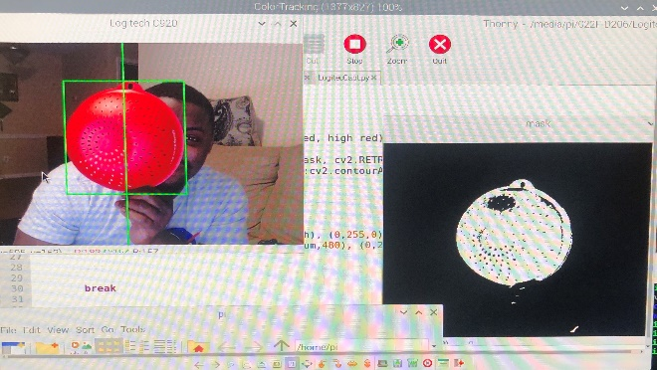
Figure 1. Object tracking by video feed

Results: Desired future goals for the project are to track desired objects using artificial intelligence/machine learning. Currently, the custom prototype 3-D printed design of the camera system designed and printed. Additionally, the camera-testing platform is built and waiting for future enhancements. Enhancements include permanent installation of each camera prototype, as well as implementation of electronics to automate platform and camera function.
Another future goal is to implement visual and motor integration using an Arduino microcontroller, and a Raspberry Pi 4 as the computer of the operation. This will be accomplished by creating bounding boxes around the targeted object that is being tracked within the software and obtaining Pixel to real world coordinates. Additionally, with those coordinates we’ll relate them to the motors signal which will essentially move the motors in each direction due to what is being tracked.

Conclusions: Additional work remains to in developing this complete prototype tracking system. Develop is still in progress to reach a goal of having a complete mechatronics-tracking platform by the end of the internship.

