PLASMA FOR CREWED TRANSIT AND PLANETARY HABITATION

K.W. Engeling, Ph.D., M. Shah, R.P. Pitts, M.M. Tessema, G.D. Massa, Ph.D., A. Meier, , Ph.D., D. Rinderknecht, N. Azim, and E. Petersen
National Aeronautics and Space Administration,
Kennedy Space Center, FL 32899 USA

R.P. Gott, Ph.D. and C. Johnson, Ph.D.
University Space Research Assosciation
Kennedy Space Center, FL 32899 USA

J.A. Olson, Ph.D.
Southeastern Universities Research Association,
Kennedy Space Center FL, 32899 USA

M. Hummerick, and C. Franco, Ph.D.
AECOM Management Services Inc.,
Kennedy Space Center, FL 32899 USA

As human exploration moves beyond low Earth orbit, innovative life support and resource production systems become forerunners for human colonization. Plasma systems allow for complex chemical processes while mitigating consumable needs. Plasma technology and applications can redefine the space environment. With this, scientists at NASA are looking to close known space technology gaps and create a paradigm shift in space-based applications. NASA’s Kennedy Space Center is exploring the use of low-temperature plasma for applications in agriculture, sanitation, regolith reduction, waste gasification, water activation, and nutrient recovery techniques. Using low temperature plasmas, we report on the success criteria and experimental results for plasma applications for crewed transit and planetary habitation.
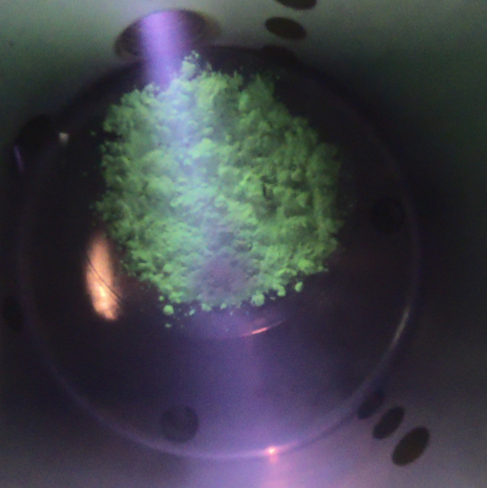
Hydrogen plasma interaction with Lunar Highlands Simulant.
________________________________
* Work supported by NASA’s Human Exploration and Operations Mission Directorate Advanced Exploration Systems Logistics Reduction, Science Technology Mission Directorate Center Innovation Fund, and Kennedy Space Center Center Engineering and Safety Operations Independent Research and Technology Development

