Supplemental Material
S1 Data Analysis
Here we describe the details of the methods and results for each sample which are not germane to the determination of exposure history as discussed in the main text.

S1.1 ²¹Ne measurement
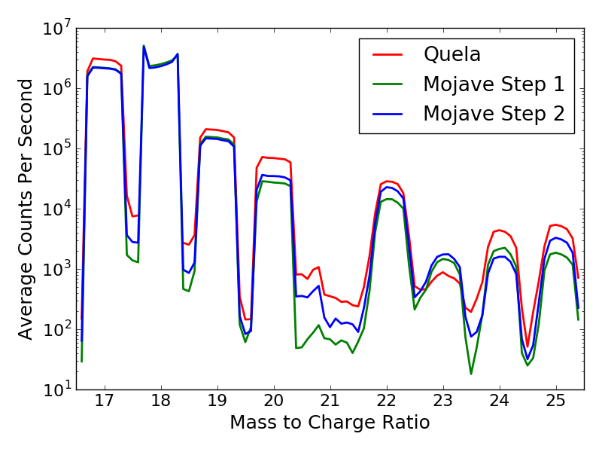
Figure S1: Mass spectra for Quela and Mojave 2, demonstrating squared-off peakshapes and the impact of the radiofrequency shift at m/z 20.9 on measurements at m/z 21.0. Counts shown are the average of the complete time series from each run. The dip in the peak at m/z 18 is a result of detector saturation due to H₂O.
A shift in the radiofrequency (RF) for the QMS occurs at m/z 20.9 to allow for measurements at higher masses. This shift briefly disturbs the stability of the ion path through the quadrupole mass analyzer, negatively impacting the measurement of ²¹Ne using m/z 21.0. To avoid this issue, the off-integer mass at m/z 20.8 was used as a proxy for measurement of 21.0 in Mojave 2. Due to the nearly flat-topped peak shape of the QMS measurements (Figure S1), this selection of m/z to characterize ²¹Ne abundance does not vary substantially from the “true” value that would be measured at m/z 21.0. This substitution was validated using the noble gas measurement of Quela, where a mass spectrum was collected across the m/z 21.0-21.5 range both with and without an RF shift. The reduced data using m/z 21.0 and m/z 20.8 are indistinguishable from one another; we therefore conclude that use of m/z 20.8 as a proxy for m/z 21.0 is appropriate for Mojave 2.
Background measurements are not made for non-integer masses after the system is pumped down. This lack of data is a minor complication in using m/z 20.8 for ²¹Ne quantification in Mojave 2 as it precludes direct measurement of a background to subtract from the isobar-corrected ²¹Ne signal. The same assumption that m/z 20.8 and m/z 21.0 are equivalent was made, and the ratio of semi-static to background measurements at m/z 21.0 was applied to the uncorrected semi-static measurement of m/z 20.8 to derive an estimated background.

S1.2 Mojave 2
Table S1: Results of the noble gas experiment on Mojave 2, with production rates and calculated ages.
Mojave 2 | ³He | ²¹Ne | ³⁶Ar
High-T step aliquot 1ª (pmol g⁻¹) | 200±50 | 13±9 | 310±50
Low-T step aliquot 2 (pmol g⁻¹) | 620±110 | 32±15 | 90±20
High-T step aliquot 2 (pmol g⁻¹) | -10±30 | 15±7 | -30±20
Total aliquot 2^{b}  (pmol g⁻¹) | 615±110 | 47±22 | 90±17
Surface production rate (pmol g⁻¹ Ma⁻¹) | 0.4653 | 0.0523 | 0.2892
Age (Ma) | 1,320±240 | 910±420 | 310±60
ªThe high temperature step of aliquot 1 is highlighted in red to indicate that we do not consider the data from this run valid.
^{b}Aliquot 2 is highlighted in green as the numbers used for age calculations.
Table S2: APXS and CheMin results from Mojave 2 as reported in Martin et al. (2017) and Rampe et al. (2017). Uncertainty on chemistry measurements is 15% relative.
Chemistry (wt%) |  | Mineralogy (wt %)
SiO₂ | 49.48 | Plagioclase | 23.5 ± 1.6
TiO₂ | 1.19 | Forsterite | 0.2 ± 0.8
Al₂O₃ | 11.43 | Augite | 2.2 ± 1.1
FeO | 16.11 | Pigeonite | 4.6 ± 0.7
MnO | 0.40 | Magnetite | 3.0 ± 0.6
MgO | 4.55 | Hematite | 3.0 ± 0.6
CaO | 4.33 | Quartz | 0.8 ± 0.3
Na₂O | 3.01 | Jarosite | 3.1 ± 1.6
K₂O | 0.73 | Fluorapatite | 1.8 ± 1.0
P₂O₅ | 1.29 | Phyllosilicate | 4.7 ± 2.4
Cr₂O₃ | 0.37 | Amorphous | 53 ± 15
Cl | 0.43
SO₃ | 6.27
Ni (ppm) | 1032
Zn (ppm) | 2204
Br (ppm) | 65
Two heating steps were used for the Mojave 2 sample to separate the K-Ar ages of detrital and secondary components (Martin et al., 2017). This temperature resolution has no advantage in the analysis of cosmogenic nuclides as the major cosmogenic noble gas-bearing minerals in a sample likely share an exposure history and would therefore have the same calculated exposure age (subject to the caveats regarding ³⁶Ar discussed in section 4.2 of the main text). As no additional information would be obtained by isolating the exposure ages of a few mineral components, the two steps are simply summed for this study.
For unknown reasons, an internal alarm was triggered during the low temperature step of the noble gas experiment on Mojave 2, causing no data to be collected; the high-T step ran successfully (Martin et al., 2017). A second aliquot of Mojave 2 was run successfully and all data was returned. Discrepancies between the successful second heating steps in the first and second aliquots of Mojave 2 have been ascribed to the loss of material during sample transfer (Martin et al., 2017). The measured ³He and ²¹Ne are lower in the high-temperature step of aliquot 1 (the failed run) than in aliquot 2, supporting this hypothesis. However, ³⁶Ar decreases between aliquot 1 and aliquot 2, suggesting that lost sample may not be the cause of these discrepancies. As the exact reason for the alarm and aborted noble gas run is unknown and data from half of the heating schedule was not collected, a complete understanding of the data returned from the first aliquot is likely to be elusive. Based on the reasonable K-Ar results from aliquot 2 (Martin et al., 2017), we adopt the interpretation that those data are more reliable and therefore utilize the data from aliquot 2 in forming interpretations for this study.
No ³He was measured in the high-T step of aliquot 2. The negative calculated amount of ³He is well within uncertainty of zero, and so the high-T step is not included in age calculations. The calculated ³⁶Ar in the high-T step is also below zero, albeit outside of uncertainty. This a result of the H³⁵Cl isobar correction, which dominates the uncertainty for the ³⁶Ar calculation (Farley et al., 2014). If the input δ³⁷Cl value is incorrect, the calculated ³⁶Ar concentration varies by about 3.9 pmol/g for each change of 1‰ in δ³⁷Cl. The δ³⁷Cl cannot be measured directly in semi-static mode, so the value from the Mojave 2 evolved gas analysis, run 543 sols earlier, was used in this case. There are several potential explanations for a change in the δ³⁷Cl in this time: the uncertainty of the δ³⁷Cl given in Farley et al. (2016) could have been underestimated, resulting in a ³⁶Ar value below 0 outside uncertainty; the δ³⁷Cl may be slightly different between aliquots of Mojave 2 due to differing concentrations of Cl-rich phases; or HCl memory built up in SAM could have a heavier isotope value than the true value of Mojave 2, changing the required H³⁵Cl correction factor. A δ³⁷Cl value of -41±5‰ was used in this calculation (Farley et al., 2016); a change in either the value or the uncertainty by 3‰ results in a calculated ³⁶Ar of zero within uncertainty. Therefore, as with ³He, the high-T step for ³⁶Ar is not included in age calculations.

S1.3 Quela
Table S3: APXS and CheMin results from Quela, available on the NASA PDS and in Bristow et al. (2018). Uncertainty on chemistry measurements is 15% relative.
Chemistry (wt%) |  | Mineralogy (wt %)
SiO₂ | 44.81 | Andesine | 13.5 ± 0.7
TiO₂ | 1.05 | Hematite | 7.1 ± 0.4
Al₂O₃ | 8.48 | Ca-Sulfate | 5.5 ± 0.4
FeO | 18.93 | Sanidine | 2.3 ± 0.5
MnO | 0.22 | Pyroxene | 2.7 ± 0.7
MgO | 4.10 | Jarosite | ≤0.5
CaO | 7.48 | Quartz | ≤0.5
Na₂O | 2.19 | Clay minerals | 16 ± 3
K₂O | 0.77 | Amorphous | 52 ± 25
P₂O₅ | 1.10
Cr₂O₃ | 0.29
Cl | 1.01
SO₃ | 9.30
Ni (ppm) | 999
Zn (ppm) | 826
Br (ppm) | 42
Neither ²¹Ne nor ³⁶Ar were successfully measured for Quela, due to large uncertainties associated with both measurements. For ²¹Ne, this uncertainty was generated by a lack of spread in m/z 20 for isobaric correction, which resulted in a poor regression and large uncertainty (Figure S2; Farley et al., 2014).
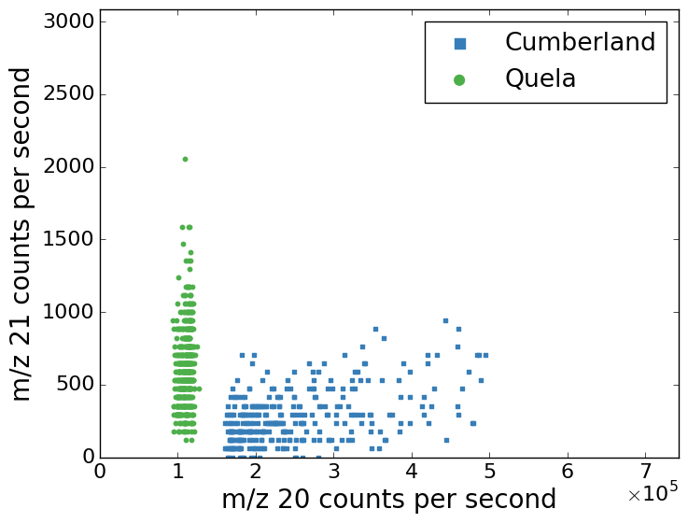
Figure S2: Quela m/z 21.0 plotted against m/z 20.0, which is used to correct for interference from H₂¹⁸O. The lack of spread in m/z 20.0 precludes valid regression to allow conversion of m/z 21.0 to a ²¹Ne signal. See Farley et al. (2014) for a detailed description of isobar correction methods.

Measurement of ³⁶Ar was unsuccessful because Quela has an anomalously large release of HCl (both in this analysis and evolved gas analysis; Sutter et al., 2017), resulting in an H³⁵Cl isobar correction much larger than any other sample yet measured by SAM. Additionally, this correction relies on accurate evaluation of the chlorine isotope ratio in Quela, but the δ³⁷Cl cannot be accurately calculated as a result of detector saturation at the peak of this large release. If chlorine isotope values typical of the Murray from Pahrump are used and the largest uncertainty measured by Farley et al. (2016) is imposed on this value, the uncertainty on the calculated age is approximately four billion years, making this measurement uninterpretable.

S1.4 Numerical Model
As described in the main text, the production profile of cosmogenic nuclides in the Martian subsurface does not permit direct application of the equations used in determining denudation rate from surface cosmogenic nuclide studies on Earth. In response, we built a numerical model to determine the concentration of cosmogenic nuclides at any depth with a given denudation rate and length of exposure after erosional resetting. This model works by calculating the cosmogenic nuclides produced throughout the subsurface (down to 1% of surface production rate, a depth of ~4 m) using an interpolated and extrapolated profile from the data presented in Wieler et al. (2002) in 1 Ma timesteps. After each timestep, the appropriate amount of material is then removed from the surface based on the designated denudation rate, shifting the entire profile upwards by an equivalent amount. This model can therefore be used to either determine the surface concentration of cosmogenic nuclides after steady-state has been reached, or can be applied to determining this concentration in a transient case where consistent denudation has occurred following a resetting erosion event. It also permits direct calculation of the amount of time required to reach steady-state if surface cosmogenic nuclide concentration and denudate rate are specified.

Supplemental References
Bristow, T. F., Rampe, E. B., Achilles, C. N., Blake, D. F., Chipera, S. J., Craig, P., et al. (2018). Clay mineral diversity and abundance in sedimentary rocks of Gale crater, Mars. Science Advances, 4(6), eaar3330. https://doi.org/10.1126/sciadv.aar3330
Farley, K., Malespin, C., Mahaffy, P., Grotzinger, J., Vasconcelos, P., Milliken, R., et al. (2014). In situ radiometric and exposure age dating of the Martian surface. Science, 343(6169), 1247166.
Farley, K., Martin, P., Archer, P., Atreya, S., Conrad, P., Eigenbrode, J., et al. (2016). Light and variable 37 Cl/35 Cl ratios in rocks from Gale Crater, Mars: Possible signature of perchlorate. Earth and Planetary Science Letters, 438, 14–24.
Martin, P. E., Farley, K. A., Baker, M. B., Malespin, C. A., Schwenzer, S. P., Cohen, B. A., et al. (2017). A Two-Step K-Ar Experiment on Mars: Dating the Diagenetic Formation of Jarosite from Amazonian Groundwaters. Journal of Geophysical Research: Planets, 122(12), 2017JE005445. https://doi.org/10.1002/2017JE005445
Rampe, E. B., Ming, D. W., Blake, D. F., Bristow, T. F., Chipera, S. J., Grotzinger, J. P., et al. (2017). Mineralogy of an ancient lacustrine mudstone succession from the Murray formation, Gale crater, Mars. Earth and Planetary Science Letters, 471, 172–185. https://doi.org/10.1016/j.epsl.2017.04.021
Sutter, B., McAdam, A. C., Mahaffy, P. R., Ming, D. W., Edgett, K. S., Rampe, E. B., et al. (2017). Evolved gas analyses of sedimentary rocks and eolian sediment in Gale Crater, Mars: Results of the Curiosity rover’s sample analysis at Mars instrument from Yellowknife Bay to the Namib Dune. Journal of Geophysical Research: Planets, 122(12), 2574–2609. https://doi.org/10.1002/2016JE005225
Wieler, R. (2002). Cosmic-Ray-Produced Noble Gases in Meteorites. Reviews in Mineralogy and Geochemistry, 47(1), 125–170. https://doi.org/10.2138/rmg.2002.47.5

