SpaceOps-2021,1,1,3,x135

Utilization of Machine Learning Techniques for Managing the Tracking and Data Relay Satellite Constellation

Kenneth Y. Ma^{a*}, Manuel Montoro^{b}, Lawrence Woods^{c}, Thomas Williams^{d}, Patel Mihir^{e} , Jonathan Steele^{f},David Cunnif^{g}, Carissa Brealey Bonacci^{h}, Ronald Miller^{i} John Zuby^{j}, Harry Shaw^{k} , Haleh Safavi^{l}

ª Peraton Corp., Herndon, VA, United States, kenneth.y.ma@nasa.gov
^{b} Peraton Corp., Herndon, VA, United States, manuel.a.montoro@nasa.gov
^{c} Peraton Corp., Herndon, VA, United States, lawrence.a.woods@nasa.gov
^{d} Peraton Corp., Herndon, VA, United States, thomas.e.williams@nasa.gov
^{e} NASA/GSFC, 8800 Greenbelt Road, MD, United States, mihir.patel@nasa.gov
^{f} Peraton Corp., Herndon, VA, United States, jonathan.b.steele@nasa.gov
^{g} NASA/GSFC, 8800 Greenbelt Road, MD, United States, david.cunniff@nasa.gov
^{h} Peraton Corp., Herndon, VA, United States, carissa.bonacci@nasa.gov
^{i} NASA/GSFC, 8800 Greenbelt Road, MD, United States, ronald.a.miller@nasa.gov
^{j} NASA/GSFC, 8800 Greenbelt Road, MD, United States, john.s.zuby@nasa.gov
^{k} NASA/GSFC, 8800 Greenbelt Road, MD, United States, harry.c.shaw@nasa.gov
^{l} NASA/GSFC, 8800 Greenbelt Road, MD, United States, haleh.safavi@nasa.gov

Abstract

National Aeronautics and Space Administration’s (NASA) Goddard Space Flight Center (GSFC) operates a constellation of ten geosynchronous Tracking and Data Relay Satellites (TDRS). The TDRS constellation consists of multiple geosynchronous communication relay satellites located around the equator so they can provide continual coverage of any mission in low earth orbit. The TDRS are located primarily in three oceanic regions around the earth. NASA’s White Sands Complex provides the ground communication support for TDRS located over the Atlantic and Pacific Oceans. Another TDRS ground station in Guam supports the TDRS over the Indian Ocean. With these satellites the TDRS network can provide continuous coverage of satellites in low-earth orbit. The NASA Space Network (SN) project office at GSFC manages the constellation of spacecraft. Major customers of the TDRS constellation include, but are not limited to, the International Space Station and the Hubble Space Telescope.
The TDRS constellation has three generations of satellites and has been active for over 30 years providing reliable communication links between customer satellites and corresponding ground stations. However, one of the major concerns for TDRS, and in any space mission, is to ensure the health and safety of the spacecraft. Generally, engineers use telemetry data to monitor and analyze the performance and state of health of the spacecraft. Telemetry data contains hundreds of parameters that monitor each important component in the spacecraft, which can be utilized to recognize and characterize the behavior of the spacecraft. Each parameter contains considerable information to represent time-dependent properties of each spacecraft subsystem and component. During the entire life of a TDRS spacecraft, thousands of gigabytes of telemetry data are transmitted in real-time from the spacecraft to the ground station at the White Sands Complex in Las Cruces, New Mexico, and recorded as historical data sets for engineers to process and analyze the events that occurred on-orbit. These parameters contain the function of multiple spacecraft subsystems, such as the attitude control system (ACS), Thermal, Electrical Power Subsystem (EPS), etc. . The first and second generations have exceeded their required lifetime and NASA is keen to manage these spacecrafts carefully in order to maximize the remaining life using the spacecraft telemetry. The challenge is to know when the risk of losing a spacecraft in geosynchronous orbit exceeds the benefit of continued operations for customer support.
In the TDRS fleet, the EPS is the most critical subsystem related to spacecraft operations. Failure of the EPS would strand a spacecraft in geosynchronous orbit. Since EPS provides power to the spacecraft, component failures ultimately lead to the inability to support the spacecraft loads and the communications payload. For instance, TDRS-8 has several anomalies in EPS including the Bus Voltage Limiter (BVL) shunt current, solar array loss of circuits, and failed battery cells. Any of these anomalies can cause critical issues to the spacecraft. Therefore, developing a system to analyze and perform early detection of a potential anomaly is an important issue in telemetry data analysis. In recent years, Telemetry Mining (TM) has been proposed to process telemetry data by using Data Mining (DM) techniques such as classification, clustering, regression and anomaly detection. Anomaly detection, also known as outlier detection, has been widely used in many data mining areas such as remote sensing, medical data processing and digital image processing. The goal of anomaly detection is to detect abnormal data, which contains a relatively low probability of occurrence among the entire data set. Early detection of anomalies is one of the most significant issues in managing the spacecraft configuration. If anomalies can be detected early enough, then the redundant resources can be used to extend the life of the operational spacecraft.
We present an unsupervised anomaly detection method to process the EPS data extracted from TDRS-8. This is different from traditional analytical methods, which use telemetry data to illustrate behavior and physical meaning of each spacecraft component. TM connects multiple parameters as a vector and then conducts data analysis on this high dimension telemetry vector. This method is looking at the properties of a high dimensional vector that is able to consider the relationship between different parameters in the anomaly detection problem. This kind of method performs much better than the traditional limit checking method. In addition, we propose a new approach of real-time anomaly detection to process telemetry data in real-time, which can then be applied to spacecraft monitoring with high reliability, low cost and high accuracy.
Keywords: Machine Learning (ML), Telemetry data processing, RXD, anomaly detection.

- Introduction
NASA/GSFC currently operates a constellation of ten geosynchronous TDRS spacecraft launched over the past 30 years. The TDRS constellation consists of multiple geosynchronous communication relay satellites located around the equator so that they can provide continual coverage of any mission in low earth orbit. Generally speaking, the spacecraft health and functionality is derived from real-time telemetry data that is collected from multiple spacecraft subsystems, which are transmitted from on-orbit spacecraft to the main ground station at the White Sands Complex in Las Cruces, NM. The telemetry stream extracted from TDRS contains hundreds of parameters from each subsystem, which can be utilized to recognize and characterize the function and behavior of the spacecraft. Each parameter contains considerable information with respect to time-dependent properties of each subsystem as well as any components inside the subsystem. During the entire life of a TDRS spacecraft, thousands of gigabytes of telemetry data are transmitted real-time from the spacecraft to the ground station. However, one major concern of spacecraft diagnosis and management is how to define a criterion to detect an anomaly of the on-orbit spacecraft using the received telemetry data. Such missions are generally under the purview of spacecraft operation engineers who watch for unexpected events and anomalous trends in telemetry data which is costly and time-consuming.
During the past several years, many papers were proposed to study the applications of machine learning (ML) on telemetry data processing, which has shown to be very useful to improve the efficiency of traditional manual inspection. To be more precise, there are three different types of ML-based anomaly detection approaches. The first type is a hard-decision classifier such as support vector machine (SVM), which aims to classify telemetry data into “anomaly” or “normal” categories. Another one is a data reconstruction-based technique such as autoencoder which considers that only non-anomaly data can be successfully reconstructed through a proper compression and reconstruction processes. A third one is a background suppression-based technique. One general example is the Reed-Xiaoli Detector (RXD), which extracts targets that are spectrally distinct from a dataset that behaves in a normal way. For this type of anomaly detector to be worked effectively, the size of the anomalous targets must be sufficiently small relative to the normal data set. It is also worth noting that most of the machine-learning classification or detection algorithms are normally used with a high-dimensional data set. Since a telemetry stream is usually constructed by hundred or even thousands of telemetry parameters, where each parameter can be utilized to identify or diagnose the behavior or state of health for each individual spacecraft component, ML is capable of combining multiple telemetry parameters so that the correlation between each individual parameter can be considered simultaneously.
Recently, the NASA Space Network (SN) team is investigating and developing a machine learning (ML)-based algorithm to automatically detect anomalies that occurred on the TDRS spacecraft. The goal is to enhance the efficiency and accuracy of spacecraft management and obtain a more accurate prediction of the spacecraft end of life. This paper develops an automatic anomaly detection algorithm for telemetry datasets, which can address the drawback of the traditional anomaly detection that is performed manually. Here, we propose to use telemetry data from electrical power subsystem (EPS) to demonstrate the analysis results of our anomaly detection algorithms because of two reasons. The EPS is related to the function of providing the power to the spacecraft. Failure of the EPS components will eventually lead to total spacecraft failure. Second, for some spacecraft, which are already beyond required lifetime such as TDRS 8, several anomalies in EPS have appeared including the abnormal shunt current of the bus voltage limiter (BVL), loss of solar array circuits and failure of battery cells. Any one of these systems could have significant influence in terms of the function to supply power. In this paper, BVL anomalies were selected to be used to study the effectiveness of our anomaly detection algorithm. We will present some of the case studies in the experiment section.

2. The anomalies of electrical power subsystem

The electrical power subsystem (EPS) is one of most significant subsystems with respect to the power source of the spacecraft, including several important components such as battery packs and solar panels. In the past ten years, several anomalies have been found on BVL components caused by the failure of metal-oxide-semiconductor field-effect transistors (MOSFETs). This failure of the MOSFETs causes the BVLs to constantly shunt power from the solar array. The general purpose of a BVL is to allow current coming from solar panel to pass through while shunting the redundant current that exceeds the requirement of the spacecraft bus. Each solar wing contains one BVL component to control the input current. A consequence to an abnormal shunt current is that the battery sometimes is required to provide power during full sun periods which took longer to charge the battery after an eclipse. Fig. 1 shows the examples of normal BVL shunt currents for TDRS 8 where (a) shows the one-minute average of the time-series telemetry data including the six parameters shown in Table 1, and Fig. 1 (b)-(c) plots the Bus voltage versus BVL shunt current.

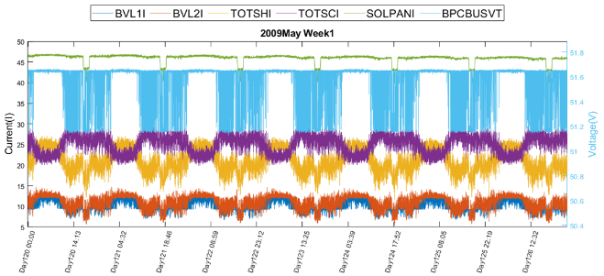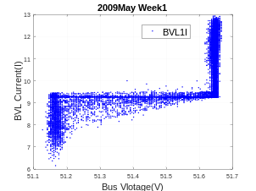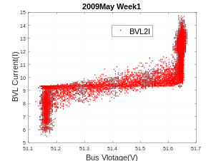
(a) (b) (c)
Fig.1. Normal behavior of BVL extracted from 2009 day 120 – 126 (a) 1-minute averaged telemetry data of six parameters (b) Bus voltage versus BVL1I (c) Bus voltage versus BVL2I.

Table 1. Definition of BVL related parameters
Abbreviation | Description
BVL1I | Bus voltage limiter 1 shunting current
BVL2I | Bus voltage limiter 2 shunting current
BVL1TMP | Bus voltage limiter 1 temperature
BVL2TMP | Bus voltage limiter 2 temperature
SOLPANI | Current provide by solar panel
TOTSHI | Total BVL shunt current (BVL1I + BVL2I)
TOTSCI | Total spacecraft current (SOLPANI - TOTSHI)
BPCBUSVT | Voltage of Bus

If we compare bus voltage versus BVLI plots shown in Fig.1 (b) and (c), the shape of BVL1I and BVL2I were very similar. That is to say, BVL1 and BVL2 have the same operational function and their shunt surrent should be indentical, or at least very close, if no unknown anomalous events ocurred. However, on some occasions, one of the BVLs contained an abnormal shunt current, as shown in Figs. 2 - 5.
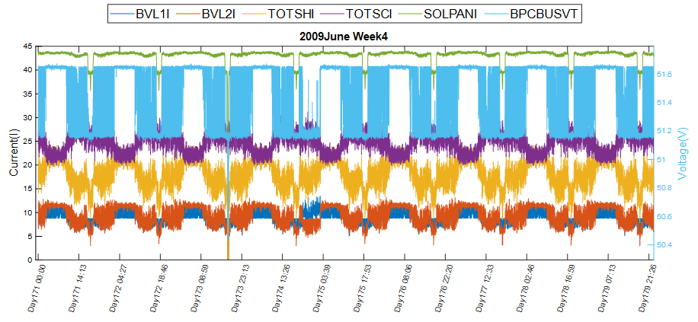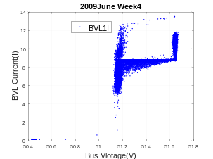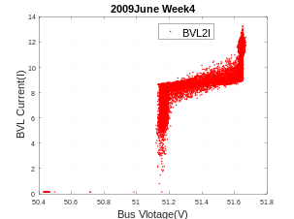
(a) (b) (c)
Fig.2. Abormal behavior of BVL extracted from 2009 day 171 – 179 (a) 1-minute averaged telemetry data of six parameters (b) Bus voltage versus BVL1I (c) Bus voltage versus BVL2I.
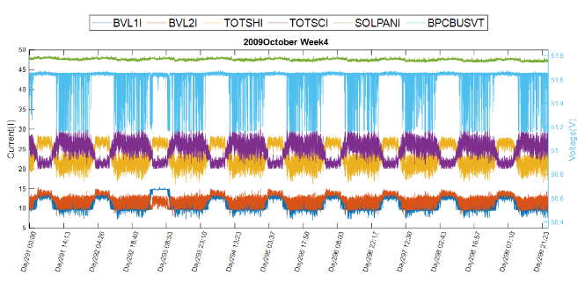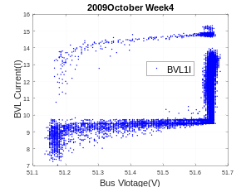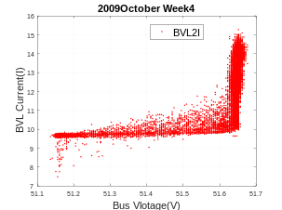
(a) (b) (c)
Fig.3. Abormal behavior BVL data extracted from 2009 day 291 – 299 (a) 1-minute averaged telemetry data of six parameters (b) Bus voltage versus BVL1I (c) Bus voltage versus BVL2I
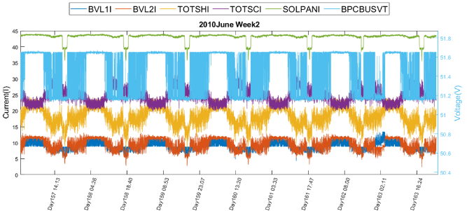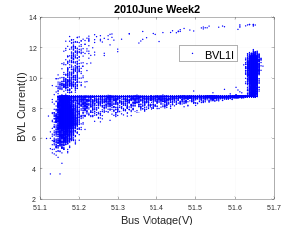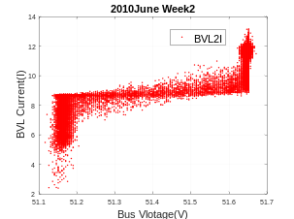
(a) (b) (c)
Fig.4. Abormal behavior BVL data extracted from 2010 day 157 – 163 (a) 1-minute averaged telemetry data of six parameters (b) Bus voltage versus BVL1I (c) Bus voltage versus BVL2I
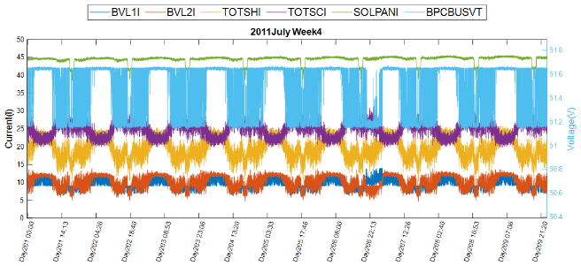
(a) (b) (c)
Fig.5. Abormal behavior of BVL extracted from 2011 day 201 – 209 (a) 1-minute averaged telemetry data of six parameters (b) Bus voltage versus BVL1I (c) Bus voltage versus BVL2I

Figs 2 - 5 demonstrates four BVL anomaly cases observed on TDRS 8 between January 2009 to December 2011. After 2011, similar anomalies occurred one to two times a year until 2017 where one module(MOSFET) of the BVL was permanently turned off. During the past few years, the Space Network(SN) team manually extracted all of the anomalous BVL events from all generation 2 TDRS spacecraft. However, such manual review of this much data is very time comsuming. Particularly, some of the anomlies would be missed because human assessment is limited to the plots shown above. To deal with this issue, we proposed a novel framework to utilize machine learning to automatically detect the BVL anomlies.

- Detection of Anomalous EPS data

Many approaches can be implemented for anomaly detection using spacecraft telemetry data. The easiest and most widely used method is limit checking, where limit checking is measuring the standard deviation (SD) of each individual parameter and then using an upper bound and lower bound of the parameter as a threshold. Once the monitored value of the parameter exceeds the decided threshold, the data point would be assigned as anomalous. Therefore, limit checking only considers the individual parameter but ignores the correlation between different parameters. This method is very easy and simple to implement but not effective enough because it is still possible that the value of one parameter does not exceed the threshold bounds but the telemetry system still has an abnormal behavior.
In past decade, many telemetry data processing techniques using machine learning (ML) have been proposed. The supervised ML method has been used to conduct telemetry data processing using support vector machine (SVM), neural network (NN), relevance vector regression, etc. However, supervised algorithms are not suitable for anomaly detection since anomalous data is not supposed to be known as a priori information. So, a reliable training data set of anomalies is difficult to attain. In this paper, we proposed to use the unsupervised anomaly detector called the RX detector (RXD) where RXD is a classic background suppression-based detector that is utilized to detect an anomalous target in a blind dataset where the anomalies are generally small and unknown.

3.1 RX anomaly detector
The RXD was developed by Reed and Yu in 1990. If we consider r is an input telemetry data vector with 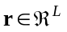 and L is the dimensionality representing the number of features. The general designing principal of RXD is to design a filter that minimizes the output energy of data samples that are “normal” while enhancing the output energy of data samples that might be “anomalies”. The RXD implements a filter specified by
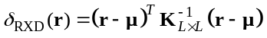 (1)
where is a sample mean and 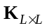 indicates the sample auto covariance matrix that is specified by a given reference data set that represents the normal behavior of the spacecraft. It is worth noting that 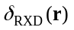 equation in (1) actually calculates a well-known Mahalanobis distance between input sample r to an observed data set mean . Intuitively, the large distance between r and indicates strong divergence of r to the normal behavior dataset, thus the high probability of r to be an anomaly. Mathematically, RXD can be considered as an inverse version of principal component analysis (PCA). Even though they are both manipulating , PCA compresses the data sample or signal to the major principal component that is specified by the largest eigenvector of corresponding to the largest eigenvalue. Since small targets or anomalous data do not present themselves in the first principal component, PCA is not suitable for anomaly detection. On the contrary, RXD takes the inverse of to suppress the eigenvectors that correspond to large eigenvalues, while enhancing the small eigenvalues that can be used to extract anomalies from blind datasets. So, PCA is designed for classification, which is different than RXD that is developed for small targets or anomaly detection. The detailed implementations of RXD-based anomalous telemetry data detection are shown below.

Algorithm 1: TDRS Anomaly detection using RXD algorithm
Input: r, C_{normal}, ε
- Let r be an input data sample vector and C_{normal} is the data set that is utilized to represent normal behavior TDRS spacecraft.
- Calculate data sample covariance matrix
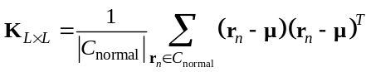
- Utilize RXD equation to compute anomaly score of r
- Declare anomaly if
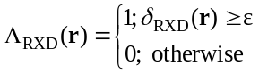
Output: 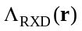,

Even though RXD is an efficient method to address the unsupervised anomaly detection problems, one major issue with RXD is how to process RXD in a real-time manner. It has to be noted that RXD is not well suited for real-time operations since we are unable to recalculate the covariance matrix, , every time new data is extracted. On the other hand, the sample correlation matrix 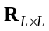 can only be updated by adding a new data sample r, which is much easier to process in real-time. Therefore, for real-time data processing, the correlation matrix version of RXD is more suitable than the proposed RXD which uses the covariance matrix. In this case, the RXD in (1) can be extended to the correlation matrix-based RXD, given by
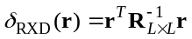 (2)
In this paper, we only used the covariance matrix based RXD in (1) to conduct the experiments because their results were very closely. Nevertheless, both can be utilized to detect anomalous telemetry data.

4. Anomaly analysis using RXD

In general, RXD can be implemented as a tool for anomalous telemetry detection and analysis in three different aspects:

1. Anomaly classification: Unlike many supervised ML classification algorithms such as NN or SVM that generally produce binary outputs, the output of the RXD detector is soft which indicates for the score of anomalies that the higher the score, the more significant the anomaly. Even though RXD is a soft-decision detector, we can still use a threshold to binarize soft decision output, , to a binary decision output as shown in algorithm 1. By doing so, RXD indeed can work as a classifier to classify input data samples into two class categories, “normal data” and “anomaly data”. However, how to select an appropriate threshold value, ε is difficult. One possible way is to utilize Otsu’s method [10] to automatically find the ε by either maximizing between class variance or minimizing within class variance. However, the ε selected by Otsu’s does not guarantee to be an optimal one. So, in this paper, ε is selected experimentally. Nevertheless, we will keep investigating how to automatically select an appropriate ε.

2. Long-term anomaly analysis: Long-term trending is most widely used for analysis of a single telemetry parameter, such as a temperature or current. That is, if anomalies appeared, the parameters may trend out of family. For instance, we can trend solar array temperature for the long term since the solar array temperature in the same season should follow the same trend. However, it is impossible to show all telemetry points into yearly or monthly trending plots. In this case, a daily or hourly mean, maximum, minimum or standard deviation of the parameter would be used. Using a similar idea, we can conduct anomaly detection using daily or hourly mean as an input feature and trend the resulting anomaly scores in the long term so that any out of family anomaly scores would be considered real anomalies. This implementation is more straightforward than utilizing the RXD as a classifier since there is no need to decide ε.

3. Short-term anomaly analysis: Even though long-term trending is indeed useful, an important fact is that long term trending uses daily mean or standard deviation, which will miss the anomalies that occurred in a short period (could be as short as one second). Since telemetry data is a function of time, an anomaly detector needs to be directly implemented in the time domain.

In the following experiments, we will present some of the studies using RXD as a tool to analyze the anomalies of the TDRS spacecraft. So far, most studies of telemetry data processing worked on the anomaly classification using different ML tools. In this paper, we primarily focus on long-term-trending analysis and time-domain anomaly detection.

4.1 Confusion matrix analysis

In the first part of the experiment, a validation data set was built to test the effectiveness of the proposed RXD algorithms. The validation data set contains 1389 data samples. Among them, 189 data samples are BVL anomalies. The other 1200 data samples are normal data that were randomly extracted from TDRS 8 between 2009 January and 2020 December that will be utilized to construct a reference data set to calculate the covariance matrix. Five parameters were utilized as input features which are BVL1I, BVL2I, BVL1TMP, BVL2TMP and BPCBUSI. The resulting confusion matrix was shown in Table 2.

Table 2. Confusion matrix: RXD anomaly classification
 | Predicted as anomaly | Predicted as normal | Total
Actual anomaly | TP = 178 | FN = 11 | 189
Actual normal | FP = 39 | TN = 1161 | 1200
Total | 217 | 1172

As mentioned in the beginning of this section, RXD needs a threshold to transform the soft detection output to a binary classification result. Here, the threshold value was selected experimentally without using any criteria. By looking at Table 2, the results clearly demonstrated that RXD is a useful tool to distinguish anomalies from normal data with average accuracy (AA) = 0.5(178/189+1172/1200) = 95.46% and precision rate (PR) = 178/218 = 81.65%. Interestingly, even though AA produced by RXD was high, its PR was much lower than AA. This is because 39 of data samples that were supposed to be normal were misclassified as abnormal and thus increased the false alarm rate. However, we want to point out that those false alarms may have been true anomalies but missed by human inspection.

4.2 Long-term anomaly detection using RXD

In this analysis, we implement RXD using a sample mean generated from 2-hour windows (12 data points for each data set). The normal data set that was utilized to compute the covariance matrix was randomly extracted from 2-hour mean data between July 2008 to December 2011. Even though a 2-hour window is large and may miss the short-term anomalies, the duration of the BVL anomalies is usually very long, at least 4 hours. In this case, we assume that the 2-hour window is sufficient to capture BVL anomalies that occurred on TDRS 8.

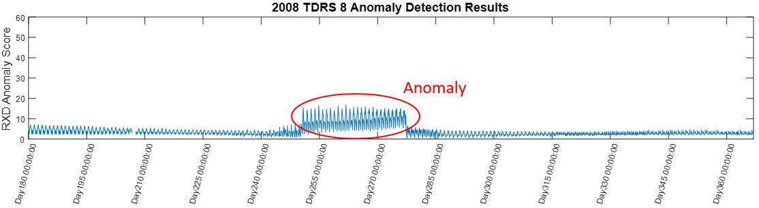
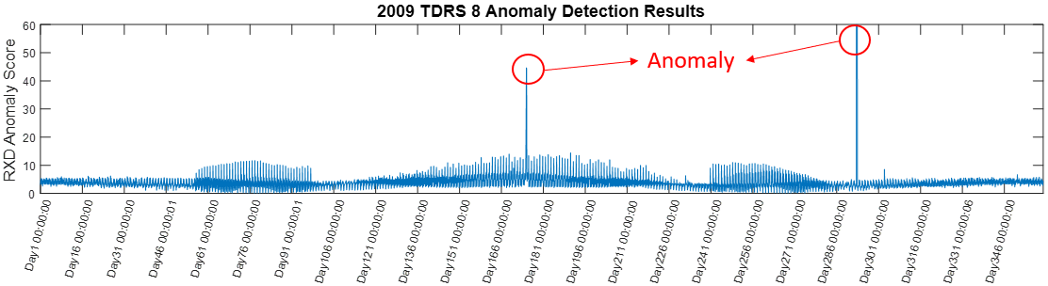
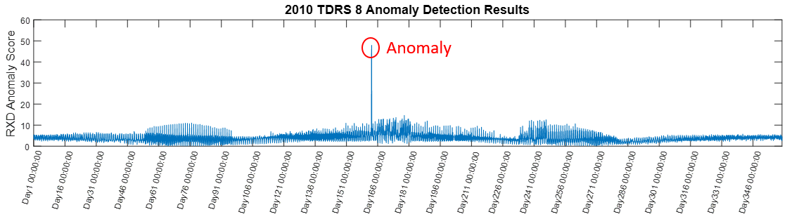
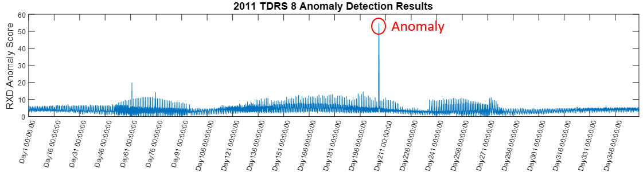
Fig. 6 Long-term trending RXD anomaly scores using a 2-hour sample mean as input data from July 2008 to December 2011.

Overall, the results in Fig. 6 were very significant. These long-term trending plots successfully captured all of the historical BVL anomalous events from July 2008– December 2011, including one anomaly in 2008, two anomalies in 2009, one anomaly in 2010 and one anomaly in 2011. These detected anomalies both showed high anomaly scores (higher than 50) in comparison to other data samples that were assumed to be normal. We can also see that the anomaly scores became slightly higher in some periods such as Day 46 -91 and Day 235-280 in each year. This is because these periods are eclipse seasons where the batteries were online to supply power to the spacecraft. Finally, we want to point out there is one false alarm that occurred in 2011 around day 61. This false alarm could be an outlier that was caused by an unknown reason but not because of the BVL.
In addition, one issue of anomaly detection is that the space environment is quite complex. For instance, it may be that the data set extracted in July would consider the data in February as anomalous. This makes difficult to build a reliable anomaly detection model. In this case, long-term trending of RXD scores could be extremely useful since we only need to focus on out of trend data samples. For instance, data in eclipse seasons always exhibited slightly higher anomaly scores but they are not real anomalies. This phenomenon can be simply demonstrated by long term trending of anomaly score curves. That is, even though the anomaly scores indeed increased during eclipse period, we would not consider the data as anomalies if they were not out of family.

4.3 Short Term Anomaly detection using RXD

Since 2-hour telemetry windows were used, we probably missed the short anomalies. This section reduces the window size to 1-minute telemetry windows so that the short-term anomalies could also be captured by the detector. Fig. 7 shows the RXD detection results using 1-minute telemetry windows for the four anomalies shown in Fig. 2 to 5.
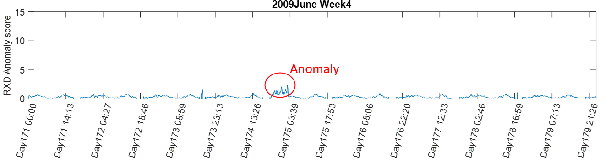
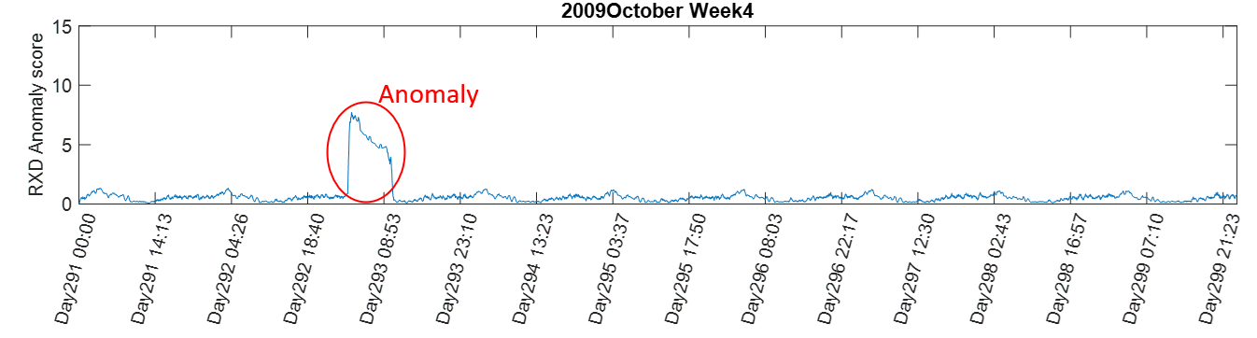
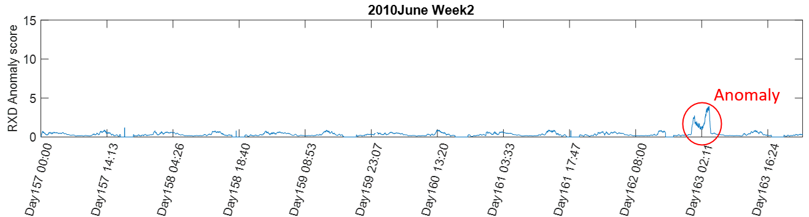
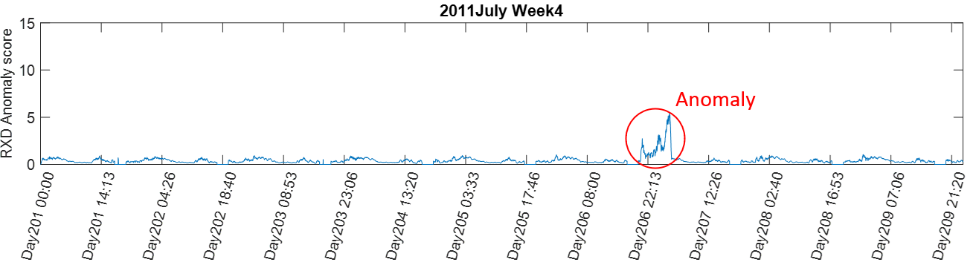
Fig. 7 Long-term trending RXD anomaly scores using 1-minute sample means as input data from July 2008 to December 2011.

As shown in Fig.7, clearly, the detector successfully detected all of the historical BVL anomalies from 2009 to 2011. However, the detection power of the 2009 anomaly was not significant. Even though we found an anomalous signal on day 174, the anomaly score is low and not much higher than normal data samples in the same week. Interestingly, if we look at the long term RXD results in Fig. 6, the detection results of the anomaly in 2009 day 174 was clear and very significant. This result illustrates that sometimes 2-hour windows would be more useful and robust than 1-minute telemetry windows for anomaly detection. This is because when a 2-hour window was used, any noise and unknown interference can be removed and the discrimination power between anomaly data and normal data improves. Nevertheless, the RXD is still able to capture all BVL anomalies shown in Fig. 2 – 5.

6. Conclusions

In this paper, we developed a novel framework of an automated and unsupervised anomaly detector to detect anomalous telemetry data. The results showed that our method provides a fast and reliable detection of anomalous data from the TDRS electrical power subsystem. The work presented in this paper is of great importance since engineers are normally unable to process hundreds of parameters manually within a short period. The RXD algorithms that were implemented using MATLAB 2020 were able to process 5 years of telemetry data within an hour, which largely improves efficiency. It also worth noting that RXD is quite different from traditional classification-based ML methods, which requires training data to train the classifier. In fact, RXD only removes the second order statistic property of the entire data set and quantifies the outlier degree of each data point, which is more convenient and reasonable in anomaly detection. However, it is not guaranteed that the RXD will always work better than a supervised learning algorithm. Once we can build a reliable training data set to represent all possible anomaly cases, the supervised method will outperform the unsupervised method. In addition, how to select features to formulate a telemetry vector was also challenging. In this paper, we connected the 5 BVL related parameters as an input feature. However, we are still investigating which parameter is more appropriate to BVL anomaly detection. Nevertheless, the proposed method can simply be extended to any type of telemetry anomalies by selecting the appropriate parameters. Finally, we will continue working on anomaly detection for other subsystems such as the attitude control subsystem or payload to enhance the reliability of spacecraft management.

References

[1] T. Yairi, Y. Kawahara, R. Fujimaki, Y. Sato and K. Machida, "Telemetry-mining: a machine learning approach to anomaly detection and fault diagnosis for space systems," 2nd IEEE International Conference on Space Mission Challenges for Information Technology (SMC-IT'06), Pasadena, CA, 2006, pp. 8 pp.-476.
[2] Z. Li, "Machine Learning in Spacecraft Ground Systems," 2017 6th International Conference on Space Mission Challenges for Information Technology (SMC-IT), Alcala de Henares, 2017, pp. 76-81.
[3] Y. Gao, T. Yang, M. Xu and N. Xing, "An Unsupervised Anomaly Detection Approach for Spacecraft Based on Normal Behaviour Clustering," 2012 Fifth International Conference on Intelligent Computation Technology and Automation, Zhangjiajie, Hunan, 2012, pp. 478-481.
[4] X. Shi, Y. Shen, Y. Wang and L. Bai, "Differential-Clustering Compression Algorithm for Real-Time Aerospace Telemetry Data," IEEE Access, vol. 6, pp. 57425-57433, 2018.
[5] M. M. Fernández, Y. Yue and R. Weber, "Telemetry Anomaly Detection System Using Machine Learning to Streamline Mission Operations," 2017 6th International Conference on Space Mission Challenges for Information Technology (SMC-IT), Alcala de Henares, 2017, pp. 70-75.
[6] B. Nassar, W. Hussein and M. Medhat, "Supervised learning algorithms for spacecraft attitude determination and control system health monitoring," IEEE Aerospace and Electronic Systems Magazine, vol. 32, no. 4, pp. 26-39, April 2017.
[7] S. A. Kannan and T. Devi, "Mining satellite telemetry data: Comparison of rule-induction and association mining techniques," 2016 IEEE International Conference on Advances in Computer Applications (ICACA), Coimbatore, 2016, pp. 259-264.
[8] Li, Quan & Zhou, XingShe & Lin, Peng & Li, Shaomin. “Anomaly detection and fault Diagnosis technology of spacecraft based on telemetry-mining.” In System and Control in Aeronautics and Astronautics (ISSCAA) .2010, pp. 233-236
[9] Fujimaki R., Yairi T., Machida K. “An Anomaly Detection Method for Spacecraft Using Relevance Vector Learning,” Advances in Knowledge Discovery and Data Mining (PAKDD), 2005, pp. 785-790.
[10] N. Otsu, "A Threshold Selection Method from Gray-Level Histograms," IEEE Transactions on Systems, Man, and Cybernetics, vol. 9, no. 1, pp. 62-66, Jan. 1979,

