Dust Particle Aeroheating Calculations for Mars Entry Hypersonic Flows
A. Sahai¹ and G. E. Palmer¹, ¹AMA, Inc. Mail Stop 230-2, Moffett Field, CA 94035.

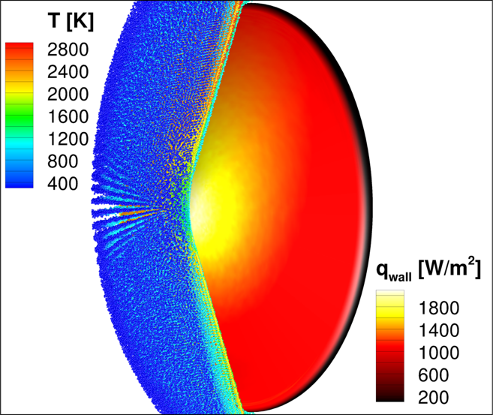
Brief Presenter Biography: Amal Sahai received a Bachelor of Technology in Mechanical Engineering from the Indian Institute of Technology Guwahati in 2012 and a Master of Science in Aerospace Engineering from the University of Illinois at Urbana-Champaign in 2015. He graduated with a PhD from University of Illinois at Urbana-Champaign in 2019 and is currently a Research Scientist with AMA, Inc. at NASA Ames Research Center.
Introduction: One of the unique aspects of designing a spacecraft that will enter the Martian atmosphere is that the vehicle will encounter dust during atmospheric entry. Small dust particles are present even under quiescent conditions, and the level of dust significantly increases when a major dust storm occurs. Because planetary missions to Mars take years from initial design to arrival at Mars, and because of the unpredictability of major global dust storms, the design of the thermal protection system (TPS) of a Mars entry vehicle requires an estimation for the potential damage caused by dust particle impacts on the heatshield.
Figure 1. Dust particle distribution and resultant surface heat flux for Schiarparelli capsule
Palmer, et al. [1] provided an overview of the Lagrangian governing equations and modeling assumptions for predicting particle trajectories. These equations were implemented into a 2-D standalone particle trajectory code and applied to estimate the concomitant heatshield erosion for a hypothetical case of the ExoMars Schiaparelli capsule entering the Martian atmosphere during a major regional and global dust storm.
The purpose of the current research effort is to build upon the modeling approach outlined in Ref. [1] and obtain a detailed description of particle-fluid and particle-particle interactions. The resulting particle solver is titled DUst Simulation & Tracking (DUST) and works in conjunction with the US3D CFD flow solver [2]. The coupled flow-particle simulation framework adopts a variable-fidelity paradigm and modeling complexity can be altered based on the level of realism being sought. Furthermore, quantities of interest such as surface heat augmentation and erosion due to particle impacts can be comprehensively characterized for a wide range of physical conditions.
A concerted effort has been made to incorporate numerical strategies that offer a balance between computational tractability and accuracy. The key elements underpinning the current work are an efficient mesh-localiztion algorithm, time-driven hard-sphere model, point-to-point MPI framework, coarse-graining using computational parcels, and high-order Adams-Bashforth time stepping. These developments combined with accurate property models deliver realistic simulations on large computational grids for different particle mass loadings. The coupled US3D-DUST framework will be applied to conduct a multi-physics examination of dust-laden flows around the the Schiarparelli capsule.

References:
[1] Palmer, G., Ching, E., Ihme, M., Allofs, D. and Gulhan, A. (2020) “Modeling Heatshield Erosion due to Dust Particle Impacts for Martian Entries,” AIAA Paper 2020-0254.
[2] Candler, G., Johnson, H., Nompelis, I., Subbareddy, P., Drayna, T., Gidzak, V., and Barnhardt, M., (2015) “Development of the US3D Code for Advanced Compressible and Reacting Flow Simulations,” AIAA Paper 2015-1893.

