REVISITING MEDLI WITH IMPROVED MODELING AND SIMULATION TOOLS
D. K. Prabhu¹, B. A. Cruden¹, J. D. Monk², A. P. Borner¹, J. M. Thornton¹, and J. B. E. Meurisse¹
¹Analytical Mechanics Associates, Inc. at NASA Ames Research Center, Moffett Field, CA 94035. (dinesh.k.prabhu@nasa.gov, brett.a.cruden@nasa.gov, arnaud.p.borner@nasa.gov, john.m.thornton@nasa.gov, jeremie.b.meurisse@nasa.gov) ² NASA Ames Research Center, Moffett Field, CA 94035. (joshua.d.monk@nasa.gov)

Brief Presenter Biography:
Dr. Prabhu is a Research Scientist with AMA, Inc., and an on-site contractor at NASA Ames Research Center working in the Aerothermodynamics Branch.
Abstract:
The thermal protection system (TPS) of the Mars 2020 capsule will carry a suite of sensors called MEDLI2 (Mars Entry, Descent, and Landing Instrument 2) [1]. This suite consists of pressure sensors/transducers and thermocouple plugs meant to measure atmospheric properties, vehicle attitude, TPS performance, etc. While the suite is similar to that carried on the successful MSL (Mars Science Laboratory) mission in 2012, it now includes pressure sensors, thermocouple plugs, and radiometers on the backshell as well. An analysis plan is therefore necessary to help with the interpretation of flight measurements.
Previous comparisons of simulations (predictions) with flight measurements along the Best-Estimated Trajectory (BET) of MSL [2] are captured in the work of Schoenenberger et al. [3] and Bose et al. [4]. These comparisons showed that there are still significant differences between predictions and measurements, especially in aerothermal environments [5]. Inclusion of radiative heating (from the shock-heated gas mixture), which was considered to be insignificant in past missions (including MSL), were found to resolve the differences only partially [6]. A typical result using flow and material response tools [4] is shown in Fig. 1 for MISP 3 (located on the leeside of the conical flank).

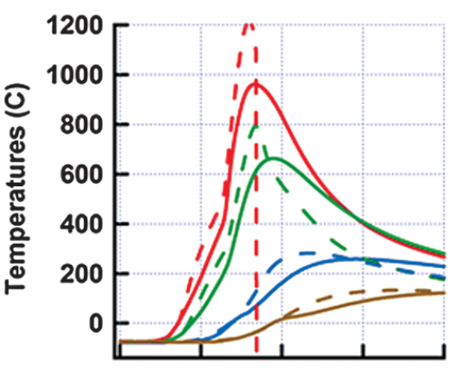
Figure 1. Disagreement between MISP 3 (solid lines) and predictions (dashes).

Clearly, there is room for improvement in modeling thermochemical processes in the shock layer, interaction of the shock-heated gas mixture with the surface, and the thermal response of the thermal protection material to the imposed environment. The last aspect is especially important because pyrolysis products from the forward heatshield will be entrained in the vehicle wake and affect the sensors on the backshell.
The objective of the proposed paper is to showcase: (i) improvements in modeling shock-layer thermochemistry (both reaction mechanism and kinetics) in Dplr [7] and radiative heating tool Neqair [8] with an expanded species set to allow for the interaction of shock-heated gas with pyrolysis products, (ii) improvements in materials modeling (properties), and (iii) coupling between the material response (Fiat [9] or Pato [10]) and the aerothermal environments. The suite of tools are applied to several points along the MSL BET in order to calibrate them for their use in post-flight analysis of Mars 2020 flight data. Predictions of aerothermal environments have been made on the complete forward heatshield, i.e., all 360°, which allows inclusion of sideslip in the computations, with good grid resolution at the interfaces of curvature changes – at the nose and conical flank and at the conical flank and shoulder. Furthermore, the number of time points selected on the BET is sufficiently large to provide a smooth blend of laminar and turbulent solutions using the MISP 3 flight data to infer a time of flow transition, and also allow for definite closure of the convective and radiative heat pulses.
In a departure from conventional approaches to post-flight analysis of entry aeroheating, an attempt has been made to understand the aerothermal environments at early times along the flight trajectory, i.e., from closer to entry interface up to the point where flow solvers based on the assumption of continuum flow can be applied with confidence. Toward this end, flow computations have been made with Sparta [11], which is a DSMC code developed by Sandia National Laboratories.
A sampling of results is included in the present abstract. Temporal variation of the predicted pressure at MEADS sensor 5 are shown in Fig. 2. The predicted value of pressure close to peak deceleration is as much as 5.5 % different from flight measurement. The surprisingly high magnitude of the difference is being investigated. The impact of improved thermochemistry is captured in Fig. 3, which shows the temporal variation of hot-wall heat flux for MISP 1. In Fig. 4, the temporal variations of temperature at various thermocouple depths of MISP 6 are shown.

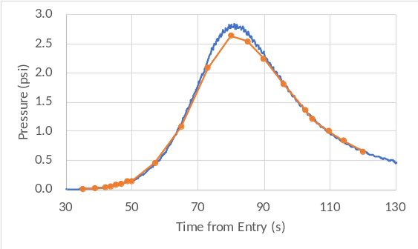
Figure 2. MEADS 5 anomaly. (solid line – flight data, points – CFD predicted)

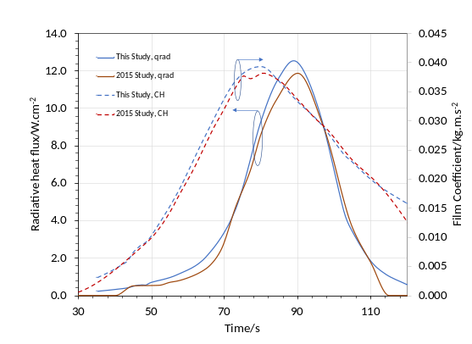
Figure 3. New predictions at MISP 1.

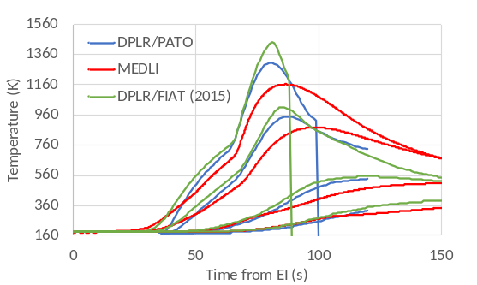
Figure 4. Temporal variations of temperatures at various thermocouple depths of MISP 6

These new results display some differences from the initial analyses of MEDLI data, which raises areas for further investigation, and application in interpretation of MEDLI2 data. The comparisons with flight data are somewhat improved and expected to provide a better understanding of the sensitivity of predicted aerothermal environments to model parameters.

Acknowledgments:
The present work was supported by Contract # NNA15BB15C from the Entry Systems and Technology Division to AMA, Inc. and the NASA Entry Systems Modeling project.

References:
[1] H. H. Hwang, et al. (2016), AIAA Paper 2016-3536, 46th AIAA Thermophysics Conference.
[2] C. D. Karlgaard, et al. (2014), JSR, 51(4), p. 1029.
[3] M. Schoenenberger, et al. (2014), JSR, 51(4), p. 1076.
[4] D. Bose, et al. (2014), JSR, 51(4), p. 1174.
[5] M. Mahzari, et al. (2015), JSR, 52(4), p. 1203.
[6] B. A. Cruden, et al. (2016), JTHT, 30(3), 642.
[7] M. J. Wright, T. R. White, and N. Mangini (2009) NASA/TM-2009-215388.
[8] B. A. Cruden and A. M. Brandis (2014) 6th International Workshop on Radiation of High Temperature Gases in Atmospheric Entry, St. Andrews, England, U.K.
[9] F. S. Milos and Y.-K. Chen (2013) JSR, 50(1), p. 137.
[10] J. B.E. Meurisse et al. (2018), Aerosp Sci Technol, 76, p. 497.
[11] Plimpton S. J., et al. (2019), Phys. Fluids, 31(8), 086101.

