Vertically Aligned Graphene/Metal Oxide based lightweight super strong, energy storage carbon fiber composites

Deepak Pandey, †‡ Kowsik Sambath Kumar, †‡ Luke B. Roberson, ¥ Jayan Thomas†‡‼*

†NanoScience Technology Center, University of Central Florida, Orlando, Florida 32826, USA
‡Department of Materials Science and Engineering, University of Central Florida, Orlando, Florida 32816, USA
¥ National Aeronautics and Space Administration, John F. Kennedy Space Center, Kennedy Space Center, Florida, 32899, USA
‼CREOL, College of Optics and Photonics, University of Central Florida, Orlando, Florida 32816, USA
Email:Jayan.Thomas@ucf.edu

In this era of budding smart technologies, flexible and smart wearable textiles are a long awaited product which are anticipated to reach a $10 B market in few years.¹ Supercapacitors are an excellent power source for these smart textiles, because they are light in weight, safe in operation, provide longer life cycle, high flexibility, and faster charge discharge capabilities.² In recent years, highly flexible supercapacitors were deveoped by coating electrochemically active materials on carbon fibers, metal wires, and cotton yarn fibres which could be weaved along with regular cotton fibres into the fabrics.^{3,4} Using high strength carbon fibers, composites can be employed for unique, high strength applications.⁸ The present study includes the fabrication of a unique composite electrode with manganese oxide and molybdenum oxide coated on a vertically aligned graphene structure on carbon fiber. Manganese oxide and molybdenum oxide are known for their excellent electrochemical properties and are very cost effective.^{5,6} Highly flexible carbon fibers were used as a substrate for deposition of vertically aligned graphene resulting in a high surface area of about 54.59 m²/g.⁷ This vertically aligned graphene on carbon fiber (VGCF) delieverd high areal capacitance of 166 mF/cm², in 1M Na₂SO₄ aqueous electrolyte. To further enhance their charge storage capabilities, manganese oxide and molybdenum oxide were coated via hydrothermal route to fabricate a high performing cathode and anode. The composite electrodes as prepared exhibited multifold enhancement in their charge storage capability. All electrodes were characterized by scanning electron microscopy, X-ray diffraction, and Raman spectroscopy. Individual electrode characteristics and asymmetric device characteristics were evaluated using electrochemical impedance spectroscopy, galvanostatic charge-discharge tests, and cyclic voltammetry.
The next step was to fabricate an asymmetric device, which combined the supercapacitor with an ultralight weight superstrong energy storing carbon fiber composite. The fabricated anode and cathode were directly assembled on an epoxy ladeened carbon fiber mat with glass fiber layers acting as the separator. 1M sodium sulfate-polyacrylamide (PAM) gel electrolyte was applied in a unique location pattern on the glass fiber to allign and sandwhich between the electrodes. The assembly was carfully sandwiched and multiple layers were stacked upon to achieve a 3 mm thickness of electrochemical energy storing carbon fiber composite. The epoxy ladened assembly was hot-pressed and cured overnight at 80 ℃.

The cured composite was cut into bar shapes with approriate dimesions. Several of such samples were prepared and were subjected to various mechanical testing including tension, flexural (3-point bend test), and impact. Tension test was performed on an INSTRON universal testing machine using a procedure adopted from ASTM D3039; longitudinal stiffness and tensile strength were estimated. The same INSTRON machine was used for the 3-point bend test to calculate the flexural stiffness and flexural strength. Testing standards were referenced from ASTM D790. Izod test was performed as the impact test to estimate the work of fracture (WOF) of the composite bar. Izod test conditions were adopted per codes given in ASTM D256.

The following images will go as a separate file jpg file:

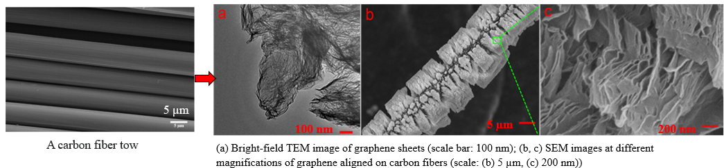
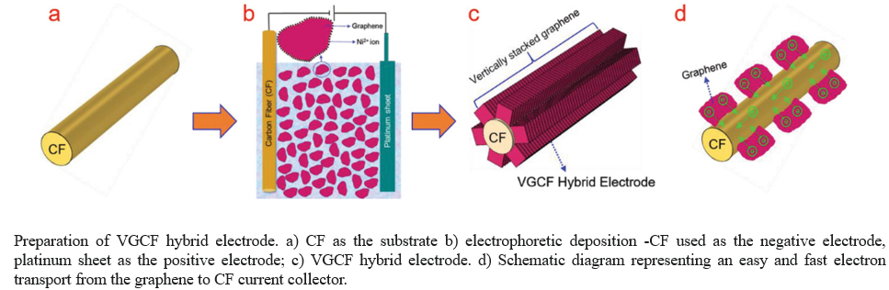
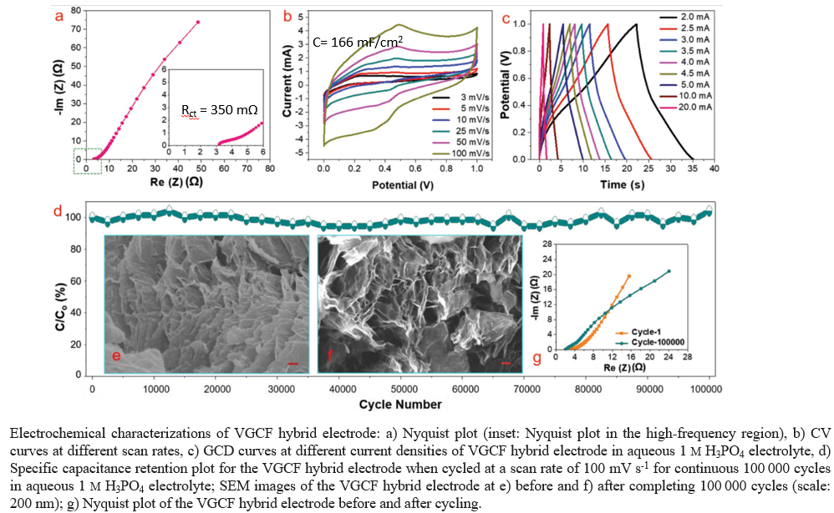

References
- Z. Yu, J. Thomas, Adv. Mater. 2014, 26, 4279.
- K. S. Kumar, N. Choudhary, Y. Jung, J. Thomas, ACS Energy Lett., 2018, 3 (2), pp 482–495.
- Y.Yang, Q. Huang, L. Niu, D. Wang, C. Yan, Y. She, Z. Zheng, Adv. Mater. 2017, 29, 1606679.
- S. J. Varma, K. S. Kumar, S. Seal, S. Rajaraman, J. Thomas, Adv. Sci. 2018, 5, 1800340.
- Z. Yu, B. Duong, D. Abbitt, J. Thomas, Adv. Mater. 2013, 25, 3302.
- I. Shakir, M. Shahid, S. Cherevko, C-H. Chung, D. J. Kang, Electrochim. Acta. 2011, 58, pp 76-80.
- J. Cherusseri, K.S. Kumar, D. Pandey, J. Thomas, Small 2019, 15, 1902606.
- Moyer, K., Meng, C., Marshall, B., Assal, O., Eaves, J., Perez, D., Karkkainen, R., Roberson, L., Pint, C. L. “Carbon fiber reinforced structural lithium-ion battery composite: Multifunctional power integration for CubeSats.” Energy Storage Materials. 2020, 24, 676-681. doi.org/10.1016/j.ensm.2019.08.003.

