Use of Mechanical Heat Switch to Speed up TVAC Transitions on Flight Hardware Below 200K
Daniel G. Bae and Juan E. Rodriguez-Ruiz
Goddard Space Flight Center, Greenbelt, MD 20771
Spaceflight hardware that operates at temperatures well below room temperature usually require being well isolated from their warmer environment in order to manage thermal parasitics adequately. This is especially true for spaceflight systems that rely on passive cooling such as a radiator. During ground testing, this design configuration can be problematic for TVAC cycling between operational temperature extremes, since the hardware temperatures may move extremely slowly and lengthen the duration of an already expensive and heavily staffed system-level TVAC campaign. One of the challenges of using an external means of speeding up temperature transitions is that a TVAC campaign usually also requires the simulation of flight-like environments to validate the design, and introducing a test feature to speed up transitions can disrupt the system such that flight-like environments are not achievable. Such an approach was used for the L’Ralph instrument level TVAC test. L’Ralph is a passively cooled instrument on the Lucy mission with planned flyby’s of the Trojan asteroids around 5.5 AU. The optics and visible detector are cooled below 190K, and the IR detector is cooled below 110K. During instrument TVAC qualification testing, a mechanical motor-controlled heat switch uses clamping pressure via a vise-grip mechanism to achieve faster temperature transitions by increasing the conduction to a cold sink. The heat switch system then disengages and employs zero-Q controls to achieve flight-like thermal environments for thermal balance plateaus. Results from stand-alone testing of the heat switch are discussed, including correlated on/off ratios and the expected conductance across its operational temperature range. Test data from an instrument level TVAC that successfully utilized the heat switch are also shown.

Nomenclature
C = Empirical Equation Fitting coefficient [K/W]
err = Accumulated temperature error due to zero-Q control system [K]
$δ$ = Arbitrary temperature sense error [K]
G = Thermal conductance [W/K]
N = Number of time steps
$\dot{Q}$ = Heat Rate [W]
T = Temperature in Kelvins [K]
AZQ = Active/Zero $\dot{Q}$
GSE = Ground Support Equipment
RoC = Rate of Change
TDA = Telescope Detector Assembly
TVAC = Thermal Vacuum

Introduction and Motivation
G
round testing of thermally passive and cryogenic optical instruments is a challenge due to their thermally isolative nature. Critical components within passive thermal control systems are typically cooled by dedicated passive radiators (i.e. high emittance coating on thermally conductive surfaces) and are thermally isolated both radiatively and conductively [1, 2]. The components are thermally isolated to minimize thermal impacts from its surroundings such that the components can be well controlled and maintained via dedicated radiators. However, such isolative systems pose ground-testing challenges because they are difficult to move in temperature. Furthermore, the main cooling method is via radiative means, but radiative cooling power decreases significantly as components become colder due to the fourth power dependence on temperature. Significant financial and schedule cost can be incurred trying to reach thermal equilibrium for ground testing. Instead, the instrument can be equipped with a non-flight component designed to drive the instrument to their respective thermal equilibriums. However, the equipment can be thermally intrusive and cause errors on thermal equilibrium cases.
The L’Ralph instrument is one of such passively controlled thermal systems, and will be flying on the Lucy mission to image Trojan asteroids [3]. The Lucy spacecraft, along with L’Ralph, will launch in late 2021. L’Ralph contains two sub-instruments named LEISA (Linear Etalon Imaging Spectral Array) and MVIC (Multispectral Visible Imaging Camera) with nominal operating temperatures of 100 K and 170 K, respectively [4]. Each sub-instrument has dedicated passive radiators and is thermally isolated from its surrounding components. Due to L’Ralph’s isolative nature, the sub instruments were expected to take multiple days to reach their thermal equilibrium temperatures if only radiative cold targets were used for cooling. Since test qualification program required multiple thermal balance points [5], a single TVAC campaign was expected to last multiple weeks to months. However, the Active Zero-Q (AZQ) system was used to significantly speed up L’Ralph’s ground thermal vaccum (TVAC) testing in 2020.
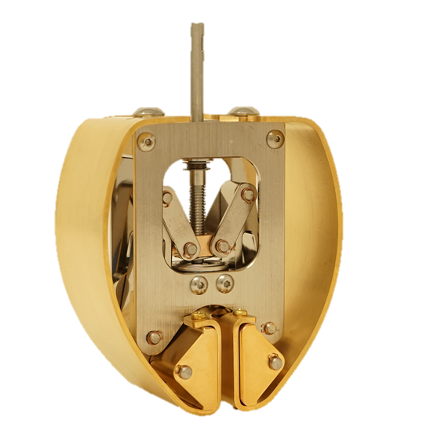
Figure 1: AZQ Heat Switch. Mechanical vise-grip heat switch with movable jaws driven by a linear rail shaft
The AZQ system is a ground support equipment (GSE) used to speed up temperature transitions for flight units in TVAC without being thermally intrusive. The AZQ system utilizes a mechanical heat switch operable down to 77 K and is shown in Figure 1. The heat switch is driven by an electric motor and the jaws move with motor’s rotation.
In “active” mode, the AZQ switch clamps its jaws together on a thermally conductive substrate that is thermally coupled to a flight unit then actively heats or cools the flight unit. By making physical contact between the heat switch and the flight unit, the heat switch provides a direct thermal path from a temperature-controlled GSE to the flight unit. The mode is especially helpful during temperature transitions. Additionally, the active mode can help make the flight unit meet the qualification temperatures should the radiative sinks and sources not be enough to drive the flight unit’s temperature.
In “zero-Q” mode, the AZQ switch disengages and controls the AZQ switch temperature to match the flight unit’s temperature. This essentially makes the presence of the heat switch thermally “disappear” and lets the flight unit freely settle to its balance temperature. Analytically speaking, the zero-Q mode significantly reduces the thermal conductance between the flight unit and the heat switch and tries to eliminate the remaining heat flow by making the temperature difference between the two zero. The mode is desired for thermal balance situations where the goal is to simulate flight-like environments as close as possible, which will not have the heat switch. Eliminating the presence of the heat switch also simplifies thermal model correlation.
Figure 2 shows a schematic of the AZQ system setup during TVAC. Note that to prevent the heat switch from damaging or optically affecting the flight unit, the heat switch is instead clamped on a flexible strap that is coupled to the flight unit (namely “Flight Interface Strap”). This paper demonstrates the proof of concept of the AZQ system and shows how it was utilized for L’Ralph’s TVAC campaign.
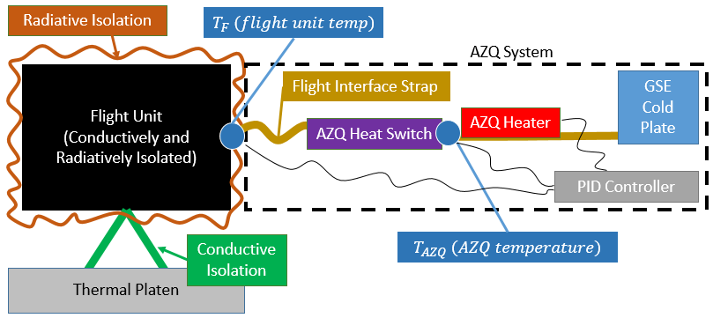
Figure 2: AZQ Setup Schematic. Figure shows the necessary components needed to operate the AZQ system.

Thermal Design of the AZQ System
The AZQ system assembly is shown in Figure 3. Thermally, the concept is straightforward; the entire thermal switch assembly is made isothermal via conductive metals and is separated from other temperature zones via thermal isolators. An LN2/GN2 cold plate is used in conjunction with a cartridge heater to control the assembly’s temperature (the cold plate with a heater serves as the “AZQ Heater”, “Cold Plate”, and “PID Controller” per Figure 2). Thermal conduction to the test article is varied by engaging and disengaging the heat switch using the motor. The entire AZQ system assembly is approximately 10 kg and 23 x 15 x37 cm³.
The heat switch is a customized vise-grip switch from High Precision Devices (HPD) Inc. as shown in Figure 1. The electronic motor is a cryogenic- (down to 77 K) and vacuum-rated stepper motor (CM PRS-200 UHVC). Note that the motor dissipates heat when it is turned on and the motor can leak heat into the heat switch assembly. However, the vise-grip is well coupled to the copper plate via Apiezon N grease to sink the parasitic leak into the copper plate before it reaches the heat switch.
As for the mechanics of the operation, the motor is mechanically coupled to the vise-grip via axle shaft coupler. The vise-grip converts rotational motion into a linear motion via threaded guide rails. The vise-grip can handle up to 2 in-lbs (0.226 N-m) of torque, which is converted to several hundred Newtons of clamping force.
The heat switch was designed with the following requirements: >0.25 W/K (on), <0.01 W/K (off). During active mode, the heat switch can drive a test article’s temperature faster with higher conductance. During zero-Q mode, the impact on the thermal balance due to the presence of the heat switch is lessened with lower conductance.
Note that the vise-grip’s disengaged mode conductance is not zero. The heat switch must clamp to the flight interface strap that must be centered between the vise-grip’s jaws (as shown in Figure 3). The centering structural supports adds a thermal path between the test article and the heat switch even when the vise-grip is disengaged.

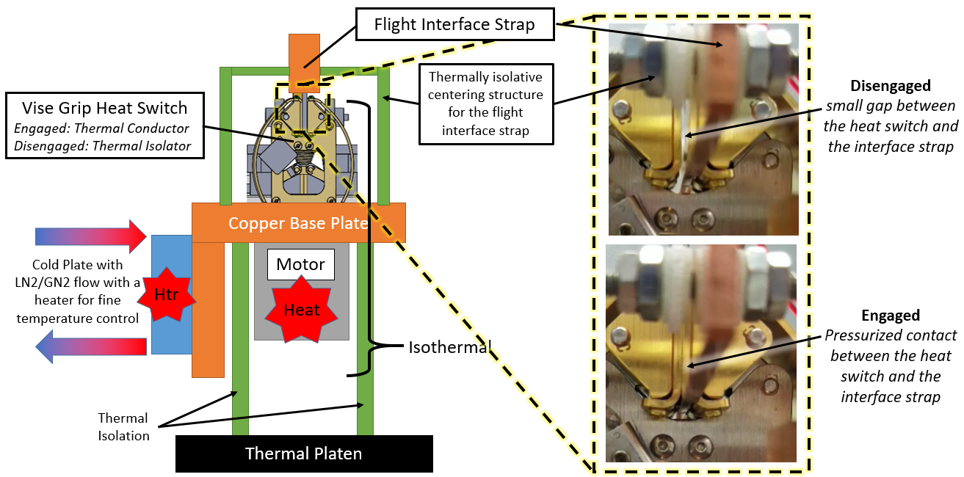
Figure 3: AZQ System Assembly and Close up View of the Engaged/Disengaged Heat Switch. The AZQ system is a standalone system with its own cooling and heating circuits. The heat switch couples to the flight unit via the flight interface strap, which is held in place by the centering structure.

The following subsections describe the need for on and off conductances in detail, and provide rationale for the requirement on/off conductance values.

Need for High Conductance
The AZQ system needs to have a high conductance value to drive the flight unit’s temperature faster during transitions. A system level TVAC thermal model for L’Ralph was run with a few heat switch engaged conductance values to analyze the magnitude needed. The results are shown in Figure 4, where a transition between qualification points was analyzed. As expected, the components reach their balance points quicker with an increase in the engaged conductance value. The figure shows significant timesaving with the use of the AZQ switch for a single temperature transition. This would also save significant cost in facilities and personnel support. Per the analytical predictions, >0.25 [W/K] engaged conductance requirement was established based on the diminishing return of timesaving with increase in conductance.

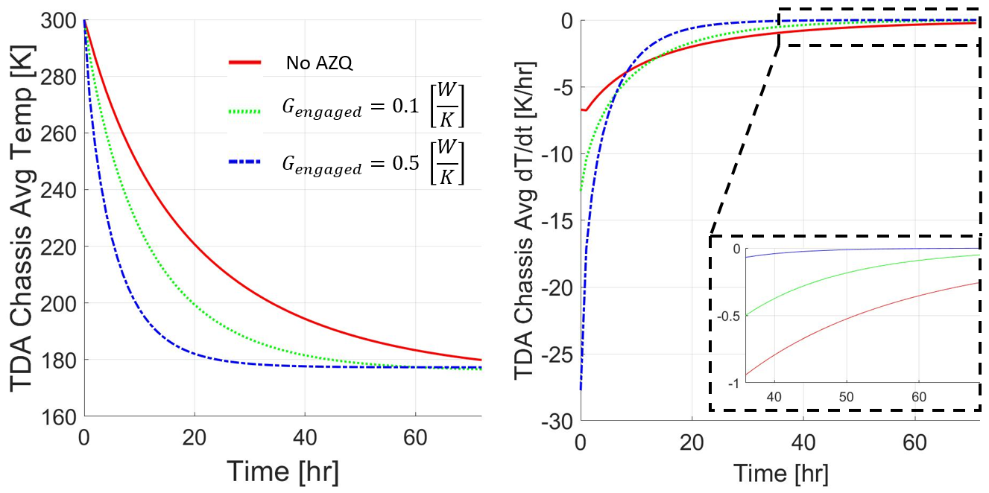
Figure 4: Impact on Temperature Transitions. Left shows the absolute temperature of the flight unit (TDA) and right shows the rate of change of the unit. The subplot on the rate plot shows a zoomed portion around 35-70 hrs. High conductance value significantly reduces the transition time between temperature balance points.

Need for Low Conductance
Contrarily, the AZQ system requires a low thermal conductance value of <0.01 W/K to ensure that the heat switch does not significantly affect the L’Ralph thermal balance cases. This section derives the need for the low conductance and proves why the thermal switch is needed.
Theoretically, the AZQ system does not require low conductance. Given a perfect and instantaneous thermal control system for zero-Qing, the test article will not be disturbed by the zero-Qing system and a regular high conductance can be used in place of the heat switch. However, a realistic zero-Q system has systematic errors and uncertainties (i.e. sensor calibration errors, sensor location uncertainty, noise, non-1D heat flow path, etc.) that can lead to undesired heat flows from the zero-Q system.
The zero-Q error can be estimated with the following assumptions and definitions (refer to Figure 2):
- ${\left.T_{F}\right|}_{True} and {\left.T_{AZQ}\right|}_{True}$ are the true temperatures of the flight unit and the AZQ controller’s temperatures, respectively
- ${\left.T_{F}\right|}_{Sense}, \text{and} {\left.T_{AZQ}\right|}_{Sense}$ are the apparent sensing temperatures of the flight unit and the AZQ controller’s temperatures, respectively
- $t_{0}, t_{1}, …, t_{N}$ are time indicators
- The flight unit temperature’s ($T_{F}$) sensitivity to the AZQ system temperature ($T_{AZQ}$) is known and is independent of temperature ($\frac{dT_{F}}{dT_{AZQ}}=constant$)
- At arbitrary time = 0 ($t_{0}$), the true temperature of the flight unit is equal to the true temperature of the AZQ system ($initial condition: {\left.ΔT\right|}_{True}\left(t_{0}\right)=0={\left.T_{F}\right|}_{True}\left(t_{0}\right)-{\left.T_{AZQ}\right|}_{True}\left(t_{0}\right)$ )
- Due to various systematic errors, the sensed flight and AZQ system temperatures are offset from the true temperature by $±\frac{δ}{2}$, respectively (${\left.T_{F}\right|}_{Sense}={\left.T_{F}\right|}_{True}+\frac{δ}{2}$ and ${\left.T_{AZQ}\right|}_{Sense}={\left.T_{F}\right|}_{True}-\frac{δ}{2}$)
Then, by iterating through the behavior of ${\left.T_{AZQ}\right|}_{Sense}$and${\left.T_{F}\right|}_{Sense}$ in zero-Q mode (where the goal is${\left.T_{AZQ}\right|}_{Sense}→ {\left.T_{F}\right|}_{Sense}$), the accumulated error due to the sensing error ($δ$) can be calculated. Figure 5 and Figure 6 show the iterative behavior graphically.
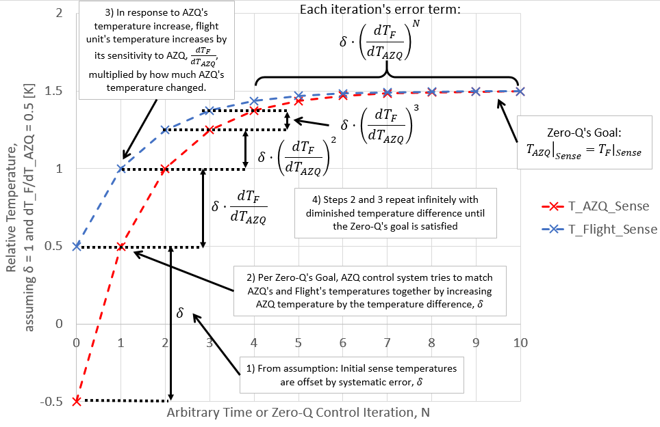
Figure 5: AZQ and flight’s sense temperature evolution over time during Zero-Q mode. Steps 1-4 shows how the zero-Q control scheme works iteratively.
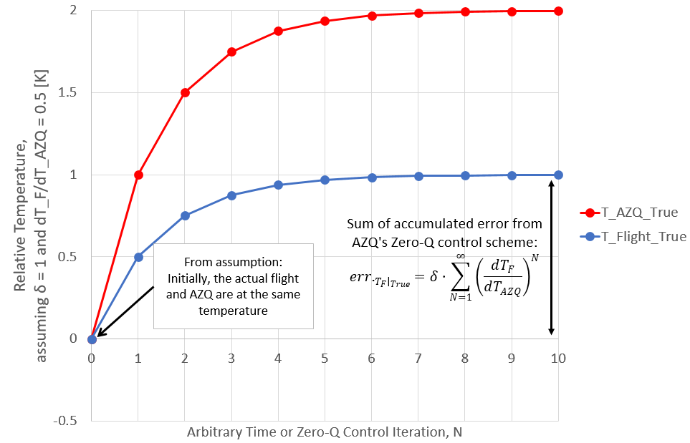
Figure 6: AZQ and flight’s true temperature evolution over time during Zero-Q mode. Even though the flight unit was zero-Qed with the AZQ system initially, due to the systematic error involved with the sensors, the true flight and AZQ temperatures diverge, which introduces undesired heat flow and error on the flight unit’s temperature.

At time 0 ($t_{0}$), based on the initial conditions (assumptions #5 and #6):
$${\left.T_{AZQ}\right|}_{Sense}\left(t_{0}\right)={\left.T_{F}\right|}_{True}\left(t_{0}\right)-\frac{δ}{2} and {\left.T_{F}\right|}_{Sense}\left(t_{0}\right)={\left.T_{F}\right|}_{True}\left(t_{0}\right)+\frac{δ}{2}$$
$${\left.ΔT\right|}_{True}\left(t_{0}\right)=0={\left.T_{AZQ}\right|}_{True}\left(t_{0}\right)-{\left.T_{F}\right|}_{True}\left(t_{0}\right)$$
Since AZQ senses that its temperature is different from the flight unit’s sensed temperature by $δ$ (even though true temperatures are the same, but the controller only knows sense temperatures), AZQ will increase its temperature by $δ$ at time 1 as part of its zero-Q mode’s goal ${\left.T_{AZQ}\right|}_{Sense}→ {\left.T_{F}\right|}_{Sense}$:
$${\left.T_{AZQ}\right|}_{Sense}\left(t_{1}\right)→{\left.T_{F}\right|}_{Sense}\left(t_{0}\right)={\left.T_{F}\right|}_{True}\left(t_{0}\right)+δ$$
However, this changes the flight unit’s temperature (${\left.T_{F}\right|}_{Sense}$) in response. The amount ${\left.T_{F}\right|}_{Sense}$ changes is based on its sensitivity to AZQ’s temperature multiplied by how much $T_{AZQ}$ has changed at time 1 (i.e. $δ⋅\left(\frac{dT_{F}}{dT_{AZQ}}\right)$):
$${\left.T_{F}\right|}_{Sense}\left(t_{1}\right)={\left.T_{F}\right|}_{Sense}\left(t_{0}\right)+δ⋅\left(\frac{dT_{F}}{dT_{AZQ}}\right)$$
But now, ${\left.T_{F}\right|}_{Sense}\left(t_{1}\right)-{\left.T_{AZQ}\right|}_{Sense}\left(t_{1}\right)= δ⋅\left(\frac{dT_{F}}{dT_{AZQ}}\right)$. Again, as part of AZQ’s zero-Q mode’s goal ${\left.T_{AZQ}\right|}_{Sense}→ {\left.T_{F}\right|}_{Sense}$, at time 2:
$${\left.T_{AZQ}\right|}_{Sense}\left(t_{2}\right)→{\left.T_{F}\right|}_{Sense}\left(t_{1}\right)={\left.T_{F}\right|}_{Sense}\left(t_{0}\right)+δ⋅\left(\frac{dT_{F}}{dT_{AZQ}}\right)$$
Again, this changes flight unit’s temperature (${\left.T_{F}\right|}_{Sense}$) in response. The amount ${\left.T_{F}\right|}_{Sense}$ changes is based on its sensitivity to AZQ’s temperature multiplied by how much $T_{AZQ}$ has changed at time 2 ($δ⋅\left(\frac{dT_{F}}{dT_{AZQ}}\right)⋅\left(\frac{dT_{F}}{dT_{AZQ}}\right)$):
$${\left.T_{F}\right|}_{Sense}\left(t_{2}\right)={\left.T_{F}\right|}_{Sense}\left(t_{0}\right)+δ⋅\left(\frac{dT_{F}}{dT_{AZQ}}\right)+δ⋅{\left(\frac{dT_{F}}{dT_{AZQ}}\right)}^{2}$$
Now, ${\left.T_{F}\right|}_{Sense}\left(t_{2}\right)-{\left.T_{AZQ}\right|}_{Sense}\left(t_{2}\right)= δ⋅{\left(\frac{dT_{F}}{dT_{AZQ}}\right)}^{2}$. The process repeats over and over again. Continuing this process, it can be easily shown that at time N:
$${\left.T_{F}\right|}_{Sense}\left(t_{N}\right)={\left.T_{F}\right|}_{Sense}\left(t_{0}\right)+δ⋅\left(\left(\frac{dT_{F}}{dT_{AZQ}}\right)+{\left(\frac{dT_{F}}{dT_{AZQ}}\right)}^{2}+…+{\left(\frac{dT_{F}}{dT_{AZQ}}\right)}^{N}\right)$$
Based on assumption #6,${\left.T_{F}\right|}_{Sense}={\left.T_{F}\right|}_{True}+\frac{δ}{2}$. Then, at time N, the flight unit’s true temperature will be:
${\left.T_{F}\right|}_{True}\left(t_{N}\right)={\left.T_{F}\right|}_{True}\left(t_{0}\right)+δ⋅\left(\left(\frac{dT_{F}}{dT_{AZQ}}\right)+{\left(\frac{dT_{F}}{dT_{AZQ}}\right)}^{2}+…+{\left(\frac{dT_{F}}{dT_{AZQ}}\right)}^{N}\right)$ (1)
Note that at time 0, the true temperatures of AZQ and flight units were already zero-Qed per assumption #5. In other words, ${\left.T_{F}\right|}_{True}\left(t_{0}\right)$ was the correct true zero-Q temperature. Meaning, the 2nd term on the right hand side of Eq.(1) represents the total amount of flight unit’s true temperature error introduced by the sensing error.
This means that because of the systematic error of the temperature sensors, the zero-Q mode control will introduce the following amount of error to the flight article’s temperature:
$err._{{\left.T_{F}\right|}_{True}}=δ⋅\sum_{N=1}^{∞}{{\left(\frac{dT_{F}}{dT_{AZQ}}\right)}^{N}}$ (2)
Note that the flight unit temperature sensitivity to the AZQ temperature will always be less than 1 [K/K] ($\frac{dT_{F}}{dT_{AZQ}}<1 \left[\frac{K}{K}\right]$), because the temperature driver cannot drive the impacted temperature more than its own temperature (assuming the driver and the impacted are already close in temperature, which is a fair assumption since the goal is trying to equilibriate their temperatures). Since$\frac{dT_{F}}{dT_{AZQ}}<1 \left[\frac{K}{K}\right]$, $err._{{\left.T_{F}\right|}_{True}}$ becomes a convergent power series where$\sum_{N=0}^{∞}{{\left(\frac{1}{x}\right)}^{N}}=\frac{x}{x-1}$. Then, Eq. (2) becomes:
$err._{{\left.T_{F}\right|}_{True}}=δ⋅\left(\frac{{\left(\frac{dT_{F}}{dT_{AZQ}}\right)}^{-1}}{{\left(\frac{dT_{F}}{dT_{AZQ}}\right)}^{-1}-1}-1\right)$ (3)
In fact, $\frac{dT_{F}}{dT_{AZQ}}$ has the following empirical form, which was derived from an approximated energy balance equation around the flight unit:
$\frac{dT_{F}}{dT_{AZQ}}= \frac{G_{AZQ}}{G_{others}⋅C⋅T_{F}^{C-1}+G_{AZQ}}$ (4)
where $G_{others}$ and C are fitting parameters.
Eq. (4) satisfies the expected behavior of $\frac{dT_{F}}{dT_{AZQ}}\left(G_{AZQ}→∞\right)→1$ and $\frac{dT_{F}}{dT_{AZQ}}\left(G_{AZQ}→0\right)→0$. As the AZQ control system is more coupled to the flight unit, the flight unit will follow the AZQ system’s temperature more closely until it is only driven by the AZQ. On the other extreme, as the AZQ control system gets more isolated from the flight unit, the flight unit is less impacted by the AZQ system’s temperature until fully isolated.
Figure 7 shows the L’Ralph telescope detector assembly (TDA) temperature sensitivity to AZQ’s temperature as a function of AZQ strap’s conductance$\frac{dT_{F}}{dT_{AZQ}} vs. G_{AZQ}$. The resulting fitting parameters from Eq. (4) were $G_{others}=0.001$ and $C=1.74$ when the TDA is at 174 K. Note that these fitting parameters will vary significantly between different flight units.

Figure 7: L’Ralph TDA Temperature Sensitivity to AZQ Temperature. Figure shows a good match between the empirical form and the simulated L’Ralph model predict.

Substituting Eq. (4) to Eq. (3) with L’Ralph TDA’s fitted parameters:
$err._{T_{F,sense}}=δ⋅\frac{{\left(\frac{G_{AZQ}}{0.078+G_{AZQ}}\right)}^{-1} }{{\left(\frac{G_{AZQ}}{0.078+G_{AZQ}}\right)}^{-1}-1}$ (5)
Eq. (5) is plotted in Figure 8, where it shows that if both $G_{AZQ} \text{and} δ$ are high, there will be significant amount of accumulated error because of the zero-Q error accumulation. Based on Figure 8, AZQ heat switch’s zero-Q mode conductance value was designed to be less than 0.01 [W/K] where the error becomes significantly less than 1 K.

Figure 8: Accumulated Zero-Q Error versus AZQ Conductance. As the conductance value across the zero-Q control medium is increased, the accumulated error can significantly increase due to systematic errors between zero-Q sensors. This plot is specific for L’Ralph only.

Experimental Setup
For L’Ralph TVAC, the heat switch assembly was expected to see temperatures between 120K to 318K and expected to cycle several times between 120 ~ 200 K. Since the heat switch was to go through various temperature cycles, this test was designed to perform various checkouts at the temperature cycle extremes.
A picture of the test assembly is shown in Figure 9. The assembly was true to the schematic as shown in Figure 3. For this test, since the flight unit was not available, only a simple copper plate called the “interface plate” was tested. The interface plate is a part of the flight interface strap.
Figure 9 also shows the locations of the thermal sensors and heaters on the heat switch assembly. T1 was the temperature measure of the flight unit, namely the interface plate ($T_{F}$ in reference to Figure 2). T2 was the measure of the vise-grip near the interface plate. T3 was the measure of the vise-grip’s base temperature ($T_{AZQ}$ in reference to Figure 2). T4 was a measure for control of the cold plate’s temperature. T1, T2, and T3 were measured with calibrated silicon diodes (Lakeshore DT-670-SD-1.4L), which have an absolute temperature reading accuracy of $± 32 mK$ at 300 K [6] and with Type-T thermocouples. A heater on the interface plate (100$Ω$) was used to provide known heat to the assembly and had a 4-wire setup for accurate voltage and current reading. The heater’s power supply was HP Model 6633B.
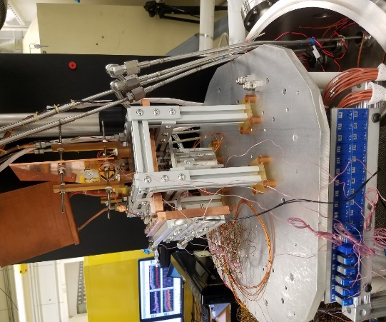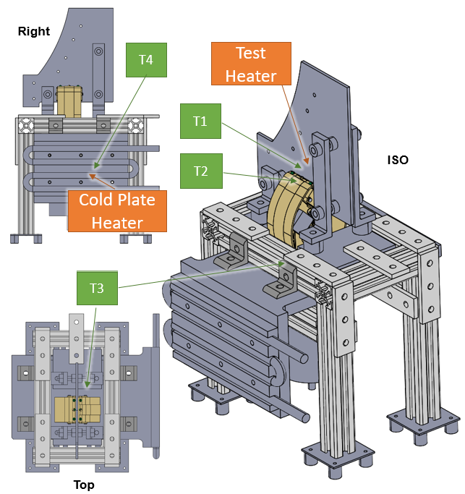
Figure 9: Picture of the Heat Switch Assembly and Thermometry. Three sensor locations were needed to characterize conductance values of the AZQ system.

The chamber platen and the shroud were thermally controlled (controllability range of 90 – 400 K) to match the interface plate’s temperature to minimize radiative heat flow that can obscure conduction measurement. The chamber has a vacuum potential down to 10⁻⁷ Torr, so any convective effects were insignificant. The chamber was equipped with LN2 flow lines for cold plate operation down to 77 K. All the temperatures and power supply units were controlled remotely via LabVIEW software. Data was collected at a rate of 0.1 Hz, with temperature monitoring resolution down to 0.01 K for both thermocouples and silicon diodes.
Conduction tests were performed at 300K (Room Temp), 200K (Hot Bal), and 120K (Cold Bal), to ensure that the heat switch reliably worked at each temperature and to identify any temperature dependent behaviors. The aim of the conductance tests was to find the engaged and disengaged thermal conductance to verify whether the requirements, specified in Section II, were met. To obtain the conductance, constant heat was applied at the interface plate until there was a significant temperature gradient (over 5 K) between the interface plate and the heat switch. Once all the temperatures were steady (<0.25 K/hr) and the rate was monotonically decreasing, thermal equilibrium was declared and data was gathered for over 30 minutes.
The conductance tests were repeated for the following conditions at each temperature zones:
- Engaged, motor on: to find engaged conductance
- Engaged, motor off: to see if detent torque of the motor/assembly is enough to maintain thermal conductance
- Disengaged, motor off: to find disengaged conductance

Data and Analysis
Tabulated test data of the balance points are shown in Table 1. Note again that the chamber shroud and platen temperatures were matched with the interface plate temperature to minimize any radiative losses.
Table 1: Summary of the Heat Switch Test Data
Phase | Heat Switch  Mode | Motor  State | Interface Plate  T1 [K] | Vise-grip Copper  T2 [K] | Heat Switch Base  T3 [K] | Heat Input  Q_{Htr} [W]
Room Temp | Engaged | on | 304.98 | 301.68 | 294.94 | 3.996
Room Temp | Engaged | on | 306.99 | 302.91 | 294.6 | 4.996
Room Temp | Engaged | off | 307.15 | 303.12 | 294.96 | 4.996
Hot Bal | Engaged | on | 197.86 | 194.78 | 188.31 | 3.995
Hot Bal | Engaged | on | 199.726 | 195.936 | 187.922 | 4.994
Hot Bal | Engaged | off | 199.817 | 196.045 | 188.065 | 4.994
ZQ 1* | Disengaged | off | 259.786 | 184.559 | 184.739 | 0.160
Cold Bal | Engaged | on | 130.823 | 127.47 | 121.228 | 3.995
Cold Bal | Engaged | on | 132.836 | 128.728 | 120.97 | 4.994
Cold Bal | Engaged | off | 133.089 | 129.007 | 121.23 | 4.994
ZQ 2 | Disengaged | off | 239.781 | 115.92 | 116.255 | 0.097
200 K | Engaged | on | 198.042 | 194.916 | 188.771 | 3.995
ZQ 3 | Disengaged | off | 239.971 | 116.83 | 117.148 | 0.104
Ambient | Engaged | on | 288.463 | 284.649 | 276.892 | 4.995
* did not reach steady-state
For the first three balance points (room temperature conductance tests), lakeshore diode readings were not available yet due to chamber setup issues. Instead, corresponding thermocouple readings were used. Using the shown data from Table 1, conductance values were obtained with the following governing equations:
$G_{Interface}=\frac{\dot{Q_{htr}}}{T_{TDA}-T_{Grip}}$ (5)
$G_{ViseGrip}=\frac{\dot{Q_{htr}}}{T_{Grip}-T_{Base}}$ (6)
$G_{HeatSwitch}=\frac{\dot{Q_{htr}}}{T_{TDA}-T_{Base}}$ (7)

Engaged Conductance
Data was compiled and separated into the temperature zones and is shown in Table 2.
Table 2: Engaged Conductances, Averages
 | Average Conductance [W/K]
Phase | Interface | Vise-grip Only | Heat Switch Total
Room Temp (300 K) | $$1.240±0.087$$ | $$0.613±0.025$$ | $$0.410±0.014$$
Hot Bal (200 K) | $$1.281±0.008$$ | $$0.629±0.003$$ | $$0.422±0.002$$
Cold Bal (120 K) | $$1.195±0.009$$ | $$0.64±0.005$$ | $$0.418±0.002$$
Average | $$1.239±0.029$$ | $$0.628±0.029$$ | $$0.416±0.005$$
Conductance values, both at the interface and that of the vise-grip, were consistently repeatable. Furthermore, the vise-grip conductance was higher (0.61 W/K) than the predicted conductance value (0.45 W/K). The predicted conductance only included the flexible copper bands as part of the calculation (2 high purity copper bands each with 115 mm length, 38 mm wide, and 1.5 mm thickness). The predicted value did not account for the rest of the vise-grip’s heat conduction paths, such as through its stainless steel frames.
The interface conductance value between the vise-grip jaws and the test article was measured at 1.2 W/K. This was significantly higher than the predicted value of about 0.17~0.35 W/K. The predicted value was based on HPD’s clamping force calculation, which was converted into an interface conductance based on bolted joint clamping forces (i.e. #2 bolt joint produces ~0.15 W/K conductance and produces about 150 pounds (667 N) of clamping force [2]). The difference could be either due to the higher than expected clamping force, or underestimating copper-gold dry interface contact conductance, which is proven to provide a better thermal interface conductance [7, 8].
Engaged conductances showed a slight dependence on temperature. The vise-grip conductance was inversely proportional to temperature, most likely due to copper conductivity’s behavior with respect to temperature. Copper conductivity increases as temperature decreases [9]. The clamping interface conductance was proportional to temperature, possibly due to: 1) Greater internal friction at cold due to shrinkage, leading to less clamping force; and/or 2) Metals stiffen at colder temperatures, leading to resistance to clamping movement and/or less micro-deformation at the clamping interface, which hinders heat transfer. Further investigation is needed for the temperature dependence, but for the scope of this paper, the overall thermal conductance is more than sufficient for the proof of concept of the design.
No significant conductance differences were found between motor on versus motor off cases. This shows that the heat switch assembly has enough stiction to maintain clamping force. This is beneficial because the heat switch motor only has to operate during engaged/disengaged mode changes, and the motor can be kept off when not needed to prevent any motor heat dissipation that could interfere with the control system.

Disengaged Conductance
Table 3 shows the disengaged conductances. Note that the disengaged conductances were lower than expected, which extended time to reach thermal balance when disengaged.
Table 3: Disengaged Conductances
Phase | Conductance [W/K] | Notes
ZQ 1 | $$<0.0021$$ | Steady state was not reached. However, $T_{Interface Plate}-T_{Base}$ was monotonically increasing when the heat input was held constant.
ZQ 2  (Before temperature cycling) | $$0.000785±0.000004$$ | Steady state reached overnight
ZQ 3  (After temperature cycling) | $$0.000847±0.000005$$ | Steady state reached overnight
Average | $$0.000816±0.000003±δ_{unknown}$$  $$δ_{unknown}≈0.00003$$ | Only the two steady state cases are considered  $δ_{unknown}$ is estimated from the spread of the two cases… could be wider
The two steady state reached values were close but are statistically different, suggesting there must be another factor affecting uncertainty in the measurement. One of the main possible source of uncertainty is the fact that the interface plate, when disengaged, was not definitively in thermal contact to the centering structure. The interface plate was constrained via three titanium threaded-rods and G10 washers, but none of the constraining components (which are in good thermal contact with the rest of the heat switch assembly) was in good and pressurized contact with the interface plate. Intermittent contact adds uncertainty to the conductance measurement, but is difficult to estimate unless many measurements are taken. With only two reliable disengaged conductance data available, it can only be assumed that the additional unknown uncertainty will be approximately the averaged uncertainty based on the standard deviation of the two measurements. However, given the on/off conductances of 0.42 W/K and 0.00082 W/K, respectively, the design requirement of >0.25 and <0.01 W/K has been met.

Temperature Cycling and Proof of Concept
Figure 10 shows the temperature cycling result of the heat switch. As expected, when the switch was engaged, the clamped finger temperature followed the switch temperature closely. When the switch was disengaged, the clamped finger’s temperature drifted slowly.
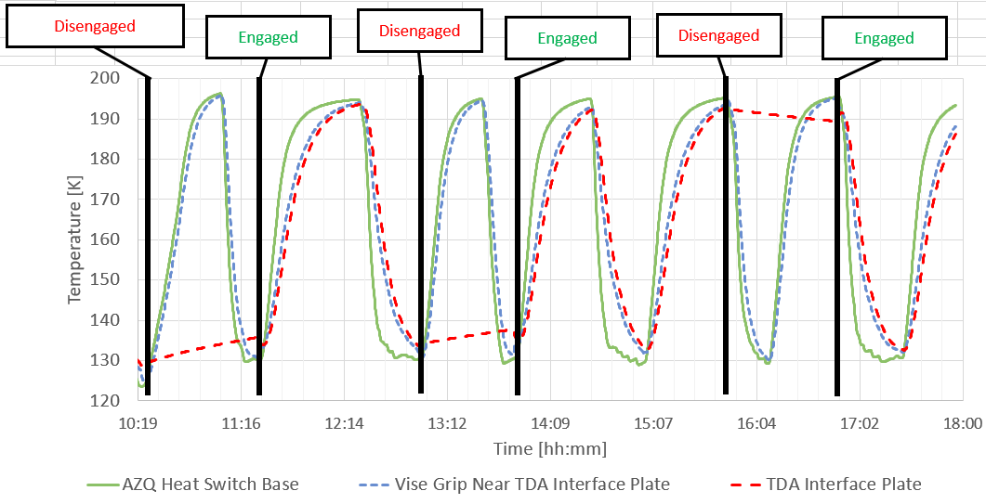
Figure 10: Temperature Cycling Result. TDA interface plate temperature follows the AZQ system’s temperature when the heat switch is engaged and significantly drags behind when disengaged, as expected.

Note that during this temperature-cycling test, the chamber shroud and the platen were held constant at 160 K (the average of hot and cold balance temperature). The clamped finger’s temperature moved towards the average when disengaged possibly due to the radiative coupling between the TDA interface plate and the chamber shroud. If the clamped finger’s temperature moved mostly due to the heat switch’s temperature, the finger’s rate of change should have changed significantly with the increase in$T_{switch}-T_{finger}$, but no significant changes were noted. The lack of significant dependence on the heat switch’s temperature during the disengaged mode proved the thermally non-intrusive nature of the disengaged mode.

L’Ralph Instrument TVAC with the AZQ System
For L’Ralph’s instrument level TVAC, the heat switch was successfully utilized. Figure 11 shows the data from one of L’Ralph’s TVAC campaign for some temperature sensors that were installed on the instrument’s optical bench. In particular, the figure is showing the transition to thermal balances. Thermal balances are where the test engineers keep the thermal environment and the instrument power steady to let the instrument go to its final thermal balance temperature for thermal model correlation purposes. Since the model was uncorrelated at the time, the exact final resulting temperatures were unknown. A methodology was developed to use the heat switch in bursts to get the instrument near the balance temperature based on the temperature trend. Had the heatswitch not been utilized, the rate of change (RoC) between thermal balances would have been only around 0.3 K/hr. Again, note that the instrument is thermally passively controlled (refer back to the introduction on the definition of passively controlled thermal system), so the expected transition rates were slow. Within a few minutes of going into the active mode, the rate of changes for the sensors were drastically increased, up to about 2 K/hr. By utilizing the AZQ system, an estimated 10 days were saved from all of L’Ralphs TVAC campaigns, which lasted, in total, about 55 days.

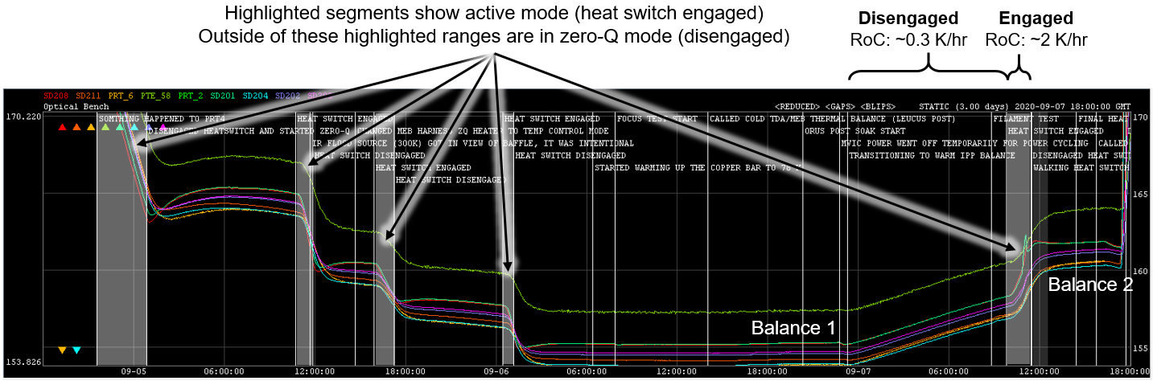
Figure 11: A portion of L’Ralph’s instrument TVAC data with the AZQ system activity. Every time the heat switch was engaged, a drastic increase in temperature’s rate of change was seen, as expected.

In addition, after the thermal balance was reached, the heat switch was disengaged and the heat switch temperature was varied by 40 K while everything else was held constant, as shown in Figure 12. The instrument was stable to within 0.05 K during the duration (~30 minutes) with no indication of accelerating temperature rate, confirming that the heat switch’s disengaged conductance was sufficiently low and that the AZQ system was working sufficiently well in the zero-Q mode.
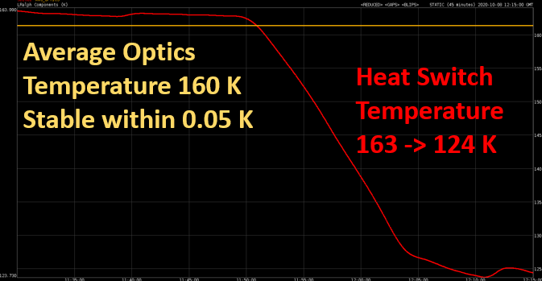
Figure 12: Heat Switch and Instrument Optics Temperature in Disengaged Mode. Despite the heat switch’s temperature dropping by 40 K, the instrument’s temperature was held stable at 160 K.

Conclusion
The AZQ system is a standalone ground support thermal control system that can aid in heating and cooling of thermally isolative cryogenic instruments. The AZQ system utilizes a heat switch to drive temperature transitions faster with the engaged mode and allow for non-intrusive thermal balance measurements with the disengaged mode. Derivations for the engaged and disengaged conductance requirements were shown. This paper demonstrated: 1) Reliable heat switch operability at its designed operational temperatures (120~300K), 2) On-command capability to “drag and release” test article’s temperatures, 3) Engaged conductance value of 0.416$±$0.005$\left[\frac{W}{K}\right]$, 4) Disengaged conductance value of approximately $0.0008\left[\frac{W}{K}\right]$, and 5) Successful utilization of the AZQ system for the L’Ralph instrument TVAC campaign that saved an estimated 10 days of testing time. The AZQ system can be easily implemented for other cryogenic flight testing programs as well. The system is fully standalone and only requires thermal interface points to be added to the flight unit for its thermal coupling. With the fomulations provided in this paper, the conductance requirements can be easily derived for other flight test systems. Further design optimizations can be done to minimize the AZQ system’s mass and improve its thermal performance.

Acknowledgments
The authors of this paper would like to acknowledge the L’Ralph project for financially supporting this proposal and the proof test of the system, Conrad Mason for the mechanical design of the assembly, High Precision Devices Inc. for fabricating a customized vise-grip heat switch and providing vital information about its mechanical design, and Allen Lunsford and Jeff Love for developing and providing heat switch control logic and its supporting hardware for the instrument level TVAC test.

References

[1] P. Mason, "Long-term performance of the passive thermal control systems of the IRAS spacecraft," presented at the Space Cryogenics Workshop, Madison, Wisconsin, USA, 1988.
[2] D. G. Gilmore, Spacecraft Thermal Control Handbook: Fundamental Technologies. El Segundo, California: AIAA the Aerospace Press, 2002.
[3] "Lucy: The first mission to Jupiter's Trojans." National Aeronautics and Space Administration. https://www.nasa.gov/content/goddard/lucy-the-first-mission-to-jupiter-s-trojans (accessed February, 06, 2020).
[4] "The Lucy spacecraft and payload." http://lucy.swri.edu/mission/Spacecraft.html (accessed February, 06, 2020).
[5] (1996). General environmental verification specification.
[6] "DT-670 Silicon Diodes," ed: Lake Shore Cryotronics, Inc.
[7] L. J. Salerno, P. Kittel, and A. L. Spivak, "Thermal conductance of pressed metallic contacts augmented with indium foil or Apiezon grease at liquid helium temperatures," Cryogenics, vol. 34, 1993, doi: 0011-2275/94/080649-06.
[8] R. Berman and C. F. Mate, "Thermal contact at low temperatures," Nature, pp. 1661-1663, 1958.
[9] N. Sanchez. "Cryogenic properties of copper." Copper Development Association Inc. https://www.copper.org/resources/properties/cryogenic/ (accessed February, 06, 2020).

L’Ralph Lead Thermal Analyst, Thermal Branch 545. Civil Servant
L’Ralph Thermal Project Development Lead, Thermal Branch 545. Civil Servant

