

*Journal of Geophysical Research - Atmospheres*

Supporting Information for

**New Particle Formation and Growth to Climate-relevant Aerosols at a background remote Site in the Western Himalaya**

**M. Sebastian1, V. P. Kanawade1,*, V. K. Soni2, E. Asmi3,4, D. M. Westervelt5,6, V. Vakkari3,7, A. -P.Hyvärinen3, J. R. Pierce8, and Rakesh K. Hooda3**

1Centre for Earth, Ocean and Atmospheric Sciences, University of Hyderabad, Hyderabad, India

2India Meteorological Department, Ministry of Earth Sciences, New Delhi, India

3Finnish Meteorological Institute, Erik Palmenin Aukio 1, Helsinki, Finland

4Servicio Meteorológico Nacional, Av. Dorrego, 4019, Buenos Aires, Argentina

5Columbia University, Lamont-Doherty Earth Observatory, NY, USA

6NASA Goddard Institute for Space Studies, New York, NY, USA

7Atmospheric Chemistry Research Group, Chemical Resource Beneficiation, North-West University, Potchefstroom, South Africa

8Department of Atmospheric Science, Colorado State University, Fort Collins, CO, USA

**Contents of this file**

Figures S1 to S4

**1. Diurnal variability in fraction of air (*Фq*) arriving Ranichauri from the plains**

As explained in [*Hooda et al.* 2018], we used specific humidity as a passive tracer for Atmospheric Boundary Layer (ABL) dynamics. The specific humidity was calculated for Ranichauri and plains (Delhi) utilizing meteorological parameters observed for the same period 2017–2018 at both the sites, such as dew point temperature Td in 0C, surface pressure (p) and vapor pressure (e) as shown in equation (1).

$q (\frac{g}{kg})= \frac{0.622 ×e}{p-(0.378×e)}$ (1)

For Delhi, we have had simultaneous measurements of meteorological parameters at three different locations in concurrence to Ranichauri site. The hourly-averaged data of Delhi and Ranichauri was used for specific humidity estimations for Delhi and Ranichauri site, respectively, as equation 1. The specific humidity estimated for Delhi was considered representing the plains since the specific humidity is a conserved variable and is usually locally well-mixed when the mixed layer depth is deep enough [e.g. *Kowol-Santen et al.*, 2001; *Weigel et al.*, 2007].

The specific humidity absolute values (*q*) showed seasonal corroboration between Ranichauri and Delhi. But, the diurnal variability in specific humidity (denoted by ‘*∂q*’) was temporally opposite with an increase at Ranichauri when there was a decrease at Delhi. The variability was obtained by subtracting the minima of each monthly cycle from all values of the respective cycle (the monthly mean diurnal cycle). A higher variability at Ranichauri may be indicating turbulence and hence an actively mixing boundary layer while a less variability in Delhi was observed. We assumed that ∂q at the Delhi sites represent the typical specific humidity values in the plains (IGP). Each hourly specific humidity value at Ranichauri was then subtracted from the corresponding hourly specific humidity value at Delhi and noted as ‘ϕq’. Based on ‘*∂q*’ values and the methodology adopted for a mountainous environment in [*Hooda et al.* 2018], we assumed, as stated in main text, that early in the morning (5:00 a.m.), there is no mixing of air between the plains and Ranichauri. The ‘ϕq at 5:00 a.m.’ is considered as ΔRP*q*, the undisturbed difference of *q* between Ranichauri and plains.

The parameter ‘(Ф*q*)’, a clear indicator that can represent the fraction of Ranichauri air originating from the plains, was estimated as presented in main text of the manuscript. Figure S1 shows the IGP boundary layer influence with different threshold values of Фq (0.25, 0.5, and 0.75). It suggests that air masses transport below from plains is dominant during pre-monsoon season and relatively sparse during post-monsoon. A similar pattern of the frequency of days is seen with maximum mixing depth (ERA-5) but with a varying magnitude. The maximum mixing depth of Delhi was utilized in terms of estimating influence of IGP boundary layer to the Ranichauri station (1930 m asl). This result is in agreement with previous studies of a mountainous environment [Collaud Coen et al., 2013; Hooda et al., 2018]. It is to be noted that defining influence of air masses from plains to Ranichauri station utilizing modelled (e.g., ERA-5) planetary boundary data (station) may be misleading since in mountainous environment the modelled estimations do not work well [De Wekker and Kossmann, 2015; Hooda et al., 2018; Serafin et al., 2018; Singh et al., 2016].

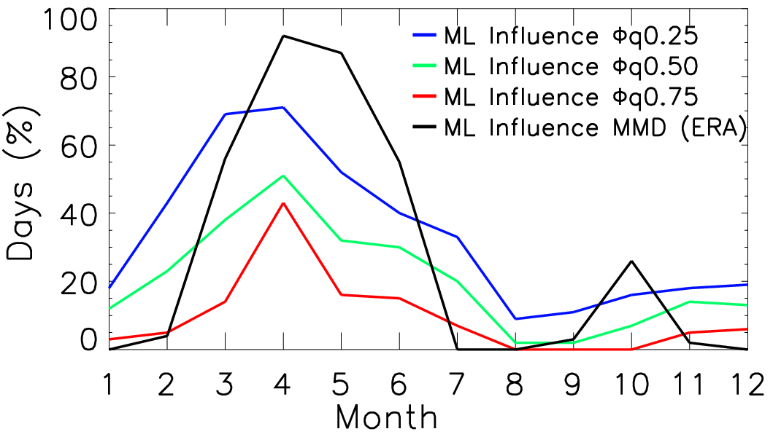

**Figure S1**. The mixing layer inﬂuence as the average monthly fraction of days affected by air from Indo Gangetic Plains illustrated with maximum mixing depth (MMD) and specific humidity (q) with three threshold values (0.25, 0.5, and 0.75) shown as blue thick line (0.25), green thick line (0.5), and red thick line (0.75). The black thick line indicate maximum mixing depth.

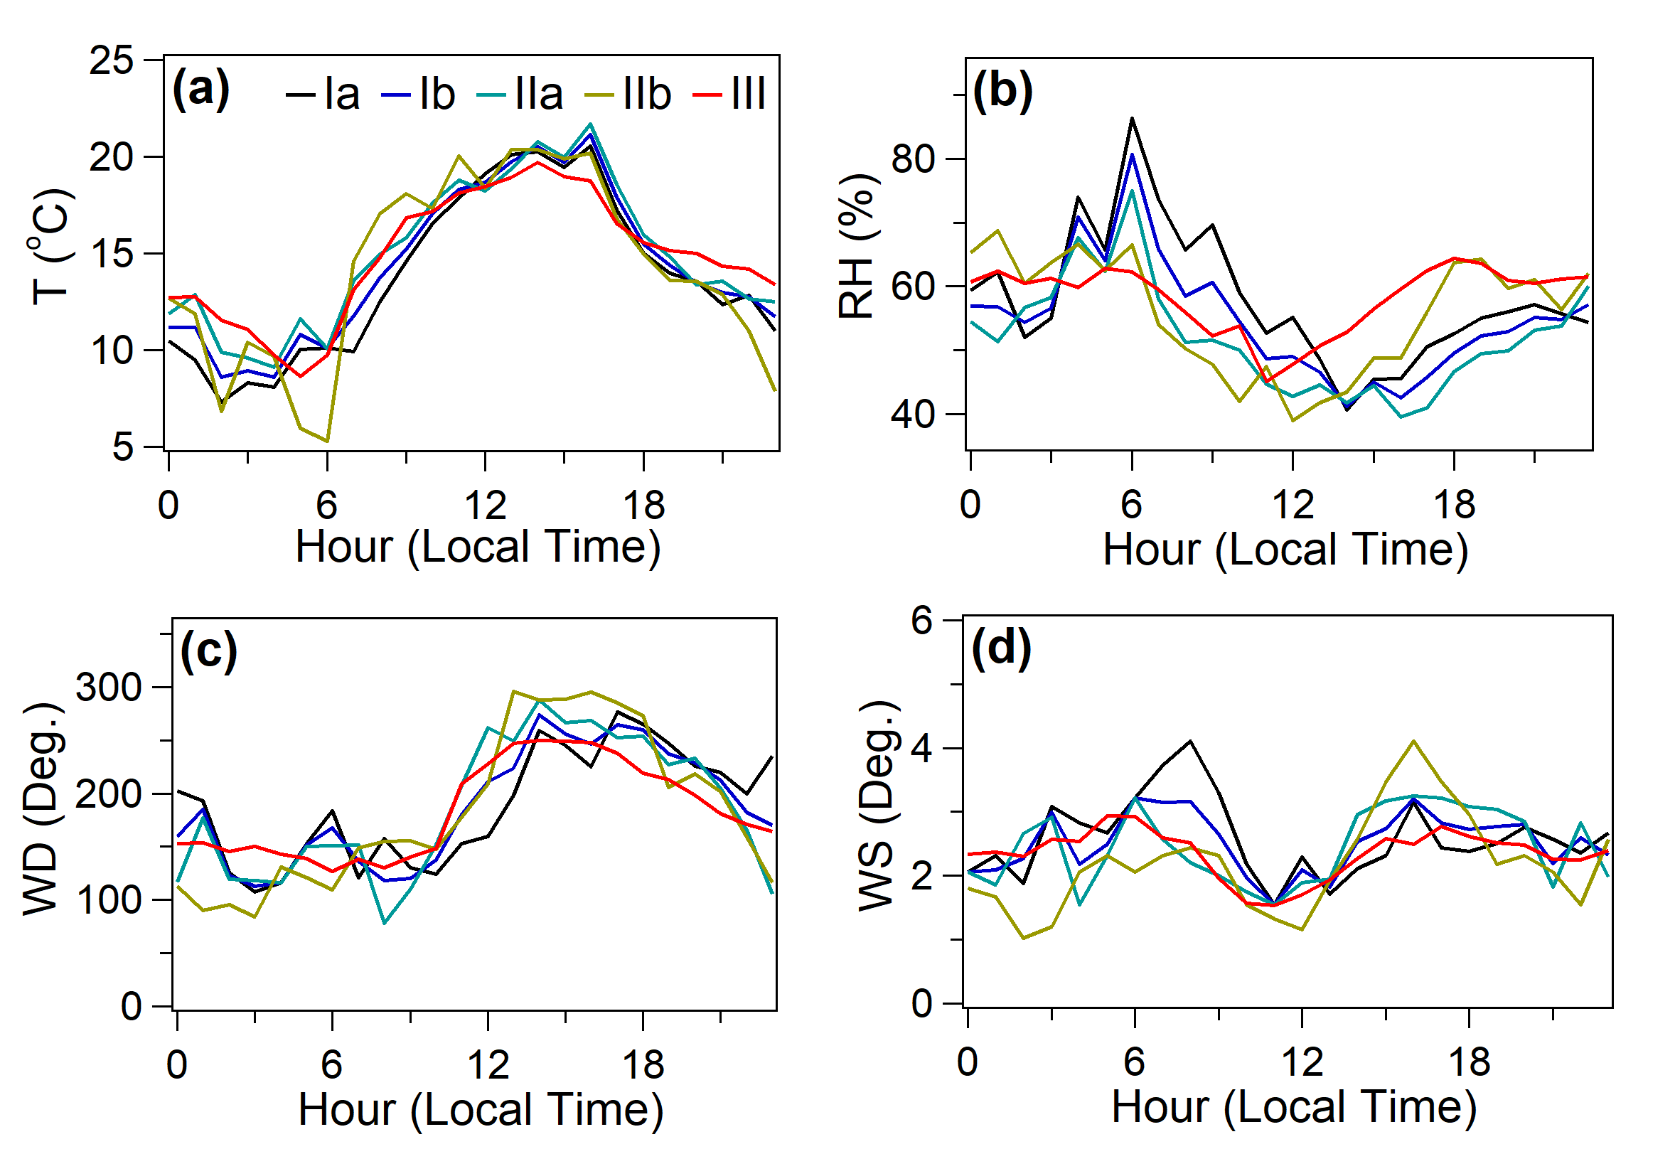

**Figure S2**. Averaged diurnal variation of meteorological parameters such as temperature (a), relative humidity (b), wind direction (c) and wind speed (d) for observed Type-I, Type-II, and Type-III events.

**2. Seasonal features in aerosol number-size distribution**

Figure S3 shows the temporal variation of aerosol size distributions in the diameter range of 10-800 nm, NTOT and BC during 1 December 2016 to 14 September 2018. The total aerosol mass and number concentrations are generally the highest during the pre-monsoon (MAM) season. The seasonally averaged aerosol size distribution for pre-monsoon brings up the growing particle mode diameter, indicating the prevalence of NPF in this season (Figure S4). In other seasons, the particle mode diameter remained between 80 and 100 nm. Figure S5 shows the box-whisker plots of monthly averaged size-segregated aerosol number concentrations (NNUC, NAIT, NACCU, and NTOT), total surface area, total volume, total condensation sink, total coagulation sink, total mass and particle mode diameter based on the entire observation days. The size-segregated aerosol number concentrations showed a distinct seasonal cycle. The total aerosol concentrations were about three-fold higher during the pre-monsoon season as compared to that of monsoon. In the monsoon season, size-segregated aerosol number concentrations (NNUC, NAIT, and NACCU), SATOT, VolTOT, CSTOT, CoagSTOT and MTOT were low and invariable. The aerosol number concentrations and other intrinsic properties sharply increased as the season progressed towards post-monsoon and winter, with increase of about two-fold relative to the monsoon season, but stayed lower than the pre-monsoon season average concentrations. Previous studies also reported a decrease of about two- to three-folds in concentrations of SATOT, VolTOT, CSTOT, CoagSTOT and MTOT during monsoon compared to the pre-monsoon season concentrations at a high altitude site, Mukateshwar [*Hooda et al.*, 2018; *Hyvärinen et al.*, 2011]. In contrast, the particle mode diameter was found to be the smallest during pre-monsoon and monsoon. This result can be attributed to the frequent occurrence of NPF during pre-monsoon and efficient wet/cloud scavenging of large size aerosols decreasing the mean size in the monsoon season.

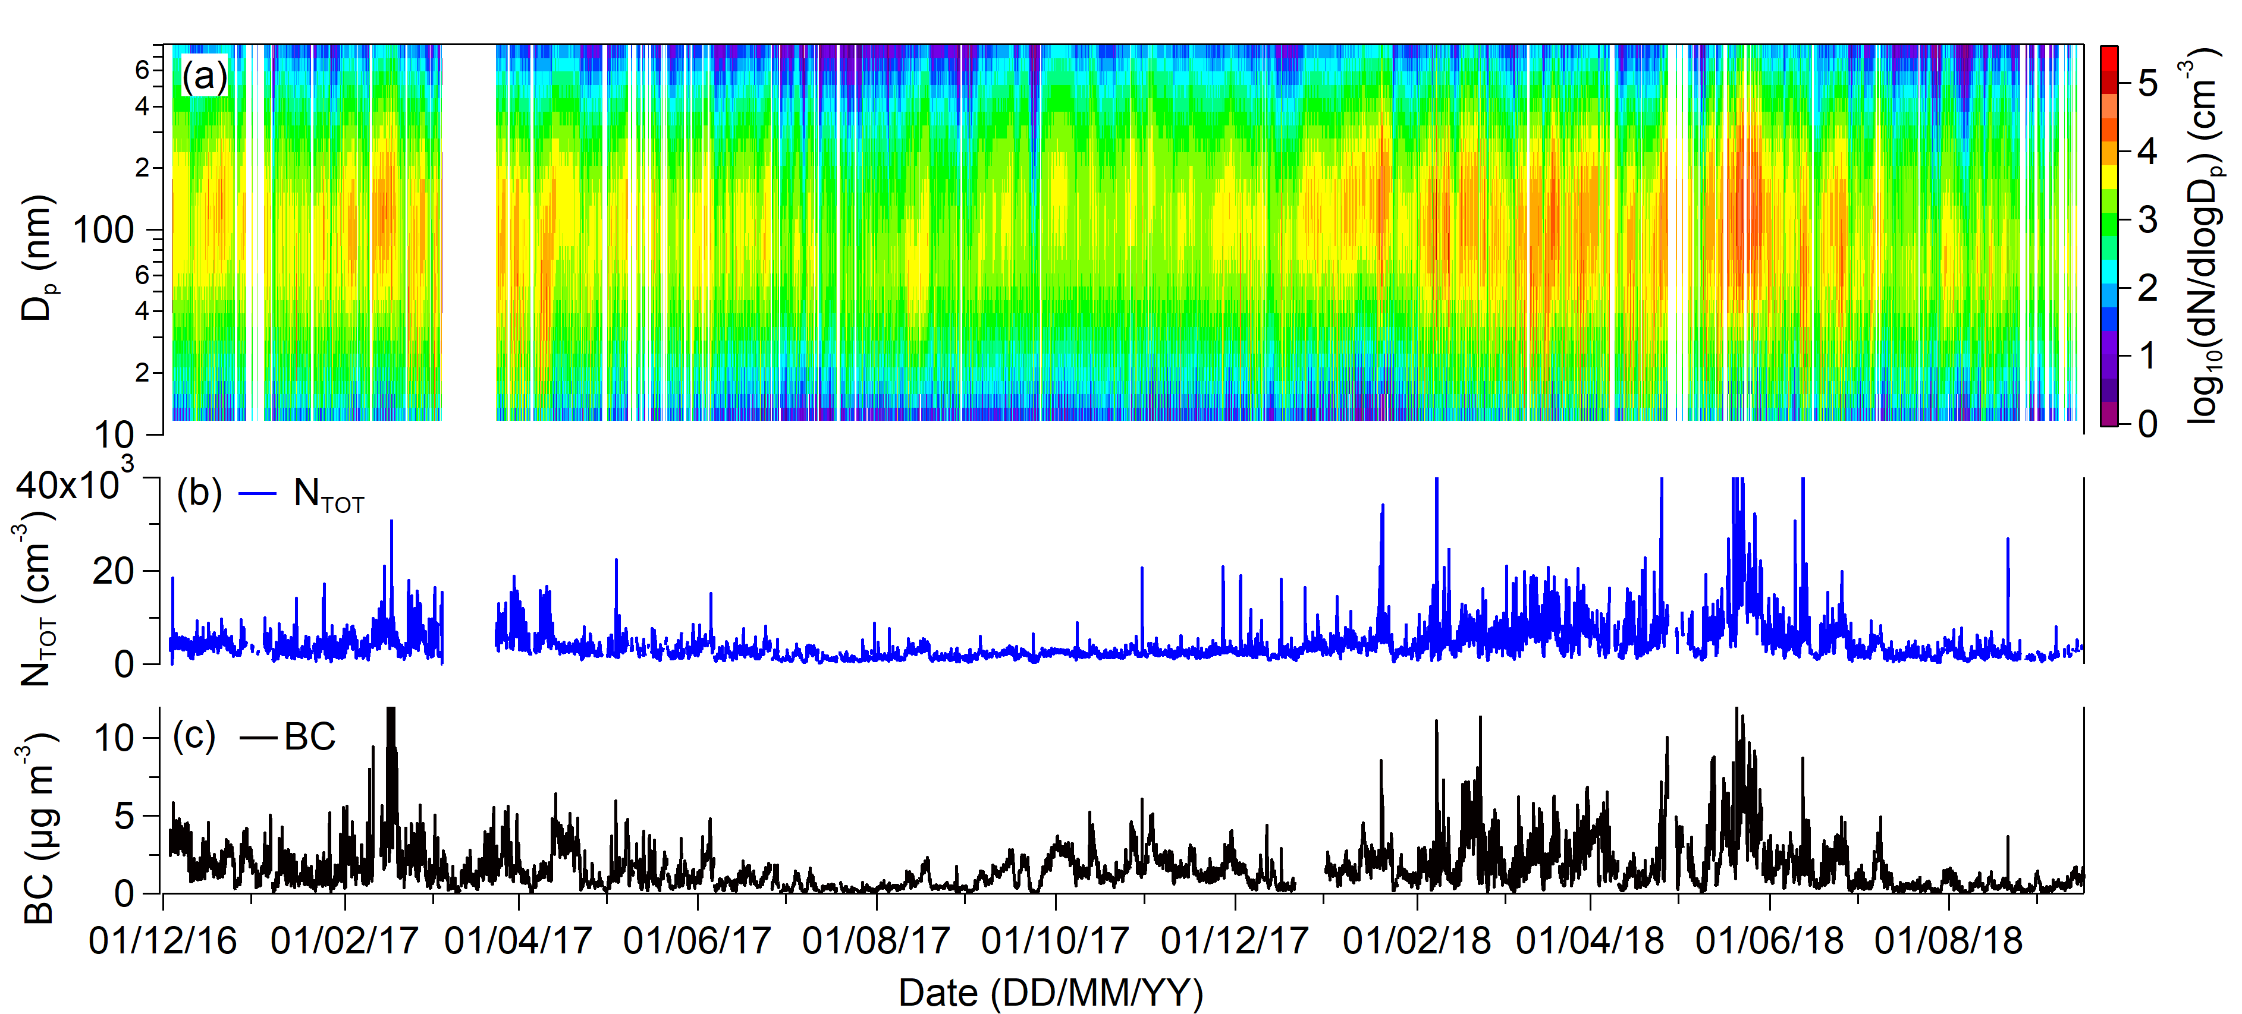

**Figure S3.** Temporal variation of hourly averaged (a) aerosol size distributions, (b) total aerosol number concentrations and (c) black carbon mass concentrations at Ranichauri during 1 December 2016 to 14 September 2018.

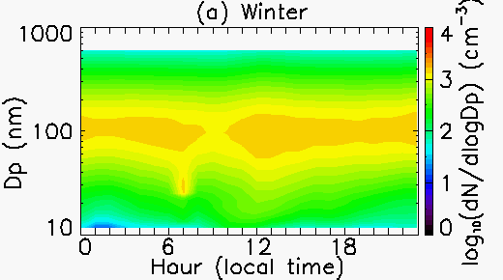 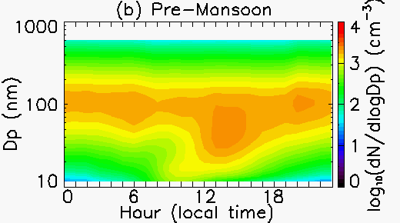

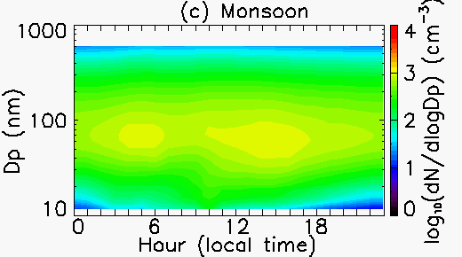 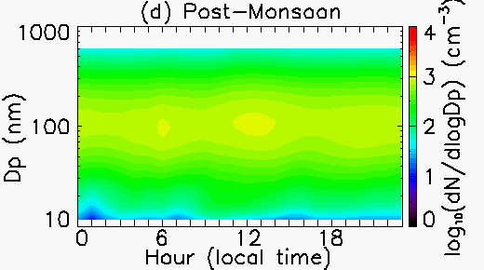

**Figure S4.** Seasonally averaged diurnal cycle of the aerosol size distribution for (a) winter, (b) pre-monsoon, (c) monsoon and (d) post-monsoon based on the entire observation days.

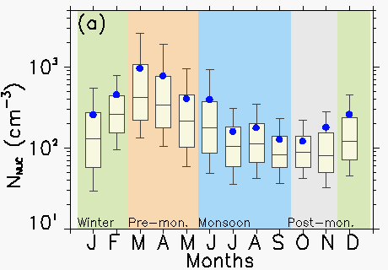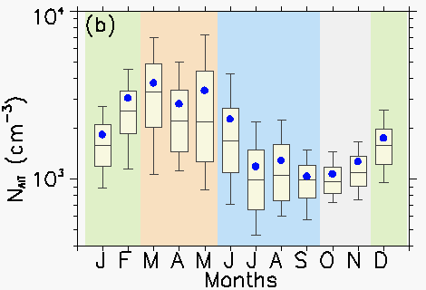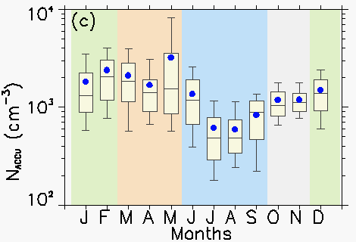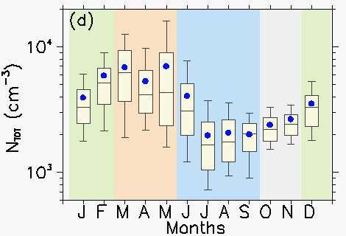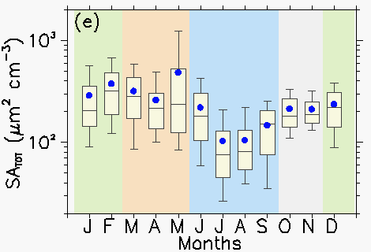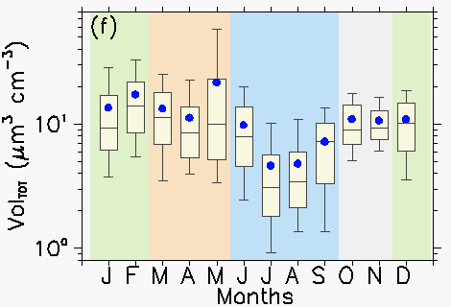 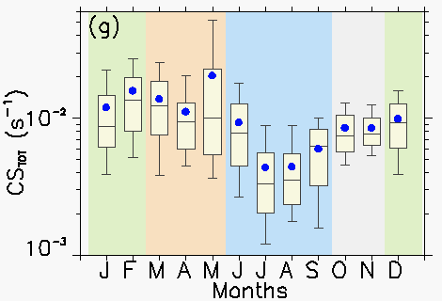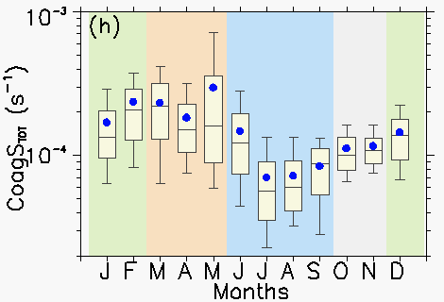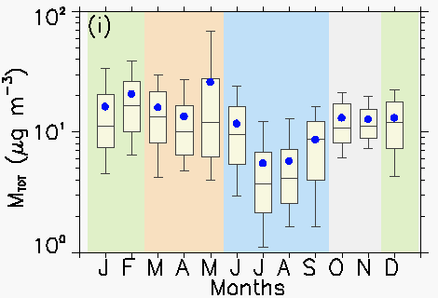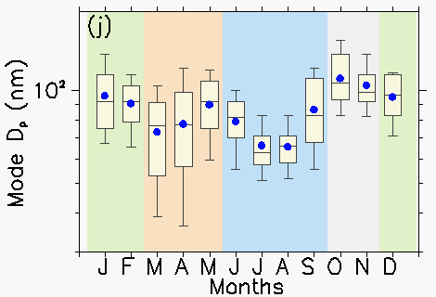

**Figure S5.** Box-Whisker plot of monthly mean (a-d) size-segregated aerosol number concentrations, (e) total surface area, (f) total volume, (g) total condensation sink, (h) total coagulation sink, (i) total mass and (j) particle mode diameter based on the entire observations days. The blue dot indicates mean, horizontal line indicates median, top and bottom of box indicate 25th and 75th percentiles, respectively, and top and bottom whisker indicate 10th and 90th percentiles, respectively. The background different colour shading viz., light green, light red, light blue and light grey indicate different seasons, viz., winter, pre-monsoon, monsoon and post-monsoon, respectively.

References

Collaud Coen, M., et al. (2013), Aerosol decadal trends – Part 1: In-situ optical measurements at GAW and IMPROVE stations, *Atmos. Chem. Phys.*, *13*(2), 869-894.

De Wekker, S. F. J., and M. Kossmann (2015), Convective Boundary Layer Heights Over Mountainous Terrain—A Review of Concepts, *Frontiers in Earth Science*, *3*(77).

Hooda, R. K., et al. (2018), Driving Factors of Aerosol Properties Over the Foothills of Central Himalayas Based on 8.5 Years Continuous Measurements, *Journal of Geophysical Research: Atmospheres*, *123*(23), 13,421-413,442.

Hyvärinen, A. P., et al. (2011), Effect of the summer monsoon on aerosols at two measurement stations in Northern India – Part 2: Physical and optical properties, *Atmos. Chem. Phys.*, *11*(16), 8283-8294.

Kowol-Santen, J., M. Beekmann, S. Schmitgen, and K. Dewey (2001), Tracer analysis of transport from the boundary layer to the free troposphere, *Geophysical Research Letters*, *28*(15), 2907-2910.

Serafin, S., et al. (2018), Exchange Processes in the Atmospheric Boundary Layer Over Mountainous Terrain, *Atmosphere*, *9*(102).

Singh, N., R. Solanki, N. Ojha, R. H. H. Janssen, A. Pozzer, and S. K. Dhaka (2016), Boundary layer evolution over the central Himalayas from radio wind profiler and model simulations, *Atmos. Chem. Phys.*, *16*(16), 10559-10572.

Weigel, A. P., F. K. Chow, and M. W. Rotach (2007), *The effect of mountainous topography on moisture exchange between the “surface” and the free atmosphere. In: Baklanov A., Grisogono B. (eds) Atmospheric Boundary Layers.* , Springer, New York, NY.