INTERPRETATION OF VEHICLE TUMBLING PREDICTIONS FROM 6-DOF ENTRY AND DESCENT SIMULATION
J. T. Needels¹, P. J. Gage², and J. P. Hill³, ¹Neerim Corporation, 5937 Chelton Drive Oakland, CA 94611,
jacob.t.needels@nasa.gov, ²Neerim Corporation, 5937 Chelton Drive Oakland, CA 94611, peter.j.gage@nasa.gov, ³NASA Ames Research Center, Moffett Field, CA 94035, jeffrey.p.hill@nasa.gov.

Brief Presenter Biography: Jacob Needels is a systems engineer with Neerim Corporation in the Entry Systems and Vehicle Development Branch at NASA Ames Research Center. He holds a B.S. in Mechanical Engineering from the University of California, Davis and an M.S. in Aeronautics and Astronautics from Stanford University.

Introduction:
Blunt body entry vehicles are subject to dynamic instability during terminal descent. This often manifests as limit cycle oscillations in total angle of attack, but can diverge into tumbling behavior under certain conditions. For the Mars Sample Return Earth Entry Vehicle (MSR EEV), there is a constraint on the orientation of the sample tubes so backward impact is impermissible. Past missions have chosen to deploy parachutes to preclude tumbling, but active events after release of MSR EEV have been ground-ruled out with the intent to maximize system reliability. Prevention of tumbling during subsonic descent is a design driver for MSR EEV.
During preliminary design of the MSR EEV, six degree-of-freedom numerical simulations indicated an unacceptably high probability of tumbling for a 60 degree sphere-cone forebody geometry, which necessitated a design change. Decreasing the forebody angle was expected to improve dynamic stability, but would also adversely impact mass, aeroheating, and manufacturing risk. Hence there was strong motivation to understand the physical drivers for the onset of tumbling, and to determine: (a) whether the causes of tumbling are representative of physically realizable vehicle entry configurations and (b) what changes can be made to existing design and analysis practices to ensure a stable vehicle.
The methodology for a Monte Carlo analysis of the entry trajectory, which was performed by colleagues at NASA Langley Research Center, is similar to that performed with the POST2 software for other flight projects [1,2]. More than 30 input parameters are assigned a range of possible values and an associated statistical distribution, to account for uncertainties in mass properties, aerodynamic properties, and entry state. The resulting range of aerodynamic loads, aerothermal loads and landing locations are used to define performance requirements for various elements of the system. The investigation reported here involves analysis of pre-existing trajectory information.
Attempts to correlate input parameters with onset of tumbling were only moderately successful: while radial center of gravity (CG) offset and the uncertainty adder applied to the total pitch damping term, $C_{mq} C_{nr}$, were identified as the top two contributors to tumbling, there are cases with larger CG offsets and larger $C_{mq} C_{nr}$ adder values that do not tumble. Vehicle total pitch damping coefficient is often the focus for dynamic stability margin estimation, but processing of Monte Carlo output data showed only a weak dependence on pitch damping value. However, all tumbling vehicles were shown to have developed high roll rates (>100 deg/sec) during the hypersonic entry phase. Anomalous roll behavior has been studied extensively in military reentry vehicles [3], and found to be due to the interaction of configurational asymmetries in mass and aerodynamic properties. The presentation will include details on the confirmation that this is also the case for MSR EEV. High roll rates are associated with a large magnitude cross product between radial center of gravity offset and aerodynamic uncertainty adders, as shown in Figure 1, which results in a persistent roll moment that leads to severe spin-up during the hypersonic dynamic pressure pulse.
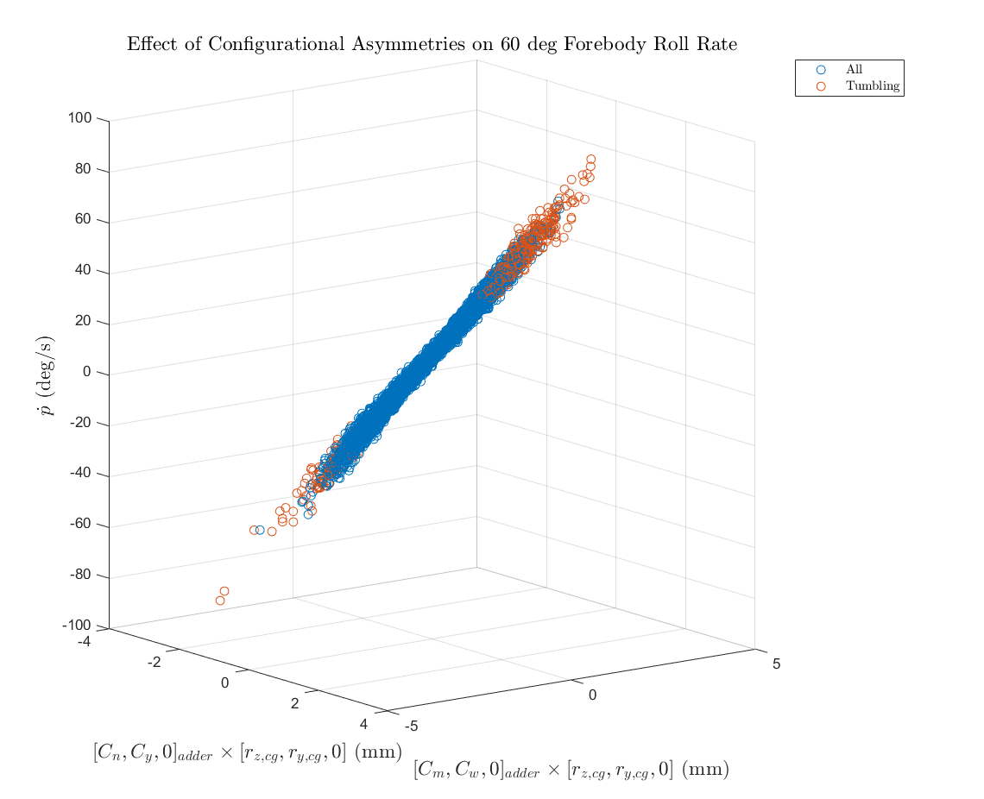
Figure 1. Impact of Monte Carlo Inputs on Roll Rate
The high-dimensional input space of Monte Carlo simulations make it unattractive to perform sensitivity assessments for dynamic stability. An analytical stability criterion due to Jaffe [4], which derives from simplification of the equations of motion for terminal descent, requires only a subset of vehicle aerodynamic and mass properties, as well as vehicle roll rate. Results of the Jaffe criterion are consistent with POST2 results, and provide insight into both stability margin of a particular point design, as well as sensitivity to variation of design parameters. The presentation will include discussion of the relevant sensitivities and the design guidance that they provide. Figure 2 provides an example, for sensitivity to drag coefficient. It does not correspond to a specific EEV design, but the general trends are representative.
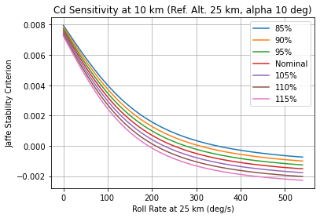
Figure 2. Design Sensitivity Assessment using the Jaffe Stability Criterion
References: [1] Schoenenberger M., et al. (2009) 41st AIAA Thermophysics Conference [2] Prince J, et al. (2011) Journal of Spacecraft and Rockets, 48:5, 756:764. [3] Glover L. (1965) Journal of Spacecraft and Rockets, 2:2, 220-225. [4] Jaffe P. (1969) AIAA Journal, 7:6, 1157–1158.

