a) b)
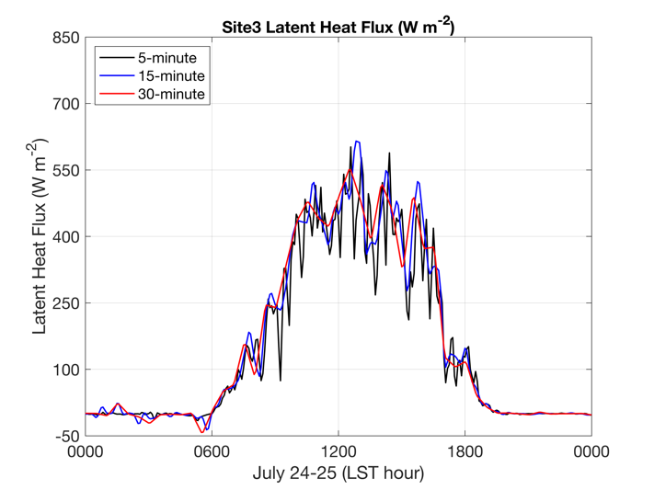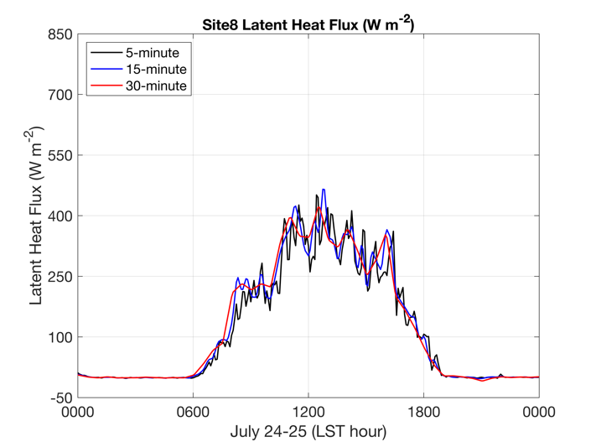
c) d)
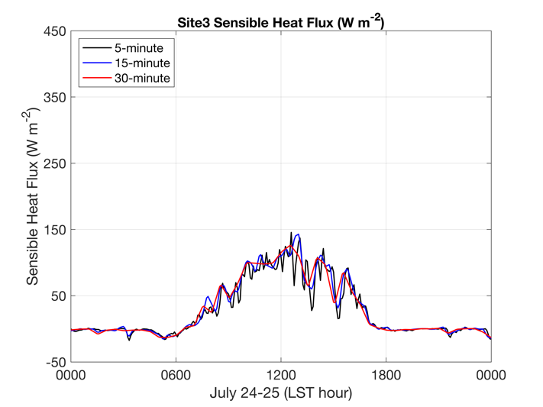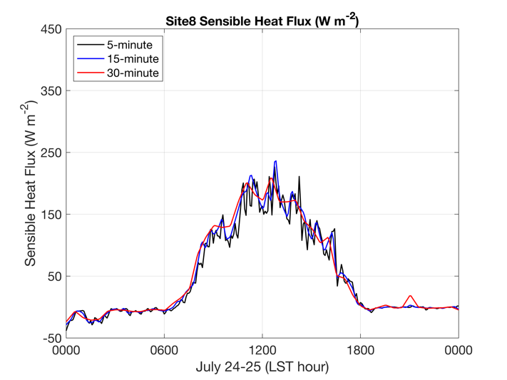
Figure 2a-d. Surface latent and sensible heat fluxes (Wm⁻²) for a selected day during IOP2, July 24th, using 5 (black), 15 (blue), and 30 (red) minute averaging. Site 3 (left column) is from irrigated cropland and Site 8 (right column) is non-irrigated cropland. Latent (Sensible) heat flux is on the top (bottom) row. Note the different y-axis scales for the latent and sensible heat fluxes.

