a) b)
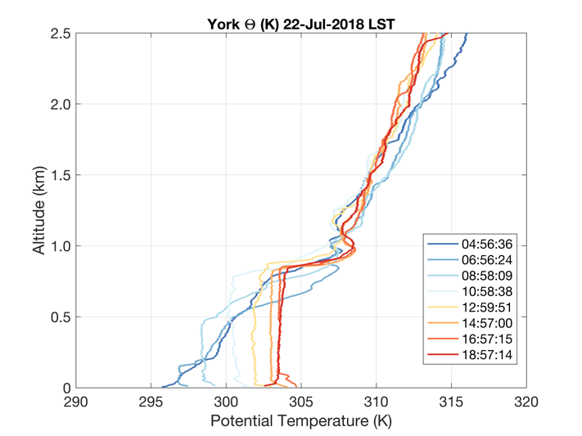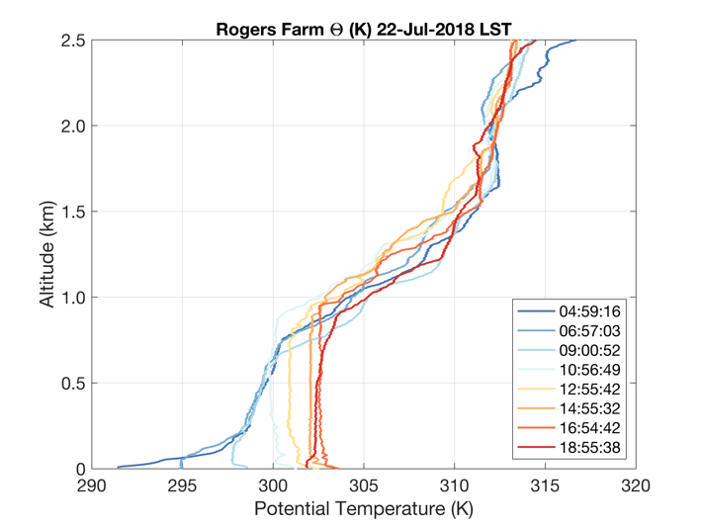
c) d)
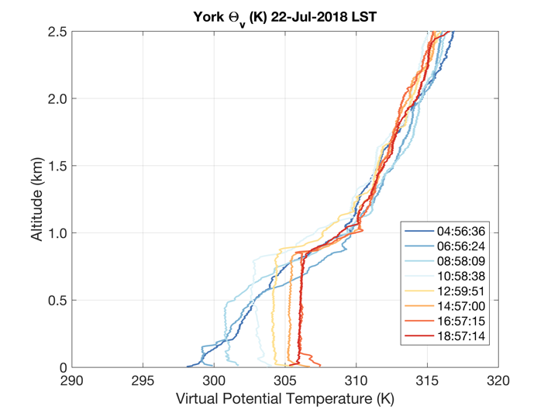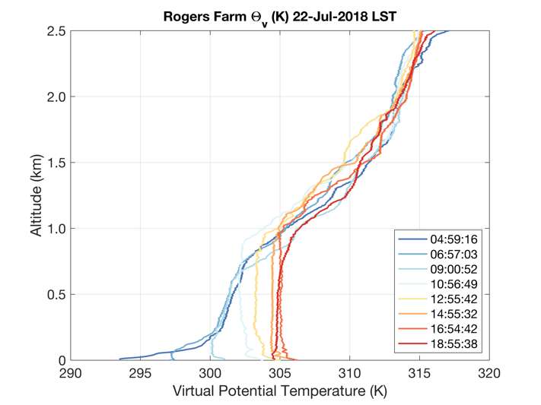
Supplementary Fig. 3a-d. Radiosonde profiles on 22 July, 2018 from the York (left column) and Lincoln (right column) ISS sites 8 times daily from ~0500 LST (~1100 UTC) to ~1900 LST (~0100 UTC), locally same day (on the following day): a, b) boundary layer and lower free atmosphere θ, c, d) boundary layer and lower free atmosphere θ_{v}.

