a) b)
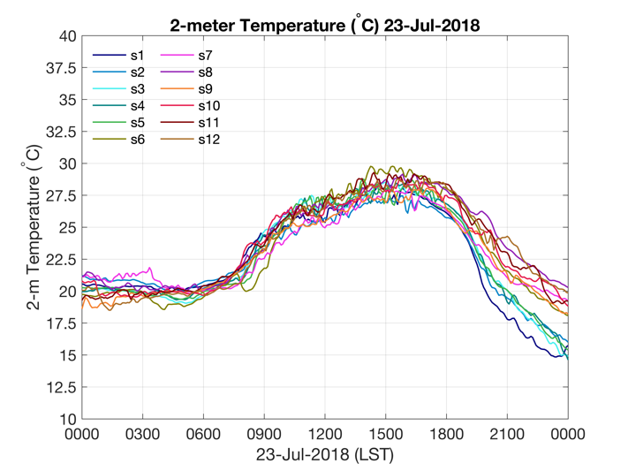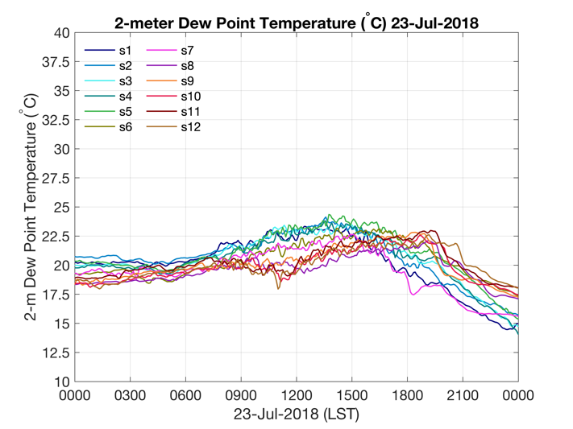
c) d)
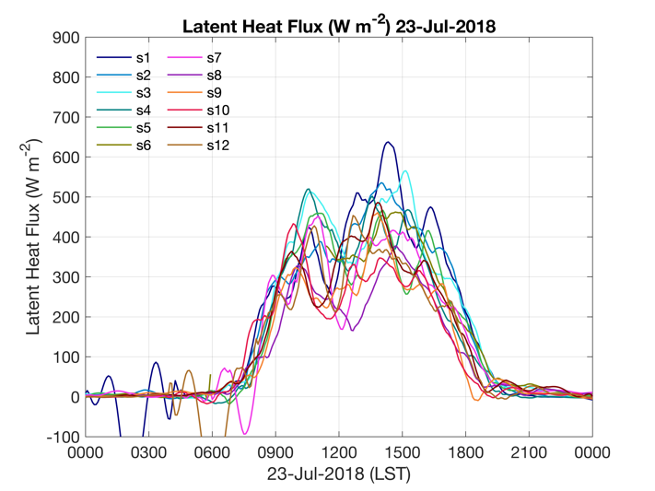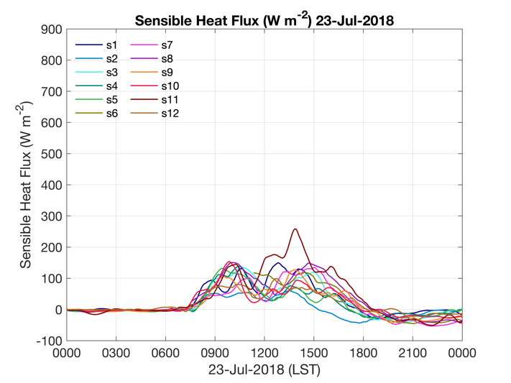

Supplementary Fig. 4a-d. ISFS site data on July 23rd 2018 for: a) 2-m temperature, b) 2-m mixing ratio, c) latent heat flux and d) sensible heat flux over irrigated [sites 1-6 (shown as s1-s6)] and non-irrigated [sites 7-12 (shown as s7-s12)] ISFS sites.

