Sustained Veggie: A Continuous Food Production Comparison

Jess M Bunchek[1]

SURA/LASSO, Kennedy Space Center, FL, 32899

Aaron B Curry[2]

Amentum/LASSO, Kennedy Space Center, FL 32899

and

Mathew W Romeyn[3]

NASA, Kennedy Space Center, FL, 32899

**The International Space Station’s Veggie system intermittently supplies the crew with fresh produce. To assess the potential for continuous crop production in Veggie and develop a baseline for future space crop production systems, a 120-day study was conducted to determine methodology for inputs, optimal yield, and crew involvement. ‘Amara’ mustard and ‘Red Russian’ kale were grown as initial crops, followed by ‘Extra Dwarf’ pak choi and shungiku as final crops. Previous grow-outs in Veggie have included harvests at 28-35 days after initiation. In this study, a 56-day grow-out with multiple harvests from the same plants was compared to the conventional, single harvest Veggie schedule. Unlike previous Veggie studies which grew all plants simultaneously, this test staggered initiation and harvest, aiming for consistent and increased production. Plant pillows were initiated in pairs weekly and positioned to reduce shading. Completed pillows were immediately replaced with fresh ones. The multi-harvest scheme used fewer pillows, totaling 46% less pillow mass than the single harvest method. Scaled to 56-day increments, yield varied by crop and harvest scheme. ‘Red Russian’ kale yielded similarly across harvest schemes. In the multiple-harvest schedule, ‘Amara’ mustard and shungiku yielded 23% to 25% higher, respectively, while ‘Extra Dwarf’ pak choi had 43% lower yield. Microbial analysis of the plants indicated no culturable human pathogens. Microbial load of a given plant appears to depend more on system age than plant age. Across harvest methods, aerobic plate counts from final crops were higher than those of initial crops. This project also considered the complexity of crew involvement in a continuous production scenario. New crew procedures that periodically remove plant material from the Veggie root mat are needed under continuous production to prevent potential pathogens and unpleasant odors. This study supports future space crop production scenarios and was funded by NASA’s Human Research Program.**

# Nomenclature

*APC* = Aerobic Plate Count

*cfu* = colony forming unit

*DAI* = Days after initiation

*EtO* = Ethylene Oxide

*HSD =* (Tukey’s) honestly significant difference (test)

*IMA* = Inhibitory Mold Agar

*ISS* = International Space Station

*KSC* = Kennedy Space Center

*PBS* = Phosphate-buffered saline

*RH* = Relative Humidity

*SPAD* = Soil-Plant Analysis Development

*TSA* = Trypticase Soy Agar

*VGU* = Veggie Growth Unit

*Y&M* = Yeast and mold

# Background

LONG-DURATION missions beyond low Earth orbit will encounter challenges in maintaining adequate nutrition and acceptability in the food system.1 In situ production of fresh vegetable and fruit crops can supplement the crew diet with nutrients deficient in the stored diet.2 Steady-state, continuous crop production during long-term, deep space missions will be critical for consistent nutrient supplementation and potential psychological benefits – together ideally improving crew health and performance.3 However, only 1-2 month crop production cycles (initiation to harvest) have been evaluated so far in a flight hardware system under environmental conditions similar to the International Space Station (ISS), followed by hardware cleanout and a crop-free period. This intermittent growth cycle does not indicate the feasibility of a realistic continuous crop production cycle, where plants are replaced once concluded and there is ideally always something ready to harvest. A continuous crop production cycle has the potential to introduce challenges from plant competition due to multiple plant ages within the cycle, increased crew time, and microbiological growth. The goals of this study were to (1) quantify these potential challenges and (2) establish baseline performance metrics of the Veggie hardware in a sustained crop production capacity to determine its effectiveness and serve as a reference for future space crop production systems.

# Experimental Design

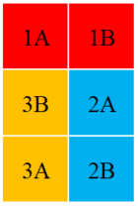

Figure 1. Cropping design used for both harvest treatments. *Pillows 1A and 1B were initiated at 0 days after study initiation (DAI), 2A and 2B were initiated at 7 DAI, and 3A and 3B were initiated at 14 DAI. “A” and “B” represent the two crops grown together in each VGU.*

The objective of this study was to demonstrate sustained crop production with two different harvest treatments: (1) a traditional 28-day, single harvest approach and (2) a 56-day, multiple harvest “cut-and-come-again” approach with two intermediate harvests and a third, final harvest. This study was the first detailed side-by-side comparison of these harvest treatments. The harvest treatments were grown concurrently for 120 days using ground-based Veggie plant growth units (VGUs) in environmental growth chambers maintained at ISS-like environmental conditions (23°C, 50% RH, 3000 ppm CO2).

Both harvest treatments utilized a multi-generational cropping design, where plants were started in pairs to achieve more frequent harvests than the traditional simultaneous start of all six plants in a Veggie Growth Unit (VGU; Figure 1). The factorial cropping design used for both harvest approaches aimed to optimize available fresh biomass while considering trade-offs such as plant competition, harvest yield, harvest frequency, and crew involvement. To minimize water loss to adjacent pillows, vacant pillow spaces were covered with polyethylene greenhouse shade cloth until initiation.

Table 1. Leafy green pairs selected for study.

|  |  |  |
| --- | --- | --- |
|  | KSC Screening Trials | Grown on the ISS |
| Crop Pair 1 | ‘Amara’ Mustard | ‘Red Russian’ Kale |
| Crop Pair 2 | ‘Shungiku’ Greens | ‘Extra Dwarf’ Pak Choi |

Each pair of leafy green crops included one species that was down-selected from recent crop screening trials at the Kennedy Space Center (crop “A”) and one species that had grown successfully on the ISS (crop “B”). Crops were also paired together based on growth habit to minimize plant competition (Table 1). The first pair of crops, ‘Amara’ mustard (*Brassica carinata* A. Braun) and ‘Red Russian’ kale (*Brassica napus* L. subsp. *pabularia*), were grown together for the first 56 days of the study (Figure 2). The crops were then transitioned to the second pair, ‘Shungiku’ greens (*Glebionis coronaria* [L.] Cass ex. Spach) and ‘Extra Dwarf’ pak choi (*Brassica rapa* L. subsp. *chinensis*), in the same manner as study initiation.

Data was analyzed with a linear mixed-effects model ANOVA (P < 0.05) and Tukey HSD test conducted in R Version 3.5.1.

|  |  |  |  |  |  |  |  |  |  |  |  |  |  |  |  |  |  |
| --- | --- | --- | --- | --- | --- | --- | --- | --- | --- | --- | --- | --- | --- | --- | --- | --- | --- |
|  |  | Days After Initiation (DAI) | | | | | | | | | | | | | | | |
|  |  |  | Crop Pair 1 | | | | | |  |  | Crop Pair 2 | | | | | | |
|  | Series | 0 | 7 | 14 | 21 | 28 | 35 | 42 | 49 | 56 | 63 | 70 | 77 | 84 | 91 | 98 |
| Single Harvest | 1 | X |  |  |  | X |  |  |  | X |  |  |  | X |  |  |
| 2 |  | X |  |  |  | X |  |  |  | X |  |  |  | X |  |
| 3 |  |  | X |  |  |  | X |  |  |  | X |  |  |  | X |
| Multiple Harvest | 1 | X |  |  |  |  |  |  |  | X |  |  |  |  |  |  |
| 2 |  | X |  |  |  |  |  |  |  | X |  |  |  |  |  |
| 3 |  |  | X |  |  |  |  |  |  |  | X |  |  |  |  |

Figure 2. Initiation dates for each crop pair throughout the 120-day study. *New pillows were initiated on the same day as the preceding pillows were harvested. Crop pair 2 (‘Shungiku’ greens and ‘Extra Dwarf’ pak choi) were integrated starting at 56 days after initiation (DAI). The final pair of pillows was initiated at 98 DAI and 70 DAI in the single and multiple harvest treatments, respectively.*

# Plant Harvest Metrics

For the single harvest treatment, all stem and leaf tissue was removed at 28 days after the plant was initiated. For the multiple harvest treatment, all of the older leaves were removed at the first harvest (28 days old), leaving only 4-6 young leaves to continue growing. The process was repeated at the second harvest (42 days old), and all stem and leaf tissue was removed at the final harvest (56 days old).

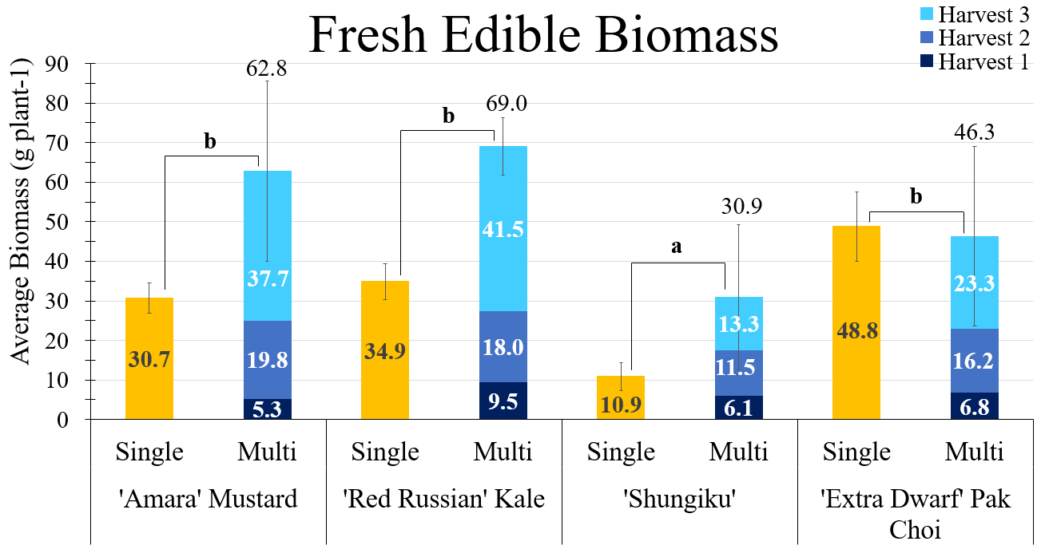**Figure 3. Average fresh edible biomass (g plant-1) for the single and multiple “multi” harvest treatments (P < 0.005).** *For “multi,” biomass is shown for each harvest and overall plant (above standard error bars). Tukey letters are presented at the crop level. (‘Amara’ mustard: nsingle = 5, nmultiple = 3; ‘Red Russian’ kale: nsingle = 6, nmultiple = 3; ‘Shungiku’ greens: nsingle = 5, nmultiple = 3; ‘Extra Dwarf’ pak choi: nsingle = 5, nmultiple = 3).*

Morphological measurements were captured at each plant’s harvest and included plant dimensions, edible biomass fresh weight, number of leaves, leaf surface area, and plant health. Plant dimensions were visually assessed as height, plant diameter measured left to right, and a second plant diameter measured front to back. Edible biomass fresh weight included stem and leaf tissue. For leaf surface area, each leaf was scanned using a leaf area meter. Finally, plant health was assessed as chlorophyll and anthocyanin content via a Soil-Plant Analysis Development (SPAD) meter and anthocyanin meter, respectfully.

The average per plant fresh edible biomass was higher in the multiple harvest approach than the single harvest for all crops (P < 0.005; Figure 3). ‘Shungiku’ did not perform as well as expected in Veggie hardware. While many ‘Shungiku’ plants did appear healthy, others suffered from tip burn (Figure 4), a symptom of deficient calcium accumulation in the leaves caused by suboptimal airflow in the VGU. Further ground testing with ‘Shungiku’ also showed inconsistent growth; however, determining the exact cause or causes would require further investigation.

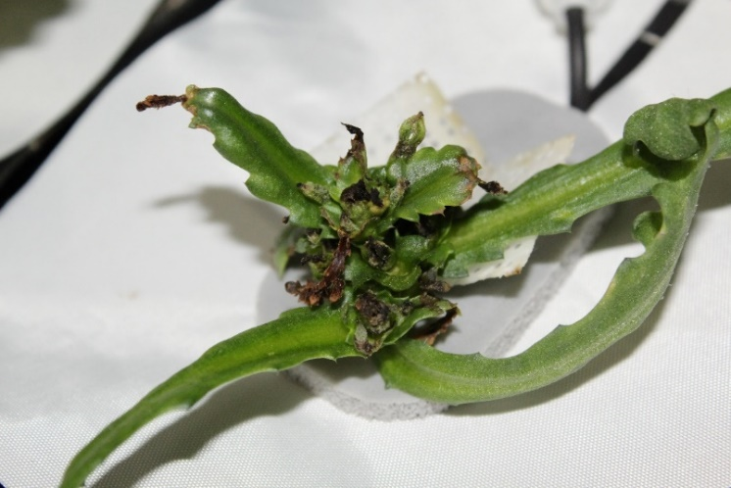 Figure 4. ‘Shungiku’ greens exhibiting tip burn at the ends of leaves. *This loss of plant vascular tissue caused plant deformities and stunting.*

However, comparing fresh edible biomass production across the same amount of time (56 days) showed that 2 successive rotations of the single harvest treatment grew as much or more than a single rotation of the multiple harvest treatment (Table 2) in the same amount of time`. ‘Shungiku’ greens were an exception, likely due to morphological inconsistencies. Multiple harvest treatment crops continued to produce biomass after the first harvest at 28 days old, but the growth rate slowed. Depending on the crop, using the single harvest treatment may be more effective at providing continuous fresh produce to crew members.

Despite mindfully selecting a cropping design to minimize plant competition, having multiple, concurrent growth stages still created plant shading (Figure 5). Competition was visually observed when older plants’ leaves would shade younger, neighboring plants. However, the extent to which shading or other competitive activities affected neighboring plants was not directly quantified in this study.

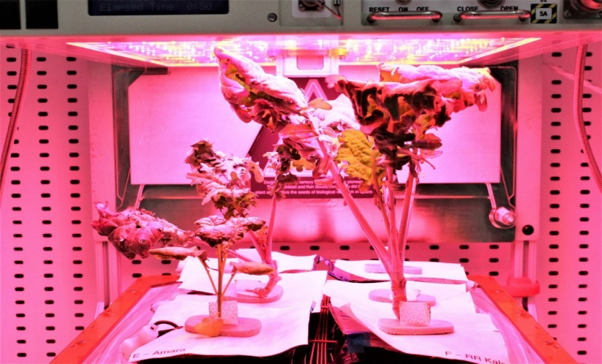

Figure 5. Plant competition in the multiple harvest treatment. *The leaf of an older ‘Red Russian’ kale plant (front right) blocked light from reaching portions of an adjacent, younger ‘Amara’ mustard plant (front left).*

Table 2. Average fresh edible biomass (g plant-1) adjusted to a 56-day growth period. *Values are based on the data presented in Figure 2, scaled to 2 growth cycles of the single harvest treatment and 1 full growth cycle of multiple harvest treatment. ‘Extra Dwarf’ pak choi biomass was higher in the single harvest treatment. ‘Amara’ mustard and ‘Red Russian’ kale were consistent across treatments. ‘Shungiku’ green biomass was unexpectedly low in both harvest treatments, likely due to morphological issues.*

|  |  |  |
| --- | --- | --- |
|  | Harvest Treatment | Fresh Edible Biomass (g plant-1) |
| 'Amara' Mustard | Single | 61.4 |
| Multiple | 62.8 |
| 'Red Russian' Kale | Single | 69.8 |
| Multiple | 69.0 |
| 'Shungiku' Greens | Single | 21.8 |
| Multiple | 30.9 |
| 'Extra Dwarf' Pak Choi | Single | 97.6 |
| Multiple | 46.3 |

Chlorophyll relates to leaf nitrogen content and photosynthetic activity, and anthocyanin, a reddish-blue plant pigment, can indicate plant stress responses.4 Chlorophyll and anthocyanin content can naturally vary by species, and the crops in this study did differ in both chlorophyll (P = 0.01) and anthocyanin contents (P < 0.001) at the crop level (Table 3). Shungiku was lowest in both plant pigments. Harvest treatment did not affect chlorophyll or anthocyanin levels for any tested crop, an indication that all of the tested crops were resilient to potential stress in the multiple harvest treatment that could have been promoted by the intermediate harvests or the longer growth cycle.

# Microbiology

Microbiological testing is an essential part of verifying food safety in produce.5 Previous crops grown in Veggie hardware have been tested microbiologically to both define and minimize the risk to crew members upon consumption.6 This testing has helped to generate a framework of good agricultural practices that aim to lessen the risk of microbial contamination. Regular monitoring is one of the most effective ways to verify that these practices are being utilized properly and are efficacious when followed. The microbial population of a plant can be influenced by several factors, including growth conditions, environmental parameters, available nutrients, and the host plant species.7 For this study, we were interested in testing microbial growth in the VGUs over time and across harvest treatments.

Table 3. Plant health assessment as average chlorophyll (P = 0.01) and anthocyanin (P < 0.001) content per plant with standard error range. *Tukey letters are presented at the crop level. For the multiple harvest treatment, a single value for each plant was obtained by averaging measurements taken across the three harvests. Then, plants from both harvest treatments were averaged at the crop level. (nAmara = 8, nRed Russian = 9, nShungiku = 8, nExtra Dwarf = 8).*

|  |  |  |
| --- | --- | --- |
|  | Chlorophyll | Anthocyanin |
| 'Amara' Mustard | 59.6 + 2.3 b | 15.6 + 0.8 c |
| ‘Red Russian’ Kale | 56.4 + 1.3 ab | 10.6 + 0.5 b |
| ‘Shungiku’ Greens | 49.5 + 4.1 a | 5.9 + 0.7 a |
| ‘Extra Dwarf’ Pak Choi | 60.3 + 2.2 b | 13.1 + 1.2 bc |

All system components were cleaned and sanitized before assembly. Plant pillow materials were sanitized using ethylene oxide (EtO) exposure in accordance with the Center for Disease Control and Prevention’s guidelines for EtO sterilization.8 This includes sterilization in an enclosed, isolated chamber followed by a 24 hour off-gassing period for all pillow materials in a laminar flow hood. Arcillite was covered, autoclaved, and dried at 70°C for 48 hours to remove any residual moisture. Seeds were surface sanitized with bleach + hydrochloric acid gas for 1 hour, followed by a 24-hour off-gassing period. Pillows were assembled in a laminar flow hood wiped with ethanol to minimize the risk of a contamination event. The VGUs were also thoroughly wiped with ethanol. During the experiment, root mats were minimally exposed when removing and introducing pillows, and all components were handled with standard sterile procedures including the use of gloves and wiping hands, surfaces, and all tools with ethanol.

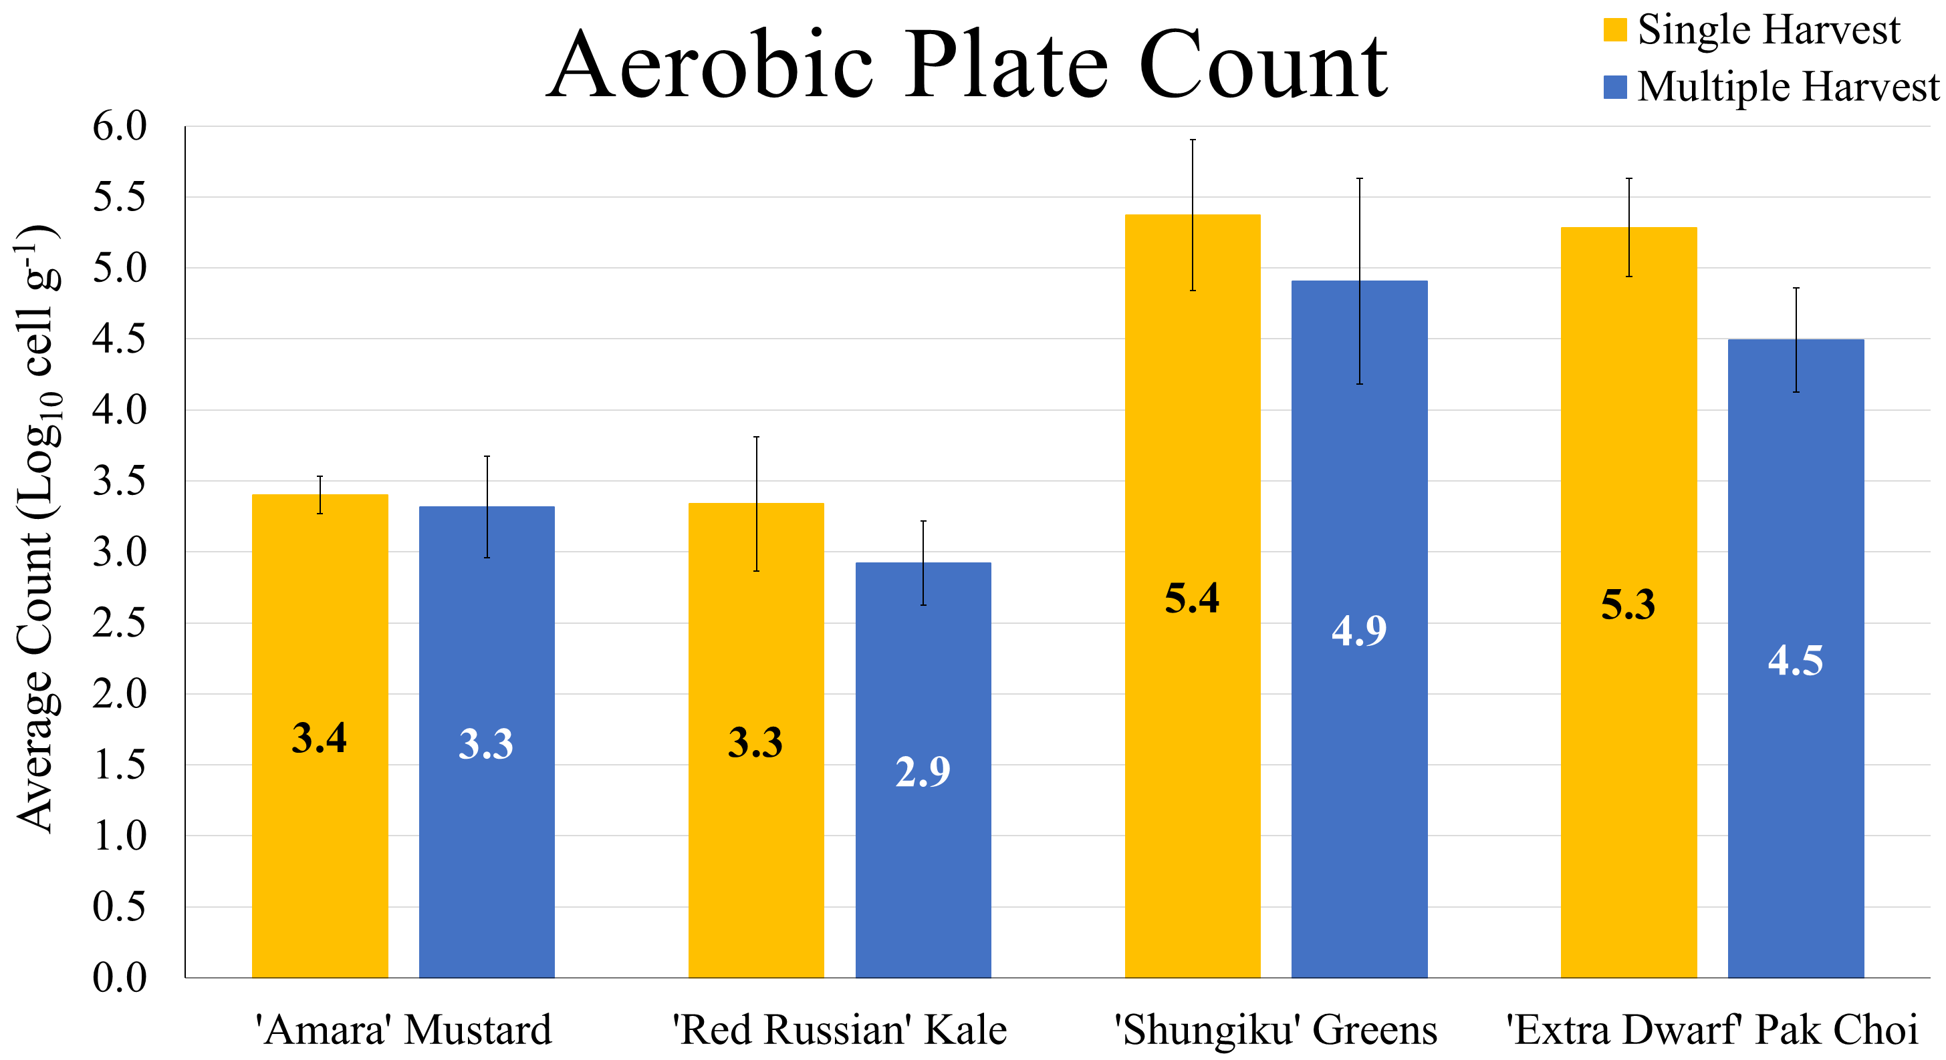

Figure 6. Average aerobic plate count (APC; Log10 cfu g-1) for the single and multiple harvest treatments increased across cropping pairs (P < 0.005). *No harvest treatment effect. Standard error bars shown.*

Plant samples were collected at each harvest event for both harvest treatments, where half of the edible biomass was placed into sterile mixing bags. Samples were then mixed for 2 minutes using a 1:10 mass-to-volume ratio of buffered peptone water. After mixing, samples were serially diluted, and the 3 highest dilutions were plated in duplicate on tryptic soy agar (TSA) for aerobic plate counts (APC) and inhibitory mold agar (IMA) for yeast and mold counts (Y&M). The agar plates were incubated for 48 and 120 hours, respectively, at 35°C. Additionally, mix sample effluent was plated on specialized petrifilm media to screen for *Escherichia coli* and *Staphylococcus aureus*.

Environmental swabs were collected at 8, 42, 78, and 120 DAI at designated positions on the bellows, cabin fan screen, and outlet duct. Swabs were placed into culture tubes of phosphate-buffered saline (PBS) and 3% Tween-80, and then vortexed for 30 seconds to dislodge cells from the swab surface. Vortexed samples were serially diluted using PBS as a dilution buffer. The 3 highest dilutions were plated using the same methods and incubation periods described above.

All plant samples and environmental swabs were negative for *E. coli* and *S. aureus.* Some samples had positive coliform petrifilms; these colonies were isolated and identified as native plant species such as *Enterobacter cloacae*. APC for ‘Shungiku’ greens and ‘Extra Dwarf’ pak choi were higher than average for both the single (µ = 4.3 Log10 cell g-1) and multiple harvest (3.9 Log10 cell g-1) treatments (P < 0.005; Figure 6). Conversely, the ‘Amara’ mustard and ‘Red Russian’ kale were below average for both harvest treatments. We preliminarily attribute this more to an increase in counts throughout the study than the crops themselves.

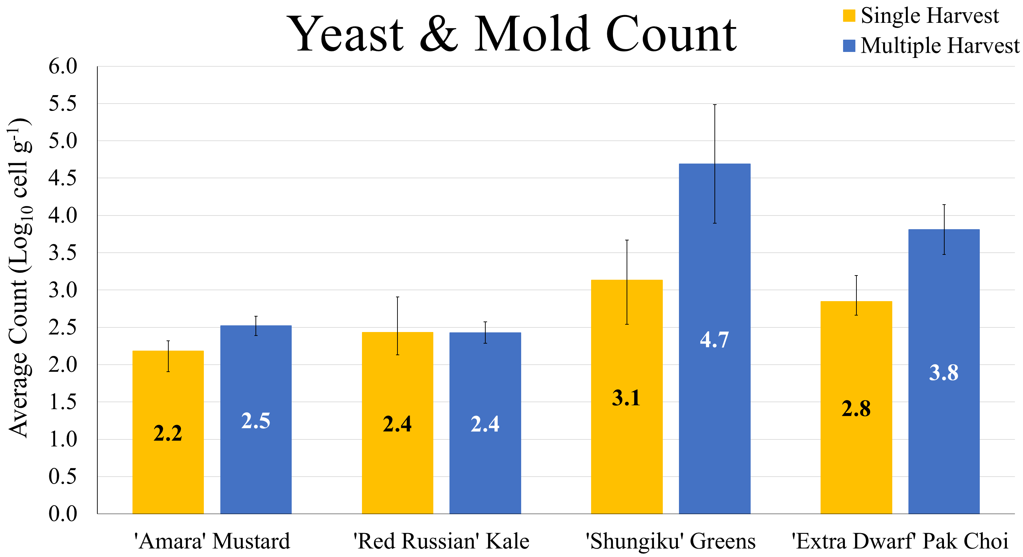

Figure 7. Yeast and mold (Y&M) count (Log10 cfu g-1) for the single and multiple harvest treatments. Plate counts increased across cropping pairs (P < 0.005), and was also higher for the multiple harvest treatment (P = 0.02). No significant interaction effect. Standard error bars shown.

For both harvest treatments, Y&M were also higher than average (µsingle harvest = 2.6 Log10 cfu g-1; µmultiple harvest = 3.4 Log10 cfu g-1) for ‘Shungiku’ greens and ‘Extra Dwarf’ pak choi than ‘Amara’ mustard and ‘Red Russian’ kale (P < 0.05; Figure 7). We again preliminarily attribute this to microbial growth over time. Y&M was also higher in the multiple harvest treatment for the latter pair of crops (P = 0.02).

Currently, VGUs and plants are not cleaned during use. As we look to produce crops consistently, regular cleaning procedures will need to be developed to avoid a potential food safety concern. Facilities are susceptible to microbial growth over time, and older plants are even more susceptible. More research is needed to determine the long-term growth pattern of microbes in VGUs, which could identify the time points at which regular cleaning would be needed.

# Waste Stream

Plant harvest index and water consumption were assessed to better understand the amount of waste generated in both harvest treatments. The remaining half of harvested edible biomass was dried for 72 hours at 70°C. Completed pillows were carefully opened and poured into a large beaker, with care taken to ensure roots did not desiccate. Root biomass was separated from the arcillite using a root washing treatment, weighed as fresh inedible biomass, and dried. Edible and inedible biomass was weighed when dry to determine the plant water content.

Fresh edible biomass from ‘Amara’ mustard, ‘Red Russian’ kale, and ‘Extra Dwarf’ pak choi ranged from 90-91% and 78-85% in the single and multiple harvest treatments, respectively (Figure 8). ‘Shungiku’ greens averaged 72% and 47%, respectively. The lower ratio of edible: inedible in the multiple harvest treatment may indicate how leafy green crops allocate resources for growth as the plants age.

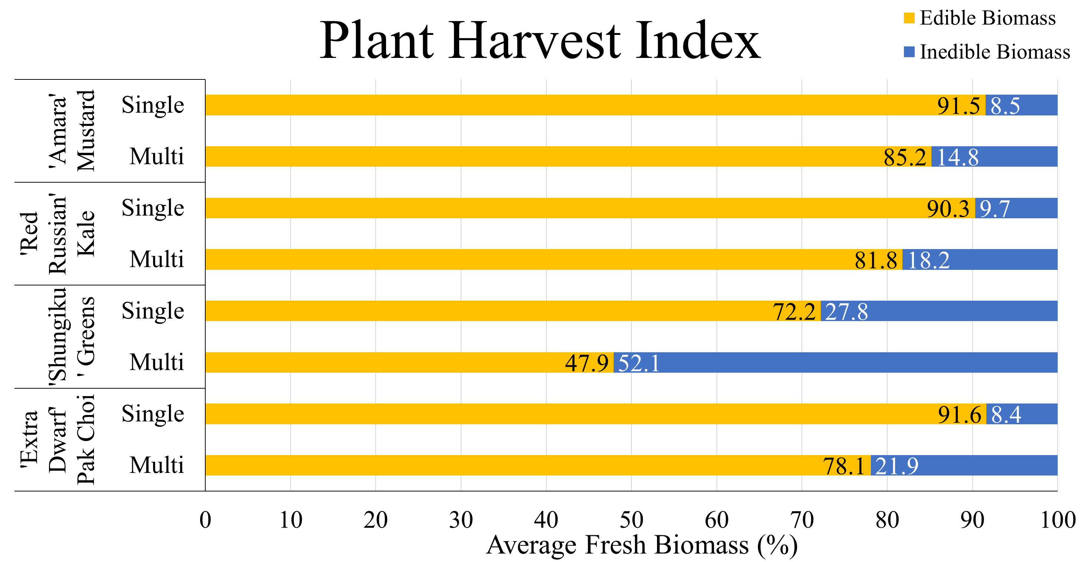

Figure 8. Average fresh edible and inedible biomass (%). *Edible biomass was slightly higher in the single harvest treatment. (‘Amara’ mustard: nsingle = 5, nmultiple = 3; ‘Red Russian’ kale: nsingle = 6, nmultiple = 3; ‘Shungiku’ greens: nsingle = 5, nmultiple = 3; ‘Extra Dwarf’ pak choi: nsingle = 5, nmultiple = 3).*

On orbit, concluded plant pillows are either returned to Earth for science sampling or trashed with root mats. Single-use components require payload space and contribute to launch mass without the ability to be reused. One way to quantify the extent of this system inefficiency is an input-output analysis across harvest treatments. In this study, the single harvest treatment used 24 pillows, including 2 pillows with failed plant establishment; the multiple harvest treatment used 13 pillows, including 1 pillow with failed plant establishment. Failed pillows are a current reality in Veggie hardware, so having spare pillows available would be vital for maintaining regularly available fresh produce. At initiation, each pillow weighs approximately 198 g. For this 120-day grow-out, the single harvest treatment used 4.8 kg, while the multiple harvest treatment used 2.6 kg in consumable hardware – 46% less than the single harvest treatment. It is worth noting that this efficiency gap is specific to Veggie and future sustained production systems will be more similar to terrestrial sustained production systems utilizing hydroponic methods and plugs similar to rockwool or oasis foam. These systems will have to conform to more stringent basal requirements resulting in an overall lower consumable hardware mass regardless of harvest method.

Table 4. Average water use efficiency per pillow over a 56-day growth period. *Average water use per pillow in the single harvest treatment was doubled to scale to 56 growing days. Water use includes amounts added to plant pillows only (L); water added to root mats is excluded. Biomass index compares how much more water was required to produce 1g fresh edible biomass in the multiple harvest treatment than the single harvest treatment.*

|  |  |  |  |  |
| --- | --- | --- | --- | --- |
|  | Harvest Treatment | Water Use (L 56 days-1 pillow-1) | Water per Fresh Edible Biomass (L g-1) | Biomass Index |
| 'Amara' Mustard | Single | 2.1 | 35 |  |
| Multiple | 2.2 | 35 | 1.0 |
| 'Red Russian' Kale | Single | 1.9 | 28 |  |
| Multiple | 2.3 | 34 | 1.2 |
| 'Shungiku' Greens | Single | 1.3 | 62 |  |
| Multiple | 1.4 | 45 | 0.7 |
| 'Extra Dwarf' Pak Choi | Single | 1.7 | 17 |  |
| Multiple | 1.6 | 34 | 2.0 |

In a closed system like the ISS, water use is also an area of potential inefficiency. Water use across harvest treatments differed by crop. Both harvest treatments were watered 1.8 L to the root mat throughout the study (600 mL each on 0, 28, and 71 DAI). On average, ‘Extra Dwarf’ pak choi pillows in the multiple harvest treatment needed twice the amount of water than the single harvest treatment to produce 1 g of edible fresh biomass (Table 4). ‘Red Russian’ kale used 20% more water in the multiple harvest treatment than the single harvest treatment to produce 1 g of fresh edible biomass, while ‘Shungiku’ greens used 70% less water. ‘Amara’ mustard used water consistently across treatments.

Whereas water use is more dependent upon the individual crop species than the harvest treatment, there is a trade-off with consumable hardware. Growth time being equal, leafy crops grown under a single harvest technique can potentially yield more edible fresh biomass but may require more plant pillow hardware to achieve this.

# Crew Time

Crew time required for continuous plant growth operation included hardware setup, maintenance, and cleanup; pillow initiation; daily plant checks and watering pillows and root mats; opening wicks 3 days after pillow initiation to encourage seedling establishment; plant thinning; harvest; and estimated plant sanitization (Table 5). Harvest time estimates exclude data collection activities that would not occur on-orbit. Current flight activities excluded from Table 6 are crew questionnaires and taste test surveys.

Table 5. Crew time estimates (minutes) for the single and multiple harvest treatments over a 120-day production period.

|  |  |  |
| --- | --- | --- |
| Task | Single | Multiple |
| Hardware | 370 | 465 |
| Pillow Initiation | 360 | 180 |
| Plant Checks & Watering | 1,470 | 1,470 |
| Wick Opening | 40 | 20 |
| Plant Thinning | 50 | 25 |
| Harvest | 420 | 715 |
| Plant Sanitization | 60 | 90 |
| Total | 2,770 | 2,965 |

# Roots typically grow through the bottom of the plant pillows in search of either water or oxygen, and these roots often venture underneath adjacent pillows. Removing and replacing pillows less frequently contributed to a greater buildup of material, so the multiple harvest treatment required more hardware maintenance time to routinely remove roots from the root mats. Plant initiation, wick opening, and plant thinning required twice the amount of time in the single harvest treatment due to the higher turnover rate of plants. Harvest and plant sanitization estimates were more time-intensive activities in the multiple harvest treatment due to the intermediate harvests. Finally, plant checks and watering time estimates were similar across treatments. Overall, continuously producing crops under a single harvest technique required approximately 200 fewer hours than crops grown under a multiple harvest technique for 4 months.Harvest Treatment Summary

Table 6. Summary table of total fresh edible biomass (g) produced in the single and multiple harvest treatments, with respect to total water added to pillows (L), total pillow hardware used (kg), and total crew time required (h) in each treatment. (nsingle = 22, nmultiple = 12).

|  |  |  |  |
| --- | --- | --- | --- |
|  | Fresh Edible Biomass per Water Use (g L-1) | Fresh Edible Biomass per Pillow Hardware (g kg-1) | Fresh Edible Biomass per Crew Time (g h-1) |
| Single | 37.6 | 145.6 | 13.7 |
| Multiple | 26.4 | 253.5 | 12.2 |

Across the 120-day study, the single harvest treatment produced a greater sum of fresh edible biomass (634 g) than the multiple harvest treatment (602 g). Further, the single harvest treatment was more efficient at producing fresh edible biomass with consumables like water and crew time, but the multiple harvest treatment required less overall pillow hardware (Table 6). However, this hardware metric is largely an aspect of Veggie and the current practice of sending pillows to orbit. In the future, a sustained production system will ideally integrate systems and techniques that require minimal single-use plant hardware.

# Discussion & Potential Future Research:

This work was a ground study to compare the effects of 2 different harvest treatments on plant production and health, microbiological activity from a food safety perspective, plant biomass efficiency and consumable waste, and potential crew involvement. This study further helped to create a baseline to help determine future hardware requirements and potential improvements. Pillows containing 4 different crops were initiated in waves to simulate a weekly harvest of plant biomass for crew consumption.

This work provides a baseline using the VGU and pillow system. This baseline can be used as a comparison point to test resource trades and crop quality and nutrition improvements as systems mature. Repeating this work with this system would have multiple benefits. First, switching harvest treatments in VGUs and crop pair order will help determine hardware effects and limit confounding factors. Second, repeating this study would allow for further investigation into the magnitude of plant competition, such as using other cropping designs and using hyperspectral imaging on the plants. Third, growing crops concurrently instead of staggered could further minimize plant competition and help predict the scalability required for continuous food production in spaceflight or on the lunar or Martian surface. Fourth, due to the low number of plants harvested each week, we were unable to conduct elemental (Ca, Fe, K, Mg, P, S), vitamin (B1, C, K), and proximate (calories, fat, carbohydrates, ash, protein, moisture) analyses. Working with more crops grown together would help ensure that enough biomass could be collected weekly to complete this task.

In this study, microbiological trends of interest included, first, the anchor crops having higher average microbial counts on both aerobic and yeast and mold plates and, second, the harvest method averages following the same trend, where the multiple harvest treatment had higher counts. Currently, it is impossible to say whether the high counts in the anchor crops were due to a higher innate population, higher susceptibility to microbial activity, or due to pre-existing systemic colonization of microbes during the first set of crops. Another round of testing could provide sufficient data for further statistical analyses, as well as demonstrating whether these trends are reproducible.

Consumable waste stream and water use could be studied in greater detail. For example, weighing plant pillows and root mats post-harvest would help determine how much water would theoretically be removed from the closed ISS system. Having more complete end measurements can better define the fate of water as available for consumption by crew members, as humidity recaptured by ISS hardware, or removed from the system as water tied up in discarded Veggie hardware.

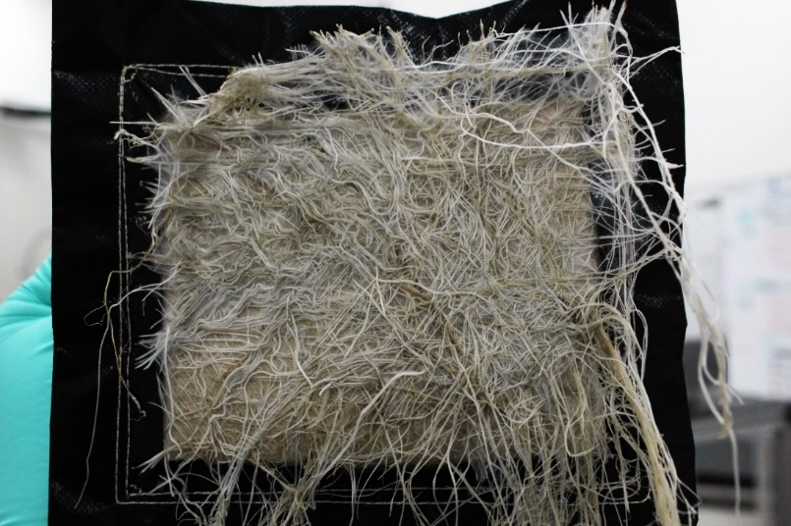

Figure 9. Roots created thick mats on pillow bottoms. The effect was exaggerated in the multiple harvest treatment where pillows were in place for 56 days. The roots on the bottom of this pillow were not exclusive to this plant.

Finally, root growth through plant pillow bottoms has been a non-issue in prior Veggie studies because all pillows have been initiated and harvested as a set. However, as pillows were individually removed and replaced in this study, roots from a completed pillow would detach and remain beneath adjacent pillows. The detached roots posed 3 issues. First, detached roots in a wet environment could begin to decay, potentially creating a food safety hazard as well as unpleasant odors. Second, root biomass was an important variable for calculating the plant harvest index. Being unable to properly remove, identify, and weigh a plant’s roots created a data gap. While the roots removed from the mat in the single harvest treatment totaled only 0.1 g fresh mass due to the regular pillow rotation, the roots in the multiple harvest treatment totaled 12 g fresh mass. Root buildup beneath the pillows in the multiple harvest treatment grew so densely that the permeable pillow bottoms were entirely covered (Figure 9). Third, if a staggered cropping design were implemented in spaceflight, regularly removing these roots would help minimize the aforementioned issues. However, a new, tedious procedure would have to be written, tested, and ensured that the crew could perform this frequently enough.

# Conclusion

Continuous leafy green production is achievable in Veggie hardware. This Sustained Veggie study identified areas of concern, such as potential hardware incompatibility of ‘Shungiku’ greens, and challenges for implementing this in spaceflight. New procedures for routine hardware cleaning would be vital for maintaining the low risk for food safety contaminants and odors, especially if production exceeded the tested 120-day duration.

This study also successfully established baseline performance metrics and identified numerous areas for future research. In addition to verifying ‘Amara’ mustard as a potential new crop for spaceflight, the data showed that current leafy green production in VGUs, which uses a single harvest technique, continues to be a viable option. The main tradeoff associated with the single harvest technique is the greater requirement of consumable hardware, whereas the multiple harvest technique requires more crew time, potentially increases overall microbial load over time, and is less effective at producing fresh edible biomass given the same amount of resources.

However, repeating this study would be valuable for achieving the following: eliminate confounding factors, extend the continuous test, verify the source of microbial growth over time, determine if microbial growth plateaus or alternative cleaning protocols solve this issue, conduct plant nutrition analyses, retest this cropping system design or an alternative design that could further minimize plant competition, determine routine hardware cleaning procedures, complete waste stream calculations, and look for areas of improved crew time.

# Acknowledgments

This work was funded by the NASA Human Research Program.

# References

1Cooper M, Perchonok M, Douglas G.L., “Initial assessment of the nutritional quality of the space food system over three years of ambient storage,” *npj Microgravity*, Vol. 3, No. 17, 2017.

2Massa G.D., Wheeler R.M., Stutte G.W., Richards J.T., Spencer L.E., Hummerick M.E., Douglas G.L., Sirmons T., “Selection of leafy green vegetable varieties for a pick-and-eat diet supplement on ISS,” International Conference on Environmental Systems Technical Paper, ICES-2015-252. 2015.

3Perchonok M.H., Cooper M.R., Catauro P.M., “Mission to mars: food production and processing for the final frontier,” *Annual Review of Food Science and Technology*, Vol. 3:311-330, E-published 28 Nov 2011.

4Chalker-Scott, L., “Environmental significance of anthocyanins in plant stress responses,” *Photochemisty and Photobiology* Vol. 70, No. 1, pp 1-9, 1999

5United Fresh Produce Association Food Safety & Technology Council, “White paper on microbiological testing of fresh produce,” [online white paper] 21 April, 2010.

6Khodadad C.L.M., Hummerick M.E., Spencer L.E., Dixit A.R., Richards J.T., Romeyn M.W., Smith T.M., Wheeler R.M., Massa G.D., “Microbiological and nutritional analysis of lettuce crops grown on the International Space Station,” *Frontiers in Plant Science*, Vol. 11, pp 199. 2020.

7Lindow S.E., Brandl M.T., “Microbiology of the phyllosphere,” *Applied Environmental Microbiology*, Vol. 69, pp 1875-1883, 2003.

8Rutala, W.A, Weber, D.J., “Guideline for Disinfection and Sterilization in Healthcare Facilities,” *Centers for Disease Control.* 2008.

1. Scientist II, Professional and Technical Services/Mail Code: LASSO-008.
2. Scientist II, Professional and Technical Services/Mail Code: LASSO-008.
3. Space Crop Production Scientist, ISS Utilization and Life Sciences/Mail Code: UB-A.