Austin Health & Air Quality
Identifying Communities Most Susceptible to Heat Exposure
in Austin, Texas using NASA Earth Observations


Technical Report
Final – April 2, 2021

Margaret McCall (Project Lead)
Alexa Lopez
Will Peters
James Sanders

Advisors:
Dr. David Hondula, Arizona State University (Science Advisor)

1. Abstract
In recent years, Austin, Texas has experienced an increase in population and urban development. Additionally, the City’s climate continues to change and currently faces extreme heat and drought. As temperatures and demand for utilities and resources rise, the number of heat-related deaths and illnesses in socially vulnerable populations (e.g., older or lower-income populations) are expected to increase. The City of Austin, The University of Texas at Austin (UT Austin), and The University of Texas Health Science Center at Houston (UT Health) partnered with NASA DEVELOP to examine the distribution of urban heat throughout the City. This project utilized land surface temperature, greenness, plant water content, and urban surface material analysis parameters derived from NASA Earth observations from Landsat 8 Operational Land Imager (OLI), Landsat 8 Thermal Infrared Sensor (TIRS), and Aqua Moderate Resolution Imaging Spectroradiometer (MODIS). The DEVELOP team created a sharable geodatabase mapping heat exposure severity, areas of high social vulnerability, and an overall heat priority score. This overall score was determined with a weighted analysis of heat-related observations and socioeconomic data. The team tested the sensitivity of this score to a wide range of parameter decisions, such as which social variables were included. This heat priority index can be used to make informed infrastructure improvement plans in targeted areas (e.g., siting of cooling centers) and ensure equitable sustainable development.
Key Terms
remote sensing, urban heat island, socio-economic vulnerability, land surface temperature, heat vulnerability

2. Introduction
2.1 Background Information
Austin is the capital of Texas, the fourth-largest city in the state, and is located within the counties of Travis, Hays, and Williamson (Figure 1). Based on the Köppen Climate Classification, Austin has a humid subtropical climate with long, hot summers and short, mild winters (Zhao, 2018). Average high temperatures occur in July-August and range from 34°C - 36°C (93.2°F - 96.8°F), though daily highs can exceed over 37°C (98.6°F) during the summer. In 1970, the metro region of Austin was already a state capital and university center and had a population of 400,000. By 2018, Austin had a population of 2.1 million and was also a major center of high-technology employment and innovation. The low unemployment rate and high quality of life help contribute to a rapidly increasing population. In 2014, Austin experienced a 2.5% population growth and 5.9% economic expansion and is ranked among the top 20 fastest-growing cities in the U.S. in recent years (Brennan 2013).

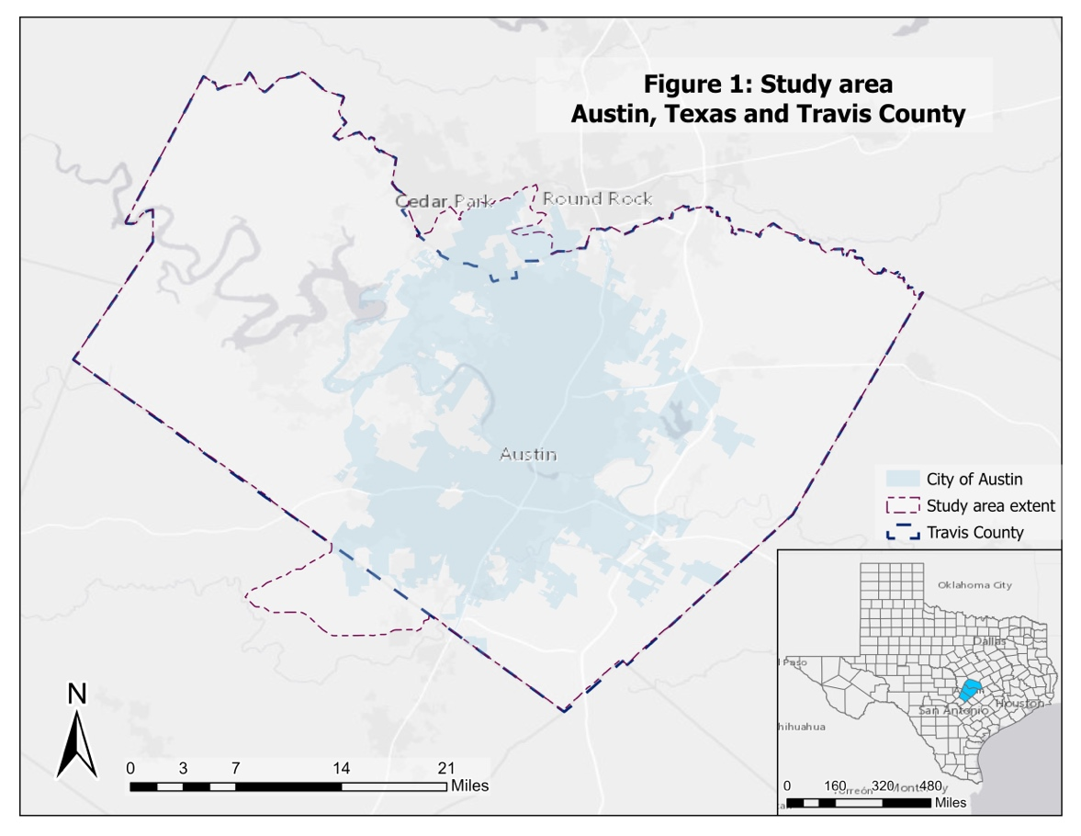
Figure 1. Map depicting the study area which includes the City of Austin and Travis County. Data taken from City of Austin (https://data.austintexas.gov/) for the city boundaries, and Texas Department of Transportation (TxDOT) (https://gis-txdot.opendata)
This rapid urbanization causes land use changes, modifying the energy balance in cities, and in turn, affecting the urban thermal environment. This results in the urban heat island (UHI) phenomenon, in which urban areas have higher air and surface temperature than their rural surroundings (Yoo, 2018). Extreme heat has been documented to disproportionally affect Austin’s most vulnerable communities like those in the eastern portions of the City (NIHHIS, 2020). These communities have been stressed by limited resources, growth pressures, and higher rates of chronic disease; heat will only exacerbate these stressors (NIHHIS, 2020). Certain populations are more susceptible to heat than others, due to inherent physical factors such as age and health. At the same time, people can have a lower capacity to cope with heat due to social or economic factors. Rapid twenty-first-century urbanization is a contributing factor of anthropogenic climate change, which is significantly increasing heat-related health threats in cities worldwide. Partnerships between city policymakers and scientists are becoming more important as the need to provide data-driven recommendations for sustainability and mitigation efforts becomes critical. UHIs are a public health risk and a utility burden on cities; therefore, mitigating them has become of interest for most city decision-makers (Mayer et al., 2018).

Satellite remote sensing is a leading tool for studying urban land surface temperature (LST). This approach can quantify the magnitude of the UHI effect across all permutations of urban surface temperature gradients and complexity (Wetherley et al., 2018). LST and air temperature are different but related measures; therefore, the higher-resolution LST data that can be derived from some satellites can supplement air temperature measurements from ground stations, which are sparse and alone are inadequate for representing fine-scale temperature gradients. This sparsity usually leads to an underestimation of temperature effects (Chen et al., 2018). Various satellite-based sensors have been used to estimate LST with thermal infrared bands, from coarse to fine spatial resolution (Zhao, 2018). However, satellite data in the visible and near-infrared wavelengths are available at resolutions an order of magnitude higher than in the thermal-infrared, and hence provide higher-resolution information on vegetation cover conditions (Zakšek & Oštir, 2012). Previous research has demonstrated a strong relationship between the Normalized Difference Vegetation Index (NDVI) and air surface temperature in temperate cities (Gallo et al., 1993; Lo et al., 1997; Pearsall, 2017; Weng et al., 2004). Other environmental factors, such as the Normalized Difference Built-Up Index (NDBI) and albedo, are added to UHI analysis to further represent LST in urban settings (Davis, Jung, Pijanowski, & Minor, 2016). In this study, we use DBI — dry-built up index — instead of NDBI, since DBI is a more accurate identifier of built-up materials in this study area than NDBI. Multiple studies of urban vegetation indicate its potential for reducing local surface temperatures (Cao et al., 2010; Gill et al., 2007; Li et al., 2013; Lu et al., 2012; Pearsall, 2017; Yokohari et al., 2001) and green spaces can greatly offset the effects of urban-induced warming by reducing heating through shade and evapotranspiration (Pearsall, 2017, Wong et al., 2011).
2.2 Project Partners & Objectives
The spring 2021 NASA DEVELOP Arizona node partnered with the City of Austin to combine NASA Earth observation data with socioeconomic indicators to address UHIs and environmental equity in Austin. The team utilized these data to identify communities that are most vulnerable to heat hazards, such adverse health effects resulting from heat, in the City of Austin. A principal component analysis (PCA) was used to create a heat exposure index using environmental variables, a heat vulnerability score from socioeconomic variables, and a heat priority score from all variables. Working with guidance and suggested strategies from The University of Texas at Austin’s Jackson School of Geosciences (UT Austin) and The University of Texas Health Science Center at Houston’s School of Public Health (UT Health), the team provided the City of Austin with the heat indices created in the project, as well as a StoryMap and online geodatabase. These tools provided by NASA DEVELOP will be used in the additional mapping of UHI to continue the monitoring of vulnerable communities and hot spots in Austin according to the strategies listed in the City’s Climate Resilience Action Plan.

3. Methodology
3.1 Methodological Approach
The focus of this project was to identify communities in Austin at particular risk of adverse effects from extreme heat. We created three indices to identify the most at-risk neighborhoods from environmental and socioeconomic variables. An index-based approach has the advantage of being transparent in terms of input data and is easy for city officials to use in decision-making. We produced three separate indices: a heat exposure index (HEI, from environmental variables), a heat vulnerability index (HVI, from socioeconomic variables), and a heat priority index (HPI, from all variables). Detail on our analytical approach is provided in section 3.4. Although the HPI integrated metric is likely the most useful for city decision-making our team provided all three measures to allow the contribution of each to be weighed and analyzed separately.

The six environmental variables included in the baseline exposure index were as follows: daytime and nighttime LST; normalized difference vegetative index (NDVI), dry built-up index (DBI), normalized difference water index (NDWI), and albedo. The 28 social variables included in the baseline vulnerability index are included in Appendix A. The team followed the methodology used in UT Austin’s Austin Area Sustainability Indicators (A2SI) project, which employed an updated version of the social vulnerability index developed by Cutter et al. (2003). This updated social vulnerability index is called SoVI® 2010-14.

3.2 Data Acquisition
Table 1 describes NASA Earth observation data used in this work. Earth observation products from Landsat 8 Operational Land Imager and Thermal Infrared Sensors and Aqua MODIS were accessed using Google Earth Engine. The study area was the union of 605 census block groups in the City of Austin and Travis County. All available images without cloud coverage were selected from April 1st to September 30th, which constitutes the summer and its shoulder months which are times where heat exposure is most hazardous to vulnerable communities. The study used data from the years 2015-2020. 61 Landsat images and 1098 MODIS images were used.

Table 1
NASA Earth observation data used
Platform & Sensor | Data Product | Parameters | Use | Source
Landsat 8 OLI & TIRS | LANDSAT/LC08/C01/T1_SR | NDVI, albedo, DBI, LST | NDVI was used to map the existing vegetation coverage in the study area over a five-year period. Albedo measures the reflection of light off a given surface. This is used for NDBI to map impervious surfaces. LST functioned as a proxy for urban heat measured at a city-wide scale of 30-100 m resolution | USGS
Aqua MODIS | MODIS/006/MYDOCG | Nighttime LST, NDWI | Nighttime LST shows urban heat exposure at night. NDWI is used as a method to differentiate water from dry land and is useful in mapping vegetation due to water content found in plants. | NASA LP DAAC at the USGS EROS Center (Vermot & Wolfe, 2015)

Table 2 describes the socioeconomic data used in this work, as well as the geographic boundary data used to identify the relevant socioeconomic data. The social variables were obtained from the American Community Survey (ACS) using the tidycensus package in R. They were taken from the 2019 version of the ACS, reflecting estimated values over the past five years. Data was obtained both at the block group and at the tract level. Table 2 also describes other ancillary datasets used for sensitivity analyses, rather than in the baseline study.

Table 2
Ancillary data used
Dataset | Data Type | Use | Source
ACS 2019 | Socioeconomic data at the block group and tract level | Established social vulnerability components of indices. | United States Census Bureau
2018 Urban Tree Canopy | Raster layer | Indicated locations where trees are present, suggesting cooler temperatures. Can be weighted when measuring heat exposure | City of Austin
City of Austin boundary | Polygon shapefile | Clipping boundary for earth observation imagery to the study area | City of Austin
Texas county boundaries | Polygon shapefile | Combined with city boundary to make up study area | United States Census Bureau
Texas census tracts and block groups | Polygon shapefile | Boundary for heat exposure mapping to the community level and applications of socioeconomic data | United States Census Bureau
In situ meteorological measurements | Point shapefile, raster layer | Shows a snapshot of street level air temperatures at 6-7am, 12-1pm and 6-7pm on August 7th, 2020. Used as a comparison to the derived heat maps by DEVELOP | CAPA Strategies, LLC
LiDAR data | Raster digital elevation models | Key input when creating the hillshade of the study area to be used in the UHI model | Texas Natural Resources Information System (TNRIS)

3.3 Data Processing
The environmental variables calculated from the NASA Earth Observation data are described in detail in Appendix B. The social variables used in the analysis did not exist explicitly in the American Community Survey, so we had to create most of them through combining several variables. This is described in detail in Appendix C. There were two social variables—median rent and median home value—for which roughly 8% of block groups were missing data for one or the other of these variables, likely due to the fact that areas with high rates of rentership may lack data on home value, and vice versa—areas with mostly home ownership may lack data on rent. To avoid having to drop either these block groups or these variables from our analysis, we filled in the missing values with estimates by using a spatial k-nearest-neighbors approach. We took the average of the rent (or the home value) of the closest 5 block groups (determined based on distance between block group centroids) to fill in missing values.

3.4 Data Analysis
3.4.1 Index creation
The starting point for our analysis and index creation was the A2SI project, which assesses heat risk by combining a social vulnerability index and a heat hazard exposure score. Previous NASA DEVELOP teams have also employed heat vulnerability indices, particularly the fall 2020 Tempe Urban Development II team and the spring 2020 Philadelphia Health & Air Quality team. In this project, our team combined the aforementioned A2SI and DEVELOP approaches, incorporating NASA Earth observations into the heat exposure approach (see Table 3).

Table 3
A2SI and NASA DEVELOP index comparison
Element | A2SI approach | NASA DEVELOP approach
Social variables | 29 | 29 (using A2SI approach)
Social index creation | PCA | PCA
Environmental (heat) variables | 2 | 6+
Environmental (heat) index creation | Imperviousness – 0.1 * tree canopy | PCA
Overall index creation | Scaling social vulnerability index by environmental score | PCA with all variables
Scale | Census block group | Census block group

Our index was based on principal component analysis (PCA). PCA is a method of statistical analysis that identifies the dimensions of greatest variability among a group of variables, allowing them to be summarized by a smaller number of dimensions. As such, PCA is “widely used in empirical applications as an aggregating technique…to formulate an index to capture the latent or unobservable underlying concept.” (Pasha et al., 2017). PCA has been used to create social vulnerability (Cutter et al., 2003) and poverty (Pasha et al., 2017) indices, as well as indices that specifically address vulnerability to heat (Harlan et al., 2013; Boogaard et al., 2020 DEVELOP; Nisbet-Wilcox et al., 2020 DEVELOP).

Our team conducted the PCA in R, following the same procedure for each of our three indices. We took the median values of the environmental variables from the filtered images, and took the mean for each census block group as the database for the PCA. Before performing the PCA, the team transformed all input variables to z-scores (mean = 0, standard deviation = 1) to make variables with different units and ranges more comparable to one another. We used the psych package in R to perform the PCA with a varimax rotation. For the HEI and HPI, we selected the minimum number of components necessary to account for 80% of the variation in the data. However, while this criterion suggested we should have selected seven components for the HVI, we instead only selected six to replicate the A2SI approach.

Next, we looked at the component loadings and decided whether that component would increase or decrease vulnerability. We then multiplied any components where higher values were associated with lower vulnerability by –1, such that for all components, a higher score indicated higher vulnerability. For example, since higher daytime LST is known to increase heat vulnerability, the component containing daytime LST should be multiplied such that the loading coefficient for daytime LST in that component is positive.
To minimize the effect of outliers, the scores from the PCA for each component for each block group were then transformed into an integer from 1 to 6, where 1 corresponds to a score <2 standard deviations below the mean, 2 corresponds to a score <1 and >2 standard deviations below the mean, and so on, following the technique from Reid, 2009.

Next, the component scores were weighted by the amount of variance their respective component explained within the data since we assumed that a component that explained more of the variance within the data was more significant. This increased the weight placed on the first few principal components.
Finally, for each block group, the scores from all the components were added together to give the overall score for the index. This score was normalized from 0-1 for ease of interpretation. Block groups that had a score in the highest quintile were flagged as being the most vulnerable.

3.4.2 Sensitivity Analysis
In order to test the robustness of our baseline index to different assumptions, the team performed an array of sensitivity analyses. The team performed sensitivity analysis by varying elements of our model as explained in Table 4.

Table 4
Modeling elements used in the sensitivity analysis
Sensitivity analysis | Model element varied | Detail on model element
Social variables and modeling approach  The team conducted a Monte Carlo analysis that varied inputs to our model along 7 dimensions | Social input data | Randomizing input data based on measured standard errors from the American Community Survey
 | Social input variables | Including SoVI variables or Reid variables—see Appendies A and H. The Reid variables are pulled from Reid et al., 2009—this is a smaller subset of social variables that are meant to reflect heat vulnerability specifically, rather than social vulnerability overall.)
 | Census geography | Conducting analysis at block group or tract level
 | Including health data | Y/N
 | Cutoff level of variance to use to select the number of components for the principal component analysis | Selecting random value in the range 0.65 – 0.8
 | Transforming component scores to integers from 1-6 before summing | Y/N
 | Weighting component scores by the amount of variance component explains in the data | Y/N
 | Mathematical construction of final index | Using PCA, adding environmental and social scores, or multiplying environmental and social scores
Environmental variables  The team varied the environmental inputs to our model in 2 ways. This variation also could have been included in the Monte Carlo analysis, but data limitations (i.e., data not covering the whole study area) and time limitations prevented that approach | Adding additional environmental variables | The following new variables were included beyond the baseline: 1) air temperature, 2) tree canopy, 3) shading. These variables were only available in an area of East Austin
 | Accounting for population distribution in environmental variables | We used high-resolution population data to explore the impact of only analyzing environmental variables at the precise location where people live—especially in rural areas and large census block groups, this approach can filter out environmental data that may not be relevant to people’s lived experiences

We used a consistent approach to compare each sensitivity scenario to the baseline. Our approach for comparing sensitivity scenarios to the baseline scenario is drawn from Turek-Hankins et al. (2020) and focuses on understanding how neighborhoods in the top quintile of scores vary depending on the approach taken—e.g., of the ~120 census block groups with the top heat priority index at baseline, how many of those are still identified in the top quintile in the sensitivity scenario—and, therefore, how many new block groups are now identified that were not identified before? Mathematically, we performed this comparison by calculating the block groups which appear in the top quintile in both the sensitivity analysis and the baseline scenario as a percentage of the total block groups.

4. Results & Discussion

4.1 Analysis of Results
4.1.1 Study Results
The three indices that comprise the study results are most easily represented as maps, all shown in Figure 2 The HEI and the SoVI, because they only contain a subset of all variables used in the analysis, can be viewed as secondary results, whereas the HPI can be viewed as the primary result. The HEI represents the cumulative impact of all environmental factors in the model that contribute to heat exposure. The central urban areas of Austin are highlighted in this map, as would be expected given the presence of heat-retaining materials like concrete. The SoVI represents the cumulative impact of all social factors in the model that contribute to social vulnerability. Broadly speaking, the eastern half of the study area appears as more vulnerable (having a higher SoVI index), and the western half is less so. This result generally corresponds with the on-the-ground knowledge from our partners.

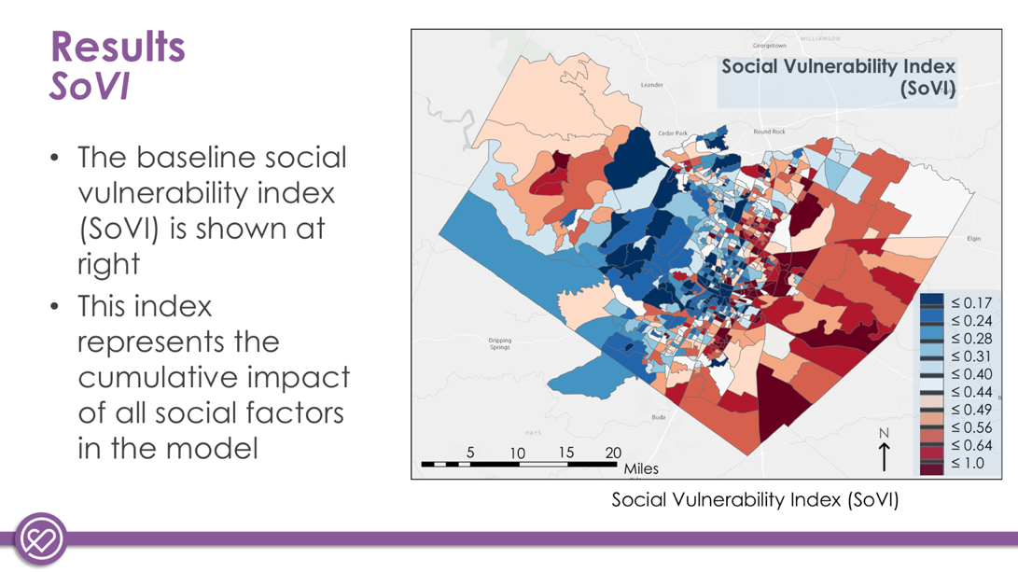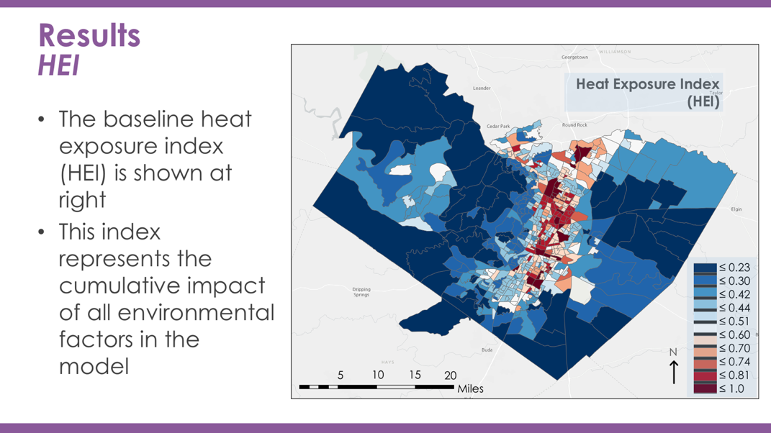
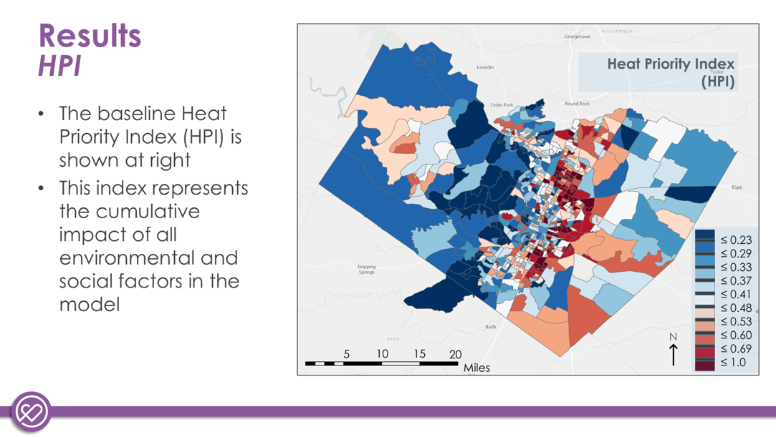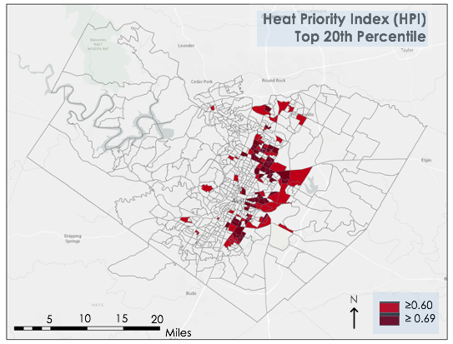
Figure 2. Clockwise from top left: Social Vulnerability Index (SoVI), Heat Exposure Index (HEI), Heat Priority Index (HPI) most vulnerable (top 20th-percentile-scoring) block groups, Heat Priority Index (HPI)

The HPI represents the cumulative impact of all social and environmental factors in the model that contribute to heat vulnerability. Because it combines both environmental and social data, this index can be viewed as the main result of our work, which can be used to suggest the most heat-vulnerable neighborhoods overall. Elements of the underlying HEI and SoVI maps can be observed in the spatial distribution of this index. The factor loading matrix for the HPI can be found in Appendix F. This matrix shows how variables cluster into principal components, as well as the contribution of each variable to each principal component.

We explicitly identified the top 20% of high-scoring block groups from the HPI. The neighborhoods identified in dark red are in the top 10% of high HPI scores, and the lighter red is in the next-highest 10% of HPI scores. Block groups in neighborhoods like Rundberg in north Austin, Montopolis near the airport, and Onion Creek in southeast Austin fall into this category. This depiction is meant to be a tool to suggest where the City of Austin could focus on gathering further information—block groups not highlighted in this figure are not necessarily not at risk from extreme heat.

4.1.2 Sensitivity Analysis
In Figure 3 we show the results of the average HPI score from the 10,000-run Monte Carlo analysis. The Monte Carlo analysis can be considered our main sensitivity analysis, since it encompassed all of the different scenarios we analyzed, except scenarios involving varying environmental variables. The most vulnerable block groups identified in the Monte Carlo analysis (i.e., block groups identified as having the top 20% of HPI scores) have a 62% overlap with the most vulnerable block groups identified in the baseline analysis. Overall, the Monte Carlo HPI scores explain 58% of the variance in the baseline HPI score, which suggests a moderately good fit between the two datasets. We interpret this result to provide a general endorsement of our baseline results—i.e., changing a variety of the assumptions in the model did not completely change the communities identified as being most vulnerable.

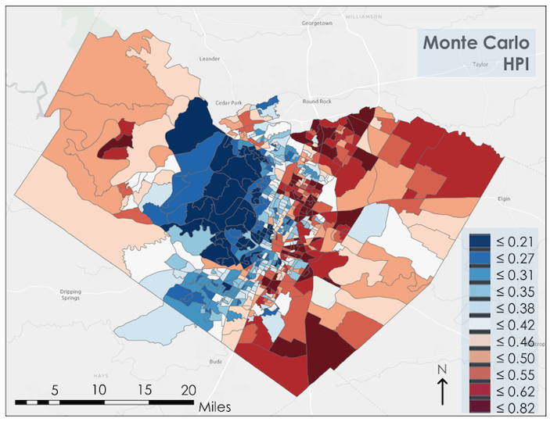
Figure 3. (Left) Average HPI score over 10,000 runs of Monte Carlo sensitivity analysis. (Right) Comparison of baseline HPI score and average HPI score from Monte Carlo sensitivity analysis (R² = 0.58).

Further results of the Monte Carlo sensitivity analysis are available in Appendix D, in particular, a map showing the fraction of the time each block group was identified as being in the most vulnerable group, as well as a map of the standard deviation of HPI scores for each block group (indicating how much or how little their scores changed between runs). Finally, see Appendix E for the result of varying elements of the model individually (rather than varying all model components at once as done in the Monte Carlo analysis).

The environmental sensitivity analysis results are also detailed in the appendix—Appendix F contains results for the East Austin sensitivities. The top 20% of HEI scores in the East Austin sensitivity analysis are quite consistent with those in the East Austin baseline: adding air temperature, tree canopy, and shade data leads to an overlap of 96%, 96%, and 93% with the top 20% of block groups in the baseline, respectively. Adding all three variables lead to an overlap of 90% with the baseline. The HPI also is not highly sensitive to the addition of these variables, having only a 94%, 94%, and 77% overlap with the baseline for the same variable additions and a 77% overlap with the baseline upon the addition of all three variables. The model seems most sensitive to the inclusion of shade as a variable.

The population-weighted sensitivities are detailed in Appendix G; more detail on the methodology can also be found there. The top 20% of population-weighted HEI scores overlap with the top 20% of baseline HEI scores at a rate of 83%. For HPI scores, the overlap is 87%. As shown in Figure G1, the HEI scores of some larger, less urban block groups demonstrate an obvious increase in their scores, which is consistent with the theory underlying this analysis: subsetting data to reflect populated areas will likely lead to a focus on more built-up, less vegetated, hotter areas, which will thus score higher on heat exposure overall. However, some larger rural block groups show a decrease in HEI; on the whole, this approach merits further study.

4.1.5 Error Analysis
Although we believe our project results to be generally robust, there were a variety of errors and uncertainties involved in our measurements and analyses. First, the American Community Survey has high standard errors in certain variables, especially on scales as small as the block group. Similarly, the health data we collected was is extrapolated down to the level of census tract using a mathematical model, leading to significant uncertainty. In terms of environmental data, satellite data was collected over a 5-year period with cloud-covered images removed, which limited our data availability. In addition, these satellite measurements are only proxies for the true variable we care about (heat stress).

Relatedly, there were other data that we did not include in our analysis, but which could have improved our results—e.g., data on waste heat, air pollution, or how people are adapting to heat. We didn’t include this data due to both time and data limitations. Finally, the indices we created were not verified against outside data, only through robustness tests. Although we followed best practices from the literature in creating this index, there are debates around which mathematical methods best reflect reality, which introduces a fundamental level of uncertainty into our work.

4.2 Future Work
This heat priority index could benefit from the inclusion of a range of additional data. Our results would be improved by incorporating granular and accurate data on other factors that contribute to the UHI effect, such as anthropogenic waste heat data or air pollution data. Granular air temperature data, such as that collected by CAPA Strategies, would be a valuable addition, but this data was not available for the entirety of our study area. In addition, there were important variables, such as homelessness, that could not be easily integrated into our vulnerability index due to data availability and sensitivity of the topic. Information on the size and locations of homeless populations in Austin would add another dimension to understanding the effects of the UHI effect in vulnerable communities.

Importantly, this heat priority index should serve as a basis for future learning about extreme heat in Austin, rather than a standalone result. It can inform community engagement efforts in identified neighborhoods, both to learn more about heat issues in these areas and to validate the results of the model. It can also be validated with further scientific analysis that quantifies the impact of extreme heat in communities around Austin.

5. Conclusions
This project identified 121 census block groups out of 605 total that are designated as being most at risk of adverse impacts from extreme heat events, identifying neighborhoods such as Rundberg, Montopolis, and Onion Creek. Our team tested the sensitivity of this designation to alternative data and modeling assumptions, determining that the communities we identified are robust, but there is a secondary set of block groups that the City should prioritize in heat mitigation efforts and further research. Finally, we provided the City of Austin with our data layers, results, and code in an interactive format that will help them adapt this tool over time and to their own purposes.

Overall, our creation of a HPI for the City of Austin will be an important tool in the City’s efforts to support its residents in a warming world. The HPI, by identifying neighborhoods most vulnerable to adverse effects from extreme heat, will help the City channel funding for mitigation projects to areas that would benefit the most. However, the index should not be taken entirely on its own: it also serves as a jumping-off point for further discussion, research, and community engagement around heat issues in Austin. As demonstrated in our sensitivity analyses, any given index cannot definitively capture heat vulnerability. This index can also be complemented by fine-scale efforts on air temperature mapping and shade analysis to create a more holistic picture of thermal conditions throughout the City. Therefore, this HPI should serve as one tool in the City’s toolbox to decide how to address extreme heat in Austin.

6. Acknowledgments
We are very thankful to the City of Austin and our partners for their support with this project, notably Marc Coudert, Dr. Kevin Lanza, Dr. Dev Niyogi, and Jessica Jones. We are also very thankful for our science advisor on this project Dr. Dave Hondula, Associate Professor for the School of Geographical Sciences and Urban Planning at Arizona State University, and Ryan Hammock, Fellow for the Arizona – Tempe NASA DEVELOP node.

Any opinions, findings, and conclusions or recommendations expressed in this material are those of the author(s) and do not necessarily reflect the views of the National Aeronautics and Space Administration.

This material is based upon work supported by NASA through contract NNL16AA05C.

7. Glossary
American Community Survey (ACS) – Annual data collection that provides up-to-date information about the socioeconomic status of communities across the United States.
Earth observations – Satellites and sensors that collect information about the Earth’s physical, chemical, and biological systems over space and time.
Google Earth Engine (GEE) – A cloud-based platform for geospatial analysis.
Land surface temperature (LST) – The radiative temperature of land surface derived from solar radiation.
LiDAR – Light Detection and Ranging, a remote sensing method that emits laser pulses and measures the reflections back to the sensor.
Normalized Difference Vegetation Index (NDVI) – An index that quantifies the density of plant growth by using visible and near-infrared light reflection.
Normalized Difference Built-Up Index (NDBI) – An index that quantifies presence of urban land cover measured by the difference between shortwave infrared and infrared reflectance.
Normalized Difference Water Index (NDWI) – An index that estimates the surface water content of vegetation using near-infrared and shortwave infrared reflectance.
Principal Component Analysis (PCA) – A computational method that attempts to explain variance within a dataset, often used as a reduction technique to identify key influencing variables within data.
Social Vulnerability Index (SoVI®) – An index that utilizes socioeconomic variables that suggests a community’s ability to prepare for, respond to, and recover from hazards.
R – R is a programming language and free software environment for statistical analysis and graphics supported by the R Foundation for Statistical Computing.
Thermal Infrared Sensor (TIRS) – An instrument aboard the Landsat 8 satellite, TIRS uses two thermal infrared wavelength bands in order to differentiate between the temperature of Earth’s surface and that of Earth’s atmosphere.
Texas Natural Resources Information System (TNRIS) – A geospatial database for the state of Texas
Urban heat island (UHI) – UHI is described as an urban area that is significantly warmer than surrounding rural regions due to anthropogenic activities and infrastructure, the UHI phenomenon is commonly observed in major cities.
Moderate resolution Imaging Spectroradiometer (MODIS) – NASA Earth observation sensor launched in December, 1999

8. References
Austin Climate Equity Plan 2020. (n.d.). Retrieved February 17, 2021, from https://www.austintexas.gov/edims/document.cfm?id=347852

Austin Homeless Point in Time Count. (n.d.). Retrieved February 17, 2021, from https://www.austinecho.org/wp-content/uploads/2020/07/PIT-2020-Three-One-Pagers.Revised-7.9.2020.pdf

Austin Office of Sustainability: Speakup Austin, Austin Community Action Plan. (n.d.). Retrieved February 17, 2021, from http://austintexas.gov/sites/default/files/files/2016-03-25_2015-16_ACCP_Implementation_Plan_-_Phase_1_Actions.pdf

Austin Urban Heat Island StoryMap. (n.d.). Retrieved February 17, 2021, from https://www.arcgis.com/apps/Cascade/index.html?appid=95bd39c1b696478dad72250fd91b562b
author, Z. W. C., Zhang, Y., Zhang, Q., & Li, Z.-L. (2004). Quality assessment and validation of the MODIS global land surface temperature. International Journal of Remote Sensing, 25(1), 261–274. https://doi.org/10.1080/0143116031000116417

Brennan, M. (2013). America’s Fastest-Growing Cities. Forbes Business. Retrieved February 22, 2021, from https://www.forbes.com/sites/morganbrennan/2013/01/23/americas-fastest-growing-cities/#6b5ed9a6244f

Cao, X., Onishi, A., Chen, J., & Imura, H. (2010). Quantifying the cool island intensity of urban parks using ASTER and IKONOS data. Landscape and Urban Planning, 96(4), 224–231. https://doi.org/10.1016/j.landurbplan.2010.03.008

Chen, Q., Ding, M., Yang, X., Hu, K., & Qi, J. (2018). Spatially explicit assessment of heat health risk by using multi-sensor remote sensing images and socioeconomic data in Yangtze River Delta, China. International Journal of Health Geographics, 17(1), 15. https://doi.org/10.1186/s12942-018-0135-y

Cutter, S. L., Boruff, B. J., & Shirley, W. L. (2003). Social vulnerability to environmental hazards*. Social Science Quarterly, 84(2), 242–261. https://doi.org/10.1111/1540-6237.8402002

Davis, A. Y., Jung, J., Pijanowski, B. C., & Minor, E. S. (2016). Combined vegetation volume and “greenness” affect urban air temperature. Applied Geography, 71, 106–114. https://doi.org/10.1016/j.apgeog.2016.04.010

Gallo, K. P., McNab, A. L., Karl T. R., Brown, J. F., Hood, J. J., & Tarpley, J. D. (1993). The use of a vegetation index for assessment of the urban heat island effect. International Journal of Remote Sensing, 14(11), 2223–2230. https://doi.org/10.1080/01431169308954031

Gill, S. E., Handley, J. F., Ennos, A. R., & Pauleit, S. (2007). Adapting cities for climate change: The role of the green infrastructure. Built Environment, 33(1), 115–133. https://doi.org/10.2148/benv.33.1.115

Harlan Sharon L., Declet-Barreto Juan H., Stefanov William L., & Petitti Diana B. (2013). Neighborhood effects on heat deaths: social and environmental predictors of vulnerability in Maricopa County, Arizona. Environmental Health Perspectives, 121(2), 197–204. https://doi.org/10.1289/ehp.1104625

Hook, S., Hulley, G. (2019). ECOSTRESS Land Surface Temperature and Emissivity Daily L2 Global 70 m V001 [Data set]. NASA EOSDIS Land Processes DAAC, accessed 1 March 2021. https://doi.org/10.5067/ECOSTRESS/ECO2LSTE.001

Li, X., Zhou, W., & Ouyang, Z. (2013). Relationship between land surface temperature and spatial pattern of greenspace: What are the effects of spatial resolution? Landscape and Urban Planning, 114, 1–8. https://doi.org/10.1016/j.landurbplan.2013.02.005

Lo, C. P., Quattrochi, D. A., & Luvall, J. C. (1997). Application of high-resolution thermal infrared remote sensing and GIS to assess the urban heat island effect. International Journal of Remote Sensing, 18(2), 287–304. https://doi.org/10.1080/014311697219079

Lu, J., Li, C., Yang, Y., Zhang, X., & Jin, M. (2012). Quantitative evaluation of urban park cool island factors in mountain city. Journal of Central South University, 19(6), 1657–1662. https://doi.org/10.1007/s11771-012-1189-9

Mayer, Z., Parker, R., Hallmark, K., Allen, G., Ramirez, A. (2018). Examining the relationship between urban heat islands and the tree canopy in Austin, TX. Bobcat Urban Foresters. http://sites.geo.txstate.edu/g4427/F18/UHI/index.html

Pasha, A. (2017). Regional Perspectives to the Multidimensional Poverty Index. 38.

Pearsall, H. (2017). Staying cool in the compact city: Vacant land and urban heating in Philadelphia, Pennsylvania. Applied Geography, 79, 84–92. https://doi.org/10.1016/j.apgeog.2016.12.010

Rasul, A., Balzter, H., Ibrahim, G. R. F., Hameed, H. M., Wheeler, J., Adamu, B., Ibrahim, S., & Najmaddin, P. M. (2018). Applying Built-Up and Bare-Soil Indices from Landsat 8 to Cities in Dry Climates. Land, 7(3), 81. https://doi.org/10.3390/land7030081

Reid Colleen E., O’Neill Marie S., Gronlund Carina J., Brines Shannon J., Brown Daniel G., Diez-Roux Ana V., & Schwartz Joel. (2009). Mapping Community Determinants of Heat Vulnerability. Environmental Health Perspectives, 117(11), 1730–1736. https://doi.org/10.1289/ehp.0900683

Turek-Hankins, L. L., Hino, M., & Mach, K. J. (2020). Risk screening methods for extreme heat: Implications for equity-oriented adaptation. PLOS ONE, 15(11), e0240841. https://doi.org/10.1371/journal.pone.0240841

U.S. Geological Survey Earth Resources Observation and Science Center. (2015-2020). Provisional Landsat OLI Surface Reflectance. Landsat 8 OLI and TIRS Level-1 Data Products. Courtesy of the U.S. Geological Survey. https://doi.org/10.5066/F71835S6

Vermote, E., Wolfe, R. (2015). MYD09GA MODIS/Aqua Surface Reflectance Daily L2G Global 1kmand 500m SIN Grid V006 [Data set]. NASA EOSDIS Land Processes DAAC, accessed 1 March 2021. https://doi.org/10.5067/MODIS/MYD09GA.006

Weng, Q., Lu, D., & Schubring, J. (2004). Estimation of land surface temperature–vegetation abundance relationship for urban heat island studies. Remote Sensing of Environment, 89(4), 467–483. https://doi.org/10.1016/j.rse.2003.11.005

Wetherley, E. B., McFadden, J. P., & Roberts, D. A. (2018). Megacity-scale analysis of urban vegetation temperatures. Remote Sensing of Environment, 213, 18–33. https://doi.org/10.1016/j.rse.2018.04.051

Wong, E., Akbari, H., Bell, R., Cole, D. (2011). Reducing urban heat islands: Compendium of strategies. Environmental Protection Agency. https://trid.trb.org/view/920168

Yokohari, M., Brown, R. D., Kato, Y., & Yamamoto, S. (2001). The cooling effect of paddy fields on summertime air temperature in residential Tokyo, Japan. Landscape and Urban Planning, 53(1), 17–27. Doi.org/10.1016/S0169-2046(00)00123-7

Yoo, S. (2018). Investigating important urban characteristics in the formation of urban heat islands: A machine learning approach. Journal of Big Data, 5(1), 2. https://doi.org/10.1186/s40537-018-0113-z

Zakšek, K., & Oštir, K. (2012). Downscaling land surface temperature for urban heat island diurnal cycle analysis. Remote Sensing of Environment, 117, 114–124. https://doi.org/10.1016/j.rse.2011.05.027

Zhao, C., Jensen, J., Weng, Q., & Weaver, R. (2018). A geographically weighted regression analysis of the underlying factors related to the surface urban heat island phenomenon. Remote Sensing, 10(9), 1428. https://doi.org/10.3390/rs10091428

Zhao, C. (2018). Studying Surface Urban Heat Island Phenomenon Using Remote Sensing in Three Metropolitan Areas of Texas, USA. https://digital.library.txstate.edu/handle/10877/7411

9. Appendices

Appendix A: Variables included in SoVI
- Median Gross Rent
- Median Age
- Median Housing Value
- Per Capita Income
- People per Unit (Average household size)
- Percent Population under 5 years or 65 and over
- Percent Asian
- Percent Black or African American Alone
- Percent Unemployment for Civilian in Labor Force 16 Years and Over
- Percent Less than high school education for population over 25 years and older
- Percent Speaking English as a Second Language with Limited Proficiency
- Percent Employment in Construction and Extraction Industry
- Percent Children Living in Married Couple Families
- Percent Female
- Percent Female Participation in Labor Force
- Percent Female Headed Households (Out of unmarried-partner households)
- Percent Native American (American Indian and Alaska Native alone)
- Percent Mobile Homes
- Percent Housing Units with No Car
- Percent population without health insurance
- Percent Poverty
- Percent Renters (Percent out of total Occupied housing units)
- Percent Households Earning over $200,000 annually
- Percent Employment in Service Industry
- Percent Hispanic
- Percent Households Receiving Social Security Benefits
- Percent Unoccupied Housing Units
Appendix B: Formulas for calculating all environmental variables
Variable | Description | Formula | Data Source
Albedo | Fraction of incident radiation | albedo = 0.246blue + 0.14green + 0.19red + 0.304NIR + 0.105SWIR + 0.008SWIR2 | All are from Landsat 8 OLI  Blue: band 2  Green: band 3  Red: band 4  Near infrared (NIR): band 5  Short-wave infrared 1 (SWIR): band 6  Short-wave infrared 2 (SWIR2): band 7
NDVI | Index of vegetation | NDVI = (NIR - red)/(NIR + red) | All are from Landsat 8 OLI  Red: band 4  Near infrared (NIR): band 5
DBI | Built up index used in dry environments  (Rasul, 2018) | DBI = (blue – TIR)/(blue + TIR) - NDVI | Blue: band 2 or Landsat 8 OLI  Thermal Infrared 1 (TIR): Landsat TIR band 10  NDVI: see above
Daytime LST | Land surface temperature during the daytime | LST = (TIR / (1 +(0.0000109 * (TIR / 0.01438) * log(E)))) * (9/5) - 459.67 | Thermal Infrared 1 (TIR): Landsat TIR band 10  E: emissivity
Nighttime LST | Land surface temperature used at nighttime | Precalculated by Terra MODIS | Terra MODIS
NDWI | Index of water present in leaves | NDWI = (SR2 – SR5)/(SR2 + SR5) | SR2: Surface reflectance band 2 from Terra MODIS  SR5: Surface reflectance band 5 from Terra MODIS

Appendix C: Formulas for calculating all social variables
If a variable has a numerator and denominator, the final result is the numerator variable divided by the denominator variable. If it does not have a denominator, the final result is simply the numerator. If a variable is not available at the census block group level, it is instead calculated at the census tract level and then allocated down to all the block groups within that census tract.
Variable | Description | Denominator Variable  (and American Community Survey variable code) | Numerator Variable  (and American Community Survey variable codes) | Available at census block group level?
Median_rent | Median gross rent for renter-occupied housing units | NA | Median Gross Rent (B25064_001) | Yes
Median_age | Median age | NA | Median Age (B01002_001) | Yes
Median_home_value | Median dollar value of owner-occupied housing units | NA | Median Home Value (B25077_001) | Yes
Per_cap_income | Per capita income in the past 12 months (in 2019 inflation-adjusted dollars) | NA | Per Capita Income (B19301_001) | Yes
Avg_ppl_house | Average number of people per household | NA | Average Household Size (B25010_001) | Yes
Under5_over65 | % Population under 5 years or age 65 and over | Total Population (B01001_001) | Population under 5 + population over 65  (B01001_003 + B01001_020 + B01001_021 + B01001_022 + B01001_023 + B01001_024 + B01001_025 + B01001_027 + B01001_044 + B01001_045 + B01001_046 + B01001_047 + B01001_048 + B01001_049) | Yes
Pct_asian | % Asian population | Total Population (B02001_001) | Population Asian Alone (B02001_005) | Yes
Pct_black | % African American (Black) population | Total Population (B02001_001) | Population Black or African American Alone (B02001_003) | Yes
Pct_unemployed | % Civilian labor force unemployed | Civilian Labor Force (B23025_003) | Civilian Labor Force Unemployed (B23025_005) | Yes
Pct_no_diploma | % Population over 25 with less than 12 years of education | Population over 25 (B15003_001) | Population with less than 12 years of education  (B15003_002 + B15003_003 + B15003_004 + B15003_005 + B15003_006 + B15003_007 + B15003_008 + B15003_009 + B15003_010 + B15003_011 + B15003_012 + B15003_013 + B15003_014 + B15003_015 + B15003_016) | Yes
Pct_little_english | % Population speaking English as a second language with limited English proficiency | Total population (C16002_001) | Population with limited English proficiency  (C16002_004 + C16002_007 + C16002_010 + C16002_013) | Yes
Pct_extractive_employment | % Employment in extractive industries (fishing, farming, mining, etc.) | Civilian employed population (C24010_001) | Population employed in natural resources, construction, and maintenance occupations  (C24010_032 + C24010_068) | Yes
Pct_kids_in_married_HH | % Children living in married couple families | Number of households (B09005_001) | Number of married couple households (B09005_002) | Yes
Pct_female | % Female | Total population (B01001_001) | Female population (B01001_026) | Yes
Pct_female_work | % Female participation in the labor force | Civilian employed population (C24010_001) | Civilian female employed population (C24010_038) | Yes
Pct_female_head_of_HH | % Families with female-headed households with no spouse present | Number of households (B11001_001) | Number of households with female householder, no spouse present (B11001_006) | Yes
Pct_hispanic | % Hispanic population | Total population (B03001_001) | Population Hispanic or Latino (B03001_003) | No
Pct_mobile_homes | % Of housing units that are mobile homes | Number of housing units (B25024_001) | Number of mobile home units (B25024_010) | Yes
Pct_native_american | % Native American population | Total population (B02001_001) | Population American Indian or Alaska Native Alone (B02001_004) | Yes
Pct_no_car | % Housing units with no car available | Number of housing tenures (B25044_001) | Households with no vehicle available  (B25044_003 + B25044_010) | Yes
Pct_poverty | % Persons living in poverty | Number of families (B17026_001) | Number of families whose income in the past 12 months is below the poverty level  (B17026_002 + B17026_003 + B17026_004) | No
Pct_pct_rented_housing | % Renter-occupied housing units | Number of housing tenures  (B25003_001) | Number of renter occupied housing accommodations  (B25003_003) | Yes
Pct_income_over_200k | % Families earning more than $200,000 per year | Number of households (B19001_001) | Number of households with income in the past 12 months > $200,000 (in 2019 inflation adjusted dollars) (B19001_017) | Yes
Pct_service_employment | % Employment in service occupations | Civilian employed population (C24010_001) | Civilian employment in service occupations  (C24010_019 + C24010_055) | Yes
Pct_social_security | % Households receiving Social Security benefits | Number of households (B19055_001) | Number of households receiving Social Security income (B19055_002) | Yes
Pct_vacant | % Unoccupied housing units | Number of housing units (B25002_001) | Number of vacant housing units (B25002_001) | Yes
Pct_nohealthcare | % population without health insurance | Total population (B27001_001) | Population without health insurance  (B27001_005 + B27001_008 + B27001_011 + B27001_014 + B27001_017 + B27001_020 + B27001_023 + B27001_026 + B27001_029 + B27001_033 + B27001_036 + B27001_039 + B27001_042 + B27001_045 + B27001_048 + B27001_051 + B27001_054 + B27001_057) | No
Pct_living_alone | % Population living alone | Total population (B11001_001) | Population living alone (B11001_008) | Yes
Pct_over65 | % Population over 65 | Total population (B01001_001) | Population over 65  (B01001_020 + B01001_021 + B01001_022 + B01001_023 + B01001_024 + B01001_025 + B01001_044 + B01001_045 + B01001_046 + B01001_047 + B01001_048 + B01001_049) | Yes
Pct_over65_alone | % Population over 65 and living alone | Number of households (B25011_001) | Population over 65 and living alone  (B25011_021 + B25011_045) | No
Pct_nonwhite | % non-white-alone population | Total population  (B02001_001) | Non-white population  (B02001_003 + B02001_004 + B02001_005 + B02001_006 + B02001_007 + B02001_008 + B02001_009 + B02001_010) | Yes

Appendix D: Additional Monte Carlo results

D1: Fraction of time a block group was designated in the most vulnerable group (i.e., in the top quintile of HPI scores) across 10,000 model runs of the Monte Carlo analysis. Dark red indicates the top 10% of groups appearing in the top quintile of scores most frequently; lighter red indicates the next 10% of groups appearing in the top quintile most frequently. White/colorless block groups were not among the 20% of block groups appearing in the top quintile of HPI scores most frequently.
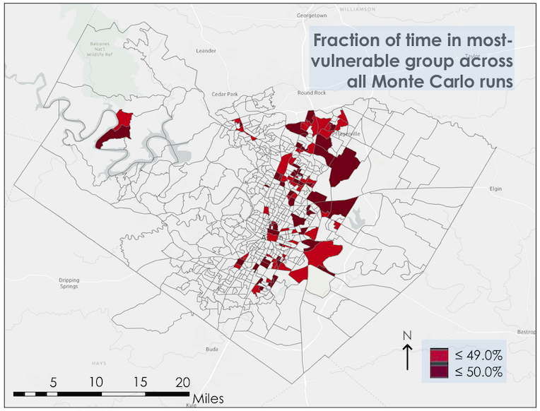

D2. Standard deviation of HPI scores for each block group across 10,000 Monte Carlo simulations.
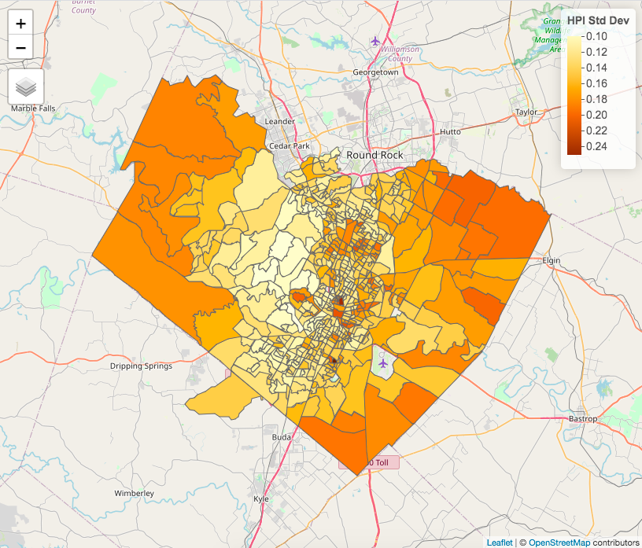

Appendix E: Impact of individual Monte Carlo sensitivity analysis variables on HPI
HPI in the following scenarios: A) Baseline, B) Baseline + health data (74% overlap with most vulnerable block groups in baseline), C) PCA scores are not transformed to integers before summed (86% overlap), D) PCA component scores not weighted by variance (69% overlap), E) Baseline, but social SoVI variables replaced with Reid variables (60% overlap), F) Change from block group to tract level (64% overlap)
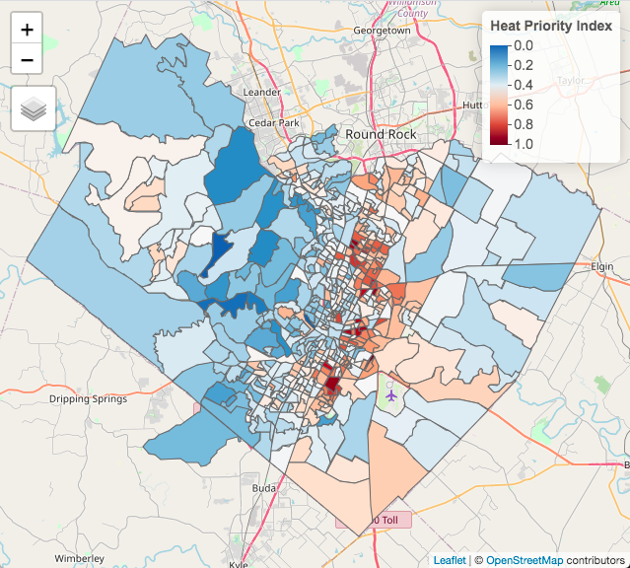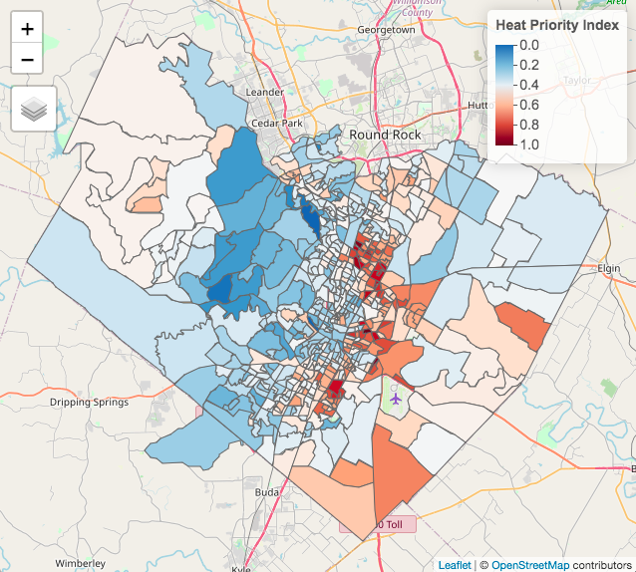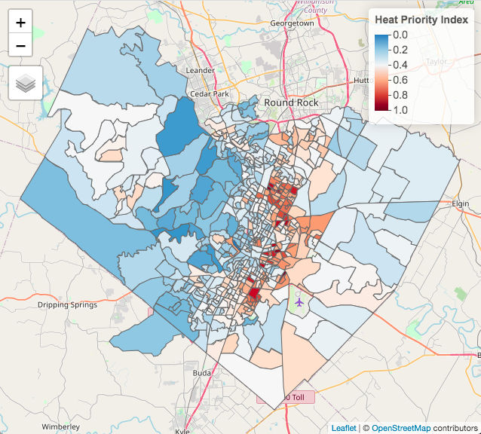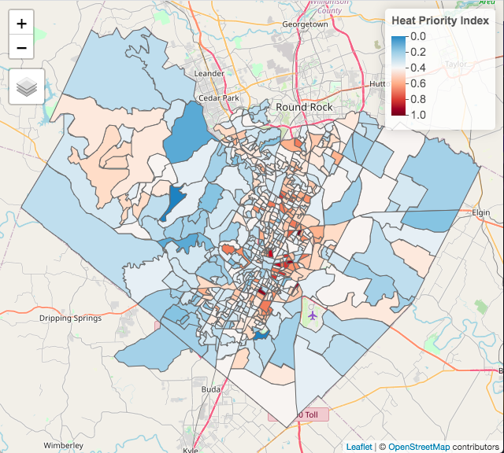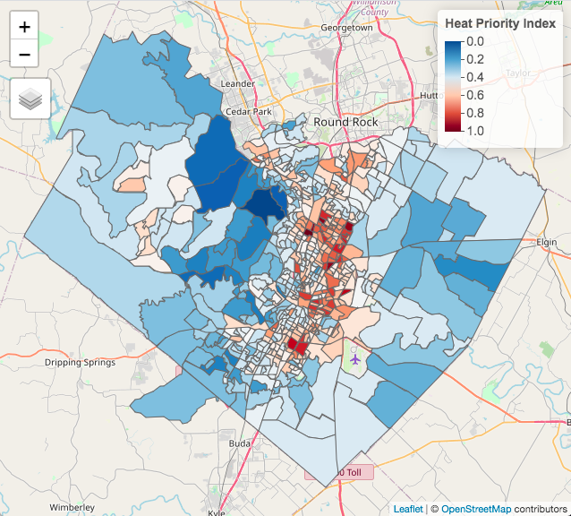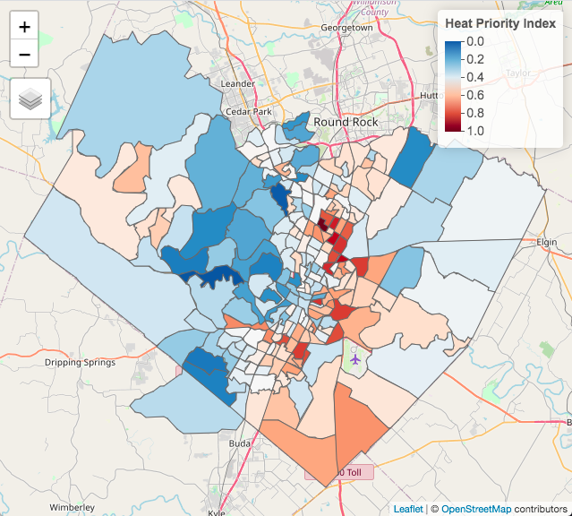
F
E
D
C
B
A
Appendix F: Environmental Sensitivity Results—East Austin
Figure F1. Distribution of spatial mean of variables by block group. Units for air temperature are degrees Fahrenheit; units for tree canopy are percentage of the block group covered by tree canopy; and units for shade are the average of total shaded areas per block group.
Figure F2. HEI scores for each scenario: (from left) baseline scenario, baseline + air temperature data, baseline + tree canopy data, baseline + shade data, baseline + all three variables.
Figure F3. HPI scores for each scenario: (from left) baseline scenario, baseline + air temperature data, baseline + tree canopy data, baseline + shade data, baseline + all three variables.
Figure F4. Top 20% of HEI scores for each scenario: (from left) baseline scenario, baseline + air temperature data, baseline + tree canopy data, baseline + shade data, baseline + all three variables.

Figure F5. Percentage overlap of census block groups with top 20% of HEI scores between the baseline and each sensitivity scenario. Percent overlap with baseline (from left): 96% (baseline + air temperature), 96% (baseline + tree canopy), 93% (baseline + shade), 90% (baseline + all three variables).

Appendix G: Environmental Sensitivity Results—Population-Based Weighting
Methodology: We followed this series of steps to “population-weight” our six environmental variables—i.e., to explicitly account for where people live when calculating environmental variable means by block group. We pursued this strategy to avoid including e.g. large unpopulated, forested areas in the block group mean, which could artificially depress the heat exposure experienced in populated areas. While this could have been included as our baseline approach, we did not have time to adequately vet the scientific approach; therefore, we included this as an example and sensitivity.
Steps (performed in ArcGIS from step 2 onward):
- Download modeled high-resolution population raster data for the United States from WorldPop (100m resolution at the equator; constrained)
- Import block group polygons and six environmental rasters for study area into ArcGIS
- Subset to Austin study area to avoid manipulating whole raster file, which is ~500 MB
- Align CRS of six environmental rasters, WorldPop raster, and block group in projected CRS using Project Raster tool for rasters (bilinear interpolation resampling) and Project tool for polygons
- Using Reclassify tool, mask WorldPop data to only contain values of 1 (where WorldPop raster value > 0) and 0 (where WorldPop raster value = 0)
- Apply mask to six environmental rasters using Raster Calculator tool (multiplication)
- Use Zonal Statistics as Table tool to calculate mean value of masked environmental data for each block group

Results:
Figure G1. Population-weighted HEI (left), and difference between population-weighted HEI and baseline HEI (right) (numbers greater than 0 indicate that population-weighted HEI was higher than baseline HEI). There is an 83% overlap between the top 20% of block groups between the baseline and population-weighted scenarios.

Figure G2. Population-weighted HPI (left), and difference between population-weighted HPI and baseline HPI (right) (numbers greater than 0 indicate that population-weighted HPI was higher than baseline HPI). There is a 73% overlap between the top 20% of block groups between the baseline and population-weighted scenarios.

Appendix G: Factor Loading Matrix for Baseline HPI
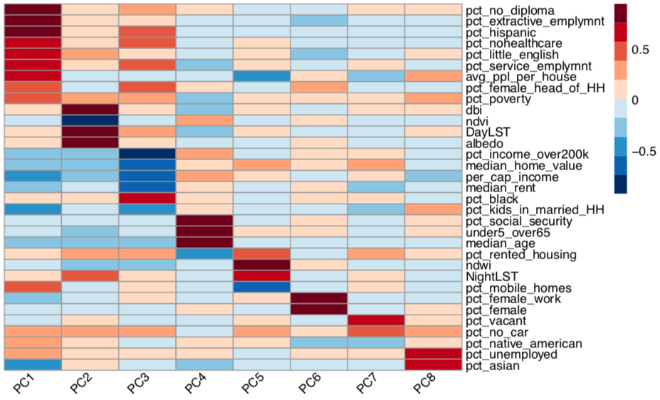

Appendix H: Social variables included in the Reid 2009 analysis
- Percent living alone
- Percent living in poverty
- Percent with diabetes
- Percent that have not graduated from high school
- Percent over 65
- Percent over 65 and living alone
- Percent nonwhite

