SSC21-V-02

NASA Leveraging Commercial Communication Ground Stations for Small Satellites

Yen Wong, Scott Schaire, Chitra Patel, Leslie Ambrose, Obadiah Kegege

NASA Goddard Space Flight Center

Greenbelt, MD 20771, USA; 301-286-7446

scott.h.schaire@nasa.gov

Denise Thorsen

University of Alaska, Fairbanks

Fairbanks, AK 99709; 907-474-7052

dlthorsen@alaska.edu

ABSTRACT

The Space Communications and Navigation (SCaN) program at NASA has reorganized its operations portfolio into two networks: the Deep Space Network and the new Near Space Network (NSN). With this reorganization, NASA can begin transforming to 100% direct-to-Earth commercial communications services for missions in the near-Earth region. NASA’s leveraging of commercial direct-to-Earth ground stations offers several benefits for the small satellite community, including lower cost, greater coverage, and increased technology infusion. In the fall of 2020, SCaN announced their intention to rely primarily on industry-provided communications services for missions close to Earth by 2030.

Commercial services are one way to infuse new technology into the ground station network without requiring an investment from NASA. Digital Video Broadcast, Satellite Second Generation (DVB-S2) is one example of a current technology. When combined with variable coding and modulation (VCM), the system automatically optimizes the data rate based on signal performance, significantly increasing total downlink data volume without an increase in the spacecraft effective isotropic radiated power (EIRP). There are several commercial service providers, including Amazon Web Service (AWS) Ground Station (AGS) and the KSATLITE ground stations that support SmallSat missions using DVB-S2 waveforms for downlinks. This paper identifies some commercial off-the-shelf (COTS) CubeSat/SmallSat DVB-S2 X-band and Ka-band radios.

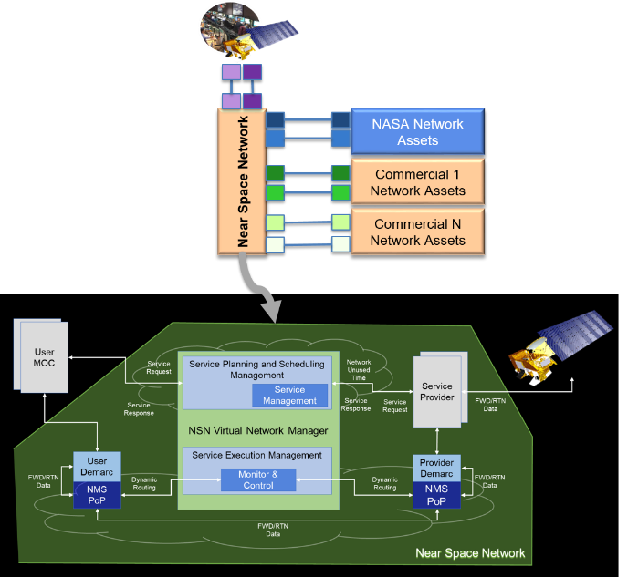Overall, NASA’s increased dependence on commercial direct-to-Earth ground stations is a significant benefit for the small satellite community.

Figure NSN Architecture Overview

# 1.0 Introduction

The NSN is a project within the Exploration and Space Communications (ESC) projects division of NASA’s Goddard Space Flight Center (GSFC) Flight Projects Directorate. The NSN is a single interface for missions seeking robust communications and navigation services. It is an end-to-end network service provider that blends the capabilities of government and commercial link providers to provide highly proficient, cost-effective solutions to missions and the nation.

The NSN collaborates with ESC’s Commercialization, Innovation, and Synergies (CIS) office to onboard new commercial providers and with ESC’s Advanced Communications Capabilities for Exploration and Science Systems (ACCESS) project to provide services through government infrastructure. In addition to larger science missions, the NSN supports the crucial research performed by CubeSats and SmallSats. The network has a proven record of accomplishment of success in SmallSat support during all phases of the mission lifecycle.

As shown in Figure 1, the NSN synthesizes both government and commercial service providers into a comprehensive network of services for missions. These include space link providers (SLPs) and terrestrial link providers (TLPs). SLPs fulfill their service through direct-to-Earth (DTE) connections via a robust arrangement of ground stations worldwide and space relay services through multiple generations of relay satellites. TLPs transmit data from ground stations to users and mission operations centers across the U.S. and globally.

In addition, the NSN provides project management leadership and subject matter expertise as required. The NSN formulates concepts, implements, operates, and maintains a data system capable of connecting national and international data link providers with NASA users and partners. The NSN uses a virtual network management capability and routinely synchronizes systems, processes, and techniques with those of the U.S. private sector in order to provide NASA, other government agencies, and partners with optimal communications and navigation mission services. Table 1 shows an increasing number of NASA NSN missions in the future.

Table 1 Projection of Near Space Missions

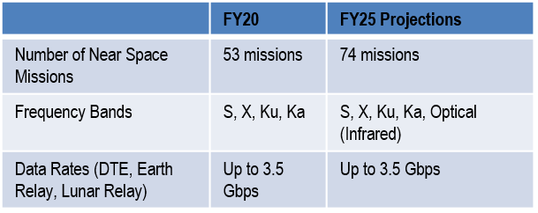

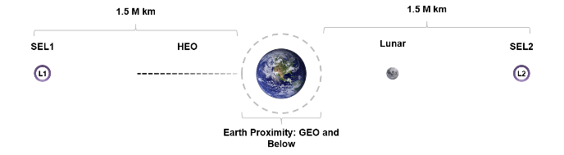

Figure 2 NSN Domain

The NSN covers the volume of space from the Earth’s surface to 2,000,000 kilometers. As shown in Figure 2, the Earth Proximity Region is the volume from Earth’s surface to GEO (36,000 km) and is a subset of the NSN. This Earth Proximity Region is the initial focus of service commercialization.

For coverage outside of NSN (> 2 million km), the Deep Space Network (DSN) supports missions out into the solar system and beyond.

# 2.0 Commercialization Goals

SCaN is committed to increase the participation of commercial communication service providers to support missions operating in the near-space region. This is consistent with NASA’s strategic goal to foster the commercialization of the Earth-proximity region through increased private sector participation.

ESC’s CIS office is the focal point for executing the commercialization goals. The CIS commercialization initiatives include: (1) fostering a more robust and interoperable space communications marketplace, (2) facilitating and increasing the industrial base, and (3) enhancing the collaboration between industry and government.

The NSN procures commercial services in bulk, resulting in significant cost-savings over single mission pricing. The NSN has been exploring the use of evolving commercial ground station services, which provide savings to the taxpayer. One such service is KSATLITE, a network of small aperture direct-to-Earth ground stations offered mainly for the small satellite community.

The first use of KSATLITE through the NSN isthe CubeSat Laser Infrared CrosslinK (CLICK) mission. This paper discusses some of the NSN scheduling system changes and terrestrial networking configurations required to integrate the KSATLITE ground stationservice into NSN. This will leverage the increased coverage and lower cost of the KSATLITE service.

Whether or not the ground station is commercial, there is a challenge to reduce the upfront mission planning and integration (MP&I) costs for missions. NASA’s GSFC Wallops Flight Facility (WFF) Test Bed was established to enable missions with little MP&I funding. The NASA Technical Education Satellite (TechEdSat) CubeSat mission successfully tested using WFF Test Bed components.

Commercial ground stations may quickly infuse new technology for NASA missions. NASA flies Small Satellites for science and for space technology advancement. NASA’s GSFC strives to provide the highest data rate communication from the longest distance from Earth with the lowest size, weight, and power (SWaP) for NASA spacecraft. This maximizes the science and technology advancement return. DVB-S2 is one such technology for lowering SWaP.1

The CubeSat Communications Platform (CCP) mission, under development at the University of Alaska Fairbanks, is collaborating with the NSN to demonstrate DVB-S2 VCM and achieve a maximum data rate in the NASA S-band 5 MHz channel. VCM will give future missions the capability to adapt to higher order modulation and efficient coding when the signal-to-noise ratio (SNR) is high. The CCP will be the first mission to demonstrate VCM with NASA ground stations.

# 3.0 First USE of the NSN and KSATLite

The KSATLITE apertures are typically 3.7-meter, smaller than the typical 11-meter class ground stations in the NSN. For NASA, the cost of using the KSATLITE apertures is a fraction of the cost of using 11-meter class apertures. The NSN has several missions that could use the smaller apertures. The addition of the KSATLITE apertures to the NSN also increases equatorial and mid-latitude coverage.

In August of 2019, the CLICK mission contacted the NSN about potential ground station support.2 The CLICK mission will demonstrate an optical CubeSat-to-CubeSat intersatellite link at 17.7 Mbps at a range of 520 km.

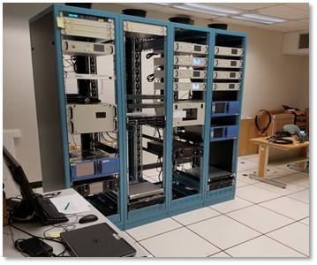In order to accommodate KSATLITE stations in addition to the NSN-owned stations, the NSN project team needed to analyze terrestrial interfaces, contracting, and NSN Scheduling System (NSNSS) interfaces. The NSN already had a contractual relationship with KSAT that was applicable to the KSATLITE stations. KSAT agreed to maintain the NSNSS scheduling format that the NSN was using with KSAT 11-meter class stations. The changes required were for a shortened lead-time from weekly to a five-day rolling schedule. This shortened lead-time also applies to multiple other commercial services. The NSNSS team accomplished the required changes in short order, in time for pre-mission testing.

Figure 3 NSN Integration and Testing for Reliable Operations (NITRO)

For the terrestrial interfaces, CLICK requested KSATLITE stations in New Zealand, Chile, and Spain. The NSN already had a connection to KSAT Svalbard, located in Norway, for commands and telemetry and through the Svalbard point of presence (PoP), for access to the KSATLITE stations. The cost of adding the KSATLITE stations turned out to be negligible and only involved firewall rules changes. If the CLICK Mission Operations Center (MOC) could connect to the NSN-owned station for telemetry and commands, and to the NSNSS located in White Sands, New Mexico, then the MOC would also have access to the KSATLITE stations.

# 4.0 Reduced Mission Planning and Integration Costs

NASA missions are typically given NSN contact time on apertures at no cost. NASA missions are responsible for covering the cost of MP&I which includes compatibility testing. Expensive large spacecraft can afford extensively detailed, documents, and comprehensive pre-mission MP&I plans. Less-expensive small satellite and CubeSat missions typically cannot afford such MP&I. The GSFC NSN is responsible for the pre-mission testing for missions using the network.

The NSN worked on a Lean Six Sigma (LSS) project to examine and propose compatibility test changes to be more responsive and cost-effective for small satellite missions. Streamlining compatibility testing could benefit all NASA missions.

One of the improvements that resulted from the LSS project was the creation of a Test Bed for Compatibility Testing at WFF, which significantly reduced the cost of testing for CubeSats.

For the spacecraft communication subsystem, end-to-end communication and compatibility testing with the selected ground network are the most critical tests.  Ideally, missions may validate compatibility by testing the flight spacecraft with the actual ground station that will be supporting the mission.  An alternative to testing with the actual ground station is to test with only the flight or an engineering test unit (ETU) radio (also common to include the flight computer) at a test lab configured with the ground station hardware.  Figure 3 shows the test lab at WFF.

End-to-end network testing primarily validates the ground station to the MOC interface. End-to-end network testing may take place at ground station antennas at Wallops. Initial end-to-end testing will validate network connectivity, showing that network connections are established, and firewall rules at the ground station and MOC are in place.  Once network connectivity is established, the MOC can transmit commands to the ground station for capture.

**5.0 Infusing New Technology-DVB-S2**

The following sections discuss how leveraging of commercial stations is enabling the infusion of new technology such as DVB-S2.

## 5.1 Benefit of DVB-S2 to Small Satellite Communications

Today, Digital Video Broadcast Satellite Second Generation (DVB-S2) has become a significant industry satellite communications standard.3 DVB-S2 uses power and bandwidth efficient modulation and coding techniques QPSK, 8PSK, 16APSK and LDPC/BCH codes to deliver performance approaching theoretical Shannon limits of radio frequency (RF) channels. When combined with variable coding and modulation (VCM) and adaptive coded modulation (ACM), the system automatically optimizes the data rate based on signal performance, significantly increasing total downlink data throughout relative to constant coding and modulation (CCM), without an increase in the spacecraft effective isotropic radiated power (EIRP).

NASA’s Glenn Research Center (GRC) has demonstrated DVB-S2 VCM/ACM at S-band with SCaN test bed on board the International Space Station through TDRSS and GRC 2.4 m ground station links. On average, ACM has shown a 1.6 dB improvement in throughput compared to the VCM system and performed within 0.25 dB of the ideal (no delay) case. In addition, ACM provided a 4.34 dB improvement as compared to the standard NASA QPSK with ½ convolutional + RS waveform.4

Numerous satellite projects (Post-Pleiades Earth Observation (EO) System, Planet DOVE CubeSat Series, Flock Constellation, Antarctic Broadband nanosat, GEOS-R NOAA NASA, EUMETSAT) have already embraced the DVB-S2 CCSDS 131.3-B-1 standard for their space telemetry for missions near earth, in GEO, or within the Moon, using CCM, VCM or ACM, in S, X and Ka-bands. Several space agencies such as CNES, NOAA, JAXA and Australia Space Research Program, are significant DVB-S2 telemetry users.5

The NSN is exploring DVB-S2 for NSN-owned and Commercial Service (CS) to: (1) increase in data throughout for pass, (2) increase in data rate with constrained bandwidth and spacecraft power, (3) understand concerns regarding offering DVB-S2 for the NSN.

The number of NASA CubeSat missions that the NSN could support exponentially increases by reducing the number of minutes of contact time required each day by each mission with high data rates. DVB-S2 facilitates mother-daughter CubeSat constellations that require higher data rates for the mother CubeSat.

DVB-S2 will increase science data return for all missions and enable support for a greater number of CubeSats/SmallSats at high data rates.

NASA’s communications and navigation posture (C&N) is moving to an industry-provided communications capability for missions that fly within the near space region. It is the interest of the NSN to collaborate with industry to infuse DVB-S2 technologies for future flight and ground communication support

## 5.2 NASA’s NSN DVB-S2 Demonstration Testing and Analysis in S- band

NASA’s NSN has conducted a DVB-S2 demonstration test at the WFF in March 2019. The test was for CubeSat/SmallSat missions for enhancing data rate performance.6 The primary objective was to determine the Bit Error Rate (BER) performance and maximum achievable data rate for DVB-S2 over the NSN S-band 5 MHz channel and characterize the performance of VCM with respect to the information throughput capabilities. Medium loop testing proved NSN could support DVB-S2 at S-band.

As shown in Table 2, results of the DVB-S2 demonstration test are impressive. The achievable data rates for QPSK, 8PSK and 16 APSK, 32 PSK modulation schemes with various code rates are well above the current data rates for the S-band 5 MHz channel with BPSK/QPSK and CCSDS convolutional and Reed Solomon (RS) coding.

Table 2 Measured Data Rates (Mbps) and Implementation Loss Performance for NSN S-band 5 MHz Channel

| **LDPC Coding Rate Modulation and Loss** | **1/2** | **3/5** | **2/3** | **3/4** | **4/5** | **5/6** | **8/9** | **9/10** |
| --- | --- | --- | --- | --- | --- | --- | --- | --- |
| QPSK Data Rate (Mbps) | 4.38 | 5.23 | 5.95 | 6.25 | 6.98 | 7.12 | 7.42 | 7.51 |
| Implementation  Loss (dB) | 0.8 | 1.4 | 0.5 | 1.0 | 1.12 | 0.62 | 0.7 | 0.5 |
| 8 PSK Data Rate (Mbps) | ------- | 7.48 | 8.12 | 9.58 | 10.0 | 10.4 | 10.98 | 11.25 |
| Implementation  Loss (dB) | -------- | 2.5 | 1.45 | 0.5 | 0.6 | 0.6 | 0.9 | 0.8 |
| 16 APSK Data Rate (Mbps) | --------- | ------- | 10.81 | 12.3 | 12.46 | 13.86 | 14.8 | 15 |
| Implementation  Loss (dB) | --------- | -------- | 2.3 | 1.8 | 1.2 | 0.8 | 0.8 | 1.0 |
| Note: Additional BER test for 32 APSK 9/10 achieved 16.23 Mbps with approximately 1 dB implementation loss. | | | | | | | | |

## 5.3 NASA NSN DVB-S2 Demonstration Testing and Analysis in X/Ka-Band7

The objectives of the testing were: (1) Determine the performance of the DVB-S2 signal and the maximum achievable data rate over the NSN X-band 375 MHz and Ka-band 1.5 GHz channels. The performance was evaluated for BER<=10-7. (2) Collect Eb/No versus BER data and signal spectra for the NSN medium loop configurations. (3) Determine implementation loss at various BER points by using collected Eb/No versus BER data.

Analysis was performed to predict the maximum achievable data rates performance over NSN X-band 375 MHz and Ka-band 1.5 GHz channels at LEO orbit, based on DVB-S2 spectral efficiency and performance requirements in CCSDS DVB-S2 131.3-B1 as well as NSN station High Data Rate (HDR) receiver capability.

The predicated maximum achievable data rates in the NSN X-band 375 MHz channel are in Table 3

The predicated maximum achievable data rates in the NSN Ka-band 1.5 GHz channel are in Table 4.

Table 3 DVB-S2 Predicted Maximum Data Rate (Mbps) in NSN X-band 375 MHz AWGN Channel

|  |  |  |  |  |  |  |  |  |  |  |  |
| --- | --- | --- | --- | --- | --- | --- | --- | --- | --- | --- | --- |
| **Mod/Coding Rate** | **1/4** | **1/3** | **2/5** | **1/2** | **3/5** | **2/3** | **3/4** | **4/5** | **5/6** | **8/9** | **9/10** |
| **QPSK** | 147 | 170 | 236.7 | 296.6 | 356.5 | 396.6 | 446.2 | 476.16 | 496.4 | 530 | 536.4 |
| **8 PSK** |  |  |  |  | 534 | 594 | 668.4 | N/A | 743.4 | 793.8 | 803.7 |
| **16 PSK** |  |  |  |  |  | 791 | 890 | 950 | 990 | 1057 | 1070 |
| **32 PSK** |  |  |  |  |  |  | 1111 | 1185.5 | 1235.7 | 1319 | 1336 |

Table 4 DVB-S2 Predicted Maximum Data Rate (Mbps) in NSN Ka-band 1.5 GHz AWGN Channel

| **Mod/Coding Rate** | **1/4** | **1/3** | **2/5** | **1/2** | **3/5** | **2/3** | **3/4** | **4/5** | **5/6** | **8/9** | **9/10** |
| --- | --- | --- | --- | --- | --- | --- | --- | --- | --- | --- | --- |
| **QPSK** | 245 | 328 | 394.7 | 494.4 | 594.5 | 661 | 743.7 | 793.5 | 827.3 | 883.3 | 894.3 |
| **8 PSK** |  |  |  |  | 890 | 990 | 1114 | N/A | 1239 | 1323 | 1340 |
| **16 PSK** |  |  |  |  |  | 1318.5 | 1483 | 1582.8 | 1650 | 1761.5 | 1783.5 |
| **32 PSK** |  |  |  |  |  |  | 1850 | 1975.8 | 2059.5 | 2219 | 2226 |

The demonstration testing will occur with the WFF NITRO in 2021, with a medium loop configuration.

## 5.4 Commercial DVB-S2 Services: Amazon Web Services (AWS)

AWS global stations at Oregon, Ohio, Hawaii, Europe, the Middle East, and Sydney, Australia provide DVB-S2/VCM/ACM service to LEO customers at about 550 km altitude.8 Currently, AWS supports about 10 Earth Observation satellites customers, and at least two constellation missions with multiple small satellites at 1 Gbps.

Today, the AWS ground station only offers DVB-S2 support for X-Band Space to Earth downlinks at 7750-8400 MHz. The station with G/T = 30.5 dB/K, uses a Kratos quantum mission receiver (QMR) to offer DVB-S2 demodulation and decode capabilities up to 250 Msps. It supports all MODCODs stated in DVB-S2 CCSDS 131.3-B-1.

Some customers utilize adaptive coded modulation (ACM) or variable coded modulation (VCM) and operate all MODCODs within the DVB-S2 standard. The highest customer data rate is 250 Msps. Other customers use CCM and only a single MODCOD within DVB-S2. The transmit bandwidth is 325 MHz.

DVB-S2X services at X-band are on the roadmap depending on the needs of customers. Future DVB-S2/S2X service over 5 Gbps (10 Gbps with dual polarization) is also on the roadmap.

## 5.5 Commercial Off-the-Shelf (COTS) CubeSat/SmallSat DVB-S2 S-Band, X-band and Ka-Band Radios

Multiple vendors offer commercial off-the-shelf (COTS) CubeSat/SmallSat DVB-S2 radio. Table 5 represents a sample set of COTS radios supporting CCSDS DVB-S2 standard at S/X/Ka-band.

**Table 5 Selected COTS CubeSat/SmallSat DVB-S2 S-band, X-band and Ka-band radios**

|  |  |  |  |  |
| --- | --- | --- | --- | --- |
| **Radio** | **Frequency Range** | **RF Power** | **Data Rate** | **CCSCS DVB-S2 Compliance** |
| **EnduroSa**t S-band Transmitter | 2200-2290 MHz | 2 W | 20 Mbps | Yes |
| **EnduroSat** X-band Transmitter | 8250-8400 MHz | 2 W | 150 Mbps | Yes |
| **Augustus Aerospace**  **S2DR HRTX** S-band Transmitter | 2200-2300 MHz | 1 W | 60 Msps | Yes |
| **Augustus Aerospace**  **S2DR HRTX** X-band Transmitter | 8025-8400 MHz | 1 W | 60 Msps | Yes |
| **Syrlinks** X-band Transmitter | 8025-8400 MHz | 1to 3 W | 122 to 149 Mbps | Yes |
| **GOMSPACE NanoCom XT8250**  X-band Transmitter | 8000-8500 MHz | 3 W | 225 Mbps | Yes |
| **SNT SAIT** X-band Transmitter | 8100-8500 MHz | 2.5 W | 250 Msps | Yes |
| **Astro** Digital Transmitter | 25.5-27.0 GHz | 0.6 W | 34 to 320 Mbps | Yes |

# 6.0 CubeSAT Communications Platform (CCP)

The CubeSat Communications Platform (CCP) is a technology demonstration mission to explore potential improvements in information throughput with two communication payloads: (a) a miniaturized S-band active phased array (SPA) 9 and (b) a Software Defined Radio (SDR) utilizing variable coded modulation (VCM). The CCP mission will autonomously perform ground tracking with the S-band phased array regardless of the attitude of the satellite itself. The CCP mission will also demonstrate VCM to match the modulation and coding protocols with the channel characteristics.

When the signal-to-noise ratio (SNR) is strong, the SDR will use a high bit rate modulation and coding. When the SNR is weak, the SDR will use a low bit rate modulation and coding to maintain link margin. The University of Alaska Fairbanks (UAF) team will test the quasi adaptive coding modulation (ACM) using ground commands, which provide feedback to the satellite on measured SNR at the ground. The CCP mission seeks to characterize the performance of the two experimental technologies both jointly and independently as well as compare them to existing standards.

The Air Force Research Laboratory University Nanosat Program is partially funding the CCP mission. The UAF team is developing the spacecraft in collaboration with NASA’s NSN. It will be the first mission to demonstrate the VCM capabilities of the NSN or a NSN commercial station (CS).

## 6.1. CCP Spacecraft

## The CCP spacecraft is a 3U (10 cm x10 cm x 30 cm) CubeSat (see Figure 4) consisting of standard commercial avionics and two technology demonstration payloads. The attitude determination and control system (ADCS) and GPS are required for characterizing the performance of the SPA. A UHF communication system (COMM) is for command and telemetry. The electrical power system (EPS) provides 5 V and 3.3 V power rails used by the payloads and spacecraft. The command and data handling (CDH) unit provides the standard spacecraft monitoring and control, and coordinates experiments between the payloads.

## 

Figure 4 CCP Spacecraft CAD Model

## The SDR subsystem is a flexible radio transmitter capable of transmitting according to protocols defined by three unique standards: Digital Video Broadcasting-Satellite, Second Generation (DVB-S2), Consultative Committee for Space Data Systems (CCSDS), and VITAMIN (Variable-Coded Modulation to maximize information), which is a custom protocol developed at the UAF. 10 Figure 5 shows a functional block diagram of the SDR. The team designed the SDR for flexibility, to support the CCP mission to characterize the relative performances of the protocols with respect to bit-error rate (BER) and Shannon Utilization Ratio to, ultimately, answer the question of how to maximize the information downlinked from a CubeSat.

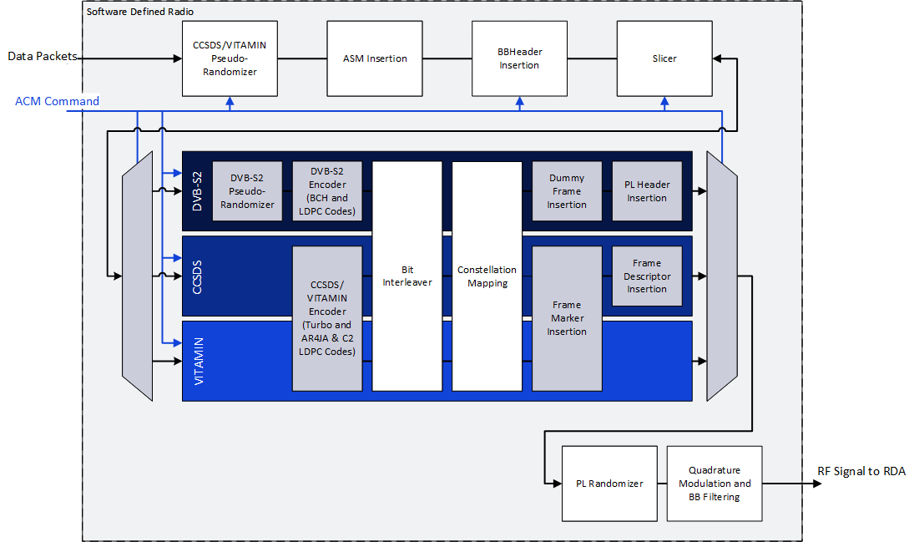

Figure 5 Functional blocks for VCM protocols: DVB-S2, CCSDS, and VITAMIN

To demonstrate the flexibility and autonomous beam forming of the SPA, the spacecraft mission includes various attitude control modes (nadir, limb, random tumble) during ground station passes. To demonstrate the improved information throughput capabilities of the VCM protocols, the spacecraft will perform downlinks with several fixed coding and modulation schemes, as well as the VCM modes. The NSN ground station will be responsible for receiving and decoding DVB-S2 experimental packets up to 16APSK. Transmission of the experimental packets assume a 5MHz bandwidth with a 0.2 filter roll-off giving a potential maximum symbol rate of 4.2 MSymbols/s. The team will compare the total information throughput for each of the experimental downlinks to the Constant Coded Modulation (CCM) and theoretical limits. These two technology demonstrations will occur first independently, and then concurrently. The NSN project team will collaborate on the experiments to demonstrate both the NSN VCM capabilities and the compatibility of the payloads with the NSN. The NSN project team currently supports missions that communicate with fixed channel codes, modulations, and symbol rates, resulting in a constant data rate that does not adapt to the dynamic link margin.

The CCP team has already developed a prototype SDR based on GNU Radio and a BeagleBone Black, which the GSFC Communication Standard and Test Laboratory (CSTL) tested with a Cortex high data rate receiver (HDR) in DVB-S2 mode. BER performance for modulations including QPSK, 8PSK and 16APSK with various coding rates such as 1/4, 3/4, 8/9, 9/10 were tested. The results indicate correct coding for the software modulator and compatibility with the CCSDS DVB-S2 standard, however, the GNU Radio/BeagleBone Black prototype was unable to transmit at the desired symbol rate. UAF is currently translating the GNU Radio code to MATLAB/Simulink HDL Coder for use with ADRV9361-Z7035 SDR.

The compatibility testing of the revised CCP DVB-S2 transmitter with NASA’s NSN ground station consists of three stages. Stage 1 is the test in the GSFC CSTL. Based on test results in CSTL, the team will develop a prototype transmitter. Once the prototype is ready, the team will test it in the WFF NITRO testbed at WFF in VA for stage 2. The testbed emulates NSN channel medium loop configuration containing an LNA, down converter and other components. The UAF team will develop an engineering unit based on test results in the CubeSat testbed. In stage 3, the team will run a formal compatibility test with the flight version of the DVB-S2 transmitter in the Compatibility Test Lab (CTL) at GSFC. The team will measure and verify the transmitter parameters against those in the CCP RF ICD during the test. A compatibility test report released after the test will document the results. This is the requirement for the certification of the compatibility of the DVB-S2 transmitter with the NSN ground station.

# *7*.0 Conclusion

NASA’s NSN is excited to offer to the NASA small satellite community evolving commercial services with technologies such as DVB-S2. The brokering of commercial service is an expansion of commercial service, which the NSN had previously successfully brokered.

CubeSat missions such as CCP and CLICK will benefit from the expanded commercial service, as will other future NASA small satellite missions.

DVB-S2 will increase science data return for all missions and enable support for a greater number of CubeSats/SmallSats at high data rates. European and U.S. commercial spacecraft have taken advantages of the efficiencies of DVB-S2. Leveraging of commercial ground stations more quickly makes available DVB-S2 for NASA missions.

The NSN is actively seeking additional flight and ground solutions for evaluation and welcomes contact for technical discussions.

## Acknowledgments

The authors wish to thank NASA’s NSN for funding investigations for improved space communications support for the SmallSat/CubeSat community. Additionally, the authors would like to thank Professor Denise Thorsen of UAF and her CCP team for sharing CCP DVB-S2 S-band transmitter development experience with NASA.

## References

1. Morello, A. and Mignone, V, “DVB-S2: The Second Generation Standard for Satellite Broad-band Services”, Proceedings of the IEEE, vol. 94, No. 1, January 2006.
2. Paul Serra and others “Optical Communications Crosslink Payload Prototype Development for the Cubesat Laser Infrared CrosslinK (CLICK) Mission”, Small Satellite Conference, Logan, UT, August 2019.
3. Morello, A. and Mignone, V, “DVB-S2: The Second Generation Standard for Satellite Broad-band Services”, Proceedings of the IEEE, vol. 94, No. 1, January 2006.
4. Joseph A. Downey, Dale J. Mortensen, and Michael A. Evans, “Variable Coding and Modulation Experiment Using NASA’s Space Communication and Navigation Testbed”, NASA/TM—2016-219126
5. Jean-Luc Issler, Centre National d’Etudes Spatiales, Space telemetry use cases of DVB-S2 CCSDS standard, December, 2015
6. Yen Wong, Scott Schaire, Steven Bundick, Obadiah Kegege, Serhat Altunc, Peter Fetterer, “NASA Near Earth Network (NEN) DVB-S2 Demonstration Testing for Enhancing Data Rates for CubeSat/SmallSat Missions”, Small Satellite Conference, Logan, UT, August 2019.
7. Yen Wong, Scott Schaire, Steven Bundick, Peter Fetterer, “NASA Near Earth Network (NEN) DVB-S2 Demonstration Testing for Enhancing Higher Data Rates for CubeSat/Small Satellite Missions at X-band and Ka-band”, Small Satellite Conference, Logan, UT, August 2020
8. FCD_GroundStation_April2020.pdf
9. J. Long, D. Thorsen and O. Kegege, "Retrodirective Phased Array Antenna for CubeSats," in IEEE Aerospace Conference Proceedings, 2019.
10. T. Sielicki, J. Hamkins and D. Thorsen, "Variable Coded Modulation software simulation," in IEEE Aerospace Conference Proceedings, 2013.