Standard Operating Procedure:
InVEST and Temperature Anomaly Mapping

NASA DEVELOP Cincinnati & Covington Urban Development – Spring 2021
Paxton LaJoie, Olivia Cronin-Golomb, Samuel Feibel, Katrina Rokosz
Table of Contents
- Creating the Inputs and Running the InVEST Model ….………………….….…….2
I.I Downloading the InVEST Model ……………………...………………………….…..2
I.II Populating the InVEST Biophysical Table …………………………………………...2
I.III Retrieving and Inputting Mean Albedo ……………………………………………...5
I.IV Calculating Building Intensity ……………………………………………………….7
I.V Adding Building Intensity to the Biophysical Table…………....……………………...8
I.VI Creating the Mean Evapotranspiration (ET) Raster …………………………………9
I.VII Running InVEST with all Inputs ………………………………………………….10

- Running Alternative Model Scenarios …………………………………...…………..11

- Land Surface Temperature (LST) Anomaly Mapping ……………………………...11
III.I Calculating Daytime LST ………………..…………………………...……11
III.II Calculating Nighttime LST …………………………………………………….…13

- Quantifying and Mapping Daytime and Nighttime Anomalies in ArcPro ..………15

The team used the Natural Capital Project Integrated Valuation of Ecosystem Service and Tradeoffs (InVEST) Urban Cooling Model to map a heat mitigation index for the study area. The resulting maps show which communities are most exposed to impacts of increased urban heat. This document will serve as a detailed standard operating procedure to walk users through downloading the model, formatting input data, and running the model successfully. This document will also walk users through retrieving and processing remotely sensed data including albedo, evapotranspiration, and land surface temperature (LST).

- Creating the Inputs and Running the InVEST Model

I.I Downloading the InVEST Model
- Download the InVEST Model from: https://naturalcapitalproject.stanford.edu/software/invest
  - User guide available here: https://storage.googleapis.com/releases.naturalcapitalproject.org/invest-userguide/latest/index.html
  - Urban Cooling Model User Guide available here: https://storage.googleapis.com/releases.naturalcapitalproject.org/invest-userguide/latest/urban_cooling_model.html#the-model

- Once downloaded the InVEST Model will show up in “Applications.” There are many folders corresponding to the different models within InVEST. Select the “Urban Cooling Model” folder.

I.II Populating the InVEST Biophysical Table
- In the folder/directory in your computer where you downloaded InVEST, you will find a folder called “sample_data.” Within this folder is a folder named “UrbanCoolingModel.” Navigate to this folder, where you will find sample input files for the InVEST Urban Cooling Model.

- Open the sample file “Biophysical_UHI_fake.” This will serve as a template for creating your own Biophysical Table for input into the InVEST Urban Cooling Model.
  - The column “lucode” refers to the numeric code of the LULC classes for your input LULC data, to which all Biophysical Table attributes are linked.
  - The “Description” field contains the description of the LULC class.

- Calculate Shade values for input to the Biophysical Table.
  - Open ArcGIS Pro. Add your canopy data for your study area, as well as your LULC raster for your study area, into the Table of Contents. Make sure that your layer for canopy is in vector format.
  - Convert your LULC raster to a polygon using “Raster to Polygon” in ArcGIS Pro.
  - Make sure your canopy layer and new LULC polygon are projected in the same coordinate reference system. If not, use the “Project” tool to do so.
  - Use the “Summarize Within” analysis tool in ArcGIS Pro. Select your LULC vector as the “Input Polygons” and your canopy vector as “Input Summary Features.” Run the tool.

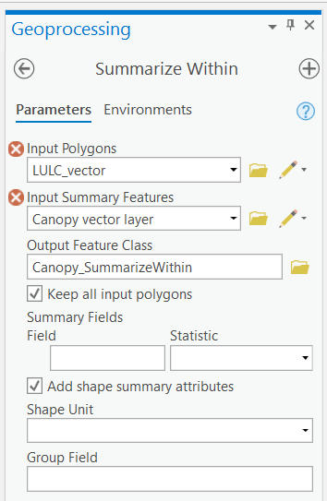

  - Open the Attribute Table of the output layer from this step (d). There will be a field containing the “lucode” for your LULC layer, in this case, labeled “gridcode.”

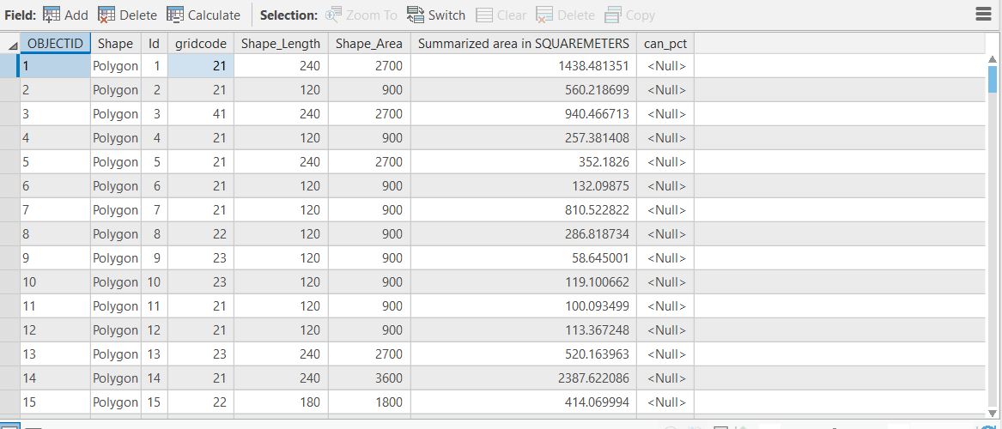

  - The “Summarized area in "UNIT"” field contains the sum of the area of your “Input Summary Features.”
  - Create a new field labeled something like “canopy_pct” to fill with values for the percent of a LULC cell or group of cells that is covered by canopy. This value can be calculated for each field using the “Raster Calculator.” To do this, divide the summary field column (area of canopy for each row) by the “Shape_Area” field, which contains the area of the LULC pixel or group of pixels within which the canopy area has been summarized. The output values in the “canopy_pct” column should range from 0-1, representing percent canopy cover. Save edits. Stop editing.
  - Click “Select by Attributes” in the map menu, or search for the tool in Geoprocessing tools. For “input rows” select your shapefile generated from “Summarize Within.” Make sure before doing so that the “canopy_pct” column is filled with values (step g).
  - Click “New Expression.” Where “gridcode (field containing lucode)” is equal to “(first lucode, i.e 11, or other number depending on LULC dataset).”
  - Right click the shapefile with canopy percent (the one we have been using) in the table of contents and click “Create Chart > Histogram.”
  - Click “Properties” to open the “Chart Properties” tab. In the “Variable, Number” field select your field containing percent canopy (canopy_pct). Now, filter by selection in your Histogram chart tab. The selection will be the “lucode” field you selected in step i. The histogram will display “canopy_pct” values for the selected lucode, including a mean at the right of the histogram. This is the mean value that you will enter into the Biophysical table for the selected LULC class.

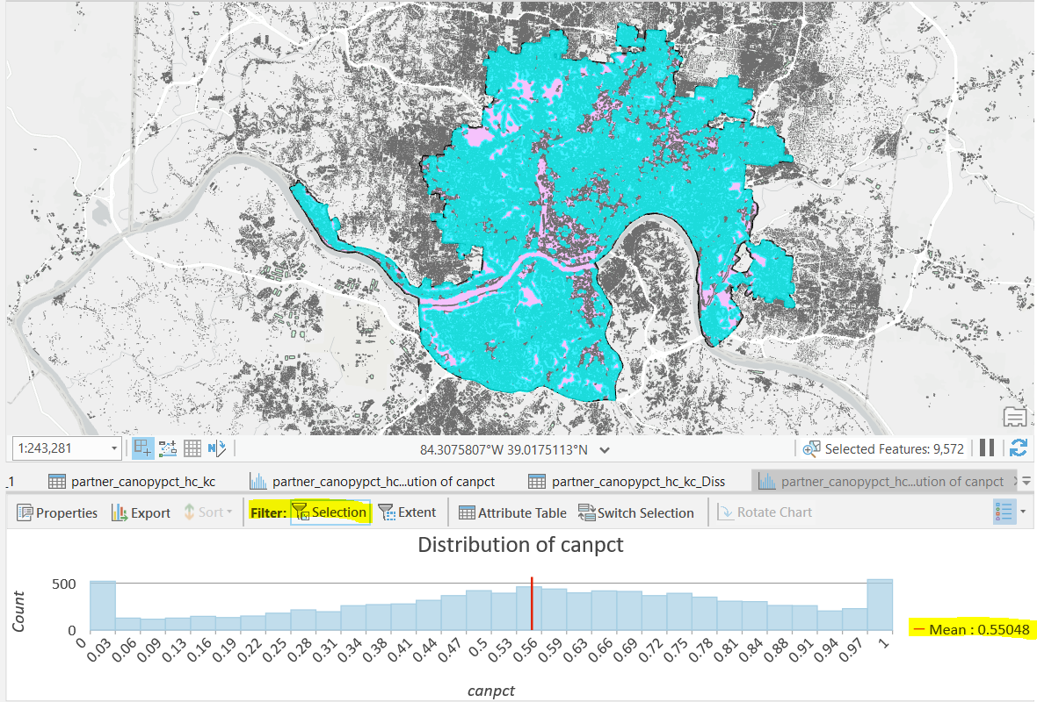
  - Repeat steps i-k for each LULC class (lucode), and enter the mean values into “Shade” field of the Biophysical table. These canopy percent values will be used in the model as a proxy for shade.

I.III Retrieving and Inputting Mean Albedo
- Open Google Earth Engine: https://code.earthengine.google.com/. Create an account if you do not already have one.

- This code requires several scripts, which is why you'll want to stay organized with a repository.
  - Create a repository by navigating to the "Scripts" tab in the left-hand panel and selecting "New.”
  - Select "Repository" and give it a unique and descriptive name.
  - While in that repository, again select "New" under the "Scripts" tab and then select "Script." Give it a descriptive name. For this example, the script will be referred to as "dLST" for daytime LST.

- Importing your area of interest.
  - Navigate to the "Assets" tab in the left-hand panel of the interface and click "New." Under "Table Uploads," select "Shape files." If you have a Geotiff or comma-separated values (.CSV) file, the following steps will be identical, except you'll click on "Geotiff" or "CSV" in this step.
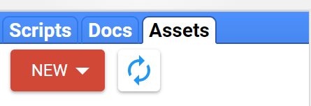
  - Click "Select" and navigate to the folder where you have your study area shapefile to import it. Give it a descriptive name and then click "Upload."
  - For this analysis, we imported a shapefile of the Cincinnati and Covington area with the reference polygons.
  - Once your shapefile uploads, it will appear within the "Assets" tab under the repository you're working. Click on it and then click "Import."
  - Navigate back to your script. Your shapefile will appear at the top of the script, in a section called "Imports."
  - To map your area of interest, use the function Map.addLayer()

- Set your desired study period by creating variables for the years of interests and the day of years of interest. Note that day of year changes on leap years.
  - Use the functions ee.Filter.calenderRange() to set the year range and ee.Filter.dayOfYear() to set the day of year range.

- Create a variable that refers to your area of interest.

- Create a cloud mask function to apply to the Landsat 5/8 imagery.
  - Within your Script tab on the left-hand side, there is a folder labeled "Examples."
  - Expand that and scroll to the folder labeled "Cloud Masking."
  - Within that folder, there is example code of cloud masking for both Landsat 5, "Landsat 457 Surface Reflectance," and Landsat 8 "Landsat8 Surface Reflectance." These scripts both rely on the "Quality Assurance" band included in the Landsat image collections. Copy and paste your desired code into your script.

- Importing Landsat 5/8 imagery.
  - The Landsat 5 image collection is "LANDSAT/LT05/C01/T1_SR." If you want to learn more about this collection, search "LANDSAT/LT05/C01/T1_SR" in the search bar at the top of the page. This will describe the band numbers and their corresponding reflectance ranges.
  - The Landsat 8 image collection is "LANDSAT/LC08/C01/T1_SR."

  - Filter the Landsat image collection by year and date ranges, and area of interest using the previously defined variables.
  - Apply the cloud mask function to the Landsat image collection.

- To generate the albedo per pixel as a new band, retrieve the albedo coefficients from page 367 of the linked paper, multiply them by the surface reflectance of the corresponding band, and then sum. Use the Tasumi coefficients for Landsat 5 and the Olmedo coefficients for Landsat 8.

- Calculate the median albedo per pixel geography in the image collection (Landsat 5, 8, etc.).

- Calculating albedo values for the Biophysical Table using your albedo raster and LULC raster in ArcGIS.
  - Open ArcGIS Pro and add your albedo raster data and LULC raster to the project.
  - Clip to the study area if needed.
  - Using the “Zonal Statistics as Table” (Spatial Analyst) tool add your LULC raster as the “input zone data,” and your albedo raster as the “input value raster.”
  - Before running the tool, make sure that the spatial reference of both files is the same. If not, use the “Project” tool to reproject and use the newly reprojected file.
  - Run the tool. The output will be a table, located at the bottom of the Table of Contents.
  - Open this table to see that values for Min, Max, Mean, Sum, and more statistics have been calculated for your “input value data” within the LULC classes of your “input zone data.”
  - You are interested in the “Mean” values for each LULC class. Sort the LULC numeric ID column to make sure the order is the same as it is in the Biophysical Table you are using.
  - Export the table using the “Table to Excel” (Conversion) tool.
  - Copy the “Mean” albedo column and add to the “albedo” column of the Biophysical table.

I.IV Calculating Building Intensity
The building intensity InVEST input assesses the number of floors per building per LULC class within the study area. Because the team did not have a single shapefile with every building height and area, this input required pre-processing to generate a useful shapefile.

- The “Ham_Buildings” shapefile includes area and height for each building in Hamilton County. To incorporate Kenton County buildings, we first converted the Kenton County Lidar files, “L_Lidar_Tiles” through “Q_Lidar_Tiles,” to shapefiles in ArcCatalog.

- Once the Lidar data has been converted to the .SHP format, use the “Merge” tool to combine the six files into one. Then, use “Clip” to isolate the buildings within the study area.

- Sort through the “Structure Type” field and eliminate patios, swimming pools, and any other types with ≤ 0 feet in as their height.

- Create a Field within “Ham_Buildings” and your newly-generated Kenton County buildings shapefile called “Floors.” Use the “Merge” tool to combine the two building files based on the “Floors” field.

- For the purposes of determining floor count in each building, we settled on an average height of 8.5 feet per floor. Within the attribute table, select “Calculate Field” to populate the Floors field by dividing the “Shape Height” fields by 8.5.

- Any attributes listed as having 0 floors should be changed to having 1 floor.

- Create an additional field within the building file called “gridcode.” This will be used to evaluate the NLCD LULC class for each building attribute.

- Using Building intensity = ∑(Building Area × Floors) ÷ Land Area, create a field called “Sigma,” equaling each attribute’s Building Area × Floors.

- Use “Zonal Statistics as Table” to calculate the sum of each building area within the NLCD LULC classes in the study area using the Sigma field.

- Normalize the sum of the building areas within each LULC category by dividing each value by the greatest sum.

I.V Adding Building Intensity to the Biophysical Table
- Once you have obtained values for building intensity, don’t forget that they must be normalized to fall within the range 0-1, with 1 being the maximum building intensity. To do this, divide all values by the largest value. This will make the largest value equal to 1.

- Once your building intensities are within the 0-1 range, add these values to the Biophysical Table in the rows corresponding to their unique LULC classes. These building intensity values will only be used by the model if “Building Intensity” is selected in the dropdown
menu for “Cooling Capacity Calculation Method” within the InVEST Urban Cooling Model GUI. Use this calculation method when running the model to produce a nighttime heat mitigation index.

I.VI Creating the Mean Evapotranspiration (ET) Raster
ET processing was done using the daily ET imagery downloaded from ISS ECOSTRESS between the years of 2018-2020 for summer months (June, July, August).

- Download ISS ECOSTRESS data for study area and reference polygons using the NASA AppEEARS tool.
  - After launching the website linked above, click the green “Launch AppEEARS” button at the top of the page.
  - Click the “Sign In” button at the top right of the page you've navigated to.
  - You’ll be directed to an EARTHDATA Login page. If you do not already have an account, register for one, and then sign in.
  - You’ll be directed to a page titled "Welcome to AppEEARS!"
  - Click the “Extract” tab at the top of the page. There will be a pull-down menu. Click "Area Sample."
  - On the next page, click Start a New Request."
  - Enter a descriptive name for your data request.
  - Upload the shapefile of your area of interest or draw a polygon in the map on the right of the page that encompasses your area of interest.
  - Input your desired start and end dates. To efficiently download just the summer imagery across multiple years, check the box labeled "Is Date Recurring" and set your year range.
  - In the search bar of the "Select the layers to include in the sample" section, type "ECOSTRESS."
  - There will be multiple data products you can select from. For ET, select the "ECOSTRESS Evapotranspiration PT-JPL" product.
  - Again, there will be multiple data products available to download. Click the "EVAPOTRANSPIRATION_PT_JPL_ETdaily" product. This product contains the daily integrated ET data. It will slide from the left panel to the right panel.
  - Under "Output Options,"specify your file format as a "Geotiff" and your projection as "Native Projection.”
  - Click the "Submit" button at the bottom right of the page.
  - The data will be sent to the email you use for your EARTHDATA Login. As this request can contain a lot of data, it may take several hours to receive this email.
  - Follow the link provided in the email sent when the data is ready.
  - Download all of the ET rasters by checking the box to the left of each. Organize the rasters into one folder.
  - Download the other metadata files at the top of the page to another folder for future reference.

- Process ET data in ArcGIS Pro.
  - Import each of the ET rasters into ArcGIS Pro.
  - A cloud and water mask were already applied in the preprocessing of the product. These are given the value of "no data" in each raster.
  - Conduct a visual inspection of each raster and remove rasters that have more than ~50% cloud cover, or are covered by more than 50% of no data pixels that form "blob-like" shapes, like clouds, across the study area.
  - Use the “Cell Statistics” tool to calculate a mean ET raster.
  - There will be areas in the resulting raster that have no data. This is where the water mask was applied. Convert these values to the minimum value in your mean ET raster.
  - Use the “Raster Calculator” tool to convert the mean ET raster from W m⁻² to mm m⁻²
  - Export the final raster.

I.VII Running InVEST with all Inputs
- Create a directory/folder, labeled accordingly, where you’d like your model outputs to export.

- Open the InVEST GUI.

- Select the folder you just created in the “Workspace” line of the GUI.

- Add your LULC raster.

- Add your ET raster.

- Add your area of interest.

- Add the biophysical table (make sure you save it as a .CSV, not .XLSX).

- Add baseline air temperature. Note: for our study, we were restricted to using mean LST values for this input due to lack of time to find a viable average air temperature.

- Under “Cooling Capacity Calculation Method” select “Weighted Factors” to run the daytime model, or “Building Intensity” for the nighttime model.

- If not using the Energy Savings Valuation Model, deselect the check box.

- Run the model. The outputs will appear in your designated Workspace folder.

- Running Alternative Model Scenarios
To model the effects of potential interventions, such as increasing tree canopy or increasing roof albedo, you can directly change values within the Biophysical Table. For example, if you want to model the effects of increasing tree canopy cover by 40% within a particular land use class, open developed areas. For example, you would add 0.40 to the shade value in the Biophysical Table that contains your baseline, or “normal scenario” data for open developed areas. For more advanced, nuanced scenarios, it may be necessary to perform operations in ArcGIS Pro to change canopy, albedo, or other input datasets before determining new mean values within each LULC class for the Biophysical Table.

- Land Surface Temperature (LST) Anomaly Mapping
The DEVELOP Team mapped daytime and nighttime temperature anomalies during summer months in Cincinnati, OH and Northern Kenton County, KY.

III.I Calculating Daytime LST
Daytime LST processing was done using the Landsat 5 Surface Reflectance image collection accessed through Google Earth Engine between the years of 2010 – 2012 for summer months (June, July, August).

- Repeat steps 1-7 in the I.III Retrieving and Inputting Mean Albedo section above. You should reuse your study area, cloud mask, and Landsat datasets.

- Calculate Normalized Difference Vegetation Index (NDVI).
  - NDVI is calculated using the following equation: (NIR - RED) / (NIR + RED).
  - NIR is band 3 and Red is band 4 for Landsat 5.
  - Create a function to calculate NDVI for your collection.

- Calculate Emissivity from NDVI.
  - The BT band is band 6 for Landsat 5.
  - Scale the BT band by multiplying it by 0.1 (it was condensed for storage).
  - Specific NDVI ranges have a corresponding emissivity. Reclassify the NDVI raster to the corresponding emissivity.

NDVI | Emissivity
< 0 | 0.9925
> 0 & < 0.15 | 0.923
> 0.15 & < 0.727 | 1.0094 + 0.047 * log(NDVI)
> 0.727 | 0.986

- Scale the Brightness Temperature (BT) band by multiplying it by 0.1
  - The BT band is band 6 for Landsat 5.

- Calculate LST from emissivity and the BT band.
  - Apply the following equation using NDVI and BT. This equation converts the LST calculation from Kelvin to Fahrenheit:

LST [°F] = (A / (1 +(0.00001145 * (A / 0.01438) * log(B))) * (9/5) - 459.67

Where A is BT [K] and B is emissivity [unitless]. Note: ‘log()’ in the equation above is the Javascript call for natural log used in GEE.

- Take the median value of the resulting LST raster.

- These equations are explained in Giannini et al. (2015).

- Export the resulting raster to your Google Drive.
  - Use the function Export.image.toDrive()
  - The "Tasks" tab in the right-hand panel of the GEE interface will turn orange. Click on the "Tasks" tab.
  - There will be the LST image in this tab with a blue "RUN" button to the right. Click "RUN."
  - Define the Google Drive folder you want to export the LST image to and click the "Run" button at the bottom. This export does take several minutes to complete, so please be patient.

III.II Calculating Nighttime LST

Nighttime LST processing was done using the LST and LST QC downloaded from ISS ECOSTRESS between the years of 2018-2020 for summer months (June, July, August).

- Download ISS ECOSTRESS data for study area and reference polygons using the steps described in the I.VI Creating the Mean Evapotranspiration (ET) Raster section.
  - Repeat steps a – j.
  - Repeat step k., except select the "ECOSTRESS Land Surface Temperature & Emissivity" product.
  - Repeat step l., except select both the "SDS_LST" and the "SDS_QC" products.
  - Repeat steps m – r, except create two separate folders for the LST and QC files.

- Make sure the LST and LST QC files downloaded from ECOSTRESS are in the same order in their respective folders.

- Open RStudio and set your working directory to the LST and LST QC file path.

- Read in packages raster, rgdal, ggplot2, dplyr, sp, and sf.

- Read in study area shape file using readOGR.
  - If your study area is in a different coordinate reference system than your raster files it will need to be reprojected using spTransform().
  - crs() can be used to check the coordinate reference system.

- Read in single LST raster.
  - This single raster file should be high quality because it is be the raster all other rasters will be snapped to. Generally, the raster with the greatest file size is the file that covers most, if not all, of the study area.
  - This raster can be checked in ArcGIS by importing it and comparing it to the study area to ensure features align, and a large proportion of the study area is covered.

- Read in all LST files using list.files().

- Filter out the nighttime LST files based on the time stamp in the file name. In this case, nighttime included all imagery collected between 22:00-03:59.
  - Create a loop to read each file name, specifically reading the substring in the hours place. For those files that have the hours substring equal to the desired nighttime hours, create a new list.

- Rasterize the list of nighttime rasters using the lapply() and raster() functions.

- Snap LST rasters together based on the single LST raster from step 6 using the resample() function.

- Crop all rasters to shapefile.

- The LST values have a scaling factor of 0.02 for storage purposes. Multiply the LST values by 0.02 by creating a function and using lapply().

- Convert LST values to Fahrenheit for the adjusted Kelvin temperature used by ECOSTRESS by creating a function and using lapply().

- Repeat steps 6 – 11 for LST QC rasters.

- Creating the cloud mask with the LST QC rasters.
  - Use the bitwAnd() function to unpack the bits in the cropped LST QC raster data, keeping bits 0-3.
  - Reclassify LST QC rasters so that every bit value greater than 1 becomes NA. We removed bits with a value of 2 or 3 because they are flagged as clouds or poor quality respectively.
  - Reclassify the LST QC rasters again to that anything that has a bit value (now either 0 or 1) becomes a value of 1.
  - Apply this created cloud mask to the cropped LST rasters by multiplying the reclassified LST QC rasters and cropped LST rasters. Pixels with NA in the LST QC raster will now be removed from the LST raster.

- Stack the LST rasters that now have the cloud mask applied.

- Calculate the mean LST of each pixel in the stack using stackApply().

- Export the raster using the writeRaster() function.

- Quantifying and Mapping Daytime and Nighttime Anomalies in ArcGIS Pro

- Import the geoprocessed daytime LST raster of mean daytime LST into ArcPro.
  - This raster should include mean LST for each pixel across the study area and reference areas.

- Use the “Zonal Statistics as Table” (Spatial Analyst) tool to calculate the minimum, maximum, and mean LST values for the Cincinnati and Covington area and the reference polygons.

- Export the resulting table as a .CSV to obtain the temperature statistics.

- Repeat steps 1 – 3 for nighttime LST.

- Subtract the average minimum, maximum and mean values of the reference polygon from the minimum, maximum and mean values of the Cincinnati and Covington area to quantify the temperature anomalies.

- Use the “Clip Raster” tool to clip the daytime and nighttime LST rasters to the extent of the Cincinnati and Covington area and the reference polygon shapefile.

- Create a new “Layout” to map the temperature gradient across your area of interest.

- Use the “Clip Raster” tool to clip the daytime and nighttime LST rasters to the extent of just the Cincinnati and Covington area.

- Use the “Raster Calculator” tool to subtract the mean daytime temperature of the reference polygons calculated in step 5 from the daytime LST raster of the Cincinnati and Covington area to create the temperature anomaly map.

- Repeat steps 8-9 for nighttime LST.

