Title: IntraVenous Fluid GENeration for Exploration Missions MINI (IVGEN Mini)
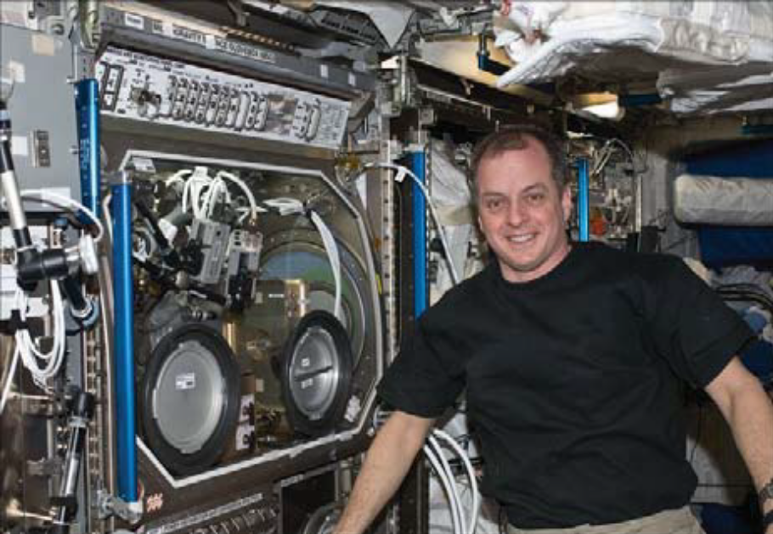

Project Introduction
Intravenous (IV) fluids are an important treatment modality for multiple medical conditions that have the potential to occur during Mars missions and that may lead to adverse crew health and mission outcomes without appropriate treatment. However, carrying sufficient volumes of IV fluids with adequate shelf life to support such missions is currently not feasible due to anticipated mass and volume constraints of future vehicles and the relatively short shelf-life of terrestrial IV fluids. The goal of the IntraVenous Fluid GENeration for Exploration Missions MINI (IVGEN Mini) project is to develop a low mass and volume IV fluid generation device that can produce IV fluids in situ and that reduces the need to launch and store large quantities of IV fluids. It builds on the original IVGEN system developed by the Human Research Program Exploration Medical Capability Element that successfully demonstrated the capability to produce in situ IV fluids aboard the ISS in 2010 using an ISS potable water source. Flight demonstration objectives for this system included purification via packed bed, bubble removal, sterilization, microgravity mixing, and United States Pharmacopeia (USP) tested compliance. The current project will focus on miniaturization of the previously flown IVGEN system and include system upgrades to make the system more reliable, easier to use, and compatible with technical constraints associated with exploration missions such as parsimonious mass/volume/power constraints and increased radiation exposures. The project will culminate in a flight technical demonstration on the ISS in 2024 and deployment of a flight ready unit on Gateway in 2026/2027.

Anticipated Benefits
IVGEN technology could be used on Earth to generate purified water and IV fluid in remote environments where medical resources are limited.

Primary U.S. Work Locations and Key Partners
Organization performing work | Role | Type | Location
Exploration Medical Integrated Product Team | Lead Organization | NASA Center | Johnson Space Center
Human Exploration and Space Operations Project Office | Support Organization | NASA Center | Glenn Research Center

Organizational Responsibility
• Responsible Mission Directorate: Human Exploration and Operations Mission Directorate
• Lead Center: Johnson Space Center
• Responsible Program: Advanced Exploration Systems (AES) Program
• Project Management: Human Exploration and Space Operations Project Office at Glenn Research Center (GRC)
• Program Manager: Lindsey Aitchison
• Project Manager: Gail Perusek
• Principal Investigators: Moriah Thompson, Rahul Suresh

Project Start Date: October 1st, 2020
Project End Date: September 30th, 2027
Technology Maturity Level (TRL)
• Start: 6
• Current: 6
• Estimated End: 8
• Technology Areas:
• Target Destination: Lunar Gateway

