Evolution of the Roman Space Telescope Flight Grism Component

Margaret Z. Dominguez^{1*}, Evan P. Bray², Victor J. Chambers¹, Wesley Fincher³, Guangjun Gao¹, Qian Gong¹, John G. Hagopian³, Jason R. Krom³, Catherine T. Marx¹, Laurie Seide⁴
1. NASA Goddard Space Flight Center, 8800 Greenbelt Rd, Greenbelt MD 20771, USA
2. Peraton, 12975 Worldgate Drive, Herndon VA 20170, USA
3. ATA Aerospace, 1300 Britt St, Albuquerque NM 87123, USA
4. SGT Inc. 7701 Greenbelt Rd, Greenbelt MD 20770, USA
*margaret.z.dominguez@nasa.gov

Abstract: The Roman Space Telescope will look to survey emission-line galaxies. The Wide Field Instrument aboard it includes a slitless spectrometer or grism, which plays an important role in such a survey. We have begun the process of building the flight grism. A status update is presented in this paper. © 2021 The Author(s)

1. Introduction: The Nancy Grace Roman Space Telescope
The Nancy Grace Roman Space Telescope is a NASA observatory designed to address a number of questions regarding dark energy, exoplanets, and infrared astrophysics. The Roman Space Telescope has a primary mirror that is 2.4 meters in diameter, the same size as the Hubble Space Telescope (HST), but with a field of view 100 times greater [1]. Roman will have two instruments, the Wide Field Instrument (WFI), and the Coronagraph Instrument. The WFI includes high and low resolution slitless spectrographs and a number of selected bandpass filters. The low-resolution spectrograph (70-170 spectral resolving power) is a prism assembly, which consists of two powered prisms. The high-resolution spectrograph (435-865 spectral resolving power) is a grism assembly, which consists of two diffractive surfaces and two powered prisms. The grism will allow the surveying of emission-line galaxies [1, 2, 3].
Grisms have been used in a number of HST instruments: Wide Field Camera 3, Near Infrared Camera and Multi-Object Spectrometer, Advanced Camera for Surveys [4]. In each of those HST instruments, only a single element grism was used. Due to Roman’s large Field of View (FOV), increased spectral resolving power and faster f/#, controlling the image quality is more challenging, even when using a compound grism assembly.

2. The Roman Grism, its evolution and current status
Currently, NASA Goddard is working on the fourth iteration of the Roman grism. The first prototype of the grism was built in 2014. Subsequently, both an Engineering Design Unit (EDU) and an Engineering Testing Unit (ETU) have been fully built and characterized [3]. We are currently working on building the flight unit, which is scheduled to be completed in spring of 2022 to allow for a scheduled launch date of the Roman Space Telescope in the mid-2020s [1].
The grism optical design, throughout its various stages, uses two diffractive surfaces and two prisms, sometimes having the diffractive surface on one of the prisms. A diffractive in a non-collimated space introduces aberrations, which depend on the angle of incidence as well as the wavelength. The best way to address these issues is by adding another diffractive surface. The evolution of the optical prescription and mechanical housing of the Roman grism, from prototype to flight is shown in Figure 1, where all grism assemblies are made of fused silica and all surfaces are either flat or spherical. The first assembly shown on the left is the grism prototype, which was made of three elements: Element #1 (E1), a convex-plano optic with a diffractive on the flat surface, is an aberration corrector made to compensate the wavelength scaled aberration created by the diffractive (Element #3). Element #2 (E2) is a prism, made to create a zero deviation grism assembly at the central wavelength, making the total assembly zero defocus in the telescope ∼f/8 beam, both prism surfaces are spherical for aberration control. Element #3 (E3), another convex-plano optic with a diffractive again on the flat surface, is the key element of the grism, and provides the required spectral dispersion, which shall be between 1.0 and 1.2 nm/pixel over all wavelengths and the full FOV [3,5].
After the prototype, the EDU, ETU and flight units were designed and built in that order. The EDU/ETU units had four elements. The flight grism design was optimized based on the EDU and further maturation of the Roman telescope design. In this design, E1 and E4 from the EDU were merged into one, making the flight E1 a double sided diffractive, allowing us to reduce packaging. Extensive modeling and Monte Carlo analysis of the new flight 3-element grism indicates equivalent or superior performance with the new design [6]. Table 1 compares parameters of the various grism versions.
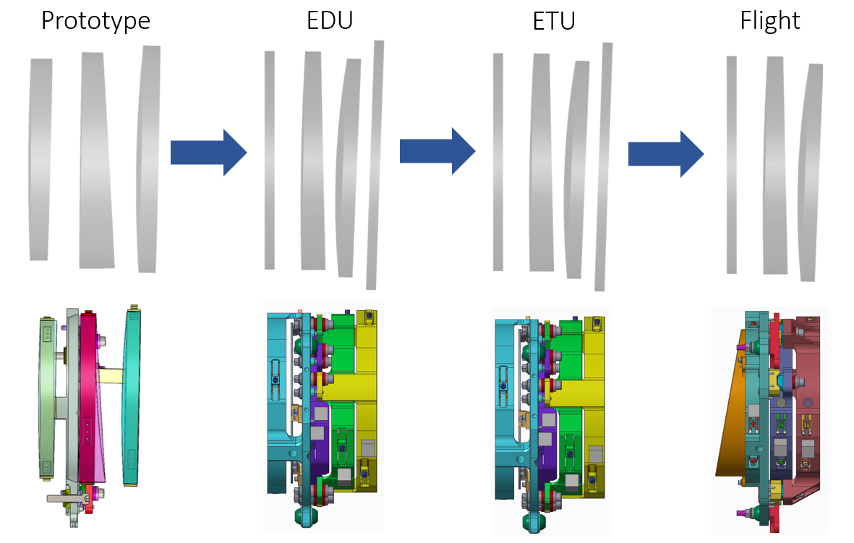
Fig. 1. Side view of the Roman grism optical prescription and mechanical housing evolution.
Table 1. Roman grism evolution parameters comparison

Parameters | Prototype | EDU | ETU | Flight
Wavelength range | 1.35 – 1.65 µm | 1.05 – 1.95 µm | 1.05 – 1.95 µm | 1.00 – 1.93 µm
Diffractive component | E1 and E3 | E1 and E4 | E1 and E4 | E1
Material | Fused silica | Suprasil | Suprasil | Suprasil
Coatings | All AR coated | All AR coated | Band-pass coated E2 | Band-pass coated E2

Currently all individual flight grism elements have been manufactured, coated and fully tested to verify their individual performance via Computer Generated Hologram testing in ambient conditions [7]. So far, they meet the individual element fabrication and coating distortion error budget allocation of 43.5nm. The next step is to align and bond them to their mechanical mounts. This will be possible because of their manufactured alignment fiducials and polished integral flats, which will allow opto-mechanical alignment in six-degrees of freedom. Afterwards the grism will be assembled to its mechanical tolerances and interferometric measurements will be collected over its full FOV. Using sensitivity analysis methods and a merit-function-based regression approach, we will find an optimized alignment that will improve the optical performance [8]. After an optimized alignment is obtained at ambient temperatures, the grism wavefront will be measured using an infrared interferometer at selected field points extending over a 20 by 14 degree FOV at its operating temperature of 175K. Ultimately, the grism will need to meet the top-level error budget allocation of 141.7nm, which we are confident we can achieve given the individual optical performance measured so far. Finally, the flight grism will undergo spectral characterization, which includes quantification of the spectral dispersion, diffraction efficiency and encircled energy.
3. References
[1] NASA Goddard. Nancy Grace Roman Space Telescope. n.d. https://roman.gsfc.nasa.gov/ (accessed March 2021).
[2] Qian Gong; David A. Content; Margaret Dominguez; Thomas Emmett; Ulf Griesmann; John Hagopian; Jeffrey Kruk; Catherine Marx; Bert Pasquale; Thomas Wallace; Arthur Whipple, “Wide-Field InfraRed Survey Telescope (WFIRST) slitless spectrometer: design, prototype, and results,” Proc. SPIE 9904, Space Telescopes and Instrumentation 2016: Optical, Infrared, and Millimeter Wave, 990412 (9 August 2016); doi: 10.1117/12.2231665
[3] Qian Gong, Matthew Bergkoetter, Joshua Berrier, Victor J. Chambers, Margaret Dominguez, Wesley Fincher, John Hagopian, Catherine Marx, Laurie Seide, "Characterization of Nancy Grace Roman Space Telescope slitless spectrometer (grism)," J. Astron. Telesc. Instrum. Syst. 6(4) 045008 (26 December 2020) https://doi.org/10.1117/1.JATIS.6.4.045008
[4] Space Telescope Science Institute. HST instrumentation. https://www.stsci.edu/hst/instrumentation/. n.d. (accessed March 2021)
[5] Q. Gong, D. Content, J. Kruk, B. Pasquale, T. Wallace, and W. Smith, "DESIGN, FABRICATION, AND TEST OF WFIRST/AFTA GRISM ASSEMBLY," in Classical Optics 2014, OSA Technical Digest (online) (Optical Society of America, 2014), paper IM3A.5.
[6] John Hagopian, Josh Berrier, John Chambers, David Content, Margaret Dominguez, Qian Gong, Jason Krom, Catherine Marx, Joseph McMann, Bert Pasquale, Laurie Seide, Arthur Whipple, Patrick Williams, "Alignment and test of the Wide Field Infrared Survey Telescope (WFIRST) Engineering Design Unit (EDU) grism," Proc. SPIE 11103, Optical Modeling and System Alignment, 1110306 (30 August 2019); https://doi.org/10.1117/12.2530697
[7] Margaret Z. Dominguez, Catherine T. Marx, Qian Gong, John G. Hagopian, Ulf Griesmann, James H. Burge, Dae Wook Kim, "Infrared computer-generated holograms: design and application for the WFIRST grism using wavelength-tuning interferometry," Opt. Eng. 57(7) 074105 (14 July 2018) https://doi.org/10.1117/1.OE.57.7.074105
[8] Margaret Z. Dominguez, Hyukmo Kang, Seonghui Kim, Joshua Berrier, Victor J. Chambers, Qian Gong, John G. Hagopian, Catherine T. Marx, Laurie Seide, and Dae Wook Kim, "Multi-field merit-function-based regression method for Wide Field Infrared Survey Telescope grism system alignment," Appl. Opt. 58, 6802-6812 (2019)

