Astrophysics

Using Ultraviolet Light to Suppress Electrostatic Noise in Gravitational Wave Observatories
Project: LISA Charge Management Device (CMD)

Snapshot: With support from NASA, the University of Florida and industrial partner Fibertek, Inc. are developing a precisely controlled ultraviolet light source that will prevent electrostatic noise from obscuring gravitational wave signals measured by the European Space Agency (ESA)-NASA Laser Interferometer Space Antenna (LISA) observatory.
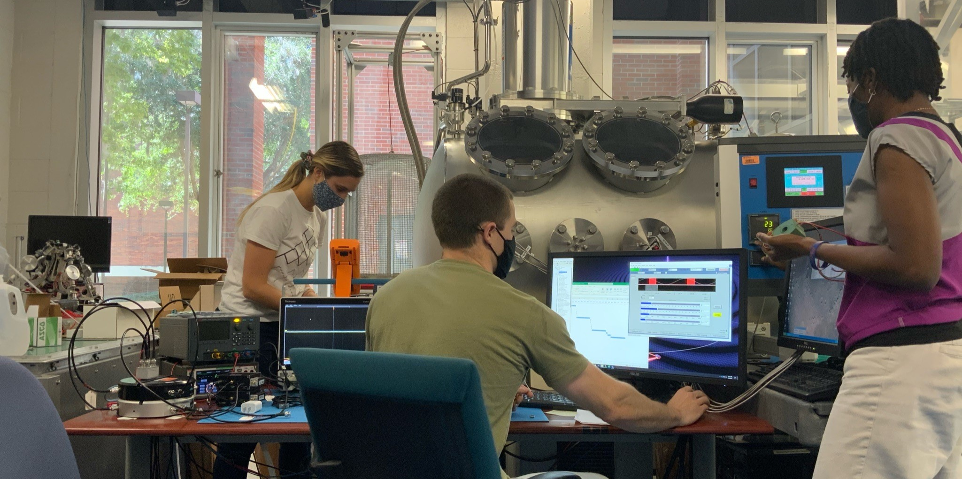
University of Florida team members performing thermal-vacuum testing of the TRL-5 CMD. From left to right: Ph.D. students Samantha Parry Kenyon and Benjamin Letson, and Postdoc, Dr. Taiwo Olatunde.

Gravitational waves are minute ripples in space-time caused by the most energetic events in the universe—like the collision of two supermassive black holes. To detect gravitational waves, we will measure the tiny variations in the motion of purely free-falling test masses housed in three Sun-orbiting spacecraft. The CMD is vital for ensuring that electrostatic charge buildup on the test masses does not disturb their motion and obscure the gravitational wave signal.
Gravitational waves enable an entirely new way of observing our universe and therefore provide enormous potential for scientific discovery. The Laser Interferometer Space Antenna (LISA), a European Space Agency mission with a significant contribution from NASA, will be the first mission to detect and observe low-frequency gravitational waves from space, complementing observatories on the ground. The millihertz, low-frequency gravitational wave band is rich in sources, ranging from merging supermassive black holes in the distant universe to smaller compact binary systems, including neutron stars and white dwarfs in our own galaxy. In fact, LISA will be able to observe thousands of sources at all times throughout its mission.
LISA will be the largest instrument ever constructed, consisting of three Sun-orbiting spacecraft that form an equilateral triangle, with each side measuring 2.5 million kilometers in length. Each spacecraft houses two precision inertial sensors that contain free-falling, gold-coated test masses (TM), protected from all disturbing forces so that they follow pure gravitational orbits (geodesics) in space-time. A “drag-free” control system is supplied with measurements of the TM position and commands external micronewton thrusters to force the spacecraft to fly in formation with the test masses. Laser interferometry is used to measure the minute variations in the distance, or light-travel time, between these purely free-falling TMs, caused by gravitational waves.
LISA represents the ultimate engineering challenge in precision ranging between spacecraft and precision inertial sensing. Variations in the distance between test masses, spaced millions of kilometers apart, must be measured to 10^{–11} m/Hz^{1/2} (a fraction of the width of an atom), and the test masses must experience free-fall at a level below 3×10^{–16} g/Hz^{1/2} (i.e., the forces that the TMs experience must be about a trillion times less than those experienced by astronauts in the “zero-g” environment onboard the International Space Station).
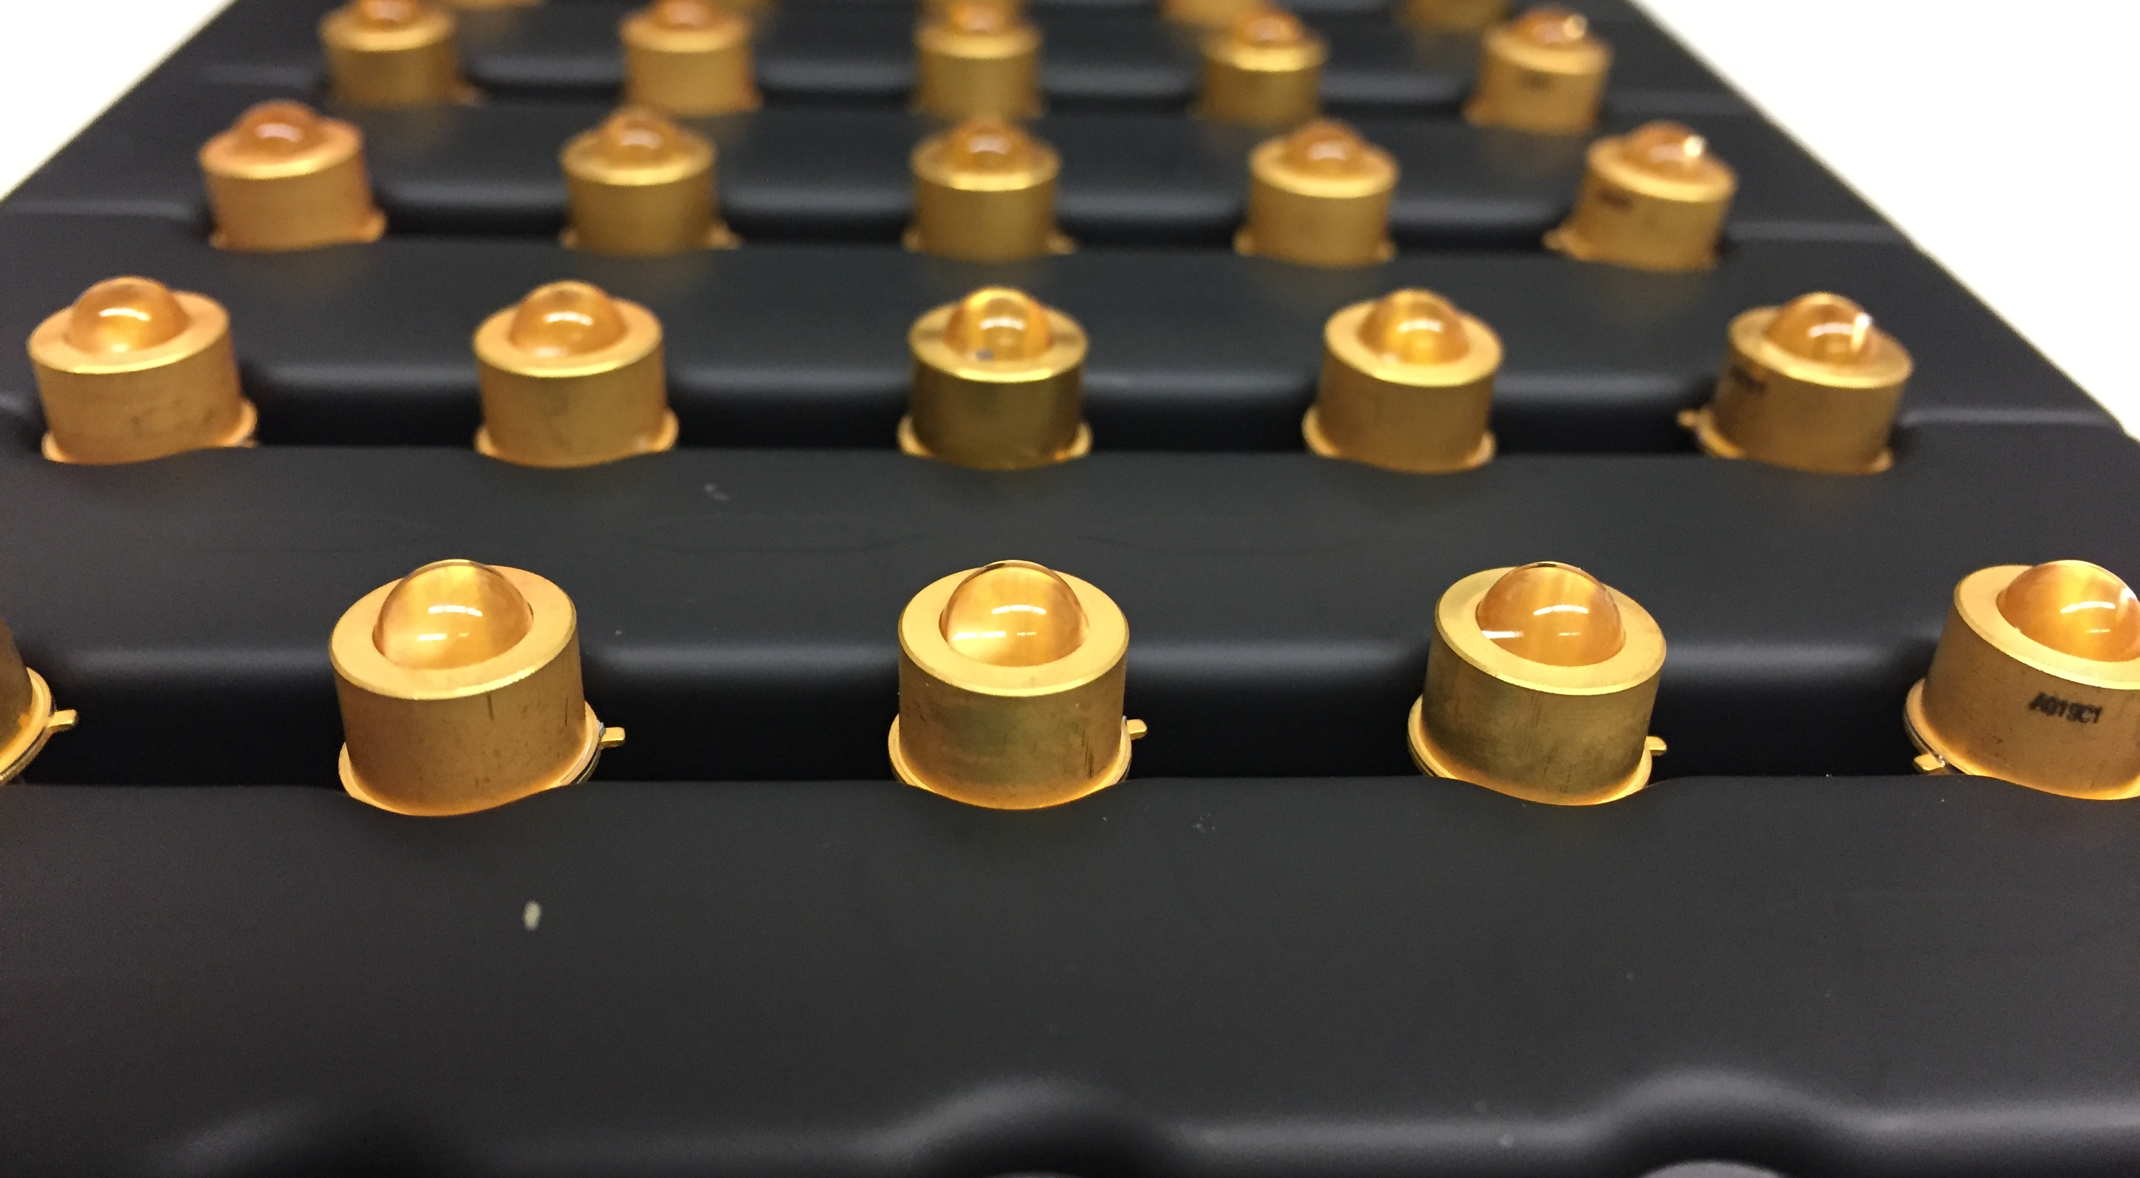
Deep UV Light-emitting diodes (LEDs) used in the LISA Charge Management Device
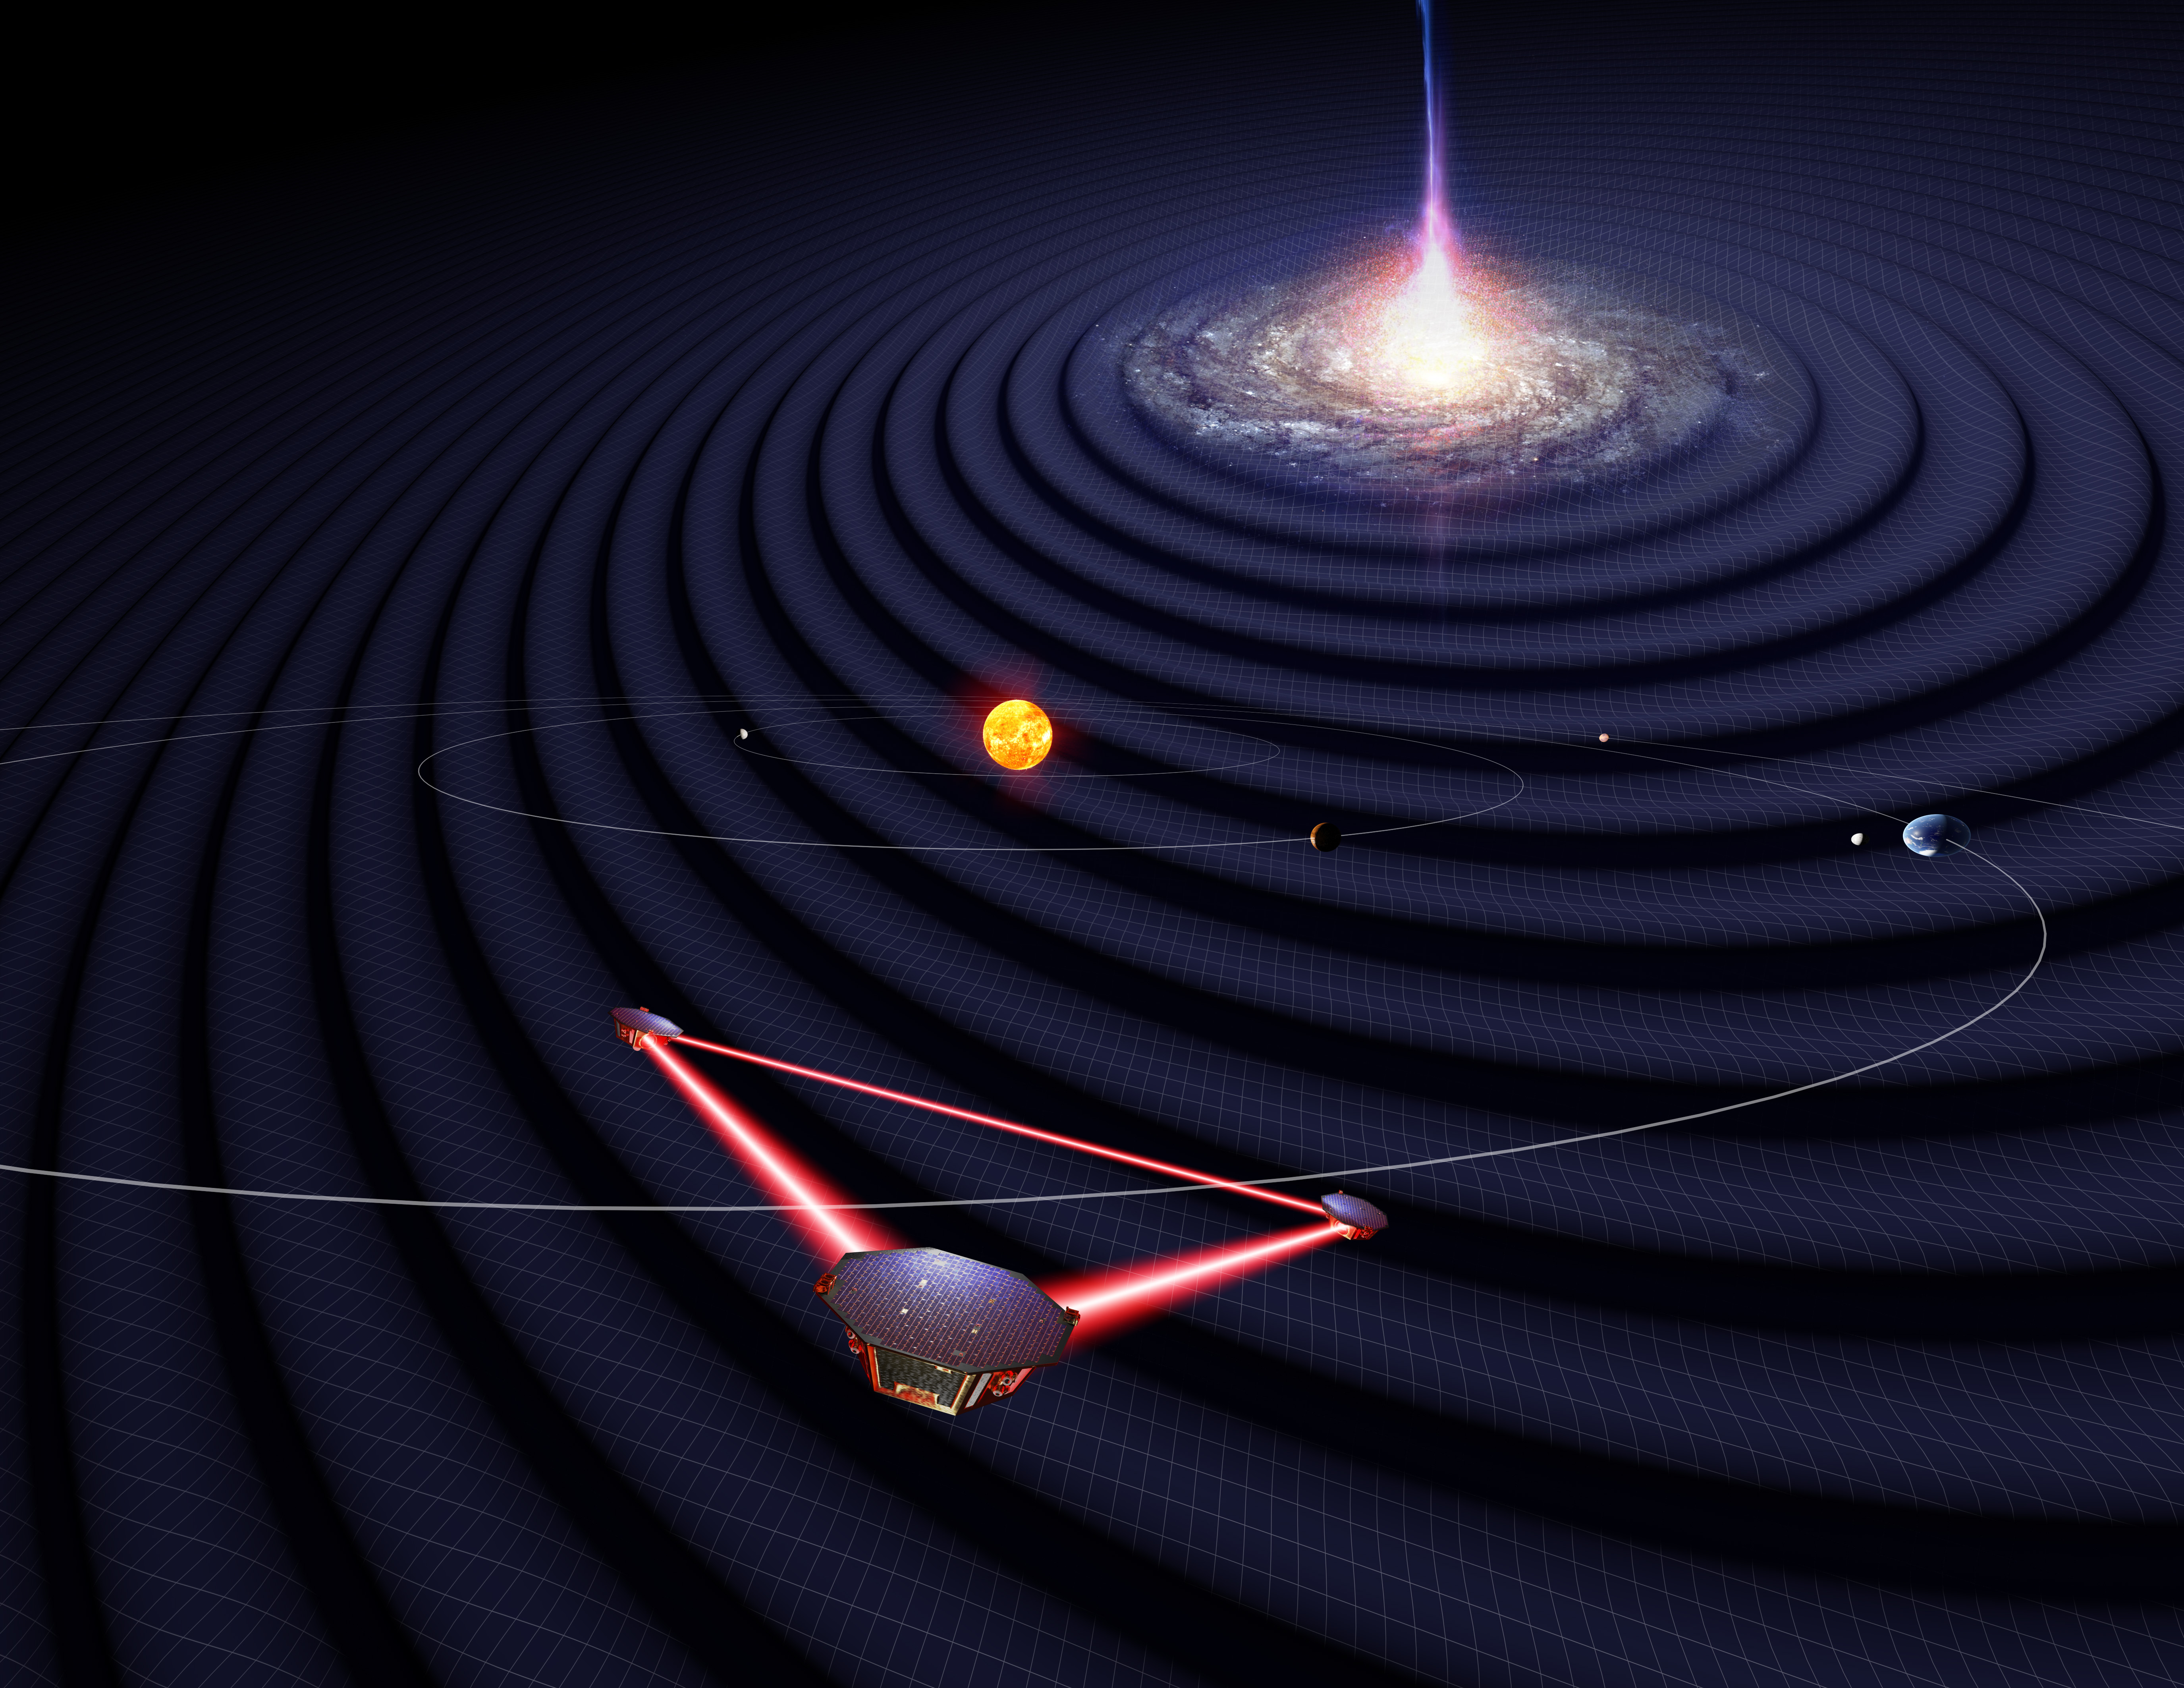
Artist’s conception of the three LISA spacecraft in orbit around the Sun (credit: University of Florida)
To achieve this level of free-fall purity, all disturbing forces acting on the LISA test masses must be reduced below the required level. Electrostatic forces caused by charge buildup on the test masses comprise one such important class of disturbances that must be suppressed. Test mass charge buildup is caused by highly energetic particles that penetrate through the spacecraft and charge the test mass either directly or via secondary electron emission. The CMD controls the electric potential of the test masses using a non-contact approach based on ultraviolet (UV) photoemission. The CMD produces UV photons with sufficiently high energy to liberate electrons from the inertial sensor’s gold surfaces; these electrons then transport electric charge to and from the LISA test masses to eliminate charge buildup.
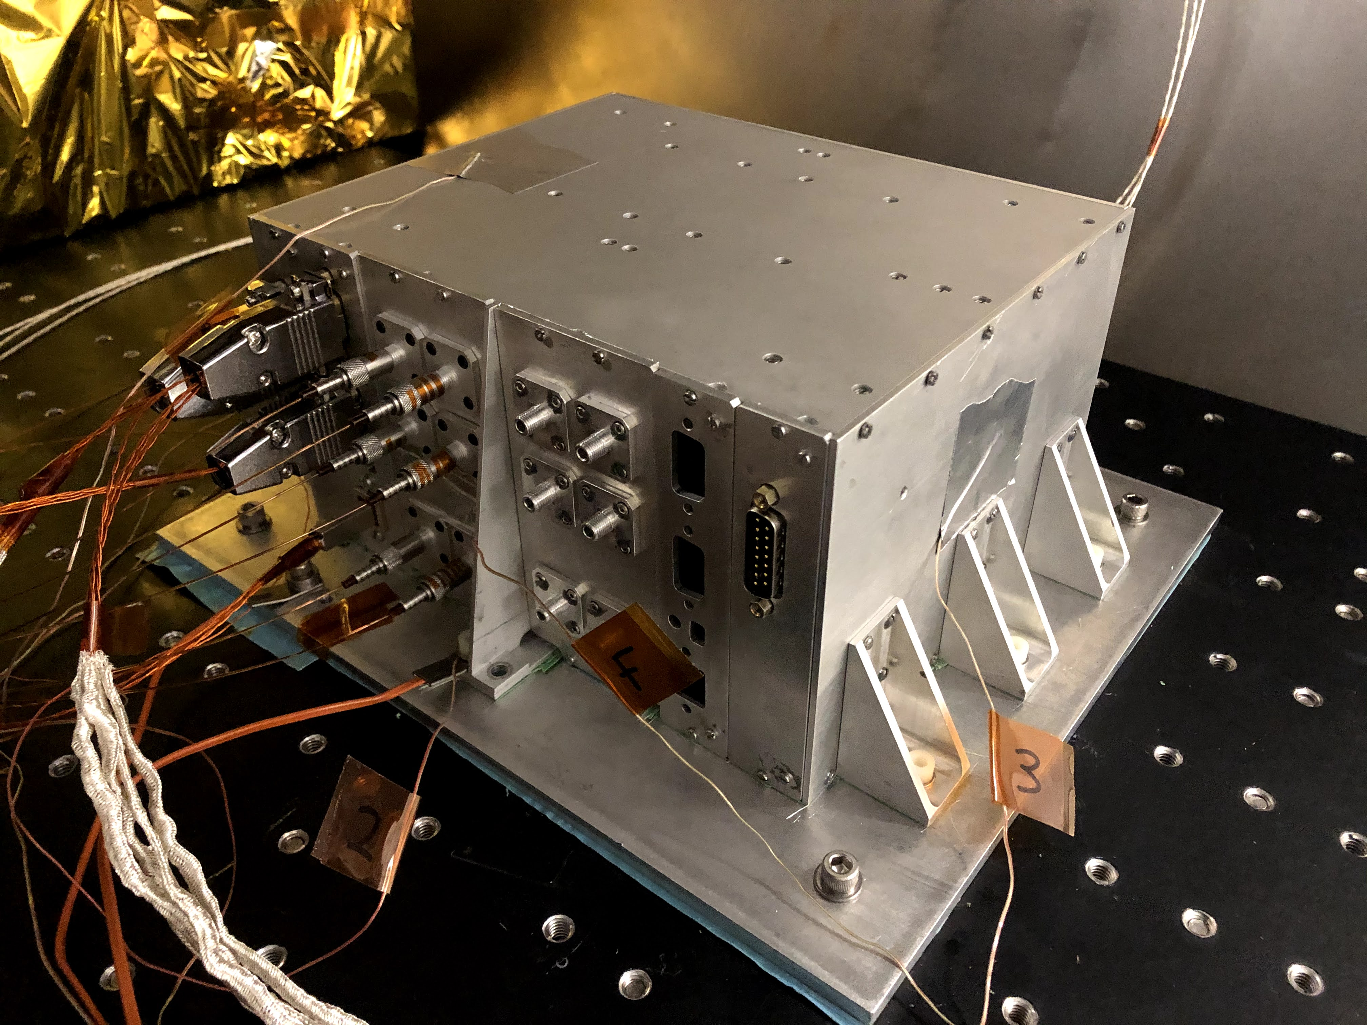
Technology Readiness Level 5 Charge Management Device undergoing thermal vacuum testing at the University of Florida
The Charge Management System on LISA Pathfinder, an ESA technology demonstration mission that was launched in 2015, used the 254 nm UV line of mercury lamps as the light source. The LISA mission CMDs will use new, efficient semiconductor UV sources operating at 240–255 nm instead of the mercury vapor lamps used by LISA Pathfinder. Compared to mercury lamps, these UV light-emitting diodes (LEDs) are smaller and lighter; consume less power; and have a wider spectrum selection, a broader operating temperature range, and a higher dynamic range, with an order-of-magnitude improvement in most of these performance areas.
The charge-control scheme enabled by these UV LED-based CMDs allows for more robust, low noise, and passively stable continuous charge maintenance because the modulation rate (bandwidth) of UV LEDs is faster than that of mercury lamps. Pulse modulation of the UV LEDs allows for (i) the generation of UV light over a wide range of power levels for very precise charge control, and (ii) the synchronization of the UV pulses with electric fields in the inertial sensor for charge control that provides robust compensation for possible test mass surface impurities. This method is an important advancement not only for gravitation wave detection from space but also for future missions to map Earth’s gravity field, which will rely on ultra-precise inertial sensors as well.
Over the past three years the CMD team has advanced the technical maturity of the CMD from Technology Readiness Level (TRL) 3 (proof of concept) to TRL-4 (component and/or breadboard validation). A replica TRL-4 CMD unit was delivered to NASA in 2019 and shipped to Italy for system-level testing using replicas of a LISA Pathfinder inertial sensor and test mass. A higher fidelity CMD unit has been designed and fabricated and is currently undergoing environmental testing at the University of Florida. The team is also performing dedicated lifetime and performance testing of the commercial UV LEDs used in the CMD to verify that they meet requirements for LISA. To date, the team has procured and tested over 200 UV LED devices. Ninety-six devices are currently undergoing a two-year lifetime test where they are operated in the same way and over the expected range of temperatures as such devices will encounter during LISA science operations in space. The CMD is expected to achieve TRL-5 (component validation in a relevant environment) this year, and it will reach TRL-6 (prototype validation in a relevant environment) by mid-2023 with support from Fibertek, Inc. Production of the flight units is planned for the second half of the 2020 decade, and the launch of the landmark LISA gravitational wave mission is scheduled for 2034.

Principal Investigator: Dr. John W. Conklin, University of Florida
Program Manager: Dr. Peter Wass, University of Florida

Sponsoring Organization: Astrophysics Division

Key terms: Gravitational waves detection, Space inertial sensors, Charge control, Deep UV light sources

Developing Tiny Micro-Shutter Arrays to Answer Big Questions
Project: NexGen Micro-Shutter Array (NGMSA)

Snapshot: Advanced technology micro-shutters enable NASA to study galaxy evolution across cosmic time.

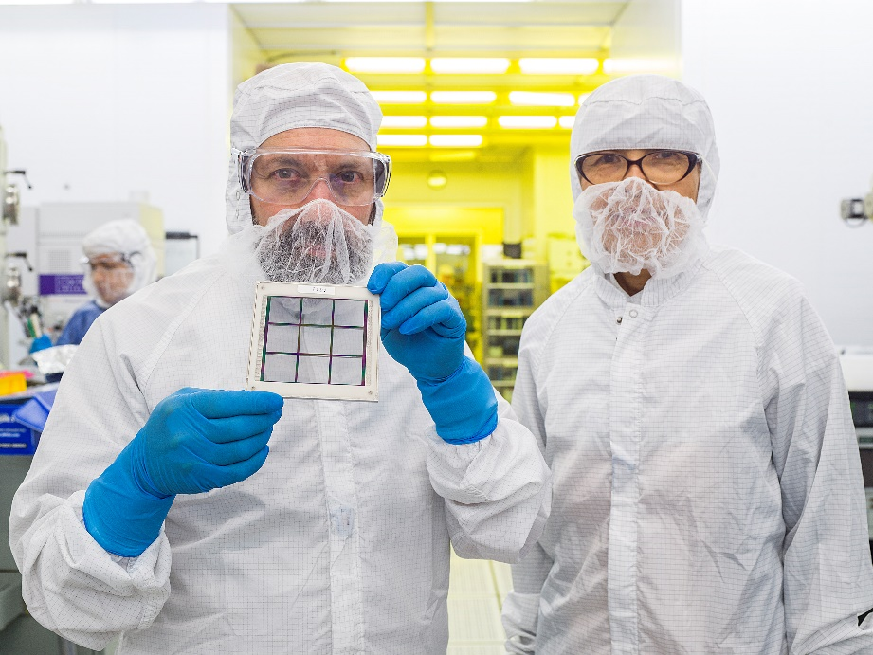
Goddard Space Flight Center astrophysicist Matt Greenhouse and lead engineer Mary Li examine a NexGen array prototype containing 282,624 programmable micro-shutters.

How did the first stars and galaxies form after the big bang? How did they evolve to produce the chemical elements that we observe in our world today? The answer is encoded in the starlight that is emitted by galaxies. Astronomers use large telescopes in space and on the ground to capture this light in order to extract the information it contains. The sharpest tool in the shed for extracting information from starlight is a technique called spectroscopy. This technique enables scientists to identify the atoms and molecules that produce the light from galaxies, stars, and planets. It also reveals the velocity at which these objects are moving relative to Earth.
A team at NASA’s Goddard Space Flight Center is developing new micro-shutter technology that will enable space telescopes to perform spectroscopy on a large number of objects simultaneously. Spectroscopic measurements of faint astronomical sources typically require very long exposures. The multiplexing capability enabled by micro-shutters is crucial for acquiring spectra on a large sample of objects to yield statistically significant results.
In Multi-Object Spectroscopy (MOS), a telescope and camera are used to form an image of the sky on an array of microscopic shutters that can be individually opened or closed by a computer. Shutters under the astronomical sources of interest in the image are commanded to be open, while all others are kept closed. In this way, light from just the sources of interest can be sent into a spectrometer that is designed to measure the spectra from each source without comingling them. Since the pattern of open and closed shutters is programmable, this technique can be applied to any field of stars or galaxies.
Developing technologies that enable MOS for use on future space telescope missions is a priority for NASA’s Cosmic Origins Program.

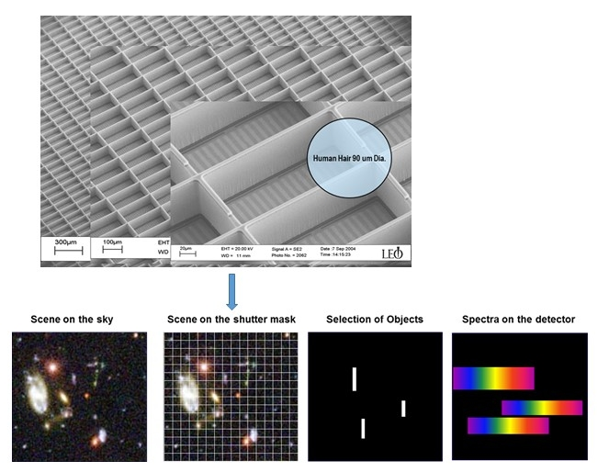
Micro-shutter arrays (top) are used to select multiple astronomical targets to enable their spectra to be simultaneously measured (bottom); each micro-shutter is similar in size to a human hair and can be commanded opened or closed to match the position of targets in any astronomical field.

The Goddard team’s first-generation micro-shutter technology enabled the James Webb Space Telescope (JWST) Near Infrared Spectrograph (NIRSpec), which will launch later this year. Webb’s micro-shutter technology involved a combination of electrostatic and magnetic actuation systems that resulted in a heavy, complex, mechanical assembly that does not scale to larger formats required by strategic mission concepts that are under study to respond to the 2020 Astrophysics Decadal Survey.
The team’s newly developed NexGen Micro-Shutter Array (NGMSA) technology eliminates the need for magnetic actuation, resulting in a shutter array assembly with very low mass, that is scalable to very large formats, and that involves no external mechanical complexity and no potentially life-limiting mechanical components. This major breakthrough has been flight-proven on a small 128 x 64 array of 200 x 100 micron shutter pixels aboard the Far-ultraviolet Off Rowland-Circle for Imaging and Spectroscopy (FORTIS) sounding rocket.
This new micro-shutter technology could be scaled to enable the large-format arrays needed for several mission concepts including the Large UltraViolet Optical InfraRed surveyor (LUVOIR), the Habitable Exoplanet surveyor (HabEx) strategic-class missions, and the Cosmic Evolution Through UV Spectroscopy (CETUS) probe-class mission, as well as the ongoing FORTIS sounding rocket program. The Goddard team is currently optimizing the NexGen array to maximize its reliability and to ensure the resiliency that is needed to withstand the rigors of spaceflight in support of the above mission concepts.
Further information is available at: https://asd.gsfc.nasa.gov/ngmsa/
Project Lead: Dr. Matthew Greenhouse, NASA Goddard Space Flight Center
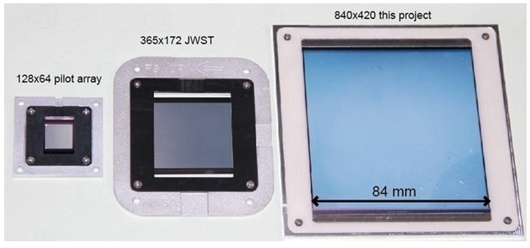
Goddard micro-shutter array products: (left) the flight-proven FORTIS array; (center) the JWST array; and (right) the current technology array that is under development for NASA’s next strategic astrophysics missions. The large array on the right is ruggedized for spaceflight by a ceramic grid structure shown in the figure at the top of this article, yielding 282,624 operational shutters within the overall 840x420 format.

Sponsoring Organization(s): Astrophysics Division Strategic Astrophysics Technology Program

Key terms: NextGen Micro-Shutter Array; GSFC Astrophysical Sciences Division, Multi-Object Spectroscopy, Spectroscopy

Planetary Science

Frosty: A Micro-fabricated Optical Seismometer to Measure Minute Forces in a Mighty Environment
Project: “Frosty” micro-fabricated optical seismometer

Snapshot: To characterize ice sheets and mantle on icy worlds, NASA is developing a new type of seismometer that is ultra-small, easy to manufacture, immune to radiation damage, and operates with low power consumption.

Icy worlds like Jupiter’s moon Europa are prime targets of study to achieve one of NASA’s longstanding goals – to determine whether or not we are alone in the universe. As such, NASA is developing technology for future missions to explore these worlds and determine habitability, surface and sub-surface composition, the type of ice and its thickness, and the water characteristics under the ice sheet. Frosty—a tiny, rugged micro-seismometer— could be part of an instrument suite used to gather this important data.
Seismic activity yields a wealth of information about a planetary body’s structure, tectonic activity, and response to the surrounding gravitational field. For example, the four passive seismic experiments in the Apollo Lunar Surface Experiments Package (ALSEP) deployed on the Moon operated as a four-station network until the conclusion of the Apollo Program in September 1977. This network allowed for the distinction between four natural seismic sources and provided extensive data for study of the Moon’s interior. While deep Moonquakes have typical magnitudes ~1 on the Richter scale, the 28 shallow Moonquakes recorded between 1969 and 1977 registered up to 5.5 on the Richter scale and some lasted up to 10 minutes because of the absence of water and its dampening effect. (A refined analysis indicated that the Moon is tectonically active.)
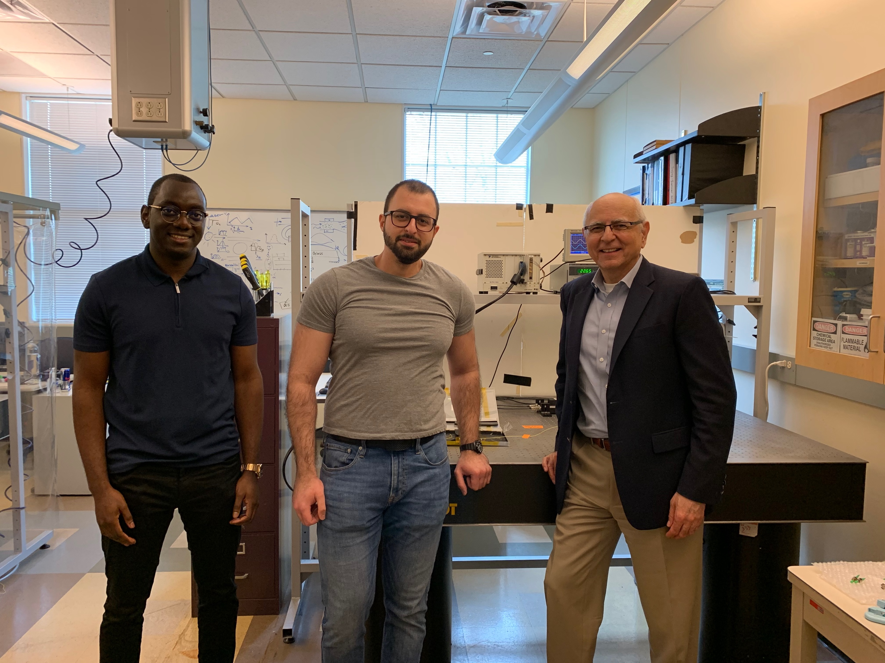
The optical seismometer team at Southern Methodist University. From left to right: Jaime Da Silva, Elie Salameh, and Prof. Volkan Ötügen.
Europa revolves around Jupiter in 3.55 Earth days. Throughout the slightly eccentric orbital cycle, Europa flexes with the variable gravitational field, generating stress in its icy crust. The seismic response to this stress can provide valuable information on the crust thickness and composition. However, the tremendous magnetic field and particle bombardment from Jupiter’s magnetosphere complicate efforts to explore Europa.
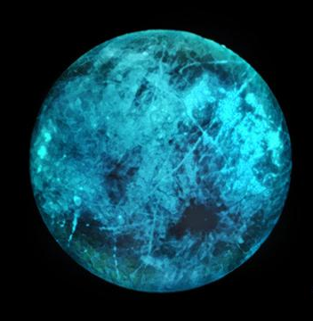
This artist’s illustration of Jupiter's moon Europa shows how the icy surface may glow on its nightside, the side facing away from the Sun. Image Credit: NASA/JPL-Caltech
A NASA-sponsored team at Michigan Aerospace Corporation and Southern Methodist University (SMU) is developing a microfabricated all-optical seismometer called Frosty that can gather data in the harsh environments encountered on icy works such as Europa. The seismometer is based on the use of optical whispering gallery modes (WGM), also known as morphology dependent resonances (MDR). At certain wavelengths, an optical mode (a multiple of the wavelength, often in the thousands) will be trapped into the resonator, forming the resonant pattern shown in the figure at right. These modes are very narrow and identifiable by a sharp drop in the detector signal. Because the modes are so narrow, a minute change in the resonator shape will induce a small shift in the wavelength at which the resonant pattern occurs. This property makes the seismometer very sensitive to motion. The team at SMU has previously demonstrated the use of WGM resonators for many applications, including sensing temperature, force, and electric fields.
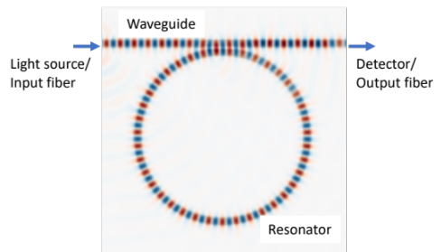
Whispering gallery mode simulation showing the resonant pattern in a waveguide-resonator assembly.
This concept affords several advantages over conventional seismometers: The resonator is very small (less than one inch) and very lightweight (less than 1/100 of an ounce). In addition, the seismometer is made of silicon, which means the radiation encountered in the icy world environment will have little or no adverse effect on the durability or performance of the instrument.
Over the last 24 months, the team has successfully assembled and tested the seismometer prototype in the lab. The prototype was installed and tested on a shaker, and subsequently tested under impulse excitation (by hitting the table on which the seismometer was mounted). The seismometer prototype performed well under both types of motions. The seismometer output was processed using a Raspberry Pi 4 to demonstrate its ability to operate using limited computational resources. The next challenge was to extend the seismometer response by damping the motion. The team pursued several approaches, and a multilayered substrate composed of compliant material sandwiched between two thin silicon layers emerged as the best option.
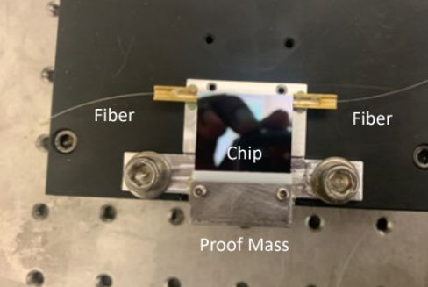
1 inch resonator chip assembled with fibers and proof mass.
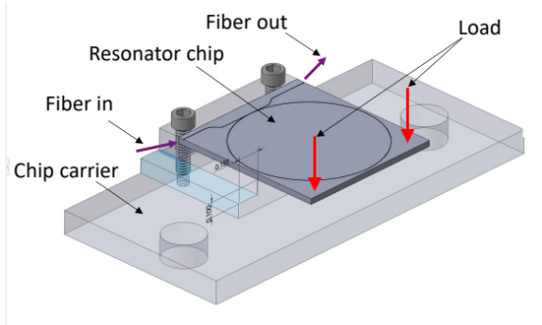
Conceptual design of the microfabricated resonator.
With the concept now successfully demonstrated, the team’s next steps include developing the next-generation seismometer that will be capable operating in the harsh conditions of an icy world (temperatures hover around minus 240 ºF). The multilayered substrate will be composed of materials capable of maintaining their mechanical characteristics at such low temperatures, and will enable design of rugged packaging to protect the sensor in the harsh space environment. The team’s final product will be a network of tiny rugged Frosty seismometers for planetary exploration.

Project Lead: Dr. Dominique Fourguette, Michigan Aerospace Corporation. Co-PI: Professor Volkan Ötügen, SMU.

Sponsoring Organization(s): Planetary Science Division‘s COLDTech Program.

Key terms: seismometer, whispering gallery mode, micro-fabricated, optical resonator, icy worlds, Europa

Heliophysics

Rediscovering the Lost Art of Fluxgate Magnetometer Cores
Project: MAGnetometers for Innovation and Capability (MAGIC)

Snapshot: A NASA-sponsored team at the University of Iowa is rediscovering and improving lost techniques to develop high-fidelity instruments needed to make the magnetic field measurements that enable many of the nation’s space science and space weather missions.
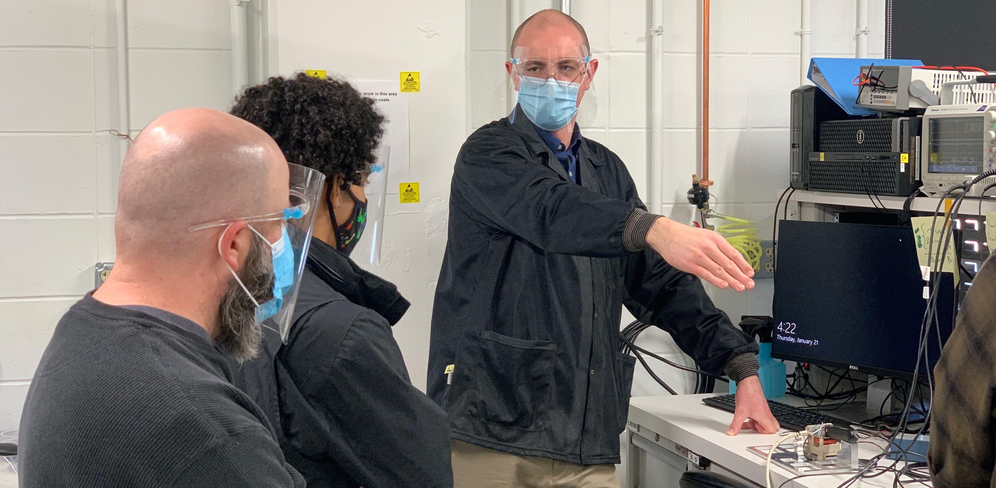
MAGIC team members from the University of Iowa, Department of Physics and Astronomy. From left to right: Steve Klinkhammer, Antonio Washington, Dr. David Miles.
Fluxgate magnetometers are essential and widely-used space science and space weather instruments, but they depend on a legacy component—a ferromagnetic core—that was developed and manufactured for the U.S. Navy using technology that has been subsequently lost to the civilian community. The stockpiles of these legacy cores are so depleted that some providers are now exploring destroying old flight-spare hardware to recover and refurbish the cores for use in new missions. This approach is obviously unsustainable. A NASA-sponsored research team at the University of Iowa is resurrecting fluxgate technology to enable a new generation of magnetic field instruments for future scientific and operational missions.
Fluxgate magnetometers have flown on a high percentage of space science missions and space weather missions to provide high-fidelity measurements of the local magnetic field. The instrument’s performance is limited by the magnetic noise of a specialized ferromagnetic core. The technology needed to create these cores was principally developed in the 1960s for military sensing applications such as submarine detection. Most spaceflight instruments are currently being built using a dwindling store of legacy cores, which were manufactured up to 1996 using unknown processes by companies and groups that no longer exist. Without a new source of high-quality space-qualified cores, the United States risks losing its capability to produce the world-class spaceflight fluxgate magnetometers that are used routinely by NASA, the National Oceanic and Atmospheric Administration, and the nation’s defense agencies.
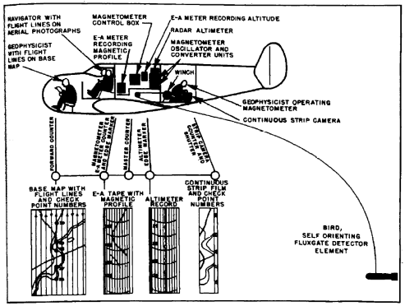
Fluxgate magnetometer development was often driven by naval sensing applications. (Rumbaugh and Alldredge, 1949).
Fluxgate magnetometers deliver magnetic field measurements by periodically saturating a piece of ferromagnetic core material to modulate the local magnetic field and sensing this modulated magnetic field using a coil of wire. Fluxgate performance is limited by the intrinsic magnetic noise of the core as it enters magnetic saturation. The preferred ferromagnetic material used by manufacturers in North America and Western Europe was 6% Molybdenum, 81.3% Nickel, and remainder Iron (6-81 Permalloy). Incredibly, it appears that essentially all North American and European spaceflight Permalloy fluxgates were manufactured from a single melt of 6-81 Permalloy by the Hamilton Watch Company in around 1969 that was then rolled into 12-micron foil. That foil was then processed to engineer low magnetic noise cores by two groups – the U.S. Naval Surface Weapons Center (NSWC) White Oak (now a Department of Agriculture facility) and Infinetics Inc. Many of the best fluxgates worldwide have nearly identical sensors since they all appear to be using legacy Infinetics S1000 cores that have been out of production since 1996, for which information about the manufacturing process has been lost.
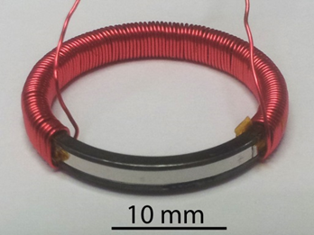
Fluxgate core with winding partially removed to show the silver ferromagnetic material that determines the noise floor. (Miles et al., 2019)
Development of future high-performance next-generation sensors requires the ability to produce new high-quality cores. A team at the University of Iowa, working with national and international collaborators, has demonstrated a manufacturing process that produces cores that match the noise performance of most cores in use today and has revealed potential optimizations that could enable lower noise sensors, miniature sensors for nanosatellites, and efficient high-volume production of sensors for constellation missions.
The University of Iowa team does not rely on legacy processes or materials. Rather, the new fluxgate cores are manufactured from scratch and integrated into a modern spaceflight magnetometer design. The ferromagnetic cores are produced starting from base metal powders that are melted into custom alloys in-house, cold-rolled into thin foils, formed into the geometry of a fluxgate core, and subjected multi-step heat treatments to optimize their magnetic properties. The team then integrates the resulting cores into a complete fluxgate sensor ready for a spaceflight application. Making fluxgate cores from scratch has enabled us to explore new designs such as the prototype ‘Tesseract’ high-stability sensor.
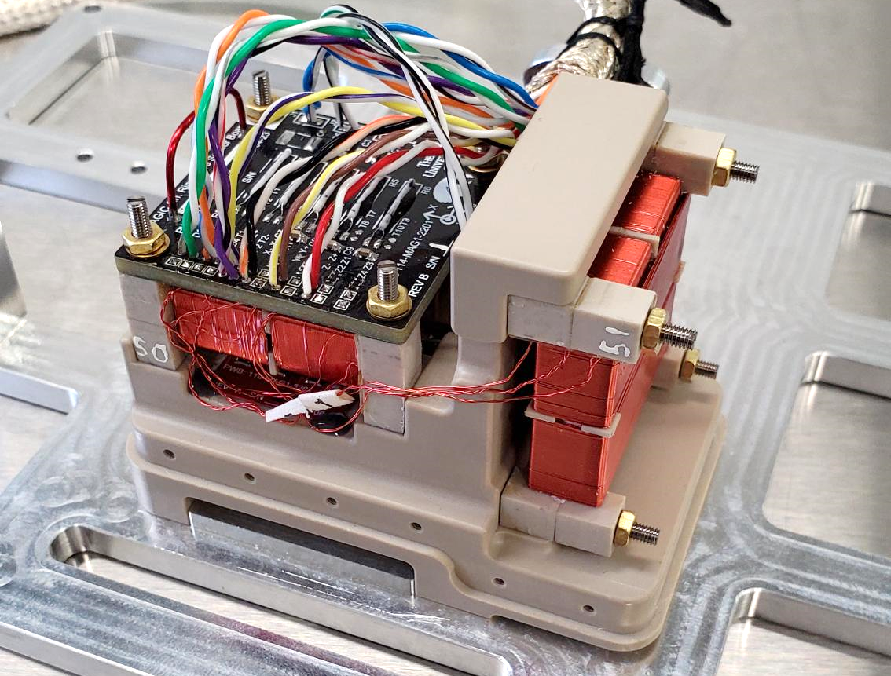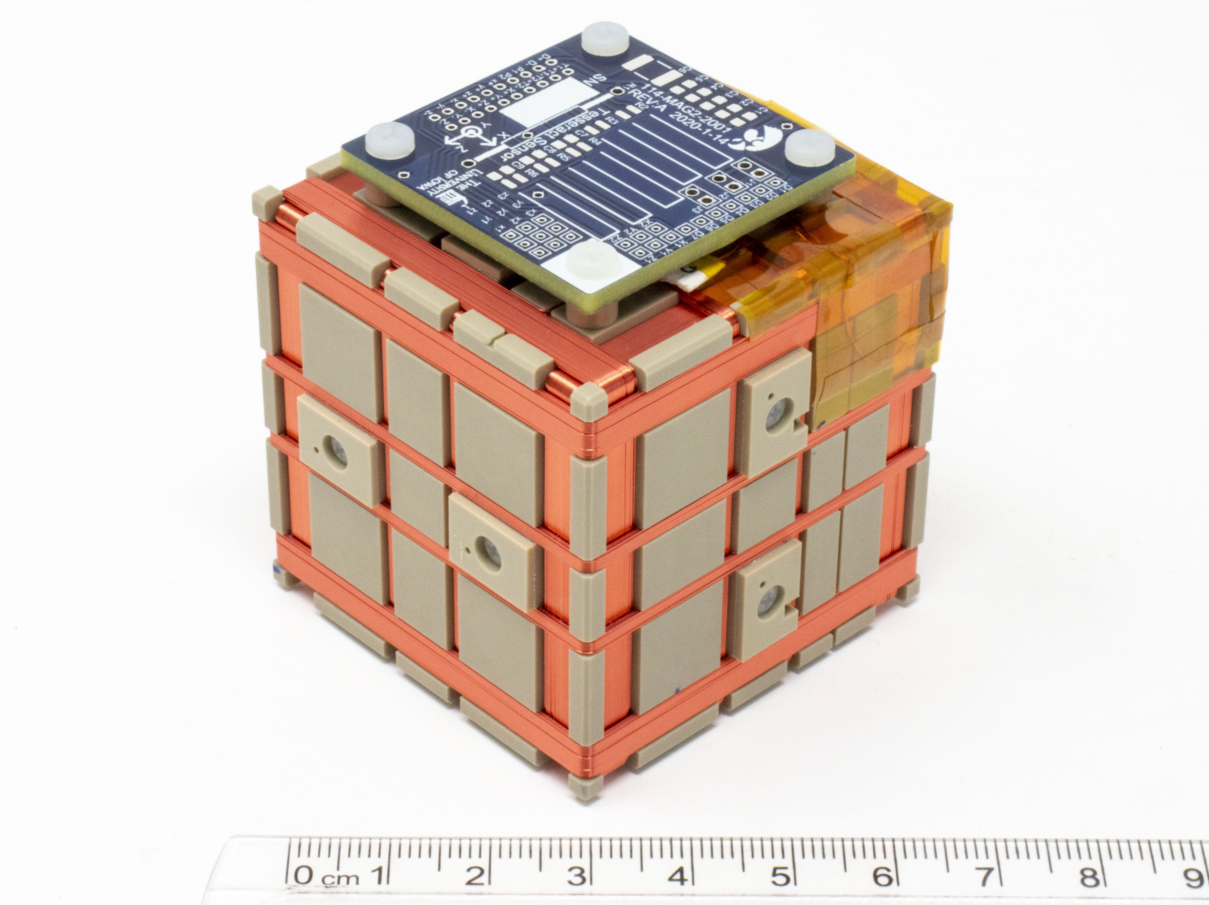
(Left) Engineering model fluxgate sensor constructed from new cores. (Right) New ‘Tesseract’ high stability sensor prototype enabled by new styles of fluxgate cores.
This work at the University of Iowa was started under a technology development grant sponsored by the Heliophysics Division’s Heliophysics Technology and Instrument Development for Science (H-TIDeS) program, and is continuing via the MAGnetometers for Innovation and Capability (MAGIC) Project sponsored by the NASA Explorers Program Office at Goddard Space Flight Center. MAGIC is a five-year effort to design, build, test, and fly a next-generation spaceflight fluxgate demonstrating the new core technology. In the last 18 months, MAGIC has established a new spaceflight instrument team and is undertaking two major technical projects. First, we are completing a detailed investigation into the factors that control magnetic noise in permalloy fluxgate sensors with the goal of achieving unprecedentedly low magnetic noise measurements and developing miniature sensors that match the noise performance of the larger cores in use today. Secondly, we are developing a complete flight-ready magnetometer design based on this new core technology. We will prove flight-heritage of this new technology through a do-no-harm technical demonstration as a hosted-payload on the Tandem Reconnection and Cusp Electrodynamics Reconnaissance Satellites (TRACERS) Small Explorer mission.

Two new MAGIC fluxgates will fly on the forthcoming TRACERS Small Explorers satellite mission.
The ongoing availability of high-quality magnetic field instruments is essential to investigations that will enable NASA to meet the overarching Heliophysics goal to “Advance our understanding of the connections between the Sun, Earth, the planetary space environments, and the outer reaches of our solar system” and the 2019 National Space Weather Strategy and Action Plan Objective 2.4 to “Identify, develop, and test innovative approaches to enable enhanced, more informative, robust, and cost-effective measurements. … This action should include … the development of novel observational approaches …”. MAGIC is aligned with the 2020 NASA Technology Taxonomy and will help deliver the Analog Fluxgate Magnetometer (AFT) listed under Taxonomy Subarea TX08.3.1. Future missions of 10s to 100s of small, low-cost spacecraft each carrying a miniature magnetometer will enable us to characterize the global morphology of the magnetosphere.
Project Lead: Dr. David Miles, University of Iowa, Department of Physics and Astronomy

Sponsoring Organization(s): The Heliophysics Division’s H-TIDeS Program sponsored initial work on this technology; the ongoing MAGIC technology demonstration is sponsored by the NASA Explorers Program Office at Goddard Space Flight Center

Key terms: magnetometer, fluxgate, magnetic fields, noise, sensors, constellation

Biological and Physical Science

Innovative Technology Measures Muscle Strength of Worms in Space to Prepare Astronauts for Future Missions
Project: Determining Muscle Strength in Space-flown C. elegans

Snapshot: Loss of muscle mass and strength in astronauts remains an issue for space exploration. Caenorhabditis elegans (C. elegans), a nematode species that is 1 mm long, shares common traits with humans and these worms are a good, cost-effective model for studying the effects of spaceflight on muscle. A NASA-funded research team has developed a new device called the NemaFlex chip to measure muscle strength over multiple generations of worms born and raised on the International Space Station (ISS).
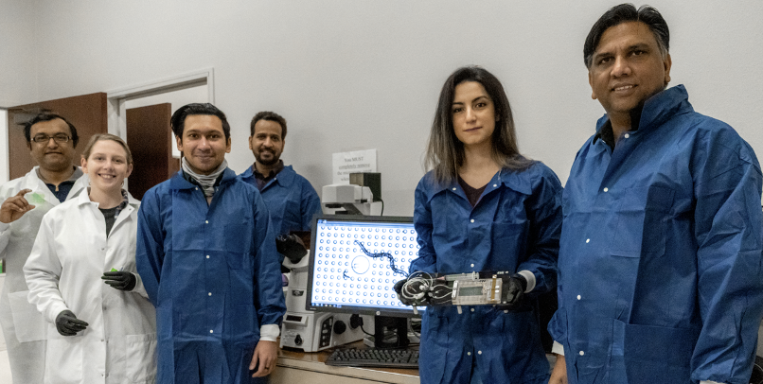
The Micro-16 team in Dr. Vanapalli’s lab at Texas Tech University during preparation of the NemaFlex hardware.
As NASA plans for long-duration spaceflights, maintaining muscle mass and strength will be critical for astronauts who embark on missions that expose them to long periods of microgravity and radiation. The lack of gravity experienced by astronauts during spaceflight is responsible for the loss of muscle mass and strength. To develop possible countermeasures, scientists hope to better understand exactly how exposure to the space environment alters muscle gene expression, leading to muscle loss and reduced strength.
The NASA-sponsored Micro-16 experiment team at Texas Tech University recently developed a new device, called NemaFlex, to enable continuous measurement of worm muscle forces. The NemaFlex microfluidic device contains a “forest” of tiny micro-pillars. As the worms crawl through the device, they exert muscle forces that deflect the micropillars. Scientists can measure the muscle strength of the worms based on this pillar deflection. Researchers have used this NemaFlex device on Earth to show that defects in muscle contraction proteins lead to a decline in worm muscle strength.
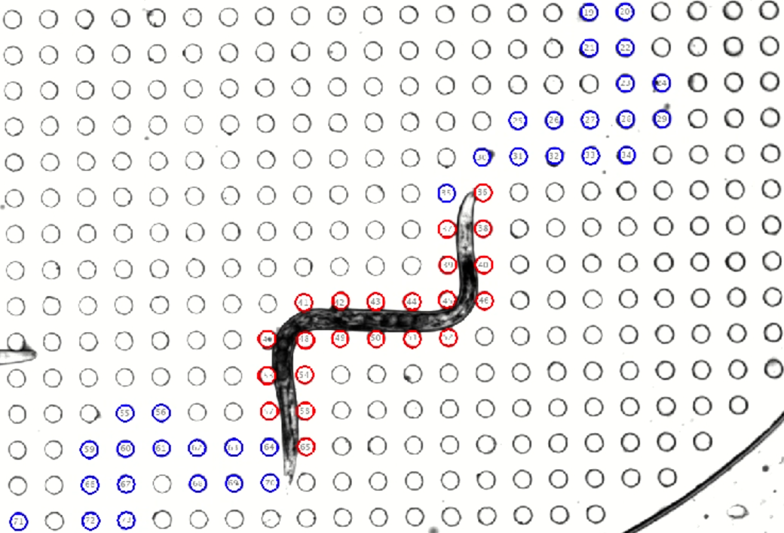
C. elegans exerts muscle forces while moving and touching the pillars in the NemaFlex chip (which appear as dots from this angle). Credit: TTU/Vanapalli Lab
NemaFlex, along with cultures of live worms to be studied and measured in space, was launched to the ISS on February 20, 2021 as part of the Micro-16 experiment. To use the NemaFlex device, astronauts inject the live cultures of C. elegans from the culture bags into the NemaFlex unit using a device called the Worm Loading Apparatus (WLA). The NemaFlex chip includes a viewing window placed over a camera to capture video of the worm activity for scientists to analyze on Earth. Multiple generations of space-reared C. elegans are being grown, observed, and measured during the Micro-16 experiment. The flight measurements will be compared with the results of muscle strength and gene expression analyses for worms bred on Earth.
Micro-16 seeks to provide researchers with a better understanding of how spaceflight-dependent changes in gene expression are linked to muscle function. Results from this experiment may support the development of countermeasures to maintain crew member health during extended missions. Successful measurement of muscle strength in flight will demonstrate that C. elegans is a comprehensive genomic model for studying muscle physiology changes in space and may enable meaningful translation of discoveries made in C. elegans to astronauts. The spaceflight experiment may also have important implications for sarcopenia (a syndrome characterized by progressive and generalized loss of skeletal muscle mass and strength that is an urgent public health problem on Earth). Additionally, it may produce a terrestrial model for testing potential therapeutic interventions to mitigate the decline of muscle strength during spaceflight.
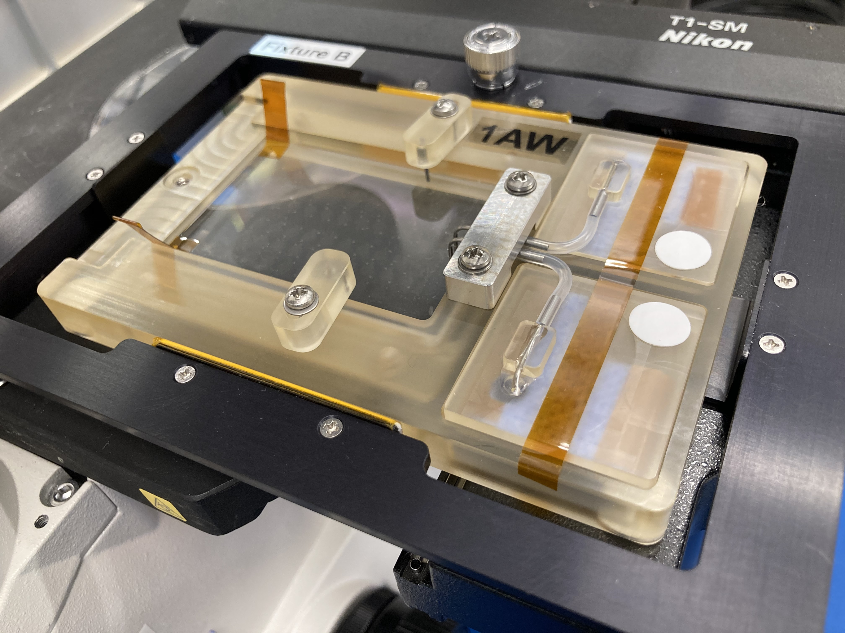
The NemaFlex hardware, invented by the Micro-16 science team, is inside the imaging cassette, which is used to image and observe the C. elegans in space. Credit: TTU/Vanapalli Lab
Principal Investigator: Siva Vanapalli, Ph.D., Texas Tech University

Sponsoring Organization(s): The Biological and Physical Sciences Division’s Space Biology Program

Key terms: muscle loss in space, Micro-16, muscle force measurement, sarcopenia, muscle degeneration, muscle disuse atrophy

Earth Science

Small Sensor Could Provide Big Insights into Earth’s Radiant Energy System

Project: DEMonstrating the Emerging Technology for Measuring the Earth’s Radiation Budget (DEMETER)

Snapshot: A team at NASA’s Langley Research Center is developing a new state-of-the-art sensor and satellite platform to enable continued monitoring of Earth’s radiant energy system. The small, lightweight sensor will provide higher resolution data, and will allow us to learn more about important Earth phenomena—from daily weather, to natural disasters, to climate change.

Solar radiation reflected from Earth’s surface back into space, as measured by the Clouds and the Earth’s Radiant Energy System (CERES) instrument aboard the Terra satellite. Monitoring the Earth Radiation Budget (ERB) helps scientist better understand everything from daily weather patterns to climate change. Credit: NASA/NOAA/CERES Team

Circling the globe multiple times each day, a network of satellites carefully measures the Earth Radiation Budget (ERB)—or, how much solar energy Earth absorbs, reflects, and emits back into space. This information helps researchers learn more about everything from daily weather patterns to climate change.

Dr. Anum Ashraf, a researcher at NASA’s Langley Research Center, wants to ensure scientists continue to receive reliable information about Earth’s radiant energy system for decades to come. Using funding from NASA’s Earth Science Technology Office (ESTO), Ashraf and her team are hard at work developing a next-generation radiometric sensor, DEMonstrating the Emerging Technology for Measuring the Earth’s Radiation (DEMETER), that will not only dramatically reduce the size and weight of satellites sent to monitor ERB, but also greatly increase the utility of these instruments for meeting the evolving needs of the climate-modeling community. From Lower Earth Orbit (LEO), DEMETER will use a non-scanning, wide-field-angle optical module and a two-dimensional detector array to measure reflected solar radiation and thermal radiation emitted by the Earth between 0.2 μm and ≥50 μm. This range of radiant energy is particularly important for understanding how radiation impacts regional weather conditions and long-term climate data trends. DEMETER will improve the resolution of available ERB data by a factor of ten and—using an onboard data processing unit—provide researchers with access to ERB data in near real time, which is critical for understanding the relationship between ERB and dynamic, fast-changing Earth systems behind things like natural disasters and agricultural production.

“We need an extensive ERB data record to understand how these energy interactions affect Earth systems. DEMETER will combine state-of-the-art instrumentation with a novel, modular spacecraft design to make sure that data record remains unbroken,” said Ashraf.

Ashraf explains that researchers have monitored ERB with satellites since 1984, when the Space Shuttle Challenger delivered the Earth Radiation Budget Satellite (ERBS) into orbit. Since then, five other satellites have joined ERBS as part of the Earth Radiation Budget Experiment (ERBE) and the Clouds and the Earth’s Radiant Energy System (CERES) project to track energy interactions between Earth and outer space.

“The data products we receive from these instruments are invaluable. By calculating the annual difference between the amount of radiation Earth absorbs and the amount of radiation Earth emits, we can clearly see how quickly the Earth is warming up due to climate change,” said Ashraf.

But while these instruments have proven themselves to be particularly durable (CERES FM-1 and FM-2, launched onboard the Terra spacecraft in 1999, continue to relay useful data), most of them are approaching the end of their planned lifespans. If these instruments were to expire, it would be extremely difficult to deploy a replacement in time to preserve the integrity and continuity of the ERB data record.

A component of DEMETER’s modular instrument platform. These small cells, just 20cm long and 10cm high, connect together to create robust vehicles for carrying sensitive instruments through space.
Credit: NovaWurks, Inc.

“Current ERB instruments that provide global broadband coverage contain complex scanning mechanisms that increase the mass, power consumption, and the cost of the payload, requiring a budget of at least 150 million dollars to get into orbit. Sending instruments that large into LEO isn’t a fast process, and even a small gap in the data record could affect our ability to create accurate models,” said Ashraf.

DEMETER would solve that problem. While the last ERB satellite sent into orbit weighed more than 2000kg, DEMETER could weigh as little as 90kg. And unlike other radiometers, DEMETER wouldn’t require a complicated scanning mechanism to track radiation. Instead, DEMETER’s wide-field-angle optical module would function as a simple “push-broom” sensor that could achieve superior global coverage using far less energy.

“This not only makes it less expensive to launch a satellite for tracking ERB, but also increases the number of potential flight windows such a mission could have. DEMETER would be much less difficult to get into space than other ERB monitoring systems,” said Ashraf.

Another unique feature of DEMETER is the cellular architecture of the spacecraft that will carry it in orbit, which can be readily reconfigured to carry new payload elements or support different orbital environments. This allows Ashraf and other scientists to easily tailor DEMETER’s instrument platform to host a wide variety of instruments.

“For example, if we decide we need to include a different instrument to monitor ERB, we can quickly reassemble our spacecraft to accommodate that new payload. It’s like building with LEGOs. You just reconstruct the satellite framework as required,” said Ashraf.

Successful collaboration between private and public researchers is key to DEMETER’s success, said Ashraf. Without working with private partners, DEMETER never would have incorporated the cellular spacecraft design that makes it such a versatile tool for monitoring ERB.

“ESTO provides institutional support within a competitive environment to drive innovation. It gives public researchers the chance to build relationships with private industry leaders, and that makes it a powerful resource for scientists trying to develop new technologies for studying our planet,” said Ashraf.

While DEMETER likely won’t fly until 2028, a final report documenting DEMETER’s system performance and a path to an accelerated flight mission is scheduled for September 2022.

“Being able to deploy ERB satellites quickly will be crucial for maximizing the value of this data record and producing invaluable insights into how ERB shapes the world we live in,” said Ashraf.

Project Lead: Dr. Anum Ashraf, NASA Langley Research Center

Sponsoring Organizations: NASA Earth Science Technology Office (ESTO); NASA LaRC Internal Research and Development (IRAD); Science Systems and Applications Inc.; Quartus Engineering Incorporated; NovaWurks Inc.; Virginia Tech

Key terms: Earth Radiation Budget (ERB); radiometry; Earth systems; Earth science; climate change; Earth observation systems

Novel Algorithms Merge Ground- and Space-based Data to Forecast Air Pollution Events

Project: Predicting What We Breathe (PWWB)

Snapshot: A NASA-sponsored research team is developing new machine-learning software that uses data from satellites and ground-based sensors to forecast air pollution events in Los Angeles. Soon, this software will become publicly available, potentially enabling cities all over the world to warn residents about impending pollution and advise them to take precautionary measures that could prevent numerous health concerns.

Sunrise over the City of Los Angeles. Researchers in LA are developing a new tool cities can use to protect their populations from air pollution. Image credit: Martin Adams
Air pollution kills approximately seven million people each year, according to the World Health Organization (WHO). That’s a life lost every five seconds to a variety of preventable cancers, infections, and other illnesses afflicting communities struggling to maintain clean air.

“Those deaths are tragic. Cities use lots of different strategies to try and protect people, but our mitigation strategies are limited by the amount of air quality data we have at our disposal,” said Jeanne Holm, Deputy Mayor of Budget and Innovation for the City of Los Angeles.

With a grant from NASA’s Earth Science Technology Office (ESTO), Holm and a team of researchers are working on advanced machine-learning software that could make it easier for cities to forecast air pollution events. Their project, aptly titled “Predicting What We Breathe (PWWB),” combines deep neural network models with other classic machine-learning algorithms to identify relationships between air quality data gathered from ground sensors in Los Angeles and imaging data gathered from Earth-monitoring satellites managed by NASA and the U.S. Geological Survey (USGS). Understanding these relationships would enable scientists to train systems used to process data from sources like Terra MODIS, Aqua MODIS, and Landsats to detect signs of impending air pollution incidents too subtle to be detected by in situ sensors in LA. In addition, PWWB would help researchers not only better classify urban air patterns in LA, but also allow them to detect similarities between those air patterns and other air regimes in megacities around the world. This capability would enable urban communities worldwide to protect their citizens from the harmful effects of air pollution with data-driven mitigation strategies.

“Our goal is to create a tool anyone can use to predict and prevent air pollution events. We want to empower other cities to keep their citizens safe as well,” said Holm
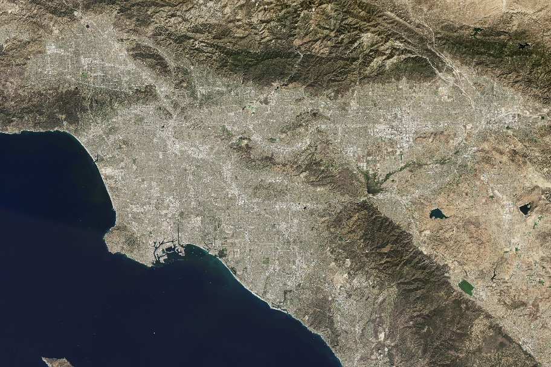
Los Angeles already uses an extensive network of air quality sensors to keep tabs on pollution. These sensors are in LA’s ports, parks, and even streetlights, providing officials with critical information about the air their citizens breathe. If air quality is poor, the city can issue an advisory encouraging citizens to take precautions.

“Effective forecasting is one of the best ways to keep citizens healthy. It gives people who are particularly prone to respiratory illness time to connect with their healthcare provider and start preventative treatments. Being proactive is key to avoiding a health emergency,” said Dawn Comer, LA’s Broadband and Digital Inclusion Coordinator.
Landsat image of Los Angeles, captured by the Operational Land Imager (OLI) instrument on Landsat 8. With PWWB, Landsats would be able to locate signs of an imminent air pollution event in images like this, enabling cities like LA to forecast air pollution events with greater accuracy. Image credit: Jesse Allen, using Landsat data from USGS

But LA’s system for detecting air pollution is limited to the Los Angeles metropolitan area, and events far away from the city can have just as big an impact on air quality as traffic on Ventura Boulevard. For example, wildfires in other parts of California could jettison large amounts of particulate pollutants into LA’s air and cause an unexpected spike in air pollution.

“Earth is a system of systems. If we want to effectively mitigate air pollution, we need to be able to look at the big picture and understand how our city fits within the broader environmental picture,” said Holm.

To discover relationships between data gathered from ground-based air quality sensors and NASA satellite observations, PWWB will use multimodal deep learning algorithms. These algorithms include several deep Recurrent Neural Network (RNN) models, which are ideal for forecasting outcomes from time-series data. That makes them well-suited to comb a wide variety of data sources—including sensor measurements, satellite images, meteorological data, and wildfire data—to locate patterns between information from LA’s sensor network and images collected by NASA and USGS. Essentially, these models are teaching data classifiers to identify signs of an impending air pollution event in the images of Earth’s surface that satellites already gathered.

“Any relationship between our air quality data and Landsat images could be too nuanced for human analysts to detect, so we need to develop new information systems to find these patterns for us,” said Holm.

Perhaps the most remarkable aspect of PWWB is its flexibility. Holm, who served the Obama Administration as an appointed Open Data Evangelist, says that her team will release their modeling software open-source on the popular coding site GitHub once it is complete, allowing anyone with a computer to access their work and tailor it to fit any urban environment in the world.

“Air pollution isn’t just an LA problem. There are people all over the world who are struggling to stay healthy in polluted urban environments, and if others can use PWWB to mitigate air pollution more efficiently, then it can only help us all in the long run,” said Holm.

Preparing PWWB for the general public is no small feat. Holm credits her team, especially her Co-Investigators at California State University, Los Angeles, and the non-profit OpenAQ, for making this project possible.

“Dr. Mohammed Pourhomayoun's team at California State University, Los Angeles, is instrumental for unraveling the complexities of normalizing satellite and ground data with varying scales of time and space, and Jeremy Taub's team at OpenAQ unites collaborators from the LA area with cities around the globe to help us apply these algorithms to real data sets collected from each of their cities,” said Holm.

Holm also credits ESTO for helping her team transform their technology concept into a world-ready tool. In particular, scientists with ESTO’s Advanced Information Systems Technology (AIST) Program were crucial for providing Holm’s team with the funding and expertise they needed to turn their vision into a reality.

“PWWB brought together a lot of brilliant, hard-working people, and ESTO equipped those people with the tools they need to succeed. We have to work together to create novel technologies for studying Earth systems,” said Holm.

PWWB is still in the early phases of development, but Holm hopes to have a valid prototype algorithm prepared by July 2021.

“There’s a lot of work to be done, but using machine-learning to process data from space-based remote sensors can really change the way we forecast air pollution events,” said Holm

Project Lead: Jeanne Holm, Deputy Mayor of Budget and Innovation for the City of Los Angeles

Sponsoring Organizations: NASA ESTO’s Advanced Information Technology Program (AIST); the City of Los Angeles; Cal State.

Key terms: Air pollution; Landsat; remote sensing; machine-learning; artificial intelligence (AI); climate change; Earth observation systems; urban development; Deep Neural Network (DNN); air quality prediction

