automated UAS measurements of reflectance and Solar Induced Florescence (SIF) for assessMENt of the Dynamics in photosynthetic function, APPLICATION FOR maIze (Zea Mays L.) IN GREENBELT, MARYLAND, US

Petya Campbell¹, Phil Townsend², Dan Mandl^{3*/4}, James MacKinnon³ and Lawrence Ong⁵

¹University of Maryland Baltimore County (UMBC) and NASA Goddard Space Flight Center (GSFC); ²University of Wisconsin; ³NASA Goddard Space Flight Center; ⁴AEROSPACE; ⁵Science Systems and Applications Inc; *Emeritus

Abstract

To enable monitoring of the parameters governing photosynthesis at the temporal frequency relevant to their dynamics and at a spatial scale that allows practical assessment and management there is a strong need for advancement in the UAS remote sensing methods and instruments. Currently, no single sensor can provide data at the desired high temporal, spectral and spatial resolutions. Our field measurements obtained using the integrated UAS Piccolo system during the summers of 2017 and 2018 demonstrate that science quality reflectance and solar induced fluorescence (SIF) data can be retrieved with high temporal frequency using small Unmanned Aerial Systems (UAS). The implemented approach facilitates consistent data comparisons in space and time and facilitates their integration with other spectral satellite and airborne data.
This investigation contributes for bridging the gap in Earth observation between field and airborne measurements by implementing autonomous methods for obtaining high temporal frequency spectroscopy measurements from an Unmanned Aerial Systems (UAS) at various illumination conditions. An advancement in the Intelligent Payload Module (IPM) facilitated the implementation of an optimization workflow to collect spectral data for characterizing vegetation reflectance and solar induced fluorescence (SIF).

Index Terms – vegetation, spectroscopy, reflectance, solar induced fluorescence (SIF), diurnal and seasonal variations, corn, optimal versus low nitrogen treatments

1. Introduction

Remote sensing approaches used to assess vegetation function are commonly based on monthly or seasonal measurements of reflectance and more recently on solar induced fluorescence (SIF), a by-product of photosynthesis which offers a strong potential for up-scaling of vegetation function [1]. Measuring vegetation function at only one point in time weekly, monthly or seasonally severely limits our ability to detect the diurnal and seasonal variations in vegetation function [2, 3].
To monitor parameters with characteristic diurnal and seasonal cycles, we need new remote sensing capabilities, capturing the key vegetation traits at a temporal, spectral and spatial scales relevant to their natural dynamics. Field, airborne and satellite spectroscopy show great potential for measuring vegetation functional characteristics. Canopy reflectance and solar induced fluorescence (SIF) capture the biophysical characteristics associated with vegetation function, which vary diurnally and seasonally.
Science-grade spectral UAS measurements can bridge the gap between field, airborne and satellite observations, if they can provide consistent surface reflectance and SIF observations, which can be compared across platforms and through time and space [4]. While current UAS applications produce data fast, they may not be directly comparable to observations obtained at other times of day or season, and to measurements from other locations and sensors [4].
The objectives of this effort were to develop an integrated system, protocols and processing workflows to ensure that Visible and Near Infra-Red (VNIR) reflectance and SIF measurements from UAS’s are collected and processed in a consistent fashion that allows integration and comparison among each-other, and to other satellite and airborne data. Our research goal was to enable the consistent measurement of the diurnal and seasonal variation in vegetation fluorescence and reflectance properties.

2. Methods

We implemented a practical two-step approach, using the Piccolo [5] dual line spectrometer and other technology components (Fig. 1), for the collection of science-quality reflectance and SIF measurements for the assessment of ecosystem function and agricultural monitoring: 1) using the technology in a proximal setting on the ground, to understand how to make calibrated measurements and retrieve radiance, reflectance and SIF; and 2) implementing the technology on an UAS platform collecting measurements by hovering at 20-30 m above the canopy.
Our objectives were, using UAS, to collect multiple times per day consistent measurements (i.e., signal strength 80-95 % of maximum) across the season, from different agricultural and forested targets.

2.1. Key Technology Components

The technology components can be summarized into software for acquisition and on-board processing, UAS and payload (fig. 1). The Payload included: 1) Piccolo spectral single point system, with a QEPro (fluorescence) and a FLMT (VNIR reflectance) line spectrometers; 2) intelligent payload module (IPM, on a Raspberry Pi) for: on-board spectrometers control, data collection, initial processing, adjustments and communications; 3) USB thumb-drive for data storage; and 4) power (Lithium batteries) (Fig. 1).

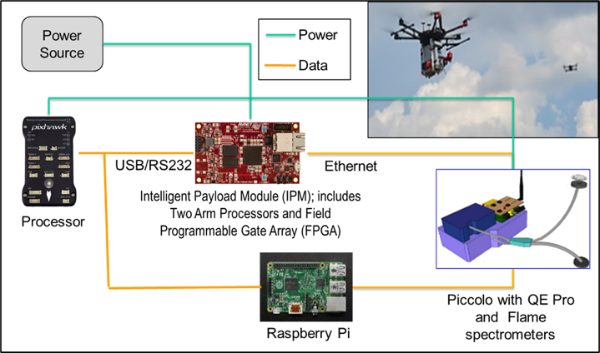
Figure 1. Key technology components of the integrated UAS Piccolo system include: Intelligent Payload Module (IPM on a Raspberry Pi) for on-board spectrometer control and optimization, data collection and communications; 2) Piccolo single-point spectral system, with a QEPro (fluorescence) and a FLMT (VNIR reflectance) line spectrometers; 3) Power: Lithium batteries; and 4) Data storage: USB thumb-drive.

2.2. Workflow for data collection and deriving radiance, reflectance, and solar induced fluorescence (SIF)

The retrieval of calibrated radiance is required for deriving reflectance and SIF, because of the different integration times of the upwelling and dowelling optics of the two spectrometers. Using a physical unit (i.e., radiance, W/m²/sr/nm) facilitates data interoperability and comparison with field and airborne spectral systems. The retrieval of high and consistent quality of radiance spectra (e.g., Signal to Noise Ratio, SNR 80>90%) is needed for comparison of data acquired under different light conditions (e.g., sun vs. shade), which change with UAS altitude, diurnally and with presence/absence of cloud cover. The workflow in Fig 2. was implemented for use on UAS for the collection of calibrated radiance and reflectance data.
Canopy reflectance and SIF were derived after post-processing, using an R code implemented for data processing with the Fluorescence Box (i.e., FLoX) systems [6, 7, 8]. The code was modified to ingest the Piccolo data stream and provide as outputs estimates of reflectance, VIs and SIF in an efficient manner.

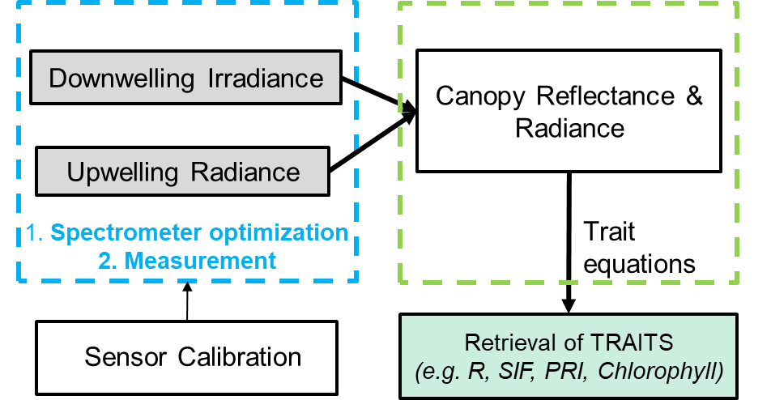
Figure 2. On-board data collection and optimization workflow (blue), and follow-up data processing to derive vegetation trait, including reflectance, Vis and SIF (green).
.
3. results

3.1. Automated optimization of the spectral system

A program for automated optimization of the two spectrometers in the Piccolo system was developed (Fig. 3). The algorithm detects when light level has changed too drastically, and aborts collection quickly so new auto integration cycle can take place. It works by taking test measurements and altering the integration time to maintain the output of the sensor within 80>95 percent of the maximum value. The program is fully configurable, so we can specify the number of passes attempted to achieve optimal value and the maximum acceptable variation in the light level. This ‘auto-integration’ allows the collection of comparable data in terms of SNR under relatively stable sunny or/and cloudy conditions. Fast changing light levels require re-optimization of the system, so when the time for optimization exceeds the time without a change in the incoming illumination, field and airborne spectral measurements become not possible.
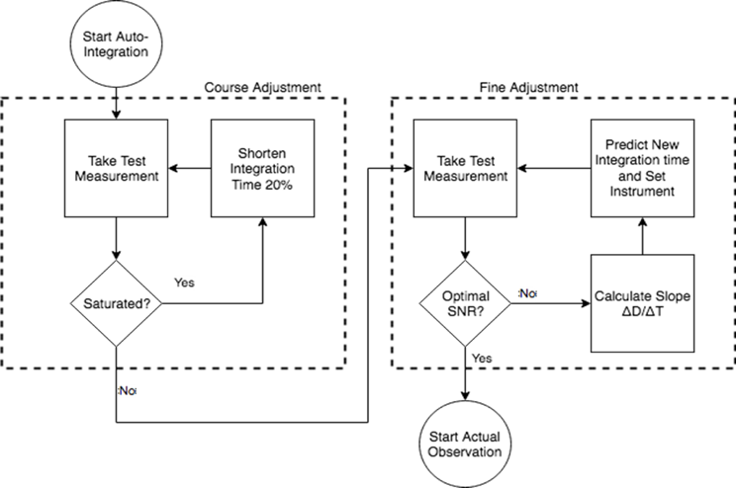
Figure 3. Workflow for coarse and fine auto-optimization of the observation’s integration time. The process is performed for each spectrometer in the Piccolo (i.e., QEPro and FLMT) and optical signal flow (i.e., upwelling and downwelling).

The initial technology readiness level (TRL) of the integrated UAS Piccolo system and workflows at the start of the project were 3/4 and at the end of the project their TRL levels were 5/6.
The spectrometers were calibrated to radiance in the NASA Goddard Space Flight Center, Biospheric Sciences optical laboratory, and the retrievals of radiance and reflectance were automated. Preliminary indicators of the quality of the acquired data are obtained in flight immediately after each measurement is completed. The optimization delivers an indication of the signal to noise level, varying from 0-1, with 0.80-0.95 being the targeted levels and 1 indicating saturation.

3.2. Changes in canopy reflectance and fluorescence during the day and season, and with nitrogen treatment

During the 2017 and 2018 we improved the optimization of both spectrometers in the Piccolo, measuring reflectance (Fig. 4., FLMT) and radiance (Fig. 5, QEPro) to obtain comparable measurements multiple times per day. The reflectance data captures the differences in the reflected vegetation signal associated with different canopy bi-directional reflectance properties, solar angle and viewing geometry (Fig. 4, see data collected on Aug. 4 and 28).
These VNIR data are currently used for retrieval of canopy reflectance, vegetation indices (VIs), solar induced chlorophyll fluorescence (SIF) and for trait retrieval using the bio-physical model SCOPE [9].
We implemented the Fraunhofer line depth approach for calculation of Piccolo SIF, using upwelling and downwelling radiance measurements (Fig. 5) with the established R-code spectral fitting method used by the ground-based automated Fluroescence boX (FLoX) system [19], modified to ingest the UAS Piccolo data.

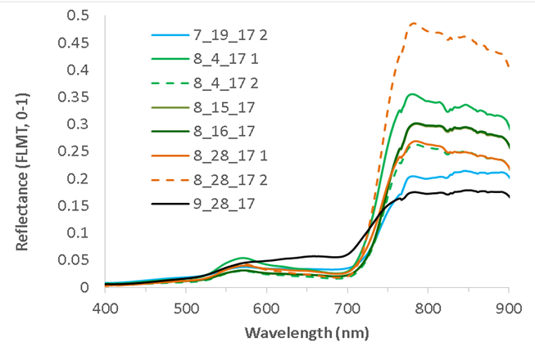
Figure 4. Repeated observations of canopy reflectance, collected 1-2 times/day (±1 hour of solar noon), across the 2017 growing season, on corn under optimal nitrogen level, in Greenbelt, MD.
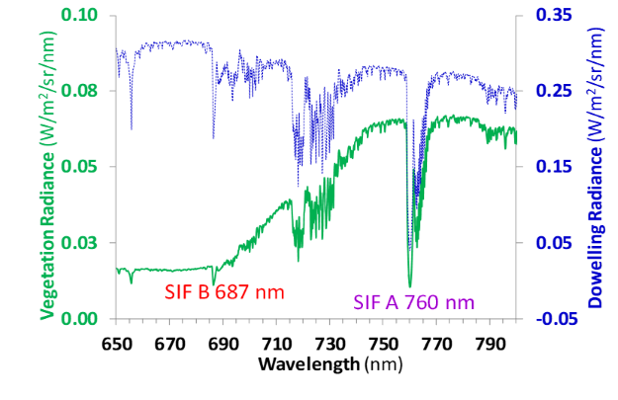
Figure 5. Measurements of downwelling radiance and reflected canopy radiance, obtained from corn canopy in Greenbelt, MD and used for deriving solar induced fluorescence (SIF) in the red (SIF B, 687 nm, green line) and far-red (SIF A, 760 nm, blue line) regions.

During the summer of 2018 we collected seasonal observations and derived SIF red (SIF B, 680 nm, Fig. 6 in red) and far-red (SIF A, 760 nm, Fig. 6 in blue) estimates for corn canopy under high and low nitrogen (N) treatment (Fig. 6).
Comparing the magnitudes in SIF across the measurements from the different growth stages, the trends in SIF A and B under high N differed in the first measurement date, while they did not show a significant difference in the later dates.
The highest SIF A signal was measured on August 6 (mid growing season) from corn canopy under high N. Under high N, on this day SIF B was lower than SIF A, and both SIF A and B reached maximum in the early afternoon (pm1). In contrast, on the same date under low N SIF A and B had similar magnitudes and gradually increased throughout the day.
During the second measurement date (8/20/18), when the corn crop was under senescence, both SIF A and SIF B had similar magnitudes, however higher SIF was always measured from the canopy under high N. Under high N highest SIF A and SIF B were reached at mid-day, while at low N both SIF A and SIF B gradually increased during the day.
On the third date (9/27/18), SIF A was significantly higher than SIF B, and similar SIF magnitudes were measured from both canopies which were the lowest for the season.
The magnitude in SIF A has been associated with canopy green biomass and chlorophyll content, which are both higher under higher N content.

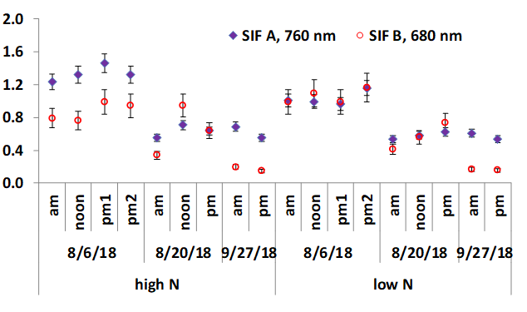
Figure 6. Repeated measurements of SIF A (blue) and SIF B (red) obtained from corn canopy in Greenbelt, MD on dates representing mature fully developed canopy (8/6/18), early senescence (8/20/18) and late senescence (9/27/18) during the 2018 growing season.

4. conclussions

This project enabled the collection of high frequency diurnal observations and the comparison of datasets acquired at varying times of day. The effort implemented the Piccolo spectral system for use on small UAS, to fill the data collection gap between in-situ field measurements and higher altitude (airborne and orbital) spectral collection systems. The technology facilitates the integration of products from multiple instruments, into a coherent, unified reflectance and SIF product stream.
Key limitations, currently precluding comparison of reflectance and SIF among different ecosystems, include solar illumination and canopy bi-directional reflectance (BRDF) effects. Further research is needed to advance their characterization from UAS.
The developed UAS enables integration of spectral observations with data from the Italian National polar-orbiting hyperspectral mission PRISM and provides a step in preparation to support future missions such as NASA’s Landsat-9 and Surface Biology and Geology (SBG), EnMAP (Environmental Mapping and Analysis Program, DLR, Germany) and ESA’s FLEX mission.

5. References

[1] Jones, H.G. and Vaughan, R.A. (2010). Remote Sensing of Vegetation: Principles, Techniques and Applications. New York: Oxford University Press, 2010, ISBN 978-0-19-920779-4.

[2] Anderson, K. and Gaston, K. (2013). Lightweight unmanned aerial vehicles will revolutionize spatial ecology. Frontiers in Ecology and the Environment. 11. 138-146. 10.2307/23470549.

[3] Kerr JT and Ostrovsky M. 2003. From space to species: ecological applications for remote sensing. Trends Ecol Evol 18: 299–305.

[4] Aasen, H.; Honkavaara, E.; Lucieer, A.; Zarco-Tejada, P.J. (2018). Quantitative Remote Sensing at Ultra-High Resolution with UAV Spectroscopy: A Review of Sensor Technology, Measurement Procedures, and Data Correction Workflows. Remote Sensing 2018, 1091.

[5] Mac Arthur, A., Robinson, I., Rossini, M., Davis, N. and K. MacDonald, (2014). A dual-field-of-view spectrometer system for reflectance and fluorescence measurements (Pccolo Doppio) and correction of etaloning. In Proceedings of the 5th International Workshop on Remote Sensing of Vegetation Fluorescence, 22-24 April, Paris (France).

[6] Verrelst, J., Camps-Valls, G., Muñoz-Marí, J., Rivera, J.P. Veroustraete, F., Clevers, J.G.P.W., Moreno, J. (2015b). Optical remote sensing and the retrieval of terrestrial vegetation bio-geophysical properties – A review. ISPRS Journal of Photogrammetry and Remote Sensing, 108, p. 273-290.

[7] Julitta, T.; Wutzler, T.; Rossini, M.; Colombo, R.; Cogliati, S.; Meroni, M.; Burkart, A.; Migliavacca, M (2017 b). An R Package for Field Spectroscopy: From System Characterization to Sun-Induced Chlorophyll Fluorescence Retrieval. ESA: ESRIN, Frascati (Rome), Italy, 2017.

[8] Campbell, P.K.E.; Huemmrich, K.F.; Middleton, E.M.; Ward, L.A.; Julitta, T.; Daughtry, C.; Burcart, A.; Russ, A.L.; Kustas, W.P. (2019). Diurnal and Seasonal Variations in Chlorophyll Fluorescence Associated with Photosynthesis at Leaf and Canopy Scales. Remote Sens. 2019, Special Issue Quantifying and Validating Remote Sensing Measurements of Chlorophyll Fluo-rescence, 11(5), 488. DOI: 10.3390/rs11050488.

[9] van der Tol, C.; Verhoef, W.; Timmermans, J.; Verhoef, A.; Su, Z. (2009). An integrated model of soil-canopy spectral radiances, photosynthesis, fluorescence, temperature and energy balance. Biogeosciences 2009, 6, 3109–3129.

