Geophysical Research Letters
Supporting Information for
ICESat-2 melt depth retrievals: application to surface melt on Amery Ice Shelf, East Antarctica
Helen Amanda Fricker¹, Philipp Arndt¹, Kelly M. Brunt^{2,3}, Rajashree Tri Datta^{2,3}, Zachary Fair⁴, Michael F. Jasinski², Jonathan Kingslake⁵, Lori A. Magruder⁶, Mahsa Moussavi^{7,8}, Allen Pope^{7,8}, Julian J. Spergel⁴, Jeremy D. Stoll², Bert Wouters^{9,10}
¹Institute of Geophysics and Planetary Physics, Scripps Institution of Oceanography,
University of California, San Diego, La Jolla, CA, USA
²NASA Goddard Space Flight Center, Greenbelt, MD, USA
³Earth System Science Interdisciplinary Center, University of Maryland, College Park, MD, USA
⁴University of Michigan, Ann Arbor, MI, United States
⁵Department of Earth and Environmental Sciences, Lamont-Doherty Earth Observatory of Columbia University, Palisades, NY
⁶Applied Research Laboratories, The University of Texas at Austin, Austin, TX and Department of Aerospace Engineering and Engineering Mechanics, The University of Texas at Austin, Austin, TX.
⁷National Snow and Ice Data Center, Boulder, CO USA
⁸Cooperative Institute for Research in Environmental Sciences, University of Colorado, Boulder, CO USA
⁹Institute for Marine and Atmospheric research Utrecht (IMAU), University of Utrecht, NL
¹⁰Department of Geoscience & Remote Sensing, Delft University of Technology, NL
Contents of this file

Text S1
Figure S1
Introduction
This file contains the following:
- a more detailed description of the Surface Removal and Robust Fit (SuRRF) ICESat-2 algorithm developed at Scripps Institution of Oceanography for this paper (Text S1).
- a figure showing histograms of differences between meltwater depth estimates and the ICESat-2 manual baseline for all algorithms used in this paper (Figure S1).

Text S1.
Surface Removal and Robust Fit (SuRRF): This method has been developed specifically for this paper, to provide a preliminary alternative to the other published algorithms. The final objective for this algorithm is to provide depths of supraglacial meltwater lakes from ATL03 data wherever this can be achieved with good confidence and where concurrent satellite imagery is available. Therefore, we here assume that the approximate outlines of each meltwater body can be verified using the imagery at hand. The SuRRF algorithms then takes as input a segment of ATL03 photon data in which such a single melt lake has been identified. The algorithm uses all ATL03 surface confidence level photons from ‘high’ to ‘noise’, but ignores other data points classified in ATL03 as 'possible_tep' or 'not_considered'.
The flat water surface in the ATL03 data is identified by histogram-binning the entire input segment and finding the elevation corresponding to the most prominent peak. To make this process more efficient and robust this is done in two steps, where the size of the bins is 25 cm in the first run and then the procedure is repeated within a +1 m band around the peak identified in the first run. Once the surface elevation is found like this, photons are classified as lake surface signal photons if they fall within three times the distance between the elevation of the peak and the elevation at which photon density drops to ½ the peak density above and below the surface elevation. The SuRRF algorithm then searches for double surface reflections from sensor saturation and dead-time effects in a band 45-65 cm below the identified water surface. This is achieved by applying Hierarchical Density-Based Spatial Clustering of Applications with Noise (HDBSCAN; Campello et al., 2013) to the data in this band and classifying all photons that belong to identified clusters as double reflection photons. All photons classified as surface signal photons or double reflections are then removed.
The lake bottom is now found by fitting a smooth line to the remaining photon data using a robust, locally weighted moving average. The weighted average is calculated in 5 m intervals in along-track location, using a tricube weight function with width 20 m in along-track distance. To reduce the impact of background noise photons, each photon is further weighted by the photon density within its neighborhood. This is calculated in “normalized” along-track-distance/elevation space (where along-track distance is multiplied by a factor of 0.01) as the sum of other photons within a distance of 1 m returned by a KD-Tree query, and weighted by an exponential radial basis function of width 0.3 m. This initial fit for the lake bottom is then iteratively refined, where in each iteration the photon elevations are weighted by the same tricube weight function as before, but also by each photon’s inverse distance to the current linearly interpolated elevation at that photon’s along-track location. Here, five iterations were used to arrive at the final lake bed elevation estimate.
For all locations where the elevation of the final smooth line is lower than the elevation of the lake surface, the water depth is then taken to be the difference between the two. At all other locations, water depth is set to zero. Note that if the ice surface elevation were to drop below the lake surface elevation beyond the extent of the melt lake in the ATL03 input segment, then the current version of the algorithm would falsely report the elevation difference as a meltwater depth. However, if concurrent imagery is assumed to be available, then the imagery can easily be used to filter out such false positives (e.g., using the normalized difference water index for snow).
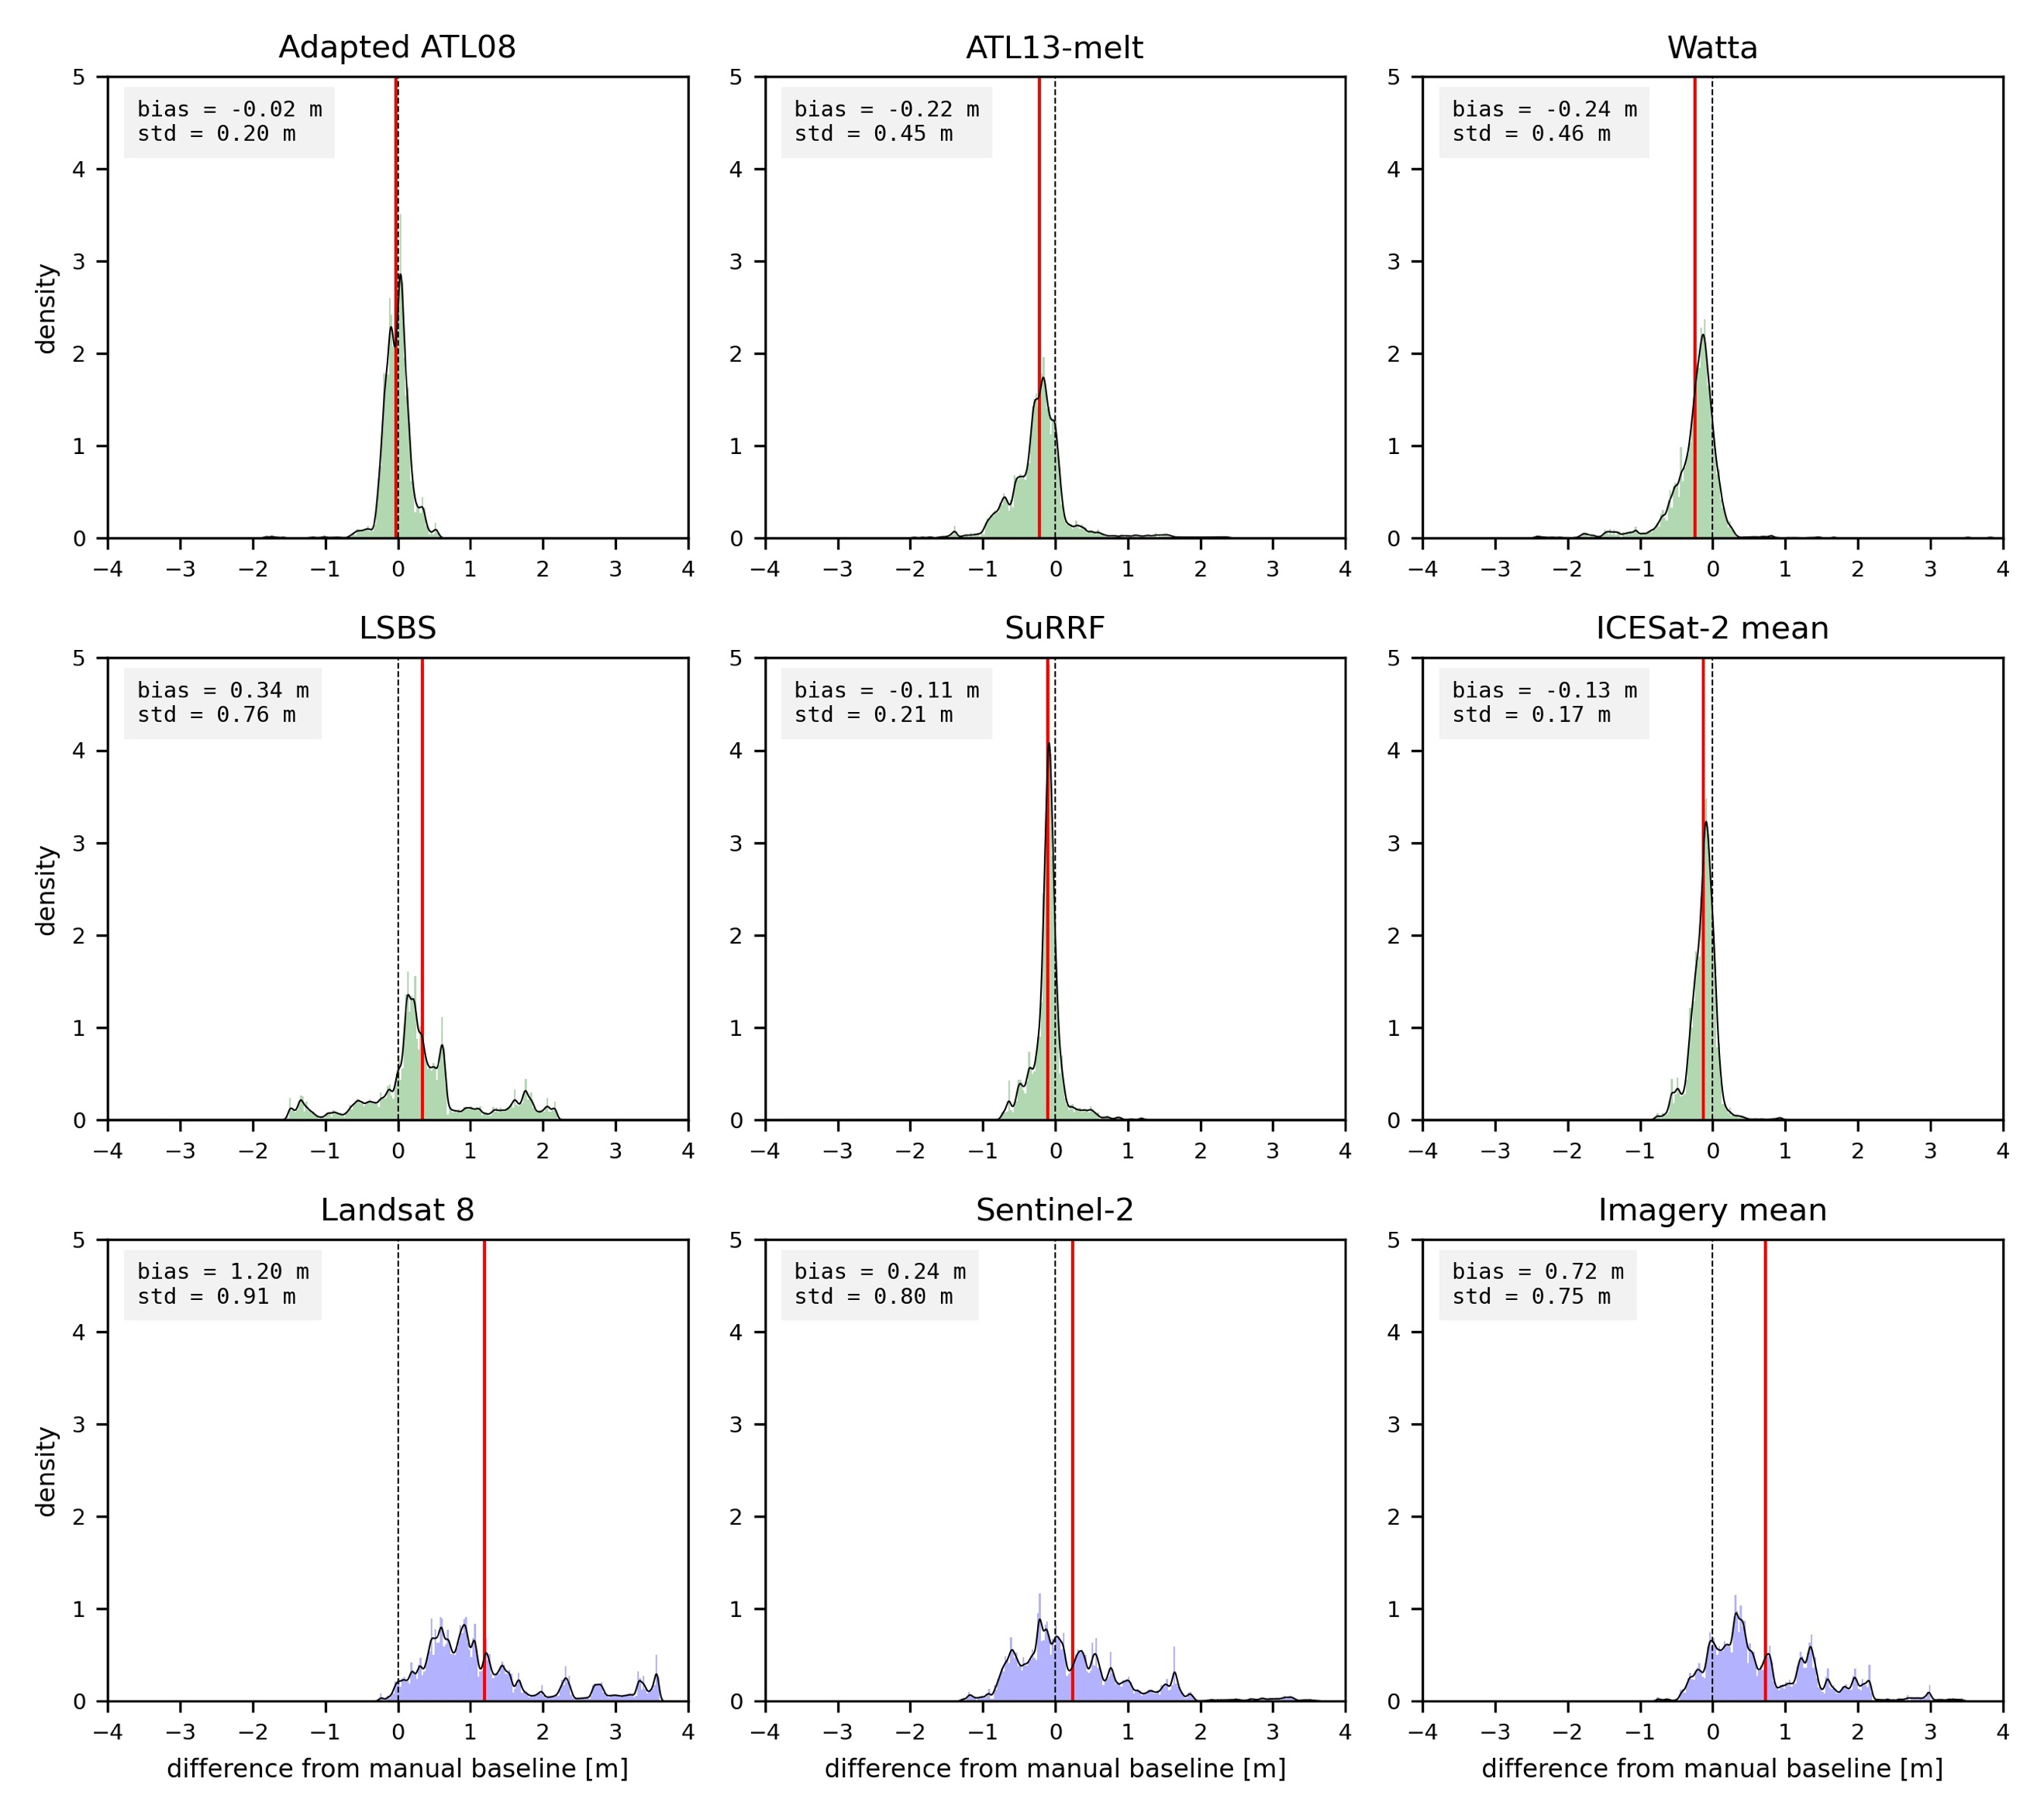
Imagery
ICESat-2
Figure S1. Histograms of differences between depth retrievals for (top six panels) five ICESat-2-based algorithms and their average and (bottom three panels) two image-based algorithms and their average with the ICESat-2 manual baseline. The ICESat-2 manual baseline serves as a proxy for ground truth in the absence of actual validation data. The statistics annotated for each histogram are the mean and standard deviation of the differences (bias and std), the root-mean-square of the differences (RMSE) and the correlation (corr).

