Artemis I PRELAUNCH Flight Readiness ANALYSIS

Steven R. Hahn, Kelsey Hodges, Nathan Lunetta, Ken Zuo
Dynamic Concepts, Inc. Huntsville, AL 35806
Austin Decker, Jonathan Band
NASA, Marshall Space Flight Center. AL 35812

The Prelaunch loads analysis traditionally captures the vehicle and Mobile Launcher (ML) loads associated with stacking in the Vehicl Assembly Building (VAB), rollout to the pad, and high-speed winds while out on the pad prior to liftoff. The following paper details the methodology used in this analysis for loads for the Artemis Flight Readiness assessment.
This paper focuses on the stacking and assembly loads, the loads induced by fueling, and the load seen during rollout to the pad. Methods for integrating multiple structural models in dynamic simulations using interface forces, constraint modes, and residual vectors is discussed. Both linear and nonlinear responses are addressed. Simulation results are compared to measured data from the Dynamic Rollout Test (DRT) and Wet Dress Rehearsal (WDR).

Prelaunch Analysis, Rollout
The analysis carried out for the rollout regime addresses the loads from the point in time at which stacking of the vehicle in the Vehicle Assembly Build (VAB) is complete to the point just before the Crawler Transporter (CT) sets the Mobile Launcher (ML) down on the launch mounts at the pad. Rollout loads are assumed to be generated due to a combination of winds, gravity, and base motion from the CT. Gravity loads include the effect of preloads induced during both the stacking of the vehicle (discussed in detail in Section 4.1) and the placement of the ML on the CT. Typical areas of concern when analyzing rollout are bending moments at the base of the vehicle, aft skirt loads, ML vehicle support post (VSP) loads, booster attach loads, and stabilizer loads. The modeling and numerical methids methods used to simulate loads as discussed and some of the significant responses predicted by the rollout analysis are highlighted.

Rollout Math Modeling
The Block 1 vehicle consists of the Multi-Purposed Crew Vehicle (MPCV, that features the launch abort system (LAS), the service module (SM) and the crew module (CM)), the MPCV Stage Adapter (MSA), the Interim Cryogenic Propulsion Stage (ICPS), the Launch Vehicle Stage Adapter (LVSA), the Core stage, and the Boosters. Individual math models have been developed for these elements and assembled into an integrated vehicle model using Craig-Bampton reduction techniques. A Craig-Bampton model for the ML is provided as well. The vehicle and the ML model are integrated using constraint forces at connection points.
During rollout the ML is supported at four pickup points by the Crawler Transporter (CT). The CT is not included as part of the integrated model, rather accelerations at interfaces are used to drive the ML/vehicle model. Coupling between the CT and the ML is presumed to be small and already reflected in the measured interface accelerations.

Vehicle Stabilization System
Due to the size and height of the SLS, it is difficult for the vehicle to withstand high wind loads when supported only at the aft skirt of the boosters. Because of this the SLS Mobile Launcher includes a stabilization system to help support a tall cantilevered structure such as SLS during high wind events. The VSS consists primarily of an arm (see Figure 1) that connects the ML to the vehicle at the top of the Core section at two points tangent to the outer mold line of the vehicle, as shown in Figure 2. Note that the mass of the VSS is intrinsic to the model but all the forces associated with the VSS struts are incorporated using a nonlinear model for force as a function of actuator displacement and velocity. The model takes the form of an ordinary differencial equation with amplitude dependent coefficients. This model was developed during VS testing at Kennedy in the Large Equipment Test Facility (LETF). The actuator forces act along the line of action (LOA) of the actuator connecting the end points of the actuator. The VS forces act primarily as a stiff spring to resist mtion during high wind, but they also add energy disspation or damping to reduce the risks associated with vortex shedding and vibration during rollout.
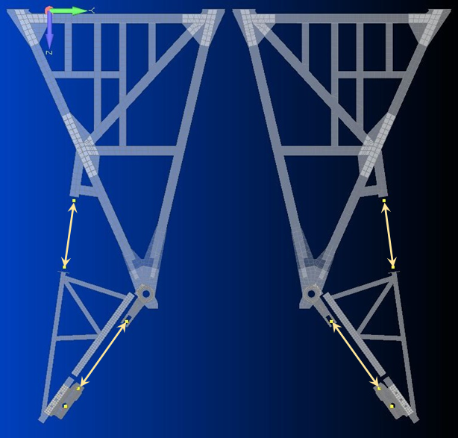
Figure 1: Overhead View of Stabilizer Arm Configuration with Actuator Forces
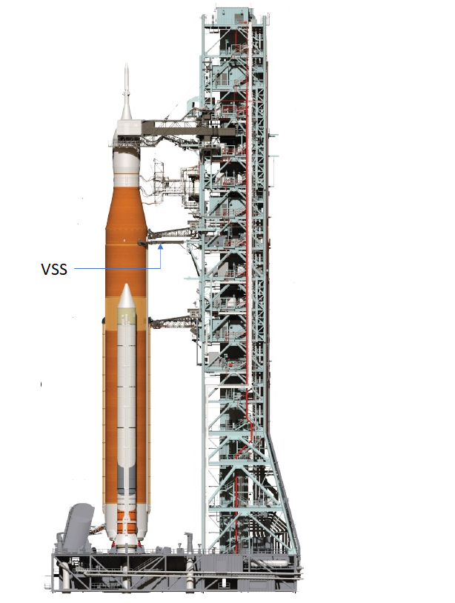
Figure 2: Integrated vehicle model on ML

Model Reduction
A modal transformation of the coupled model is created, and all modes with frequencies below 20 Hz are retained in the analysis. In addition, residual vectors corresponding to VS actuator loads and component interface loads are included. Modal damping of 1% is included for structural modes to represent structural damping and the residual vectors are damped at 20% to avoid spurious high frequency responses.

Forcing Functions
The forcing functions are organized into two groups: the gravity / stacking loads and the base drive loads.

Gravity & Preloads
The gravity analysis computes the static response of the vehicle due to the gravitational force of the earth on the vehicle during rollout. Since the static gravity analysis is based on the nominal geometry of the vehicle and ML models, this induces several artificial loads at booster–core and vehicle–tower interfaces. These artificial loads do not occur in reality because the booster aft struts are attached after the core is hung and the geometry is that of the displaced model, not the nominal model. To correct for these artificial loads, strut untie loads are applied at the stabilizer and the booster aft attachment struts to stretch these elements to the appropriate length. During stacking the Boosters are shimmed at the VSP’s to assure a slight toe-in towards the core. This bias towards the core facilitates booster attachment to the core, but is not reflected in the nominal model geometry. In order to capture the worst-case preload induced by this toe-in, a booster toe-in preload is applied at the booster forward attachment points.
Due to stacking procedures and environmental factors, the nominal geometry in the FE models does not perfectly reflect the as-built geometry of the integrated vehicle. These inconsistencies can cause errors in the interference loads at interfaces between the Booster, Core, and ML. The primary sources of interference loads are due to:
- Booster toe-in during stacking and stacking tolerances
- Booster aft attach strut installation length adjustments
- Core shrinkage due to cryogenic effects upon LH2 fueling
A set of preloads corrects the model geometry where applicable and creates the appropriate interference loads and associated strain energy release (“twang”) at liftoff. The as-built geometry of the connecting hardware is estimated by analysis with dispersions for this simulation. The high, low and nominal axial offsets due to cryogenic shrinkage documented are assessed as well as dispersed tolerance limits. This cryogenic shrinkage estimates are provided by the thermal group and the simulation loads are compared to those seen during stacking and fueling at the wet dress rehearsal after the DRT.

Base Drive Accelerations
The rollout analysis is a traditional base drive analysis, with measured accelerations at the CL/ML interface being used to drive the response of an integrated model of the ML and vehicle. Preliminary analysis used measured rollout data for the ML without a vehicle. The best data, prior to launch, is from the ISVV10 rollout, and early Artemis rollout simulations use that data as the base drive input. The Dynamic Roll Test (DRT) is the first rollout of the SLS Artemis I vehicle and this paper compares simulated rollout responses with the measured loads, acclerations, and displacements from the DRT.
Rollout loads have been found to be a strong function of CT speed due to a geometric relation of the base drive frequency content and the CCT tread roller spacing and tread size. Figure 4 shows the tread geometry and how the forcing function frequency varies with crawler speed. Because of this frequency dependance the rollout is also useful to identify the resonant modes of the coupled model.

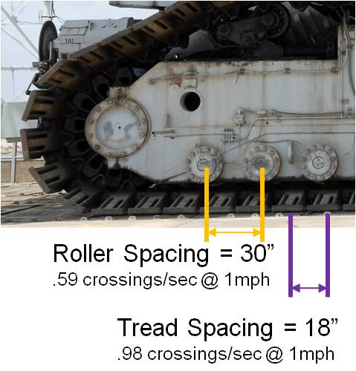
Figure 3. Tread shoe and roller spacing
All base drive forcing functions used in the analyses are high pass filtered at 0.2 Hz to eliminate low frequency noise. In addition, a low pass filter at 20 Hz is applied so that the standard Prelaunch sample rate of 80 Hz can be safely used without aliasing. A sample of the base drive accelerations and the associated crawler speed are shown in Figure 4.
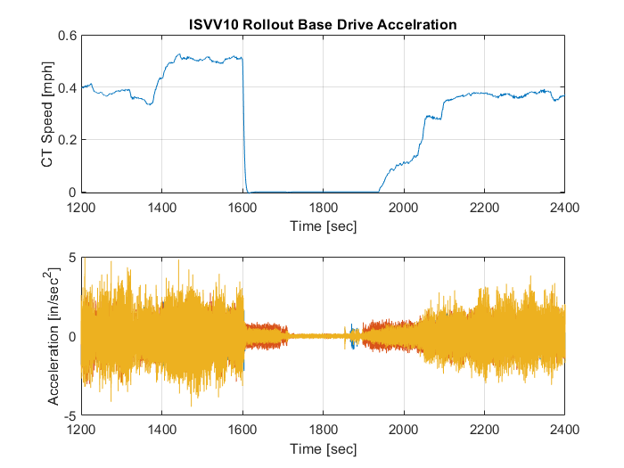
Figure 4. CT Speed and Base Drive Acceleration Time History Example

Base Drive Analysis

To perform the numerical simulation, the system mass and stiffness matrices are partitioned into degrees of freedom associated with the base drive at the crawler/MLP interface (u₂) and all remaining degrees of freedom (u₁):

$\left[K\right]→\left[\begin{matrix}K_{11} & K_{12} \\ K_{21} & K_{22}\end{matrix}\right]$$\left[K\right]→\left[\begin{matrix}K_{11} & K_{12} \\ K_{21} & K_{22}\end{matrix}\right]$

This leads to the following equations of motion for rollout:

$$\left[\begin{matrix}M_{11} & M_{12} \\ M_{21} & M_{22}\end{matrix}\right]\left[\begin{matrix}{\ddot{u}}_{1} \\ {\ddot{u}}_{2}\end{matrix}\right]+\left[\begin{matrix}C_{11} & C_{12} \\ C_{21} & C_{22}\end{matrix}\right]\left[\begin{matrix}{\dot{u}}_{1} \\ {\dot{u}}_{2}\end{matrix}\right]+\left[\begin{matrix}K_{11} & K_{12} \\ K_{21} & K_{22}\end{matrix}\right]\left[\begin{matrix}u_{1} \\ u_{2}\end{matrix}\right]=\left[\begin{matrix}0 \\ f\end{matrix}\right]$$
.
The Craig-Bampton transformation provides a very useful basis for performing a base drive simulation. Unlike the previous CB reduction, which was used to reduce the model size, here the transformation’s primary function is to provide a convenient basis set. In keeping with the earlier partitioning, the physical degrees of freedom are chosen to be the 12 base drive degrees of freedom, u₂,
$\left\{\begin{aligned}u_{1} \\ u_{2}\end{aligned}\right\}=Ψ_{CB}\left\{\begin{aligned}η_{1} \\ u_{2}\end{aligned}\right\}$
The Craig-Bampton transformation matrix ($Ψ_{CB}$) is given by,
$Ψ_{CB}=\left[\begin{matrix}Φ & Ψ \\ 0 & I\end{matrix}\right]$
where $Ψ$ are the constraint modes of the system and $Φ$ are the fixed boundary modes of the system. Note that the generalized coordinates, η, have the physical interpretation of the modal response of the system grounded at the drive points. There is some additional model reduction as the fixed boundary modes are limited to those under 20 Hz.
The utility of the CB transformation can be seen when it is applied to the equations of motion:

$\left[\begin{matrix}I & Φ^{T}\left(M_{11}Ψ+M_{12}\right) \\ \left(Ψ^{T}M_{11}{+M}_{21}\right)Φ & \left(Ψ^{T}M_{11}Ψ+M_{12}Ψ+Ψ^{T}M_{12}+M_{22}\right)\end{matrix}\right]\left\{\begin{matrix}\ddot{η_{1}} \\ \ddot{u_{2}}\end{matrix}\right\}+\left[\begin{matrix}Ω^{2} & 0 \\ 0 & K_{22}\end{matrix}\right]\left\{\begin{matrix}η_{1} \\ u_{2}\end{matrix}\right\}=\left\{\begin{matrix}0 \\ f\end{matrix}\right\}$
$$⇓$$${\ddot{η}}_{1}+Ω^{2}η_{1}=-Φ^{T}\left(M_{11}Ψ+M_{12}\right){\ddot{u}}_{2}$
The modal responses can be found using the measured base drive accelerations alone. A full recovery of the system response would include the constraint modes, but their contribution is generally small if there is significant dynamic amplification. Additionally, computing the contribution of the constraint modes involves double integration of the base drive accelerations. Given the presence of a significant amount of low frequency noise, this is a difficult computation. For the rollout simulation it was decided to include the contribution of the constraint modes, but special care was taken in integrating the base drive accelerations. First, a high pass filter at 0.2 Hz eliminated most of the low frequency noise, and second, an integration method in the frequency domain was employed to avoid drift and the accumulation of round-off error.
Note that above equations of motion do not include the damping matrix, which is poorly defined for this system. The simulation includes modal damping that is 1% of critical damping for the modal responses. The forces due to the actuators in the VSS require special consideration since the actuator force is nonlinear. The damping force is computed using a separate model that takes state input from the structure and returns a force that is applied to the structure. The actuator force can be applied in the model coordinate frame using a transformation matrix, T,
$$δ_{v}=Tv=T\left[\begin{matrix}Φ & Ψ \\ 0 & Ι\end{matrix}\right]\left\{\begin{matrix}\dot{η} \\ {\dot{u}}_{2}\end{matrix}\right\}$$
$$f_{D}=Tf_{act}$$

The complete equations of motion with the damping forces included are given by,
${\ddot{η}}_{1}+{2ζ\dot{η}+Φ^{T}f_{D}+Ω}^{2}η_{2}=-Φ^{T}\left(M_{11}Ψ+M_{12}\right){\ddot{u}}_{2}$
The equations of motion were integrated using a 4th order Runge Kutta method to find the modal displacements and velocities. Damping forces are computed in the integrator by first computing δ_{v} and then computing the fixed interface modal forces at each step as indicated in the equations above. The initial conditions were undefined by the measured data and were set to 0, but this has minimal effect on the response after several seconds into the simulation.

What’s new in this paper
The SciTech version of this paper will provide details for the analysis methodology used in the Prelaunch analysis. This will include techniques for efficiently reducing complex finite element models so that they can be used in time domain simulations. Novel approaches for integrating multiple structural models efficiently into a coupled structural dynamic simulation are presented, and the simulation is compared to measured responses during the Dynamic Roll Test.

Table 4-1. Summary of Aft Strut Axial Offsets for VAC1R Preloads
 | High  (min angle) [in] | Nominal [in] | Low  (max angle) [in] |  | High-Zero [in] | Low-Zero [in]
Unfueled Offsets (RSS) | 3.714 | 4.145 | 4.575 |  | 3.714 | 4.575
Model Geom | 5.000 | 5.000 | 5.000 |  | 5.000 | 5.000
Adjustment | -1.286 | -0.856 | -0.425 |  | -1.286 | -0.856
Fueled Offsets (RSS) | -0.490 | -0.004 | 0.483 |  | 0.000 | 0.000
Model Geom | 0.000 | 0.000 | 0.000 |  | 0.000 | 0.000
Adjustment | -0.490 | -0.004 | 0.483 |  | 0.000 | 0.000
Unfueled to Fueled Delta | 4.204 | 4.148 | 3.961 |  | 3.714 | 4.575
Aft Strut Axial Offsets Due to Radial Shrink
Element: | Hot [in] |  |  | Cold [in]
Booster side of strut | 0.017 |  |  | -0.021
Core side of strut | -0.080 |  |  | -0.205

