NASA Centennial Challenges Deep Space Food Challenge Competition to Incentivize Innovation in Food Systems for Long-Duration Space Exploration Missions

Monsi Roman and Angela Herblet
NASA Marshall Space Flight Center, Huntsville, AL, USA

James Broyan
NASA Johnson Space Center, Houston, TX, USA

Grace L. Douglas
NASA Johnson Space Center, Houston, TX, USA

Dawn Turner
NASA Marshall Space Flight Center, Huntsville, AL, USA

The Centennial Challenges (CC) program, currently part of NASA’s Space Technology Mission Directorate (STMD), is one of the vehicles NASA uses to develop and execute public prize competitions. Since opening its first challenge in 2005, the CC program has initiated more than 20 challenges in a variety of technology areas. This paper provides the background, development and execution of the Deep Space Food Challenge as one approach to fulfilling NASA’s Space Policy Directive 1 (“To the Moon, then Mars”). Specifics about the CC program’s accomplishments will also be discussed.
The Deep Space Food Challenge (DSF) was developed in collaboration with the Canadian Space Agency (CSA) to create novel food production technologies with minimal inputs, and maximum safe, nutritious, palatable food outputs for long-duration space missions, which have potential to benefit people on Earth.
When humans return to the lunar surface in the mid-2020s, the early missions will use prepackaged foods similar to those in use on the International Space Station (ISS) today. However, extending the duration of lunar missions requires reducing resupply dependency on Earth. Testing a sustainable system on the Moon that meets lunar crews’ needs is a fundamental step for lunar sustainability and future Mars exploration. NASA and CSA are focused on how to furnish crew members with a viable food system for long duration space missions that provides all daily nutritional needs through a variety of palatable, safe food with limited resource requirements and no dependency on resupply from Earth; and enables acceptable, safe and quick preparation methods.
On Earth, technology solutions for food systems could also be used to produce nutritional sources for urban and rural environments; potentially leading to a reduced impact on our Earth’s resources. Challenges, such as the DSF, are an embodiment of NASA’s continuing commitment to technological advancement and innovation through non-traditional programs.

Nomenclature
ATP = Authority to Proceed
CC = Centennial Challenges
CSA = Canadian Space Agency
DPMC = Directorate Program Management Council
DSF = Deep Space Food Challenge
EVA = Extravehicular Activity
FSC = Food Secure Canada
HQ = NASA Headquarters
ISS = International Space Station
JSC = Johnson Space Center
KSC = Kennedy Space Center
LEO = Low Earth Orbit
MRE = Meals-Ready-to-Eat
MSFC = Marshall Space Flight Center
NASA = National Aeronautics and Space Administration
PCO = Privy Council Office
RFI = Request for Information
SME = Subject Matter Experts
STMD = Space Technology Mission Directorate
TA = Technology Area
USAID = United States Agency for International Development
USD = United States Dollars
N

I. Introduction
ASA has a long history of and continues to foster space exploration technologies that simultaneously revolutionize life on Earth. Technologies such as GPS, memory foam, firefighting equipment, DustBusters, and Cochlear implants came from the development of products needed for space travel.¹ Like most Centennial Challenges, The Deep Space Food Challenge has significant potential to positively impact space and Earth communities.
People around the world struggle with food scarcity and insecurity. Numerous factors contribute to these issues including steady population growth, rising affluence, public policies, alternative uses of food products, water shortages, global warming, isolation, and soil erosion.² According to the United States Agency for International Development (USAID), more than 800 million people across the planet go to bed hungry every night.³ Feeding America highlights that food insecurity and hunger are similar concepts but have different definitions: “Hunger refers to a personal, physical sensation of discomfort, while food insecurity refers to a lack of available financial resources for food at the household level.”⁴
“Food deserts” have been a frequent topic in studies conducted by the United States Department of Agriculture. This term is used to describe regions “where people have limited access to a variety of healthy and affordable food.”⁵ Extremely rural and urban regions face food scarcity for a variety of reasons including unfavorable proximity to affordable groceries and/or food distributors, expensive shipping, poverty rates, and environmental factors such as extreme weather. Northern Canada is an example of an area that especially faces food scarcity. According to Food Secure Canada (FSC), “Inuit, First Nations, Inuit and Métis adults across the North experience five to six time’s higher levels of food insecurity than the Canadian national average.”⁶ FSC describes their food issues as multi-faceted and claims that organizations and the government are struggling to successfully eliminate the issues associated with food in the northern regions. Canada’s struggles are just one of the many food scarcity issues around the planet.
Astronauts on long duration space missions and those who live in food deserts face the same dilemma: living in an isolated space where resupplying food is expensive, and the environment is working against you. It’s no secret that space travel requires an enormous budget, and without a sustainable, palatable, nutritious, and safe food system it might be impossible to properly fuel astronauts. The same technology that could be used on a spacecraft headed to Mars could be utilized in isolated areas on Earth.
Another cross-over between earth and space food needs is the ability to create healthy and delicious food. Some populations who experience food scarcity can also be forced into making unhealthy eating choices because of cost comparison and accessibility.⁷ Healthy foods are typically more expensive and harder to access making unhealthy options like fast-food more appealing to those who struggle financially or environmentally.⁸ Food scarcity can cause a significant domino effect in the decline of quality of life (See Figure 1 below).⁹

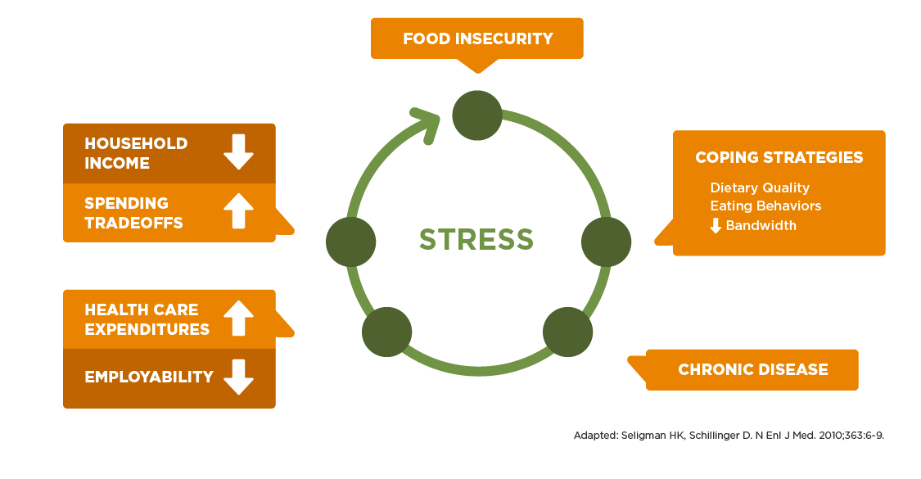
Figure 1. A Conceptual Framework: Cycle of Food Insecurity & Chronic Disease

By the same token, if an astronaut does not have access to food that tastes appealing, they may not eat enough, which may result in numerous negative impacts including insufficient nutrition, and a decline in physical and mental well-being. Ultimately, mission success depends on astronaut health and performance, which depends on a safe, nutritious, and acceptable food system. There are many overlapping challenges and consequences related to earth and space food scarcity which exhibits the need for challenges like Deep Space Food.

II. Food Production Needs for Deep Space Exploration
Julie Robinson, chief scientist for the ISS, in an article for The Atlantic described NASA’s efforts in providing food for the astronauts as something they have spent years perfecting. “But even though the meals are meant to last, they wouldn’t survive the long journey to Mars”.¹⁰ Although most of the food on ISS is shelf stable due to the need for a multi-year room temperature shelf life, some fresh food (apples, oranges, etc.) is provided when cargo missions resupply them, usually every few months. On a long Mars mission it’s obvious there will be no fresh food resupply. However, even near-term planned lunar missions will not be able to provide fresh food and will rely on prepackaged foods. Current food production methods require significant support systems and resources that require a lot of mass which makes them ‘expensive.’ If food production systems can be made more resource efficient, then it’s possible to begin testing them on the shorter lunar surface missions so that they can be relied on for long duration lunar and Mars surface missions to improve crew nutrition and reduce resupply cost. The current method of using stored foods will also not sustain a long-term mission because some of the nutrients in the food degrade over time. Some quality aspects also degrade, which may not provide the enjoyable and desirable experience that is critical for the crew’s physical and mental health^{11, 12}.
Because of these requirements, food for long duration missions need integrative, new technology solutions acceptable to the crew. Potential solutions may include the following types of offerings: prepackaged foods, bioregenerative foods and automated nutrition. There are several advantages with prepackaged foods: safety can be determined prior to launch, there is no risk of food scarcity, they minimize crew time for preparation, and they have demonstrated ability to support human health and performance for 6-12 months. However, these foods are resupplied regularly. Food launched from earth contains 46% water in the system and as life support recycling technologies become more efficient, there is less need for this water.¹³ For longer duration missions, NASA has a goal to increase the shelf life of these foods up to 5 years and this is likely to require a combination of formulation, processing, packaging, and environment. A second type of food source, bioregenerative foods, are food sources grown in flight. Bioregenerative food production is an important part of closing the life support oxygen loop for long term planetary sustainability. Although significant amounts of water may be used to produce food locally (and the water in the non-edible waste products), the water can be recycled at ~96% recovery. If food is produced at significant scale, it has the potential to also contribute to carbon dioxide removal and oxygen production, but that is not the focus of this challenge. These foods also provide: great psychological appeal, higher nutrient density, fresher food quality, variety/customization, and fit the mission goal of self-reliance; however, with this choice comes limits. Bioregenerative foods have a risk of: food scarcity, microbiological risk, high crew time requirement, infrastructure and a low technology readiness level.¹⁴ But, this method is critical to mission self-reliance and the only way to have fresh foods on a mission to Mars. Finally, customization of foods for astronauts can be found in automated processing such as in 3D food printing systems. In these systems, different food components can be printed for astronauts to help support personalized nutrition for specific goals such as targeted vitamins and energy requirements. Ultimately, any food system or combination of systems needs to meet nutritional needs for astronauts, who tend to eat less in spaceflight.^{15,16} It will also need to integrate within the limited resources available in a crewed mission and/or can be sent ahead of the crew with the known constraints.¹⁷
There are efforts in the area of existing life support systems currently used to demonstrate the potential to grow food crops on ISS, but those are proof of concept and will not be sufficient for long-term deep space exploration or habitation. ISS payloads are small scale, and science focused, and these salad crop demonstrations have had mixed success in spaceflight.¹⁸ Although predecessors of future extraterrestrial farms beyond Earth exist, the process is not yet reliable or predictable enough to have earned a place as a critical system in the spacecraft. New technologies will need to be developed to enable long-term, Earth-independent missions, and to address issues such as the volume and water needs of food production. Investing in food and human systems is one of the best ways to demonstrate that we are working on sustainable, permanent presence on the moon, not just an Apollo redo. All the technology that will be needed to support a sustainable food production system on the Moon will have direct application to a planetary mission- in fact it will help increase the reliability of this system and decrease the risks for long duration missions to Mars and beyond.
While providing the appropriate amount of nutrients to the crew is critical, what’s often overlooked in proposed food solutions is the “human factor”. Mission crew are willing to sacrifice in the name of exploration and the overall mission; however, when it comes to food, even “superhuman” crew can only tolerate so much. There have been several instances from past missions of crew who lost significant weight.¹⁹ And while solutions such as algae and bugs have been suggested, there are not only gaps in knowledge in resource and vehicle integration requirements but there are gaps in process and product acceptability. In spaceflight, astronauts may need to be involved in processes we do not experience on Earth. Therefore, the entire process as well as the final product would have to validate as generally acceptable to most people in their kitchens after a long day of work before these would be viable options on an exploration mission. The psychological benefits of interacting with food - whether it’s growing, preparing or consuming it - are invaluable. Understanding this, acceptability of a food system by crew is a key criteria to be considered in a proposed solution.²⁰
Food is a critical component in combination with exercise in maintaining crew health during long microgravity transits so that they can safely tolerate entry deceleration loads and be able to independently egress the landing vehicle. Exercise without sufficient nutrient intake is insufficient and leads to both undesirable bone and muscle loss. Unlike ISS crews returning to earth, crew landing on distant planets (such as Mars) will not have ground support to help the de-conditioned crew egress the landing vehicle. It’s also undesirable to wait several days before the crew can readapt to gravity before they are able to egress and descend several meters to the surface. Similarly on the surface, caloric loads will be higher due to frequent extravehicular activities (EVAs) and sufficient nutrition and exercise is also required to mitigate the risk of injury from fatigue to falls.
Ultimately, it is important to remember that food is key to mission success, as it impacts all aspects of physiology, and therefore health and performance. A variety of whole foods provide proteins, fats, carbohydrates, and fiber, as well as thousands of bioactive compounds, with impacts on factors that include the microbiome, the immune system, and the brain.²¹⁻²⁸ Although vitamin supplementation may have roles in spaceflight, it cannot replace a complete food system for many reasons, reviewed previously.²⁹

III. Current State of Food Production Technology for Space Flight
Food and nutrition are key determinants of human exploration mission success. The military has found the key to successful missions is to provide a food system that best supports health and performance. This includes limiting the use of shelf stable meals-ready-to-eat (MREs) to 21 days or less.³⁰ However, the NASA is planning missions that will put the first woman and next man on the moon this decade and will send humans to Mars next decade and it will require more than 21 days of shelf stable foods to achieve this mission. Propulsion capability will need to increase to supply missions as distance from Earth increases and planetary physics makes regular resupply unfeasible. Providing food and nutrition will be a significant challenge.
The upcoming Orion missions require a 10% reduction in food mass compared with current models. Total food mass for a Mars scenario is constraining. At first thought, one might consider a simple solution of meal replacement with something very dense and/or improving packaging design, increasing fat content or reducing water content, but there are multiple resource integration, shelf stability, nutrition, and acceptability challenges with each of these. Four crew members would need around 10,500 kg of food with current lightweight, flexible, high-barrier packaging for a 3-year mission. Any packaging change would need to provide similar or better oxygen and moisture barrier properties, which are important to achieve long duration shelf life.³¹ Mass reduction strategies must consider long term acceptability, nutrition, and variety. In short, and as highlighted in Figure 2, any space food system must meet basic criteria, reviewed in detail here³²
- Safety
- 5-Year Stability
- Acceptability
- Nutrition
- Variety
- Reliability
- Resource Minimization
- Food Production Hardware & Software
- Usability

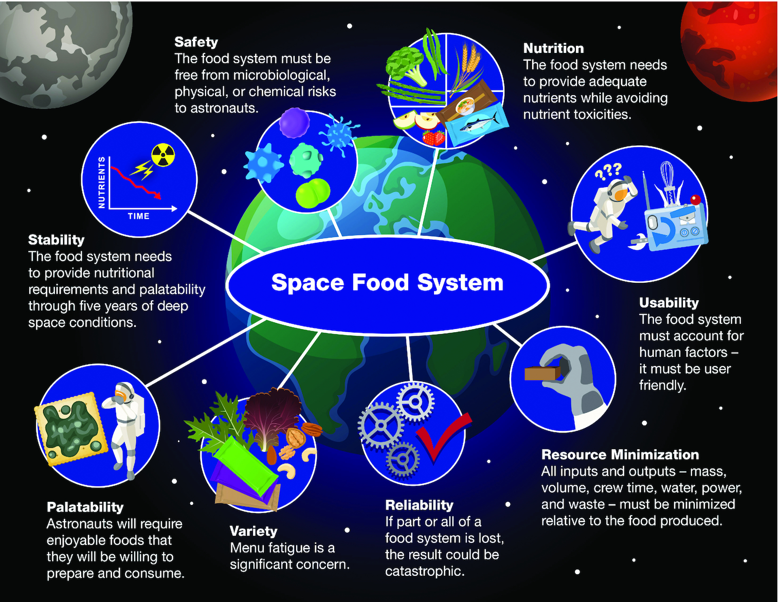
Figure 2. Requirements of a Space Food System

Food technology roadmaps are in development and include food production, including technologies that may emerge from the DSF CC. Food production is acknowledged as an important area with its inclusion in NASA’s technology taxonomy section TX06.3.5 ‘Food Production, Processing, and Preservation’.³³

IV. Crowdsourcing as a Tool for Identifying Technology Solutions
NASA uses competitions and prizes as one way of helping maintain and advance America's leadership in technology and innovation. Crowdsourcing provides the agency an alternate-but-complementary path to further humankind’s exploration. Since the time of its inception, this approach, as described by Lee, Fong, Barney and Hawk, has proved the success of the open innovation advantage to solve complex problems integrating large knowledge solutions across disciplines while incorporating diverse ideas and viewpoints.³⁴ Additionally, adding to the evidence stated by Lee, Fong, Barney and Hawk, CC competitions show the significance of knowledge divergence and the power of heterogeneous thinking to find new solutions for technical, innovative challenges for space and earth. This approach to addressing NASA’s key technology needs is based on the principle that engaging the public can harness capabilities that will increase possibilities of finding open innovative solutions.
To this day, Centennial Challenges offers incentive prizes to generate revolutionary solutions to technical problems of interest to NASA and the nation. In keeping with the spirit of the Wright brothers, Robert Goddard as well as many other American innovators, Centennial Challenges seeks innovations from diverse, multi-disciplinary and non-traditional sources including individual citizens as well as those in academia, industry, and other government agencies. The Program’s goal is to stimulate research and technology solutions to support NASA missions and inspire new national aerospace capabilities through public prize competitions.
Historically, competitions and prizes such as these have always created broader avenues through which to spur innovation from the most seemingly unlikely and humble sources. For example, after laboring for decades to determine the proper measurement of longitude at sea, the British Parliament passed a bill providing compensation for any citizen who could make a breakthrough. Though attempted by mathematicians, astronomers, and veteran navigators, it was an uneducated clock maker living in poverty named John Harrison who won the prize with his invention of the marine chronometer in 1761. In the 1920s, an American hotelier with a passion for aviation, Raymond Orteig, established a $25,000 USD prize for any person who could fly across the Atlantic Ocean. Ultimately, it wasn’t a daredevil stunt pilot or WWI fighter ace that won the Orteig Prize, but a humble mail pilot named Charles Lindberg.
It was with these historical examples in mind that in 2005, Congress amended the National Aeronautics and Space Act of 1958 to authorize NASA to create challenges such as the CC Program, through which prizes could be awarded to United States citizens or entities who succeeded in meeting the challenge requirements. The challenges selected by the Program are thoroughly deliberated through broad consultations with subject matter experts (SME), both inside and outside the federal government.
In the past 15 years, the CC Program has initiated 21 challenges in a variety of technology areas, including: propulsion, robotics, communications and navigation, human health, science instrumentation, nanotech, materials and structures, and aerodynamics. Eighty-eight prizes totaling more than $8.3 million (Fig. 3) have been awarded, and several new companies have been born in the private sector using those technology advancements. While changes made to the Program in the last two years have yielded many measurable positive outcomes, like the significant increase in participation in the challenge competitions (Fig. 4) and increase in prize purse awards (Fig. 5), the Program continues to look for ways to increase the benefits to the Agency and participants. By increasing the collaborations with other government agencies/academia and the public understanding of the Program, NASA expects to continue the improvement of the CC Program and looks forward to great outcomes that will continue to be of benefit to the Agency and the Nation.

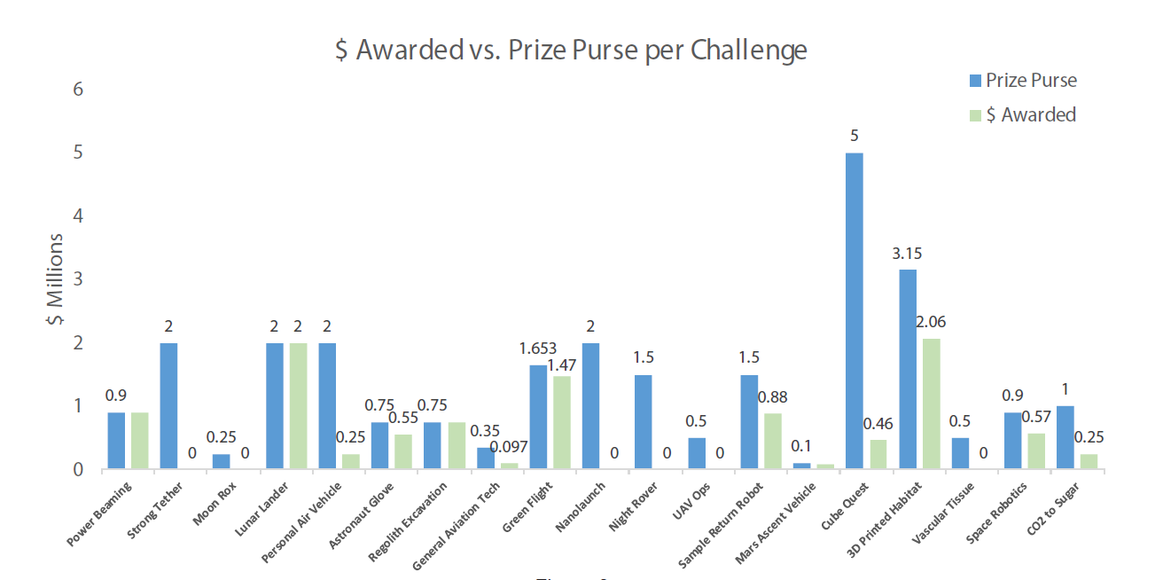
Figure 3. Amount awarded in each Centennial Challenge.

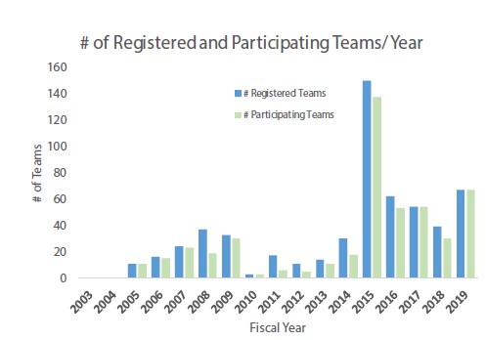
Figure 4. Challenge participation significantly increased since the program’s beginnings.

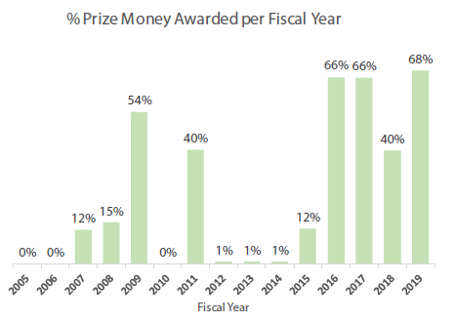
Figure 5. In recent years, a large amount of the prize purse has been awarded to competitors.

International teams can participate in the CC competitions granted that the country’s request to participate is accepted by the Program and with the understanding that, because of the Program legal authority, they are not eligible to win prize money. Despite this, the Program has accepted registrations from more than eight countries, and five teams (Japan, Singapore, Spain, European Space Agency/Germany and South Korea) have won top honors in two challenges (3D-Printed Habitat and Space Robotics). After the challenges have been completed, participants are offered information and guidance on opportunities to continue the development of their respective innovations and suggestions on transitions into a NASA Program, increasing the overall benefit to both NASA and the teams themselves. As mentioned earlier, food is a global interest which means crowdsourcing from around the world for the Deep Space Food Challenge will foster diverse perspectives on the best ways to combat food scarcity.
In a recent study, Ademir Vrolijk and Zoe Szajnfarber found crowdsourcing to be an invaluable method for Centennial’s 3D Printed-Habitat Challenge.³⁵ The study explained that the formulation of the challenge required the subject matter experts to meticulously identify technology gaps and needs so that the challenge had clear and realistic rules and objectives. Because of NASA, CCP’s, and the SME’s rigorous planning and awareness of crowdsourcing nuances and benefits, the challenge was able to thrive. SME’s and competitors were able to broaden their networks and significantly contribute to NASA and Earth additive construction capabilities. 3D-Habitat competitors continue their success today through things such as securing contracts with NASA and/or developing their own businesses. The same planning and crowdsourcing strategies have been implemented for the Deep Space Food Challenge, hopefully resulting in similar outcomes to the 3D-Habtiat Printed Challenge.

V. Purpose of the Deep Space Food Challenge
The CC program is one of the vehicles that NASA is using to identify new and innovative solutions to push the technology forward. In compliment to other agency projects and initiatives, the CC program has undertaken the task of developing and executing a public prize competition that focuses on the technology gaps and opportunities within the current food system. The Deep Space Food Challenge will seek to develop and demonstrate novel technologies, systems or approaches for food production for long duration space exploration missions that also directly benefit Earth.

A. Challenge Formulation
The Challenge formulation process began with an assessment of the current state-of-the-art technology. This assessment was informed by interviews with the CC program team, the plant research team at NASA Kennedy Space Center (KSC), and 17 other experts, plus a review of the relevant literature and internal NASA documents. The assessment did not seek to identify all opportunities for technology development, but rather to identify opportunities for a potential challenge that would incentivize industry, academia, non-governmental organizations, and the general public to develop solutions that would benefit NASA and the world.
NASA has plans to go to the Moon in the next decade in a way it has never gone before - with innovative new technologies and systems to explore more locations across the surface than was ever thought possible. This time, when NASA goes to the Moon, the goal is to stay, and use what is tested and learned on the Moon to take the next giant leap of sending astronauts to Mars. The success of these long-term exploration missions will ultimately rely upon life support systems for crew that are Earth-independent, and that will meet all of the crew’s needs without relying upon frequent (or any) resupply missions. Much innovation needs to occur to meet these lofty goals and public prize competitions can play a part. Two such areas include food and water, where opportunities exist for a Centennial Challenge to help fill existing technology gaps. And with the re-energized efforts to return to the Moon in the very near-term, using the lunar surface as a potential “testbed” to develop and test new technologies and systems is a fast-approaching reality.
Taking this vision into consideration, the first step in assessing the current state of the technology began with NASA’s expanded Technology Roadmaps (originally developed in 2010, and updated in 2015), which detail its anticipated mission capabilities and associated technology development needs through 2035.³⁶ Within those roadmaps, Technology Area (TA) 6 focuses on human health, life support, and habitation systems. The overarching focus area of TA 6 is described as follows:
“For future crewed missions beyond low-Earth orbit (LEO) and into the solar system, regular resupply of consumables and emergency or quick-return options will not be feasible, and spacecraft will experience a more challenging radiation environment in deep space than in LEO. Therefore, TA 6 focuses on developing technologies that enable long-duration, deep-space human exploration with minimal resupply consumables and increased independence from Earth, within permissible space radiation exposure limits.”³⁷
Additionally, the research mentioned in previous sections of this paper contributed to establishing the role the Challenge will play in meeting the agency’s mission needs. It was these types of findings from the initial opportunity assessment that were then refined and used to help frame further discussions with a broader range of experts. Thirty-five experts from NASA, industry and academia came together to validate and prioritize the findings from the assessment. The following eight key opportunity areas were identified, and are shown in Table 1.

Table 1. Key Opportunity Areas for a Potential Challenge
Food Production Efficiency | - Cost effective  - Energy efficient  - Optimization of height/volume/density, water, nutrients, light
Growing method and medium | - Regolith to soil  - Hydroponics  - Alternatives
Systems integration modeling | - Modeling ECLSS and air/water/plant integration  - Big data analysis  - Develop models and applications for remote operations
Plant modification | - Effectiveness, efficiency  - Engineer plants to fit a given environment  - Plant sensing  - Molecular farming
Organic waste management | - Recover nutrients, carbon, and water from inedible biomass
Food safety | - Make plants safe for consumption without damaging taste, smell, or appearance  - Ease, scale, effectiveness
Automation of horticultural processes
Water systems | - Potential integration with plant food production systems  - Water storage and safety

The outcomes of these discussions were then used to formulate three potential challenge structures based on researched, vetted, and validated topic areas. These three potential challenge concepts were designed to offer different levels of flexibility for both NASA and the challenge participants. The goals in offering three options was to provide NASA with maximum flexibility in determining what works best for the Agency’s needs, and provide different on-ramps and off-ramps for teams. In this formulation stage, it is not expected that all three concepts will be launched as a Centennial Challenge; rather it is proposed that one of the concepts will be further researched, vetted, refined, and, potentially launched as a Centennial Challenge
- Comprehensive Structure - designed in two phases, with the first phase laying the groundwork for the full development of the teams’ solutions in the second phase. Once launched the same teams would continue throughout the entire competition and NASA would commit to launching the entire competition.
- Staged Structure - designed as a large-scale, staged competition with phases. Each of the phases builds upon the previous phase. This challenge structure could be launched through just the first Phase, through the first and second Phases, or through all three Phases, depending on the appetite of NASA and its allied organizations (however, the first Phase must be launched before the second Phase, etc.). These stages are designed to build upon each other to eventually reach an audacious outcome. Teams can choose to participate in all Phases that are launched or exit or enter at any Phase. The goal of this Challenge is to address a single, primary need for future long-term missions: essential nutrients for the crew that are produced in real-time, reducing the need for stored foods that lose their nutrients over time.
- Building Blocks Structure - designed as multiple separate challenges that can run simultaneously or one at a time. Although they are designed to be independent of each other (and therefore can be launched in parallel or sequentially and any can be launched with or without the others), they are also designed to complement each other. In this manner, if more than one is launched, the aggregate value will exceed the value of the individual challenges. NASA could decide to launch one or more challenges, and it will not negatively impact the outcome if NASA decides not to launch them all. In addition, teams can choose to participate for one or more challenges.
The next step in moving the potential Challenge from formulation and into the formal development process, was to pull the landscape analysis, research results, and potential Challenge topics and structures into a more detailed written report and charts for consideration by NASA’s Directorate Program Management Council (DPMC) at NASA Headquarters (HQ) in Washington, D.C. The CC Program Manager and Principal Technologist presented the case for the Challenge including:
- Why a public prize competition and how it meets NASA’s needs
- Supporting research and analysis results founded during formulation
- The case for the Moon as a “test bed”
- Proposed Challenge concept and recommended structure
After consideration and further discussion the Council gave the Authority to Proceed (ATP) to the CC program to further develop the topic and requirements with a staged structure approach.

B. Challenge Development
Once ATP was granted, a core team of SMEs was selected to continue the development of the Challenge, and begin to formulate the Official Challenge Rules. These SMEs included experts from NASA KSC, NASA JSC, and NASA HQ. In an effort to gather feedback from the general public and gage interest from potential competitors, the CC program with the support of NASA SMEs core team put together a Request for Information (RFI)³⁸ and supporting draft challenge rules for public consideration.
As the Challenge developed, and word about NASA’s intention spread through the RFI, CC program, with the support and coordination of NASA HQ formed an agreement with the Canadian Space Agency (CSA) supported by the Privy Council Office (PCO) to jointly release the Deep Space Food Challenge. In the same way that international collaborations have been key throughout the history of space exploration, the Deep Space Food Challenge is a collaborative effort between NASA and CSA in support of the space policies of both the United States Government and the Government of Canada. The Challenge is a prize competition launched in parallel, in Canada by CSA, and in the U.S. by NASA Centennial Challenges Program. Figure 6 below shows where NASA and CSA are operating independently and where they overlap. During the development process, NASA and CSA coordinated on the Challenge design and agreed upon the Challenge statement, goals and assessment criteria. When it comes to executing the challenge, NASA and CSA each manage their own Rules document, applicant guide, prize purse and eligibility criteria. It’s important to note that CSA has no responsibility in the NASA-led challenge and likewise, NASA has no responsibility in the CSA-led challenge.

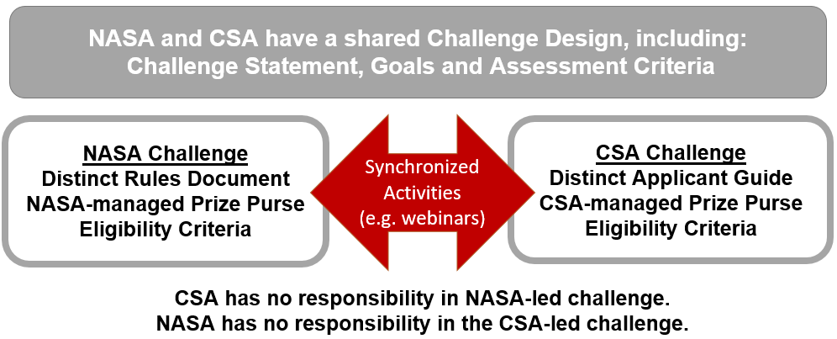
Figure 6. NASA and CSA’s Parallel Challenges

All interested Teams must select to compete in one of three competitor categories: U.S. Team, Canadian Team, or Other International Team. Each competitor category has its own set of eligibility criteria to compete and win a prize. The eligibility criteria, as well as the challenge rules and performance criteria can be found on the Official Challenge Website (deepspacefoodchallenge.org). The remainder of this paper will describe details and structure from the NASA-led Challenge.

C. Challenge Structure
The Deep Space Food Challenge is expected to be composed of three phases:
- Phase 1: Design. Requires Teams to design a novel food production technology concept and provide a detailed explanation of how it meets the Challenge goals and performance criteria.
- Phase 2: Kitchen Demonstration. Would require Teams to build a food production technology prototype (equivalent to a TRL 4) and demonstrate the prototype during a Kitchen-Level demonstration at a designated facility. Teams would also provide samples of food outputs (e.g., tangible nutritional products) from the prototype, and may be asked to provide a vision for future commercialization of the technology.
- Phase 3: Full System Demonstration. Would require Teams to build a full-scale food production technology and demonstrate the technology at a designated facility. Teams may be asked to provide a business plan for commercialization of the demonstrated technology.
The initiation of Phase 2 is contingent on the emergence of promising submissions in Phase 1 that demonstrate a viable approach to achieving the Challenge goals. In Phase 2, Teams would build and demonstrate prototypes of their proposed food production technology. The rules for Phase 2 will be released prior to the opening of Phase 2. The initiation of Phase 3 is contingent upon the outcomes of Phase 2.

D. Challenge Constraints and Assessment Criteria
Each Team admitted to Phase 1 of the Challenge will generate a robust design for an innovative food production technology that fits within the set of constraints in Table 1 in the rules. Teams will describe the process and all the inputs entering and outputs exiting the food production technology. They will also describe the full operational process including, but not limited to, how many crew members will be needed to operate the system, how the system is operated, and how long the process will take to produce their defined outputs. Since this is a Design Phase, the goal is to give as much freedom to the Teams to bring forward novel and innovative ideas. But to ensure teams are also considering the environment they are designing for, the following constraints should be considered and taken into account: Volume, Power, Water, Mass, Data connection, Crew Time and other Operational Constraints. All of the specifics for these constraints can be found in Table 1 in the rules.
Adherence to these constraints is part of the scoring rubric. However, for Phase 1, it is not scored with points. Rather it is meant to be considered by the judges to ensure that the teams have designed with the constraints in mind, and that the proposed food production technology, at a minimum, falls within those constraints. Later demonstration phases will evaluate and score these constraints.
Teams will be evaluated on two sets of criteria: overall criteria and performance criteria. Overall criteria are meant to assess the overall quality of the design and include: Adherence to Constraints, Design Approach and Innovation, scientific and Technical Merit, Feasibility of Design, and Terrestrial Potential.
The Performance criteria (Acceptability, Safety, Resource Inputs and Outputs and Reliability/Stability) will assess the solution’s technical potential, both for the food production technology (as a system) and the resulting food products. More specific details can be found in the Rules document on the challenge website (deepspacefoodchallenge.org).

E. Prizes
NASA will award $25,000 USD to up to 20 top scoring U.S. Teams that achieve a score in five or more of the scoring categories for a total prize purse of $500,000 USD. Additionally, winning teams will be invited to compete in Phase 2 (should Phase 2 open for competition). Teams must meet the eligibility requirements for the NASA Prize in order to be eligible to receive a prize from NASA.
Non-Canadian International teams that meet eligibility requirements for participating in the Challenge can be recognized as Challenge winners. NASA and CSA will recognize the top 10 scoring International teams.

VI. Conclusion
For long duration space missions, pushing the limits of current technology will be crucial to mission success. These innovations can also have positive impacts for food limitations on Earth. The Deep Space Food Challenge challenges innovators to engage in this journey to improve food systems for new space missions and for food needs around the globe. Phase 1 of the Challenge opened for registration on January 12, 2021 with full and final details on rules, eligibility criteria and prize purse amounts available on the challenge website (deepspacefoodchallenge.org). Teams from around the world are invited to register and participate in designing, and potentially developing and demonstrating novel and innovative systems, technologies and approaches to not only meet the nutritional needs of exploration mission crew, but to also improve the accessibility of food on Earth, in particular, via production directly in urban centers and in remote and harsh environments. As Phase 1 concludes and announces winners, and the development of a potential Phase 2 is initiated, more information and updates will be provided in future papers as appropriate.

VII. Acknowledgements
The authors would like to thank all parties that contributed to the assessment process and all of the experts that participated in the formulation discussions and supported the development of the Deep Space Food Challenge.

References
1 Coleman, D.,DiCicco, M., Seck,N., and Jones, J., NASA’s Spinoff 2019, Spinoff Program Office, NASA Goddard Space Flight Center, Greenbelt, MD, 2019.
2 Brown, L. R., Full Planet, Empty Plates: The New Geopolitics Of Food Scarcity, Norton & Company, Incorporated, W.W., New York, 2012.
3 “Feed The Future,” USAID, [online article]; URL: https://www.usaid.gov/what-we-do/agriculture-and-food-security/increasing-food-security-through-feed-future [cited March 24, 2020].
4 “What Is Food Insecurity?,” Feeding America, [online article] URL: https://hungerandhealth.feedingamerica.org/understand-food-insecurity/
5 Dutko, P., Ver Ploeg, M., & Farrigan, T., “Characteristics and Influential Factors of Food Deserts,” United States Department of Agriculture, Economic Research Service, ERR-140 (August 2012).
6 “Affordable Food in the North,” Food Security Canada, [online article] URL: https://foodsecurecanada.org/resources-news/news-media/we-want-affordable-food-north
7 Harrison, M., Lee, A., Findlay, M., Nicholls, R., Leonard, D. and Martin, C., “The Increasing Cost Of Healthy Food,” Australian and New Zealand Journal of Public Health, Vol. 34, (2010), pp. 179-186. URL: https://doi.org/10.1111/j.1753-6405.2010.00504.x
8 Rao, M., Afshin, A., Singh, G., Mozaffarian, D., “Do healthier foods and diet patterns cost more than less healthy options? A systematic review and meta-analysis” BMJ Open, Vol. 3, No. 12, (5 December 2013), pp. e004277, URL: https://doi.org/10.1136/bmjopen-2013-004277
9 “What are the Connections between Food Insecurity and Health?” Feeding America [online article], URL: https://hungerandhealth.feedingamerica.org/understand-food-insecurity/hunger-health-101/
¹⁰ Koren, M., “How Do Plants Grow in Space?”, The Atlantic [online article]; URL: https://www.theatlantic.com/science/archive/2019/01/plants-flowers-international-space-station-moon-mars/581491/ [cited 30 January 2019].
¹1 Catauro, P.M., Perchonok, M.H.,. "Assessment of the Long‐Term Stability of Retort Pouch Foods to Support Extended Duration Spaceflight." Journal of Food Science, Vol. 77. No. 1 (2012), pp. S29-S39.
12 Landon, L. B., Douglas, G.L., Downs, M.E., Greene, M.R., Whitmire, A.M., Zwart, S.R., Roma, P.G., "The Behavioral Biology Of Teams: Multidisciplinary Contributions To Social Dynamics In Isolated, Confined, And Extreme Environments," Frontiers In Psychology, Vol. 10 (2019), pp. 2571.
¹³ Douglas, G. L., Broyan, J.L., Johnson, M.,” Space Food System Water Content: Considerations for ECLSS Water System Closure”, 50th International Conference on Environmental Systems, Virtual Conference (Submitted for publication)
¹⁴ Anderson, M. S., Barta, D., Douglas, G., Motil, B., Massa, G., Fritsche, R., Quincy, C., Romeyn, M., Hanford, A., “Key Gaps For Enabling Plant Growth In Future Missions,” AIAA SPACE and Astronautics Forum and Exposition, [online database], URL: https://doi.org/10,2514/6.2017-5142 [cited 15 September 2017].
^{15, 19,29} Smith, S. M., et al., “Evidence Report: Risk Factor of Inadequate Nutrition,” NASA Human Research Program, Human Health Countermeasures Elements, NASA Johnson Space Center, Houston, TX, 2015.
¹⁶ Douglas, G. L., Cooper, M., Bermudez-Aguirre, D., Sirmons, T., Perchonok, M., “Evidence Report: Risk of Performance Decrement and Crew Illness Due to an Inadequate Food System,” NASA Human Research Program, Human Health Countermeasures Elements, NASA Johnson Space Center Houston, TX, 5 October 2016.
17 “Methods, Technologies & Requirements for Developing a Safe, Nutritious & Palatable Food System in Space,” Institute for Advancement of Food and Nutritional Sciences, 2019 Mid-Year Science Program, Arlington, VA, [cited 25 June 2019].
18 Massa, G.D., Dufour, N.F., Carver, J.A., Hummerick, M., Wheeler, R., Morrow, R., Smith, T. M., “VEG-01: Veggie Hardware Validation Testing on the International Space Station,” Open Agriculture, Vol. 2, 2017, pp. 33-41.
²⁰ Koren, M. “How Do Plants Grow in Space?” The Atlantic [online article], URL: https://www.theatlantic.com/science/archive/2019/01/plants-flowers-international-space-station-moon-mars/581491/ [cited 30 January 2019].
²¹ Liu, R.H., “Health benefits of fruit and vegetables are from additive and synergistic combinations of phytochemicals, “ The American Journal of Clinical Nutrition, Vol. 78, No. 3, September 2003, pp. 517S–520S, URL: https://doi.org/10.1093/ajcn/78.3.517S
²² Levy, Maayan et al. “Microbiome, metabolites and host immunity.” Current opinion in microbiology, Vol. 35, February 2017, pp. 8-15. URL: https://doi.org/10.1016/j.mib.2016.10.003
23 Lieberman, Harris R. “Nutrition, brain function and cognitive performance.” Appetite Vol. 40, No. 3, June 2003, pp. 245-254. URL: https://doi.org/10.1016/s0195-6663(03)00010-2
24 Godos, J., Currenti, W., Angelino, D., Mena, P., Castellano, S., Caraci, F., Galvano, F., Del Rio, D., Ferri, R., & Grosso, G. (2020). Diet and Mental Health: Review of the Recent Updates on Molecular Mechanisms. Antioxidants (Basel, Switzerland), 9(4), 346. https://doi.org/10.3390/antiox9040346
25 Lieberman, H.R., Bukhari, A.S., Caldwell, J.A., Wilson, M.A., Mahoney, C.R., Pasiakos, S.M., McClung, J.P., Smith, T.J., Two Days of Calorie Deprivation Induced by Underfeeding and Aerobic Exercise Degrades Mood and Lowers Interstitial Glucose but Does Not Impair Cognitive Function in Young Adults, The Journal of Nutrition, Vol. 147, No. 1, January 2017, pp. 110–116, URL: https://doi.org/10.3945/jn.116.238246
26 Day, D.S., Young, A., Askew, E.W., “Nutrition and Military Performance,” Military Quantitative Physiology: Problems And Concepts In Military Operational Medicine, edited by K.E. Friedl WS, Office of the Surgeon General, Ft Detrick, MD, 2012, pp. 157-179.
27 Peuhkuri K., Sihvola N., Korpela R., “Diet promotes sleep duration and quality” Nutrition Research, Vol. 32, May 2012, pp. 309-319.
28 Cryan, J. F., O'Riordan, K. J., Cowan, C., Sandhu, K. V., Bastiaanssen, T., Boehme, M., Codagnone, M. G., Cussotto, S., Fulling, C., Golubeva, A. V., Guzzetta, K. E., Jaggar, M., Long-Smith, C. M., Lyte, J. M., Martin, J. A., Molinero-Perez, A., Moloney, G., Morelli, E., Morillas, E., O'Connor, R., … Dinan, T. G. (2019). The Microbiota-Gut-Brain Axis. Physiological reviews, 99(4), 1877–2013. URL: https://doi.org/10.1152/physrev.00018.2018
3⁰ Friedl, K. E., Hoyt, R.W., "Development and Biomedical Testing Of Military Operational Rations." Annual Review of Nutrition [online journal], Vol. 17, Jul 1997, pp. 51-75.
³¹ Sirmons, T. A., Roma, P. G., Whitmire, A. M., Smith, S. M., Zwart, S. R., Young, M., & Douglas, G. L. (2020). Meal replacement in isolated and confined mission environments: consumption, acceptability, and implications for physical and behavioral health. Physiology & behavior, 219, 112829.
32 Douglas, G.L, Zwart, S.R., Smith, S.M., “Space Food for Thought: Challenges and Considerations for Food and Nutrition on Exploration Missions,” The Journal of Nutrition [online journal], Vol. 150, No. 9, Sep. 2020, pp. 2242-2244.
33 Office of the Chief Technologist, “2020 NASA Technology Taxonomy,” [online report], URL: https://www.nasa.gov/sites/default/files/atoms/files/2020_nasa_technology_taxonomy_lowres.pdf [cited March 2021].
34 Y. Lee, E. Fong, J. Barney, and A. Hawk, “Why Do Experts Solve Complex Problems Using Open Innovation? Evidence from the U.S. Pharmaceutical Industry,” Berkeley Haas School of Business University of California Berkeley; California Management Review, Vol.62, No. 1, 1 Nov. 2019, pp. 144-166.
35 Vrolijk, A., Szajnfarber, Z., “Exploring how Prize Challenges Complement an Organization’s Innovation Efforts,” CESUN 2020 Engineering Systems Symposium [online conference database], URL: https://docs.lib.purdue.edu/cgi/viewcontent.cgi?article=1031&context=cesun [cited February 2021].
36 Office of the Chief Technologist, “2015 NASA Space Technology Roadmaps (Archive)” [online database], URL: https://www.nasa.gov/offices/oct/home/roadmaps/index.html [cited July 2015].
37 “NASA Technology Roadmaps - TA 6: Human Health, Life Support, and Habitation Systems,” 2015 NASA Technology Roadmaps [online report], URL: https://www.nasa.gov/sites/default/files/atoms/files/2015_nasa_technology_roadmaps_ta_6_human_health_life_support_habitation_final.pdf [cited July 2015].
38 Roman, M., “National Aeronautics and Space Administration (NASA) Centennial Challenges Program – Space Food Challenge,” beta.SAM.gov [online database], URL: https://beta.sam.gov/opp/aba71029770e498aaaa8367d40562564/view [cited 25 September 2020].

¹ Program Manager, Centennial Challenges Program, MSFC-ST21.
² Challenge Manager, Centennial Challenges Program MSFC-ST21.
STMD System Capability Lead Deputy, Environmental Control Systems and Life Support – Crew Health & Performance, JSC-EC711
Lead Scientist, Advanced Food Technology, Human Health and Performance Directorate, JSC-SF411
Challenge Manager, Centennial Challenges Program MSFC-ST21

