Supplemental Information: An Application of Gaussian Mixture Regression for the Correction of Low Cost PM_{2.5} Monitoring Data in Accra, Ghana
Celeste McFarlane, Garima Raheja, Carl Malings, Emmanuel K. Appoh, Alison Felix Hughes, Daniel Westervelt,*
S1. Hourly Models
Methodology
Hour averaged PurpleAir PM_{2.5} data yielded the following evaluation metrics when compared with reference PM_{2.5} data.
R² = 0.61; MAE = 8.4 µg m⁻³; cvMAE = 0.33 µg m⁻³; bias = 3.33 µg m⁻³; MNB = 0.13 µg m⁻³
In order to build a GMR model and correct PurpleAir PM_{2.5} data towards reference values, the BIC of GMMs built with 1-15 model components was evaluated (Figure S1).
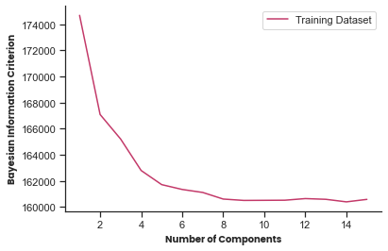
Figure S1. Bayesian Information Criterion evaluated for Gaussian Mixture Models with one to ten model components built with hour averaged training data.
Evaluating the BIC for hourly models yielded no clear minimum value, contrasting the BIC analysis done on daily data which had a clear minimum of 4 components (Figure 2). As the number of model parameters increase, so does the risk of the model overfitting the data. Despite introducing a penalty term for increasing model parameters, the BIC for hourly GMMs is inconclusive about the ideal number of model components. It is unlikely, however, to avoid overfitting when increasing model components to a value as high as 15. The plateau of the BIC analysis shown above suggests that GMMs with 8 to 15 components should have similar performance. Accordingly, to avoid overfitting, the GMM was built with 8 components. The inconclusiveness of the BIC however, leaves room for concern regarding overfitting.
A cross validation methodology similar to that of daily averaged data was employed (Section 2.3.3). In contrast to the method employed in section 2.3.3, the minimum BIC was not used in each training fold due to concerns of overfitting mentioned above. Instead, each model within the cross validation was built with 8 components.

Model Comparison
Table S1 presents the performance metrics of hourly calibration models trained on 80% of the entire dataset. While RF yielded the best correlation, GMR yielded the best accuracy.
Table S1. Statistics of hour averaged PM_{2.5} data, MLR, RF and GMR calibration models
Model | Model Inputs | R² | MAE  (µg m⁻³) | cvMAE (µg m⁻³) | Bias  (µg m⁻³) | mnBias (µg m⁻³)
Raw Data | -- | 0.61 | 8.39 | 0.33 | 3.33 | 0.13
MLR | PurpleAir PM_{2.5}, temperature, RH | 0.73 | 4.70 | 0.19 | -0.17 | -0.01
Random Forest | PurpleAir PM_{2.5}, temperature, RH | 0.80 | 4.23 | 0.17 | -0.26 | 0.04
GMR | PurpleAir PM_{2.5}, temperature, RH | 0.76 | 4.14 | 0.17 | -0.24 | 0.01
Table S.2 presents the results of the performance evaluation metrics generated by the 10-fold cross validation performed within the 80% training set.
Table S2. Evaluation metrics of 10-fold cross validation performed on hourly calibration models
Evaluation Metric | Model | Cross Validation Fold
Evaluation Metric | Model | 1 | 2 | 3 | 4 | 5 | 6 | 7 | 8 | 9 | 10
R² | GMR | 0.78 | 0.70 | 0.66 | 0.80 | 0.65 | 0.65 | 0.78 | 0.73 | 0.74 | 0.71
R² | MLR | 0.74 | 0.62 | 0.74 | 0.79 | 0.63 | 0.68 | 0.72 | 0.73 | 0.76 | 0.67
R² | RF | 0.73 | 0.78 | 0.77 | 0.81 | 0.79 | 0.73 | 0.82 | 0.75 | 0.78 | 0.81
MAE (µg m⁻³) | GMR | 3.95 | 4.29 | 3.74 | 3.84 | 4.28 | 4.41 | 4.37 | 4.09 | 3.98 | 4.53
MAE (µg m⁻³) | MLR | 4.44 | 5.04 | 4.25 | 4.38 | 5.04 | 5.03 | 4.83 | 4.65 | 4.52 | 5.07
MAE (µg m⁻³) | RF | 4.13 | 4.47 | 3.95 | 3.91 | 4.30 | 4.53 | 4.28 | 4.16 | 4.21 | 4.24
cvMAE | GMR | 0.16 | 0.17 | 0.15 | 0.16 | 0.17 | 0.17 | 0.17 | 0.17 | 0.16 | 0.18
cvMAE | MLR | 0.18 | 0.20 | 0.17 | 0.18 | 0.20 | 0.20 | 0.19 | 0.19 | 0.18 | 0.20
cvMAE | RF | 0.17 | 0.18 | 0.16 | 0.16 | 0.17 | 0.18 | 0.17 | 0.17 | 0.17 | 0.17
Bias (µg m⁻³) | GMR | 0.11 | 0 | -0.25 | 0.29 | -0.13 | -0.09 | 0.42 | 0.23 | -0.37 | -0.07
Bias (µg m⁻³) | MLR | -0.03 | -0.27 | 0.04 | 0.57 | -0.29 | 0.03 | 0.18 | 0.39 | -0.16 | -0.45
Bias (µg m⁻³) | RF | -0.35 | 0.07 | -0.24 | 0.33 | -0.07 | -0.14 | 0.26 | -0.01 | -0.47 | -0.33
mnBias | GMR | 0.004 | -0.0001 | -0.010 | 0.01 | -0.005 | -0.004 | 0.02 | 0.009 | -0.01 | -0.003
mnBias | MLR | -0.001 | -0.011 | 0.002 | 0.02 | -0.011 | 0.001 | 0.007 | 0.02 | -0.01 | -0.02
mnBias | RF | -0.014 | 0.003 | -0.010 | 0.01 | -0.003 | -0.006 | 0.01 | -0.0002 | -0.02 | -0.01
Table S.3 compares evaluation metrics of GMR within the cross validation to that of MLR and RF and reports the percentage of training folds with superior model performance.

Table S3. Comparison of model performance within a 10-fold cross validation performed on hourly training data.
Evaluation Metric | % Cross Validation Folds
Evaluation Metric | * = MLR | * = RF
GMR R² ≥ * R² | 70% | 10%
GMR MAE ≤ * MAE | 100% | 80%
GMR cvMAE ≤ * cvMAE | 100% | 90%
|GMR Bias| ≤ |* Bias| | 50% | 60%

Within the cross validation GMR consistently provided better accuracy than MLR and RF. RF, however, consistently provided better correlation than both GMR and MLR. The effectiveness of RF with respect to improving correlation is likely due to how the model handles noise. In MLR, noise is not only generalized to a single function across all observations, but to a single value (the y-intercept). This contrasts GMR where during regression, GMR generates an entire unique conditional probability distribution for each observation. These distributions will each handle noise differently. The GMR may be able to understand the noise and appropriately pick it a part or it may overfit the data trying to understand the noise. With an inconclusive BIC, however, it is hard to know whether we have successfully generalized the noise with GMR or overfit it. RF finds a middle ground between MLR and GMR in this regard. The number of trees, nodes, and parameters evaluated at each node can be fine-tuned with the intention of avoiding over fitting. While GMR did consistently provide better accuracy than MLR and RF, without a conclusive BIC, GMR may not be a suitable application for hourly data.
S2. Cross Validation of Daily Averaged Models
Table S4. Evaluation metrics of 10-fold cross validation performed on daily calibration models
Evaluation Metric | Model | Cross Validation Fold
Evaluation Metric | Model | 1 | 2 | 3 | 4 | 5 | 6 | 7 | 8 | 9 | 10
R² | GMR | 0.30 | 0.71 | 0.71 | 0.49 | 0.79 | 0.73 | 0.76 | 0.36 | 0.68 | 0.68
R² | MLR | 0.71 | 0.60 | 0.52 | 0.68 | 0.64 | 0.69 | 0.59 | 0.58 | 0.76 | 0.46
R² | RF | 0.70 | 0.71 | 0.64 | 0.83 | 0.53 | 0.83 | 0.72 | 0.64 | 0.59 | 0.79
MAE (µg m⁻³) | GMR | 2.92 | 2.84 | 3.35 | 3.25 | 5.69 | 3.14 | 2.74 | 6.71 | 2.51 | 4.48
MAE (µg m⁻³) | MLR | 3.29 | 3.55 | 3.64 | 3.65 | 6.45 | 3.36 | 3.29 | 6.68 | 2.93 | 5.26
MAE (µg m⁻³) | RF | 2.95 | 2.78 | 3.11 | 5.12 | 7.20 | 2.27 | 2.81 | 6.4 | 3.23 | 3.02
cvMAE | GMR | 0.12 | 0.12 | 0.14 | 0.13 | 0.18 | 0.13 | 0.11 | 0.22 | 0.11 | 0.18
cvMAE | MLR | 0.13 | 0.15 | 0.16 | 0.14 | 0.24 | 0.14 | 0.13 | 0.23 | 0.12 | 0.18
cvMAE | RF | 0.12 | 0.12 | 0.13 | 0.21 | 0.28 | 0.10 | 0.11 | 0.23 | 0.13 | 0.11
Bias (µg m⁻³) | GMR | -0.07 | 0.10 | 1.78 | 0.12 | -0.29 | 0.75 | -0.34 | -2.39 | -0.31 | 2.63
Bias (µg m⁻³) | MLR | 0.81 | 0.4 | 1.56 | 1.1 | -3.89 | -0.24 | 0.25 | -3.55 | 0.90 | 2.22
Bias (µg m⁻³) | RF | 0.19 | -0.46 | 1.84 | 2.28 | -4.14 | -0.19 | 0.23 | -3.25 | 1.09 | 0.83
mnBias | GMR | -0.003 | 0.004 | 0.076 | 0.005 | -0.009 | 0.03 | -.01 | -0.08 | -0.01 | 0.10
mnBias | MLR | 0.03 | 0.02 | 0.07 | 0.05 | -0.13 | -0.01 | 0.01 | -0.11 | 0.04 | 0.09
mnBias | RF | 0.008 | -0.02 | .079 | 0.093 | -0.13 | -0.008 | 0.01 | -0.10 | .05 | .03
S3. Full Time Series Comparison of Daily Models
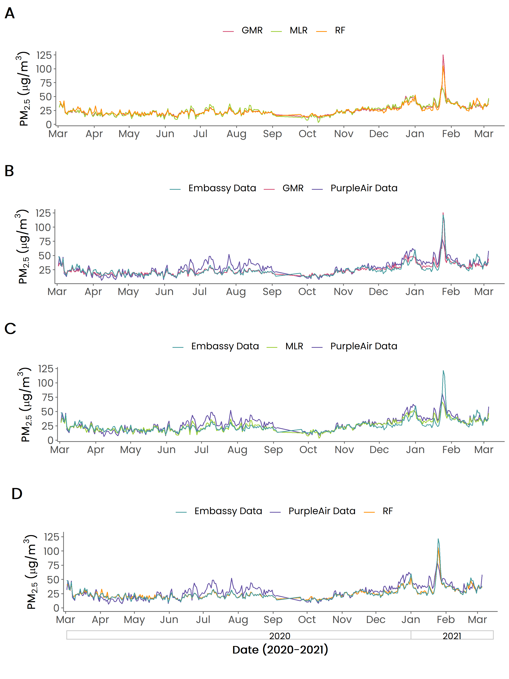
Figure S2. Performance evaluation and calibration of PurpleAir PM_{2.5} data between March 2020 and March 2021 at the US Embassy in Accra, Ghana. Figure A shows the GMR calibration data in pink, MLR calibration data in green and RF calibration data in orange. Figure B shows GMR calibration data in pink against PurpleAir PM_{2.5} data in purple and PM_{2.5} data in teal. Figure C shows MLR calibration data in green against PurpleAir PM_{2.5} data in purple and PM_{2.5} data in teal. Figure D shows RF calibration data in orange against of PurpleAir PM_{2.5} data in purple and PM_{2.5} data in teal.

