Supplementary information

The supplementary material provides background information on the Agricultural Model Intercomparison and Improvement Project (AgMIP) Regional Integrated Assessment (RIA) approach and results as applied in the case of a smallholder mixed farming system, Nkayi district in semi-arid Zimbabwe.

Supplements 1. Material and methods

Study area and agricultural systems

The AgMIP RIA approach was applied as point passed assessment, representing Nkayi district with mixed crop livestock farming in semi-arid Zimbabwe, with heterogeneous smallholder farming communities (Figure 1). The reference time period was mid-century.

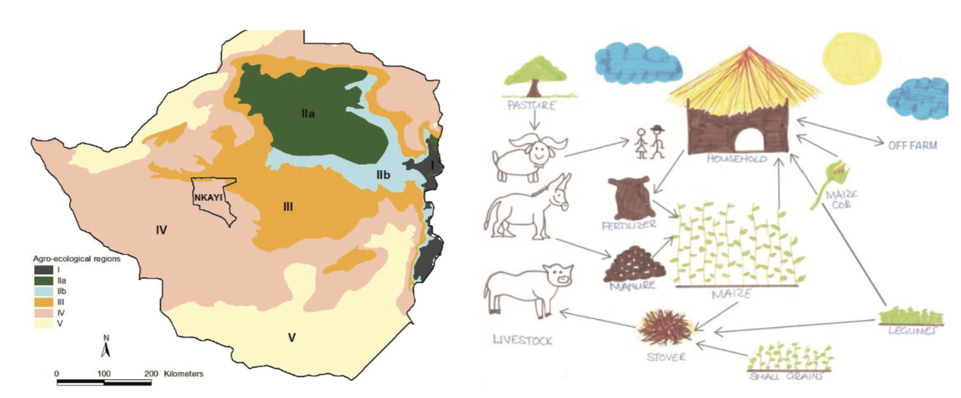

Fig 1. Study location, Nkayi district in natural region IV in Zimbabwe (left) and schematic representation of the typical mixed crop-livestock farming system found there, with its components and interactions (biophysical and economic, right, adapted from Masikati et al., 2015)

Regional Integrated Assessment approach
Given the increasing risks that the agriculture sector faces, decision makers therefore require better tools and science-based information to inform policies and technological innovation. Agricultural models and linked tools can help identify and prioritize strategies for the agriculture sector. The AgMIP RIA approach is novel in that it integrates geo-physical, bio-physical and socio-economic information across temporal and spatial scales.
AgMIP RIA characterizes climate change impact, vulnerability and adaptation of agricultural systems, assessed in the context where farmers often rely on a complex mix of crops, livestock and non- agricultural activities for their livelihoods. These are special AgMIP RIA features:
- A transdisciplinary, systems-based focus that reflects real complexities and can include multiple crops, livestock, aquaculture, off farm income sources, market interactions, and policy incentives in current and possible future systems;
- Incorporation of a high degree of heterogeneity in biophysical and economic conditions that are typical of most agricultural regions;
- Quantification of not only average impacts, but also the distribution of impacts in diverse populations;
- Ability to test of different adaptations and technologies and the potential impact of climate on both current and future production systems;
- Ability to test and design policy interventions aimed at increasing adoption of adaption and mitigation strategies to increase the likelihood of their success;
- Ability to reflect both average climate changes and interactions with climate variability;
- Ability to differentiate between different types of farming systems and producers
- Quantification of not only average impacts, but also the distribution of impacts in diverse populations;
- Ability to test of different adaptations and technologies and the potential impact of climate on both current and future production systems;
- Ability to test and design policy interventions aimed at increasing adoption of adaption and mitigation strategies to increase the likelihood of their success;
- Ability to reflect both average climate changes and interactions with climate variability;
- Ability to differentiate between different types of farming systems and producers;
- Use of multiple climate, crop, livestock, and economic models, thus facilitating the assessment and reporting of key uncertainties in climate, crop, biophysical, and economic dimensions of the analysis.

Multi-modeling approach

This section synthesizes AgMIP RIA structure and model validation, including climate, crop, livestock and economic simulations.

- Climate
Figure 2 illustrates the full ensemble of climate projections for Nkayi District, the selected 2 sets of 5 GCMS, for RCP 4.5 and RCP 8.5, and the hot dry (HD) and hot wet (HW) GCMs selected for this publication (Homann-Kee Tui et al., 2021).

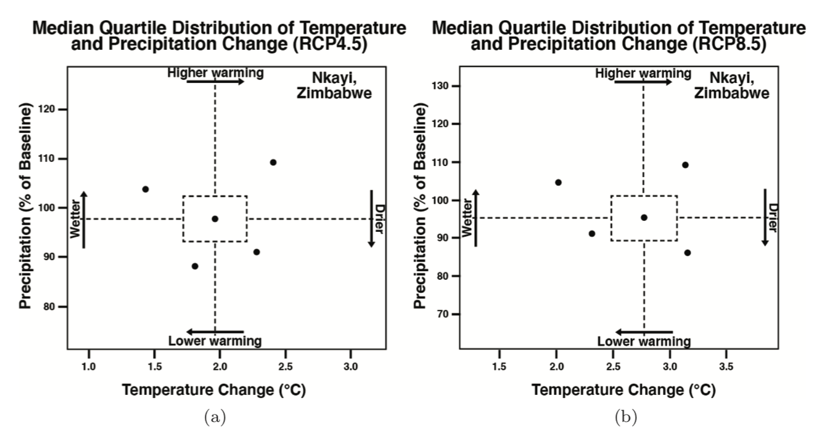
Fig 2. GCM projections for the mid-century period, plotted as temperature change for the growing season in degrees C (x axis) versus growing season rainfall in percent (y-axis), with growing season (GS) being the months October - March (ONDJFM), (a) RCP 4.5 and (b) RCP 8.5.

Table 1 summarizes the representation of those 2 sets of 5 GCMs (Homann-Kee Tui et al., 2021). It shows the minimum, mean and maximum of the 5 considered GCMs over the growing season (GS, here ONDJFM) of temperature changes, total rainfall percent change and number of rainy days change.

Table 1. Changes in growing season (GS) temperature, rainfall percentage, and number of rainy days over the 30-year future periods for the five representative GCMs in Nkayi for RCP 4.5 and 8.5.
RCP | Future period | Data summary | GS temp change (°C) | GS rain change (%) | GS rainy day change (days)
RCP 4.5 | 2010-2039 | Mean | 1.04 | -1.28 | -2.72
RCP 4.5 | 2010-2039 | Min | 0.6 | -13.4 | -11.8
RCP 4.5 | 2010-2039 | Max | 1.4 | 9.5 | 1.9
RCP 4.5 | 2040-2069 | Mean | 1.94 | -6 | -6.06
RCP 4.5 | 2040-2069 | Min | 1.4 | -14 | -11.4
RCP 4.5 | 2040-2069 | Max | 2.3 | 2.6 | -0.3
RCP 4.5 | 2070-2099 | Mean | 2.42 | -4.68 | -7
RCP 4.5 | 2070-2099 | Min | 1.6 | -12.7 | -16.6
RCP 4.5 | 2070-2099 | Max | 2.9 | 3.1 | -1
RCP 8.5 | 2010-2039 | Mean | 1.14 | -9.38 | -8
RCP 8.5 | 2010-2039 | Min | 0.9 | -19 | -15.3
RCP 8.5 | 2010-2039 | Max | 1.4 | 0.5 | 0.3
RCP 8.5 | 2040-2069 | Mean | 2.66 | -10.38 | -12.7
RCP 8.5 | 2040-2069 | Min | 2 | -22.6 | -26.4
RCP 8.5 | 2040-2069 | Max | 3.1 | 0.1 | -4.2
RCP 8.5 | 2070-2099 | Mean | 4.74 | -13.34 | -16.68
RCP 8.5 | 2070-2099 | Min | 3.7 | -32 | -37.6
RCP 8.5 | 2070-2099 | Max | 5.5 | -3 | -2.5

- Crops

Figure 3 relates the APSIM and DSSAT crop models against observed data from on-station experimental data (Homann-Kee Tui et al., 2021). The predicted results were satisfactory although the models had a tendency to slightly overpredict maize stover.

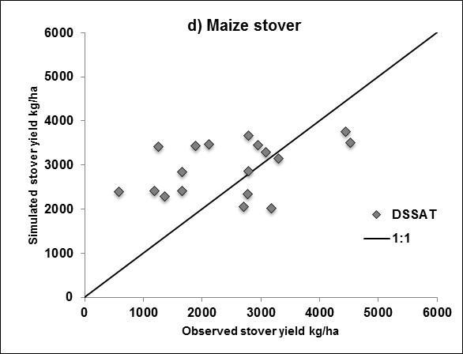
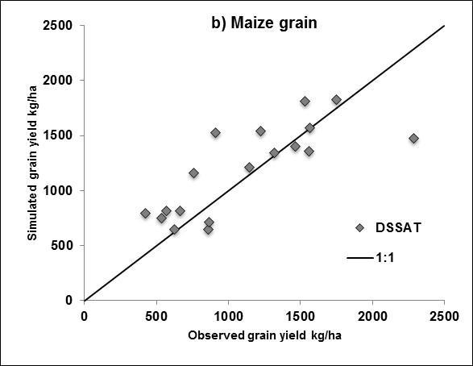
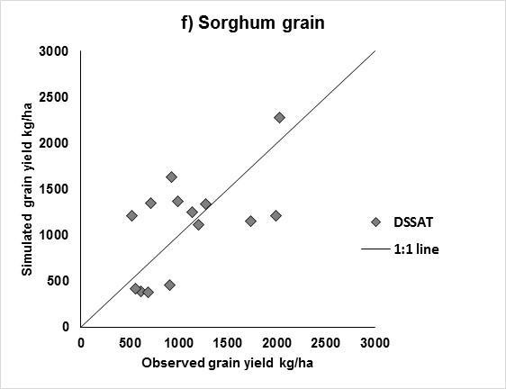
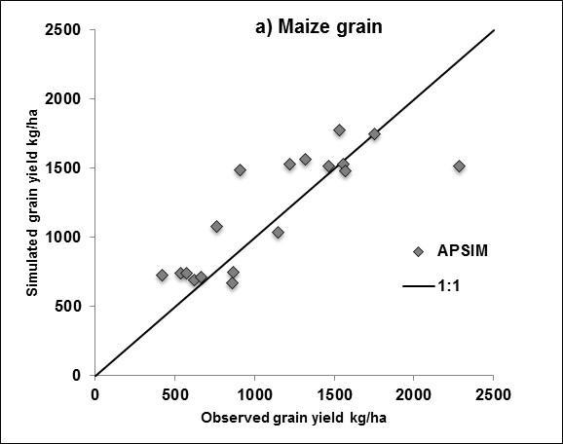
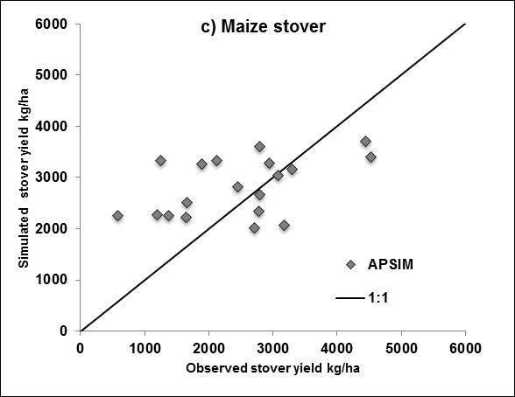
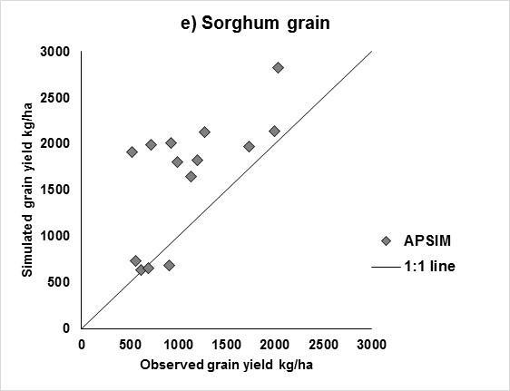

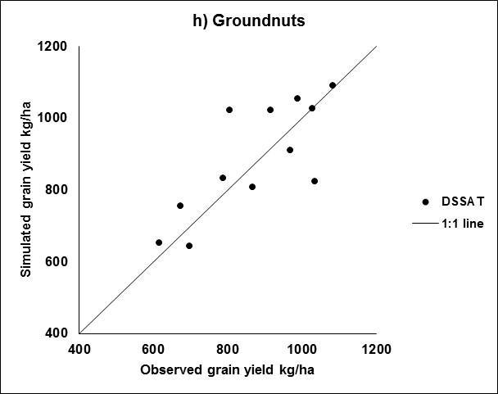
biomass
grain
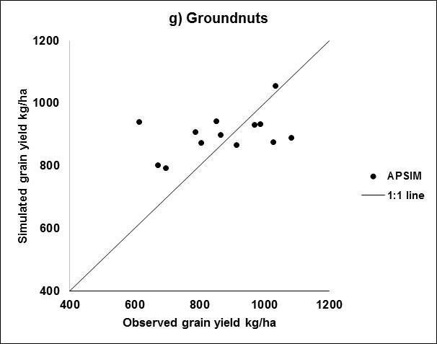

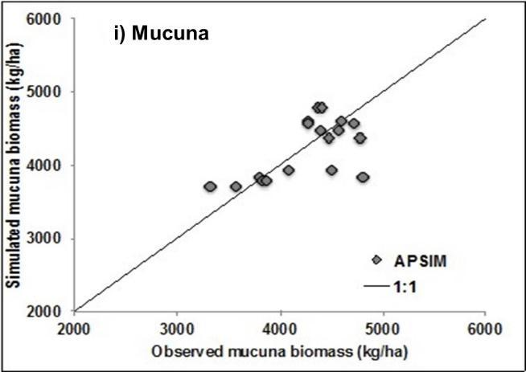
biomass
Fig 3. APSIM (left) and DSSAT (right) crop models calibration using on-farm experimental data for Nkayi District, for the current system and baseline climate.

Figure 4 shows fundamental crop model responses, to carbon dioxide, temperature, and rainfall changes, using groundnuts as example (Homann-Kee Tui et al., 2021). Sensitivity varied across the two crop models and soil types. Changing climate had a lower impact on yield losses in low organic carbon soils (OC < 0.7%) than in average or better soils (OC> 0.7%). Response to CO₂ was large for groundnut (20-55%). Although increased temperature would reduce groundnut yields, the increases caused by higher CO₂ can offset possible negative effects of increased temperatures in the future on that crop.

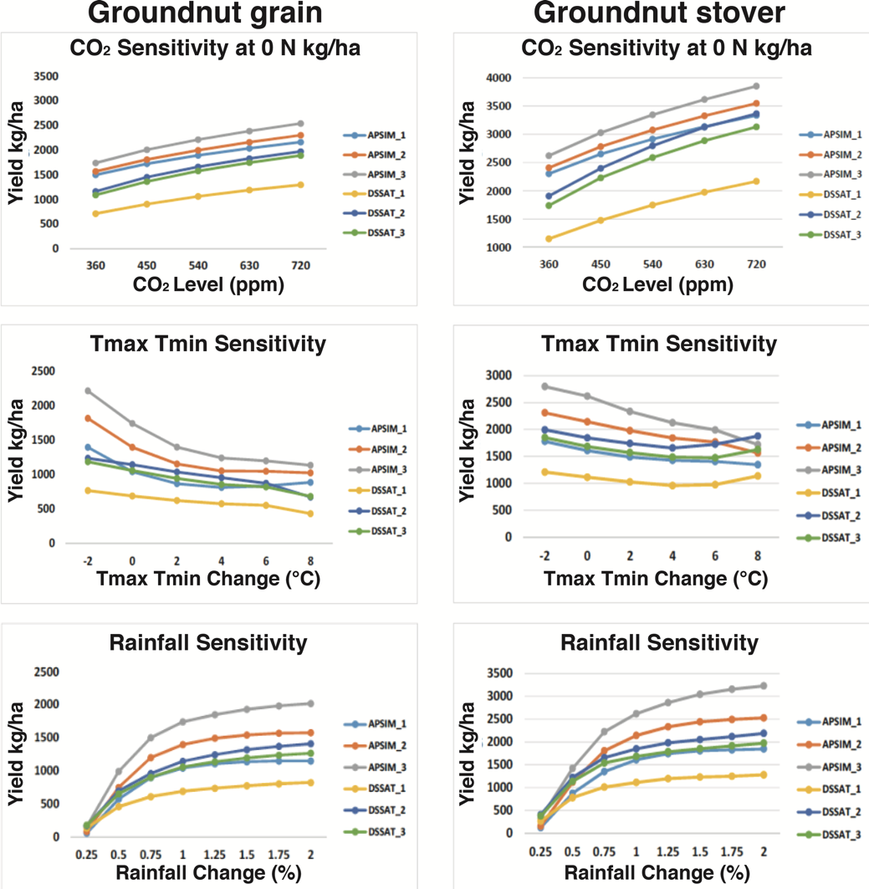

Fig 4. Sensitivity of groundnut grain and stover to carbon dioxide, temperature, and rainfall change on different soil types, Nkayi Zimbabwe.

- Livestock

Figure 5 compares the LIVSIM simulation outputs with the farmer-reported data and a sensitivity analysis was performed (Homann-Kee Tui et al., 2021). LIVSIM overestimated livestock production as compared to values reported by farmers, but captured the variability between households reasonably well. The overestimation is not surprising as the model does not simulate events like diseases, mortality and theft.
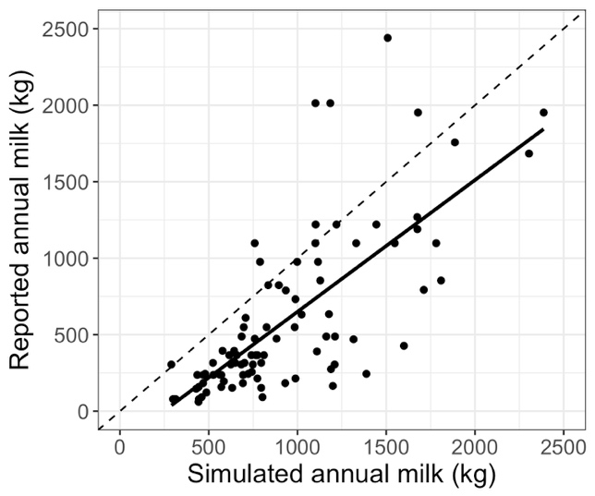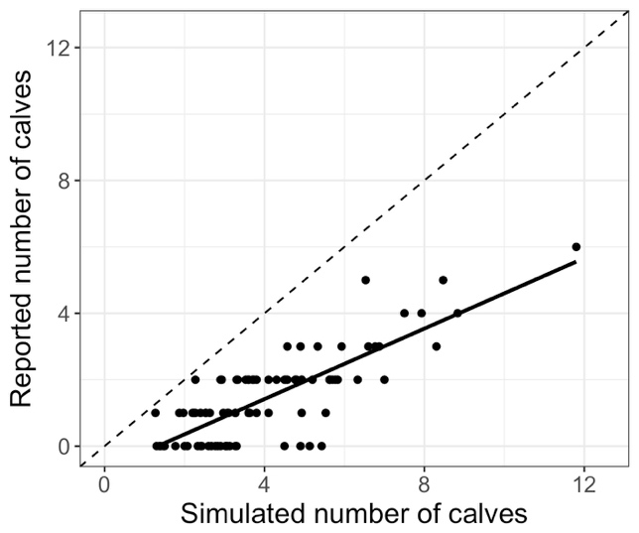
(b)
(a)
Figure 5. Scatterplots of reported versus LIVSIM simulated annual milk production (a) and number of calves born in the herd (b) for the current system and baseline climate. The dotted line is the 1:1 line and the full line is the regression line.

- Economics
The TOA-MD model was parameterized using household surveys conducted in 2011 with 160 farmers interviewed in 8 villages assessed farm and household size, off-farm income, revenues from crops and livestock, and the costs of production. In addition, 8 focus group discussions, one per each village surveyed, assessed agricultural output and input prices, perceived as normal prices during the observation year, not peak prices (Homann-KeeTui et al., 2013). For the calculation of net returns, monetary values of the crop (grain and residues) and livestock (sale, draft power, manure, milk) outputs were estimated with observed values or at opportunity cost, with internally used crop and livestock outputs factored in as costs under the respective activities, taking into account the local user practices. For the analysis presented here, the farm households were stratified into three groups according to livestock ownership (none; 0 – 8 cattle, or more than 8 cattle).

As Antle et al (2017) explain, the TOA-MD model simulates climate impacts by using a simple analogy to technology adoption. Farms cannot choose whether to have climate change or not, but if farms had such a choice, those that would choose to “adopt” climate change are those who would gain from it; farms that would prefer not to “adopt” climate change are those who would lose from it. An important implication of this model, when used to predict a technology adoption rate, is that the rate is typically between zero and 100 percent – it is rare for all farms to adopt a technology because in a heterogeneous population not all farms perceive it to be beneficial. The analogy to climate impact assessment is that there are typically both losers and gainers from climate change. The phenomenon of losers and gainers from climate change can be explained (at least in part) by the heterogeneity in the conditions in which the farms operate, such as soils, water resources, topography, climate, the farm household’s socio-economic characteristics, and the broader economic, institutional and policy setting.

Table 2 summarizes the parameters, trends and narratives for the Business As Usual Pathway (RAP BAU), Sustainability Pathway (RAP SDT) and the Rapid-Economic Growth pathway (RAP REG), which were developed with stakeholder collaboration to project the current systems into the future. Table 3 lists important farm characteristics, as generated for the different farm types present under the various RAPs, and Table 4 lists the exogenous productivity and producer price trends as derived from the IMPACT model (Homann-Kee Tui et al., 2021).
  - The Business as Usual Pathway (RAP BAU): RCP (8.5), SSP2 (medium challenges to mitigation and adaptation): Baseline for developing the more transformative RAPs: Continuous socio-economic challenges aggravate poverty, food and nutrition insecurity, vulnerability to price fluctuations and other shocks
  - Sustainability pathway (RAP SDT), RCP4.5 (mid-range GHG concentration), SSP1 (low challenges): Collaborative programs, enabling and incentivising policies promote the uptake of environmentally sound, well integrated productivity enhancing technologies and inclusive market and value chain development.
  - Rapid-Economic Growth pathway (RAP REG), RCP8.5 (top range of GHG concentration), SSP3 (high challenges): Commercial interests dominate, at strong trade-offs between economic growth and increasing inequality aggravating inefficient resource use especially for the poor, with harm to the environment.

Table 2. Narrative for key agricultural systems’ variables, according to three representative agricultural pathways (RAPs)
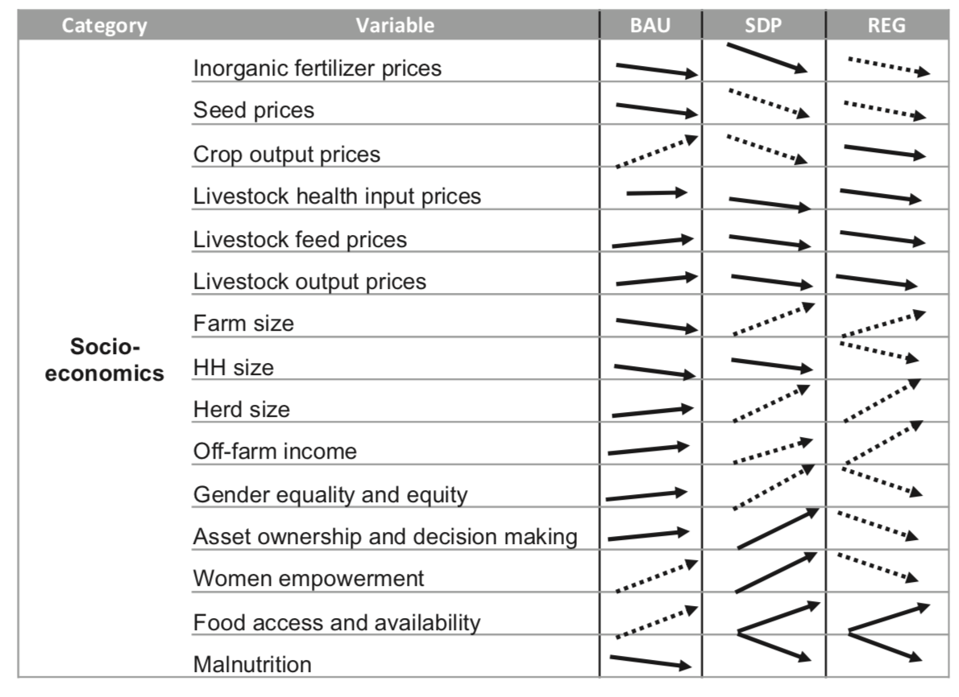

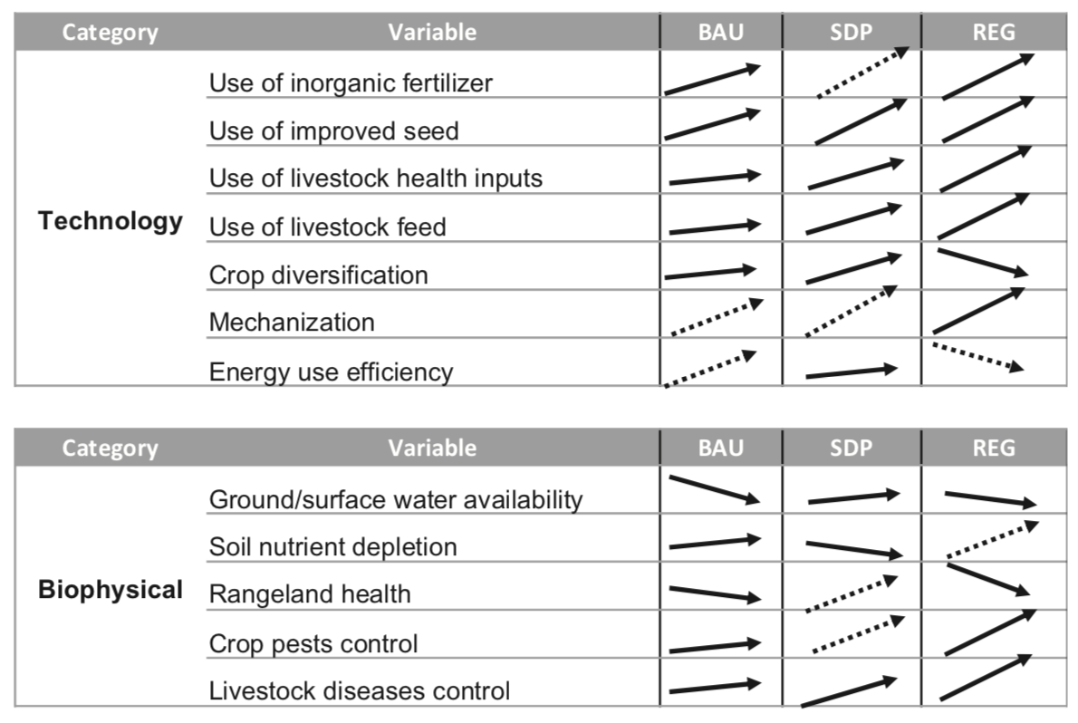

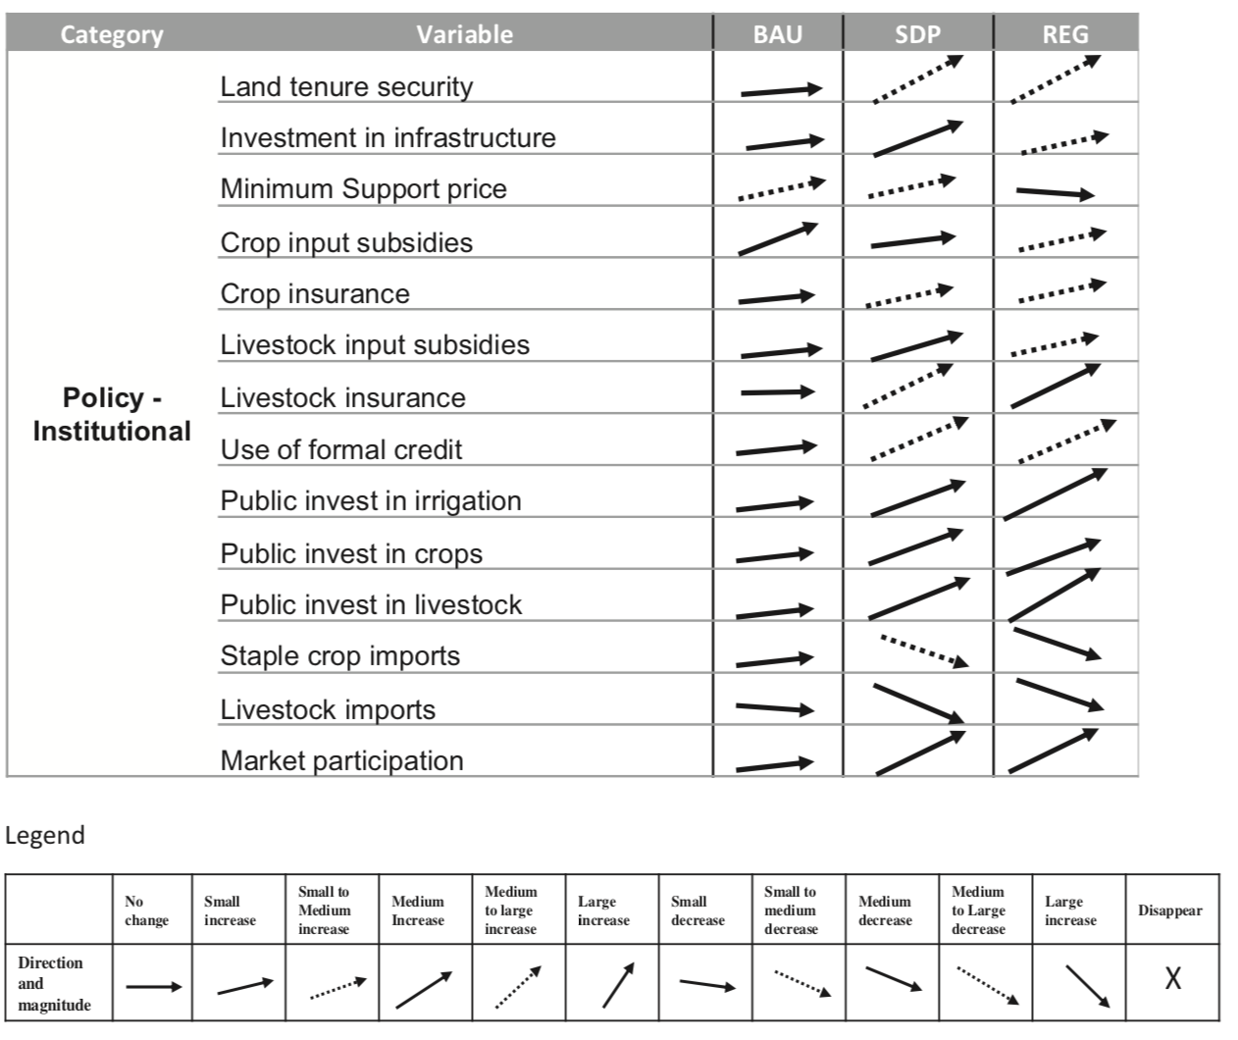

Table 3. Current agricultural systems and projected future changes, used to quantifity model parameters, current and mid-century under RAP Business As Usual, RAP Sustainable Development and RAP Rapid Economic Growth, for Nkayi district.

RAP REG
RAP SDT
RAP BAU

Notes: HH=Household; TLU=Tropical Livestock Unit; Cattle = 1.14 TLU; goats and sheep = 0.11 TLU.
*Everyone who had no cattle before would have at least five heads of cattle

Table 4. Exogenous productivity and producer price trends (1= no change), projected for agricultural outputs mid-century under RAP BAU, RAP SDT and RAP REG at national level, under high and low price assumptions, without and with climate change, used to quantifity model parameters (source: IMPACT).

 | Business As Usual (RAP BAU) |  |  |  |  | Sustainable Development (RAP SDT) |  |  |  |  | Rapid Economic Growth (RAP REG)
 | Produc-tivity | High price |  | Low price |  | Produc-tivity | High price |  | Low price |  | Produc-tivity | High price |  | Low price
 | Produc-tivity | No CC | With CC | No CC | With CC |  | No CC | With CC | No CC | With CC |  | No CC | With CC | No CC | With CC
Maize | 1.4 | 1 | 1.1 | 1 | 1.1 | 2.1 | 1.5 | 1.6 | 1 | 1.1 | 1.7 | 1.4 | 1.6 | 1 | 1.1
Sorghum | 1.35 | 1 | 1.1 | 1 | 1.1 | 2.4 | 1.4 | 1.6 | 1 | 1.2 | 2 | 1.5 | 1.8 | 1 | 1.2
Groundnut | 1.35 | 1 | 1.1 | 1 | 1.1 | 1.7 | 1.7 | 1.8 | 1 | 1.1 | 1.5 | 1.7 | 1.8 | 1 | 1.1
Beef | 1.3 | 1 | 1.15 | 1 | 1.15 | 2.1 | 1.4 | 1.4 | 1 | 1.1 | 1.7 | 1.2 | 1.2 | 1 | 1.1
Goat meat | 1.25 | 1 | 1.1 | 1 | 1.1 | 1.6 | 1.4 | 1.5 | 1 | 1.1 | 1.3 | 1.2 | 1.5 | 1 | 1.1
Milk | 1.1 | 1 | 1.05 | 1 | 1.1 | 1.2 | 1.2 | 1.2 | 1 | 1.1 | 1.1 | 1.2 | 1.1 | 1 | 1.1

Supplements 2. Results

Figure 6 and Figure 7 illustrate maize and groundnut crop yields responses as well as milk production under current climate, in terms of (a) their sensitivity to climate change and (b) impacts of improved management, DSSAT crop model.

Fig 6. Sensitivity to climate change of maize (left) and groundnut (right) in current farming systems on three soil types with varying quality, as simulated by DSSAT. Baseline yields in the current climate (CUR_Base) are compared with yields under climate change for RCP 4.5 and 8.5, each for a hot-dry (HD) and a hot-wet (HW) climate scenario, and with current-climate yields under improved management in Step 1 (only for maize) and Step 2.

Fig 7. Sensitivity to climate change of milk production in current systems of cattle-owning farm types (poor and non-poor only) as simulated by LIVSIM using DSSAT results as input. Baseline milk production in the current climate (CUR_Base) is compared with production under climate change for RCP 4.5 and 8.5, each for a hot-dry (HD) and a hot-wet (HW) climate scenario, and with current-climate milk production under improved management in Step 1 and Step 2.

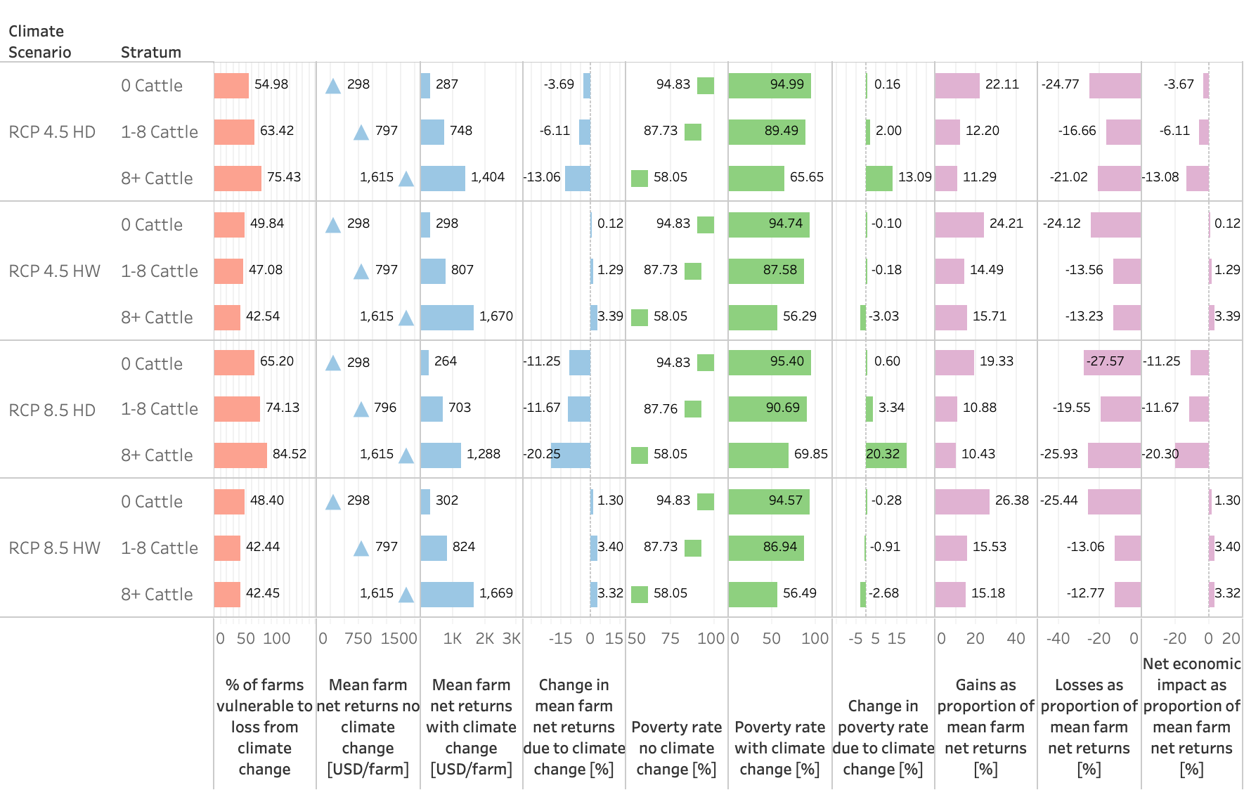

Fig 8. Sensitivity to climate change (CC), for climate scenarios (Hot/Dry, Hot/Wet), emission scenario (RCP 4.5, RCP 8.5) and farm types in Nkayi, Zimbabwe, using DSSAT results as input.

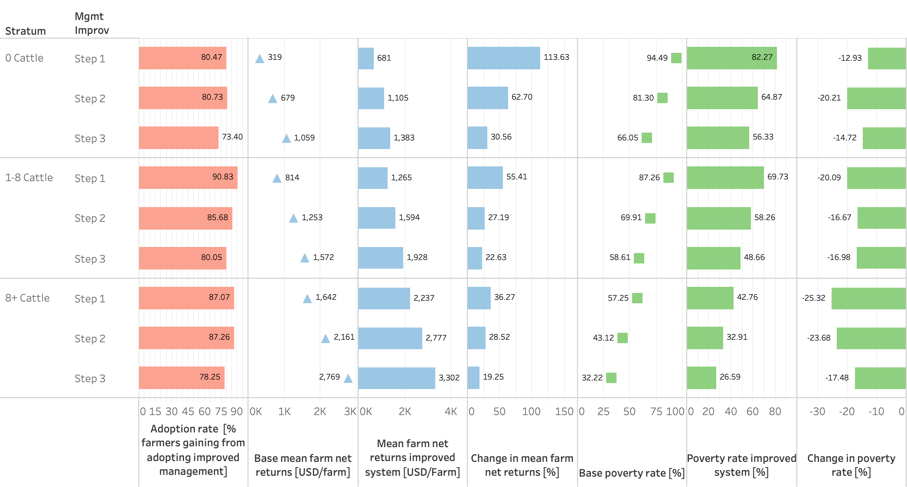

Fig 9. Adoption, farm net returns and poverty rates, by farm types and improvement steps, using DSSAT results as input.

Figure 10 and Figure 11 illustrate maize and groundnut crop yields responses as well as milk production under future climates, in terms of (a) impacts of climate change and (b) impacts of climate change adaptation.

Fig 10. Impacts of climate change and adaptation (AP) on maize (left) and groundnut (right) yields, on three soil types with varying quality (from poor, over medium to good), as simulated by two crop models (APSIM and DSSAT) for two contrasting RAPs (SDT: sustainable development, REG: Rapid Economic Growth). Yields in the current (1980-2020) climate (Base) are compared with yields under mid-century climate change for RCP 4.5 in SDT and 8.5 in REG, each for a hot-dry (HD) and a hot-wet (HW) climate scenario, and with the yields obtained with an adaptation package (AP).

Fig 11. Impacts of climate change and adaptation (AP) on milk production in cattle-owning farm types (extremely poor (with cattle only in the SDT RAP), poor and non-poor), as simulated by LIVSIM using DSSAT results as input for two contrasting RAPs (SDT: sustainable development, REG: Rapid Economic Growth). Milk production in the current climate (Base) is compared with milk production under climate change for RCP 4.5 in SDT and 8.5 in REG, each for a hot-dry (HD) and a hot-wet (HW) climate scenario, and with milk production obtained with an adaptation package (AP).

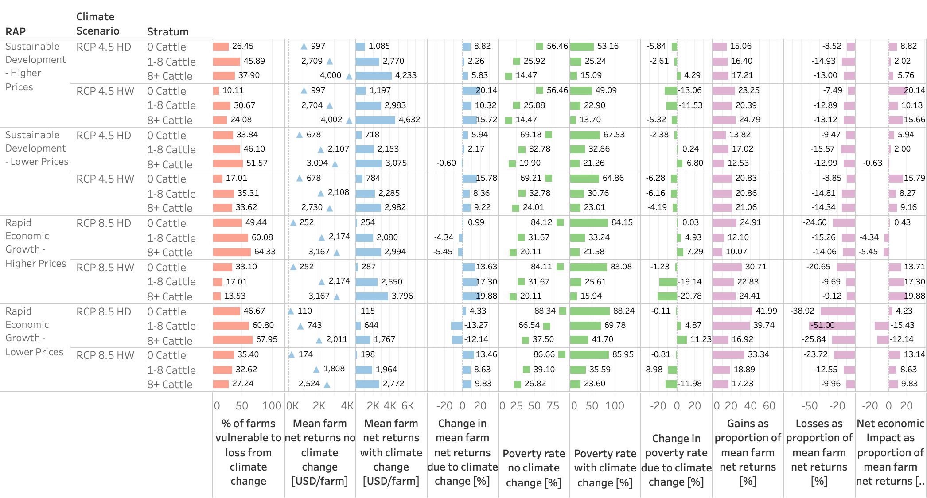

Fig 12. Economic impacts of climate change by pathways (RAP SDT, RAP REG), price levels (1=high prices, 2=low prices) and farm types, using DSSAT results as input.

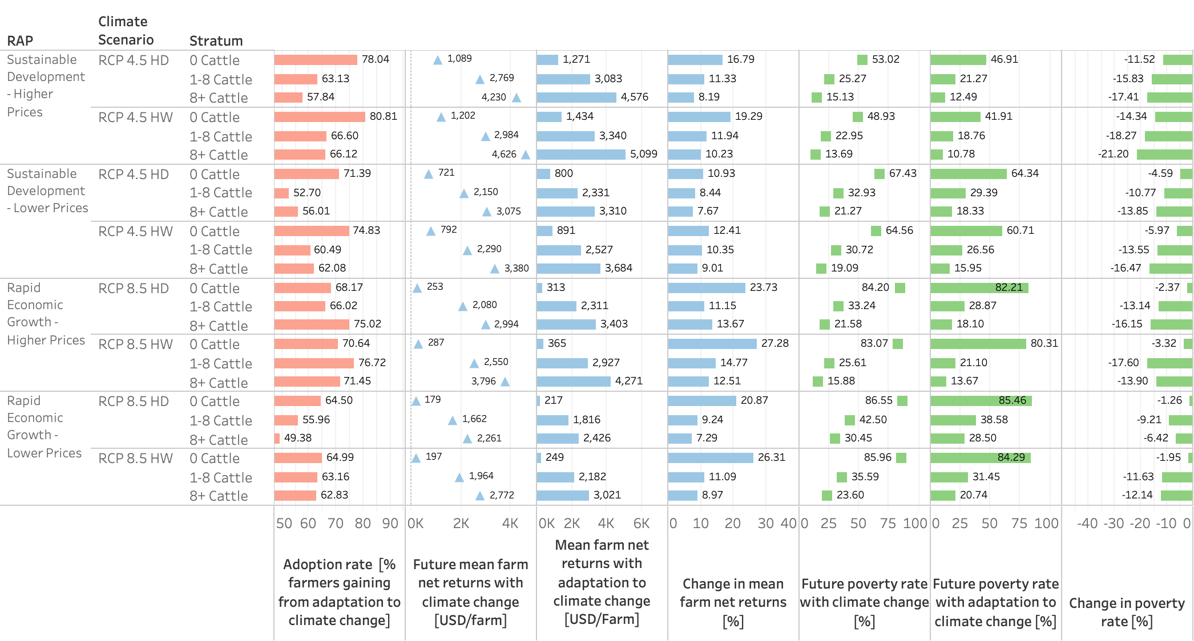

Fig 13. Economic impacts of climate change adaptation, by pathways (RAP SDT, RAP REG) and price levels (1=high prices, 2=low prices), climate scenarios and farm types, using DSSAT results as input.

