Ames Unitary Plan Wind Tunnel Continues Operations During Pandemic
-Jon VanHorn and Eric Paciano (NASA Ames).
The NASA Ames Unitary Plan Wind Tunnels successfully supported multiple test programs; accumulating almost 1500 User Occupancy Hours from July to December of 2020. This proved to be very challenging, due to the COVID-19 pandemic. However, special protocols were put in place to ensure the safety of both the operational crew and customers. The facility was able to successfully complete these programs without a single recorded case of sickness at the facility. One notable test program was the Sierra Nevada Dream Chaser, which tested both in the 11-ft Transonic and 9x7-ft Supersonic Test Sections.
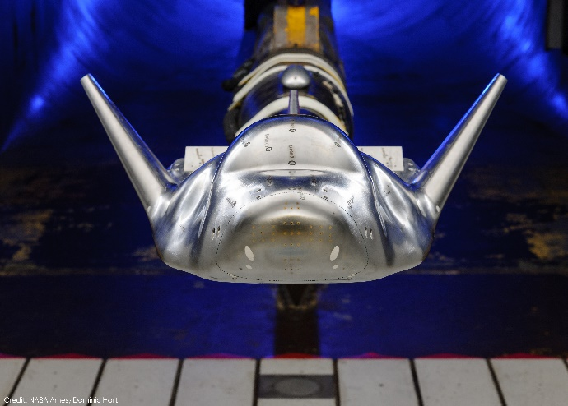
SNC Dream Chaser Model Tested in Ames 11-ft TWT in August 2020
In December of 2020, the Ames UPWT began a multi-month maintenance period. Many systems were upgraded during this time. One notable upgrade was the installation of the large optical windows in the 11-ft test section. These windows will allow for a greater, unobstructed view of the model while using optical test techniques (such as Shadowgraph).
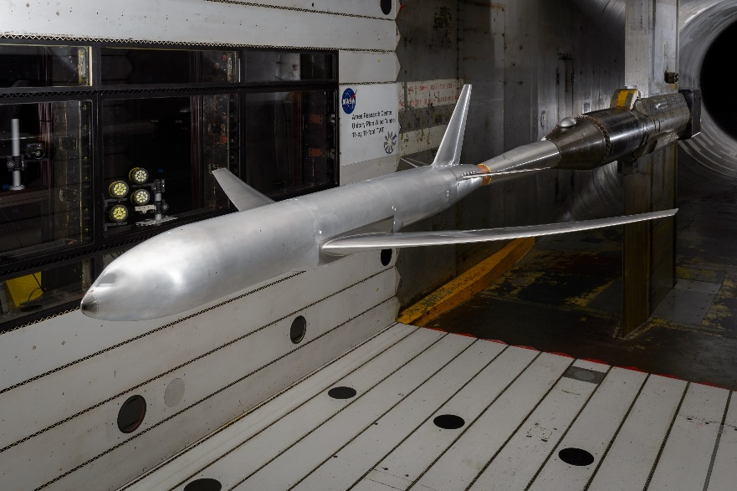
Ames Check Standard Model, as seen through the new large optical windows at the 11-ft TWT
An Integrated Systems Test was successfully completed in May 2021, ensuring the tunnel and all supporting subsystems performed safely and the facility was ready to resume customer operations. Immediately following the Integrated Systems Test, the Ames Check Standard Model was tested to document flow field changes that might impact the wall interference correction scheme.

