**NASA Space Launch System Completes Key Hot Fire Test and Begins Vehicle Integration**

John Honeycutt[1] and Joseph C. Cianciola[2]

*NASA Marshall Space Flight Center, Huntsville, Alabama, 35812, USA*

John Blevins[3]

*NASA Marshall Space Flight Center, Huntsville, Alabama, 35812, USA*

Johnny Heflin[4]

*NASA Marshall Space Flight Center, Huntsville, Alabama, 35812, USA*

Bruce Tiller[5]

*NASA Marshall Space Flight Center, Huntsville, Alabama, 35812, USA*

Dave Reynolds[6]

*NASA Marshall Space Flight Center, Huntsville, Alabama, 35812, USA*

**The Moon is again in reach. NASA and its commercial and international partners are on the way back. The team is working to land the first woman and the first person of color on the planetary body. NASA and its partners made significant progress towards that goal in the latter half of 2020 and the first half of 2021, including on the agency’s Space Launch System (SLS) rocket – a key part of the Artemis program. The SLS core stage for the Artemis I mission – the first launch of SLS and an uncrewed Orion capsule – completed the Green Run test series and was successfully mated with the SLS twin solid rocket boosters on the mobile launcher at Kennedy Space Center (KSC). All of the major systems for Artemis I are at KSC for assembly, integration, and launch, targeted for late 2021. Work also continued on SLS hardware for Artemis II, which will be the first flight of crew on Orion and SLS. Work progressed on core stage components, booster segments, and other hardware for Artemis III and future missions. This paper will detail the progress made.**

1. **Introduction**

NASA and its commercial and international partners are on the way to the first human landings on the Moon in more than 50 years, which will land the first woman and first person of color as part of the Artemis program.

NASA and its teams are developing the rocket, spacecraft, in-space habitat, life support, and lander technologies required. The first three flights of SLS will lead to the first human landing since Apollo. Those missions will be followed by missions that will build a sustainable presence on and around the Moon. Technologies developed and experience gained from long-term lunar inhabitance will help build the foundation for crewed missions to Mars – the agency’s ultimate goal.

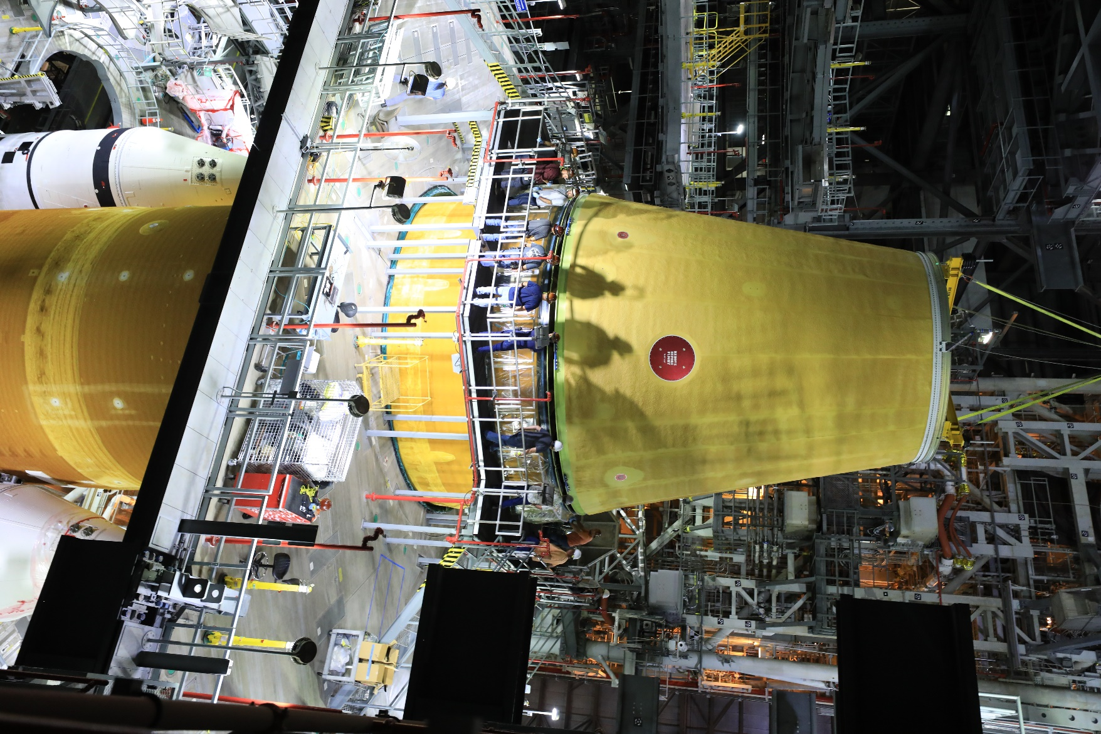

**Fig. 1 The core stage for the Artemis I Space Launch System rocket mated with the solid rocket boosters, and launch vehicle stage adapter on the mobile launcher at NASA’s Kennedy Space Center.**

At the time of this writing, the Artemis I SLS rocket is stacked with the core stage mated between the solid rocket boosters and the launch vehicle stage adapter (LVSA, built by prime contractor Teledyne Brown) stacked on top of the core stage (Fig. 1). The other major components of the rocket and capsule are all at KSC awaiting stacking and integration. Artemis I will be the first flight of SLS, carrying an uncrewed Orion spacecraft (built by prime contractor Lockheed Martin) beyond the Moon (Fig. 2). Launch is targeted near the end of 2021, assuming no major issues are encountered at KSC during integration of the vehicle for the first time. The prime contractor for rocket assembly, Jacobs Engineering Inc., is leading the integration efforts. Hardware and components for the Artemis II, III, IV, and future missions are in various stages of manufacture, assembly, and testing at the Michoud Assembly Facility in New Orleans, Marshall Space Flight Center (MSFC) in Alabama, Stennis Space Center (SSC) in Mississippi, and at numerous industry partner locations around the United States.

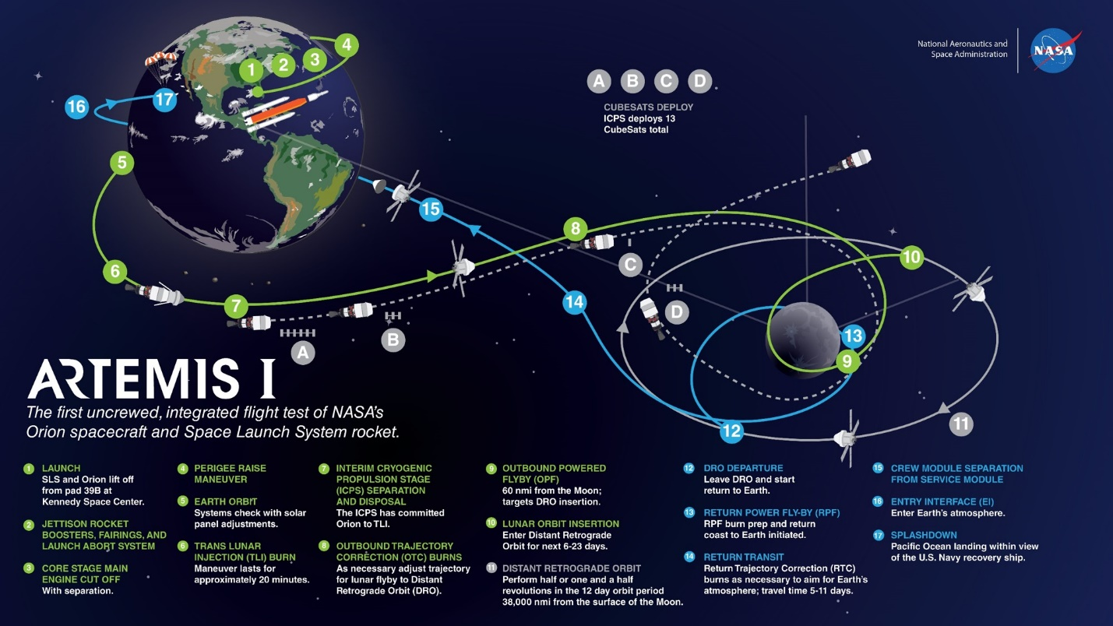  
**Fig. 2 The Artemis I test flight will last several weeks and give NASA the opportunity to thoroughly test all systems in deep space prior to commencing crewed lunar missions.**

1. **SLS Design and Architecture**

NASA’s crewed exploration will rely on SLS for decades to come. The rocket uses technologies developed for the Space Shuttle Program, which have been upgraded for more demanding deep space missions. The first block of SLS and its future evolutions will maximize payload mass and volume to the Moon while providing the highest chance for mission success as well as reliable, safe transportation for crew.

The RS-25 liquid-propellant engines that served as the space shuttle main engines (SSMEs, built by prime contractor Aerojet Rocketdyne) and shuttle’s twin solid rocket boosters (SRBs, built by prime contractor Northrop Grumman) are at the heart of SLS. Both systems have been upgraded in performance and adapted to the new SLS environments and for the new deep space missions. The newly designed core stage (designed and fabricated by Boeing) houses four RS-25s and their liquid hydrogen (LH2) and liquid oxygen (LOX) tanks and is the backbone for the rocket. The core stage will hold 537,000 gallons of LH2 and 196,000 gallons of LOX. The stage also houses the avionics for the rocket and has the attach points for the SRBs. This will be the basic architecture used for all six variants of SLS (Fig. 3).

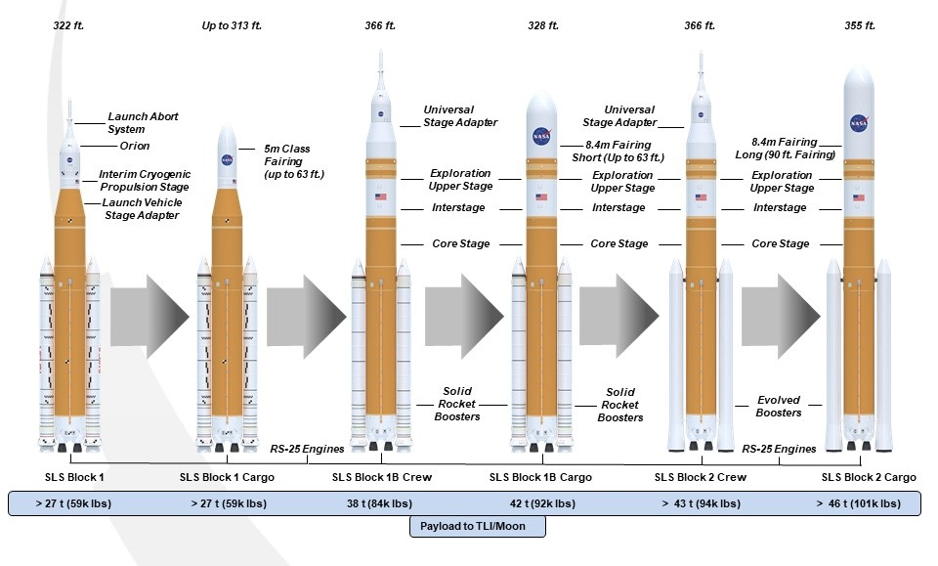

**Fig. 3 Primary components and performance of the planned SLS variants.**

The SLS Block 1 in crew configuration stands 322.4 feet tall and weighs 5.75 million pounds fueled. Maximum thrust is 8.8 million pounds; approximately 7.2 million pounds of that coming from the SRBs and the remaining 1.6 million pounds from the RS-25s. Each RS-25 produces approximately 416,000 pounds of thrust at launch and more than 512,000 pounds in a vacuum and operate for the entire roughly 480-second core stage operation. The Block 1 payload to trans-lunar injection (TLI) is more than 59,535 pounds. The ICPS provides the upper stage propulsion for Block 1 and is powered by a single Aerojet Rocketdyne RL10 LH2/LOX engine with 24,750 pounds thrust. The ICPS is based on the existing United Launch Alliance (ULA) Delta IV Cryogenic Second Stage. Block 1 can launch either the Orion crew vehicle or provide more than 8,000 cubic feet of volume for payloads in a 5 m-class payload fairing. The Artemis I crew configuration is shown below (Fig. 4).

Following Block 1, SLS will evolve to the Block 1B variant – taller, slightly heavier, and more powerful. Block 1B is 366 feet tall and weighs six million pounds fueled. The Exploration Upper Stage (EUS), with its four RL10s, is being designed by The Boeing Company and replaces the single-engine ICPS. It will produce 97,360 pounds thrust, accounting for most of the Block 1B TLI payload increase. Replacement of heritage RS-25s performing at 109 percent thrust with new-production engines operating at 111 percent rated power level (RPL) also contributes slightly more thrust while lowering engine cost by approximately 30 percent. Block 1B will be able to send more than 83,766 pounds in the crewed Orion configuration and more than 92,594 pounds in the cargo configuration into TLI. The payload fairing is 8.4 m in diameter and available in varying lengths. A 62.7-foot (19.1 m) shroud will provide an available payload volume of 21,930 cubic feet. A 10 m-diameter fairing is also under consideration.

The final Block 2 variant stands 366 feet tall and weighs 7.4 million pounds fueled. Due primarily to the replacement of current SRBs with evolved SRBs, maximum thrust is 9.5 million pounds. The boosters will have increased thrust from 3.6 million pounds each to 3.9 million pounds each. The EUS remains the upper stage. The crew configuration TLI payload increases to more than 94,799 pounds, and the cargo configuration increases to more than 101,413 pounds. The 8.4 m diameter payload fairing is available for the Block 2 vehicle, with the 10 m fairing concept being studied.

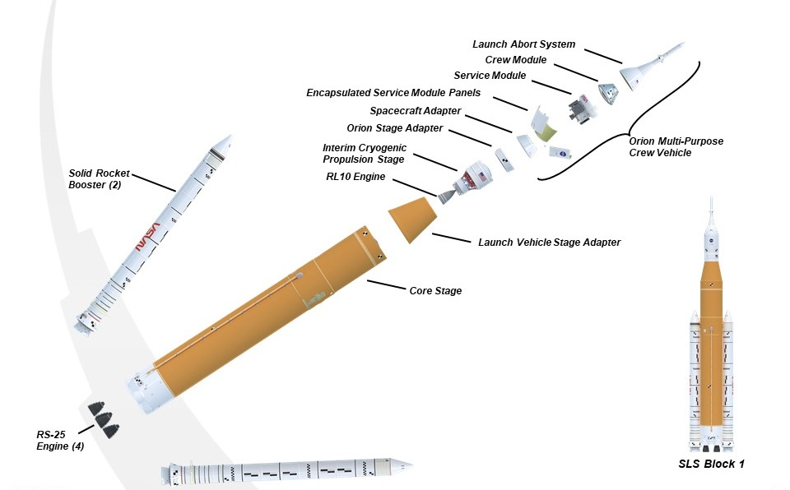

**Fig. 4 Expanded view of the Artemis I Block 1 vehicle.**

1. **SLS Progress**

The NASA-industry team reached many important milestones over the past year in preparation for the launch of the Artemis I mission and the assembly and development of hardware for the next missions and versions of the SLS rocket. This section will detail the progress made.

1. **Artemis I**

The SRBs for Artemis I were stacked on the mobile launcher – a process that began on in November 2020. Prior to stacking the flight hardware, teams at KSC completed rehearsal handling and stacking of pathfinder SRB motor segments at various KSC facilities and onto the mobile launcher. On November 24, stacking of the flight boosters began at the Vehicle Assembly Building (VAB) at KSC. The four-month process was completed on March 9, 2021. Teams then prepared the boosters to be joined with the core stage, which was integrated into the stack in June.

The LVSA was mated to the stack on June 21. The ICPS was transported to the VAB and will be added to the stack this summer. The Orion Stage Adapter (OSA) structural test article (STA), along with a mass simulator for the Orion spacecraft, is scheduled to be added to the flight hardware on the mobile launcher for modal testing (Fig. 5). Following the testing, the OSA STA and Orion mass simulator will be de-stacked and the flight OSA with secondary payloads installed and the Orion spacecraft will be stacked and integrated.

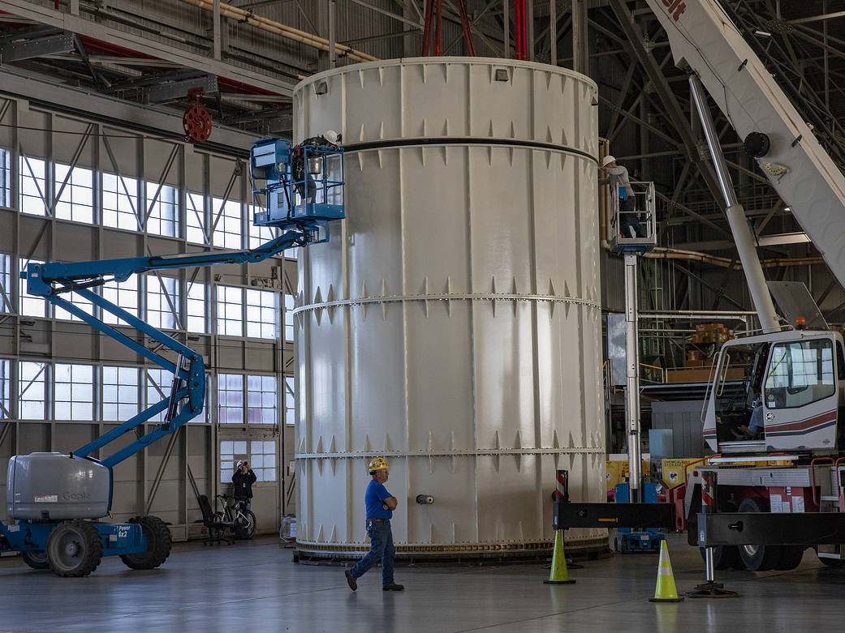

**Fig. 5 The Orion mass simulator will be used for modal testing on SLS prior to the Artemis I launch.**

The Artemis I OSA, which serves as the interface between the ICPS and Orion capsule and service module, is in the Space Station Processing Facility (SSPF) at KSC. It will be moved to the VAB for integration later this year along with the CubeSat secondary payloads, which will be integrated into the adapter for launch.

Artemis I has 13 6U CubeSats manifested, with universities providing several of the payloads. These university labs, as well as some NASA projects providing Artemis I CubeSat payloads, were adversely affected by the COVID-19 pandemic. In order to give the payload developers additional time to ready their CubeSats, NASA’s Exploration Systems Development (ESD) decided to use the OSA STA temporarily in the stack for certain vehicle tests while the small satellites are simultaneously being installed in the flight OSA in a parallel processing flow. Payloads are currently either at KSC in preparation for installation into commercial off-the-shelf (COTS) dispensers and battery charging or en route. NASA’s Near-Earth Asteroid Scout (NEA Scout) CubeSat can be seen in Fig. 6 as it is integrated into its commercial off-the-shelf dispenser for the Artemis I launch.

**Fig. 6 NASA’s Near-Earth Asteroid Scout (NEA Scout) CubeSat is integrated into its commercial off-the-shelf dispenser for the Artemis I launch.**

Engineers at MSFC are performing final checks and tests to certify the software for Artemis I.

While teams are preparing the vehicle for flight, other teams are conducting countdown and mission simulations. These simulations include teams at KSC, the SLS Engineering Support Center (SESC) at MSFC, and the Flight Operations Directorate at Johnson Space Center (JSC) and help teams practice pre-launch and launch activities. They enable the teams to define and refine the communication pathways, as the SESC will be monitoring data and camera views of the rocket to support the KSC Launch Control Center (LCC). The SESC also supported the Green Run test series, collecting and storing data for analysis.

The four RS-25 engines for the Artemis I flight were installed on the core stage in 2019. They were tested as an integrated unit with the core stage during the Green Run test series in 2020 and 2021. The eight-part Green Run test series of the Artemis I core stage began in February 2020, and on January 28, 2021 the first hot-fire test of all four engines and the core stage was conducted. Despite shutting down earlier than planned, the test resulted in useful data for engineers. On March 18, a full-duration hot-fire test was successfully conducted at SSC, and the Green Run test series was complete (Fig. 7).

The hot-fire test was the final, culminating test of the program, which included a number of tests and first-time events to ensure smooth integration and operation of the core stage. Those tests were:

* Test 1: Apply forces simulating launch to the unpowered, suspended core stage to verify vehicle models needed for the operation of the rocket’s guidance, navigation, and control systems
* Test 2: Turn on and check out the avionics on the core stage to ensure the computers and software boot up as expected
* Test 3: Simulate potential issues to test systems that shut down other systems if there’s a problem to verify that the vehicle will detect and protect itself and systems in the event of a failure or anomaly
* Test 4: Test main propulsion components that connect to the engines to ensure the commands are performed as expected and the valves and other hardware respond as expected
* Test 5: Test thrust vector controls and check out all of the related hydraulic systems, verifying that the RS-25 engines can steer the rocket
* Test 6: Simulate launch countdown to validate timeline and sequence of events
* Test 7: Load and drain more the more than 700,000 gallons of LH2 and LOX from the stage
* Test 8: Fire all four RS-25s for up to eight minutes

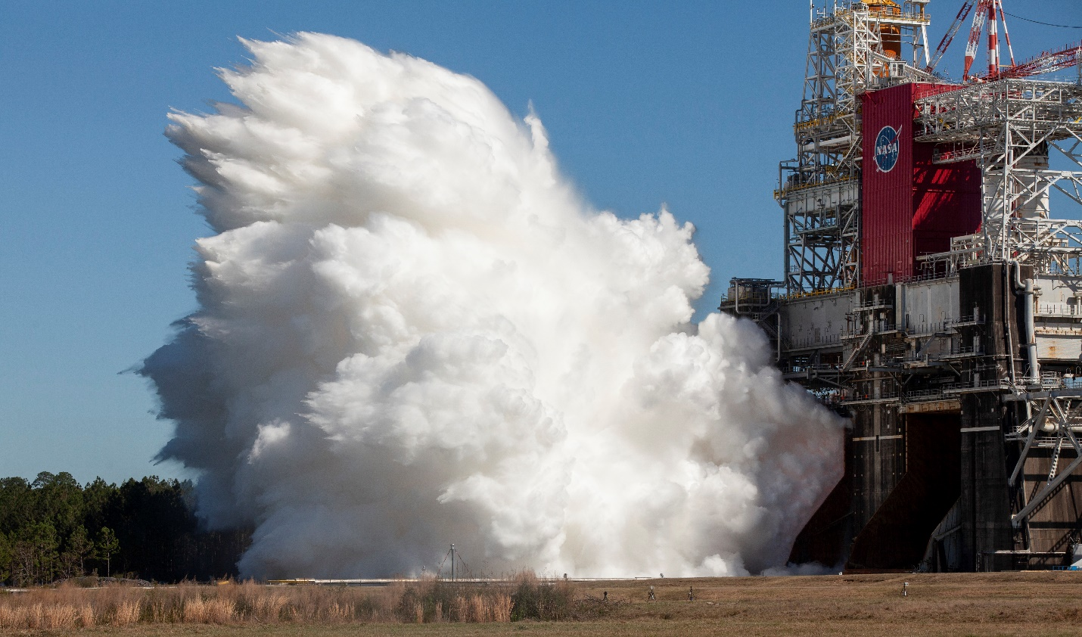 **Fig. 7 The SLS core stage undergoes a successful hot fire test as part of the Green Run test series at SSC.**

Following the successful hot fire test, the stage was removed from the B-2 test stand, loaded on the Pegasus barge, and transported to KSC. It arrived at KSC on April 27 and was unloaded and transported to the VAB on April 29 where NASA’s Exploration Ground Systems (EGS) and integration lead contractor Jacobs took the lead. The core stage then underwent refurbishment in the VAB’s transfer aisle before being mated.

1. **Artemis II**

Artemis II will be the first flight of SLS and Orion with crew onboard. The mission will test Orion’s systems as the astronauts voyage to the vicinity of the Moon. Hardware production for the rocket is well underway at Northrop Grumman, MAF, MSFC, and ULA.

The motor segments for the Artemis II mission are completed and are in storage at Northrop Grumman’s facility in Utah. The booster forward skirts are being outfitted with instrumentation and the thermal protection system. Assembly of the aft skirts, thrust vector control systems, and booster separation motors is underway.

At Michoud, the major components for the core stage have been manufactured. On May 18, the LOX tank and intertank were joined, completing the first part of the forward join (Fig. 8). The forward skirt was added May 24, forming the forward join. Teams have started installing the thermal protection system on the LH2 tank, as part of its preparation. The engine section is undergoing wiring harness installation along with high-pressure helium tests. The RS-25 engines for Artemis II are complete and are awaiting shipment to MAF.

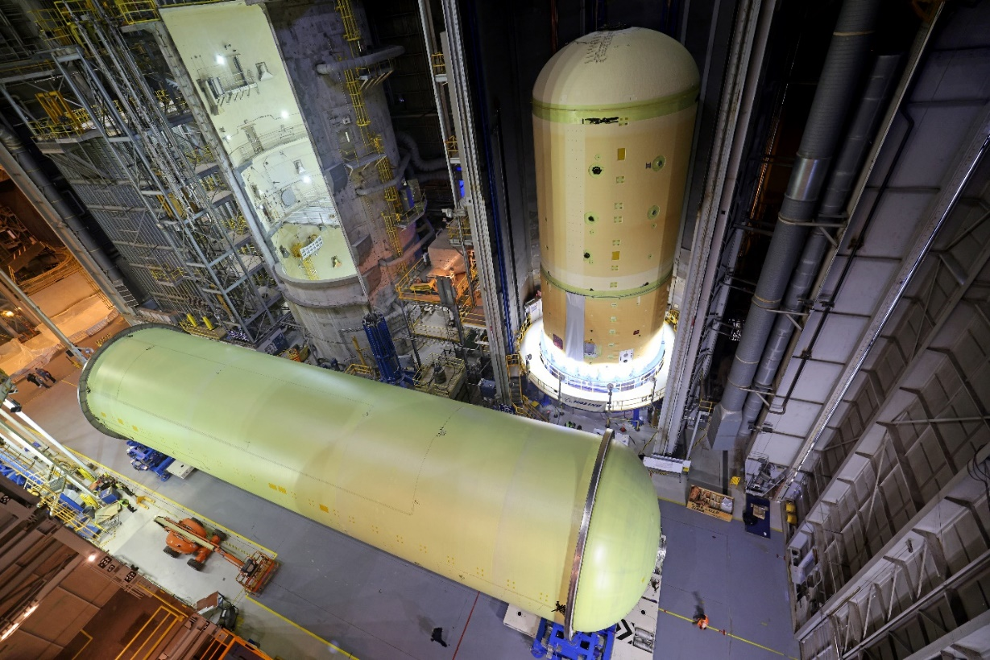 **Fig. 8 The forward join of the core stage for Artemis II is underway, rear, while the LH2 tank for core stage 2 is shown in the foreground.**

The OSA and LVSA are manufactured at MSFC. The circumferential weld that joins the upper and lower cones of the LVSA is complete at MSFC’s Advanced Weld Facility, and the frangible joint that enables stage separation will be installed later this summer (Fig. 9). Welding is complete on the OSA, and non-destructive evaluation is underway on the diaphragm that protects the crew module from gases generated during launch.

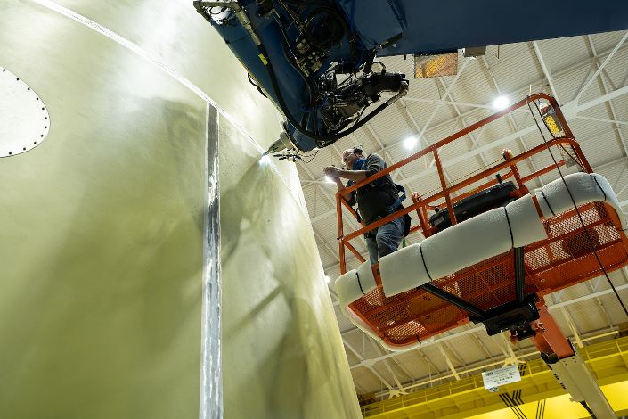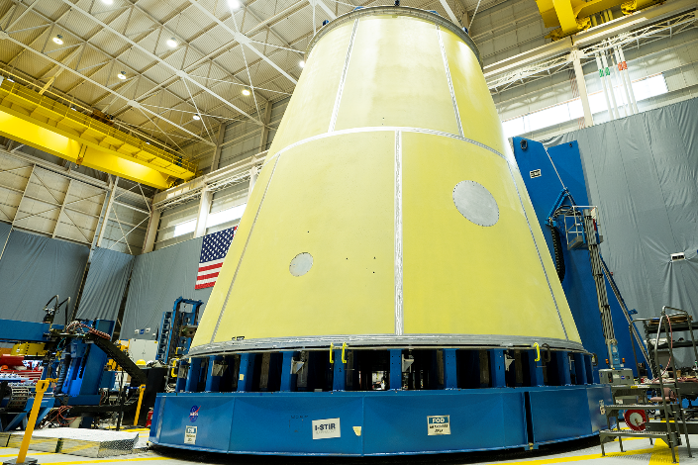  
**Fig. 9 Technicians welding the LVSA for Artemis II, left, and the completed weldment, right.**

The major subassemblies for the ICPS, including the LH2 and LOX tanks, are nearing completion. The stage is expected to be completed this summer. The RL10 engine for the stage is in processing.

1. **Artemis III and Beyond**

Components for Artemis III and future Artemis missions are also in manufacturing and assembling. Artemis III will be the first crewed lunar landing since Apollo 17 in 1972.

For Artemis III, the intertank is in process at MAF. The LOX tank is in early manufacturing, and the LH2 tank is structurally complete and is being analyzed for any defects. The engine section is also being assembled. The RS-25s are in processing. Vertical welding for the LVSA is completed, and non-destructive evaluation is underway. Vertical welding on the OSA is also complete, and non-destructive evaluation was performed on the welds. All 10 motor segments have been cast at Northrop Grumman. Refurbishment of heritage hardware for the forward assemblies and the aft assemblies is underway. Production is slated to begin later this year on the ICPS; its RL10 engine is complete.

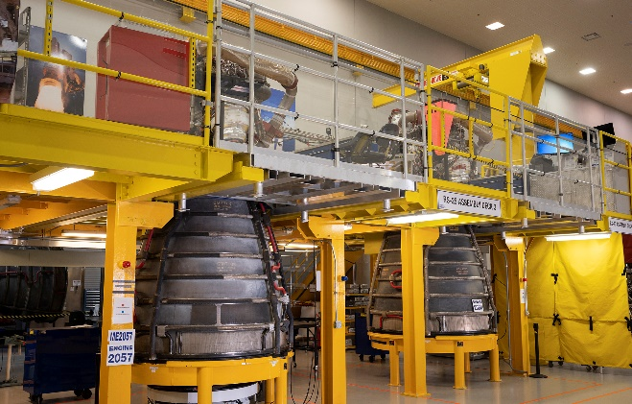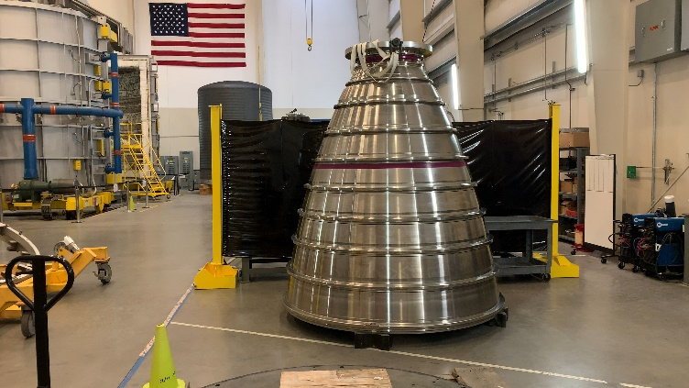  
**Fig. 10 Two RS-25 engines for the Artemis III mission undergo inspection at SSC, left, and an RS-25 nozzle from the new production line for Artemis V and beyond, right.**

Artemis IV will also use heritage SRB hardware from the shuttle program, and those motor cases are being refurbished now. The SLS Program will run out of shuttle-heritage booster cases after the eighth flight of SLS. For the ninth flight, upgraded motor cases, nozzle hardware, propellant, forward and aft structures, nose cap and frustum structures, avionics, and electronic thrust vector control systems for the evolved boosters will be introduced. These evolved boosters will define the Block 2 SLS variant.

Construction of Artemis IV core stage components has started at Michoud, and the first welds of the EUS confidence panels at Michoud have been completed. The RL10 engines for the EUS are complete. Welding of an EUS structural test article (STA) is scheduled to begin late in 2021. Design work on the new payload adapter (PLA) is progressing, and manufacturing demonstration panels for the universal stage adapter (USA) for Block 1B have been produced.

Construction of the first new RS-25 engines, to be flown on the Artemis V and future missions, is underway. Exhaust nozzles and their regenerative cooling tubes are currently being stacked and brazed by prime contractor Aerojet Rocketdyne. Powerheads, main combustion chambers and turbomachinery are also in various phases of manufacturing (Fig. 10).

1. **Test Programs**

In addition to building and preparing flight hardware, NASA and its partners conducted and concluded multiple tests of various systems.

Multiple hot fire tests both in Utah and at MSFC to support SRB upgrades and evolutions have been conducted over the past several years. Some of these tests evaluated new propellant ingredients from new vendors to help maintain and build the supplier base, reduce cost, and improve performance of the boosters. Other tests provided data to help qualify the current SLS SRBs. Additionally, new solvents and other materials for preparation of the boosters and for use in the boosters are also under evaluation in this test program. Additionally, the Booster Obsolescence and Life Extension (BOLE) contract modification will be developing test programs that will supply, the critical data needed in building and using new booster segments when the supply of Space Shuttle Program segments has been depleted.

In January 2021, NASA and Aerojet Rocketdyne kicked off the latest series of RS-25 single engine tests in support of SLS. The test program will have seven hot-fire tests in the A-1 test stand at SSC that will help engineers evaluate new engine components while reducing risk during engine operation. The test engine will be tested in a variety of conditions to verify its capabilities. Data from the test series will be used to enhance production of the engines and engine components using cutting-edge and cost saving technologies such as additive manufacturing.

The structural test articles that NASA and partners used to verify the designs and models of the core stage’s LH2 tank, LOX tank, intertank, and engine section have completed their test program. The final test was the LOX tank test to failure, which occurred in summer 2020 (Fig. 11).

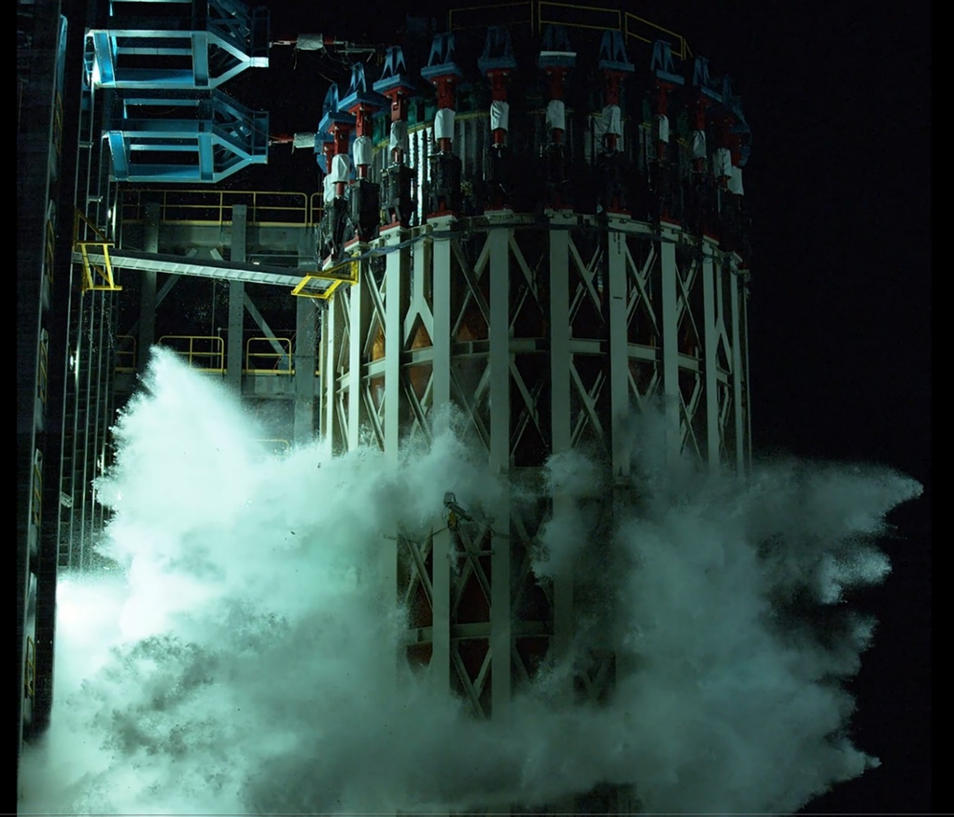 **Fig. 11 The SLS core stage LOX tank is tested to failure at MSFC.**

1. **Summary and Conclusions**

Significant progress on the SLS rocket for Artemis I and future Artemis mission was made by NASA and its industry partners during the second half of 2020 and the first half of 2021. At KSC, the Artemis I boosters, core stage, and LVSA are stacked for testing before launch. Completion of the Green Run test series and transportation of the core stage to KSC prior to that were critical steps to ensuring a successful first flight of SLS and returning humans to the Moon on future missions. Green Run testing certified the SLS core stage for all future missions. Successful stacking of Artemis I SRBs on the ML at KSC laid the foundation for the next step, integrating the core stage. Later this summer, the ICPS will be stacked, the rocket will be powered on, the umbilicals attached, and testing will continue. Following testing and completion of the flight stack, the vehicle with the Orion spacecraft will roll out to launch complex 39B for wet dress rehearsal. The final major test prior to launch, wet dress rehearsal, will test teams, systems, and countdown procedures, including tanking and de-tanking propellant. After wet dress rehearsal, the vehicle will roll back to the VAB one final time prior to launch. There, teams from EGS and Jacobs will perform final checks and closeouts to prepare for launch. Once all these steps are complete, the team will look for launch opportunities for Artemis I.

Artemis II, III, IV, and V hardware and components continue to be manufactured and processed, ensuring the launch vehicles for the next missions are ready and that the contractor base is strong and capable of delivering for the nation’s Moon program.

The SLS rocket, including its advanced iterations, will anchor NASA’s human and robotic exploration programs for decades to come. The unparalleled capability of the rocket will continue to be a national resource as NASA and its partners break the chains of Earth and explore space like never before.

1. Manager, Space Launch System Program.
2. Deputy Manager, Space Launch System Program.
3. Chief Engineer, Space Launch System Program, AIAA Associate Fellow, #101797.
4. Liquid Engines Manager, Space Launch System Program.
5. Boosters Manager, Space Launch System Program.
6. Deputy Boosters Manager, Space Launch System Program.