Energy Efficient Large-Scale Storage of Liquid Hydrogen

J E Fesmire¹ A M Swanger¹ J A Jacobson² and W U Notardonato³
¹NASA Kennedy Space Center, Cryogenics Test Laboratory, Kennedy Space Center, FL 32899 USA
²CB&I Storage Solutions, 14105 S. Route 59, Plainfield, IL 60544 USA
³Eta Space, 485 Gus Hipp Blvd, Rockledge, FL 32955 USA

Email: james.e.fesmire@nasa.gov
Abstract. The world’s largest liquid hydrogen storage tanks were constructed in the mid-1960s at the NASA Kennedy Space Center. These two vacuum-jacketed, perlite powder insulated tanks, still in service today, have 3,200 m³ of useable capacity. In 2018, construction began on an additional storage tank at Launch Complex 39B. This new tank will give an additional storage capacity of 4,700 m³ for a total on-site storage capacity of roughly 8,000 m³. NASA’s new Space Launch System (SLS) heavy lift rocket for the Artemis program includes an LH₂ tank that makes up the bulk of the vehicle, holding 2,033 m³ of LH₂ in its 8.4-m diameter by 40-m height. The new storage tank includes two new energy-efficient technologies: a glass bubbles insulation system in lieu of perlite, and an Integrated Refrigeration and Storage (IRAS) heat exchanger for controlled storage capability. The evacuated glass bubbles insulation system is based on the prior two decades of research to prove the thermal performance benefits as well as the mechanical and vacuum integrity; and has been shown to reduce LH₂ boiloff by 46% versus perlite in field demonstrations. The IRAS capability is centered on a heat exchanger system that is built within the inner vessel to reject heat from the bulk liquid through the future implementation of an external helium refrigerator. Controlled storage via IRAS, when fully implemented, will provide full control of the ullage pressure, zero boiloff, and even production of densified LH₂ pending its adoption on future launch vehicles. The design basics are described along with main construction and testing processes involved. The key features of the new technology items and implications on simplified operations and long-term energy savings are addressed.
1. Introduction
From the head start provided by the Atomic Energy Commission in the 1950s, NASA went from a two m³ LH₂ storage tank to a pair of 3,200 m³ tanks by 1965. These two tanks, built by Chicago Bridge & Iron under the Catalytic Construction Co. contract, are still the world’s largest LH₂ storage tanks and are still in service today [1]. NASA’s new Space Launch System (SLS) heavy lift rocket for the Artemis program includes an LH₂ flight tank holding 2,033 m³ of LH₂ in its 8.4-m diameter by 40-m height. To support this capability, an additional LH₂ storage tank is needed. In 2018, construction began on an additional storage tank at Launch Complex 39B. This new tank will give an additional storage capacity of 4,732 m³ for a total on-site storage capacity of roughly 8,000 m³.
The new storage tank incorporates two new energy-efficient technologies to provide large-scale liquid hydrogen storage and control capability by combining both active thermal control and passive thermal control. For the passive thermal insulation, an evacuated glass bubbles-based insulation system is implemented in lieu of evacuated perlite powder which has been the mainstay in large-scale tanks for the last 80 years. The evacuated glass bubbles insulation system is based on the prior two decades of research led by the Cryogenics Test Laboratory at NASA Kennedy Space Center to prove the thermal performance benefits as well as the mechanical and vacuum integrity; and has been shown to reduce LH₂ boiloff by 46% versus perlite in field demonstrations [2].
For the active thermal control system, an internal heat exchanger is implemented for the future addition of an Integrated Refrigeration and Storage (IRAS) system for complete controlled storage capability. This heat exchanger, built within the inner vessel, is designed to reject heat from the bulk liquid when coupled to a refrigerator circulating cold helium gas. Controlled storage via IRAS, when fully implemented, will provide full control of the ullage pressure, zero boiloff, and even production of densified LH₂ pending its adoption on future launch vehicles [3]. The IRAS technology is also built on the prior two decades of research led by the Cryogenics Test Laboratory to liquid hydrogen operations energy efficient, operationally effective, and safe by combining active and passive thermal control in an integral design approach [4-6]. Figure 1 presents a scaled comparison of the new LH2 storage vessel and the original Apollo-era tanks.
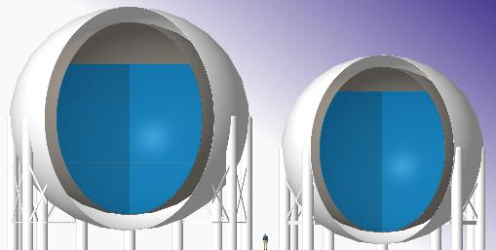
Figure 1. Scale comparison of new 4,700-m³ storage tank (left) and Apollo-era 3,200-m³ tank (right)
2. Fundamental Tank Configuration and Design
The detailed design of the new tank is by CB&I Storage Solutions (CB&I) as part of the PMI contract for the launch facility improvements. The tank configuration follows the basic approach of the previous tank per ASME BPV Code Section VIII, Division 2 and ASME B31.3 for the connecting piping. The inner vessel is constructed from SA240 Grade 304 stainless steel and is suspended by the stainless-steel hanger rods that connect to the outer sphere slightly above the equator. Additionally, at the equator there are stainless steel rods in the horizontal plane that transfer the lateral loads and keeps the inner sphere concentric with the outer sphere. The hanger and sway rods also provide enough flexibility to allow the inner sphere to shrink during the initial cooldown without overstressing either the inner or outer sphere. The outer sphere is fabricated from SA516 Grade 70 carbon steel. The usable capacity of the tank is 4,732 m³ (1,250,000 gal) with a total volume of 5,300 m³ (1,400,000 gal) and a minimum ullage volume of 10%. The specified maximum boiloff is a Normal Evaporation Rate (NER) of 0.048% (600 gal/day, 2,271 L/day), and the Minimum Design Metal Temperature (MMDT) and pressure ratings are 4.3 K (-452 °F) and full vacuum to 6.6 barg (95 psig) respectively.
The 25.3-m outer diameter spherical tank has 15 support legs welded to the equator and stands at an overall height of 28.0 m. The tank has a 1.7m annular space between the inner and outer sphere. The annular space is sized so that when the inner sphere contracts during cooldown, the top head of the inner vessel will remain covered by insulation. The piping between the inner and outer sphere is routed with pipe loops and vapor traps to ensure there is enough flexibility in the lines. The pipes penetrate the outer sphere through a stainless-steel sleeve that acts as a thermal distance piece to ensure the carbon steel outer does not experience cryogenic temperatures.
The tank is supplied from a tanker manifold and an ambient air vaporizer for pressurization. The tank includes a vent stack on top for normal boiloff gas and is connected to a dedicated facility flare stack of 0.3-m diameter. Other standard piping nozzles include a 300-mm diameter vacuum-jacketed liquid withdrawal line. The three key ingredients of thermal performance for an LH₂ tank design are: evacuated insulation; structural supports; and piping penetrations. The total heat load being transmitted to the inner vessel is determined by the combination of these three interdependent factors [7]. An overall elevation cutaway view of the new 4,700-m³ LH₂ storage tank is shown in Figure 2.
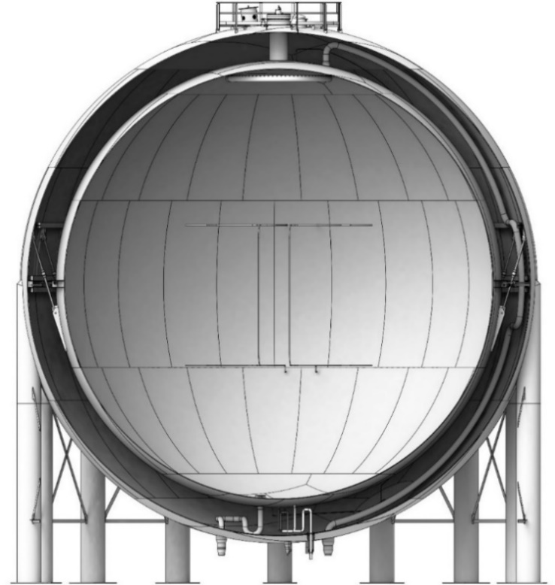
Figure 2. Overall elevation view of the new 4,700-m³ LH₂ storage tank.
3. Tank Technology
3.1 IRAS Heat Exchanger
A basic IRAS arrangement is depicted in Figure 3. In the traditional storage tank, there is no control. If the vessel is sealed, the heat energy within the liquid increases and the ullage pressure rises according to the heat load being transmitted from the ambient environment. The safety relief valve opens at the maximum design pressure of the inner vessel and the hydrogen is vented to the atmosphere (or burned in a flare stack). This scenario is typically circumvented by continuously venting the vessel at a lower pressure. In the IRAS tank the pressure and temperature of the liquid are controlled by simply rejecting the incoming heat through the cold helium gas being circulated through the internal cooling coil (or heat exchanger) [10], thereby eliminating the need to vent boiloff gas.
The internal IRAS heat exchanger, or cooling coil, in the new LH₂ sphere consists of upper and lower manifolds positioned at the 25% and 75% fill level elevations and are constructed of fully welded, 38-mm (1.5-inch) 316L stainless steel tubing. Total coil length exposed to the hydrogen is 43.3 m, yielding a heat exchange area of roughly 5.2 m². Helium refrigerant is to be fed to the coils via 51-mm (2-inch NPS), 304L stainless steel piping routed through the vacuum annulus. Bayonet connections and isolation valves are provided for the inlet and outlet flexible VJ lines from the future refrigeration system. A closed cold-helium process cycle is planned to reject the ambient heat load for zero boiloff (ZBO) operations and additional margin for LH₂ densification to temperatures as low as 14 K [8,9]. The heat exchanger design, influenced by prior IRAS tank demonstrations [11], is shown in Figure 4.

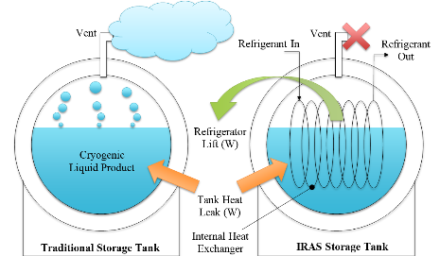
Figure 3. IRAS storage tank compared to traditional storage tank.
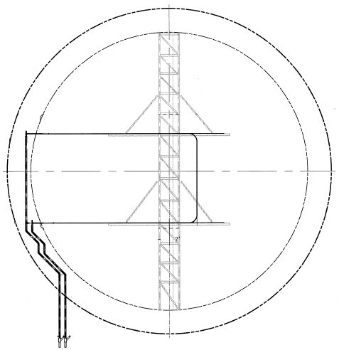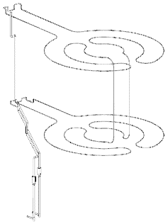
Upper Manifold
Lower Manifold
Vacuum-Jacketed Piping Feedthroughs
Outer Sphere
Support Tower
Inner Sphere
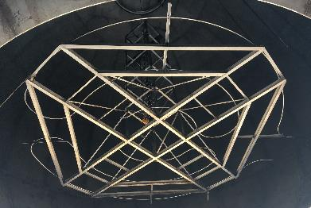
Figure 4. Heat exchanger configuration inside the sphere (upper left); 3D view of refrigerant feedlines and manifold (upper right); top manifold and support frame being lifted into place within the inner vessel of the new LH₂ storage tank (lower).
Study of the Space Shuttle Program over 30 years showed that about half of the LH₂ purchased was not used to launch the vehicle into space but was lost due to combined heat leak through the supply chain [12]. Following demonstration testing of a 125 m³ IRAS system at KSC in 2015-16, economic analysis showed that for every dollar spent on electricity to power the system, seven dollars in LH₂ could be saved [13]. This pathfinder test program proved the feasibility and quantified the performance benefits for an IRAS system including ullage pressure control, zero boiloff, and liquid densification, and laid the groundwork for infusion of the technology into the current sphere.

3.2 Glass Bubbles
The glass bubbles insulation system is based on the use of type K1 glass bubbles by 3M filling the entire annular space. A microscopic view of the glass bubbles is presented in Figure 5 (left). The nominal 60-micron diameter hollow microspheres of borosilicate glass have a bulk settled density of approximately 65 kg/m³ [14]. Based on 15 years of research, testing, and development by a national team led by the Cryogenics Test Laboratory, this glass bubble system was determined to perform reliably in annular space applications including large-scale spheres. Extensive crush testing was conducted, both isostatic and point-to-point, as well as numerous types of vibration and settling tests [15,16]. The conclusions were consistent across all tests: bubbles are better; bubbles do not compact; bubbles do not break; bubbles are easy to manage. The cost of the glass bubbles is roughly 3x the cost of perlite powder.
Cryogenic-vacuum thermal performance test data using both cryostat test instruments and experimental test tanks were produced to characterize the thermophysical properties of glass bubbles and other bulk-fill insulation materials [16]. The effective thermal conductivity of glass bubbles compared to perlite powder, under identical test conditions in both the Cryostat CS-100 and in 1000-liter (CESAT) spherical test tanks is presented in Figure 6 [17]. Note that the typical operating condition for site-built VJ LH2 tanks includes a cold vacuum pressure (CVP) of about 10 to 30 millitorr. Therefore, the bubbles are predicted to give a thermal performance benefit of from 40 to 100% compared to the high density (132 kg/m³) perlite powder traditionally used [18]. Field testing of a 190-m³ (50,000-gal) VJ LH₂ sphere at Stennis Space Center gave an average boiloff reduction of 46% over three thermal cycles in six years [19]. A photo of the glass bubbles tanker offloading and installation in the annular space of the 190-m³ field test sphere is shown in Figure 5 (right).
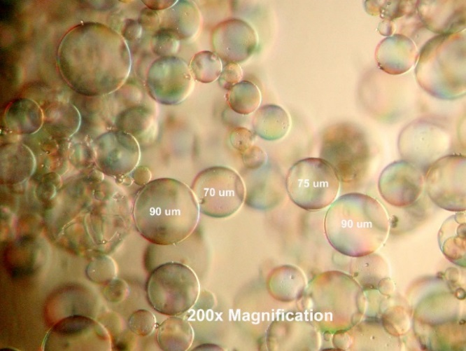
Figure 5. Type K1 Glass Bubbles: microscopic view (left) and tanker offloading/installation for demonstration testing at Stennis Space Center in 2008 (right).
Cryogenic-vacuum thermal performance test data using both cryostat test instruments and experimental test tanks were produced to characterize the thermophysical properties of glass bubbles and other bulk-fill insulation materials [17]. Effective thermal conductivity of glass bubbles compared to perlite powder, under identical test conditions in both the Cryostat-100 and in 1000-liter (CESAT) spherical test tanks is presented in Figure 6 [18]. Note that the typical operating condition for site-built tanks is a cold vacuum pressure (CVP) of about 10 to 30 millitorr. Therefore, the bubbles are predicted to give a thermal performance benefit of from 40 to 100% compared to the high density (132 kg/m³) perlite powder traditionally used [19]. Field testing with a 190-m³ (50,000-gal) VJ LH₂ sphere at Stennis Space Center gave an average boiloff reduction of 46% over three thermal cycles in six years [20]. Glass bubbles tanker offloading and installation to the 190-m³ field test sphere is shown in Figure 5 (right).
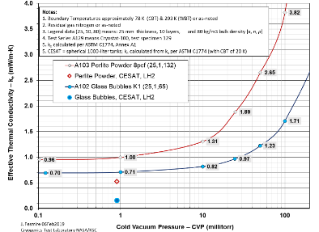
Figure 6. Glass Bubbles versus Perlite Powder: cryogenic-vacuum thermal performance data.
4. Tank Construction
Tank construction began in mid-2019 and is planned for completion in late-2021. There are several options for constructing a double wall sphere which are primarily driven by site conditions. For this project, CB&I developed proprietary construction techniques and temporary framing that allowed the inner and outer sphere shells to be constructed simultaneously while allowing installation of the heat exchanger tower and access to the annular space for installation of interconnecting piping.
The project also includes facility additions including a pair of vaporizer systems, flare stack, piping manifolds, connecting VJ transfer line connecting to the existing storage tank, as well as the site preparations, facilities, and electrical services. Select photos of the new LH₂ tank under construction, including an overall view with VJ transfer line, the final plate section for external shell, and a view of annular space. Installation of the glass bubbles insulation system is planned for late summer 2021 followed by purging and evacuation of the annular space.
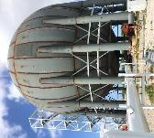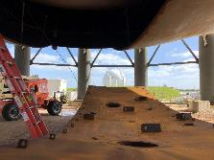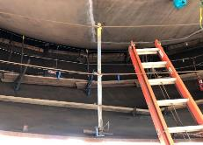
Figure 7. New LH2 tank under construction: overall view with VJ transfer line (left); final plate section for external shell (middle); and view of annular space (right).
5. Tank Testing and Commissioning
In addition to the mandated NDE required by ASME Section VIII, the sphere also requires a cold shock test and helium mass spectrometer testing of the inner shell, outer shell, and interconnecting piping. For the cold shock test, the inner sphere will be filled liquid nitrogen to a maximum level equating to the equivalent mass of a full tank of LH₂. The cold shock test will be done prior to the glass bubble installation so the outer shell temperature will be constantly monitored to ensure the shell temperature remains above the minimum design metal temperature for the duration of the test. The sphere will also have two vacuum retention tests. The first vacuum retention test will be performed before installation of the glass bubbles to confirm the annular space is sufficiently clean to minimize off-gassing. The final vacuum retention test will be done after the glass bubbles have been installed. A photo of the construction site in shown in Figure 8. Tank commissioning is planned for fall-2021.
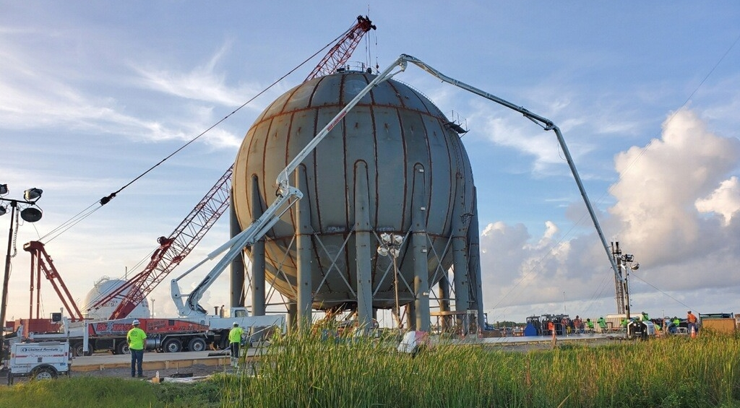
Figure 8. New 4,700 m³ LH₂ tank under construction with prior 3,200 m³ tank in background.
6. Conclusion
The design basics were described along with main construction and testing processes involved. The key features of the new technology items and implications on simplified operations and long-term energy savings were addressed. These technologies show potential for use in the future global logistics supply chains of liquid hydrogen storage and transfer from large-scale (up to 10,000 m3 capacity) to mega-scale (up to 100,000 m3 capacity).
For large-scale spherical LH₂ storage tanks the evacuated perlite powder system has been used for the last 60 years. The driver for the adoption of the glass bubbles insulation system is the substantial energy/product savings. Perlite powder is the main target for replacement with glass bubbles, and installations can be new construction or retrofits. While the cost of the glass bubbles, on a materials basis, is roughly three times higher than perlite, the total build cost and long-term value proposition are the main factors. An industry collaboration project is underway work to develop an insulation system and conceptual design for the proposed application of mega-scale tanks.
The new tank system includes an internal heat exchanger for future connection to a helium refrigeration system to enable any combination of the following capabilities: complete ullage pressure control, zero boiloff, zero-loss transfer, and densification. The facility site work to accept the refrigeration system has also been completed. A study is underway for the refrigeration system design, specification, and build plan with a focus on modular components.
Following tank commissioning and first operational experience over a sufficient period, a follow-on report is planned to discuss and analyze the thermal performance and functional characteristics of the new 4,700 m³ LH₂ storage tank.
7. References
[1] Fesmire J, Sass J, Nagy Z, Sojourner S, Morris D and Augustynowicz S, Cost-efficient storage of cryogens, Advances in Cryogenic Engineering, Vol 53B, American Institute of Physics, pp 1383-1391 (2008).
[2] Fesmire J, Research and development history of glass bubbles bulk-fill thermal insulation systems for large-scale cryogenic liquid hydrogen storage tanks, NASA Kennedy Space Center (2017).
[3] Notardonato B, Fesmire J and Swanger A, IRAS maximizes cryogenic process efficiency, Cold Facts, Cryogenic Society of America, Vol 33, No 3, pp 26-27 (2017).
[4] Baik J and Notardonato W, Initial test results of laboratory scale hydrogen liquefaction and densification system, Advances in Cryogenic Engineering, Vol 823, pp 1530-1537 (2006).
[5] Notardonato W, Johnson W, Swanger A and Tomsik T, Ground operations demonstration unit for liquid hydrogen initial test results, Advances in Cryogenic Engineering, IOP: Materials Science and Engineering 101 (2015).
[6] Swanger A, Transient modeling of large-scale integrated refrigeration and storage systems, International Cryogenic Engineering Conference, Oxford University, United Kingdom (2018).
[7] Fesmire J and Swanger A, Advanced cryogenic insulation systems, 25th IIR International Congress of Refrigeration, Montreal, Canada, IIR No. 1732 (2019).
[8] Notardonato B, Swanger A, Jumper K, Fesmire J, Johnson W and Tomsik T, Zero Boil-Off Methods for Large Scale Liquid Hydrogen Tanks using Integrated Refrigeration and Storage, IOP Conf. Series: Materials Science and Engineering 278 (2017).
[9] Swanger A, Notardonato B, Fesmire J, Jumper K, Johnson W and Tomsik T, Large Scale Production of Densified Hydrogen to the Triple Point and Below,” Advances in Cryogenic Engineering, IOP 278 (2017).
[10] Swanger A, Jumper K, Fesmire J and Notardonato W, Modification of liquid hydrogen tank for integrated refrigeration and storage, IOP Conf. Series: Materials Science and Engineering 101 (2015).
[11] Fesmire J, Tomsik T, Bonner T, Oliveira J, Conyers H, Johnson W and Notardonato W, Integrated Heat Exchanger Design for a Cryogenic Storage Tank, Advances in Cryogenic Engineering, AIP, Vol 1573, 1365-1372 (2014).
[12] Partridge J, Fractional consumption of liquid hydrogen and liquid oxygen during the space shuttle program, in Advances in Cryogenic Engineering, AIP, Vol 1434 (2012).
[13] Notardonato, W., Swanger, A., Fesmire, J., Jumper, K., Johnson, W. and Tomsik, T., Final test results for the ground operations demonstration unit for liquid hydrogen. Cryogenics, 88, pp.147-155, (2017).[14] Fesmire J and Augustynowicz S, Thermal Performance Testing of Glass Microspheres under Cryogenic-Vacuum Conditions, Advances in Cryogenic Engineering, Vol 49, American Institute of Physics, pp 612-618 (2004).
[15] Werlink R, Fesmire J and Sass J, Vibration Considerations for Cryogenic Tanks Using Glass Bubbles Insulation, Advances in Cryogenic Engineering, AIP, Vol 1434, pp 265-272 (2012).
[16] Majumdar A, Steadman T, Maroney J, Sass J and Fesmire J, Numerical modeling of propellant boil-off in a cryogenic storage tank, Advances in Cryogenic Engineering, Vol 53B, American Institute of Physics, pp 1507-1514 (2008).
[17] Scholtens B, Fesmire J, Sass J and Augustynowicz S, Cryogenic thermal performance testing of bulk-fill and aerogel insulation materials, Advances in Cryogenic Engineering, Vol 53A, American Institute of Physics, pp 152-159 (2008).
[18] Sass J, Fesmire J, Nagy Z, Sojourner S, Morris D and Augustynowicz S, Thermal performance comparison of glass microsphere and perlite insulation systems for liquid hydrogen storage tanks, Advances in Cryogenic Engineering, Vol 53B, American Institute of Physics, pp 1375-1382 (2008).
[19] Allen M, Baumgartner R, Fesmire J and Augustynowicz S, Advances in Microsphere Insulation Systems, Advances in Cryogenic Engineering, Vol 49, American Institute of Physics, pp 619-626 (2004).
[20] Sass J, Fesmire J, St. Cyr W, Lott J, Barrett T and Baumgartner R, Glass bubbles insulation for liquid hydrogen storage tanks, Advances in Cryogenic Engineering, AIP, Vol 1218, pp 772-779 (2010).

