NANCY GRACE ROMAN SPACE TELESCOPE OBSERVATORY IMPLEMENTATION AND CHALLENGES

NASA’s Nancy Grace Roman Space Telescope (Roman), previously referred to as Wide Field Infrared Survey Telescope (WFIRST), was named after Dr. Nancy Grace Roman, an astronomer and NASA pioneer of modern space-based astronomy who is known as the “mother of the Hubble Space Telescope”. Roman is a deep space infrared observatory with a Hubble-sized telescope and wide field of view instrument (greater than 100 times that of Hubble’s) that will conduct a high latitude time-domain survey, a high latitude imaging and spectroscopic survey, and a galactic bulge time-domain survey to characterize dark energy and expand the census of exoplanets in our galaxy while allowing a broad range of astrophysics research. Roman will also demonstrate exoplanet coronagraphy with active wavefront control technology and provide general investigator programs for the science community.

Roman is finishing the critical design phase and is planning for launch in 2026. It will operate in a quasi-halo orbit about Sun-Earth L2, 1.5 million kilometers from Earth, for a five-year primary mission life. The Observatory features an Optical Telescope Assembly with an existing, repurposed 2.4m primary mirror, a Wide Field Instrument with a focal plane array comprised of 18 HgCdTe near-infrared detectors and a grism, prism and filter elements for imaging and spectroscopy in support of the primary surveys, as well as a Coronagraph instrument technology demonstration with starlight suppression technology for direct imaging and spectroscopy of exoplanets. The telescope is mounted to the Instrument Carrier composite truss structure which also optically meters each instrument, includes a Launch Load and Vibration Isolation System to provide passive isolation of spacecraft jitter sources while also supporting the payload during launch and is attached to the Spacecraft Bus. The Spacecraft also includes a Solar Array Sunshield, Deployable Aperture Cover, Lower Instrument Sunshade, High Gain Antenna System, and Outer Barrel Assembly. Figure 1 shows an overview of the Roman Observatory. When fully integrated, Roman will be the largest Observatory assembled and tested at NASA’s Goddard Space Flight Center.

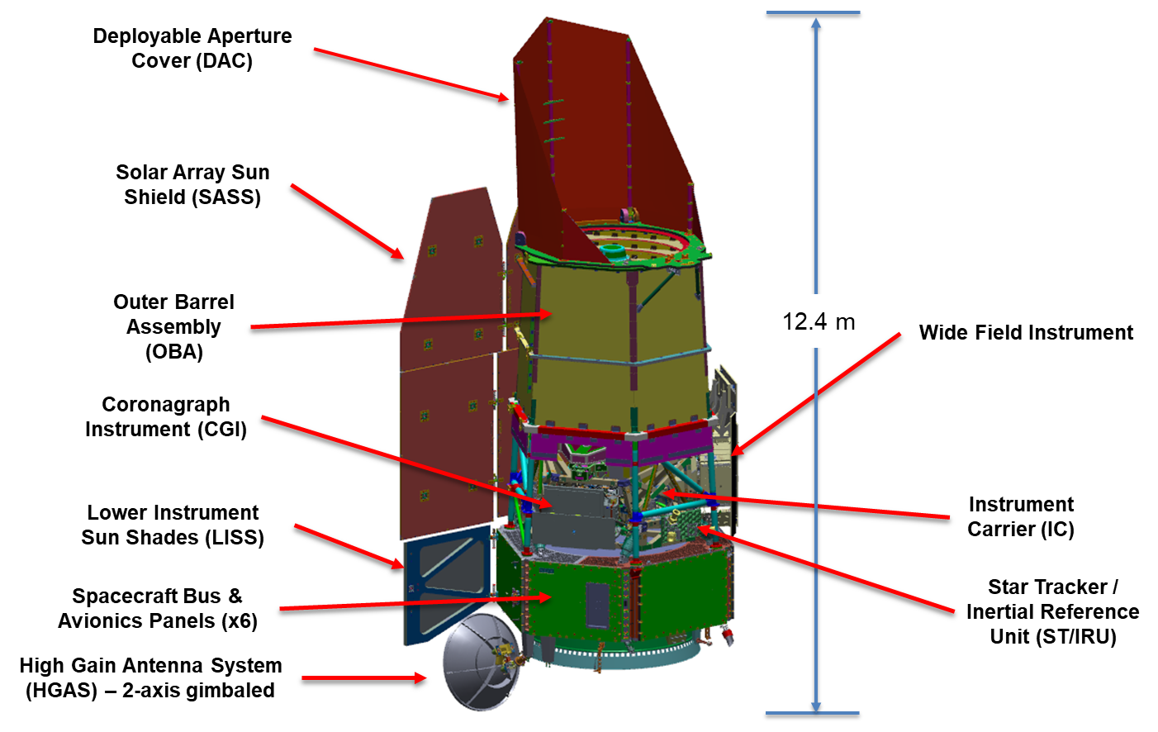

Figure 1. Roman Observatory Overview
Development of scientific satellites is challenging by nature, as the pursuit to broaden scientific knowledge always pushes the boundary of what has come before. The implementation of the Roman mission is a prime example and expected challenges have been augmented by the foundational decision to use the existing telescope components, developed in the early 2000s by another Government agency for a different application. Other unique aspects of the Roman mission, such as its survey nature, the vast amount of data required to meet science objectives, and packaging of the Observatory elements around the existing telescope components, create constrained design spaces that drive competing requirements across Observatory subsystems. Given these challenges, systems engineering has been a critical discipline in balancing implementation decisions for the Roman mission and will continue to play a key role going forward.

This paper will discuss details of the Roman Observatory configuration, as well as some of the systems engineering challenges and the decision-making process used to mature the Roman Space Telescope preliminary design to implementation.

