Additive Manufacture of Porous Zirconium Carbide for Nuclear Thermal Propulsion In-Core Insulators

Omar Mireles and Ryan Wilkerson
NASA Marshall Space Flight Center

Francisco Medina and Edel Arrieta
University of Texas, El Paso

Nuclear Thermal Propulsion requires high temperature insulators to manage to thermal environment between high temperature fuel elements and structure. The unforgiving in-core operating conditions limit potential material candidates. Zirconium Carbide (ZrC) is a promising candidate due to a high melting temperature, hydrogen compatibility, and low neutron absorption cross sections. However, fully dense ZrC is not an insulator but it has been found that the thermal conductivity of ZrC decreases by increasing porosity to approximately 60 percent theoretical density (%TD). Previous methods for generating porous ZrC were difficult, expensive, and time consuming. Binder jet additive manufacture can print ceramic materials to near net shape. Binder jet is not utilized in many aerospace applications due to a low post-sintering density of 60 %TD. For this application the inherent lower density is leveraged as an advantage in production porous ZrC in order to control the thermal conductivity. A feasibility study was conducted to investigate binder jet parameter development for ZrC, heat treatment optimization (burn-out and sinter), microstructural characterization, mechanical testing, and thermal testing to generate near-net shape ZrC components with ~60 %TD with the desired thermal conductivity and mechanical strength.

Nomenclature

AM = additive manufacture
DED = directed energy deposition
D10 = diameter at which 10% of the population lie below
D50 = diameter at which 50% of the population lie below
D90 = diameter at which 90% of the population lie below
HT = heat treatment
k = thermal conductivity
L = liter
L-PBF = laser powder bed fusion
MSFC = Marshall Space Flight Center
NTP = nuclear thermal propulsion
PSD = particle size distribution
SEM = scanning electron microscopy
SPS = spark plasma sintering
t = layer thickness
T_{m} = melt temperature
UTEP = University of Texas at El Paso
Z = build direction
ZrC = zirconium carbide
ΔXY = geometric change perpendicular to the build direction
ΔZ = geometric change parallel to the build direction
ρ = density
µm = micrometer
%RD = percent relative density
%TD = percent theoretical density
%wt = weight percent

Introduction
Nuclear Thermal Propulsion (NTP) is under development for enabling rapid-transit of long duration human missions beyond low earth orbit. The unforgiving reactor operating conditions severely limit potential material candidates for fuel, structure, moderator, insulators, etc. Although seemingly inconsequential, insulating materials are of critical importance to manage to thermal environment between heat generating fuel elements at high temperature and reactor structure [1]. Examples of such insulators include tie-tube sleeves and slats in the core perimeter as shown in Figure 1.

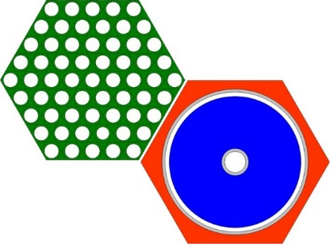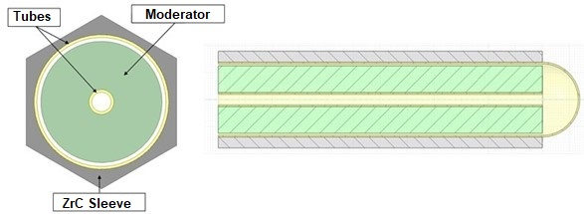
Fig 1. NTP fuel and tie-tube concept (left) and tie-tube insulation sleeve concept (right). [1]

Zirconium carbide (ZrC) is a promising material candidate for NTP due to a high melt temperature (T_{m}) of 3,520 °C, excellent hydrogen compatibility at elevated temperature, low neutron absorption cross sections, relatively low density (ρ) of 6.73 g/cm³, high compressive strength, and hardness [2, 3]. Unfortunately, fully dense ZrC has a thermal conductivity (k) at ambient temperature of approximately 20 W/m-K, which can considered a weak conductor [4]. However, decreasing ρ to approximately 60 percent theoretical density (%TD) decreases k to under 2.5 W/m-K and remains low with increasing temperature as shown in Figure 1.

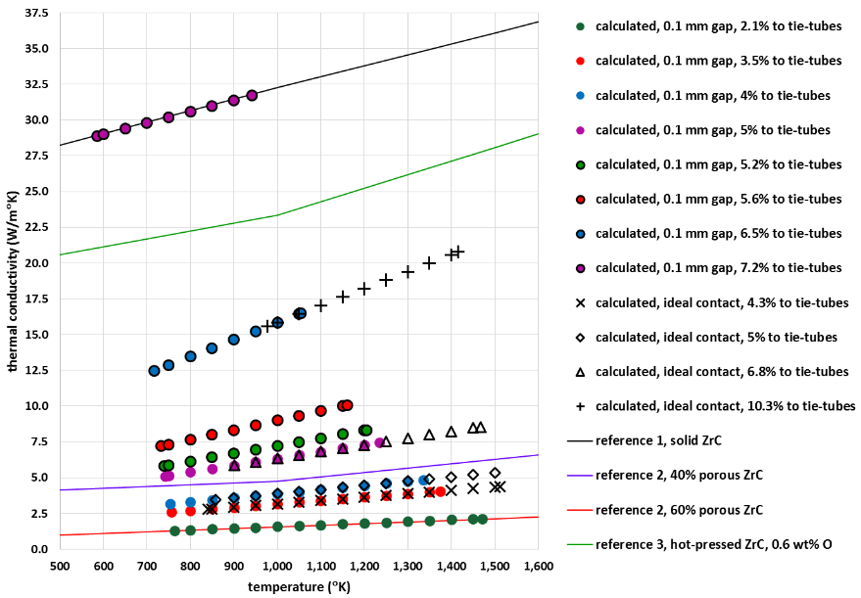
Fig 2. Thermal conductivity of ZrC as a function of temperature and density. [1]

Previous efforts during the ROVER-NERVA programs fabricate porous ZrC involved hot pressing ZrC powder mixed with a pore-former such as Teflon that was later removed by hydrogen decomposition at elevated temperature [4]. Another method involved compressing carbon felt to shape in a die, machining the felt preform to a near net shape, chemical vapor infiltration and conversion of the carbon fibers into ZrC ligaments (which ranged from 40-110 hours to achieve), and finally grinding to final shape [4]. These traditional processes did show promise although they were relatively difficult, time consuming, expensive, and did not extend beyond lab scale demonstration articles. Spark plasma sintering (SPS) is an excellent modern method to manufacture ZrC in the desired geometries, but unfortunately, this process results in high density material on the order of > 99 %TD [5, 6]. The ability to produce ZrC at desired ρ is not a currently within commercial industry capability and the need develop a reliable supply is of great importance to NTP development efforts.
NASA Marshall Space Flight Center (MSFC) is developing and applying additive manufacture (AM) for propulsion systems in order to produce complex and optimized components from an array of materials with numerous advantages over traditional manufacturing. A number of contemporary manufacture methods were considered and a possible candidate method identified was Binder Jet AM. Binder jet is a powder bed AM process where a liquid resin binder is deposited onto a layer of powder in order to adhere the powder particles together. After binder deposition a heat lamp attached to the recoater assembly lightly cures the layer before the next layer of powder is applied and bound layer, which then repeats layer after layer. After the build is complete the build chamber is removed from the AM machine and is heated in an oven to cure the binder to give the AM parts adequate strength for power removal and post-process handling. These “green parts” are placed in a furnace to first burn-out the polymeric binder then the furnace temperature is raised to sinter the parts (induce densification), which will improve the mechanical properties of the heat treated or “brown parts”. Binder jet AM is used in many applications, such as custom mold production from foundry sand used in castings, as well as metallic and non-metallic components. However, the primary disadvantage inherent to binder jet AM is the post-sintered ρ is low, on the order of 60 %TD. This low ρ is considered a significant disadvantage in AM production environments, especially compared to other AM technologies that routinely exceed 99.95 %TD. However, for this specific application the inherent lower ρ parts produced by binder jet AM is leveraged as an advantage in production ZrC at the desired 60 %TD for the production of high temperature NTP insulators.

Methodology
The objective proposed effort is to investigate and develop the binder jet and post-process and heat treatments to generate near-net shape ZrC with approximately 60 %TD that provides the desired thermal conductivity that retains sufficient mechanical strength to survive operational loads. The work was done as part of a Cooperative Agreement Notice between NASA MSFC and the University of Texas at El Paso (UTEP) W.M. Keck Center for 3D Innovation. MSFC primary experience in AM is primarily laser powder bed fusion (L-PBF) and directed energy deposition (DED) methods but lacked experience with binder jet AM. The research agreement represents a cost-effective approach to investigate this novel AM development proof-of-concept prior to large scale utilization.

Powder Characterization
One advantage of binder jet AM is that unlike other AM methods binder jet feedstock can use a relative broad particle size distribution (PSD), angular morphology, and non-fully dense particles to reduce feedstock requirements and cost. As with any AM process, identifying the appropriate feedstock is necessary to determine initial AM viability. ZrC grade AX powder was obtained from H.C. Starck for use in the investigation. Grade AX powder is necessary since it has a maximum hafnium content of 0.2 wt%, which is of critical importance to minimize hafnium due to a large neutron absorption cross section. A Retsch Camsizer X2 was used to determine PSD, which found D10 to range from 2-4 µm, D50 from 7-12 µm, and D90 from 17-27 µm. A scanning electron microscope (SEM) at relatively low magnification was used to characterize the angular powder morphology as shown in Figure 3.

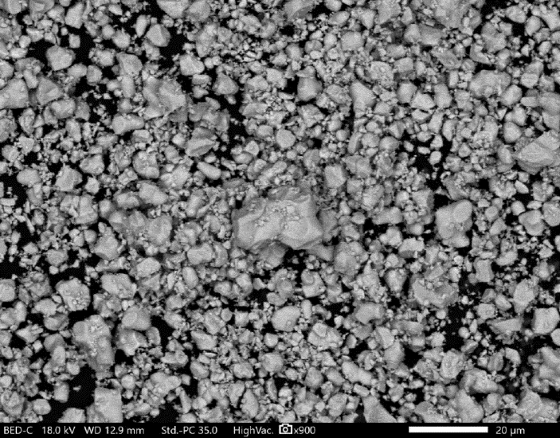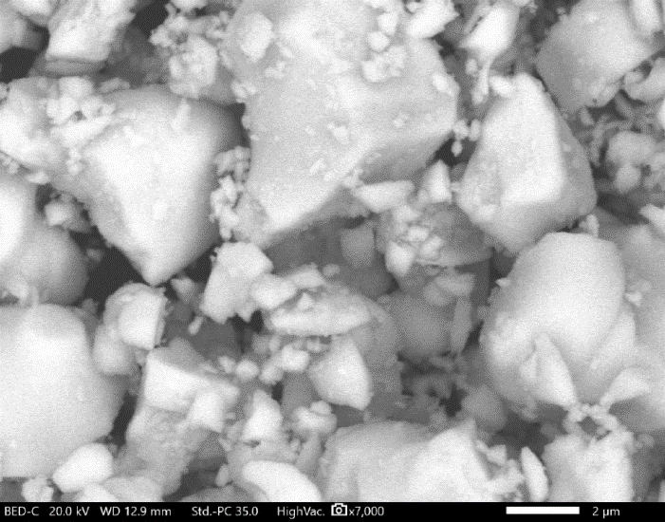
(A)
(B)
Fig 3. SEM micrographs of as-received ZrC powder (A) at 900x and (B) 7000x.

Binder Jet AM Parameter Development
UTEP conducted ZrC parameter development comprising of 36 trial builds using an ExOne M-Lab binder jet AM platform. ExOne solvent-based Fluid-Fuse binder was selected based on experimental results with the ZrC powder. The ZrC powder was evaluated for spreadability and flowability in the M-Lab system by observation of how the powder was deposited by the recoater assembly, ensuring uniformly distributed and smooth powder bed layers. It is also important to ensure machine mechanisms move freely with continued usage. A previous parameter set for Al₂O₃ powder of similar particle size and morphology characteristics was used as the starting trial for the ZrC Grade AX powder. Binder jet AM parameters known to impact ρ were varied in wide range of variability for the design of experiments. Layer thickness (t) from 10 to 40 µm, recoater powder spread speed from 1 to 10 mm/s, binder saturation from 25% to 75%, and drying times from 8 to 90 seconds comprised the variable trade space. After build completion, the build chamber is removed from the AM machine and placed in an oven to cure green parts. The curing heat treatment was conducted at 200 °C for 4 hours in air, followed by oven cool to ambient temperature. The green specimens were removed from the build envelope and underwent powder removal. The green specimens were found to have and sufficient mechanical strength to withstand handling and transportation to MSFC for heat treatment and characterization. In addition, the green parts were found to have acceptable geometric resolution and repeatability for the part geometries of interest.
Ceramic AM, like traditional ceramic manufacture methods, involve post-forming heat treatment that result in geometric part shrinkage. AM ceramic part shrinkage is generally anisotropic, with XY (in-plane) and Z (build direction) generally shrinking 15% and 25% respectively. The actual shrinkage values are highly dependent on feedstock, print parameters, and build orientation; therefore, these values are determined through iterative experimental measurement. In addition, shrinkage affects the desired sintered ρ and it is necessary to map and thoroughly understand how parameter adjustment can be used to achieve the target ρ value. Again, this approach is in contrast to the typical binder jet AM approach to use parameter optimization to result in maximum ρ parts. The final scaling factors are established once the optimized print parameters and heat treatments had been identified. No scaling factors were applied to the CAD files for the initial builds to compare the design dimensions to the as-printed and heat treated conditions in order to determine shrinkage compensation scale factors for future builds. As mentioned previously, build parameters were determined to be acceptable when producing green parts with observable good geometric definition, consistent surface texture and sufficient strength to survive de-powdering, transportation, and heat treatment. ZrC parameter sets were identified and used to produce density, geometry, and prototypic tie-tube sleeve insulator geometric specimens as shown in Figure 4.
(A)
(C)
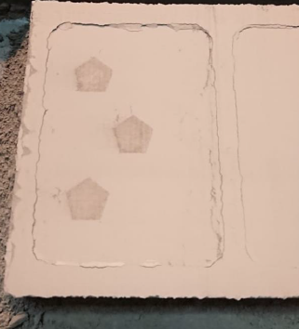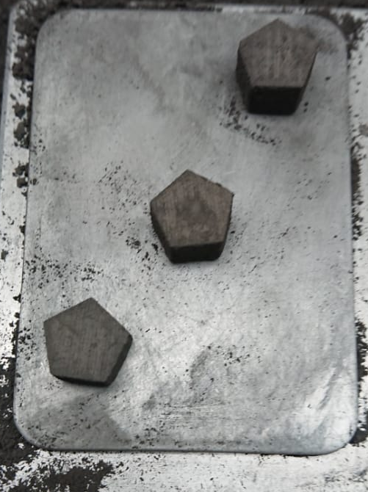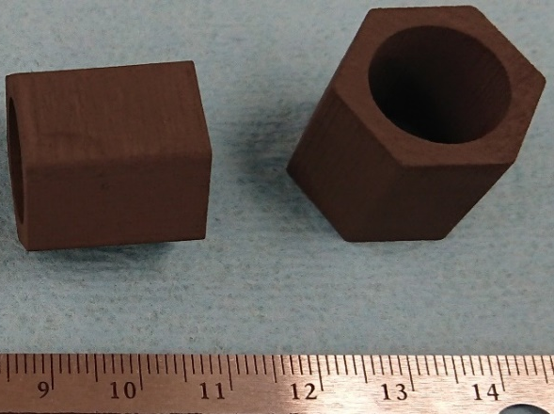
(B)
Fig 4. AM process (A), as-built AM ZrC specimens (B), and as-built tie-tube example AM parts (C).

As-Built Characterization
Green specimens dimensions were measurement using digital calipers in order to establish as-built geometric baseline dimensions, then the as-built geometry was compared to the CAD geometry. The CAD flat-to-point distance was 11.18 mm with a height of 7 mm. The average as-built flat-to-point distance was 11.3 mm and the height was 7.57 mm, which in terms of variation from the CAD dimensions was 1.07% and 8.1% larger respectively. As-built green specimen ρ was measured using Archimedes’ method or helium pycnometry and resulted in an average of 41.506 %RD. The as-built microstructure was characterized using an optical microscope, which provides insight on the ceramic ZrC particles are suspended within a solidified polymeric matrix as shown in Figure 5(A).

Heat Treatments
As-built specimens underwent post-process heat treatments to arrive at the final condition with the desired mechanical and physical properties. Green specimens were placed in a furnace and for de-binding burnout, which is a heat treatment where the binder experiences thermal decomposition at elevated temperature over the course of several hours. Next, the furnace temperature is raised to the sintering temperature for ZrC for a predetermined hold time. A graphite furnace at NASA MSFC was used to establish the high temperature environment needed to heat treat specimens through burn-out and sinter steps. Heat treatment was conducted in both argon and vacuum environments. The Heat Treatment 1 (HT1) schedule initiated burn-out by increasing the furnace temperature at 0.5 °C/min to 600 °C and hold for 1 hour. Next, the temperature was raised at 30 °C/min to 1900 °C for 2 hours sinter. HT1 was conducted in high purity argon atmosphere at ambient pressure. Heat Treatment 2 (HT2) was identical to HT1 except the sinter temperature was 2000 °C and was conducted in a vacuum of 1x10⁻⁴ Torr. HT1 resulted in specimens with ρ of 54 %TD, which is relatively close to the target of 60 %TD. HT2 specimen density was in work at time of publication. A compilation of geometric variation vs. condition is shown in Table 1.

Table 1. ZrC specimen geometric variation vs. condition.
Condition | Flat-To-Point (mm) | ΔXY (%) | Height (mm) | ΔZ (%) | Density (%RD)
CAD | 11.18 | - | 7 | - | -
As-built | 11.3 | 1.07 | 7.57 | 8.14 | 41.506
HT1 | 10.955 | -3.05 | 6.42 | -15.19 | 54
HT2 | 10.870 | -1.92 | 7.397 | -1.20 | In-work

ZrC exhibits stability in a sub-stoichiometric (C/Zr < 1) composition range and subsequent heat treatment trials could be conduct to optimize this ratio [2]. Additional heat treatments schedule variations are planned to vary the sinter hold temperature from 1750-2120 °C in order to produce a range of ρ and corresponding sintering profiles to control ρ, which controls k. Heat treatment characterization was delayed due to both Covid-19 pandemic social distancing as well as furnace maintenance delays and are expected to be completed within the next 6 months.

Post Heat Treatment Characterization
Sintered brown AM specimens underwent geometric dimensional measurement using digital calipers. As discussed, determining the shrinkage in XY and Z directions is of critical importance as these measurements are used to derive scale factors that are used to modify the size of the CAD files in the build layout software in order to compensate for heat treatment induced shrinkage. It was found that the median geometric shrinkage in XY (flat-to-point) was on the order of 3.05% and 15.19% in the Z (height), which is within the expected ΔL/L for AM ceramic materials. The sintered microstructure was characterized using an optical microscope at low to moderate magnification and SEM as shown in Figure 5(B). The ZrC particles show sintering and substantial porosity.

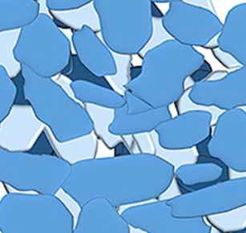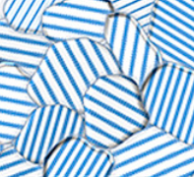
PLACEHOLDER IMAGES TO BE REPLACED WITH SAMPLE IMAGES WHEN AVAILABLE
(A)
(B)
Fig 5. Optical micrographs of ZrC specimens in the (A) as-built and (B) heat treated conditions.
Compression Testing
Mechanical testing of sintered brown parts was conducted using a Psylotech meso-scale load frame in order to determine compressive strength as a function of ρ. Specimens were tested with load applied perpendicular (XY) and parallel (Z) to the build direction (Z). The resulting stress-strains diagrams and nominal compressive strength values are still in work and data was not available at time publication. Initial results did indicate that the compressive strength of the heat treated AM ZrC is proportional to ρ and has some anisotropy in XY and Z directions, which was expected and a common mechanical behavior for ceramic AM. It must be noted that the compressive strength was measured at ambient temperature only and therefore has limited utility. In order to determine if AM ZrC is an appropriate method for the intended application the mechanical properties require complete characterization up to 2500 °C, which is within the expected operating temperatures for an NTP engine.

Effective Thermal Conductivity Measurements
The effective thermal conductivity of porous ZrC was intended to characterize the resulting k vs. ρ from 500 °C to 2000 °C. As mentioned, the heat treatment schedules were not completed at time of publication; however, after all specimens are heat treated they will be sent to commercial vendor that provides thermophysical property characterization of k via the step heat method. This task is expected to be completed within the next 6 months.

Scalable AM Assessment
A study was conducted to evaluate the feasibility of increasing production from a proof-of-concept into large scale utilization needed to meet NTP engine needs. Print parameters will require moderate translational adjustments when transferring the process to a larger production scale binder jet AM platform, such as an ExOne M-Flex. Parameter scaling is a common process for most AM methods, due primarily to the variation in mechanism sizes used in the build process. For example, the M-Lab system has a dispensing tank next to the build area from where the recoater directly transports and spreads the powder over the build platform, while the ExOne M-Flex uses a hoper and an oscillator to dispense the powder immediately ahead of the recoater. However, it is important to note that this assertion on translating print parameters to a different platform is invalid when the systems are from different equipment manufacturers; in this case, using the same parameters are not be expected to yield consistency or success with the previous machine. Due to differences in timing and integration between software, hardware, mechanisms, sensors and electronics used for powder management, and most importantly, proprietary binder formulation flow through the print head to dispense it at pico-liter scale plays a vital role during the AM and heat treatment process.
Small scale research and development AM platforms require only small amounts of powder feedstock to conduct an feasibility investigation. The small powder volume is especially important when printing expensive and/or new (limited availability) powders that require custom production heats. The M-Lab AM system is very convenient for initial parameter development purposes due to the small build envelope of 40 mm x 60 mm x 35 mm (0.084 L) and low cost of operation. However, that M-Lab is not an appropriate AM platform for large parts or high production volumes once printing parameters have already been determined beyond the investigation phase. UTEP and MSFC conducted a scalability study for production class platforms such as the ExOne M-Flex with a build envelope of 400 mm x 250 mm x 250 mm (25L). Although there are variations of a few seconds depending on the material, on average, M-Flex build speed per layer is 35 seconds compared to approximately 60 seconds of the M-Lab. Among the main reasons of the production system printing faster is that its print head has the equivalent to four times the capacity of the small machine. Therefore, the M-Flex requires fewer printing passes and has a direct impact on print time and cost.
Considering a uniform shrinkage-compensation upscale factor of 1.15 for the tie-tube geometries shown in Figure 4, the M-Lab can only fit a maximum of 4 tie tube segments per build. However, an M-Flex utilizing the full build envelope volume can produce 10 layers of 170 tie-tube segments each (plus foundation and blank layers), resulting in 1700 tie tube segments per build. At the slowest case where a 50 µm layer thickness is used the build consists of 5,000 layers at 35 seconds each, for a total build time of approximately 3,000 minutes or 50 hours. AM machine initialization, build removal, curing, and de-powdering add up approximately 7 hours to post-processing, independent of the build size. Heat treatment ramp, burn-out, ramp, sinter, and furnace cool adds approximately 25 hours to each build, again, independent of build size. The total production time is approximately 82 hours, not including any required final geometric shaping (e.g grinding), non-destructive evaluation, geometric tolerance verification, etc., which would add a considerable amount of time to the production schedule. In summary, the hundreds to thousands of insulating segments required for a full-scale NTP engine using scaled parameters can be produced using a single existing production scale platform, such as the M-Flex.

Conclusion
Preliminary results indicate that ZrC insulators with complex shapes at desired %TD is feasible using commercially available ZrC powder via binder-jet AM followed by sintering in a high temperature graphite furnace. Existing powder and AM platforms are sufficient to meet production requirements. The availability of furnaces capable of reaching the required temperature with required cleanliness will be the primary production constraint. As expected, heat treatment schedules heavily influence part relative density, effective thermal conductivity, and compressive strength. ZrC maturation (TRL 3 to 4) with desired properties is of importance to enable NTP. Recommendations for future work include optimization of the sintering heat treatment to achieve sub-stoichiometry to future optimize the effective k, complete compression testing of heat treated specimens, complete effective k measurements, hot hydrogen exposure testing, evaluation of fatigue life, determine service life at operating conditions estimate, and AM of full-size technology demonstrators, and component testing.

Acknowledgements
The authors would like to thank Marvin Barnes, Christopher McKinney, Jhonathan Rosales, John Peugeot, and Omar Rodriguez of NASA MSFC; and Ahmad Abu-Issa, Hector Escarcega, and Carlos Rodriguez of UTEP. This project was funded under NASA Cooperative Agreement Notice #80MSFC19M0051.

References
[1] Mireles, O. R., et al., “Potential for Additive Manufacture in Nuclear Thermal Propulsion,” Proceedings of the Nuclear and Emerging Technologies for Space (NETS) conference, 2016.
[2] Katoh, Y., et al., “Properties of Zirconium Carbide for Nuclear Fuel Applications,” Journal of Nuclear Materials, Vol 441, Issue 1-3, pp. 718-42, 2018.
[3] Ozaki, Y. and Zee, R. H., “Investigation of Thermal and Hydrogen Effects on Emissivity of Refractory Metals and Carbides,” Materials Science and Engineering, A202, pp 134-141, 1995.
[4] Wagner, P., “Research, Development, and Production of Substoichimetric Zirconium Carbide for High-Temperature Insulation,” National Technical Information Service, LA-5224, 1973.
[5] Sciti, D., Guicciardi, S., and Nygren, M., “Spark Plasma Sintering and Mechanical Behaviour of ZrC-based Composites,” Scripta Materialia, Vol 59, pp 638-641, 2008.
[6] Wei, W., et al., “Zirconium Carbide Produced by Spark Plasma Sintering and Hot Pressing: Densification Kinetics, Grain Growth, and Thermal Properties,” MDPI, Materials, Vol 9, Issue 7, 2016.

