An Approach for Identifying IASMS Services, Functions, and Capabilities From Data Sources
Kyle Ellis  NASA Langley Research Center Hampton, VA USA | Paul Krois  Crown Consulting, Inc  Aurora, CO USA |  | Robert Mah  NASA Ames Reserch Center  Moffett Field, CA USA |  | John Koelling  NASA Langley Research Center Hampton, VA USA
Lawrence Prinzel  NASA Langley Research Center  Hampton, VA USA |  | Misty Davies  NASA Ames Reserch Center  Moffett Field, CA USA |  | Samantha Indre Infeld  Analytical Mechanics Associates  Hampton, VA

Assuring safety in the NAS with the inclusion of new entrants that are part of Advanced Air Mobility (AAM) will require overcoming unique safety challenges that result from combining innovative technologies with novel airspace concepts for moving people and cargo using semi-autonomous/autonomous vehicles. Overcoming these AAM safety assurance challenges is the focus of the In-time Aviation Safety Management System (IASMS). The IASMS Concept of Operations (ConOps) describes an interconnected set of services, functions, and capabilities (SFCs) designed to manage operational risks, identify unknown risks, and inform system design to mitigate risk. This paper describes a broad approach for identifying SFCs involving technology trends in research, assessment of known and unknown risks in safety reports, and causal and contributing factors in aviation accidents and incidents. This approach leverages these sources to identify potential SFCs that enable the Monitor, Assess, and Mitigate (M-A-M) functionality that represents the enabling framework of the IASMS.
Keywords—In-time Aviation Safety Management System, Advanced Air Mobility, risk management, safety assurance, safety reports, accidents, and incidents

Introduction
Assuring safety as the new entrants that comprise Advanced Air Mobility (AAM) transform the National Airspace System (NAS) requires overcoming unique safety challenges and mitigating risks. AAM combines innovative technologies with novel airspace concepts for moving people and cargo using semi-autonomous/autonomous vehicles. The focus of an In-time Aviation Safety Management System (IASMS) is to seamlessly integrate and accelerate risk management and safety assurance while overcoming these emerging challenges. The IASMS Concept of Operations (ConOps) described herein is an interconnected set of services, functions, and capabilities (SFCs) designed to manage operational risks, identify unknown emergent risks, and inform on potential improvements to system designs. These SFCs are configured as part of an architecture that enables the IASMS and its key functions of Monitor-Assess-Mitigate.

Purpose
Continued evolution of AAM concepts and associated innovations with new technologies will be paralleled with new and additional sources of safety data and information. The AAM ecosystem will be able to use such data and information to strengthen and accelerate the identification and mitigation of safety risks. These risks may be mitigated early as part of system design and development depending on such factors as technical feasibility and cost, or later during actual operations through procedures, training, re-engineering of design, and other means.
The IASMS ConOps provides an important framework for risk management and safety assurance in the AAM ecosystem because the public has a low tolerance for aviation incidents and accidents. The IASMS and the AAM ecosystem would have processes to develop understanding and use insights on safety risks to keep them from occurring and escalating [1].
The IASMS intends to be broadly applicable to design and operations involving Parts 121 (commercial air transport), 135 (on-demand and taxi operations, and critical event response/transportation missions), 91 (General Aviation), and 107 (small Unmanned Aircraft System or sUAS) including leading to a common overall architecture.
This paper describes an approach for identifying SFCs based on technology trends in research, assessment of known and unknown risks in voluntary safety reports, and causal and contributing factors in aviation accidents and incidents. This paper focuses on SFCs that address existing aviation safety issues and concerns. These SFCs could reduce safety risks to current aircraft as well as new entrants in the near term. These SFCs that have a near-term impact would add to the Monitor-Assess-Mitigate (M-A-M) functionality that represents the framework of the IASMS. SFCs provide the means to address a wide range of aviation safety situations to maintain and ensure system-wide safety.
We define SFCs broadly, but in terms useful to the context of an IASMS. Specifically, a Service generates and distributes information for use during an aviation operation. The information may be available via “request-reply,” “publish-subscribe,” and/or “broadcast.” A Function is one or more actions that translates a set of inputs to a desired set of outputs. A Capability is the ability to perform or achieve certain actions or outcomes. It may require service(s), function(s), an underlying system, and/or human involvement to achieve the identified outcomes. For example, many of us, when we are driving in a car with a smart phone, have the Capability to navigate from our starting point to our destination in the shortest possible time without prior knowledge of the path or traffic situation. We accomplish this outcome through the Functions of the car to drive forward, increase and decrease speed, turn, and stop in response to our input; the Functions of the driver to take input from our eyes and ears as to the immediate environment and instructions from a phone, and give output to the car to navigate it; and the Functions of the phone to get input from some Services and give visual and audio output to instruct the driver or offer information and choices. The phone’s navigation app is using the Services of the GPS signal to its receiver, the map data, and the traffic data.
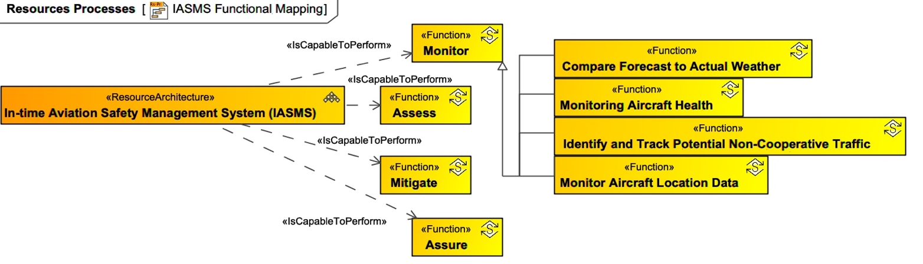
An IASMS, in order to manage safety, will perform the basic, or top-level functions: Monitor, Assess, and Mitigate. The SFCs that are required to address safety risks in the AAM ecosystem will include functions that do part of one of these top-level functions. They can be considered “sub-functions” as shown in Figure 1.
Fig. 1. Functional decomposition mapping from the IASMS system model using SysML and Unified Architecture Framework (UAF).

IASMS in Advanced Air mobility
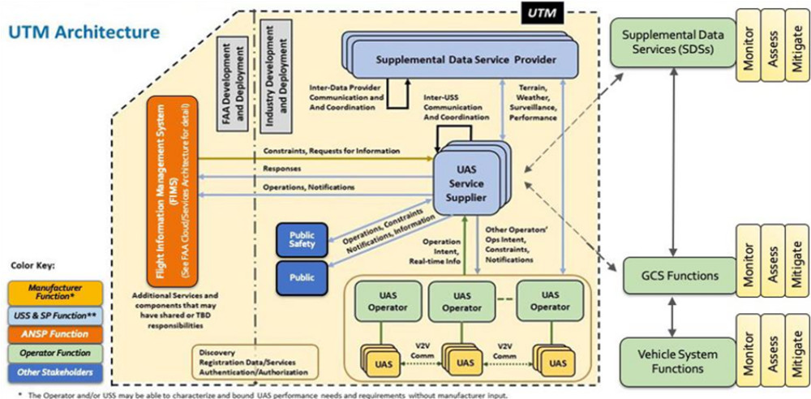
The National Academies committees reports on IASMS and AAM posed safety implications that could result from integration of AAM into the transformation of the NAS [2, 3]. Development of a ConOps for IASMS was a top recommendation that bridges real-time alerting, such as the Traffic Alert and Collision Avoidance System (TCAS), with more encompassing capabilities that involve an in-time temporal parameter. In-time safety assurance accounts for and integrates different timelines for monitoring data, assessing that data for anomalies, precursors, and trends, and mitigating risks. For example, safety data archival analysis could be accelerated to provide more timely safety assurance.
Fig. 2. UTM Architecture depicted with top-level M-A-M safety assurance functions.
The Federal Aviation Administration (FAA) in its Vision 2035 posed that in the future the vehicles with their flight performance characteristics will determine the services needed for the range of possible missions [4]. The demand for services such as for trajectory management, performance-based operations, access, and flow management will vary according to how users operate. Smart systems will be pervasive with services provided from the surface to space, and services and systems constantly evolving on pace with the need. Necessary information will be universally shared through service provisioning, and transparency enables equitable access to the airspace.
The FAA Vision 2035 builds in the FAA UAS Traffic Management (UTM) Concept of Operations and its architecture that shows UAS operators, UAS service suppliers (USSs), and Supplemental Data Service Providers (SDSPs) exchanging data including through the FAA Flight Information Management System (FIMS) [5]. The UTM architecture, shown in Figure 2, represents a system-of-systems that the National Academies said supports the central IASMS safety assurance functions of Monitor, Assess, and Mitigation for risk management.
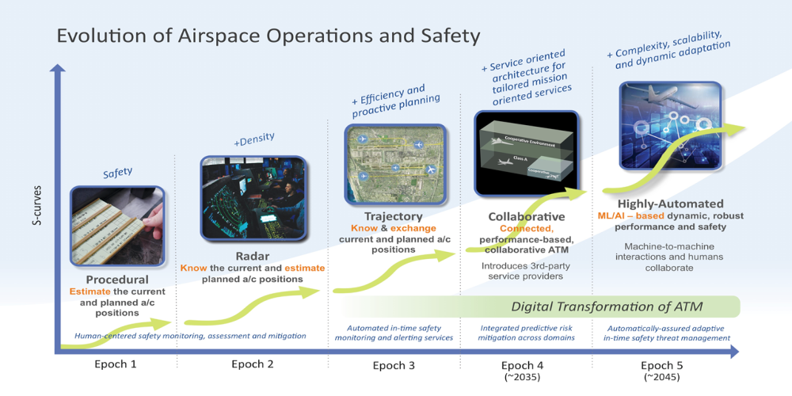
AAM represents innovations and advancements in technology that enable new concepts of operation. The envisioned future airspace will involve increasingly diverse operations for emerging aviation markets including Part 135 on-demand air taxis, small package delivery, autonomous cargo delivery, emergency and disaster response, and Part 107 sUAS operations. The future airspace will continue to involve Part 121 commercial air carriers and Part 91 General Aviation. In all segments of the NAS the IASMS SFCs can be identified for providing effective means for improved risk management and safety assurance. These SFCs and an IASMS architecture will be an information cloud-based system for intent-sharing, digital data exchange, and inter-operability enabling collaborative operations with an integrated, federated architecture [6, 7, 8, 9, 10]. The federated architecture will necessitate standardized application protocol interfaces and integrated air-ground-cloud service architectures. These architectures also necessitate increasingly autonomous technologies to scale with the growth in traffic volume and the complexity of airspace operations involving urban, rural, and regional flights.
Fig. 3. Epochs representing evolution of airspace operations and safety.
Enabling the future air transportation system is foreseen as a path of Epochs that represent increasingly complex transitions, as shown in Figure 3. These transitions start with today’s trajectory-based operations in Epoch 3 using current and planned aircraft position information, to collaborative operations in Epoch 4 (circa 2035) that involve performance-based, collaborative air traffic management (ATM) with increasingly autonomous systems, and on toward highly automated operations in Epoch 5 (2045+) involving machine learning and artificial intelligence that enable scalability through dynamic, robust performance and in-time safety threat management.
Integration of IASMS in transitions across the Epochs involves an increasingly complex architecture with high volume growth in digital data communications required by the SFCs. This evolution of SFCs provides in-time information and feedback for design and operations. For design this could involve changes to automated systems for risk mitigations and resolving design shortfalls. For operations this could involve changes to airspace design or procedural adaptations pre-flight, in-flight or post-flight. Changes in design requirements and operational recommendations in each Epoch would improve the safety foundation for the next Epoch.

Approach
The IASMS serves to monitor, assess, and mitigate aviation risks. The nature of these risks and their mitigations are depicted in Figure 4 as a higher-level operational view. Reference SFCs for risk mitigations were identified based on work by NASA, industry, Department of Defense, and existing aviation system capabilities [11]. For example, the risk called Flight Over People/Moving Vehicles would be mitigated by the vehicle maintaining safe lateral distance around people and moving vehicles as established in the flight plan or as information is updated during the flight (e.g., changes to the route of flight or 3rd party risk assessment), and the Reference SFCs include Proximity to Threat Service, Non-participant Causality Risk Assessment, ICAROUS-Route conflict resolution module, and Safe2Ditch.
Risk management and safety assurance use existing data sources and databases that can be assessed and analyzed for potential SFC concepts. The data includes technology trends in aviation safety research, voluntary safety reports, and accident/incident reports. This approach to identify SFCs could have near term impact on addressing safety risks to current aircraft and new entrants.
A system model of the IASMS defines its capabilities, the functions and services that may implement that capability, the types of data involved, and the physical elements that perform the functions and services. Such a framework helps NASA and its partners visualize and establish consistency across a complex landscape of network architectures for various applications, maturity levels, and constraints.
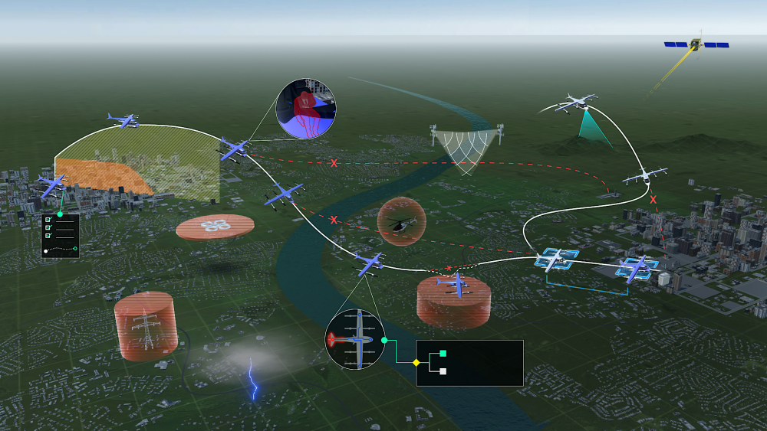
As SFCs are identified, they will be added into this framework in which the descriptions, inputs, outputs, interfaces, and behaviors can be iterated with SFC developers via tailored views of the elements and their relationships and behaviors. For example, to focus on a particular service we can look at the hardware parts installed on a vehicle to receive and use that service in one model view, the interfaces of those parts with signals, controls, and communications to other systems and people in another view, and then the activity flow over time of nominal and off-nominal use of that service in a third view.
Fig. 4. Operational view of the IASMS.

Research on aam Technologies and operations
Research posits that SFCs can be designed to monitor the aviation safety margins that are appropriate for AAM, including with regards to the distance between current flight parameters and nominal flight parameters under ideal conditions. These in-time comparisons will become more complex as the density of operations increases at least in certain areas and can include planned and actual 4D trajectory, and the expected and actual departure time, fix/waypoint crossing times, and arrival time. These comparisons would be integrated as part of SFCs that redefine and inform new safety margins. An increased safety margin improves management of operational risks while reducing the potential for anomalies. An increased safety margin also has implications for operator confidence in the certainty of its operations and trust in automation. Technology trends in aviation safety research could be used to refine and improve existing SFCs and define needs for additional SFCs that provide safety improvements to the design and operation of vehicles, airspace design, and operator performance requirements.
NASA is working with industry, academia, and other government agencies on a wide range of aviation safety research topics to develop new concepts and technologies for in-time aviation safety management and assurance.
- NASA uses the Small Business Innovation Research (SBIR) program to fund external proposals for research, development, and demonstration of innovative technologies, annually under the Future Aviation Systems Safety subtopic. The studies include automated real-time safety analyses of ATC approach clearances based on multiple sources of relevant real-time data such as aircraft data, weather data, past and current operations data, and crew data. This technology could play a foundational role in automated clearance selection and delivery as it can operate orders of magnitude faster and on a wider range of information than can be cognitively processed by a human. Other studies include an automated real-time safety analysis of unstable high energy landing approach and safety margin, and automated real-time identification and assessment of cybersecurity risks.
- NASA also uses the NASA Research Announcement (NRA) process to fund external proposals for foundational research in aviation safety areas to enhance core capabilities. The studies range from: 1) research and development of an innovative human-in-the-loop IASMS solution with a proactive methodology to identify, assess, and mitigate hazards, 2) development of a real-time automated risk estimation and prediction capability for safe AAM operations, to 3) development of a formal systems approach to detect and assess emerging hazards for increasingly autonomous urban flight operations.
- NASA in-house research is focused on developing technologies on topics including: 1) verification and validation [12, 13, 14], 2) data driven anomaly detection, diagnosis, and prognosis [15, 16, 17], 3) IASMS ConOps and SFC concept development including the architecture enabling information requirements [1, 11, 18], and 4) collaboration with external partners to apply and demonstrate new capabilities.
- NASA is working with FAA and has formed a Research Transition Team (RTT) IASMS ConOps Subgroup to build a ConOps having a nearer term (next 7 years) focus on IASMS and introducing new SFCs to augment the safety management process. The objectives of the ConOps is to provide a way forward for the existing SMS to transition toward the concept of an IASMS, to be more proactive, in time, and scalable to address risks and hazards of envisioned 2035/2045 airspace.
- In addition, NASA hosts an AAM Ecosystem Crosscutting Working Group to discuss and disseminate broad information on topics ranging from ConOps, autonomy, to the National Campaign. All discussions are open to the public.
More mature commercially available products are evolving and can be refined and integrated into SFCs. Some examples include ATAC’s SkyView system that provides software tools for gathering aviation performance data and air traffic visualization [19]; Resilienx’s FRAIHMWORK platform that provides automated fault detection, fault tolerance, fault isolation, and situational awareness services [20, 21]; and TruWeather’s service that improves weather strategy for drone and air taxi operators [22, 23].
NASA is developing innovative approaches that can safeguard against major accidents and incidents that have occurred in the NAS and those anticipated with the inclusion of envisioned AAM operations. The innovations use operational performance data at the systems-level to monitor, detect, and predict flight variations exceeding safe nominal patterns, such as would be caused by navigational error, severe weather complications, or hijacking of UAS controls. These innovative approaches have high potential to prevent accidents and incidents in the new AAM era. It is anticipated that elements of the innovations will evolve into SFCs for the IASMS. Many of the elements have been developed into proof-of-concepts by NASA through the SBIRs, NRAs, and in-house research referenced above.

Safety data sources
There are varied sources of in-time safety data corresponding to different timelines ranging from real-time to post-flight. The IASMS collects, assesses, and generates safety data and information for real-time operation risk mitigations and post-flight data mining. The safety data and information would be used during the pre-flight planning phase and during operational flight. The IASMS performs the monitor, assess, and mitigate functions through SFCs that are embedded within the network architectures of vehicles, operators, supplemental data service providers (SDSP) and ANSP/USS/PSUs. These SFCs exchange data across the common architecture devised for the IASMS.

Real-time safety data
SFCs provide real-time safety data for assuring in-time safety and mitigating imminent risks. Automated systems will have to be trusted to effectively monitor, assess, and mitigate such risks depending upon the balance of responsibility across human and automation actors in the system,. With increased automation, SFCs will need to automatically distribute data through the architecture to effected vehicles, operators, and the USS/PSU. In the current system, examples of real-time safety include TCAS and the Traffic Advisory System (TAS).
NASA is developing near real-time data mining methods to automatically detect unusual or anomalous data in real-time sensor data so that people can direct their attention to the unusual data [24, 25]. The approaches include supervised (using examples of faults) and unsupervised (using only nominal training data), augmented with machine learning in some cases, for automatic anomaly detection and identification of precursors. NASA is applying the technology to monitor safety in both aviation and space exploration domains. This technology can also be used to construct monitors for use in a model-based diagnosis and prognostics system.

Post-flight safety data
SFCs generate substantial amounts of data and represent post-flight data sources that can be conceptualized as an aviation safety data cloud involving, in some manner, the Aviation Safety Information and Analysis System (ASIAS), post-flight data download, reduction and analysis systems in use today, and other safety report systems.
Identifying anomalies, precursors, and trends from the safety data cloud depends on numerous factors. One factor corresponds to the statistical power or confidence that the risk is real, i.e., how much data would be needed before they provide an indication of a risk. This confidence could be relative to numerous factors related to the type of vehicle, time of day, amount of pilot experience, and many other potential correlates.

ASIAS-like safety data cloud: ASIAS supports the exchange of safety information to continuously improve aviation safety. ASIAS uses multiple data types provided by airlines (involving Flight Operations Quality Assurance or FOQA, and Aviation Safety Action Program or ASAP), aircraft operators (digital flight data), the FAA Air Traffic Organization (involving safety reports, air traffic control voice data, surveillance data, weather data, and data from the National Flight Data Center), and the National Oceanic and Atmospheric Administration (NOAA). The ConOps for ASIAS 3.0 provided more advanced predictive analytics, enhanced collaboraive activities, and improved responsiveness [26]. Key intersections between ASIAS and IASMS include providing ASIAS information to partners in-time to enable more rapid decisions to mitigate vetted and valid risks, more closely integrating automated processes with human expertise to increase the efficiency and quality of risk discovery, and expand ASIAS to new communinities such as UAS and commercial space.

Flight data: While FOQA is part of ASIAS, it poses special challenges and opportunities for AAM and especially UAS and sUAS. These include development of adaptive analytic strategies to guide automated detection of safety risks and recalibration of models and metrics using machine learning to scale with the growth of data access and volume. Flight data will enable cross-domain monitoring and assessment of risk for controlled airspace such as involving UAS and Part 121 air carrier operations. Previous research considered that only 17% of small-sized air carriers (less than 5,000,000 enplaned passengers annually) made use of FOQA. In a study of pilots flying in a Learjet 60 fleet within a FAA aviation system standards office, results indicated that feedback provided to pilots in quarterly reports produced significant reductions in exceedance rates over the course of the program [27]. This poses that IASMS SFCs could accelerate the detection, analysis, and mitigation of exceedances for AAM operators and pilots.

Safety reports: Safety reports by aviation professionals can involve the Mandatory Occurrence Report (MOR) process or be in the form of voluntary safety reporting. Safety reports are important to the safety promotion pillar of any SMS as it is a representation of the organization’s commitment to a strong safety culture. The human operator can be characterized as last in a series of safety nets to prevent an incident or accident from occurring. NASA developed and operates the Aviation Safety Reporting System (ASRS) as a confidential reporting system that collects information from pilots, maintenance technicians, air traffic controllers, and others, and then archives that data for routine and special studies on potential air safety hazards [28]. FAA established guidance on voluntary safety reporting with the objective to identify hazards and unsafe conditions so that corrective action could be taken to eliminate or reduce the risk [29].
The IASMS can take advantage of past information about hazards and unsafe conditions to prevent or reduce risk through changes in the design of vehicles and automated systems as well as changes in operations including airspace and procedures. On the one hand, assessment of archived data and identification of anomalies, precursors, and trends typically occurs at pre-established time periods or on an ad hoc, as needed bases. On the other hand, data could be continuously monitored in-time such as through a data and reasoning fabric provided as a service such as through a SDSP [30]. Information provided by that service could be used by an operator as part of a pre-flight checking function that could advise or warn about a potential operational risk. The scale of data sharing and the complexity of the architecture could vary based on operational safety requirements between operators, service providers, and regulatory bodies.
A MOR is an adverse event reported by the FAA and can range from possible sightings of a UAS with little or no risk, to Near Mid-Air Collisions (NMACs) with a manned commercial air carrier. One model of MOR risk treated the probability of collision based on the density of manned aircraft operations, the number of MORs, the number of NMAC reported and the traditional proximity criteria for a NMAC [31]. The purpose of the categorization model was to provide a quick, high-level snapshot of NAS performance in terms of risk of UAS operations to manned aircraft operations. Proximity criteria were of different levels consisting of (category A) collision, (category B) significant potential for collision involving events in which there was less than 500 feet (ft) reported between a manned aircraft and UAS, events in which the manned aircraft took evasive action to avoid a collision, and events described as ‘close calls’ in which the pilot of the manned aircraft did not detect the UAS in time to maneuver, (category C) UAS activity within 3 miles but more than 500 feet from manned aircraft, and (category D) reports of UAS activity that did not indicate a conflict with a manned aircraft (i.e., these reports either did not include proximity information, or specified a distance of more than 3 miles between the manned aircraft and UAS). Given these criteria, the factors agreed to be used in the severity categorization process were the proximity of the UAS to the manned aircraft and the proximity of the event to an airport.
Voluntary safety reporting can be an important indication of an organization’s commitment to SMS, safety promotion, and safety culture. In the NAS, three reporting systems used today are the NASA ASRS used by all aviation professionals, the FAA Aviation Safety Action Program (ASAP) used by employees of air carriers, repair stations, and other entities, and the FAA Air Traffic Safety Action Program (ATSAP) used by air traffic controllers, supervisors, and managers engaged in and supporting air traffic services. Voluntary safety reports such as the ASRS provide rich narratives about incidents, accidents, their precursors, and their resolution. The reports can be used to understand the chain of events that can lead to a problem. Data gathered by a reporting system can be systematically mined to identify precursors, anomalies and trends and gain understanding of causal and contributory factors. Virtually all such data analysis is done on a time frame of weeks to months to years after the flight. Moreover, it may take a period of time before the voluntary safety report process is completed for an incident. Following data analysis, potential risks can be further processed involving corrective actions such as changes to equipment design, operational procedures, or training. IASMS SFCs to rapidly process, characterize and integrate safety reports into SMS processes pose a great opportunity to be increasingly responsive to this form of data.
ASRS is a voluntary reporting system, so the data are not sufficient to be used to represent the relative frequency of occurrence of a particular concern or problem. But when combined with other data such as FOQA data and pilot/controller voice recordings, the resulting analyses would provide more evidence and confidence that there is an emerging risk. For this reason, NASA has been conducting research on text mining, anomaly detection on FOQA data, and pilot/controller voice analysis.
The IASMS intends for the data analysis and corrective actions to occur in a timelier manner to mitigate the risk as soon as possible before it occurs or worsens, and if needed modify the engineering design of automated systems. For the IASMS to accomplish this, the architecture would need to include SFCs that continuously monitor and assess the data for risks that would be verified and with relevant mitigations determined. The balance between humans and automation reflected by the SFCs would likely change across the AAM Epochs, e.g., determining relevant mitigations could become increasingly automated with later Epochs.
ASRS data analysis can provide important perspective and insight into risk management. For example, one study that reviewed 220 UAS events found that air traffic controllers should have information about vehicle performance characteristics and locations of loiter points to be used as part of lost link procedures [32].
It may also be important to consider developing SFCs that monitor patterns in data coming from different sources for detecting weak signals in the data. NASA as part of Technical Challenge 1 is maturing monitor and assess capabilities for near-term commercial applications. For example, several reports filed by U.S. pilots with ASRS related to the new Boeing 737 MAX and its Maneuvering Characteristics Augmentation System (MCAS) might have served as a weak signal of design and operational risk presaging the Lion and Ethiopian accidents [33]. Research by EUROCONTROL on weak signals described it as involving proactive methods to constantly monitor a system’s performance and resilience to provide information about emerging risks and vulnerabilities. Monitoring for weak signals involves a process of pattern finding and priming according to cycles of change and adaptation in both specific situations and with wider operational changes and using multiple time scales [34]. Considerations include the number of reports submitted over some period of time and multiple levels of safety advisories and warnings representing different levels of criticality. Weak signals could apply to known risks as initial indications of precursors. Weak signals could extend to detecting unknown risks that may take different forms and may necessitate SFCs that can identify potential new anomalies. Such unknown risks might be assessed by subject matter experts to check on the introduction of new vehicles, airspace design, and other considerations. SFCs could enable the monitor-assess-mitigate functions for in-time safety.
Another data type under consideration is pilot-controller voice communications. Voice is still the main source of pilot-ATC communications and a large body of airspace situational awareness and operational information is contained therein that never makes it back into effective use in the NAS.
NASA has been developing technology to monitor and analyze pilot-controller voice communications by adding real-time speech-to-text using IBM Watson’s data analytics processor that uses natural language processing (a technology that analyzes human speech for meaning and syntax). Under an SBIR effort, speech-to-text was applied to ATC communications with risk state analysis data fusion to provide a real-time risk and safety margin monitoring capability for the NAS. The research was focused on analyzing controller-pilot voice communications for anomalies and clearance deviations, and combining that with information from other data sources (flight plans, position reports, weather, infrastructure status, and traffic density) through advanced analytics with cloud computing for a scalable capability. Adding voice communications monitoring remains an important element to include to achieve NASA’s system-wide safety monitoring goals.
The scaling of different data sets poses important challenges for aggregating and developing methods used in reasoning services. Data reasoning can mean being aware of and interpreting data between systems. Reasoning services range from speech recognition to advance machine learning models, as standalone (silo) services or integrated in more complex applications [30]. A level of minimal data sharing could be required from regulatory bodies to support safety, and an increased level of data sharing potentially required among operators and service providers for operational safety and efficiency. Data reasoning would enable safety-critical operations using an architecture and functionality required for shared system-wide coordination and considering data trust and confidence, communications performance, in-time implementation, and airspace system safety. This could also include uncertainty information about the data and reasoning service.
Identifying SFCs through use of data reasoning with sources of IASMS data has some correspondence with the NASA Ames air traffic management data warehouse, dubbed Sherlock, first developed in 2009 [35]. Sherlock provides a central source of heterogeneous aviation data that are produced by different providers in different formats and encodings [36]. The thesis is that the IASMS can enable the discovery of new ways to improve safety by integrating and analyzing digital data generated and shared in the national airspace ecosystem.
Devising a data warehouse for AAM operations could mirror Sherlock in several ways for maximum effectiveness. A higher-level conceptualization of an AAM data warehouse architecture is shown in Figure 5. The concept would merge data in real-time and post-flight using flight plans, end-to-end trajectories, vehicle performance, and meta data. For AAM, flight plan and track data would be processed or at least correlated into end-to-end flight records for each flight. This requires merging data from different sources and linking a specific track to the flight plan to generate a single set of records per flight. Metadata could be collected for each flight’s track data such as corridor path, vertiport landing pad, in-trail spacing, and waypoint crossing time. Some of these track data could be correlated with trajectory predictions and predicted conflicts made by automated systems aboard the vehicle and on the ground.
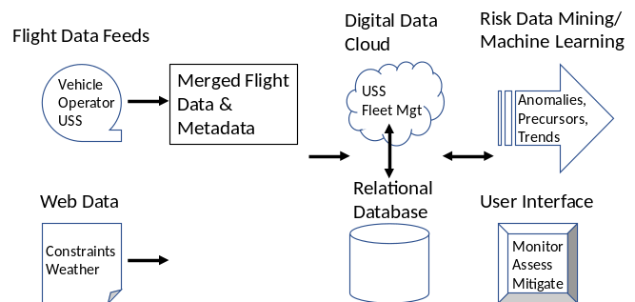

Fig. 5. IASMS data warehouse architecture concept.

aviation accidents and incidents
Lessons learned from aviation accidents and incidents could help prevent accidents in the future. By keeping accidents in mind, we can more effectively and efficiently improve aviation safety. The common causes in these events include flawed assumptions, human error, organizational lapses, pre-existing failures, and unintended effects. It is important to learn from these events so future accidents and incidents can be prevented by meticulous actions that can be encapsulated in the development of SFCs.
The most common cause of aviation accidents is human error, usually by the pilot in over 50% of the cases. Other cases include malfunction/failure of aircraft systems, deficient maintenance, hazardous environment (weather, birds, etc.), air traffic management errors, and any combinations of the above. Understanding the causal factors and the sequence of events that led to accidents/incidents would help to identify SFCs needed in the IASMS.
For instance, in the Asiana 214 accident (2013), the plane crashed on final approach into SFO. The weather was very good, light wind, 10 miles visibility, no precipitation, and no wind shear. The instrument landing system’s vertical guidance (glide slope) however was unavailable. The pilots performed a visual approach, but it was too slow and too low. The autopilot and auto throttle were turned off and the plane was operated manually during final descent. The plane’s airspeed had fallen well below the target and was below the glide path. The pilots said they typically rely on the automated devices for speed control during final descent [37].
The NTSB found that mismanagement of approach and inadequate monitoring of airspeed led to the crash. Over-reliance on automation and lack of systems understanding by the pilots were cited as major factors contributing to the accident. Lack of compliance with standard operating procedures and crew resource management were other factors cited. In short, the NTSB stated that the flight crew’s mismanagement of the descent during visual approach, unintended deactivation of automatic speed control, inadequate monitoring of airspeed, and delayed execution of a go-around led to the accident. In addition, contributing to the accident are the complexities of the auto throttle and autopilot flight director systems that were inadequately described in Boeing’s documentation, Asiana’s pilot training and execution of visual approaches, inadequate supervision of pilot flying, and crew fatigue.
In the Air Canada 759 incident (2017), the plane was on final approach at SFO, however, instead of lining up with the runway, the plane had lined up with a parallel taxiway on which four fully loaded passenger planes were stopped awaiting takeoff clearance. The Air Canada plane descended to 59 feet above ground and missed colliding with one of the planes on the taxiway by 14 feet. The weather was clear, and the pilot was not required to utilize the instrument landing system and relied instead on a visual approach [38].
The NTSB determined the probable cause was the crew’s confusion of the runway with the parallel taxiway, with contributing causes including the crew’s failure to use the instrument landing system as well as pilot fatigue.
In the UPS 1354 accident (2013), the cargo plane crashed short of the runway during a localizer non-precision approach at the Birmingham, Alabama airport (BHM). Because the flight's scheduled arrival time was 0451, only the shorter runway with a non-precision approach was available. The dispatcher did not discuss the forecasted weather for low ceilings upon arrival, the single-approach option to the airport, or the soon reopening of a longer precision approach runway with the flight crew [39].
The NTSB determined that the probable cause included fatigue for both flight crew members, their failure to properly configure and verify the flight management computer for the profile approach, the captain's failure to communicate his intentions to the first officer once it became apparent the vertical profile was not captured, and the first officer's failure to make the required minimums callouts.
The Asiana 214, Air Canada 759, and UPS 1354 accidents illustrate how combinations of different factors can lead to increased risks and disastrous situations. These types of events and different causal factors have implications on the types of SFCs that would be needed to monitor and safely manage future flights, as well as the different types of data that are needed to be included.
For example, the previously mentioned NASA-developed technology to monitor and analyze pilot-controller voice communications by adding real-time speech-to-text could quickly identify anomalies and provide real-time safety alerts. When combined with the other factors included in the risk state assessment framework, it would have identified accidents and incidents such as Asiana 214, Air Canada 759, and UPS 1354 as high risk flights before the events occurred.
Similarly, what we learned from the Challenger and Columbia space shuttle accidents is that we must keep the safety lessons from them alive to help engineers build safety into their basic design and focus attention on the high-risk areas in the management systems. It is important that lessons learned from aviation accidents and incidents such as those mentioned above must be kept alive in developing accident/incident preventions through SFCs.
Technologies that could address these safety risks are:
- In-time monitoring of the safety margin during landing approach. Several past and current SBIRs are developing technologies that would detect anomalies and identify precursors, identify unstable high energy approaches, and provide continuously updated go-around predictions as the flight progresses to touchdown to improve their safe and orderly execution by providing more time for operators to act and increase operational safety margins..
- In-time navigation monitoring and estimating hazard damage. A SBIR is underway to develop a 3-D, 6-degree of freedom, time-dependent hazard trajectory volume that could represent the trajectory of a UAS in case of a failure. This volume is larger than a projection of the crash area on the ground as some UAS may glide for a distance while others may spin before crashing. The model will track the energy (e.g., velocity and mass) along the trajectory from failure to impact.
- In-time vision-based trajectory monitoring during approach. This technology could provide independent/ supplemental verification of safety margin.
Some proactive risk prevention SFCs could involve providing training information for AAM operators and pilots based on real accident and incident information, verifying checklist completion, and estimating pilot fatigue based on accident data including considering long haul and local commuter flights for which pilot scheduling and fatigue are particularly challenging, and time between flights.

Discussion
Part of the goal of the IASMS is to provide risk management and safety assurance on an in-time scale that can range from real-time to sometime later depending on the nature of the risk. The more serious or imminent the harm, the faster the risk needs to be mitigated. Mitigating harm to people or property is the focus of the IASMS. Aviation accidents and incidents attract significant media attention since the public has low tolerance for them. The IASMS concept uses SFCs to monitor, assess, and mitigate risk using an architecture that shares safety data and information where it is needed, when it is needed, and for how it is needed by those humans and automated systems having the responsibility to ensure safe operations. SFCs are, so to speak, the coins of the realm with the IASMS concept, and as such, entail a certain cost to develop and operate, and in turn result in benefits from risk mitigation as well as avoidance of the financial costs that could result from accidents.
This paper has discussed the range of safety data used today and the types of data needed in the future in the context of the IASMS ConOps. The IASMS concept of SFCs can be expected to mature as understanding and insight are gained concerning technology innovations, changes in the regulatory landscape, and emerging market forces. Just as in-time safety accelerates along the temporal parameter, the IASMS scales for increasing complexity of vehicles, airspace and operations.
Continuing to assure the safety of AAM as designs and operations gain in complexity can be achieved by defining SFCs that scale with growth of automated systems. These SFCs could leverage information from findings and recommendations synthesized across on-going research, safety data analysis, and accident and incident reports. As SFCs begin to be developed, they need to be vetted, validated and assured. These SFCs can be refined corresponding with improved accuracy of algorithms and how limitations with current practices would be resolved.
An important question for the IASMS ConOps is how SFCs are prioritized or can be differentially weighted in some manner. For example, some SFCs may involve alerting the human pilot to a risk, whereas other SFCs could generate possible risk resolutions for the pilot to choose, and still other SFCs could automatically execute a risk resolution without human intervention. In this case, the weighting depends on the balance between humans and automation as well as the costs of automated systems (monetary cost of SFC development and certification, cost to vehicle weight, cost of computational processing, and so forth). These considerations will scale with increasing complexity of the ecosystem relative to airspace size and layout, and the number of flight operations involving diverse vehicles and missions.

Acknowledgment
The authors extend their appreciation to Ms. Laura Bass for her contributions in the development of this paper.
References
[1] K. Ellis, P. Krois, J. Koelling, L. Prinzel, M. Davies, and R. Mah, “A Concept of Operations and Design Considerations for an In-time Aviation Safety Management System (IASMS) for Advanced Air Mobility (AAM),” AIAA Sci Tech, 2021.
[2] National Academies of Sciences, Engineering, and Medicine, “In-time Aviation Safety Management: Challenges and Research for an Evolving Aviation System,” 2018. Washington, DC: The National Academies Press. https://doi.org/10.17226/24962.
[3] National Academies of Sciences, Engineering, and Medicine, “Advancing Aerial Mobility: A National Blueprint,” 2020. Washington, DC: The National Academies Press. https://doi.org/10.17226/25646
[4] MITRE CORPORATION, “The Future of Aerospace: Interconnected from Surface to Space,” 2020, FAA Managers Association Managing the Skies. Retrieved from faama.org.
[5] Federal Aviation Administration, “Unmanned Aircraft Systems (UAS) Traffic Management (UTM) Concept of Operations v2.0,” 2020, FAA, Washington, DC.
[6] M. Patterson, D. Isaacson, N. Mendonca, N. Neogi, K. Goodrich, M. Metcalfe, B. Bastedo, C. Metts, B. Hill, D. DeCarme, C. Griffin, and S. Wiggens, “An Initial Concept for Intermediate-State, Passenger-Carrying Urban Air Mobility Operations,” AIAA Sci Tech, 2021.
[7] H. Yoo, J. Li, J. Homola, and J. Jung, “Cooperative Upper Class E Airspace: Concept of Operations and Simulation Development for Operational Feasibility Assessment,” AIAA Aviation, 2021.
[8] N. Craven, S. Verma, S. Monheim, A. Cheng, R. Wood, V. Dulchinos, C. Seah, F. Renema, A. Farrahi, D. Zahn, D. Liddell, J. Lin, M. Gurram, Q. Li, M. Snycerski, and M. Cencetti, “Report: X3 Simulation with National Campaign-Developmental Test (NC-DT) Airspace Partners,” NASA/TM–20210011098, 2021.
[9] S. Zelinski, "Operational Analysis of Vertiport Surface Topology," 39th Digital Avionics Systems Conference (DASC), Virtual Event, 11-16 Oct. 2020.
[10] S. Verma, S. Monheim, K. Moolchandani, P. Pradeep, A. Cheng, D. Thipphavong, V. Dulchinos, H. Arneson, T. Lauderdale, C. Bosson, E. Mueller, and B. Wei, "Lessons Learned: Using UTM Paradigm for Urban Air Mobility," 39th Digital Avionics Systems Conference (DASC), Virtual Event, 2020.
[11] K. Ellis, P. Krois, J. Koelling, L. Prinzel, M. Davies, R. Mah, and S. Infeld, “Defining Services, Functions, and Capabilities for an Advanced Air Mobility (AAM) In-time Aviation Safety Management System (IASMS),” AIAA Aviation, 2021.
[12] G. Brat, K. Havelund, S. Park, W. Visser, “Model Checking Programs,” Proc. ASE ’00: 15th IEEE Int’l Conf. on Automated Software Engineering, Grenoble, France, pp. 3-11, Sep. 11-15, 2000.
[13] J. Schumann, “Verification & Validation of Adaptive Systems: Course Presentation,” Lecture Series "Discrete Mathematics and Logic” UNESCO, Tunis, Tunisia, Apr. 7-11, 2008.
[14] S. Jacklin, P. Gupta, J. Schumann, M. Richard, K. Guenther, F. Soares, “Towards Development of Advanced Verification and Validation Tools for the Certification of Learning Systems in Aerospace Applications,” Proc. AIAA Infotech, Arlington, Virginia, Sept. 26-29, 2005.
[15] B. Matthews, S. Das, K. Bhaduri, K. Das, R. Martin, and N. Oza, “Discovering Anomalous Aviation Safety Events Using Scalable Data Mining Algorithms,” Journal of Aerospace Information Systems, Vol. 10 No. 10, 467-475, October 2013
[16] V. Janakiraman, B. Matthews, and N. Oza, “Discovery of Precursors to Adverse Events using Time Series Data,” 2016 SIAM International Conference on Data Mining, Miami, FL, 2016.
[17] R. Martin and S. Das, “Near Real-Time Optimal Prediction of Adverse Events in Aviation Data,” Proceedings of AIAA Infotech@Aerospace Conference, Atlanta, GA, April 2010.
[18] S. Young, E. Ancel, A. Moore, E. Dill, C. Quach, J. Foster, K. Darafsheh, K. Smalling, S. Vazquez, E. Evans, W. Okolo, M. Corbetta, J. Ossenfort, J. Watkins, C. Kulkarni, and L. Spirkovska, “Architecture and Information Requirements to Assess and Predict Flight Safety Risks During Highly Autonomous Urban Flight Operations,” NASA/TM–2020-220440, 2020.
[19] J. Rodrigues and A. Aguiar, “Demo: Extracting 3D Maps from Crowdsourced GNSS Skyview Data,” 25th Annual International Conference on Mobile Computing and Networking, 2019.
[20] Resilienx, “FRAIHMWORK™ Solution: Fault Recovery & Isolation, Health Monitoring frameWORK,” 2021, accessed at https://www.resilienx.com/fraihmwork.
[21] Department of Defense, “Multi-modal Sensor Performance Health Monitoring,” 2021, access at https://www.sbir.gov/node/1942757.
[22] TruWeather Solutions, “TruWeather Solutions Playing Key Operational Role During FAA UPP2 At New York UAS Test Site,” 2021, accessed at https://truweathersolutions.com/truweather-solutions-playing-key-operational-role-during-faa-upp2-at-new-york-uas-test-site/.
[23] Commercial UAV News, “TruWeather Proves Why the Drone Industry Need Better Weather Data,” 2018, accessed at https://www.commercialuavnews.com/infrastructure/truweather-drone-industry-better-weather-data.
[24] NASA, “A Web-based Collaboration Tool for Those Interested in Data Mining and Systems Health,” https://c3.nasa.gov/dashlink/
[25] N. Oza, et. al., “Nikunj Oza Projects,”
https://c3.nasa.gov/dashlink/members/27/projects/
[26] Federal Aviation Administration, “Concept of Operations: Aviation Safety Information Analysis and Sharing 3.0,” 2019.
[27] S. Lowe, E. Pfleiderer, and T. Chidester, “Perceptions and Efficacy of Flight Operations Quality Assurance (FOQA) Programs Among Small-Scale Operators, Federal Aviation Administration Office of Aerospace Medicine,” DOT/FAA/AM-12/1, 2012.
[28] C. Billings, J. Lauber, H. Funkhomer, E. Lyman, and E. Huff, “NASA Aviation Safety Reporting System Quarterly Report Number 76-1, April 15, 1976, through July 14, 1976,” NASA TM X-3445, 1976.
[29] Federal Aviation Administration, “Aviation Safety Action Program,” AC No. 120-66C, 2020.
[30] W. Van Dalsem, S. Shetye, A. Das, K. Krishnakumar, S. Lozito, K. Freeman, A. Swank, P. Shannon, and L. Tomljenovic, “A Data and Reasoning Fabric to Enable Advanced Air Mobility,” AIAA Sci Tech Forum, 2021.
[31] K. Cardosi, J. Lu, M. France, T. Lennertz, A. Hoffman and T. Sheridan, “Monitoring Risk Associated with Operations of Unmanned Aircraft Systems (UAS) in the National Airspace System: Models for Analysis of Mandatory Occurrence Reports involving UAS-Manned Aircraft Encounters,” DOT/FAA/TC-18/33, DOT-VNTSC-FAA-18-08, 2018
[32] K. Cardosi and T. Lennertz,“Human Factors Considerations for the Integration of Unmanned Aerial Vehicles in the National Airspace System: An Analysis of Reports Submitted to the Aviation Safety Reporting System (ASRS),”DOT/FAA/TC-17/25, DOT-VNTSC-FAA-17-11, 2017.
[33] C. Aspinwall, A. Giorgi, and D. DiFurio, “Several Boeing 737 Max 8 Pilots in U.S. Complained About Suspected Safety Flaw, Dallas Morning News, March 12, 2019.
[34] D. Woods, T. Licu, J. Leonhardt, M. Rayo, E. Balkin, and R. Ciponea, “Patterns in How People Think and Work: Importance of Patterns Discovery for Understanding Complex Adaptive Systems,” EUROCONTROL, 2021.
[35] M. Eshow, M. Lui, and S. Ranjan, “Architecture and Capabilities of a Data Warehouse for ATM Research,” IEEE DASC, 2014.
[36] R. Keller, “The NASA Air Traffic Management Ontology: Technical Documentation,” NASA Technical Memo #2017-219526, June 2017.
[37] National Transportation Safety Board, “Descent below visual glidepath and impact with Seawall, Asiana Flight 214, Boeing 777-200ER, HL 7742, San Francisco, California, July 6, 2013,” Aircraft Accident Report NTSB/AAR-14/01, 2014.
[38] National Transportation Safety Board, “Taxiway Overflight Air Canada Flight 759 Airbus A320-211, C-FKCK, San Francisco, California, July 7, 2017,” Aircraft Accident Report NTSB/AIR-18/01, 2018.
[39] National Transportation Safety Board, “Crash During a Nighttime Nonprecision Instrument Approach to Landing, UPS Flight 1354, Airbus A300-600, N155UP, Birmingham, Alabama, August 14, 2013,” Aircraft Accident Report NTSB/AAR-14/02, 2014.

