High Speed Interferometry for James Webb Space Telescope Testing
B. Saif, L. Feinberg, R. Keski-Kuha
NASA/Goddard Space flight Center, Greenbelt, Maryland 20771, USA

Abstract
High speed interferometry (HSI) was one of the enabling technologies to the successful development and testing of the James Webb Space Telescope (JWST) optical system that consists of a 6.5 meter diameter, segmented, lightweight primary mirror and lightweight carbon fiber composite structure. This paper reviews the interferometry that was used first to demonstrate that the lightweight mirror and lightweight composite structure technologies were ready for JWST and later to verify performance of the fully assembled primary mirror and the telescope at cryogenic temperature. The tools and techniques developed for JWST are being advanced to benefit future missions that require stable mirrors, precision metering structures, active controls and diagnostic metrology.
- INTRODUCTION
The James Webb Space Telescope (JWST)¹ Optical Telescope Element (OTE) is a three mirror anastigmat consisting of a 6.5 meter diameter, segmented, lightweight primary mirror (PM), a secondary mirror and a tertiary mirror. The metering structure is a lightweight carbon fiber composite structure (Figure 1). Lightweight mirror and structure technology development as well as verification that the telescope meets its performance requirements on orbit required state-of-the-art interferometry with high sensitivity, fast exposure time and insensitivity to vibration. These requirements were met by instantaneous phase shifting interferometry where pixelated phase mask allows simultaneous capture of all four phase shifted interferograms. This technology was the key feature that allowed us to successfully demonstrate the required technology readiness level for the JWST telescope lightweight mirrors and large, lightweight composite structure, manufacture the primary mirror segments and verify their performance at cryogenic temperature, perform the center of curvature test of the fully assembled telescope before and after environmental testing and phase the primary mirror at cryogenic temperature at Johnson Space Center. 4D Technology now subsidiary of Onto Innovation in Tucson, Arizona built several interferometers (Figure 2) for the JWST project including Phasecam, Electronic Speckle Pattern Interferometer (ESPI), High Speed Interferometer (HSI) and Multi-Wave Interferometer.
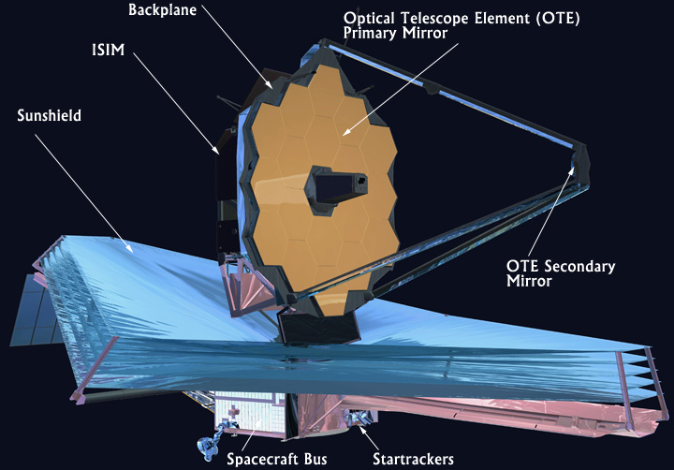

Figure 1. James Webb Space Telescope.

PRIMARY MIRROR SEGMENT ASSEMBLY TESTING
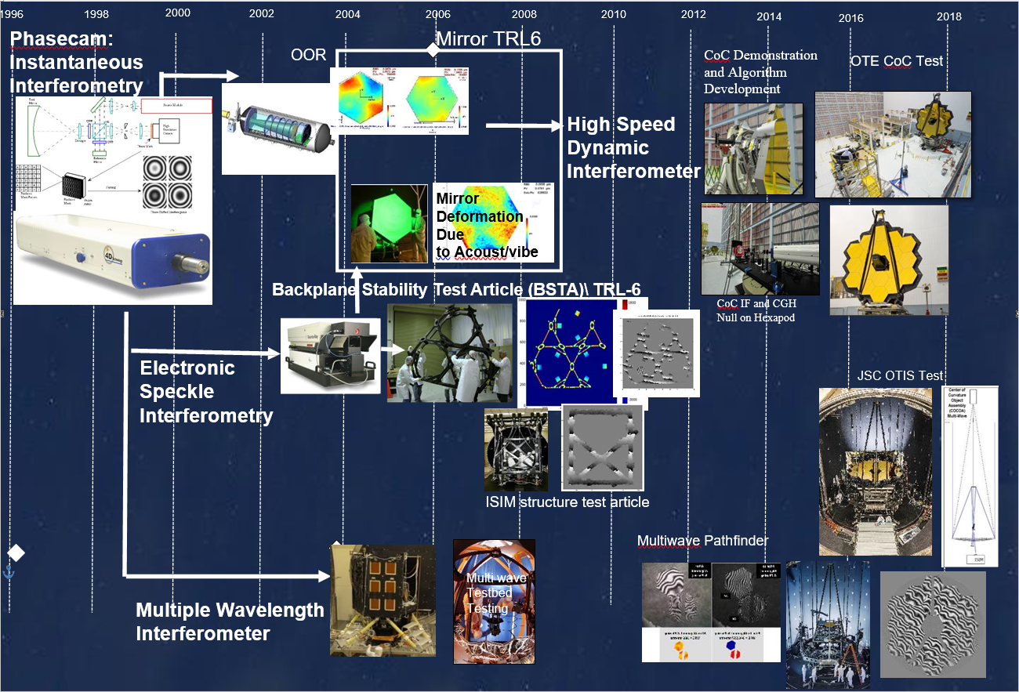
Phasecam was the key piece of metrology equipment throughout the primary mirror segment assemblies (PMSAs) manufacturing and testing sequence² including grinding and polishing operations at SSG Tinsley now Coherent in Richmond, CA, actuator assembly integration at Ball Aerospace and Technologies Corporation (BATC) in Boulder, CO and performance measurements at cryogenic temperature at the X-Ray and Cryogenic Facility (XRCF) at Marshall Space Flight Center (MSFC) in Huntsville, AL^{3,4}. Figure 3 shows the test configuration at XRCF, PMSAs being readied for testing and final cryogenic acceptance test results of the 18 PMSAs as a composite. Including measurement uncertainty, the as-measured figure error of the entire Primary Mirror is 25nm rms, meeting the requirement.

Figure 2. JWST interferometry history.
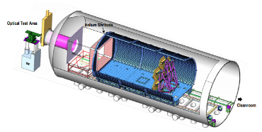
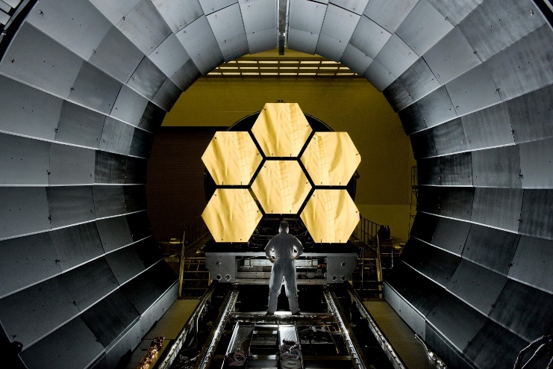
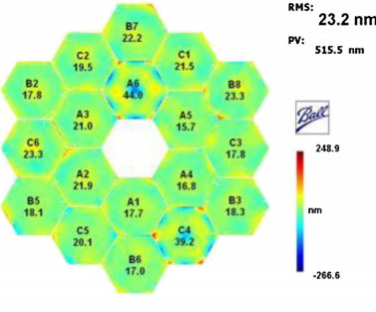
(a)
(b)
(c)

Figure 3. (a) PMSAs ready for testing, (b) PMSA test configuration at XRCF, (c) final performance.

STRUCTURAL VERIFICATION
In parallel with the mirror development the telescope team developed techniques to demonstrate large, lightweight composite structure technology at cryogenic temperature. This required technology to measure out of plane surface deformations in large, lightweight, precision, optical structures. The device had to be able to measure deformations in carbon fiber composite structure with diffused surface to nanometer level accuracy in high vibration environment at cryogenic temperature. The solution to the problem was developed by 4D Technology in collaboration with Goddard Space Flight Center. 4D Technology configured their simultaneous phase shifting interferometer Phasecam for speckle interferometry. It combines the classical speckle pattern interferometer for measurements of out-of-plane motions with a spatially phase-shifted interferometer.
The electronic speckle pattern interferometer (ESPI) is designed and configured to provide a direct measurement out-of-plane deformations and displacements of large test articles to high accuracy. The object under test is illuminated with a high-power pulsed Nd:YAG laser operating at the second harmonic (532 nm). The maximum energy output per pulse is about 0.9 J. The pulse duration is 9 ns, and the pulse repetition rate is 10 Hz. The laser is seeded to keep it in a single mode. The pulse repetition rate sets the upper boundary of the ESPI measurement rate. The coherence length of the laser is about 3 m. A two-element lens was used to generate an f #=5 beam to illuminate the structure under test. The f #- number of the beam can be controlled by changing the distance between the two lenses. The technique was verified on a meter class structure as part of the interferometer characterization at GSFC before the Backplane Stability Test Article (BSTA) test.
Backplane Stability Test Article (BSTA) was developed to demonstrate large precision cryogenic structures technology readiness. Its purpose was to measure the thermal stability of a structure similar to the JWST OTE Backplane structure and to validate the processes and finite element models that were used to design and predict the Backplane cool-down and operational thermal performance. The BSTA is a full size, one-sixth section of the JWST Primary Mirror Backplane Assembly (PMBA). The BSTA, measuring almost 3 m across, contained most of the prominent structural elements of the backplane (Figure 4).
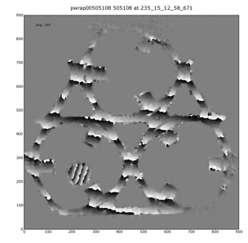
Its thermal stability was measured at cryogenic temperatures at MSFC‘s XRCF and included nearly continuous measurements over a six-week period covering the temperature range from ambient down to 30K using the ESPI. To our knowledge it is the largest structure ever measured with ESPI at cryogenic conditions. The interferometer measured rigid body motion and deformations of BSTA to nanometer level accuracy. BSTA test verified thermal stability of a structure similar to the JWST OTE backplane structure and validated the design processes and finite element models for the flight primary mirror backplane⁵.

Figure 4. BSTA Test.

In addition to BSTA test the other large cryogenic structure tested for JWST was a section of the Integrated Science Instrument Module (ISIM) composite structure named Breadbox (Figure 5). As with primary mirror backplane this test verified thermal stability of a structure similar to ISIM structure and validated the design process and finite element models for the flight ISIM structure.
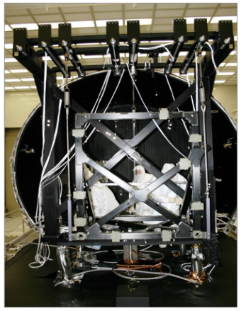
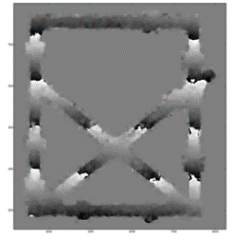
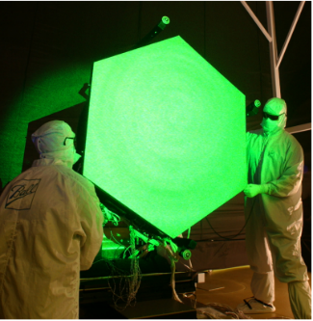
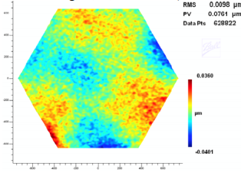
(a)
(b)

Figure 5. (a) ISIM structure test article. (b) Mirror deformation due to vibration test.
As part of achieving TRL-6 for the PMSAs it was necessary to demonstrate the ability of the PMSA design to survive launch by performing vibration and acoustic tests on a flight PMSA. To perform these tests, flight primary mirror segment B1 was pulled out of the normal manufacturing flow; assembled to a flight configuration including a fully operational hexapod and radius of curvature system; sine-burst and acoustically tested; and measured for surface figure changes. (Figure 5). Because the mirror was not polished, an ESPI metrology technique was used to measure surface changes⁶. Analysis predicted any potential shape change would be smaller than the ESPI measurement uncertainty, and as expected, no figure change was detected - thus demonstrating TRL-6.
- COC TEST
Upon completion of their element level integration and test programs the James Webb Space Telescope (JWST) Optical Telescope Element (OTE) and Integrated Science Instrument Module (ISIM) were integrated to the next level of assembly called OTE/ISIM (OTIS) at Goddard Space Flight Center (GSFC) in Greenbelt, Maryland in 2016. Before shipping the OTIS to Johnson Space Center (JSC) for optical test at cryogenic temperature a series of vibration and acoustic tests were performed to simulate the launch conditions for the telescope assembly. As part of this environmental testing several methods were employed to look for changes which may have occurred to the telescope or flight instruments. This included accelerometers placed on the OTIS and observed before, during, and after the environmental tests. Additionally, functional testing of all the electronic and motorized components were performed. Finally, as part of the overall test plan a center of curvature (CoC) optical test was performed to look for changes in the primary mirror shape to the nanometer level to help assure the telescope’s primary mirror was not adversely impacted by this environmental testing as well as help us in understanding potential anomalies identified during the JSC tests. This is important since the primary mirror must meet its 25nm rms surface figure specification on-orbit if the observatory’s science objectives are to be met.
The main instrument used to perform both static and dynamic measurements is a custom-made high-speed interferometer (HSI) designed and built by 4D Technology in collaboration with Goddard Space Flight Center. To assure integration times are kept short, this interferometer is equipped with a high-power 25 mW He–Ne laser with path matching capability. Pixelated phase mask allows simultaneous capture of all four phase shifted interferograms. Therefore, it can obtain relative spatial phase differences in one exposure. This reduces sensitivity to background vibrations. The HSI camera is a high-speed CMOS. The frame rate is limited by the size of the camera detector region of interest selected for data transfer. This interferometer is capable of characterizing both static and dynamic characteristics of the mirrors. The CoC tests included both a static mirror figure testing and a dynamic mirror response test. Capability of taking surface figure measurements at a rate of 5.9 kHz allowed dynamic testing.
The optical layout of the primary mirror testing was the classical interferometric center of curvature test^{7,8,9}. The primary mirror segments were tested statically and dynamically by measuring the surface of each segment using a CGH at Center of Curvature (CoC) of the primary mirror. Each segment was individually measured using the HSI. The dynamic characterization was performed with the aid of a vibration stinger applying a low-level input force, to measure the dynamic characteristic changes of the PM backplane structure. Figure 6 shows the test layout.

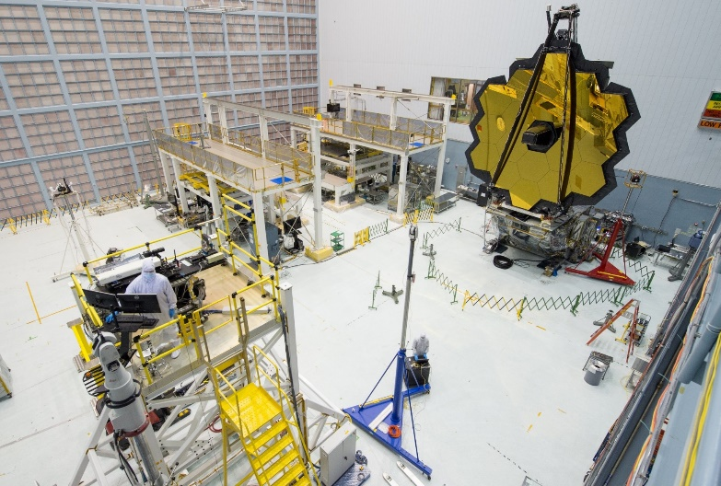
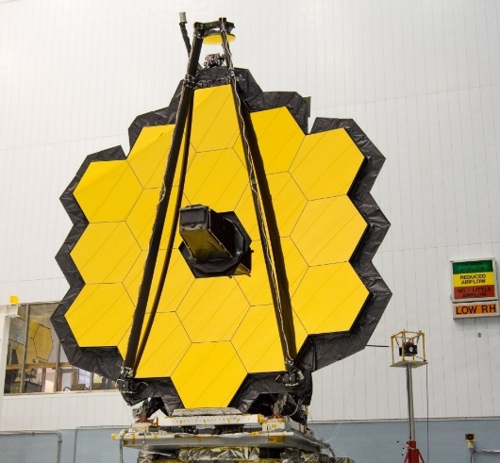

Figure 6. CoC test layout.

The six degree of freedom alignment of the CGH to the mirror segment is critical. This alignment is set using several metrology methods including features built into the CGH design, as well as the use of an alignment CGH. A detailed description of the alignment process can be found in Ref. 8.
The CoC test is a differential test. The post-environmental test results are differenced from the pre-environmental measurements. Therefore the post-environmental alignment state must match the pre-environmental alignment to within the budgeted tolerances. To achieve the decenter and clocking portion of the alignment of the mirror relative to the CGH a new method was developed. This method did not require the attachment of any fiducials onto the primary mirror, as this would have been problematic given the approximate 6 mm gap between segments. Instead the new method used an alignment camera system with features on the CGH that act as lenses to focus light spots onto the mirror surface to determine the alignment of the mirror relative to the CGH. The method assured that the mirror-to-CGH alignment matched for the pre and post environmental CoC tests. Custom software written by Space Telescope Science Institute (STScI) was used to analyze images and provide for rapid alignment of the mirror. Details of the alignment process are discussed in Ref. 8.
The primary mirror was measured before and after environmental exposure statically by measuring the surface figure of each segment using standard interferometric techniques and typical speed. For static measurements 1500 individual phase maps are collected and averaged using 4D Technology’s 4Sight software. This process takes approximately 20 minutes. Therefore, environmental effects such as background vibration and air turbulence are averaged over this 20 minute time period. This helps reduce specific errors that contribute to the wavefront measurement.
Each segment was measured individually (i.e., no full aperture measurement of the entire primary mirror) before and after the environmental testing. The delta measurement was analyzed for surface figure and astigmatism changes to the mirror shape. The data collected was post processed to separate the astigmatism change from the surface figure change. Measurement uncertainty error budget was developed for the delta of the pre and post environmental measurements of the static portion of the CoC test. It includes measurement repeatability, alignment, temperature, gravity and data processing terms. Each prescription type (A, B, & C) has its own uncertainty due to its specific alignment sensitivities.

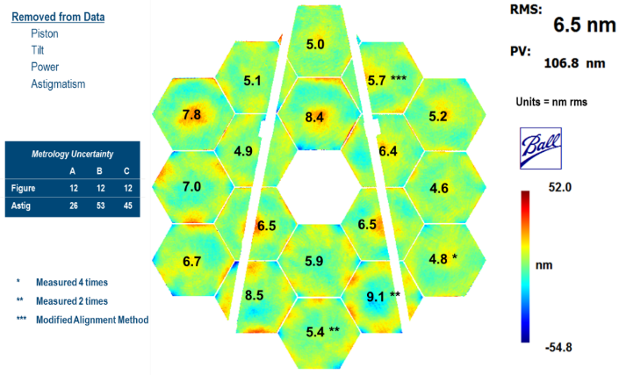
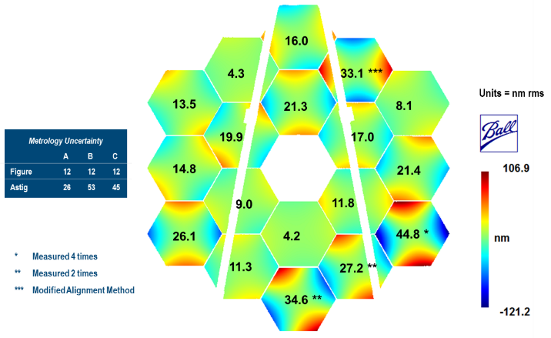

Figure 7. Static measurements surface figure and astigmatism changes.
Static CoC testing met its goal to measure mirror changes to an accuracy sufficient to conclude that the mirrors were not adversely affected by environmental testing allowing the OTIS assembly to move forward to the cryogenic test. Results showed that no changes occurred to any mirror segment’s surface figure or astigmatism shape greater than the calculated metrology uncertainty (Figure 7). The new alignment method that did not require any fiducials to be attached to the mirrors worked well for aligning the mirrors. Finally, a study of the worst case measured result, the pB3 astigmatism, was conducted to show that even if it were real it could be compensated for in flight with a -0.25 mrad clocking of the mirror.

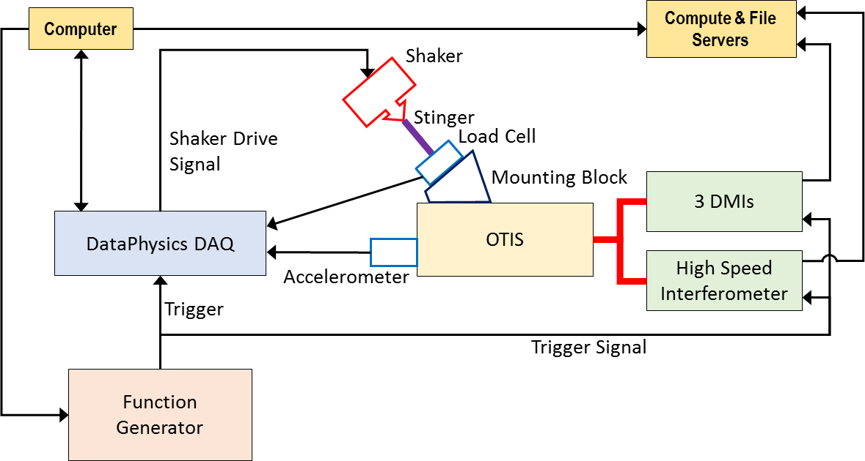

Figure 8. Dynamic Measurement System Block Diagram.

The main goal of the dynamics portion of the CoC test was to acquire diagnostic survey data of the OTIS vibrational characteristics at low input levels. A block diagram of the dynamic measurement is shown in Figure 8. The CoC dynamics test uses low level of forcing functions on order of 10 N or less. This force was a dynamic load applied to the OTIS composite structure while the HSI observed a PMSA. The loading condition was repeated for each PMSA and the full primary mirror (PM) correlated response was generated by applying transfer functions. Using these low-level inputs as references, the dynamic response of the OTIS is measured before and then again after the environmental testing and analyzed for changes in the observed response.
The OTIS was subjected to a number of mechanical operations and environmental tests between the two CoC tests. This includes stowing and deploying the primary mirror wings, stowing and deploying the primary mirror segments, the vibration and acoustic testing, and the transfer of the OTIS assembly on and off several handling fixtures. Despite these events no significant changes were observed in the dynamic CoC data. Although statistical differences in response functions were observed, they were not considered significant in magnitude.
Each PMSA segment was aligned sufficiently to reduce the fringe density and assure quality data. Absolute alignment was not necessary for the dynamics measurements since the first frame of 59000 total frames per test is used as a reference for temporal changes to the mirror position or shape. Once aligned a series of 10 second measurements are taken with a frame rate of 5.9 kHz. While the interferometer is capable of spatial resolutions up to approximately 2K x 2K the dynamics data was collected at 240x240 to enable maximum camera speed. The high speed was essential for balancing velocity limits and background noise level limits. Measurements were taken under various input stimulus conditions including: Background with no input stimulus, Sine Sweep over 25-50 Hz or 10-50 Hz and Random input. Reproducibility measurements were taken by repeating the data collection process for particular mirrors on a different day. This reproducibility data was key to assuring that measured changes were real.
One method to analyze the data is to look at the transfer function gain and phase parameters at a particular frequency. The global data is analyzed to find frequencies where we have high quality data for all segments. We then map out the transfer function over a circular aperture, for Zernike fitting purposes, applied to each mirror surface. A full primary mirror composite image of correlated response is constructed to aid in visually looking for differences. Figure 8 shows the results for rigid body and astigmatism at 43.0 Hz.
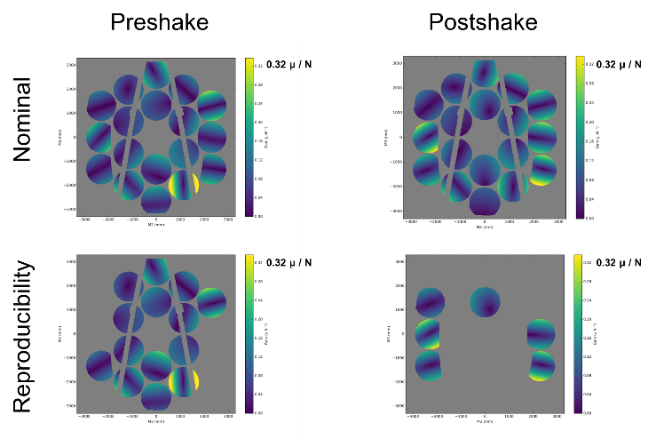
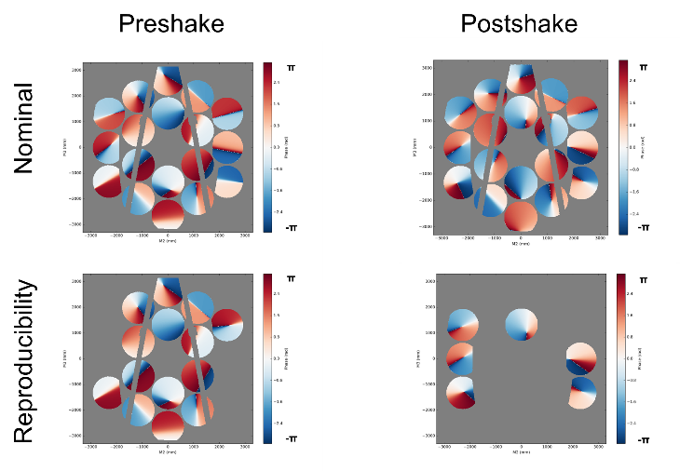
Rigid Body (Z1-Z3) at 43.0Hz
Transfer Function Phase
Rigid Body (Z1-Z3) at 43.0Hz
Transfer Function Gain

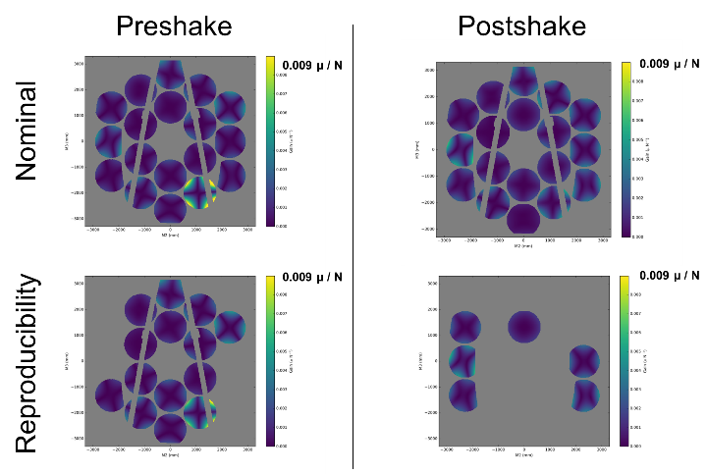
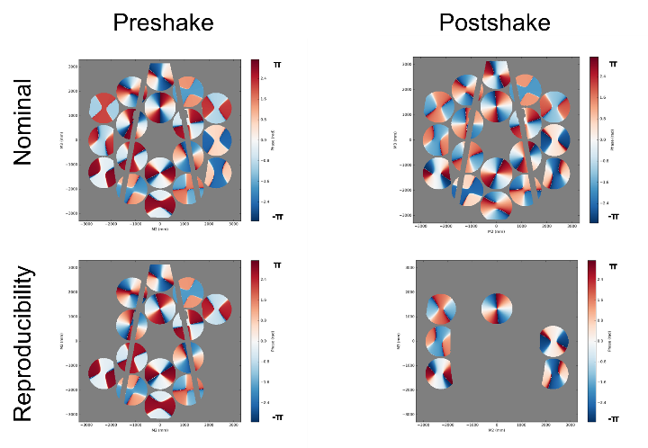
Astigmatism (Z5-Z6) at 43.0Hz
Transfer Function Phase
Astigmatism (Z5-Z6) at 43.0Hz
Transfer Function Gain

Figure 9. Rigid body and astigmatism results at 43 Hz.

The dynamics portion of the CoC test successfully measured the opto-mechanical modes of the telescope in low amplitude stimulation to nanometer precision. The dynamic results confirmed that no unacceptable change occurred to the OTIS assembly. The successful CoC test increased our confidence in moving forward with the OTIS optical test at cryogenic temperature at JSC.

- OTIS CRYO-VACUUM TEST
The James Webb Space Telescope Optical Telescope Element and Integrated Science Instrument Module (OTIS) were tested at the cryogenic operating temperature at the Johnson Space Center (JSC) in 2017. The execution and results of this 100-day test are summarized in Ref. 10 including the as-run test configuration and top-level functional, optical, thermal, and operational results from the test. Only the interferometry portion of the test is discussed in the following paragraphs.
A key piece of metrology equipment for the optical portion of the OTIS test was a multi-wave interferometer (MIWF) developed for this test. Early in the program a technology pathfinder interferometer was built for GSFC by 4D Technology and tested to demonstrate alignment and phasing of a segmented mirror. The design of this prototype multi-wavelength interferometer was modified and enhanced by L3Harris and 4D Technology to meet OTIS test technical requirements. The MWIF is an instantaneous phase-shifting interferometer with multi-wavelength capability, designed for testing segmented mirrors. It has two single-wavelength lasers (687 nm & 660 nm) and one tunable wavelength laser (680- 690 nm). Measurements can be made at the fundamental laser wavelength of 687 nm and at synthetic wavelengths from 16.8 um to 15 mm, produced by combining two measurements made at separate laser wavelengths allowing mirror segments with millimeter-level piston errors to be phased to the nanometer level.
Upon delivery the core performance of the interferometer was verified at L3Harris. The first step in preparation for the OTIS test the method to align and phase a mirror with 18 adjustable segments was tested at BATC on their Test Bed Telescope (TBT). This included the custom software developed by L3Harris. TBT is 1/6 scale JWST OTE with 18 adjustable segments. This was an essential step in preparation for phasing the primary mirror at JSC. This was the only time the interferometer saw 18 segments before testing the primary mirror at JSC. The real segmented data allowed us to find problems and correct them before JSC tests.
Next step in preparation for the flight OTIS test was the pathfinder test at cryogenic temperature in Chamber A at JSC. The multi-wave interferometer (MWIF) was part of the Center of-Curvature Optical Assembly (COCOA). COCOA also included a reflective null, a MWIF null calibration system, coarse and fine alignment systems, and Displacement Measuring Interferometers (DMIs). The COCOA was located above the He shroud in an LN2 environment, but was maintained at room temperature; a cold shutter isolated the COCOA from the OTIS when not in use. The multi-wave interferometer and DMIs were housed in a pressure tight enclosure outside the helium shroud in an LN₂ environment but was maintained at room temperature. A hexapod support system permitted positioning of the COCOA in six degrees-of-freedom. To reduce the risk of test interruptions MWIF lasers were fiber fed from an external source. That allowed access to the source module without warming up and breaking vacuum during the cryo test in case the lasers needed to be replaced during test. Absolute Distance Meter Assembly (ADMA) was used to measure and set the spacing between the PM and the focus of the COCOA null (i.e., the PM center-of-curvature) for determination of the ROC.

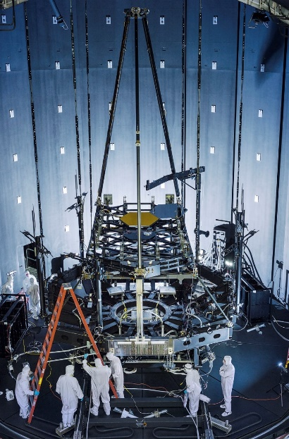
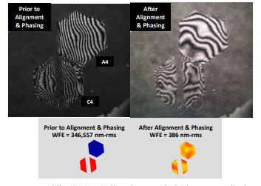
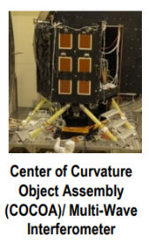
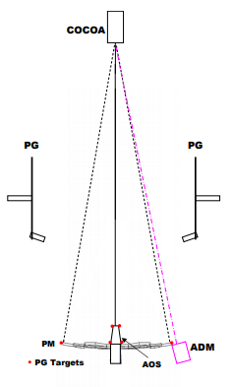

Figure 10. Pathfinder test.
The test article was the Pathfinder OTE, consisting of the pathfinder primary mirror backplane center section and secondary mirror support structure, two spare PMSA’s, the spare secondary mirror assembly, and either the AOS simulator (first test) or the flight AOS (second test). One of the spare PMSAs was not polished to flight specifications and was uncoated. The two PMSAs were successfully aligned and phased using the multi-wave interferometer (Figure 10). Overall the Pathfinder testing verified the performance of the PM center-of-curvature optical metrology system in the JSC cryogenic test environment¹¹. In addition to hardware the test provided assessment of software, procedures and data analysis tools and provided experience in operating the systems in the JSC cryogenic test environment JSC. Lessons learned greatly benefitted the cryogenic testing of the flight OTIS.
After completion of the third pathfinder test that checked out the thermal GSE flight OTIS was installed into the setup and the 100-day OTIS Cryo-Vacuum (CV) test started. The top-level objectives of the OTIS cryogenic testing were to check the OTE and OTE-to-ISIM alignment and to assess the optical performance. The testing included center-of-curvature measurements of the PM, using the Center-of-Curvature Optical Assembly and the Absolute Distance Meter Assembly, along with the photogrammetry (PG) system. The primary mirror (PM) center-of-curvature metrology system was used to align the 18 PMSAs into a phased PM, with the proper radius of curvature (ROC) and conic constant, align the PM globally to the Aft Optical Subsystem (AOS), and measure the phased PM wavefront error (WFE), ROC, and conic constant. Results were compared to predicted PM WFE, ROC and conic constant at 1g and to estimate the 0g PM WFE as well as to determine the PM collecting area.
Primary Mirror (PM) Center of Curvature test was a key OTIS test at JSC. It is the only pre-launch demonstration of PM phasing capability at cryogenic temperature and only full aperture PM figure measurement. It verified the PM assembly process, confirmed sufficient actuator range for on orbit operations and demonstrated PMSA functionality at cryogenic temperatures with flight processes and connections. The multi-wave interferometer (MWIF) was key GSE for meeting the goals of the test. Hundreds of MWIF runs were made during the OTIS CV test. During the alignment and phasing process PM segment piston errors were corrected by a step-down process using progressively shorter “synthetic wavelengths” based on MWIF images. The PM segments were then aligned in tilt, radial decenter, clocking, and radius of curvature to minimize total PM wavefront error (WFE). Figure 11 shows the OTIS in Chamber A and a sample interferometer image of the phased primary mirror. PM WFE meeting test requirements was achieved (e.g. 118nm Peak-to-Valley piston errors, 34nm rms, vs. a 150nm P-V requirement; segment tilts <83nrad). Comparison of the final observed surface shape for the PM segments was also in excellent agreement with model predictions. The COCOA systems and the ADMA, mounted behind an edge of the PM with the segment radius-of-curvature actuators were used to set the PM radius of curvature to its nominal value within requirements, and to measure its conic constant which also met requirements. In addition to PM phasing and alignment the center-of-curvature optical metrology system was also used to check and adjust the PMSA/PM alignment, as necessary, in support of other OTIS testing, such as the pass-and-a-half testing with the science instruments. Detailed description of the PM test can be found in Ref. 12.
Overall the OTIS CV test demonstrated the functional health and required performance of the OTIS hardware. The test met all of the optical test objectives including the PM testing using the center-of-curvature optical metrology system. Alignment of the adjustable elements of the telescope was demonstrated to be within requirements, with residual actuator range sufficient to meet required allocations for measurement uncertainties and ground-to-flight changes. The expectation, based on OTIS testing, is that the JWST will meet its specifications and provide the exiting science that it is designed for.

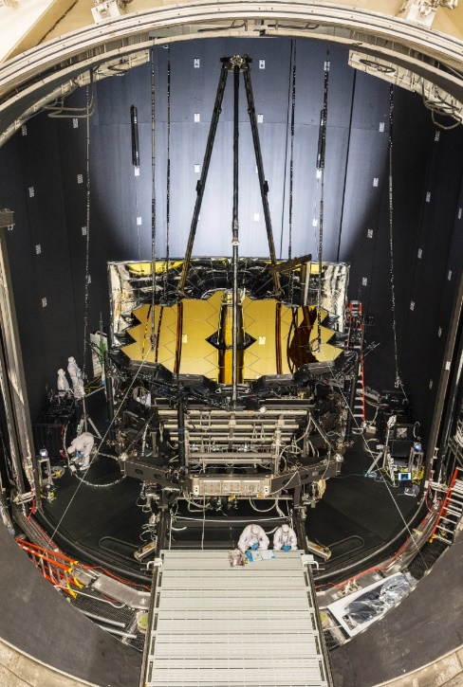

Figure 11. OTIS at in Chamber A at JSC and phased primary mirror fringes.

- SUMMARY
JWST test program required state-of-the-art interferometry with high sensitivity, fast exposure time and insensitivity to vibration. These requirements were met by instantaneous phase shifting interferometry where pixelated phase mask allows simultaneous capture of all four phase shifted interferograms. 4D Technology Phasecam was the key piece of metrology equipment throughout primary mirror segments manufacturing and testing sequence. Electronic Speckle Pattern Interferometer (ESPI), Multi-Wave Interferometer (MWIF), and High Speed Interferometer (HSI) were all based on the pixelated phase mask technology. ESPI test demonstrated design, analysis and manufacturing technology readiness of large composite precision cryo structures technology as well as PMSA compliance with TRL-6 requirements. CoC test using the HIS informed about the health of the OTIS before shipping it to JSC for optical testing at cryogenic temperature. The MWIF enabled the alignment and phasing of the PM segments at cryo at JSC with the proper ROC & conic constant. The results of all the testing performed indicate that JWST is capable of meeting its performance requirements on orbit. The tools and techniques developed for JWST are being advanced to benefit future missions that require stable mirrors, precision metering structures, active controls and diagnostic metrology^{13,14,15}.

REFERENCES
[1] Sabelhaus, P., Decker, J., “An Overview of the James Webb Space Telescope (JWST) Project”, Proceedings of SPIE, Vol. 5487, p 550-563 (2004).
[2) B. Gallagher, M. Bergeland, B. Brown, D. Chaney, T. Copp, J. Lewis, B. Shogrin, K. Smith, J. Sokol, J. Hadaway, H. Glatzel, P. Johnson, A. Lee, D. Patriarca, I. Stevenson, J. Cluney, T. Parsonage, J. Calvert, B. Rodgers, A. McKay, S. Texter, L. Cohen, L. Feinberg, "JWST mirror production status," Proc. SPIE 8146, (2011).
[3] J. Hadaway, D. Chaney, L. Carey, "The optical metrology system for cryogenic testing of the JWST primary mirror segments," Proc. SPIE 8126 (2011).
[4] P. Lightsey, C. Atkinson, M. Clampin, L. Feinberg, “James Webb Space Telescope: large deployable cryogenic telescope in space”, Optical Engineering, Vol. 51 (2012).
[5] B. Saif, M. Bluth, P. Greenfield, W. Hack, B. Eegholm, P. Blake, R. Keski-Kuha, L. Feinberg, and J. W. Arenberg, “Measurement of large cryogenic structures using a spatially phase-shifted digital speckle pattern interferometer”, Applied Optics, Vol. 47, Issue 6, pp. 737-745 (2008).
[6] K. Smith, D. Chaney, B. Saif, "Electronic speckle pattern interferometric testing of JWST primary mirror segment assembly," Proc. SPIE 8126 (2011).
[7] B. Saif, D. Chaney, W. S. Smith, P. Greenfield, W. Hack, J. Bluth, A. Van Otten, M. Bluth, J. Sanders, R. Keski-Kuha, L. Feinberg, M. North-Morris, and J. Millerd, “Nanometer level characterization of the James Webb Space Telescope optomechanical systems using high-speed interferometry,” Appl. Opt. 54, 4285–4298 (2015).
[8] B. Saif, D. Chaney, P. Greenfield, K. Van Gorkom, K. Brooks, W. Hack, M. Bluth, J. Bluth, J. Sanders, K. Smith, L. Carey, S. Chaung, R. Keski-Kuha, L. Feinberg, S. Tournois, W. S. Smith, V. Kradinov, “JWST Center of Curvature Test Method and Results”, Proc. SPIE Vol. 10401 (2017).
[9] B. Saif, R. Keski-Kuha, D. Chaney, P. Greenfield, K. Van Gorkom, K. Brooks, W. Hack, M. Bluth, J. Bluth, J. Sanders, K. Smith, L. Carey, S. Chaung, L. Feinberg, S. Tournois, W. S. Smith, V. Kradinov , “JWST optical telescope element center of curvature test”, Proc. SPIE. 10698 (2018).
[10] R. Kimble, L. Feinberg, M. Voyton, J. Lander, J. S. Knight, M. Waldman, T. Whitman, M. B. Vila Costas, C. Reis, K. Yang, "James Webb Space Telescope (JWST) optical telescope element and integrated science instrument module (OTIS) cryogenic test program and results," Proc. SPIE 10698 (2018).
[11] J. Hadaway, C. Wells, G. Olczak, M. Waldman, T. Whitman, J. Cosentino, M. Connolly, D. Chaney, and R. Telfer, “Performance of the primary mirror center-of-curvature optical metrology system during cryogenic testing of the JWST Pathfinder telescope," Proc. SPIE 9904, 99044E (2016).
[12] J. Hadaway, C. Wells, G. Olczak, M. Waldman, T. Whitman, J. Cosentino, M. Zarella, M. Connolly, D. Chaney, R. Telfer, "Performance of the center-of-curvature optical assembly during cryogenic testing of the James Webb Space Telescope," Proc. SPIE 10698 (2018).
[13] B. Saif, D. Chaney, P. Greenfield, M. Bluth, K. Van Gorkom, K. Smith, J. Bluth, L. Feinberg, J. Wyant, M. North-Morris, R. Keski-Kuha, ” Measurement of picometer-scale mirror dynamics”, App. Opt. 56(23) 6457-6465 (2017).
[14] B. Saif, P. Greenfield, M. North-Morris, M. Bluth, L. Feinberg, J. Wyant, R. Keski-Kuha, ”Sub-picometer dynamic measurements of a diffuse surface”, App. Opt. 58(12) 3156-3165 (2019).
[15] B. Saif, P. Greenfield, M. Bluth, L. Feinberg, J. Wyant , and R. Keski-Kuha, “Tracking Sub-Nanometer Thermal Structural Changes with Speckle Interferometry”, App. Opt. 59(22) G204-G208 (2020).

