GPM Ground Validation at NASA Wallops Precipitation Research Facility

Charanjit S. Pabla^{1,2}, David B. Wolff², David A. Marks^{1,2},
Stephanie M. Wingo^{3,4}, and Jason L. Pippitt^{1,5}
¹Science Systems and Applications, Inc., Lanham, MD
²NASA Goddard Space Flight Center, Wallops Flight Facility, Wallops Island, VA
³University of Alabama in Huntsville, Huntsville, AL
⁴NASA Marshall Space Flight Center, Huntsville, AL
⁵NASA Goddard Space Flight Center, Greenbelt, MD

Corresponding author: Charanjit S. Pabla, Charanjit.S.Pabla@nasa.gov
ABSTRACT
The Wallops Precipitation Research Facility (WPRF) at NASA Goddard Space Flight Center, Wallops Island, VA has been established as a semi-permanent super-site for the Global Precipitation Measurement (GPM) Ground Validation (GV) program. WPRF is home to research quality precipitation instruments, including NASA’s S-band dual-polarimetric radar (NPOL), and a network of profiling radars, disdrometers, and rain gauges. This study investigates the statistical agreement of the GPM Core Observatory Dual Frequency Precipitation Radar (DPR), combined DPR-GPM Microwave Imager (GMI) and GMI Level II precipitation retrievals compared to WPRF ground observations from a six-year collection of satellite overpasses. Multi-sensor observations are integrated using the System for Integrating Multiplatform Data to Build the Atmospheric Column (SIMBA) software package. SIMBA ensures measurements recorded in a variety of formats are synthesized into a common reference frame for ease in comparison and analysis. Given that instantaneous satellite measurements are observed above ground level, this study investigates the possibility of a time lag between satellite and surface mass-weighted mean diameter (D_{m}), reflectivity (Z), and precipitation rate (R) observations. Results indicate that time lags vary up to 30 minutes after overpass time but are not consistent between cases. In addition, GPM Core D_{m} retrievals are within Level I mission science requirements as compared to WPRF ground observations. Results also indicate GPM algorithms overestimate light rain (< 1.0 mm hr⁻¹). Two very different stratiform rain vertical profiles show differing results when compared to ground reference data. A key finding of this study indicates multi-sensor DPR/GMI combined algorithms outperform single sensor DPR algorithm.

SIGNIFICANCE STATEMENT
Satellites are beneficial for global precipitation surveillance because extensive ground instruments are lacking, especially over oceans. Ground validation studies are required to calibrate and improve precipitation algorithms from satellite sensors. The primary goal of this study is to quantify the differences between satellite raindrop size and rain rate retrieval with ground-based observations. Rainfall rate algorithms require assumptions about the mean raindrop size. Results indicate Global Precipitation Measurement (GPM)/satellite-based mean raindrop size is within acceptable error (± 0.5 millimeters) with respect to ground measurements. In addition, GPM satellite measurements overestimate light rain (< 1.0 mm hr⁻¹) which is important during the winter months and at high-latitudes. Illuminating the challenges of GPM satellite-based precipitation estimation can guide algorithm developers to improve retrievals.

1. Introduction
Among NASA’s Global Precipitation Measurement (GPM) mission goals (Hou et al. 2014; Skofronick-Jackson et al. 2017), improving satellite-based precipitation observations and advancing the understanding of the global water and energy cycles requires robust statistical and physical ground validation (GV) against research quality surface observations. To address these goals, several multi-agency field campaigns were conducted prior to and after the launch of the GPM Core satellite to collect targeted, multi-sensor precipitation observations in a variety of meteorological and geographical regimes (e.g., Skofronick-Jackson et al. 2015; Jensen et al. 2016; Houze et al. 2017). These relatively short collections of field campaign data (30 to 60 days) have significantly improved ground validation science (e.g., Chen et al. 2017; D’Adderio et al. 2018; Liao et al. 2020; Chase et al. 2020), yet they lack the longer-term record afforded by a fixed observing site. The NASA Wallops Flight Facility Precipitation Research Facility (WPRF) provides an extensive network of ground-based precipitation sensors deployed across the Maryland/Virgina Eastern Shore region (Wolff et al. 2015; Wingo et al. 2018). Components include scanning and profiling radars spanning S- through W-band frequencies, 1- and 2-D disdrometers, and multiple types of rain gauges. The instruments are deployed such that precipitation variability and processes at scales ranging from tens of meters in the vertical to approximately 100 km in the horizontal are sampled. With data collection beginning August 2014, including partial interruptions for field deployment to remote field campaigns (IFloodS, IPHEx, and OLYMPEx), the WPRF serves as a long-term super site supporting GPM GV objectives (e.g., Gatlin et al. 2015; Tokay et al. 2016; Tan et al. 2016; 2018; Liao and Meneghini 2019; Thurai et al. 2020).
Numerous studies have demonstrated the importance of ground-based measurements for validating satellite-based precipitation observations. Validation for the Tropical Rainfall Measuring Mission (TRMM; Simpson et al. 1996; Kummerow et al. 1998) relied in large part on well-calibrated radars and rain gauges at long-term GV sites (Wolff et al. 2005; Wolff and Fisher 2008; Fisher and Wolff 2011). GPM validation relies on similar approaches with an emphasis on evaluating not only satellite precipitation rates, but also physically derived precipitation properties such as the particle size distributions (PSD), through targeted field measurements around the world (Hou et al. 2014; Petersen et al. 2016). International validation sites support a host of studies evaluating the performance of precipitation estimates based on TRMM (e.g., Schumacher and Houze 2000; Liao et al. 2001; Wolff and Fisher 2008; Wang and Wolff 2012) and GPM (Chen et al. 2017; Krishna et al. 2017; Tan et al. 2018; Adirosi et al. 2021) observations. In essence, GV is comprised of comparing satellite retrievals with ground-based radar, rain gauge, and disdrometer measurements as a reference “truth”. Ground measurements have their own uncertainties and retrieval assumptions that need to be carefully evaluated and corrected (Kidd and Levizzani 2011; Hou et al. 2014). Additionally, instantaneous measurements from satellites pose a challenge for ground comparison due to different temporal and spatial sampling scales. For example, Adirosi et al. (2021) compared GPM DPR precipitation and PSD retrievals with disdrometers over Italy with three strategies to account for the different spatial and temporal scales between DPR and point measurements. The study showed the optimal method (DPR footprint surrounded by a 3 x 3 km box around the disdrometer measurement) outperformed the point and mean methods. In another study, Biswas and Chandrasekar (2018) showed r greater than 0.80 for DPR Ku- and Ka-band compared to S-band reflectivity using a volume matching method. These studies document that choosing a specific method to compare space and ground measurements can have slightly different results.
Due to ground clutter effects, precipitation is sensed by satellite-based radars not at the surface but aloft and approaching the surface. Depending on height above the surface, satellite viewing angle, and drop size and fall speed, precipitation comparisons between satellite sensors and surface instruments require some degree of time lag in order to observe the same volumes. Several previous studies attempted to quantify optimal time lags when comparing satellite products with surface measurements (Part and Barros 2010; Amitai et al. 2012; Terao et al. 2017; Tan et al. 2018). These studies document that above ground satellite-derived precipitation observations correlate with time lag of less than 10 min for surface rain gauge observations (Zawadzki 1975). To accurately compare snapshot satellite observations with ground measurements, an appropriate time lag should be carefully considered beforehand.
This study compares mass-weighted mean diameter (D_{m}, mm), reflectivity (Z, dBZ), and precipitation rate (R, mm hr⁻¹) retrievals from GPM satellite sensors with those obtained by NASA’s S-band dual-polarimetric radar (NPOL), a network of profiling radars, disdrometers, and rain gauges from six years (2014-2020) of GPM Core Observatory overpasses at the WPRF. The Dual Frequency Precipitation Radar (DPR, Iguchi et al. 2017), Combined Radar-Radiometer Algorithm (CORRA, Grecu et al. 2016), and Goddard Profiling (GPROF, Kummerow et al. 2015) algorithms’ retrievals are combined with WPRF surface measurements using the System for Integrating Multiplatform Data to Build the Atmospheric Column (SIMBA, Wingo et al. 2018) data fusion software. A 25 km² research grid (about the same footprint size as GPM DPR) with 500 m horizontal and 250 m vertical spacing is set over the WPRF (37.934°N and -75.471°W), where the NPOL 197° azimuth samples, as shown in Fig. 1. The WPRF region regularly experiences post-tropical cyclones, airmass convection, frontal systems, and nor’easters. Due to low frequency of convective precipitation over the research area, this study considers only stratiform precipitation cases.
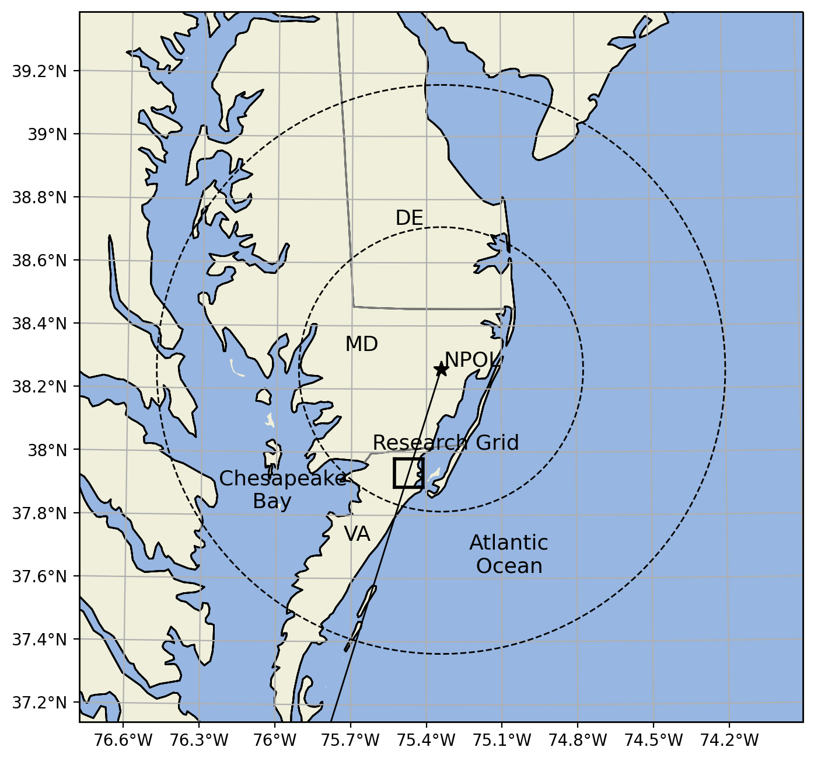
Fig. 1. A regional view of the Wallops Precipitation Research Facility (WPRF) located over the Delmarva Peninsula. The star indicates the NPOL location, with 50 and 100 km range rings, while the solid line represents the 197° RHI directly over the 5 km x 5 km SIMBA research column grid box, centered at 37.934°N and -75.471°W located at NASA Wallops Flight Facility. NPOL is about 38 km away from the center of the SIMBA column (square box).
Research has shown that the gamma DSD parameter D_{m} in GPM/DPR retrievals is correlated to R (Seto et al. 2016; Chase et al 2020). The R-D_{m} optimized relation was first adopted to simultaneously retrieve R and D_{m} for a given Z in the GPM DPR Version 4 algorithm and is currently being used in the latest Version 6 algorithm (Seto et al. 2021). In addition, GPM Level II precipitation algorithms serve as a reference, and in some instances input, to produce global Level III gridded datasets (Huffman et al. 2017; Tan et al. 2018). For example, the Integrated Multi-satellitE Retrievals for GPM (IMERG) product uses information from the GPM satellite constellation to estimate high temporal and spatial resolution precipitation rate over most of the Earth’s surface (Tan et al. 2016; Huffman et al. 2017). Errors in GPM sensor retrieval products propagate into IMERG (Tan et al. 2018). Therefore, GPM Level II retrievals require thorough validation to improve algorithms and hence final data products.
The following section details the WPRF data record and instrumentation. Section 3 presents analysis methods while Section 4 presents results from time lag analysis, discusses the statistical performance of the GPM DPR, DPR/GMI CORRA, and GPROF algorithms, and compares vertical precipitation profiles between GPM sensors and ground-based measurements. A summary and conclusions are discussed in Section 5.

2. Instrumentation and Data
a. GPM data
The GPM Core Observatory satellite has two instruments: 1) the Dual-Frequency Precipitation Radar (DPR) operating at Ka (35.5 GHz) and Ku (13.6 GHz) frequencies, and 2) the GPM Microwave Imager (GMI) radiometer operating at multiple frequencies and polarizations between 10 and 183 GHz (Hou et al. 2014). The DPR consists of three scanning modes: Matched Scan (MS) that consists of both Ka- and Ku-band swaths, Normal Scan (NS) that contains dual-frequency estimates in the inner swath and Ku-band only estimates in the outer swath, and High-sensitivity Scan (HS), that contains Ka-band only, with an approximate 25.0 km² nadir footprint resolution. The Ka scanning mode was modified on 21 May 2018 to include the outer swath of Ku for coincident measurements (Iguchi 2020). For this study, the Level II DPR V06A (2ADPR, Iguchi et al. 2017), Level II Combined Radar-Radiometer V06A (2BCMB, Grecu et al. 2016), and Level II GPROF V05A-B (2AGPROF, Kummerow et al. 2015) satellite products obtained from NASA’s Precipitation Processing System (PPS) are used. Specifically, D_{m}, Z_{e} (corrected for attenuation), and R at the lowest clutter free height (LCFH) from 2ADPR NS, 2BCMB NS, 2BCMB MS algorithms with approximate 5 km horizontal and 0.125-0.250 km vertical resolution are extracted over the study region. In addition, 2AGPROF with an approximate 15 km horizontal resolution surface R retrieval is also extracted.
The 2ADPR NS algorithm functions as a single frequency algorithm with Ku-band measurements in the outer swath (Seto et al. 2021), while the CORRA algorithms take advantage of the multi-frequency measurements (Grecu et al. 2016). For example, the 2BCMB NS takes advantage of both Ku-band and GMI channels while 2BCMB MS utilizes all three sensors (Ku + Ka + GMI). For PSD retrieval, a normalized gamma model is assumed with a fixed shape parameter that is set to 3 in DPR algorithm (Seto et al. 2013) and 2 in the CORRA (Grecu et al. 2016). In addition, DPR algorithm rely on an optimized relationship between R and D_{m} (Seto et al. 2016, 2021) in both single and dual-frequency measurements. On the other hand, the DPR/GMI CORRA relies on DPR calibrated Z and GMI brightness temperature with an a priori database of DSD to retrieve D_{m} and R (Kummerow et al. 2015; Grecu et al. 2016). The CORRA takes advantage of Ku-band Z, path integrated attenuation, and GMI brightness temperatures throughout the NS swath while the algorithm relies on both Ku- and Ka-band Z along with path integrated attenuation and GMI brightness temperatures throughout the MS swath to estimate R (Olson et al. 2018). The key difference between the three algorithms (2ADPR NS, 2BCMB NS, 2BCMB MS) is mostly what sensor is available within the measurement swath area to retrieve the different retrievals important for this study. Finally, the operational GPROF algorithm relies on 89-GHz brightness temperature at a horizontal resolution ranging from 5 – 17 km from GPM constellation members (Kummerow et al. 2015; Skofronick-Jackson et al. 2017) to estimate surface R.
b. Ground-based radar data
NASA has established the WPRF as a semi-permanent super-site for the GPM GV program encompassing NASA’s NPOL radar among myriad other instruments. NPOL is an S-band (2700-2900 MHz) dual-polarimetric radar, operating in simultaneous transmit and receive mode with a 1° beamwidth and 125 m range resolution (Wolff et al. 2015), located 38 km northeast of WPRF near Newark, MD as shown in Fig. 1. The maximum range is 135.0 km (high quality polarimetric data analysis range is within 100 km). The NPOL radar scanning strategy includes plan position indicator (PPI) and range-height indicator (RHI) scans. During GPM Core Observatory overpasses, a special scanning strategy is employed with PPI elevations ranging from 0.7° to 20.0°, RHIs over NASA instruments at azimuths of 195, 197, 199, and 223°, and cross-track/along-track RHIs depending on DPR nadir track relative to NPOL. RHI scans along the 197° azimuth directly over WPRF research grid are used for comparisons to take advantage of the high vertical resolution of RHI data. Raw moment data is calibrated and quality controlled (Pippitt et al. 2015) to produce corrected horizontal reflectivity (Z_{h}, dBZ), differential reflectivity (Z_{dr}, dB), differential phase (°), specific differential phase (K_{dp}, ° km⁻¹), and correlation coefficient (ρ_{hv}). NPOL S- to Ku-band frequency adjustment is applied using the Liao and Meneghini (2009) method to accurately compare ground radar with high frequency DPR. The combination of the standard radar observables is used to compute D_{m} and R retrievals. For example, NPOL D_{m} retrieval is a function of Z_{dr} based on an empirical relation derived from WPRF disdrometer measurements (Tokay et al. 2020a). After quality control, a combination of Z_{h}, Z_{dr}, and K_{dp} driven by a bin-by-bin fuzzy-logic hydrometeor classification is used to retrieve NPOL R (Cifelli et al. 2011; Dolan et al. 2013; Pippitt et al. 2015). Vertical profiles of Z, D_{m}, and R are extracted over the WPRF research grid for validating GPM sensor retrievals.
In addition to NPOL, the WPRF operates several vertically profiling Micro Rain Radars (MRRs) operating at K-band (24 GHz). A single MRR unit operated during each satellite overpass. The MRR raw data is processed by Meteorologische Messtechnik GmbH (METEK) software, which includes several precipitation moments such as Z and R using a Z-R relation (Peters et al. 2005). MRR K-band Z is adjusted to Ku using disdrometer DSD measurements coupled with a radar scattering model to accurately compare with DPR following the Liao et al. (2020) method. In addition, D_{m} profiles are retrieved using the Doppler spectra based on the Testud et al. (2001) method. MRR data at 35 m vertical and one-minute temporal resolution are resampled to 250 m, while neglecting the first two range gates near the surface due to ground clutter (Peters et al. 2005).

c. Disdrometer data
This study uses data from five two-dimensional video disdrometers (2DVD) deployed at the WPRF site. The 2DVD optical disdrometer measures the size, shape, and fall speed of hydrometeors within a 100 cm² area with 0.2 mm bin resolution (Kruger and Krajewski 2002; Tokay et al. 2013). Raw 2DVD data are processed assuming at least 10 drops and a minimum rain rate of 0.1 mm hr⁻¹ per DSD sample to compute one-minute averaged moments. The normalized gamma distribution is assumed to retrieve Rayleigh Z, D_{m}, and R (Tokay et al. 2001; 2013; 2020a). The GPM GV Team truncates D_{m} retrieval below 0.5 mm due to 2DVD sampling limitation for small drops below about 0.5 mm and uncertainty in polarimetric radar drop size retrieval (Tokay et al. 2013; Thurai et al. 2017; Thurai and Bringi 2018; Tokay et al. 2020a).
Five laser-based Particle Size Velocity Version 2 (PARSIVEL²) disdrometers deployed are also used in this study. These disdrometers measure the size and fall speed of hydrometeors within a 54 cm² sampling area with bin resolution ranging from 0.125 to 1.0 mm depending on raindrop size (Tokay et al. 2014). PARSIVEL² data are quality-controlled and processed similarly as 2DVD observations to produce one-minute samples of Rayleigh Z, D_{m}, and R (Tokay et al. 2001; 2013; 2020a). Research has shown that PARSIVEL² measurements can underestimate small drops below 0.76 mm and overestimate moderate to large drops above 2.4 mm (Tokay et al. 2013). The D_{m} truncation mentioned in Section 2c also applies to PARSIVEL² measurements. These limitations can influence satellite validation efforts.

d. Rain gauge data
Properly maintained rain gauges play an important role in validating satellite-based rainfall products. There are four tipping bucket rain gauges utilized in this study, with each tip corresponding to 0.254 mm accumulation at one second precision. The tipping buckets provide the time of each tip to the nearest second and then one minute rainfall rates are derived using the cubic spline interpolation method (Wang et al. 2008). These rates are averaged (described in the next section) to reduce sampling errors and compared with DPR and GPROF retrievals.

3. Methods
a) Matching satellite and ground-based observations
Validating GPM satellite sensor precipitation and DSD retrievals requires multi-sensor datasets from ground-based radars, disdrometers, and rain gauges. These data are recorded in different formats and coordinate systems with varying temporal and spatial resolutions. The GPM Validation Network (VN) software, developed by NASA (Schwaller and Morris 2011; Gatlin et al. 2020) is a tool that geometrically matches ground-based scanning radar data with DPR and GMI to conduct precipitation validation studies. Motivated by GPM GV efforts, another software package, the System for Integrating Multiplatform Data to Build the Atmospheric Column (SIMBA, Wingo et al. 2018) was developed to combine ground-based polarimetric radar, rain gauge, disdrometer, and MRR data with DPR and GMI retrievals onto a user-defined 3-dimensional Cartesian grid for precipitation studies. SIMBA was recently used to investigate precipitation rate variability and non-uniform beam filling over a DPR footprint using the NASA
GPM GV Pocomoke gauge network near WPRF (Pabla et al. 2020).
The present study uses SIMBA (Version 1.6) to combine multi-platform WPRF datasets into precipitation column products for the six-year study period. The study area is the WPRF research grid box containing an MRR unit, multiple disdrometers, and tipping bucket rain gauges along with the NPOL 197° azimuth RHI sampling directly over the site, as shown in Fig. 1. The research grid is centered over WPRF, extending 5 km x 5 km in the horizontal and 6 km in the vertical, deliberately comparable to the DPR footprint size. Horizontal and vertical resolution is 500 m x 500 m and 250 m, respectively. For the analysis in this study, all matched input data closest to the NPOL timestamp is included within the column grid. This timestamp is typically within two minutes of the GPM nadir track closest approach to NPOL. In addition, ground instrument extraction time interval (to assess precipitation measurement lag between satellite and ground instruments) is set to +30 minutes relative to the NPOL timestamp. NPOL measurements are gridded within SIMBA. The GPM 2ADPR, 2BCMB, and 2AGPROF data files with native resolution from PPS are ingested over the research grid. More details on the interpolation and fusion of GV datasets with GPM DPR and GMI retrievals are provided in Wingo et al. (2018). For each overpass case listed in Table 1, SIMBA outputs a single netCDF file with GV observations and satellite retrievals fused to a common grid, and attributes preserving operating parameters (e.g., ground radar scan strategy, satellite algorithm version, precipitation fields, resolutions, etc). Different methods can be employed to compare point measurements collected at the ground with satellite measurements above ground. In this study, ground measurements (2DVDs, PARSIVEL²s, gauges, MRR) are temporally and spatially averaged within the research grid. First, 1-minute ground measurements from multiple units of each instrument type are temporally averaged over a specific time window (discussed later) within +30 after overpass. Next, temporally averaged measurements are then averaged spatially over the 5 x 5 km grid by taking the mean of multiple units to obtain a single value for each instrument type that is directly compared to satellite measurements. In addition, MRR measurements are extracted at 250 meters in the SIMBA vertical grid level while NPOL is extracted at 1000 meters to avoid partial beam blockage at the 197° RHI.
Event Date (YYYY-MMDD) | Timestamp (HH:MM:SS) | WPRF Distance (km) | NPOL Distance (km) | Orbit | Satellite Sensor | MRR | 2DVD | PARSIVEL² | Gauge
2014-1229 | 15:51:24 | 85.4 | 55.4 | 4745 | GMI, Ku, Ka | 0 | 2 | 3 | 4
2015-0521 | 22:02:40 | 33.5 | 45.8 | 6974 | GMI, Ku, Ka | 1 | 2 | 4 | 4
2015-0811 | 12:55:30 | 76.2 | 75.3 | 8244 | GMI, Ku, Ka | 0 | 3 | 2 | 2
2016-1206 | 15:41:09 | 35.5 | 13.2 | 15760 | GMI, Ku, Ka | 1 | 5 | 5 | 1
2017-0401 | 05:49:58 | 77.4 | 73.6 | 17558 | GMI, Ku | 1 | 3 | 5 | 1
2018-0212 | 09:05:39 | 79.7 | 80.2 | 22491 | GMI, Ku, Ka | 0 | 5 | 3 | 3
2018-1113 | 01:07:38 | 35.1 | 11.54 | 26748 | GMI, Ku, Ka | 1 | 4 | 5 | 1
2018-1220 | 14:14:41 | 105.9 | 94.5 | 27332 | GMI*, Ku | 1 | 4 | 1 | 0
2019-0708 | 12:54:54 | 73.1 | 96.8 | 30442 | GMI, Ku, Ka | 1 | 0 | 3 | 1
2020-0104 | 08:14:48 | 35.4 | 2.7 | 33239 | GMI, Ku, Ka | 1 | 3 | 4 | 1
2020-0225 | 07:59:05 | 110.6 | 96.2 | 34048 | GMI, Ku | 1 | 3 | 4 | 1
2020-0924 | 17:40:35 | 116.5 | 119.1 | 37352 | GMI, Ku | 1 | 1 | 0 | 0
2020-1029 | 07:37:06 | 57.8 | 54.3 | 37890 | GMI, Ku, Ka | 1 | 4 | 3 | 1
Table 1. List of GPM Core satellite overpasses considered in the study. Columns represent event date, timestamp in UTC, WPRF research grid center distance from satellite nadir track, NPOL distance from satellite nadir track, orbit number, available satellite sensor, and number of available units for each ground-based instrument. NPOL was available and operating for each event. *Note, on 20 December 2018, 2AGPROF algorithm failed to capture light rain in the research grid. Refer to text for more information.

b. Statistical evaluation metrics
Four metrics are used to evaluate time lag comparisons and the statistical level of agreement between D_{m}, Z_{e}, and R. The bias, normalized bias (NB), mean absolute error (MAE), and the Pearson correlation coefficient (r) are defined as:
$bias= \frac{1}{n}\sum_{i}^{n}{(X_{i}-Y_{i})}$, (1)
$NB= \frac{1}{n}\sum_{i}^{n}{\frac{X_{i}- Y_{i}}{Y_{i}}}$, (2)
$MAE= \frac{1}{n}\sum_{i}^{n}{\left|X_{i}- Y_{i}\right|}$, and (3)
$r= \frac{\sum_{i}{\left(X_{i}- \overline{X}\right)}(Y_{i}- \overline{Y})}{\sqrt{\sum_{i}{{(X_{i}- \overline{X})}^{2}}}\sqrt{\sum_{i}{{(Y_{i}- \overline{Y})}^{2}}}}$ , (4)
where, X is the satellite retrieval and Y is the ground reference (NPOL, MRR, 2DVD, PARSIVEL², Gauge). The overbar in (4) indicates overall mean of the variable while n is the number of samples. Positive values of bias and NB indicate satellite retrieval overestimation relative to the ground reference.

4. Results
Precipitation from cold season frontal systems to warm season airmass showers and widespread stratiform rain are observed by GPM satellite sensors with coincident ground instruments, including scanning NPOL radar, profiling MRR, five 2DVDs, five PARISVEL²s, and four gauges. There were 311 GPM Core Observatory overpasses between February 2014 and December 2020 at the WPRF. Time periods when NPOL was deployed in field campaigns (away from WPRF) and under maintenance are not included. In addition, cases are filtered to include only those with surface liquid precipitation greater than 0.01 mm hr⁻¹ in the WPRF research grid (Fig. 1) and exclude events where the difference between freezing height and DPR LCFH is less than 1.0 km to avoid melting layer contamination. After applying these criteria, there are 13 overpass events with measurable precipitation in the Ku swath, 12 in GMI, and nine in the Ka swath considered in this study as shown in Table 1. It is important to note that the 2AGPROF algorithm missed the capture of light rain (<0.10 mm hr⁻¹) on the 20 December 2018 overpass. While the gauges did not record rainfall from this specific event, the optical disdrometers indicate light rain rates (< 0.10 mm hr⁻¹). This explains the mismatch between Ku and GMI cases listed in Table 1.

a. Time lag analysis
A time lag analysis is crucial to the investigation for several reasons. First, raindrops in a sample volume are distributed with varying sizes and fall speeds. For example, a 1-mm diameter raindrop falling from a height of 1-2 km takes about four to eight minutes to reach a surface measuring instrument such as a disdrometer or rain gauge. For a 5-mm diameter raindrop falling from the same height, it would take two to four minutes to reach the surface, assuming no horizontal wind advection and no drop breakup and/or sorting processes. These assumptions are not valid in the real environment. Second, GPROF depends on ice scattering properties above the freezing level over land to determine surface R using a priori database while DPR attenuation corrected Z, D_{m}, and R are extracted between 1-2 km height above the surface to avoid ground clutter (Tan et al. 2018). Therefore, appropriate time lag correlations between satellite and ground measurements should be employed. Comparisons from GPM profiling algorithms are extracted at least 1-km below the freezing level (obtained via GPM data file attribute) to avoid melting hydrometeors and above the LCFH. Freezing level heights range from 2.3 km in the cool season to about 4.7 km in summer months. LCFH from 2ADPR NS and 2ADPR MS range 0.75 to 2.0 km and 0.75 to 1.25 km above surface in the research grid, respectively. The height varies from orbit to orbit due to the distance between DPR nadir track and WPRF sampling region.
Fig. 2 shows the correlation coefficient (denoted by r) and bias for D_{m} retrievals at the LCFH from a) 2ADPR NS, b) 2BCMB NS, and c) 2BCMB MS with time lag disdrometer and MRR measurements from all cases in Table 1. The r values between satellite (2ADPR NS, 2BCMB NS, and 2BCMB MS) and disdrometers are moderately high (> 0.6) at overpass time, but the peak value (circles) occurs minutes after the overpass. For example, r value peaks for 2ADPR NS and 2BCMB NS with MRR is > 0.80 and occurs eight to nine minutes after the overpass. Interestingly, the peak for 2BCMB MS with 2DVD, PARSIVEL², and MRR is > 0.90 and occurs near two minutes after the overpass. In addition, the minimum bias for all three algorithms is below 0.15 mm and occurs between overpass time and six minutes after overpass time.
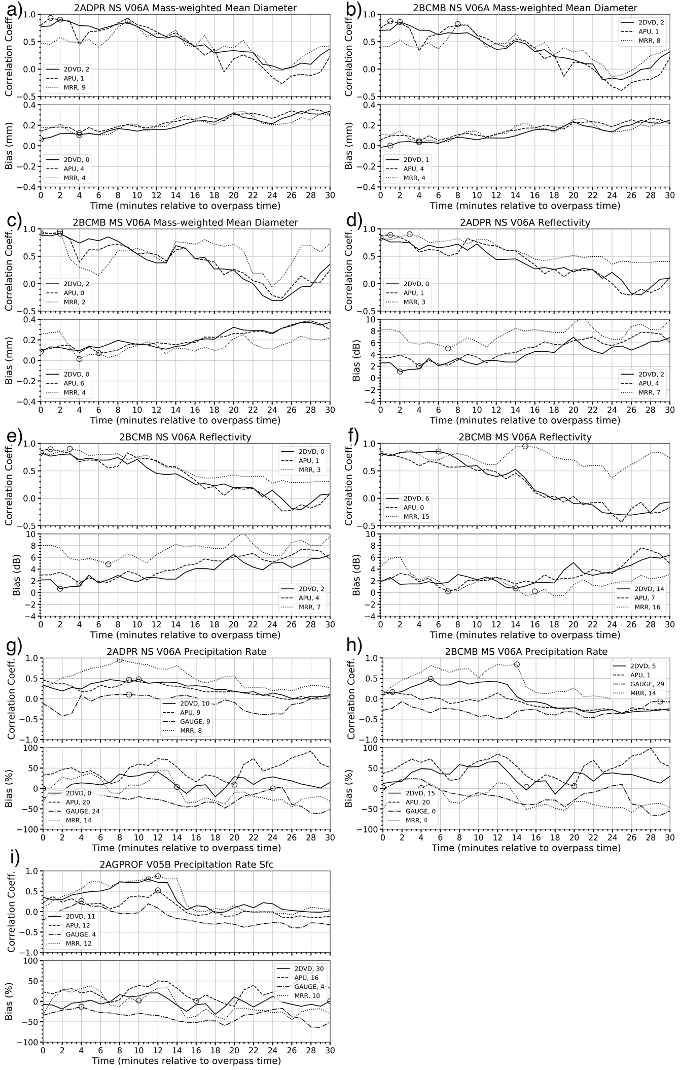
Fig. 2. Correlation and bias of D_{m} from a) 2ADPR NS, b) 2BCMB NS and c) 2BCMB MS; Z_{e} from c) 2ADPR NS, d) 2BCMB NS, and e) 2BCMB MS, R from f) 2ADPR NS, g) 2BCMB MS, and h) 2AGPROF compared to 2DVD, APU, MRR, and Gauge measurements for all stratiform cases listed in Table 1. APU represents PARSIVEL² disdrometer. All algorithms are Version 06A except 2AGPROF Version 05A-B. Circles (and values in legend) represent max (min) correlation (bias) at a given time after overpass for the four ground instrument platforms. Time axis is minutes after overpass time.

In Fig. 2, similar results are shown for attenuation-corrected Z_{e} retrievals from d) 2ADPR NS, e) 2BCMB NS, and f) 2BCMB MS. The r peaks between all three algorithms and disdrometers are near 0.8 at overpass time, but the peak with MRR occurs three minutes after overpass time except when comparing 2BCMB MS where the peak is at 15 minutes after overpass. In addition, the minimum bias for 2ADPR NS and 2BCMB NS with 2DVD is < 1.2 dB and occurs two minutes after the overpass time, while the minimum bias with PARSIVEL² is near 2.0 dB and occurs four minutes after overpass time. The minimum bias relative to MRR Z is near 5.0 dB and occurs seven minutes after overpass time. The minimum bias for 2BCMB MS with all three ground platform instruments is less than 0.8 dB and occur between seven and 16 minutes after overpass time. Furthermore, the bias compares well with ± 3dB bounds used in the Schwaller and Morris (2011) study comparing TRMM PR corrected reflectivity in the VN network.
Fig. 2 also shows the r and NB for R from g) 2ADPR NS and h) 2BCMB MS from LCFH and i) 2AGPROF with time lag disdrometers, gauges, and MRR measurements for all cases. The r peaks for 2ADPR NS and 2BCMB MS with disdrometers and gauges are < 0.5 and occur between overpass time and 29 minutes after overpass but r value improves to near 0.9 when compared with MRR at eight and 14 minutes after overpass. The peak r value (circle) for 2AGPROF with all ground platform measurements except gauges is > 0.5. The highest r value for 2AGPROF with the MRR and 2DVD is near 0.85 and occurs 11 and 12 min after the overpass. In addition, the minimum NB is within ±15% and occurs between overpass and 30 minutes after overpass depending on which algorithm and ground instrument comparison in question. For example, the minimum NB for 2ADPR NS with disdrometers and gauges is < 10% and occurs between zero and 24 minutes after overpass. The minimum NB for 2BCMB MS with 2DVD and PARSIVEL² is near 5% and occurs 15 and 20 minutes after overpass, respectively, while NB compared with gauges is near 2% and occurs at overpass time. The minimum NB for 2AGPROF with 2DVD and PARSIVEL² is < 5% and occurs 16 and 30 minutes after overpass, respectively, while NB compared with gauges is -13% and occurs 4 minutes after overpass.
Maximum r peaks between zero to nine minutes for D_{m}, between zero to 15 minutes for Z_{e}, and between zero to 29 minutes for R. Minimum bias occurs between zero to six minutes for D_{m}, between two to 16 minutes for Z_{e}, and between zero to 30 minutes for R. These findings are consistent with past studies analyzing time lags with TRMM (Amitai et al. 2012) and GPM (Tan et al. 2018) retrieval products. However, these studies compare satellite precipitation retrieval against gauge networks while this study analyzes Z_{e} and D_{m} as well as R against a network of a variety of research quality instruments. While this study focuses on the LCFH of the satellite-based radar retrievals, Utsumi et al. (2019) analyzes range bins above the clutter free gate. Their results show that the r peak is delayed as the TRMM PR instantaneous precipitation rate observation height increases. One important finding in their study states the r peak delay is not only dependent on the fall speed of raindrops but perhaps controlled by the variability of drop size distributions and horizontal motion of precipitating systems. Other factors that may play a role in the variability in the optimal time lag include satellite and ground-based retrieval assumptions, satellite radar viewing angle, and low sample size (especially 2ADPR MS product due to the narrow Ka swath coverage over WPRF). In fact, the Amitai et al. (2012) study shows r value drops slightly when TRMM precipitation rate is compared between gauges with nadir track slightly off the gauge network, assuming a five-minute time lag. The present study lacks the sample size to replicate a similar experiment. Furthermore, simply choosing a specific time that provides the optimal result is not adequate based on the results shown. The optimal time varies based on the statistical metric and precipitation moment in question. Instead of picking a nominal lag similar to Tan et al. (2018), a specific range is chosen between zero and +30 minutes based on the discussion and results presented earlier in this section. Hence, in subsequent sections ground based (except NPOL) retrievals are first averaged between two and eight minutes inclusive after overpass time and then the statistical metrics are computed between ground and satellite retrievals for analysis.
b. Direct comparisons and evaluation of satellite algorithm performance
In this section, direct comparisons between GPM Core satellite sensor retrievals of D_{m}, Z_{e}, and R with ground-based disdrometers, radars, and gauges are discussed. The top row in Fig. 3 shows scatter plots for D_{m} retrieval at the LCFH and 1.0 km below the freezing level from a) 2ADPR NS, b) 2BCMB NS, and c) 2BCMB MS V06A with ground-based observations for the stratiform overpass cases in Table 1. The black solid line in the diagrams represents the 1:1 line, while the dotted lines signify GPM Core Level I science requirements for D_{m} to be within ± 0.5 mm (Skofronick-Jackson et al. 2017) with respect to ground measurements. Total samples on scatter diagrams vary for each algorithm compared to ground, depending on ground instrument availability for each overpass (See Table 1). All GPM and GV D_{m} pairs lie between 0.5 and 2.0 mm and show that GPM D_{m} retrieval meets science requirements with respect to ground radar and disdrometer measurements (with two borderline exceptions). Since there were no requirements set for the normalized intercept parameter (N_{w}), this study does not include N_{w}. In addition, the bottom row in Fig. 3 shows the statistical comparison of the three GPM Core D_{m} algorithms for all stratiform precipitation cases compared to ground measurements. The r value is above 0.5 for all three algorithms compared with ground-based data. Generally, the highest r occurs with 2BCMB MS potentially due to the multi-frequency (Ku+Ka+GMI) algorithm, though it should be pointed out again the samples include nine cases in 2BCMB MS and 14 cases in 2ADPR and 2BCMB NS. The overall bias ranges from near 0.0 mm for 2BCMB NS to just above 0.1 mm for 2ADPR NS and 2BCMB MS algorithms. The MAE for the D_{m} retrieval ranges from 0.10 mm to near 0.30 mm among the three algorithms. In terms of bias and absolute error, 2BCMB NS V06A performs optimally. 2ADPR NS, 2BCMB NS, and 2BCMB MS V06A D_{m} retrieval performs best when compared to NPOL D_{m} and worst when compared to MRR D_{m}. The optimal performance with NPOL D_{m} is very promising for GPM GV. Several ground validation studies have reported consistent results in literature. For example, DPR and DPR/GMI combined D_{m} retrieval algorithms in stratiform rain over Italy indicate absolute bias < 0.5 mm using a C-band network (D’Adderio et al. 2018) while DPR retrievals show MAE < 0.20 mm using a disdrometer network over the same region (Adirosi et al. 2021). In addition, MAE in 2ADPR and 2BCMB V06A D_{m} retrievals in stratiform rain compare quite well with the global study using a network of S-band radars in Gatlin et al. (2020).
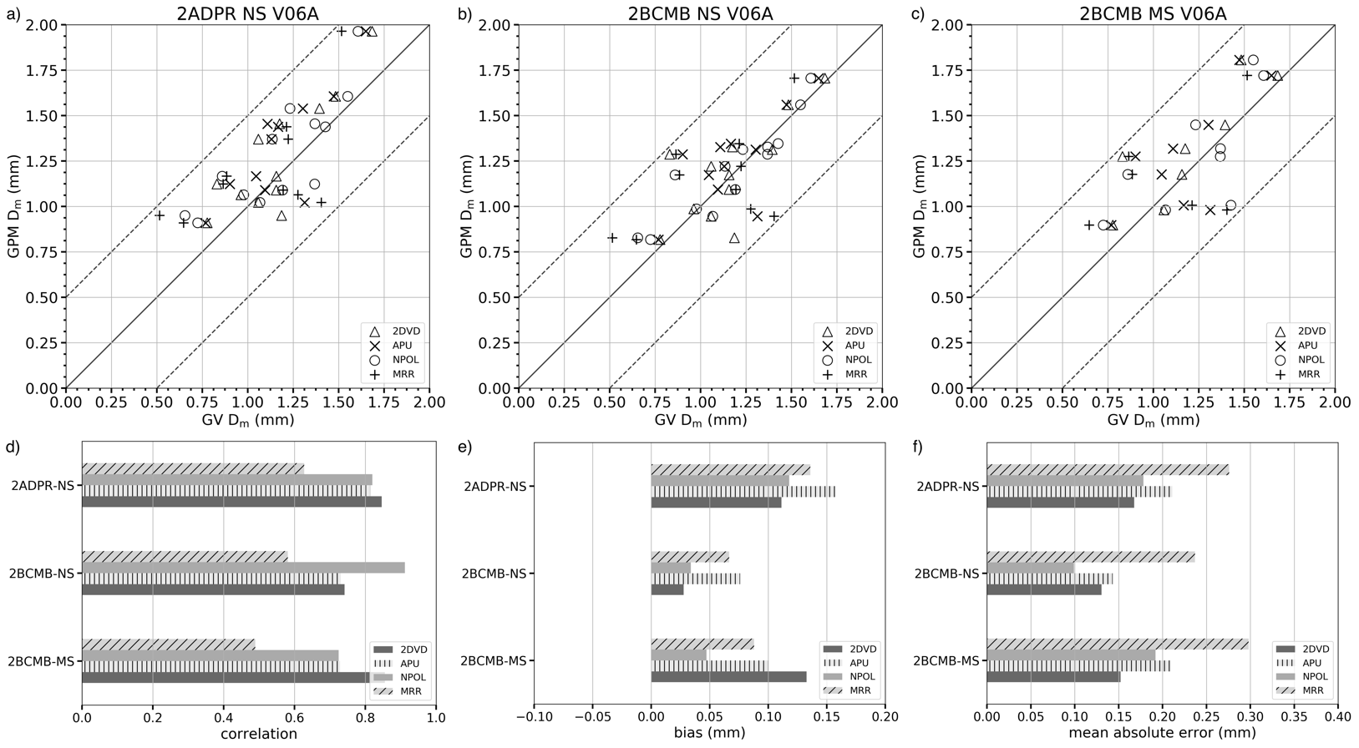
Fig. 3. Scatter plots of D_{m} retrieval from the GPM core satellite and GV instruments for a) 2ADPR NS, b) 2BCMB NS, and c) 2BCMB MS Version 06A algorithms and d) correlation, e) bias, and MAE for all cases. Each symbol in scatter plot represents one observation pair of GPM + GV case listed in Table 1. A seven-minute average is taken between two and eight minutes after overpass time of 2DVD (triangle), APU (cross), and MRR (plus) measurements. NPOL (circle) measurements are averaged over a 5 x 5 km grid at 1.0 km height. The 250-meter MRR values are averaged over the same seven-minute period as the disdrometers. Black solid line represents the 1:1 line while the dotted lines represent GPM Core Level 1 science requirements.

Documenting and quantifying error in satellite Z_{e} measurements is also important to the radar community. For example, studies report using satellite Z_{e} to compare and calibrate ground radar data (Schwaller and Morris 2011; Kim et al. 2014; Warren et al. 2018), and Z_{e} errors can greatly affect PSD and precipitation retrievals in GPM satellite algorithms (Seto et al. 2016; Grecu et al. 2016). The top row in Fig. 4 shows similar scatter as Fig. 3 but for Z_{e} retrievals. The black solid line in the diagrams represents the 1:1 line, while the dotted lines signify the Schwaller and Morris (2011) ± 3 dB error bounds used in TRMM PR reflectivity validation. For perspective, a 3 dB change in reflectivity results in roughly a factor of 2 or 50% change in rainfall rate using a specific Z-R relation. There is much more variance in Fig. 4a) 2ADPR NS (Ku+Ka in the inner swath; Ku in the outer swath) and b) 2BCMB NS (Ku+GMI) vs c) 2BCMB MS (Ku+Ka+GMI), potentially due to matched beam region with the multi-frequency algorithm (Ku+Ka+GMI). The bottom row in Fig. 4 illustrates the statistical performance of the algorithms compared to ground measurements for all cases. The r value ranges from 0.7 to near 0.8 among the different algorithms compared to ground measurements. The 2ADPR NS r near 0.7 with 2DVDs is slightly lower compared to Adirosi et al. (2021) study showing 0.87 over Italy. Bias error ranges from near 1.0 to 5.0 dB while the MAE hovers around 2.5 to 5.0 dB among the different algorithms compared to ground measurements. The bias is much higher when compared to MRR measurements instead of the disdrometers and NPOL, potentially due to inaccurate retrievals due to vertical air motion, known to be a significant challenge for using MRR observations (Peters et al. 2005; Jameson et al. 2021). The MAE with 2DVDs is on the high end compared to the stratiform partition study over Italy (Adirosi et al. 2021). The disagreement may partly be due to the averaging time difference between the studies (10-minute vs seven-minute averaging after overpass time in this study) and the methodology used to match satellite and ground measurements. It is difficult to pinpoint a single ground instrument that best compares with satellite algorithms due to the different optimal performance in each metric. However, between the three algorithms 2BCMB MS performs the best compared to all ground measurements with a bias near 1.0 dB.
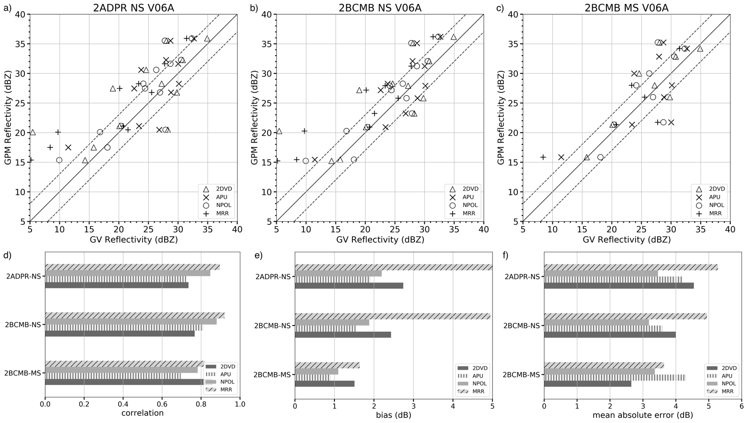
Fig. 4. As in Fig. 3 but for Z_{e}. The black line in scatter plot represents the 1:1 line while the dotted line is Schwaller and Morris (2011) ± 3 dB bounds.

The top row in Fig. 5 shows scatter diagrams for R retrieval at LCFH from a) 2ADPR NS and b) 2BCMB MS V06A, and surface R from c) 2AGPROF V05B compared to ground-based data. There is some variance among the different algorithms, but points lie near the 1:1 line (note the log scale). The evident outlier clearly seen top left in Fig. 5c, where GPROF overestimates relative to 2DVD (triangle symbol) and near surface MRR (plus symbol) is from the 24 September 2020 drizzle to light rain event. In fact, this outlier is also present in 2ADPR NS (Fig. 5a). The Ka swath (or 2BCMB MS algorithm) did not have coverage over the WPRF research grid for this case. Results show GPM DPR and GPROF algorithms overestimate rainfall rates below 1.0 mm hr⁻¹ while rates above 1.0 mm hr⁻¹ are generally nearer to the 1:1 line. In fact, the overestimation for low rates between 2AGPROF and ground measurements agrees with the Tan et al. (2018) study over a small-scale rain gauge grid in Pocomoke, Maryland (roughly 18 km from WPRF). The bottom row in Fig. 5 represents the statistical performance of the algorithms compared to ground measurements for all cases. The r value generally ranges from near zero to as high as 0.75 among the different algorithms compared to surface measurements. Interestingly, r for 2BCMB MS with rain gauges is negative and near -0.25. The negative r may in part be due to the cubic spline interpolation of tip data into rates (Wang et al. 2008), temporospatial mismatch between DPR and gauges, and most importantly due to low sample size. The negative r values are not a surprise as other studies have shown results comparing gauges with satellite derived rain rates. For example, Tan et al. (2018) compared DPR Ku and GPROF instantaneous R between the Pocomoke gauge network for two different time lags. The r value is 0.35 with no lag (i.e., DPR Ku compared against averaged gauge rates at overpass time) while it jumps to 0.57 when compared to five minutes after overpass. The value of r is 0.23 for GPROF with no lag while it decreases slightly to 0.19 for a five-minute lag. A check is performed for no time lag (i.e., compare GPM DPR and GPROF retrievals with surface measurements at overpass time) and adding a nominal five-minute lag, similar to the Tan et al. (2018) study; results (not shown) did not differ when compared to a mean time lag between two and eight minutes after overpass as shown above. In addition, NB for R retrieval from 2ADPR NS, 2BCMB MS and 2AGPROF in Fig. 5e is within ± 40% with respect to ground measurements. These results are consistent with past studies (e.g., Gatlin et al. 2020; Adirosi et al. 2021). The 2ADPR NS algorithm performs best when compared to NPOL, 2BCMB MS performs best when compared to gauges, and 2AGPROF performs best when compared to 2DVD all with a NB < 5.0%. Furthermore, MAE ranges from 1.0 to 2.0 mm hr⁻¹ among the different algorithms compared to ground measurements which is consistent with past studies (e.g., Chase et al. 2020).
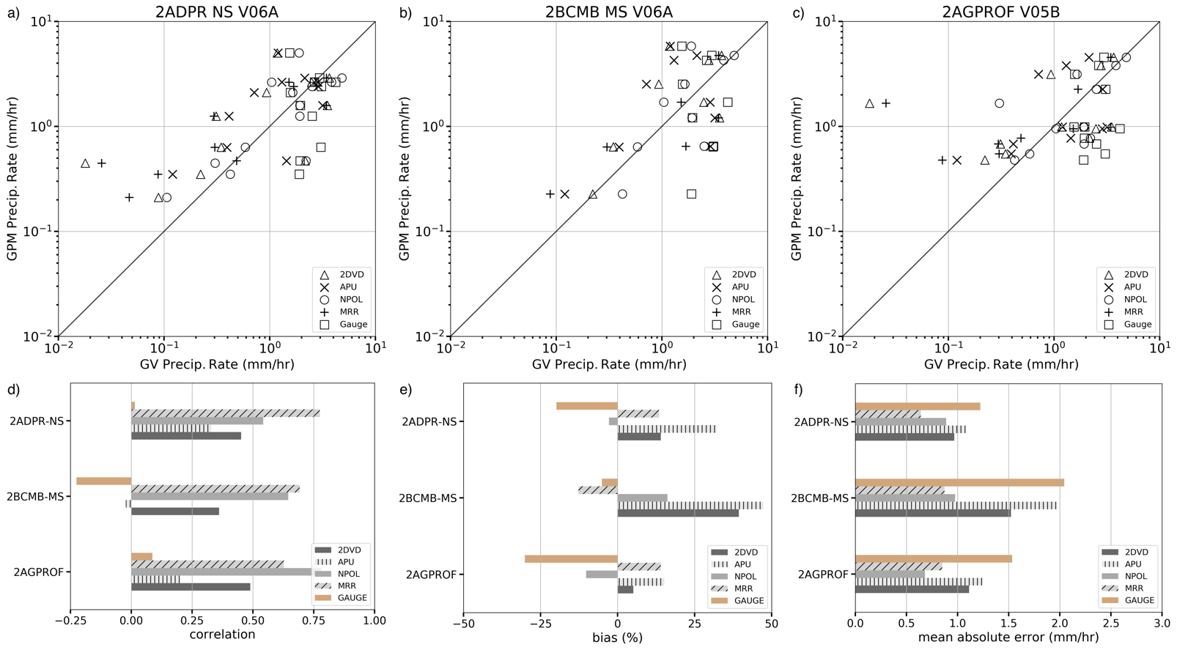
Fig. 5. As in Fig. 4 but for R. Black line in scatter plot represents the 1:1 line. Note the logarithmic scale.

c. Vertical column comparisons
This section compares the profiles of GPM DPR and DPR/GMI CORRA attenuation corrected Z_{e}, R, and D_{m} aloft and GPROF near-surface R with surface-based measurements. DPR values below the clutter free bin are excluded in SIMBA (Wingo et al. 2018). The advantage of SIMBA-generated output is to simultaneously compare precipitation products from different algorithms from the same sensor or different sensors in a common coordinate system.
Widespread light stratiform rain from a descending GPM Core Observatory overpass on 04 January 2020 at 0814 UTC, is shown in Fig. 6a with DPR Z_{e} and R map shown in Fig 6b. Fig. 7a displays 5 km x 5 km horizontal mean surface and column profiles of Z, R, and D_{m} from GPM Core algorithms and surface-based measurements while NPOL Z_{h}, Z_{dr}, ρ_{hv} and hydrometeor identification (HID, Dolan et al. 2013) from NPOL RHI along 197° azimuth are shown in Fig. 7b. The WPRF location is shown with a black dotted line near 40 km range in Fig. 7b. The 2ADPR and 2BCMB Z_{e} profiles compare well with S-to-Ku adjusted NPOL throughout the column except slight deviation just above the melting layer near 4.0 km. However, near-surface Z_{e} (essentially values extracted from the lowest-clutter free bin with some additional processing within the retrieval algorithm) from 2ADPR NS and MS (near 29 dBZ) are high relative to disdrometer Rayleigh Z (triangle and cross symbols) and near surface MRR K-to-Ku adjusted Z (dashed-dotted line) ranging from 20-23 dBZ. Refer to Table 2a for surface values from the different sensors and platforms. NPOL Z in Fig. 7b shows enhanced values just below 4.0 km (bright band) and lowering correlation with slightly enhanced Z_{dr} as a confirmation of melting in Fig. 7a mean profiles. The sharp reduction of NPOL Z below 1.0 km in Fig. 7a is due to beam blockage at 197° azimuth. DPR values below 1.0 km height are not shown due to clutter. The 2ADPR and 2BCMB R profiles agree well with NPOL in the column and MRR derived rate at 1.0 km. The near-surface algorithms 2ADPR NS and MS R overestimate relative to disdrometer measurements and underestimate relative to gauges. The surface 2BCMB NS, MS and 2AGPROF are all slightly low compared to disdrometers but underestimate relative to gauges. This case is drizzle dominated as seen from HID plot in Fig. 7b. The gauges are the outlier in this comparison potentially due to the cubic spline method used to retrieve R from tip accumulation data. The 2ADPR NS, 2BCMB NS, 2BCMB MS D_{m} profiles are slightly high but generally agree with NPOL in the column and at 1.0 km with MRR. LCFH extracted D_{m} retrieval from satellite algorithms are comparable to 2DVD D_{m} but underestimate by 0.3 mm relative to PARSIVEL² (refer to Table 2a). The combination of these profiles can highlight precipitation processes in a vertical column. For example, the near constant D_{m} profile below the melting level indicates minimal drop break up or growth.
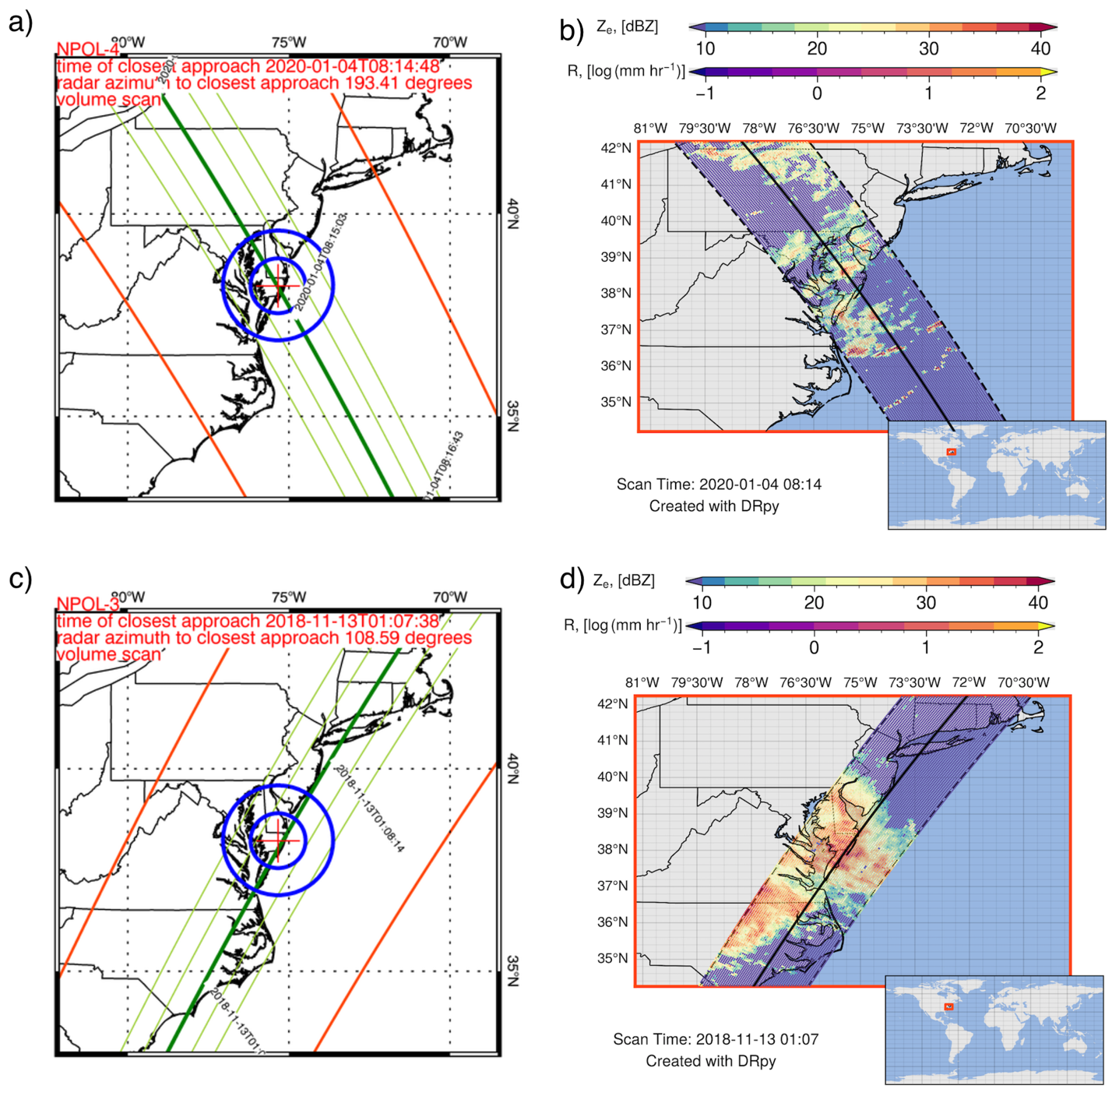
Fig. 6. GPM Core satellite overpass orbit track in a) 04 January 2020 0814 UTC and c) 13 November 2018 0107 UTC with GMI (red), DPR Ku (outer), and Ka (inner) swath lines (green) and NPOL 75 and 150 km range rings (blue). Plots created by DRpy (Chase 2022) in b) and d) show DPR Version 6A near surface Z_{e} and R associated with the two cases.

Another stratiform rain case from an ascending GPM Core Observatory overpass on 13 November 2018 at approximately 0107 UTC is shown in Fig. 6c with DPR Z_{e} and R map shown in Fig 6d. Fig. 7c displays mean profiles and surface values within the study’s research grid centered over the WPRF. A four-panel NPOL RHI in Fig. 7d shows a strong bright-band (BB) melting signature near 2 km above the surface. The 2ADPR and 2BCMB NS Z_{e} profiles closely match NPOL S-to-Ku adjusted Z within the bright band while overestimate beneath the bright band by about 3.0 dB. On the other hand, the 2ADPR and 2BCMB MS Z_{e} profiles underestimate throughout the profile (including within the BB) by 5-10 dB. However, both algorithms slightly overestimate by 1-3 dB below the bright band compared to NPOL and MRR K-to-Ku adjusted Z. It is possible that the DPR and CMB algorithm attenuation correction in Z may be a reason why Z_{e} values are overestimated relative to NPOL and MRR. In addition, ice scattering effects may be contributing to the deviations seen in both 2ADPR and 2BCMB MS algorithms. Ice scattering has been mentioned in past studies affecting Ku and GPROF signals that are used in both 2ADPR and 2BCMB algorithms (Tan et al. 2018). It is worth mentioning that attenuation is not a concern in stratiform S-band radar data. Surface Z_{e} from 2ADPR NS is near 37 dBZ and 2ADPR MS is 34 dBZ while 2DVD and PARSIVEL² report 35 and 33 dBZ respectively. The rain rates from both 2ADPR NS and 2BCMB MS algorithms match quite well relative to NPOL in the column below the BB. Surface rain rate algorithms from 2ADPR, 2BCMB, and GPROF overestimate relative to disdrometers and gauges (See Table 2b). Profiles of 2ADPR NS, 2BCMB NS, and 2BCMB MS D_{m} retrievals show very little change with height while NPOL D_{m} decreases and then increases towards the ground. MRR D_{m} shows a decreasing trend toward the ground. LCFH extracted D_{m} retrieval from 2ADPR NS overestimate relative to disdrometers by almost 0.3 mm at the surface while both 2BCMB NS and 2BCMB MS values are within 0.05 mm relative to disdrometer derived as can be seen from Table 2b. The multi-frequency information from Ku, Ka, and GMI outperforms the single frequency in terms of D_{m} retrievals shown. The D_{m} values are high (> 1.5 mm) compared to the previous case due to thickness of the melting level as shown in Fig. 7d. This feature has been studied recently in Gatlin et al. (2018) experiment comparing NPOL RHI with 2DVD data. The combination of SIMBA derived vertical profiles with NPOL RHI helps illustrates the microphysical processes occurring within the precipitating column including the BB.
The two vertical profile cases are similar with respect to GPM nadir track (refer to Fig. 6) and precipitation type but differ quite a bit in terms of precipitation depth and satellite algorithm validation with ground measurements. For example, the January 2020 case has less echo above the melting layer with melting wet snow contributing to surface light rain and drizzle as seen from NPOL RHI in Fig. 7b. The November 2018 case has considerably more echo above the melting level in the ice region with a very thick melting layer as shown in NPOL RHI in Fig. 7d. An interesting feature in Fig. 7a shows satellite algorithm differences in Z in the ice/snow region due to limited echo. The satellite R algorithms compare well with NPOL and MRR in the column for both cases but deviations are seen near the surface compared with disdrometers and gauges. D_{m} profiles from satellite algorithms generally compare well with NPOL and MRR in the column for both cases while slight deviations are seen when near surface LCFH extracted values are compared with surface disdrometers. The level of agreement between satellite D_{m} retrieval with ground measurements in both cases are within Level I science requirements which is consistent with the combined case analysis in Section 4b.
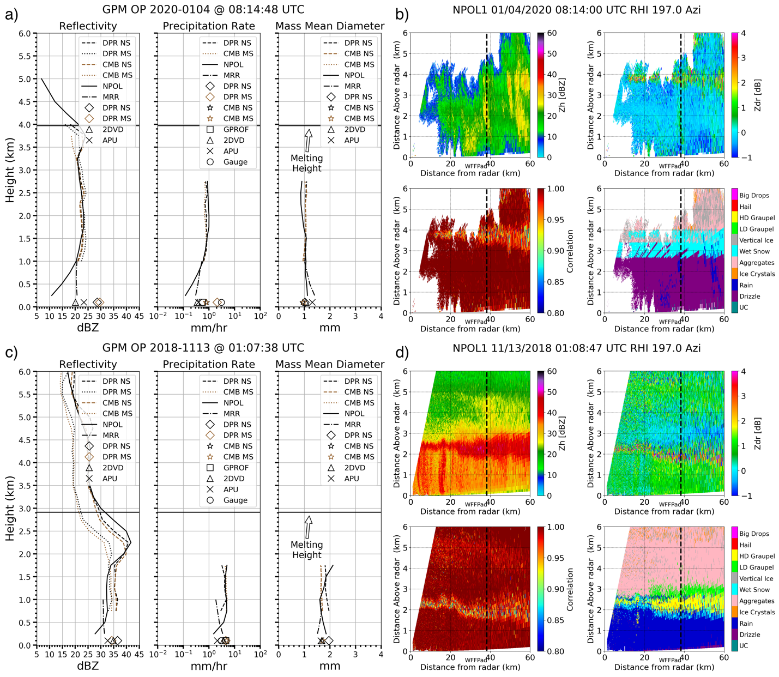
Fig. 7. Mean surface and profile of Z, R, and D_{m} from GPM sensor algorithms and surface observations with black horizontal line representing the melting level for a) 04 January 2020 and c) 13 November 2018 cases. NPOL 197° RHI reflectivity (Z_{h}), differential reflectivity (Z_{dr}), correlation (ρ_{hv}, and hydrometeor identification (HID) for b) 04 January 2020 and d) 13 November 2018 cases. The dotted vertical line near 40 km represents WPRF. The Python ARM Radar Toolkit, Py-ART (Helmus and Collis 2016) is used for displaying radar data in b) and d).

- GPM Overpass 04 January 2020, Orbit 33239
 | Z (dBZ) | R (mm hr⁻¹) | D_{m} (mm)
2ADPR NS | 28.6 | 2.10 | 1.02
2ADPR MS | 29.6 | 2.10 | -
2BCMB NS | - | 0.81 | 0.95
2BCMB MS | - | 0.76 | 0.98
2AGPROF | - | 0.55 | -
2DVD | 20.1 | 0.35 | 1.06
PARSIVEL² | 23.4 | 0.39 | 1.31
Gauge | - | 3.05 | -

b) GPM Overpass 13 November 2018, Orbit 26748
 | Z (dBZ) | R (mm hr⁻¹) | D_{m} (mm)
2ADPR NS | 36.6 | 4.58 | 1.96
2ADPR MS | 34.3 | 4.58 | -
2BCMB NS | - | 4.83 | 1.71
2BCMB MS | - | 4.89 | 1.72
2AGPROF | - | 4.55 | -
2DVD | 34.9 | 3.67 | 1.68
PARSIVEL² | 32.7 | 2.14 | 1.65
Gauge | - | 2.97 | -

Table 2. Surface and near surface values from Fig. 7a and 7c.

5. Summary
This study compares GPM Level II precipitation products with ground validation measurements to document retrieval differences for a six-year collection of GPM Core Observatory overpasses between February 2014 and December 2020 at the WPRF on the Delmarva Peninsula. The observations include 13 stratiform precipitation cases with coincident observations from NPOL, MRR, 2DVDs, PARSIVEL²s, and tipping bucket rain gauges. Specifically, Level II DPR V06A, Level II DPR/GMI CORRA V06A, and Level II GPROF V05A-B algorithms are evaluated in the column profiles and at the surface, when appropriate. The mass-weighted mean diameter (D_{m}, mm), attenuation corrected reflectivity (Z_{e}, dBZ) and precipitation rate (R, mm hr⁻¹) products from GPM satellite sensors are used to evaluate algorithm retrievals. The SIMBA Version 1.6 software package, developed for the GPM mission ground validation program (Wingo et al. 2018) is used to combine multi-sensor and multidimensional datasets into a common coordinate system for comparison. SIMBA is a unique data fusion package where a user can include multiplatform and multiparameter observations and define an analysis grid specific to their research needs to conduct scientific research. In this study, a 3-dimensional DPR footprint-scale research grid is defined over the WPRF sampling region.
Comparing instantaneous GPM sensor precipitation measurements above the surface with ground observations should involve some time lag due to fall delay. Therefore, this study conducts a time lag comparison of R to surface platforms, similar to past studies (e.g., Amitai et al. 2012; Tan et al. 2018), but with two additional validation parameters that are crucial to GPM algorithm developers (D_{m} and Z_{e}). GPM DPR and DPR/GMI CORRA data are extracted at least 1-km below the melting level to avoid partially melted hydrometeors and above the lowest clutter free height (LCFH) to avoid ground clutter contamination. Quality controlled NPOL observations, high temporal and spatial resolution MRR, disdrometer, and rain gauge data are used to evaluate the performance of the algorithms. The time lag investigation indicates maximum correlation coefficient (r) values [minimum bias and normalized bias (NB)] are between overpass time and 30 minutes after overpass. Similar to past findings by Tan et al. (2018), there is no consistent value of time lag, but it does vary between zero and 30 minutes after the overpass. Therefore, GPM DPR, DPR/GMI CORRA, and GPROF retrievals are compared with the mean between two and eight minutes after overpass time ground-based measurements.
The GPM DPR, DPR/GMI CORRA, and GPROF retrievals’ statistical performance is evaluated over a 5 km x 5 km research grid with one minute resolution surface disdrometers, rain gauges, and MRR measurements averaged between two and eight minutes after overpass. The r value for 2ADPR NS, 2BCMB NS, and 2BCMB MS D_{m} retrieval is above 0.5. The highest r value to ground observations occurs with the 2BCMB MS D_{m} algorithm possibly due to multi-frequency information from Ku, Ka, and GMI sensors. The overall bias ranges from near 0.0 to as high as 0.1 mm while the MAE range from 0.10 to 0.30 mm between the three algorithms. The 2BCMB NS V06A D_{m} retrieval algorithm performs optimally, based on the bias and MAE statistical metrics. GPM Level I science requirements for D_{m} to be within 0.5 mm error with respect to ground measurements (Skofronick-Jackson et al. 2017) are met for all three algorithms in the stratiform precipitation cases evaluated in this study. When comparing 2ADPR NS, 2BCMB NS, and 2BCMB MS Z_{e} retrievals with ground observations, r values range between 0.7 and 0.8. Bias error ranges from 1.0 to near 5.0 dB while MAE is near 2.5 to 5.0 dB. MRR K-band Z is measured and corrected for attenuation through METEK’s processing software (Peters et al. 2005) and Ku adjusted using WPRF disdrometer measurements, while disdrometer Z is computed using Rayleigh scattering assumptions. Additionally, NPOL S-band reflectivity is converted to Ku-band following the Liao and Meneghini (2009) method before comparing to GPM. Bias error is near 5.0 dB when 2BCMB NS and 2ADPR NS are compared with MRR Ku-adjusted Z, while the error remains below 2.0 dB for 2BCMB MS. Between the three algorithms, 2BCMB MS perform well in the context of the ground-based data, with bias near 1.0 dB. Results from GPM Core precipitation retrieval algorithms show rates below 1.0 mm hr⁻¹ generally overestimate compared to all ground measurements, while rates above 1.0 mm hr⁻¹ rates are generally nearer to the 1:1 line. The r value ranges from 0 to 0.75 between 2ADPR NS and 2BCMB MS LCFH, and 2AGPROF compared to surface measurements. While the overall GPM Core R NB is within ± 40% with respect to ground measurements, 2ADPR NS performs best when compared to NPOL, 2BCMB MS performs best when compared to gauges, and 2AGPROF performs best when compared to 2DVD with a bias less than < 5%. Overall, results show that the multiple frequency information in the CORRA (i.e., 2BCMB NS and 2BCMB MS) outperforms the single frequency retrieval (i.e., 2ADPR NS). This finding is important and agrees to other studies in literature (e.g., D’Adderio et al. 2018; Gatlin et al. 2020; Bringi et al. 2021). In addition, it is important to point out the relative uncertainty with choosing different time lags. For example, the statistical metrics were computed for time lags one to five, six to 10, one to 10, and one to 30 minutes after overpass and results showed minimal impact relative to two to eight minutes after overpass time. The satellite D_{m} bias with ground-based measurements fluctuates ± 0.10 mm which demonstrates meeting GPM Core Level I science requirements regardless of the time lag choice. The bias in Z_{e} fluctuates about ± 1.0 dB while the NB in R is < 25%.
Two examples of SIMBA precipitating columns are shown to examine GPM DPR and DPR/GMI CORRA performance on an individual case as opposed to combining all cases. The first example from 04 January 2020 shows GPM DPR and DPR/GMI Z_{e} match well with NPOL in the column, however, near surface algorithms overestimate compared to disdrometer derived Rayleigh Z. GPM DPR and DPR/GMI R agree with NPOL and MRR in the column but near surface algorithms overestimate compared to disdrometers and underestimate relative to gauges. Furthermore, GPM DPR and DPR/GMI D_{m} profiles agree well with NPOL and MRR in the column. In the second example from 13 November 2018, 2ADPR and 2BCMB NS Z_{e} profiles match NPOL within the BB while overestimate below BB while 2ADPR and 2BCMB MS Z_{e} profiles underestimate within the BB. In addition, 2ADPR NS and MS near surface Z_{e} algorithm is comparable to disdrometers and near surface MRR. The R profiles from 2ADPR algorithm compare well relative to NPOL. However, all three 2ADPR NS, 2BCMB MS, and GPROF surface algorithms overestimate relative to disdrometers and gauges. Also, profiles of 2ADPR NS, 2BCMB NS, and 2BCMB MS D_{m} retrievals show subtle changes with height in the column while NPOL D_{m} decreases and then increases towards the surface. The two cases are similar with respect to the GPM satellite nadir track but the precipitation depth and the algorithm retrievals differ compared to ground measurements. The disagreement between satellite and surface measurements shown in this study is potentially due in part to the comparison strategy used. Several studies have highlighted the implications of mismatch between satellite and ground measurements due to complex geometry related to FOV and orbit track (Bolen and Chandrasekar 2003; Amitai et al. 2012; Adirosi et al. 2021). In addition, ground measurements have their own uncertainties (e.g., instrument sampling limitations) and retrieval assumptions (e.g., empirical fitting errors) related to data quality control that may affect accurate comparisons to satellite sensors.
Results in this study are limited to 13 GPM Core Observatory overpasses over the WPRF sampling region with the emphasis on DPR retrievals along with GMI. However, since February 2014 the WPRF database has over 100 of GMI only swath coverage overpasses with coincident ground measurements. There are many cases in the database to explore issues such as light rain affecting 2AGPROF surface R retrieval (e.g., Tan et al. 2018; Skofronick-Jackson et al. 2019; Petersen et al. 2020). Moreover, the DPR, like other satellite radars suffer from the blind zone due to ground clutter (Maahn et al. 2014; Skofronick-Jackson et al. 2019). Vertical profiles of Z, R, and D_{m} from NPOL and MRR beneath the DPR LCFH (e.g., Fig. 7a and c) can provide insight to algorithm developers on parameterization techniques and future research on how to improve process understanding in the DPR blind zone.

Acknowledgments.
We thank Jianxin Wang (NASA Goddard Space Flight Center and Science Systems and Applications Inc.) for processing and quality control of the tipping bucket rain gauge data, and Drs. Walt Petersen (NASA Marshall Space Flight Center) and Ali Tokay (NASA Goddard Space Flight Center and Joint Center for Earth Systems Technology/University of Maryland Baltimore County) for thoughtful discussions on the analysis in this study. We also thank the entire GPM Wallops Precipitation Research Facility engineers and technician staff for installing, calibrating, and maintaining ground precipitation instruments. Comments from three anonymous reviewers helped improve the quality of the paper. This work was supported by previous Program Scientist Dr. Gail Skofronick-Jackson (NASA HQ) and current GPM Project Scientist Dr. Scott Braun (NASA Goddard Space Flight Center). In addition, this study is funded by GPM Deputy Project Scientist for Ground Validation David Wolff (NASA Goddard Space Flight Center and Wallops Flight Facility) under GPM Ground Validation Program. Charanjit Pabla, David Marks and Jason Pippitt are supported through SSAI contract (NG17HP01C) with NASA, and Stephanie Wingo’s efforts are supported by NASA Marshall Space Flight Center award (NNM11AA01A) with University of Alabama in Huntsville and Earth System Science Center.

Data Availability Statement.
The GPM GV WPRF dataset used in this study and the latest version for SIMBA can be obtained from https://gpm-gv.gsfc.nasa.gov/. NPOL radar data can be accessed through https://pmm-gv.gsfc.nasa.gov/pub/gpmarchive/Radar/NPOL/Newark/. GPM data can be downloaded from NASA PPS https://arthurhou.pps.eosdis.nasa.gov/.

REFERENCES
Adirosi, E., and Coauthors, 2021: Validation of GPM rainfall and drop size distribution products through disdrometers in Italy. Remote Sens., 13, 2081.
Amitai, E., C. L. Unkrich, D. C. Goodrich, E. Habib, and B. Thill, 2012: Assessing satellite-based rainfall estimates in semiarid watersheds using the USDA-ARS Walnut Gulch gauge network and TRMM PR. J. Hydrometeor., 13, 1579–1588.
Biswas, S., and V. Chandrasekar, 2018: Cross-validation of observations between the GPM dual-frequency precipitation radar and ground based dual-polarization radars. Remote Sens., 10, 1773.
Bolen, S. M., and V. Chandrasekar, 2003: Methodology for aligning and comparing spaceborne radar and ground-based radar observations. J. Atmos. Oceanic Technol., 20, 647-659.
Bringi, V., Mircea Grecu, Alain Protat, Merhala Thurai, and Christian Klepp, 2021: Measurements of rainfall rate, drop size distribution, and variability at Middle and Higher Latitudes: Application to the Combined DPR-GMI Algorithm. Remote Sens., 13, 2412.
Chase, R. J., 2022: DRpy Github Page. Accessed 31 March 2022, https://github.com/dopplerchase/DRpy.
Chase, R. J., S. W. Nesbitt, and G. M. McFarquhar, 2020: Evaluation of the microphysical assumptions within GPM-DPR using ground-based observations of rain and snow. Atmosphere, 11, 619.
Chen, H., V. Chandrasekar, and R. Bechini, 2017: An improved dual-polarization radar rainfall algorithm (DROPS2.0): Application in NASA IFloodS field campaign. J. Hydromet., 18, 917-937.
Cifelli, R., V. Chandrasekar, S. Lim, P. Kennedy, Y. Wang, and S. Rutledge, 2011: A new dual-polarization radar rainfall algorithm: Application in Colorado precipitation events. J. Atmos. Oceanic Technol., 28, 352–364.
D’Adderio, L. P., G. Vulpiani, F. Porcu, A. Tokay, and R. Meneghini, 2018: Comparison of GPM Core Observatory and ground-based radar retrieval of mass-weighted mean raindrop diameter at midlatitude. J. Hydrometeor., 19, 1583–1598.
Dolan, B., S. A. Rutledge, S. Lim, V. Chandrasekar, and M. Thurai, 2013: A robust C-band hydrometeor identification algorithm and application to a long-term polarimetric radar dataset. J. Appl. Meteor. Climatol., 52, 2162–2186.
Fisher, B, and D. B. Wolff, 2011: Satellite sampling and retrieval errors in regional monthly rain estimates from TMI, AMSR-E, SSM/I, AMSU-B, and the TRMM PR. J. Appl. Meteor. Climatol., 50, 994-1023.
Gatlin, P. N., M. Thurai, V. N. Bringi, W. Petersen, D. Wolff, A. Tokay, L. Carey, and M. Wingo, 2015: Searching for large raindrops: A global summary of two-dimensional video disdrometer observations. J. Appl. Meteor. Climatol., 54, 1069–1089.
Gatlin, P. N., W. A. Petersen, K. R. Knupp, and L. D. Carey, 2018: Observed response of the raindrop size distribution to changes in the melting layer. Atmosphere, 9, 319.
Gatlin, P. N., W. A. Petersen, J. L. Pippitt, T. A. Berendes, D. B. Wolff, and A. Tokay, 2020: The GPM Validation Network and evaluation of satellite-based retrievals of the rain drop size distribution. Atmosphere, 11, 1010.
Grecu, M., W. S. Olson, S. J. Munchak, S. Ringerud, L. Liao, Z. S. Haddad, B. L. Kelley, and S. F. McLaughlin, 2016: The GPM combined algorithm. J. Atmos. Oceanic Technol., 33, 2225–2245.
Helmus, J. J., and S. M. Collis, 2016: The Python ARM RadarToolkit (Py-ART), a library for working with weather radar data in the Python programming language. J. Open Res. Software, 4, p.e25.
Hou, A. Y., R. K. Kakar, S. A. Neeck, A. Azarbarzin, C. D. Kummerow, M. Kojima, R. Oki, K. Nakamura, and T. Iguchi, 2014: The Global Precipitation Measurement (GPM) Mission. Bull. Amer. Meteor. Soc., 95, 701-722.
Houze, R. A. Jr., and Coauthors, 2017: The Olympic Mountains Experiment (OLYMPEX). Bull. Amer. Meteor. Soc., 98, 2167-2188.
Huffman, G. J., and Coauthors, 2017: NASA Global Precipitation Measurement (GPM) Integrated Multi-satellitE Retrievals for GPM (IMERG). Algorithm Theoretical Basis Doc., version 4.6, 28pp., https://docserver.gesdisc.eosdis.nasa.gov/public/project/GPM/IMERG_ATBD_V4.6.pdf.
Iguchi, T., S. Seto, R. Meneghini, N. Yoshida, J. Awaka, M. Le, V. Chandrasekar, and T. Kubota, 2017: GPM/DPR level-2 algorithm theoretical basis document. NASA Goddard Space Flight Center, 81 pp., https://arthurhou.pps.eosdis.nasa.gov/Documents/ATBD_DPR_201708_whole_1.pdf.
Iguchi, T., 2020: Dual-Frequency Precipitation Radar (DPR) on the Global Precipitation Measurement (GPM) mission’s core observatory. Satellite precipitation measurement, V. Levizzani et al., Eds., Springer, 183-192.
Jameson, A. R., M. L. Larsen, and D. B. Wolff, 2021: Improved estimates of the vertical structures of rain using single frequency Doppler radars. Atmosphere, 12, 699.
Jensen, M., and Coauthors, 2016: The Midlatitude Continental Convective Clouds Experiment (MC3E). Bull. Amer. Meteor. Soc., 97, 1667-1686.
Kidd, C., and V. Levizzani, 2011: Status of satellite precipitation retrievals. Hydrology and Earth System Sciences, 15, 1109-1116.
Kim, J.-H., M.-L. Ou, J.-D. Park, K. R. Morris, M. R. Schwaller, and D. B. Wolff, 2014: Global Precipitation Measurement (GPM) ground validation (GV) prototype in the Korean Peninsula. J. Atmos. Oceanic Technol., 31, 1902–1921.
Krishna, U. V., S. K. Das, S. M. Deshpande, S. L. Doiphode and G. Pandithurai, 2017: The assessment of global precipitation measurement estimates over the Indian subcontinent. Earth Space Sci., 4, 540-553.
Kruger, A., and W. F. Krajewski, 2002: Two-Dimensional Video Disdrometer: A Description. J. Atmos. Oceanic Technol., 19, 602–617.
Kummerow, C., W. Barnes, T. Kozu, J. Shiue, and J. Simpson, 1998: The Tropical Rainfall Measuring Mission (TRMM) sensor package. J. Atmos. Oceanic Technol., 15, 809–817.
Kummerow, C. D., D. L. Randel, M. Kulie, N. Wang, R. Ferraro, S. J. Munchak, and V. Petkovic, 2015: The evolution of the Goddard profiling algorithm to a fully parametric scheme. J. Atmos. Oceanic Technol., 32, 2265-2280.
Liao, L., R. Meneghini, and T. Iguchi, 2001: Comparisons of rainrate and reflectivity factor derived from the TRMM Precipitation Radar and the WSR-88D over the Melbourne, Florida site. J. Atmos. Oceanic Technol., 18, 1959–1974.
Liao, L., and R. Meneghini, 2009: Changes in the TRMM version-5 and version-6 precipitation radar products due to orbit boost. J. Meteor. Soc. Japan, 87A, 93–107.
Liao, L., and R. Meneghini, 2019: Physical evaluation of GPM DPR single- and dual-wavelength algorithms. J. Atmos. Oceanic Technol., 36, 883–902.
Liao, L., R. Meneghini, T. Iguchi, A. Tokay, 2020: Characteristics of DSD bulk parameters: Implication for radar rain retrieval. Atmosphere, 11, 670.
Maahn, M., C. Burgard, S. Crewell, I. V. Gorodetskaya, S. Kneifel, S. Lhermitte, K. Van Tricht, and N. P. M. vanLipzig, 2014: How does the spaceborne radar blind zone affect derived surface snowfall statistics in polar regions. J. Geophys. Res. Atmos., 119, 13 2604–13 2620.
Olson, W. S., and Coauthors, 2018: GPM Combined Radar-Radiometer Precipitation. Algorithm Theoretical Basis Document, version 5, 68pp., https://arthurhou.pps.eosdis.nasa.gov/Documents/Combined_algorithm_ATBD.V05.pdf.
Pabla, C. S., D. B. Wolff, D. A. Marks, S. M. Wingo, J. L. Pippitt, and J. Wang, 2020: Performance of S-band ground-based radar precipitation rate retrieval algorithms over a dense gauge array. 100th Conf. on AMS Annual Meeting, Boston, MA, Amer. Meteor. Soc., 1053.
Peters, G., B. Fischer, H. Münster, M. Clemens, and A. Wagner, 2005: Profiles of raindrop size distributions as retrieved by microrain radars. J. Appl. Meteor., 44, 1930–1949.
Petersen, W. A., P. Kirstetter, D. B. Wolff, C. Kidd, A. Tokay, V. Chandrasekar, M Grecu, G. Huffman, G. S.-Jackson, 2016: GPM Level 1 Science Requirements: Science and performance viewed from the ground. In Proceedings of the 8th International Precipitation Working Group Workshop, Bologna, Italy, 3–7 October 2016.
Petersen, W. A., P. Kirstetter, J. Wang, D. B. Wolff, and A. Tokay, 2020: The Global Precipitation Measurement ground validation program. Satellite Precipitation Measurement, V. Levizzani et al., Eds., Advances in Global Change Research Series, Vol. 69, Springer-Nature, 471–502.
Pippitt, J., D. B. Wolff, W. A. Petersen, and D. A. Marks, 2015: Data and operational processing for NASA’s GPM Ground Validation program. 37th Conf. on Radar Meteorology, Norman, OK, Amer. Meteor. Soc., 111.
Prat, O. P, and A. P. Barros, 2010: Assessing satellite-based precipitation estimates in the southern Appalachian Mountains using rain gauges and TRMM PR. Adv. Geosci., 25, 143–153.
Schumacher, C., and R. A. Houze Jr., 2000: Comparison of radar data from the TRMM satellite and Kwajalein oceanic validation site. J. Appl. Meteor., 39, 2151–2164.
Schwaller, M. R., and K. R. Morris, 2011: A ground validation network for the global precipitation measurement mission. J. Atmos. Oceanic Technol., 28, 301–319.
Seto, S., T. Iguchi, and T. Oki, 2013: The basic performance of a precipitation retrieval algorithm for the Global Precipitation Measurement mission’s single/dual frequency radar measurements. IEEE Trans. Geosci. Remote Sens., 51, 5239-5251.
Seto, S., T. Shimozuma, T. Iguchi, and T. Kozu, 2016: Spatial and temporal variations of mass-weighted mean diameter estimated by GPM/DPR. 2016 IEEE International Geoscience and Remote Sensing Symposium, Beijing, China, IEEE, 3938–3940.
Seto, S., T. Iguchi, R. Meneghini, J. Awaka, T. Kubota, T. Masaki, and N. Takahashi, 2021: The precipitation rate retrieval algorithms for the GPM Dual-frequency Precipitation Radar. J. Meteor. Soc. Japan, In Press.
Simpson, J., C. Kummerow, W.-K. Tao, and R. F. Adler, 1996: On the Tropical Rainfall Measuring Mission (TRMM). Meteor. Atmos. Phys., 60, 19–36.
Skofronick-Jackson, G., and Coauthors, 2015: Global Precipitation Measurement Cold Season Precipitation Experiment (GCPEx): For measurement’s sake, let it snow. Bull. Amer. Meteor. Soc., 96, 1719-1741.
Skofronick-Jackson, G., and Coauthors, 2017: The Global Precipitation Measurement (GPM) Mission for Science and Society. Bull. Amer. Meteor. Soc., 98, 1679-1695.
Skofronick-Jackson, G., M. Kulie, L. Milani, S. J. Munchak, N. B. Wood, and V. Levizzani, 2019: Satellite estimation of falling snow: A Global Precipitation Measurement (GPM) Core Observatory perspective. J. Appl. Meteor. Climatol., 58, 1429–1448.
Tan, J., W. A. Petersen, and A. Tokay, 2016: A novel approach to identify sources of errors in IMERG for GPM ground validation. J. Hydrometeor., 17, 2477–2491.
Tan, J., W. A. Petersen, G. Kirchengast, D. C. Goodrich, and D. B.Wolff, 2018: Evaluation of Global Precipitation Measurement rainfall estimates against three dense gauge networks. J. Hydrometeor., 19, 517–532.
Terao, T., and Coauthors, 2017: Direct validation of TRMM/PR near surface rain over the northeastern Indian subcontinent using a tipping bucket raingauge network. SOLA, 13, 157–162.
Testud, J., S. Oury, R. A. Black, P. Amayenc, and X. Dou, 2001: The concept of normalized distribution to describe raindrop spectra: A tool for cloud physics and cloud remote sensing. J. Appl. Meteor., 40, 1118–1140.
Thurai, M, P. Gatlin, V. N. Bringi, W. Petersen, P. Kennedy, B. Notaros, and L. Carey, 2017: Toward completing the raindrop size spectrum: Case studies involving 2D-video disdrometer, droplet spectrometer, and polarimetric radar measurements. J. Appl. Meteor. Climatol., 56, 877-896.
Thurai, M., and V. N. Bringi, 2018: Application of the generalized gamma model to represent the full rain drop size distribution spectra. J. Appl. Meteor. Climatol., 57, 1197–1210.
Thurai, M., V. N. Bringi, D. B. Wolff, D. A. Marks, C. S. Pabla, 2020: Drop size distribution measurements in outer rainbands of hurricane Dorian at the NASA Wallops Precipitation-Research Facility. Atmosphere, 11, 578.
Tokay, A., A. Kruger, and W. F. Krajewski, 2001: Comparison of drop size distribution measurements by impact and optical disdrometers. J. Appl. Meteor., 40, 2083–2097.
Tokay A., W. A. Petersen, P. Gatlin, and M. Wingo, 2013: Comparison of raindrop size distribution measurements by collocated disdrometers. J. Atmos. Oceanic Technol., 30, 1672–1690.
Tokay A., D. B. Wolff, and W. A. Petersen, 2014: Evaluation of the new version of the laser-optical disdrometer, OTT Parsivel2. J. Atmos. Oceanic Technol., 31, 1276-1288.
Tokay, A., L. P. D’Adderio, D. B. Wolff, and W. A. Petersen, 2016: A field study of pixel-scale variability of raindrop size distribution. J. Hydrometeor., 17, 1855–1868.
Tokay, A., L. P. D’Adderio, D. B. Wolff, and W. A. Petersen, 2020a: Development and evaluation of the raindrop size distribution parameters for the NASA Global Precipitation Measurement Mission ground validation program. J. Atmos. Oceanic Technol., 37, 115–128.
Tokay, A., L. P. D’Adderio, D. A. Marks, J. L. Pippitt, D. B. Wolff, and W. A. Petersen, 2020b: Comparison of raindrop size distribution between NASA’s S-Band Polarimetric Radar and two-dimensional video disdrometers. J. Appl Meteor. Climatol., 59, 517-533.
Utsumi, N., H. Kim, F. J. Turk, and Z. S. Haddad, 2019: Improving satellite-based subhourly surface rain estimates using vertical rain profile information. J. Hydrometeor., 20, 1015–1026.
Wang, J., B. Fisher, and D. Wolff, 2008: Estimating rain rates from tipping-bucket rain gauge measurements. J. Atmos. Oceanic Technol., 25, 43-56.
Wang, J., and D. B. Wolff, 2012: Evaluation of TRMM rain estimates using ground measurements over central Florida. J. Appl. Meteor. Climatol., 51, 926–940.
Warren, R. A., A. Protat, S. T. Siems, H. A. Ramsay, V. Louf, M. J.Manton, and T. A. Kane, 2018: Calibrating ground-based radars against TRMM and GPM. J. Atmos. Oceanic Technol., 35, 323–346.
Wingo, S. M., W. A. Petersen, P. N. Gatlin, C. S. Pabla, D. A. Marks, and D. B. Wolff, 2018: The System for Integrating Multiplatform Data to Build the Atmospheric Column (SIMBA) precipitation observation fusion framework. J. Atmos. Oceanic Technol., 35, 1353–1374.
Wolff, D. B., D. A. Marks, E. Amitai, D. S. Silberstein, B. L. Fisher, A. Tokay, J. Wang, and J. L. Pippitt, 2005: Ground validation for the Tropical Rainfall Measuring Mission (TRMM). J. Atmos. Oceanic Technol., 22, 365–380.
Wolff, D. B., and B. L. Fisher, 2008: Comparisons of instantaneous TRMM ground validation and satellite rain-rate estimates at different spatial scales. J. Appl. Meteor. Climatol., 47, 2215–2237.
Wolff, D. B., D. A. Marks, and W. A. Petersen, 2015: General application of the Relative Calibration Adjustment (RCA) technique for monitoring and correcting radar reflectivity calibration. J. Atmos. Oceanic Technol., 32, 496-506.
Zawadzki, I. I, 1975: On radar-raingauge comparison. J. Appl. Meteorol., 14, 1430-1436.

