Maya Forest Water Resources I
Using NASA Earth Observations to Map Forested Inundation in the Maya Forest

Technical Report
Final - August 13th, 2021

Madelyn Savan (Project Lead)
Kathryn Tafoya
Lara O’Brien
Stephanie Jiménez
Tamara Rudic

Advisors:
Benjamin Holt (NASA Jet Propulsion Laboratory, California Institute of Technology)
Dr. Bruce Chapman (NASA Jet Propulsion Laboratory, California Institute of Technology)
Dr. Emil Cherrington (SERVIR, NASA Marshall Space Flight Center)

1. Abstract
As climate change increases the severity and frequency of extreme weather events in the tropics, it is vital for the safety of local communities and the health of ecosystems to monitor seasonal inundation. Forested inundation affects the ability of forested wetlands to provide ecosystem services, such as flood mitigation, water filtration, carbon storage, and erosion mitigation. While ground-based monitoring has traditionally been used to map inundation extent, those methods are costly and time-intensive. The NASA DEVELOP team focused on seasonal inundation throughout 2008 in the Maya Forest, when changes in inundation were drastic. To monitor seasonal inundation, our team used in situ field data and Earth observations from Landsat 7 Enhanced Thematic Mapper (ETM+), Advanced Land Observing Satellite (ALOS) Phased Array type L-band Synthetic Aperture Radar (PALSAR) 1, Shuttle Radar Topography Mission (SRTM), and products from the Ice, Cloud, and Land Elevation Satellite (ICESat). The team applied a Random Forest algorithm to Landsat 7 imagery, generating an object-level land cover classification with an overall accuracy of 72.1% and forest class with 100% recall and 78% precision. The team applied L-band backscatter thresholds from existing literature to forest-masked ALOS imagery and refined the thresholds in an iterative process using field data and hydrology models to delineate seasonal inundation extent. These publicly available data products help end users from Belize’s Land Information Center (LIC) and Forest Department, Guatemala’s Center for Monitoring and Evaluation (CEMEC), and Mexico’s El Colegio de la Frontera Sur (ECOSUR) to inform land management and protect community infrastructure.

Key Terms
ALOS PALSAR, L-band, Landsat 7, Random Forest, seasonal flooding, Tropical Depression 16

2. Introduction

2.1 Background Information
The Maya Forest is the largest remaining tropical rainforest in North and Central America and remains highly vulnerable to land-use change, including deforestation, as well as extreme weather events that are increasing in severity and frequency (Emmanuel, 2005; Duran et al., 2008). Within the Maya Forest, wetlands provide essential ecosystem services such as water filtration, erosion control, carbon storage, flood mitigation, and support for high levels of biological diversity (Ellison, 2004). These ecosystem services were crucial to agroforestry practices of the Maya civilization, who utilized wetlands and inundation dynamics for traditional farming. Centuries of knowledge can be used today to inform conservation and development efforts within the forest and surrounding communities (Ford & Nigh, 2009). Community members and local environmental departments can make informed management decisions regarding forests, agriculture, and development from vital knowledge acquired by monitoring flood prone areas and forested wetland loss.
In 2008, Tropical Depression 16 caused widespread flooding, affecting the lives of more than 410,000 people in Central America (ReliefWeb, 2008). The study area for this project focused on the greater Maya Forest region extending across Mexico, Guatemala, and Belize to examine observed seasonal inundation (Figure 1). The team examined inundation during the dry season (March-May) and tropical storm season (June-November) inundation throughout 2008, the year when Tropical Depression 16 hit Central America. Traditional optical remote sensing techniques are difficult to interpret when studying flooding dynamics, especially in tropical rainforests, due to frequent cloud cover and the inability of optical sensors to penetrate the forest canopy (Chapman et al., 2015). Therefore, the project team adopted the use of complementary satellite measurements from Landsat 7 ETM+ and ALOS PALSAR-1 to enable detailed examination of inundation using L-band Synthetic Aperture Radar (SAR) data with optical land cover classification (Adeli et al., 2020; Evans et al., 2010; Rebelo, 2010; Mahdianpari et al., 2017).
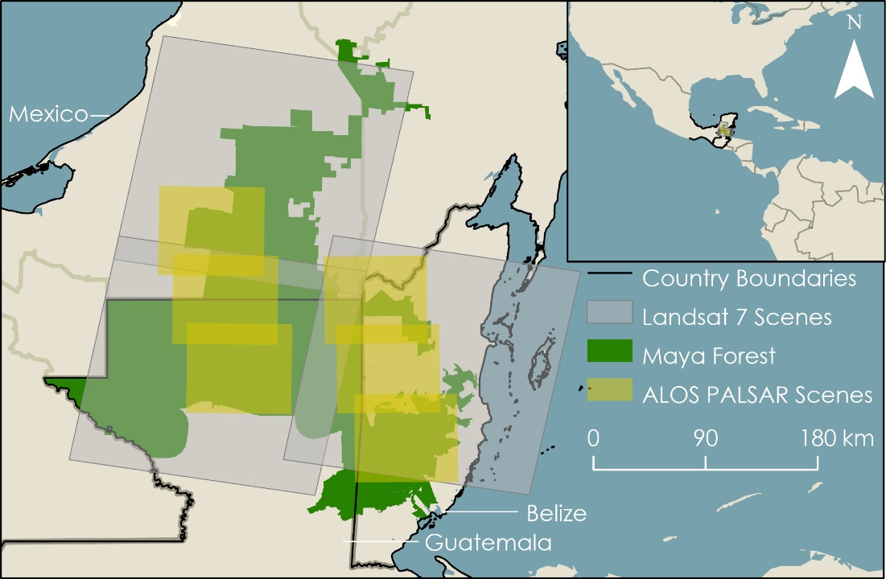
Figure 1. The project study area extends across Mexico, Belize, and Guatemala, and is encompassed by three Landsat 7 scenes and six ALOS PALSAR-1 scenes throughout 2008.

2.2 Project Partners & Objectives
This project was supported by partners from Belize’s Land Information Center (LIC) and Forest Department, Guatemala’s Center for Monitoring and Evaluation (CEMEC), Mexico’s El Colegio de la Frontera Sur (ECOSUR), the MesoAmerican Research Center (MARC) at the University of California Santa Barbara, Boles Environmental Consulting, and NASA SERVIR. Belize’s LIC will use the maps showing inundation extent to identify areas prone to highly variable inundation levels and define flood risk zones in anticipation of future flooding events. The Forest Department in Belize will use the end products to monitor current and potential wetlands in national protected areas and develop sustainable forest management strategies. CEMEC in Guatemala plans to use these methods to help reduce the cost associated with the ground-based monitoring methods that are currently being employed. The combination of multi-sensor imagery and multi-sourced comparisons acts as an alternative for mapping inundation below the forest canopy when faced with a study area lacking non-comprehensive field data. This framework for understanding inundation patterns within the Maya Forest and surrounding regions during extreme weather events such as Tropical Depression 16 will be used by partners to make more informed decisions about where to conduct field surveys, adjust safety concerns, and prioritize conservation efforts.

Project objectives aimed to identify which data sources (L-band SAR, LiDAR, and optical satellite imagery) and methodologies are optimal for mapping forested inundation within the Maya Forest. The team further aimed to write preliminary scripts in Google Earth Engine (GEE) to provide a foundation for reproducible methodology that can be refined by the second term of this project. Finally, the team created a set of observed seasonal wetland inundation maps in GEE and Esri ArcGIS Pro.

3. Methodology

3.1 Data Acquisition
The team downloaded images from ALOS PALSAR-1 and Landsat 7 ETM+ Earth observations data from the Alaska Satellite Facility and GEE data catalog, respectively. The team downloaded ALOS radiometric and terrain corrected (RTC) products for June, September, and October of 2008 for Path 168 (Frames 320-340) and May, August, and October for Path 170 (Frames 330-350) over the study area for a total of eighteen (18) images (Figure 1). The team acquired Landsat 7 ETM+ images during the dry season (March-May) throughout 2007-2009. Additional acquired data included a digital elevation model (DEM) from the 2000 NASA Shuttle Radar Topography Mission (SRTM) and a canopy height model (CHM) derived from ICESat-1 2005 satellite data accessed through the GEE data catalog. Detailed information about the satellite imagery and products are found in Table 1 below. Data provided by project partners as shown in Table 2 included shapefiles of the regional environmental features and infrastructure.

Table 1
Satellite remote sensing data products, dates of coverage, and sources used.
Data Products | Data Parameters | Temporal Coverage Used for Study | Source | Use
ALOS PALSAR-1 RTC L-Band SAR | Hi-Resolution Terrain Corrected (RTC) L-Band SAR FBD Ascending HH+HV Polarized 46-Day Global 20 meters. | May-October (2008) | Alaska Satellite Facility (ASF) | Inundation mapping
Landsat 7 Enhanced Thematic Mapper Plus (ETM+) Collection 2, Level-1 30-meter multispectral data | Landsat 7 ETM+ sensor imagery containing four visible and near-infrared (VNIR), two short-wave infrared (SWIR), and one thermal infrared (TIR) band. Spatial resolution: 30 meters. | March-May (2007-2009) | United States Geological Survey (USGS); Google Earth Engine (GEE) | Land cover classification
NASA Shuttle Radar Topography Mission (SRTM) Digital Elevation 30 meters | Digital elevation models on a near-global scale. Spatial resolution: 1 arc-second (~ 30 meters). | 2000 | NASA/USGS/JPL-Caltech; GEE | Inundation mapping
Global Forest Canopy Height (derived from ICESat-1 data) | Global tree height database based on a fusion of spaceborne-lidar data from the ICESat-1 Geoscience Laser Altimeter System (GLAS) instrument and ancillary geospatial data. Spatial resolution: 1 kilometer. | 2005 | NASA/JPL; GEE | Land cover classification

Table 2
Data provided by project partners and other regional entities.
Data Products | Creation Date | Source(s)
Land use and land cover for Campeche, Mexico | 2009 | CEMEC
Wetlands Cartographic Model Scale 1:50 000 (Modelo Cartográfico de Humedales Escala 1:50 000) | 2014 | Instituto Nacional de Estadística y Geografía (INEGI)
Protected Areas of Belize, Guatemala, and Southern Mexico | 2004 | MARC; Eco-Regional Plan of the Maya, Zoque and Olmeca Forests
Three Country Boundary Lines | 2004 | MARC; Eco-Regional Plan of the Maya, Zoque and Olmeca Forests
Mesoamerican Soils: Belize, Guatemala, and Southern Mexico | 2004 | MARC; Eco-Regional Plan of the Maya, Zoque and Olmeca Forests
Localities with Populations of 2000 or more | 2004 | MARC; Eco-Regional Plan of the Maya, Zoque and Olmeca Forests
Geology of Mesoamerica: Belize, Guatemala, and Mexico | 2004 | MARC; Eco-Regional Plan of the Maya, Zoque and Olmeca Forests
Waterways of Mesoamerica: Belize, Guatemala, and Southeastern Mexico | 2017 | MARC; OpenStreetMap®
Major Roads and Urban Centers in Mesoamerica: Belize, Guatemala, Southern Mexico | 2017 | MARC; OpenStreetMap®
Archaeological Sites: Belize, Guatemala, and Mexico | 2017 | MARC

3.2 Data Processing
3.2.1 Overview
The team produced inundation maps by using a two-step classification process as outlined in Figure 2 below.
For the first step, the team combined optical imagery (Landsat 7) with a global canopy elevation model (derived from ICESat-1 LiDAR) and segmented the imagery using object-based image analysis to classify six general land cover types. In the second step, the team applied L-band backscatter thresholds to segmented HH polarized SAR images to map inundation across the Maya Forest. The team tested multiple L-band backscatter thresholds for forested inundation against various regional data layers to select an optimal threshold for the Maya Forest region. In addition to mapping observed inundation with the final threshold during a year of major flooding, the team created maps comparing pixel and object-level mapping schemes and compared inundation extents at different thresholds. The team conducted all analyses in GEE.

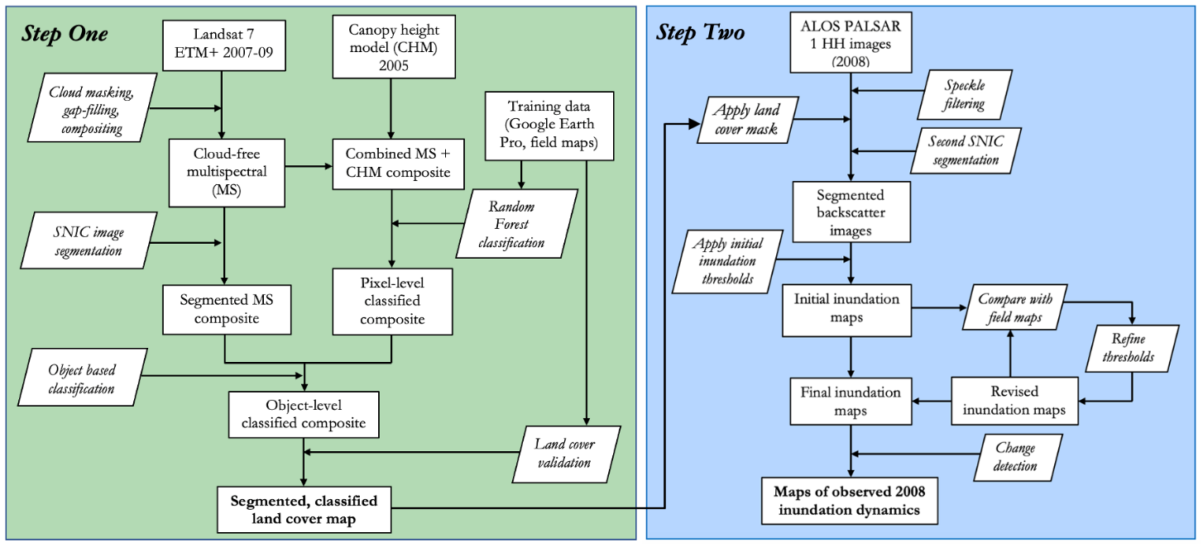Figure 2. Overview of methodology workflow.

3.2.2 Preprocessing
Spatial and temporal availability of L-band SAR imagery limited the extent under which inundation dynamics could be captured in this study. The team defined the study area by the extents of six selected frames from two ALOS PALSAR-1 swath paths also encompassing the partners’ regions of interest. Additional refinement of the study region utilized regional knowledge and expertise from the project partners. Elevation and optical datasets were clipped to cover the six selected ALOS frames.

The USGS georeferenced and performed radiometric and terrain corrections on the Landsat 7 ETM+ Collection 2 Level-1 surface reflectance products using the Landsat Ecosystem Disturbance Adaptive Processing System (LEDAPS) algorithm version 3.4.0 (Schmidt et al., 2013). The team conducted additional preprocessing using the pixel quality assessment (QA) bands. The QA bands created with the C Function of Mask (CFMASK) algorithm (developed by Foga et al., 2017) identified how much a pixel was affected by surface, atmospheric, and sensor conditions. The team therefore used these bands to mask all pixels affected by clouds or shadows. The team carried out further processing to reduce the striping effect caused by Landsat 7’s scan line corrector failure, which resulted in images with stripes of erroneous pixels across the scene. As per recommendation from USGS, the team corrected the striping effect by compositing a multi-year dry season image collection into a single, cloud-free, shadow-free, and gap-free image by taking the median values of all overlapping, unmasked pixels. Finally, the team applied the focal mean function available in GEE to fill any remaining gaps. This function applied a morphological mean filter to the composited image using a circular kernel of radius 1 to fill gaps.

3.2.3 Step 1: Object-Based Land Cover Classification
Object-based image analysis (OBIA) provides a more accurate method of classifying satellite imagery over a vast geographic area with complex land cover categories compared to traditional pixel-level approaches (Evans et al., 2010, Rodriguez-Galiano et al., 2011). OBIA involves two parts: image segmentation and classification. In the first step of this study, the team performed image segmentation on the Landsat composite imagery then classified each of the segmented polygons using a Random Forest classifier into one of six land cover classes: forest, cropland, grassland, open water, settlement, and other lands.
Image segmentation is a process that groups neighboring pixels with similar spectral characteristics into distinct clusters. This study used the simple non-iterative clustering algorithm (SNIC) available in GEE to segment the Landsat composite image. SNIC is a computationally efficient segmentation algorithm based on the process of superpixel clustering, wherein centroids are initialized on a regularly-spaced seed grid and connected pixels are clustered based on distance and spectral similarity (Achanta and Süsstrunk, 2017). The algorithm takes in four user-defined parameters: the spacing of the initial seed grid, influencing final cluster size; the compactness factor, influencing the shape of final clusters; the neighborhood tile size, set to avoid tile boundary effects; and the connectivity, defining how to merge adjacent clusters (either 4 or 8-pixel connected). The team used the default values for compactness, neighborhood tile size, and connectivity but varied the seed grid size parameter to determine an optimal size value. The tested, final SNIC parameters are displayed in Table 3.

Table 3
Tested and final SNIC parameters used for segmentation.
Parameter | Values Tested | Final Values
Seed grid size | 26, 32, 36, 42 | 26
Connectivity | 8 | 8
Neighborhood Tile Size | 256 | 256
Compactness Factor | 0, 2 | 0

After selecting the optimal SNIC parameters and segmenting the Landsat composite, the team resampled the CHM to 30-meters to match Landsat resolution and added canopy height as a band to the Landsat composite. The team then performed a Random Forest (RF) classification on the combined image. RF is an iterative supervised machine learning algorithm that provides a robust method for classifying remotely sensed data. The ability of RF to handle noisy observations and a relatively small number of training data made RF a useful technique in delineating imagery of large areas with complex landscapes into land cover classes (Rodriguez-Galiano et al., 2011).
The team collected training points for each of the six land cover classes through a combination of visual interpretation of high-resolution imagery and existing datasets from the project partners. In the absence of sufficient ground-truthed training data from the time period of interest (2008), an accepted alternative to gathering training points was to use imagery of higher quality than the imagery being used for the classification (Olofsson et al., 2008). Therefore, the team compared the Landsat imagery to high-resolution imagery available in Google Earth Pro (GEP) to visually scrutinize potential training points for each land cover type. The team standardized the criteria for visually identifying land cover type before collecting the points in order to ensure consistency in the final training point collection. Where high resolution imagery was not available in 2008 in GEP, but available in nearby years, the team ensured that the land cover types consistently matched the most recently available years before and after 2008 and scrutinized the potential training point in the Landsat composite image to confirm each determined land cover type. Examples of each land cover type as viewed in GEP and in the Landsat composite are displayed in Figure A1 of the Appendix for reference. These land cover classes are consistent with those described by the Belize Collect Earth Protocol (Correa et al., 2019) except that the team omitted the wetlands class and added an open water class. Wetlands can occur in a variety of environments, including forests and herbaceous landscapes, and are extremely difficult to detect with optical imagery alone, so the team did not seek to identify wetlands in the Step 1 classification. The team collected a total of 1,232 training points, of which 863 (70% of the total points) trained the classifier while 369 (30% of the total points) validated the results. A full list of the training point distribution and class definitions can be found in Table 4.

Table 4
Land cover class descriptions and training point distributions.
Land Cover Class | Description | Total Points | Training Set | Test Set
Forest | All forested lands defined as having a canopy cover >30% and trees >5 m high. Includes mature broad-leaf forest, secondary broad-leaf forest, pine forest, and mangrove forest as well as managed forest plantations | 222 | 154 | 68
Grassland | Includes unmanaged grasslands, pasturelands, shrublands, fallow croplands, and recently abandoned croplands. | 208 | 149 | 59
Cropland | Includes only active cropland excluding agricultural tree plantations. | 202 | 141 | 61
Settlement | Includes urban and rural settlements and open archaeological sites. | 200 | 143 | 57
Open Water | Includes only open water, such as lakes, rivers, and ponds, and excludes forested wetlands or seasonally flooded wetlands. | 200 | 134 | 66
Other | Includes areas of bare earth, sand, and areas disturbed by mining. | 200 | 142 | 58

The team trained the RF classifier with 1000 trees and a bag fraction of 0.5 on the training point set using the six Landsat 7 bands (red, green, blue, near infrared, and two shortwave infrared bands), the normalized difference vegetation index (NDVI), and canopy height as input features. NDVI is a widely used measure of pixel greenness that detects vegetation in remotely sensed images using a ratio of the red and near infrared bands. NDVI was added as a band within the classification to assist the distinction between vegetated areas, non-vegetated areas, and different vegetation types (Kriegler, 1969). The team compared a pixel-level classification approach to an object-level approach by first conducting a simple pixel-level classification and then aggregating the pixel-level classification using the clusters created in the SNIC segmentation. Typically, OBIA uses spatial characteristics of the individual clusters to aid in classification; however, omitting this step increases computational efficiency. The team used the pixel-level classification to determine the most common classified land cover type within each cluster and labelled each cluster based on the most common pixel-level to create an object-level classified map.

3.2.4 Step 2: Forested Inundation Mapping
Once the land cover classification in Step 1 was completed, the team created forested inundation maps in Step 2 demonstrating seasonal variability between the wet and dry seasons in 2008. Mapping inundation below the canopy included using L-band SAR from ALOS PALSAR-1 in combination with ancillary datasets and supporting data from project partners. While the L-band ALOS products from the Alaska Satellite Facility contained both HH and HV polarized bands, the team primarily used the HH-band for this project. For inundated forests, HH backscatter appears very bright compared to the surrounding non-inundated forest. This is due to a strong double-bounce reflection from the vertical forest structure and horizontal water surface. With HV polarization, the backscatter is dominated by volume scattering from vegetation, and, therefore, the difference between inundated and non-inundated forest is not as apparent (CEOS, 2018).

To begin Step 2 processing in GEE, the team applied the first level of noise reduction to the individual ALOS HH-band images using the Refined Lee speckle filter algorithm adapted for GEE, created by NASA SERVIR-Mekong. The first tests segmenting SAR images without speckle filtering proved unsuccessful at capturing HH variability that was visually evident in the image, even with images processed to the RTC level.
Once the images were put through Refined Lee speckle filter to reduce noise, the segmentation captured clusters well. Reducing the noisiness allowed for the detection of inundation extent under the forest canopy and facilitated comparison of land cover specific backscatter thresholds to those found in the literature. To detect continuous objects of inundation, the team combined the speckle filtered SAR images with the land cover map from Step 1 (reprojected from 30 meter to 12.5-meter spatial resolution) and segmented this combined image using the SNIC algorithm in GEE.

Since this project was primarily focused on observing forested inundation, non-forest classes were masked out over the segmented ALOS images using the forest class from the land cover classification map. All Alaska Satellite Facility ALOS PALSAR-1 RTC products are provided in gamma naught (γ⁰), a linear power unit. The gamma naught values were converted to decibels (dB) in order to apply initial threshold values using Equation 1 below. None of the image altering or averaging techniques were applied to images in dB to keep calculations accurate and consistent.

dB = 10 × log(γ⁰) (1)

Once the values were converted to dB, the team applied L-band HH polarized backscatter thresholds from previous literature to the forest-masked ALOS imagery to create a binary classification of inundated and non-inundated forest. These initial threshold values were drawn from previous studies conducted in similar ecological regions, including one study that found that seasonally inundated forests in the Central Amazon in Brazil had average L-band backscatter thresholds of –2.9 (+/- 1.7) dB (CEOS, 2018). Another study from the Brazilian Pantanal had an average backscatter threshold that fell around –3.9 dB (Evans et al., 2010). For the initial threshold tested, the team decided to use –4.6 dB (the lower limit of these values) to create binary inundation maps indicating everything below the value as not inundated and everything above as inundated. While backscatter thresholds were only applied to the forest class in this study, these methods are designed to be reproducible and can be applied to other land cover types.

The L-Band HH-polarization backscatter thresholds were applied at both the pixel-level and object-level. For the object-level method, a minimum mapping unit of 0.5 hectares was applied to the October images to exclude small segments that are likely to be noise rather than actual inundation. Following tentative inundation classification, the team refined the thresholds through an iterative process using both quantitative and qualitative methods. The team compared inundation maps to field and other data, including the team’s flood model and data provided by the project partners (see Tables 2 & 5). Data from the project partners included a set of potential wetland points created by one of the partners, Dr. Anabel Ford (MARC), who visually determined potential wetland sites from optical imagery based on her expert knowledge of the ecology of the Maya Forest. Any potential mapping errors and discrepancies for each tentative threshold were examined and refined by the team accordingly.

Table 5
List of collected, generated, and partner data used quantitatively or qualitatively in the iterative threshold analysis.
Supporting Data | Source | Quantitative | Qualitative
HV band for each frame | ASF | X
Flood Model | DEVELOP team (using DTM) | X
Swamps & Wetlands | MARC | X
Potential Wetlands in Mexico | INEGI | X
Potential Swamps and Wetlands | Dr. Anabel Ford (MARC) |  | X
Digital Terrain Model (DTM) | DEVELOP team derived from global canopy height model (ICESat-1) and NASA SRTM |  | X
Soil type | MARC |  | X
Geology | MARC |  | X
Archaeological sites | MARC |  | X

Once a final backscatter threshold was determined, the team created inundation maps for all of the ALOS images at each of the three dates available for each frame. The team then stacked and combined the three inundation maps for each frame into a single product. To represent the duration of inundation over the three dates from each month, the team created a map counting the number of times a pixel was inundated (0- never flooded, 1- flooded during one month, 2- flooded during two months, 3- flooded during all three months). Maps of observed seasonal changes were also created by the team in ArcGIS Pro for both swath paths.

3.3 Data Analysis
During the initial process of testing out different SNIC parameters in Step 1, the team scrutinized the segmentation results by overlaying the generated segments on the Landsat composite image to determine how well the algorithm captured land cover variability. The accuracy of the RF classification was calculated by confusion matrices using the 30% of training points held out for validation. The team calculated confusion matrices for both object-level and pixel-level classifications and compared each accuracy percentage in order to determine the best level to use for inundation analysis.

Using threshold values from literature as a starting point, the team refined threshold values through an iterative process to determine the optimal thresholds for the region. The team compared the object-level and pixel-level inundation maps created in Step 2 and analyzed the differences through visual assessment to narrow down which classification level performed best at classifying inundation. Finally, the team used the series of final inundation maps to calculate the seasonal change in total inundation extent.

4. Results & Discussion

4.1 Analysis of Results
4.1.1 Step 1 Image Segmentation and Classification Accuracy
Optimal SNIC parameters included a size of 26 and a compactness factor of 0. When the compactness factor was set to be greater than zero, the resulting segments were forced into compact shapes that did not visually reflect the spatial heterogeneity of the land cover evident in the Landsat image. Of the tested values for the size parameter, a smaller value of 26 was found to most adequately capture the heterogenous landscapes without demanding excessive computational time. Residual striping effect of the Landsat 7 composite minimally affected the segmentation process – a visual inspection of the segments revealed that actual differences in land cover outweighed striping artifacts during segmentation except over a few small forested areas near the boundaries of Landsat tiles and large bodies of water. In the latter cases, the segments that were coerced by striping artifacts remained within the same land cover type and therefore were not expected to negatively affect the classification process. In the former, this effect was observed only in a few isolated instances and therefore deemed acceptable to continue with the analysis.

When the Random Forest classification was performed at the pixel-level, the team found an overall classification accuracy of 78.6%. At the object-level using the SNIC parameters described above and in Table 3, the team found a classification accuracy of 72.1% (Figure 3). Both the pixel and object-level maps had very high recall (i.e., percent of total points of one class correctly classified as that class) of the forest class, the only class this study focused on. The object-level classification additionally had higher recall for the grassland, cropland, and other land classes while the pixel-level classification had higher recall for the settlement and open water classes. The object-level scheme also notably had lower precision (i.e., percent of total points with the same classification that are actually in that class) for the forest class but higher precision for the cropland and settlement classes. While the overall classification accuracy was higher for the pixel-level scheme, the team chose the object-level scheme in order to work with homogeneous land cover objects rather than noisier classes at the pixel-level (Figure 4).

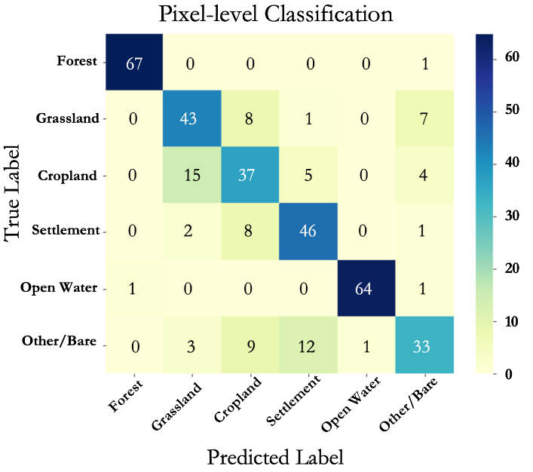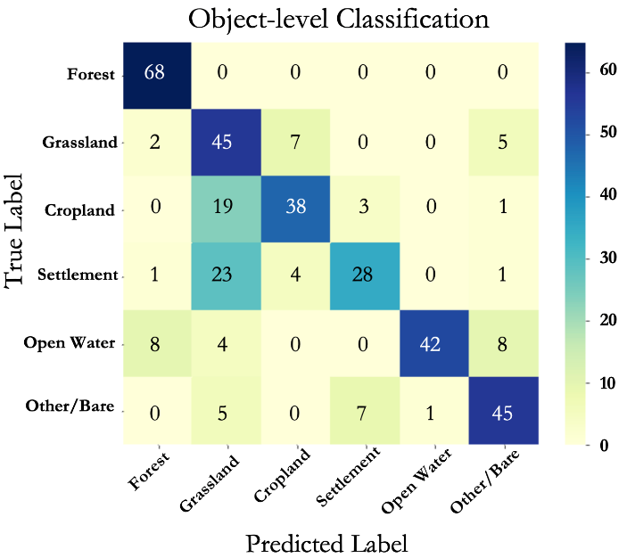
Figure 3. Confusion matrix for the pixel-level (left) and object-level Random Forest land cover classification (right).

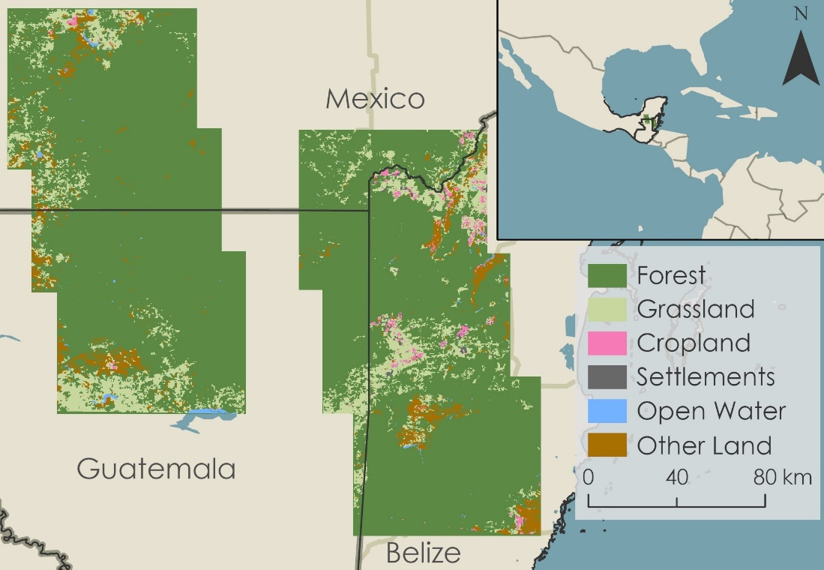

Figure 4. Land cover map delineating forest, grassland, cropland, settlement, open water, and other land derived from the Random Forest object-level classification over the entire study area encompassed by the six ALOS PALSAR-1 frames.

While the team expected that the object-level classification scheme would out-perform the pixel-level scheme, the pixel-level classification had a slightly higher overall accuracy. The confusion matrices (Figure 3) show that the majority of the decreased accuracy of the object-level classifier was due to lower recall of the settlement and water classes. This suggests that the disparity in performance between the two schemes may be due to the fact that settlement and open water classes are typically spatially small features in the landscape, such as small rural settlements and ponds, and therefore are more likely to be grouped in clusters with the larger surrounding land cover types by the segmentation algorithm. The majority of misclassified settlement points were classified as grassland, which may be due to the fact that small rural settlements in the study region are often located next to grasslands. As this study focused on mapping inundation within forests, the team chose to proceed with the object-level land cover map for the inundation analysis because it had perfect recall on the forest class and because, when applying inundation thresholds, it is easier to work with homogeneous objects rather than a pixel-level map. However, future studies could benefit from both larger training data sets and a combined object and pixel-level approach. In this approach, the pixel-level classifications of spatially smaller classes, such as settlements, could be superimposed on top of an object-level map to increase the recall values of those classes.

4.1.2 Step 2 Image Segmentation and Inundation Mapping Results
At the RTC level, ALOS imagery is corrected for layover and shadow as well as incidence angle and these corrections are provided within the product package. Each image from both paths had a corresponding layover and shadow masked product the team examined prior to analysis. Path 168 had layover and shadow effects between 10e-6% to 0.006% while path 170 had < 10e6%. It can be assumed that the amount of layover and shadow masked in the products is minimal enough to not drastically skew results. As for the SNIC segmentation, adding the land cover classification from Step 1 as a band to the speckle filtered images produced the best results. Refined Lee speckle filtering reduced the noise initially, while the SNIC segmentation created object-clusters from associated pixel values. The inherent noisiness of SAR imagery is difficult to work with and caused concern about whether segmentation performed on speckle filtered images over-averaged backscatter values, leading to an underestimation in identifying inundated forest. Adding the land cover classification ensured that the resulting segments did not encompass more than one land cover type. The team accomplished further isolation of the backscatter values for inundated forest by applying the land cover classification from Step 1 to mask out non-forest classes.
The pixel-level inundation map was rather sensitive to noise, making over-estimation of inundation cause for concern, while the object-level inundation map adequately captured areas of high-density pixel-level inundation and filtered out noisier pixel-level features. Figure 5 displays a zoomed-in look at the pixel versus object-level differences. The full results are displayed in Figures A2 and A3.

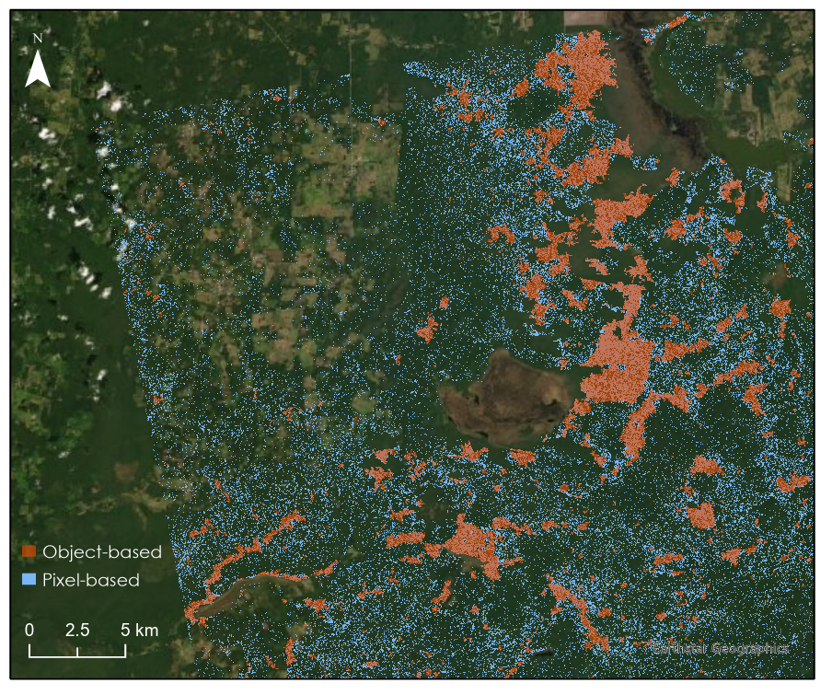
Figure 5. L-band backscatter thresholds were applied at the pixel-level and object-level (segmented). The object-level image analysis was chosen over the pixel-level because the object clusters average out connected pixels of similar values while the pixel-level captures the inherent noisiness of SAR imagery thus affecting the ability to clearly delineate areas of inundation. This figure zooms into the Northwest corner of Path 170, Frame 350 during the wet season October 5, 2008.

To maintain a more conservative analysis of inundation below the forest canopy, the team continued to apply the thresholds at the object-level. The results of the team’s first round of quantitative threshold analysis, conducted on all 8 tested thresholds, is displayed below in Table 6 for path 170, frame 340. Due to the lack of available ground-based validation data for inundation extent in 2008, the study cannot report accuracy values for the inundation detection maps. However, the availability of additional data from the project partners allowed for further refinement of the backscatter threshold values extracted from the literature in an iterative process and led to additional confidence in the inundation detection procedure.

Table 6
Example of the quantitative threshold analysis for tile 170-340. The green highlighted rows indicate the final three thresholds observed qualitatively.
L-band Backscatter threshold | Percent of forest inundated | Field Map 1: Potential wetlands of Mexico |  | Field Map 2: Flood model |  | Field Map 3: Potential swamps and wetlands of Central America
 |  | Ratio 1 | Ratio 2 | Ratio 1 | Ratio 2 | Ratio 1 | Ratio 2
-4.6 | 0.150 | 0.013 | 0.952 | 1.015 | 0.992 | 0.223 | 56.189
-4.8 | 0.244 | 0.015 | 0.692 | 1.128 | 0.677 | 0.391 | 60.575
-5.0 | 0.340 | 0.056 | 1.859 | 1.550 | 0.667 | 0.526 | 58.539
-5.2 | 0.601 | 0.160 | 3.001 | 3.978 | 0.970 | 0.874 | 55.041
-5.4 | 0.993 | 0.318 | 3.605 | 6.834 | 1.008 | 1.389 | 52.922
-5.6 | 1.513 | 0.672 | 5.000 | 7.628 | 0.738 | 2.066 | 51.625
-5.8 | 2.177 | 0.925 | 4.785 | 10.678 | 0.718 | 2.982 | 51.803
-6.0 | 3.195 | 1.801 | 6.347 | 16.062 | 0.736 | 4.008 | 47.436
* Ratio 1 is the total inundated area within that field map divided by the total area of the field map and Ratio 2 is the total inundated area within that field data divided by the total inundated area. All values are displayed as percentages.

The iterative semi-validation process required several quantitative and qualitative analyses between the initial inundation maps and ancillary data, including data produced by the team and originating from project partners. Beginning with the quantitative aspect of threshold refinement, the team detected patterns between the tentative inundation maps and the flood model, swamps and wetlands shapefiles, potential wetlands of Mexico maps, and Dr. Ford’s potential swamps and wetland points. Patterns in counts of overlapping pixels showed several peaks in percent overlap between the tentative inundation map and compared maps. The peaks were then compared to the average dB values found throughout the HV band that was masked by the inundation identified for that threshold. If the HV bands showed low values, that was indicative of less influence on high backscatter values due to dense forest, while high HV values indicate possible interference from dense forest when classifying the objects as inundated. Collective observation between all six frames during October (the month when the most inundation was expected) led to defining three thresholds for qualitative refinement: –4.8, –5.4, and –5.8 dB. These three were chosen in part due to the quantitative analysis, but also chosen for –4.8 being closest to the higher end of literature values, and –5.4 and –5.8 having the most consistent results between frames. An example comparison of detected inundation using these three thresholds is displayed in Figure 6, and the full results for all six tiles are displayed in Figures A4 and A5.

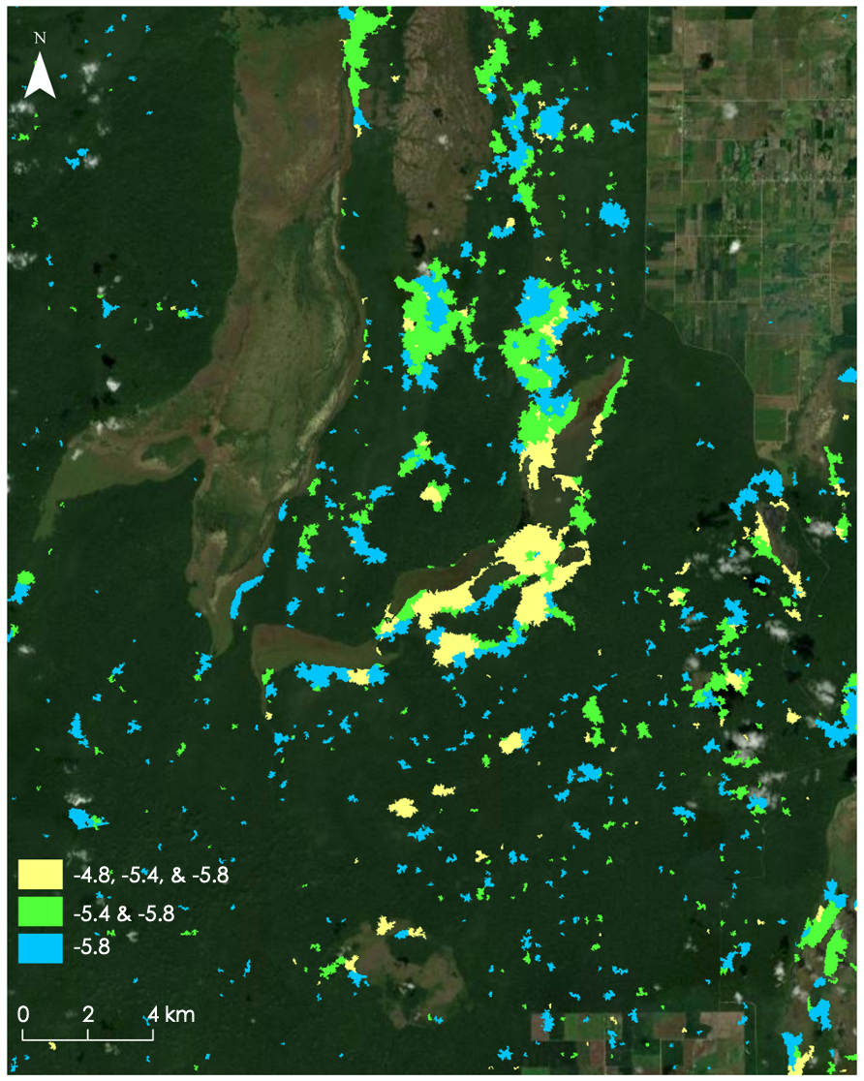
Figure 6. Map of swath path 168 frame 340 showing the top three thresholds chosen to compare observed inundation. To demonstrate the overlapping values, yellow represent potential inundation at all three thresholds, green represents potential inundation at –5.4 and –5.8 dB, and blue represents potential inundation at –5.8 dB.

Once the initial quantitative analysis suggested these three thresholds, the team conducted qualitative and additional quantitative observations to determine the optimal threshold value from these three intermediate values. Dr. Ford advised the team that it is unlikely to find wetlands or continuous inundation at known archaeological sites. The team collected observations after visually inspecting the location of known archaeological sites and where the identified inundation fell within the digital terrain model (water is likely to collect at depressions). Finally, the soil types, geology underlying the potential inundation areas were overlaid with the ALOS data to observe any patterns or similarities across each. For soil type, inundation was detected over gleysols, leptisols and vertisols. Alluvium was the most common underlying geology, with limestone being a secondary common rock type in inundated areas. As for the DTM, most observations for inundation fell within a depression. -5.4 dB was chosen as the final refined threshold for the study as shown by the quantitative and qualitative results in Tables 7 and B1. The seasonal variation in inundation using this threshold is demonstrated in Figure 7, and maps of the seasonal change in inundation are provided for the full study area in Figures A6 and A7.

Table 7
This table represents the final L-band backscatter threshold of –5.4 dB resulting from the study. All ratios are presented in percentages.
L-band Backscatter Threshold | Path-Frame | Percent of forest inundated | Field Map 1: Potential wetlands of Mexico |  | Field Map 2: Flood model |  | Field Map 3: Potential swamp and wetlands of Central America
 |  |  | Ratio 1 | Ratio 2 | Ratio 1 | Ratio 2 | Ratio 1 | Ratio 2
-5.4 | 168-  340 | 2.2 | 4.72 | 17.2 | 0.05 | 0.001 | 5.46 | 31.9
 | 168-  330 | 2.0 | No data | No data | 9.26 | 19.3 | 3.31 | 10.8
 | 168-  320 | 5.5 | No data | No data | 9.26 | 3.42 | 0 | 0
 | 170-  350 | 3.4 | 13.3 | 64.8 | No data | No data | 8.98 | 1.14
 | 170-  340 | 0.60 | 0.160 | 3.00 | 3.98 | 0.970 | 0.874 | 55.0
 | 170-  330 | 0.77 | No data | No data | 3.81 | 13.9 | 1.10 | 0.774

A. June B. September C. October
Figure 7. Example map series showing seasonal inundation change from a) June (orange), b) September (green), and c) October (blue) in an area of northwest Belize from path 168 frame 340 created using a threshold of –5.4 dB for inundated object detection.

Final results of the study included applying the –5.4 dB threshold to each frame of both paths in order to count how frequently inundation is observed across all three months. Observing how frequently inundation occurs provides insight into potential wetlands or areas at high risk of seasonal flooding (Figures 8, A8, and A9).

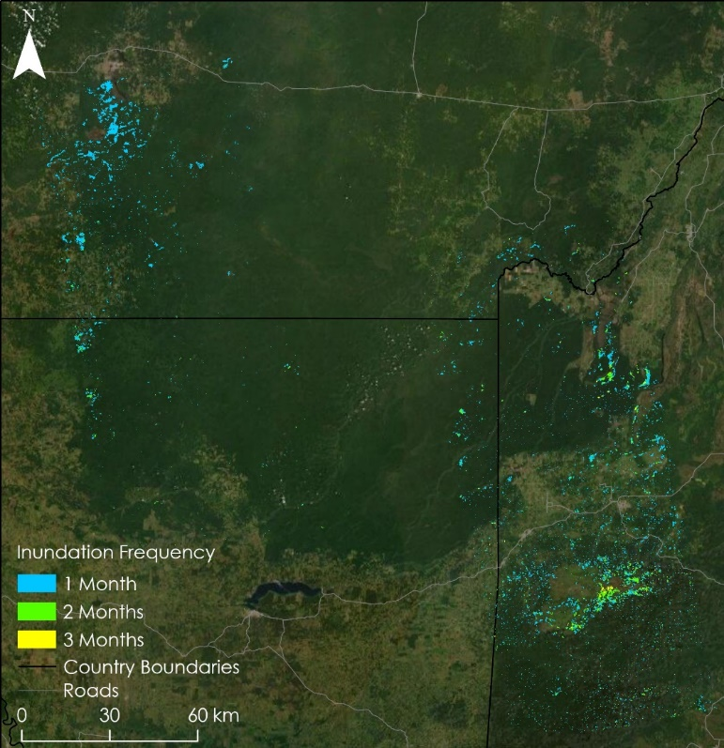
Figure 8. The above map delineates inundation duration throughout the entire study area including each ALOS PALSAR-1 frame from both Path 168 and 170, where areas inundated during one month are blue, two months are green, and areas inundated for all three months are yellow.

The observed inundation change displayed in Figures 7, A6, and A7 indicated that the highest inundation extent occurred in June and October in the path 168 tiles and May and October in the path 170 tiles (Table B2), which is consistent with the average monthly precipitation values recorded for the study region in 2008 (CCKP, 2021). Qualitative assessment of the three thresholds mapped in Figure 6 indicates that a threshold value of –5.4 dB seems to correspond most accurately to actual inundation. Inundation at the –5.4 dB threshold had relatively high correspondence between the predicted flood model and mapped inundation. The team observed that inundation at the –5.4 dB threshold often corresponded with gleysols, a soil type that is indicative of wetlands. The consistency between soil type, flood model outputs and observed inundation builds confidence in the inundation classification and the threshold selection. However, the team also observed that inundation seemed to be overestimated in hillier and more mountainous terrains found in path 168 frame 320, specifically in the Mountain Pine Ridge region of Central Belize (bottom right corner of Figure 8). The team suspects that the complex terrain in this region increased the double-bounce effect, leading to increased backscatter values that were erroneously detected as inundation in this study.

4.1.3 Limitations
Ground-based field studies in the Maya Forest are costly, intensive, and time consuming due to the large area of the forest and the complex terrain, and field studies of inundation extent are especially difficult because of the added dangers of traversing flooded terrains. Additionally, inundation below forest canopies cannot be identified through visual interpretation of high-resolution optical imagery. The absence of comprehensive inundation field data made it difficult to validate the results of this study. To address this, each inundation map and average threshold value were quantitatively and visually scrutinized against high resolution georeferenced map layers including a flood model, hydrology and potential wetland layers, digital terrain models, land use, soil, geology, and archaeological sites in order to assess the inundation extents output by each threshold. With these layers, the team was able to calculate differences in the areas of each classified polygon.

Another limitation within this study was understanding the difference between inundation identification at the object and pixel-levels. The pixel-level identification required applying the threshold to the forest masked Refined Lee filtered combined landcover classification image. The object-level identification required this image to be segmented using SNIC, then forest masked and run through the threshold. Averaging object clusters lead to the entire cluster being classified as inundated or non-inundated by the threshold, which could lead to a failure to capture the intricate details of flooding under the forest. The pixel-level identification, however, was affected by the inherent noisiness of SAR image even after filtering. This could lead to an overestimation of inundation within the scene. In this study, the team did in fact observe a potential overestimation of inundation using a pixel-level scheme, but also acknowledges that the object-level scheme could be erasing finer spatial details in inundation. Therefore, it is important to display the similarities and differences between each method to demonstrate potential variability in the extent of flooding.

As in all remote sensing studies, the temporal and spatial resolution of the Earth observations presented a constraint. In regards to spatial resolution, the Landsat 7 imagery had a courser resolution of 30 meters while ALOS imagery had 12.5-meter resolution. Additionally, residual striping from Landsat 7’s scan line corrector failure contributed minor errors, mostly resolved by compositing during preprocessing. Temporally, the team had limited access to ALOS PALSAR-1 imagery from the specific study year and the corresponding wet and dry seasons. As a result, each scene is a snapshot of inundation extent during that specific day, and may include exaggerated or underexaggerated flood extents from agricultural irrigation and small storm events. Some identified inundated areas may have contrasting identities due to differences in resolution, errors in the object classification algorithm, differences in data acquisition date ranges, and any threshold errors. This research identified regions of high priority for the project partners and the next DEVELOP term to refine and validate with field data currently being collected.

4.2 Future Work
This project was limited by the availability of satellite data and validation data such as ground-based inundation surveys. The goal for this term was to test methodologies for detecting inundation beneath the forest canopy using L-band SAR and other data to provide initial workflows and inundation thresholds. Further research can refine inundation detection with the addition of validation data. The study was limited to the temporal coverage of ALOS PALSAR-1 (2006-2011) because at the time of this research, no other L-band SAR data were freely available after 2011, and L-band is crucial for below-canopy inundation detection since it is the only SAR wavelength capable of penetrating dense forest canopies. The release of ALOS PALSAR-2 and the launching of NASA-ISRO SAR satellite (NISAR) will introduce freely available global coverage of L-band SAR up to the present day, drastically increasing the capabilities of future researchers to study inundation in diverse land cover types.

This research demonstrates the synergistic power of combining the outputs of multiple sensors and data types – Landsat 7 ETM+, ALOS PALSAR-1, LiDAR-derived elevation products, and field maps – for improved detection of inundation in heterogenous landscapes where detailed ground-truthed data are not available. In the coming years, the team predicts further gains in inundation mapping in all land cover types stemming from the availability of overlapping, multitemporal C-band SAR from Sentinel-1, which can detect inundation in open landscapes such as grasslands and settled areas, and L-band SAR from ALOS PALSAR-2 and NISAR. These datasets will allow for detailed time series analyses of wetland regions for more robust study of inundation dynamics, including the accurate classification of permanent wetland and seasonally inundated regions.

The ultimate goal of the work presented here is for this methodology to be validated by future ground-based surveys of inundation extent so that partnering organizations and others in the Maya Forest region have a reliable and easy-to-follow workflow for mapping and monitoring wetlands. While the results presented here are not validated by ground-truthed inundation points, the inundation backscatter thresholds for each land cover type have been comprehensively scrutinized against the available data in the region, and the addition of field validated results in the near future will allow for a robust validation of these thresholds.

5. Conclusions

In the absence of robust validation datasets, this two-step methodology provided a reasonable scheme to detect inundation in a varied landscape. An object-level approach proved fruitful in both steps because of the reduced noise and the creation of homogeneous objects, which streamlines subsequent analysis procedures.

The seasonal inundation maps presented in this study will provide partners with a reasonable estimation of inundation extent in and around the Maya Forest region. Furthermore, these maps will narrow down locations of potential wetlands and flood-prone areas that the partners can use to plan targeted field campaigns for the purpose of gathering validation data. When validation data are acquired, the inundation backscatter thresholds determined in this analysis can be further refined using the detailed workflow and GEE scripts developed in this study. These validated thresholds and methodology may then be used for wetland and inundation mapping in additional years and regions. The results of this study will help the project partners gain a more robust understanding of wetland and seasonal inundation dynamics and allow for more informed forest management practices and strengthened protection of the Maya Forest’s unique wetland ecosystems.

6. Acknowledgments

We gratefully acknowledge our node fellow, Erica Carcelén, for her constant support and mentorship and our science advisors Dr. Bruce Chapman, Dr. Emil Cherrington, and Ben Holt for their technical guidance and project feedback. We would also like to thank all our partners who collaborated on this project with us for providing valuable insight into the context of monitoring and management of the Maya Forest in Belize, Guatemala, and Mexico as well as for providing field data and geospatial layers that were useful in our analysis: Edgar Correa, Alfred Cal, Victor Hugo Ramirez, Jorge Mendoza Vega, Victor Manuel Ku Quej, Josue Ramos, Dr. Ed Boles, and Sherman Horn. We would also like to thank our partners Dr. Anabel Ford and Thomas Crimmel at the Mesoamerican Research Center for sharing with us their airborne LiDAR data and additional geospatial datasets that were useful in our analysis. Thank you, Jorge Arturo Cabrera Hidalgo, for your inspirational words. Thanks to Sarah Payne and Alexander Gunnerson from the Coastal California Water Resources team for the scripting help. Finally, we would like to additionally thank Betzy Hernandez Sandoval, Sean McCartney, Kathy Elizabeth Salinas Mojica, Olinda Salguero Orellana, Vinicio Cerezo Arevalo, Jose Orlando Reyes Canales from the Central American Integration System (SICA).

Any opinions, findings, and conclusions or recommendations expressed in this material are those of the author(s) and do not necessarily reflect the views of the National Aeronautics and Space Administration.

This material is based upon work supported by NASA through contract NNL16AA05C.

7. Glossary

Earth observations – Satellites and sensors that collect information about the Earth’s physical, chemical, and biological systems over space and time.
Inundation – Process describing a land surface becoming covered with water, as in a flood.
SAR – Synthetic Aperture Radar. An active remote sensing process involving the transmission of microwave signals from a sensor to the Earth’s surface, where the signals interact with the surface, experience some level of backscattering, and return to the sensor.
Backscattering – The process by which the microwave signals emitted by a radar sensor are scattered by the surface, resulting in a portion of the original signal being reflected back to the sensor. Generally, a smooth surface will have low backscatter values because less of the signal will be reflected back to the sensor, while rough surfaces will have high backscatter values because a larger portion of the signal will be reflected back to the sensor.
ALOS PALSAR – Advanced Land Observation Satellite Phased Array Type L-band Synthetic Aperture Radar.
LiDAR – Light Detection and Ranging. A form of active remote sensing where a pulsed laser is transmitted towards the surface and measures the distance between the sensor and any surfaces or features the laser interacts with on its path. DEM products can be derived from LiDAR data.
DEM – Digital elevation model. DEM is an umbrella term that may refer to a DSM or a DTM.
DSM – Digital surface model. DSMs model the height of the first return from a LiDAR signal, or the first surface that the signal hits and is reflected off of.
DTM – Digital terrain model. DTMs model the height and topography of the bare earth surface.
CHM – Canopy height model. Calculated by subtracting a DTM from a DSM. Models the height of the forest canopy above the ground.

8. References

Adeli, S., Salehi, B., Mahdianpari, M., Quackenbush, L. J., Brisco, B., Tamiminia, H., & Shaw, S. (2020). Wetland monitoring using SAR data: A meta-analysis and comprehensive review. Remote Sensing, 12(14), 2190. https://doi.org/10.3390/rs12142190.
ASF DAAC. (2021). ALOS PALSAR_Radiometric_Terrain_Corrected_low_res; Includes Material © JAXA/METI 2007. Accessed through ASF DAAC 24 June 2021. DOI: https://doi.org/10.5067/JBYK3J6HFSVF.
Bray, D. B., Duran, E., Ramos, V. H., Mas, J. F., Velazquez, A., McNab, R. B., & Radachowsky, J. (2008). Tropical deforestation, community forests, and protected areas in the Maya Forest. Ecology and Society, 13(2). https://doi.org/10.5751/ES-02593-130256.
Chapman, B., Mcdonald, K., Shimada, M., Rosenqvist, A., Shroeder, R., & Hess, L. (2015). Mapping regional inundation with spaceborne L-band SAR. Remote Sensing, 7, 5440-5470. http://dx.doi.org/10.3390/rs70505440.
Committee of Earth Observation Satellites (CEOS). (15 November, 2018). A Layman’s Interpretation Guide to L-band and C-band Synthetic Aperture Radar data Version 2.0. Global Forest Observations Initiative. https://ceos.org/document_management/SEO/DataCube/Laymans_SAR_Interpretation_Guide_2.0.pdf
Ellison, A.M. (2004). Wetlands of Central America. Wetlands Ecology and Management, 12, 3–55. https://doi.org/10.1023/B:WETL.0000016809.95746.b1.
Emanuel, K. (2005). Increasing destructiveness of tropical cyclones over the past 30 years. Nature, 436, 686 –688. https://doi.org/10.1038/nature03906.
Evans, T.L., Costa, M., Telmer, K., & Silva, T. S. F. (2010). Using ALOS/PALSAR and RADARSAT-2 to map land cover and seasonal inundation in the Brazilian Pantanal. IEEE Journal of Selected Topics in Applied Earth Observations and Remote Sensing. 3(4),1939-1404. https://doi.org/10.1109/JSTARS.2010.2089042.
Farr, T.G., Rosen, P.A., Caro, E., Crippen, R., Duren, R., Hensley, S., Kobrick, M., Paller, M., Rodrigues, E., Roth, L. Seal, D. Shaffer, S. Shimada, J., Umland, J., Werner, M. Oskin, M. Burbank, D., and Alsdorf, D.E. (2007). The shuttle radar topography mission. Reviews of Geophysics, 45(2). https://doi.org/10.1029/2005RG000183.
Floods in Central America: Tropical Depression No. 16 causes problems at the end of the 2008 hurricane season. ReliefWeb. (2008, November 4). https://reliefweb.int/report/belize/floods-central-america-tropical-depression-no-16-causes-problems-end-2008-hurricane.
Foga, S., Scaramuzza, P.L., Guo, S., Zhu, Z., Dilley, R.D., Beckmann, T., Schmidt, G.L., Dwyer, J.L., Hughes, M.J., & Laue, B. (2017). Cloud detection algorithm comparison and validation for operational Landsat data products. Remote Sensing of Environment, 194, 379-390. http://doi.org/10.1016/j.rse.2017.03.026.
Ford, A., & Nigh, R. (2009). Origins of the Maya Forest garden: Maya resource management. Journal of Ethnobiology, 29(2), 213-236. https://doi.org/10.2993/0278-0771-29.2.213.
Garlati, A. (2013). Climate change and extreme weather events in Latin America: An exposure index. (No. 4821). Inter-American Development Bank, Research Department. https://dx.doi.org/10.2139/ssrn.225.
Google Earth Pro V 7.3.4.8248. (2021). Maxar Technologies, CNES/Airbus, Landsat, Copernicus.
Kriegler, F.J., Malila, W.A., Nalepka, R.F., and Richardson, W. (1969). Preprocessing transformations and their effects on multispectral recognition. Proceedings of the Sixth International Symposium on Remote Sensing of Environment, p. 97-131.
Mahdianpari, M., Salehi, B., Mohammadimanesh, F., & Motagh, M. (2017). Random forest wetland classification using ALOS-2 L-band, RADARSAT-2 C-band, and TerraSAR-X imagery. ISPRS Journal of Photogrammetry and Remote Sensing, 130, 13-3. https://doi.org/10.1016/j.isprsjprs.2017.05.010.
Olofsson, P., Foody, G.M., Herold, M., Stehman, S. V., Woodcock, C.E., & Wulder, M. A. (2014). Good
practices for estimating area and assessing accuracy of land change. Remote Sensing of Environment, 148, 42-57. https://doi.org/10.1016/j.rse.2014.02.015.

Rebelo, L. M. (2010). Eco-hydrological characterization of inland wetlands in Africa using L-band SAR. IEEE Journal of Selected Topics in Applied Earth Observations and Remote Sensing. 3(4): pp. 554-559. https://doi.org/10.1109/JSTARS.2010.2070060.
Schmidt, G.L. & Jenkerson, C.B. & Masek, J. & Vermote, E. & Gao, Feng. (2013). Landsat ecosystem disturbance adaptive processing system (LEDAPS) algorithm description. U.S. Geol. Surv. Open File Rep. 1057. https://doi.org/10.3133/ofr20131057.
Simard, M., Pinto, N., Fisher, J., Baccini, A. 2011. Mapping forest canopy height globally with spaceborne lidar. Journal of Geophysical Research, 116(G4). https://doi.org/10.1029/2011JG001708.
U.S. Geological Survey (USGS). (2008). LANDSAT/LE07/C02/T1_L2. Google Earth Engine, accessed July 6, 2021. http://doi.org/10.5066/P9TU80IG).

World Bank Climate Change Knowledge Portal (CCKP): Historical Data (2021). https://climateknowledgeportal.worldbank.org/

9. Appendices

Appendix A
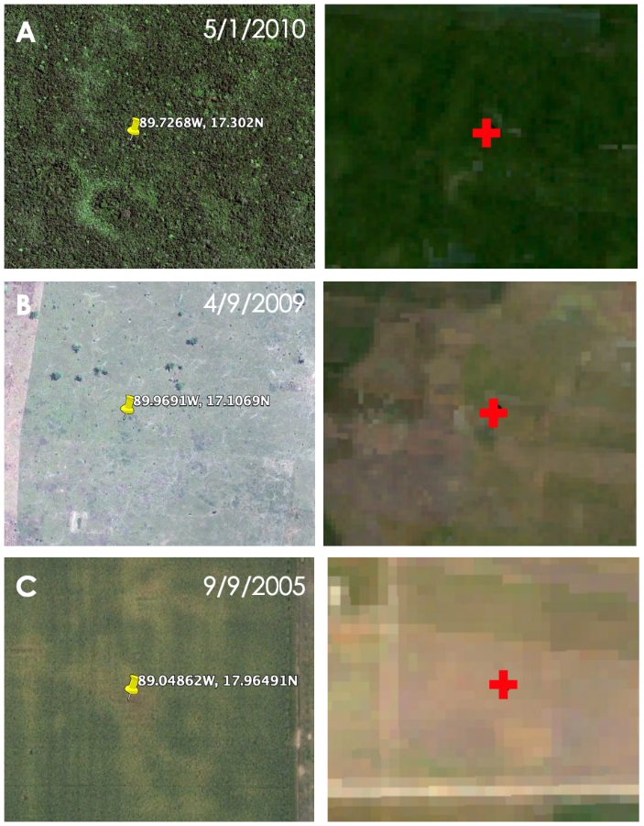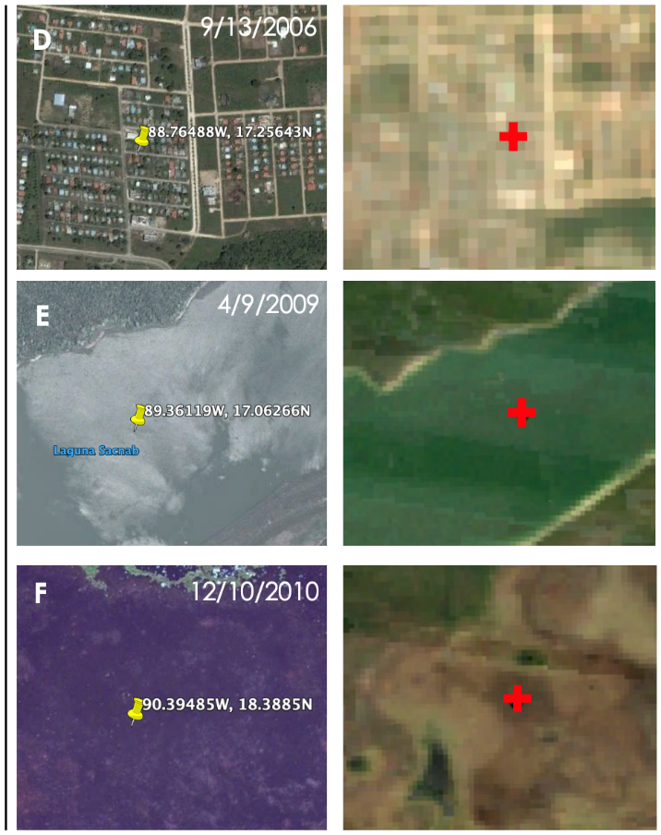
Figure A1. Example training points for a) forest, b) grassland, c) cropland, d) settlement, e) open water, and f) other land classes. The left image of both columns depicts the high-resolution imagery available in Google Earth Pro with the yellow pin denoting the training point, and the right image of both columns depicts the corresponding point (denoted by the red cross) in the Landsat 7 ETM+ composite image.

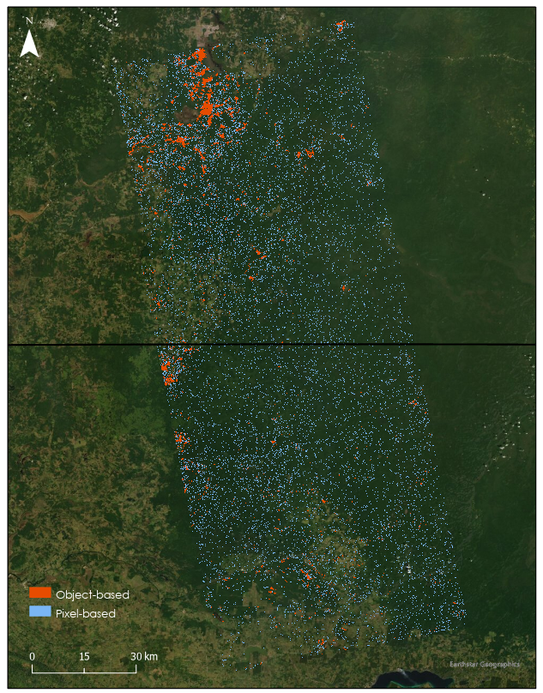
Figure A2. Pixel-level versus Object-level method for ALOS PALSAR-1 Path 170.

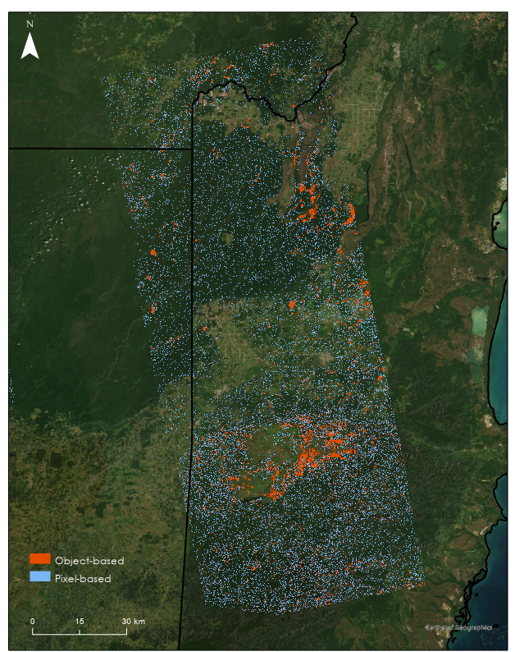
Figure A3. Pixel-level vs. Object-level method for ALOS PALSAR-1 Path 168.

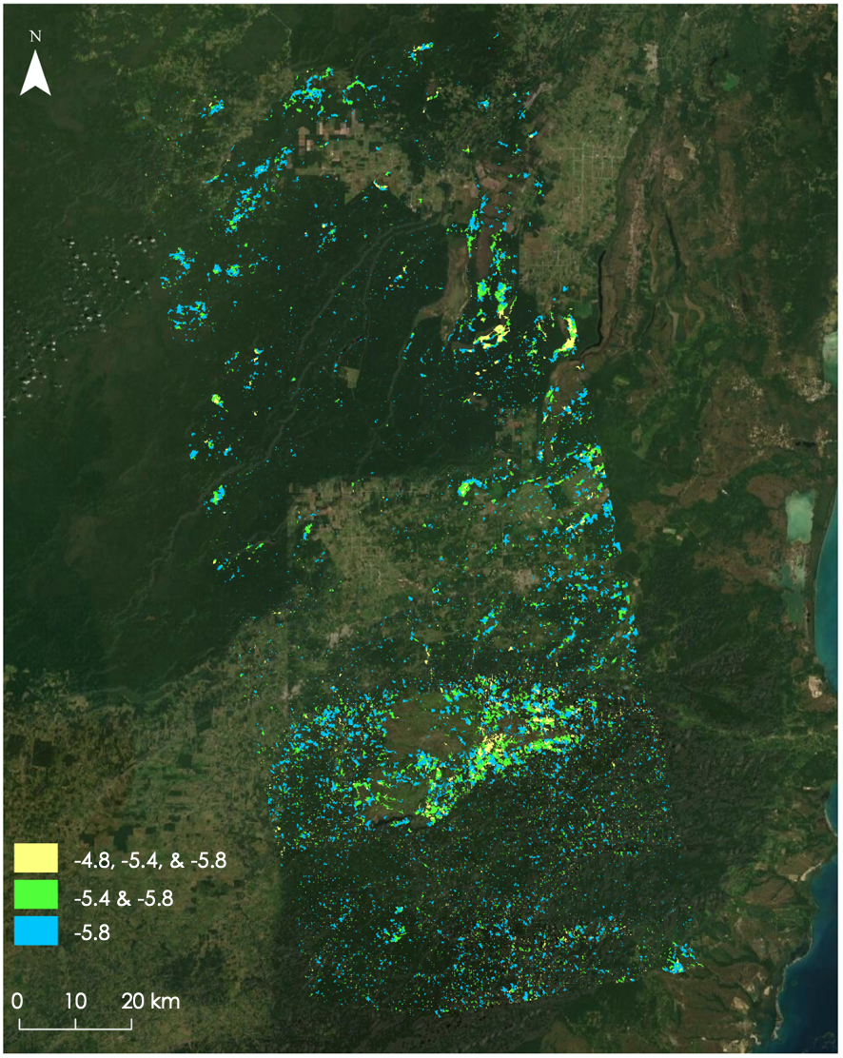
Figure A4. Map of inundation extent using three different thresholds for ALOS PALSAR-1 Path 168.

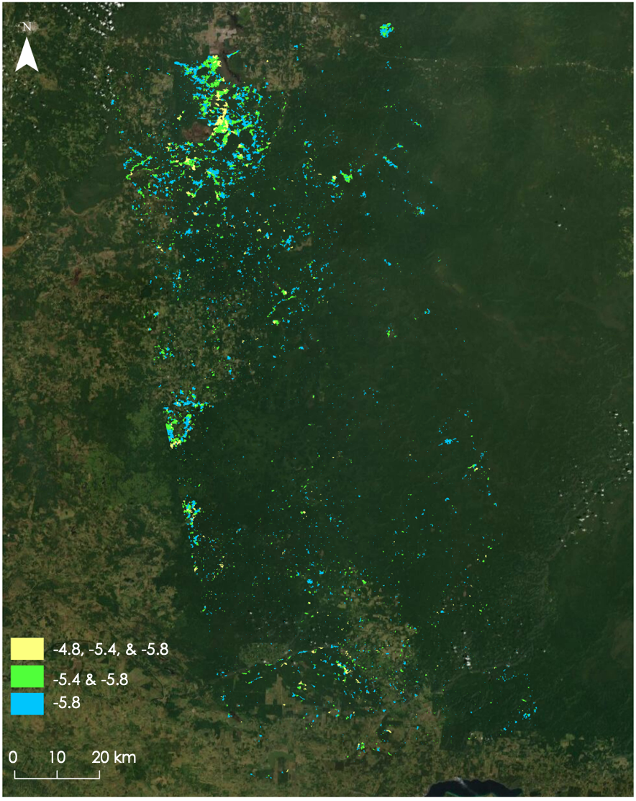
Figure A5. Map of inundation extent using three different thresholds for ALOS PALSAR-1 Path 170.

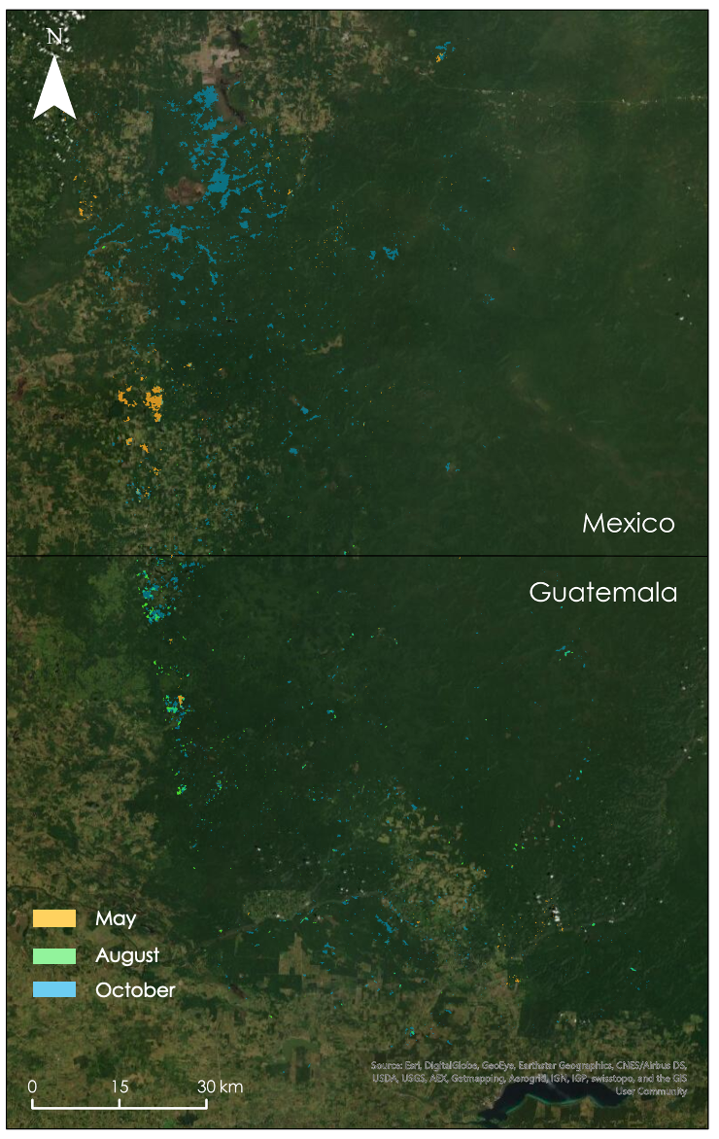
Figure A6. Map of seasonal inundation in ALOS PALSAR-1 Path 170.

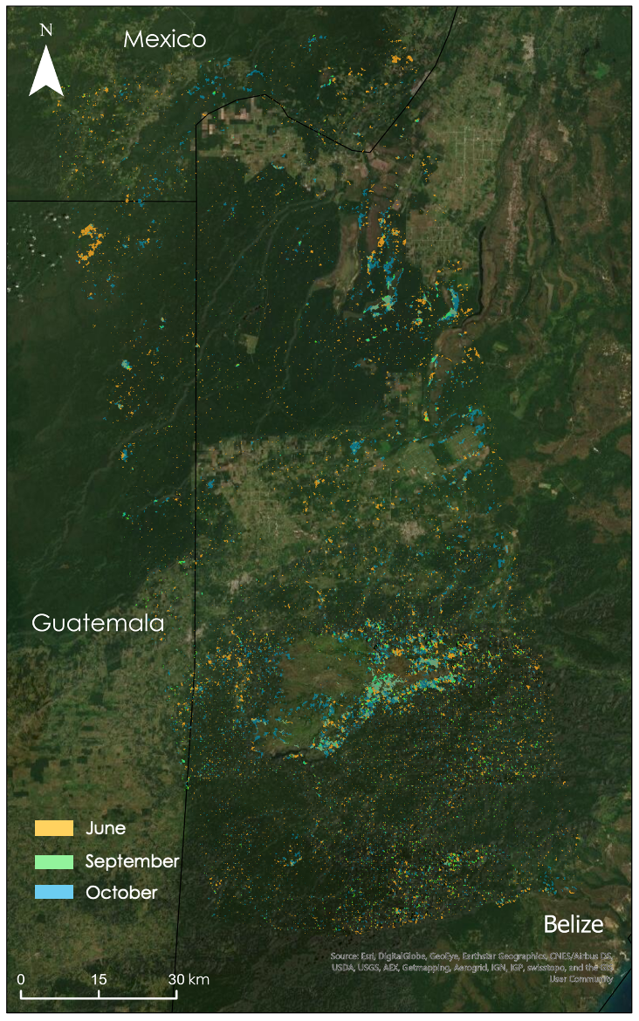
Figure A7. Map of seasonal inundation in ALOS PALSAR-1 Path 168.

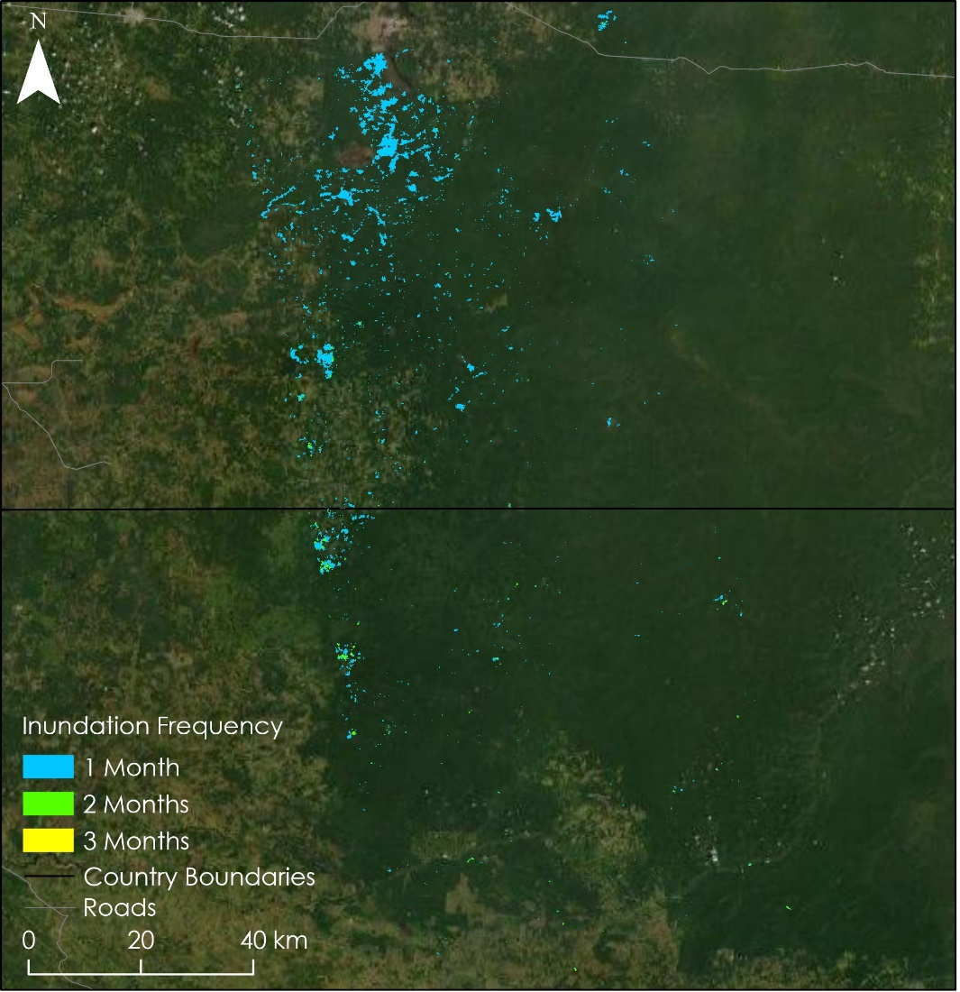
Figure A8. Map of inundation duration in ALOS PALSAR-1 Path 168.

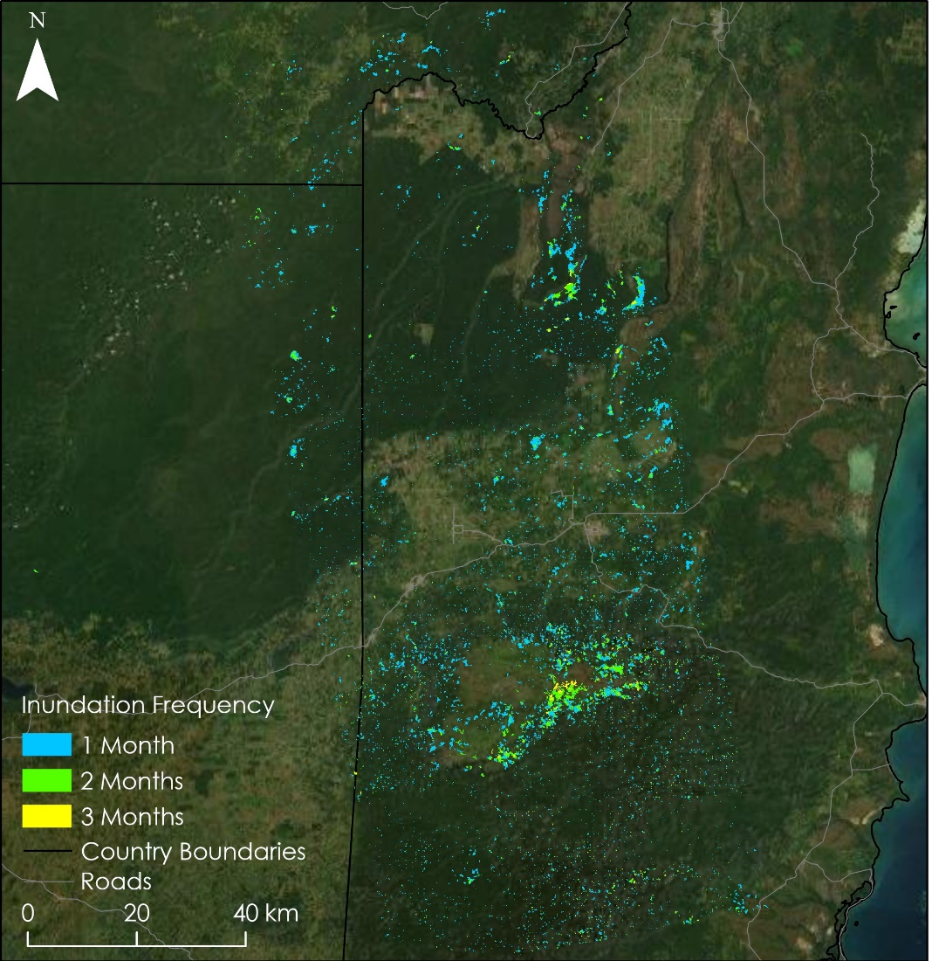
Figure A9. Map of inundation duration in ALOS PALSAR-1 Path 168.

Appendix B

Table B1
Results from the quantitative and qualitative iterative process for refining forested inundation at the –48., -5.4, and –5.8 threshold using HV-band data and regional data provided by project partners.
Threshold (dB) | Quantitative |  |  | Qualitative
 | Average HV values | Dr. Ford’s wetland points | Archaeo-logical Sites | DTM | Geology | Soil
-4.8 | 0.069 | 32.67% | 0 sites | No flooding mapped at peaks or ridges | Primarily alluvium. Fewer observations of limestone and volcanic | Primarily leptosol and gleysol. Fewer observations of cambisol and vertisol
-5.4 | 0.068 | 71.34% | 0 sites | Primarily no flooding mapped at peaks or ridges with the exception of the southwestern region of our study area | Primarily alluvium. and limestone. A few observations of volcanic | Primarily leptosol, gleysol and vertisol. Several observations of fluvisol and cambisol
-5.8 | 0.067 | 78.00% | 2 sites | Primarily no flooding mapped at peaks or ridges with the exception of the southwestern region of our study area | Primarily alluvium and limestone. A few observations of volcanic | Primarily leptosols, gleysols and vertisols. Several observations of fluvisols and cambisol

Table B2
Totals of mapped inundation from SAR imagery at the –5.4 dB threshold level. Totals were computed for each ALOS PALSAR-1 path analyzed in this study by counting total pixels classified as inundated
ALOS Path # | Date | Area of total inundation under the forest (ha)
168 | June 1, 2008 | 33987.86
 | September 1, 2008 | 6841.27
 | October 17, 2008 | 36226.79
170 | May 20, 2008 | 2844.92
 | August 20, 2008 | 1540.79
 | October 5, 2008 | 19852.02

