Powder River Basin Water Resources

Mapping Russian Olive in the Powder River Basin to Inform Invasive Species Management

 **Technical Report**

Final – August 12, 2021

Catherine Buczek (Project Lead)

Carly Andrews

Karissa Courtney

Dahlia Shahin

Amy Tian

***Advisors:***

Dr. Anthony Vorster, Colorado State University, Natural Resource Ecology Lab (Primary Science Advisor)

Brian Woodward, Colorado State University, Natural Resource Ecology Lab (Primary Science Advisor)

Dr. Paul Evangelista, Colorado State University, Natural Resource Ecology Lab

Dr. Catherine Jarnevich, United States Geological Survey

Peder Engelstad, Colorado State University, Natural Resource Ecology Lab

Nicholas Young, Colorado State University, Natural Resource Ecology Lab

# 1. Abstract

Since its introduction in the late 1800s, *Elaeagnus augustifolia* (Russian olive) has become a widespread invasive shrub that poses a threat to native riparian species in the United States by competing with native riparian plants for space and resources. To date, limited information on the distribution of Russian olive in the Powder River Basin of Montana and Wyoming have hampered management efforts and decision making. Here, we detect and model the distribution of Russian olive using field surveys, ocular sampling, and variables from Landsat 8 Operational Land Imager (OLI), Sentinel-2 MultiSpectral Instrument (MSI), and Shuttle Radar Topography Mission (SRTM) using the Random Forest algorithm. We derived topographic, spectral, and hydrological variables from Landsat 8 OLI, Sentinel-2 MSI, and SRTM to utilize as model inputs. The team was able to successfully create a spectral Russian olive detection map for the Powder River Basin (RMSE = 15.44%, R2 = 0.6482). The team also examined change in stream channel geomorphology from 1984-2020 in a time-series analysis using Landsat visible imagery and the RivMAP MATLAB package and found little change. Our results will help our partners at the Powder River County Weed Board, Gay Ranch, United States Geological Survey, and University of Northern Colorado to locate and prioritize areas for riparian habitat restoration and to understand the region’s hydrology and geomorphology.

**Key Terms**

Landsat 8, Sentinel-2, random forest, riparian zone, invasive species, conservation, remote sensing, ecological restoration

# 2. Introduction

***2.1 Background Information***

Riparian ecosystems occur at transition zones between aquatic and terrestrial systems. They provide many ecosystem services including flood mitigation and improving water quality and water quantity (Ocampo et al., 2006). Riparian zones often contain unique plant communities that offer food sources and habitat for aquatic and terrestrial organisms (Gregory et al., 1991), and are “diverse, dynamic, and complex” terrestrial habitats (Naiman et al., 1993). When invasive species establish themselves in riparian zones, they can reduce biodiversity, decrease food and habitat availability, and impact local hydrology (Tabacchi et al., 2000). In the western United States, Russian olive (*Elaeagnus augustifolia*) invasion is widespread in riparian ecosystems (Katz and Shafroth, 2003).

Native to Europe and Asia, Russian olive was introduced to the United States in the late 1800s and has since become widespread, influencing vegetation composition and structure in riparian zones (Katz & Shafroth, 2003). It was introduced for its ornamental value, erosion control, and windbreak benefits between farmlands (Collette and Pither, 2015). Russian olive is a deciduous tree that has distinctive silvery-gray foliage and produces yellow insect-pollinated flowers that fruit with a large single seed (Katz & Shafroth, 2003). Russian olive disperses quickly through animal vectors primarily by birds (Katz & Shafroth, 2003) and by short-term flooding along waterways (West et al., 2020). The species can survive colder conditions as it requires a period of cold temperatures for bud break and seed germination (Nagler et al., 2011). Furthermore, Russian olive is a nitrogen fixer and can increase stream nitrogen saturation, sometimes resulting in eutrophication and oxygen deficiencies. With these traits taken together, Russian olive is a stress tolerant species that crowds out native vegetation and has become widely established as the fifth most abundant species along rivers in 35 states (Nagler et al., 2011; Zouhar, 2005).

The Powder River is a tributary of the Yellowstone River in Wyoming and Montana (Pizzuto, 1994), it covers c. 31,000 km2, and has a semi-arid climate. The Powder River Basin is surrounded by the Laramie, Casper, and Bighorn Mountains (Bergquist, 2007) and is partly responsible for transporting snowmelt during peak season, which serves as an important water resource for farms, ranches, municipalities, and supports high biodiversity in lowland regions (Clark et al., 2001; Bureau of Land Management [BLM], 2003). The river is experiencing changes to its hydrologic and riparian ecosystems that may be influenced by a multitude of factors, including invasive species such as Russian olive (BLM, 2003). We mapped current (2019-2021) Russian olive extent within the study area along the Powder River (Figure 1) and created a time series of stream channel change from 1984-2020. Our research can assist local land managers who are uncertain of Russian olive’s current extent and ecological impact.

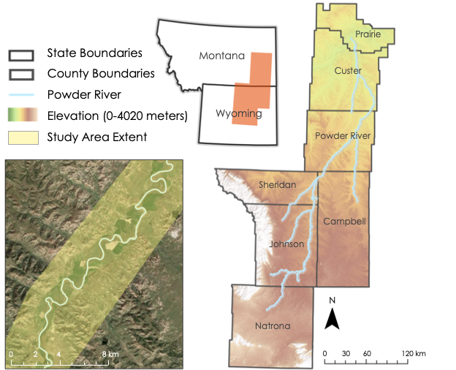

*Figure 1.* Study area in the Powder River Basin and five of its tributaries located in southeastern Montana and northeastern Wyoming, United States. The Powder River passes through seven counties. The bottom left inset depicts the study area extent (transparent yellow) that was provided by our partners at the University of Northern Colorado and serves as the riparian zone for our study.

Remote sensing data offers powerful tools that can be used to build a Russian olive detection map that describes the spatial extent of Russian olive on a large scale (Xie et al., 2008). Few studies have been conducted that use remotely sensed data to map Russian olive in large regions. Hamilton et al. (2006) successfully mapped Russian olive along a six-mile portion of Salina Creek, Utah, but were constrained by aerial imagery availability and a very hands-on methodology. Combs et al. (2011) also successfully mapped Russian olive using National Agriculture Imagery Program’s (NAIP) high resolution imagery, drawing polygons around areas with Russian olive presence. Both Combs et al. (2011) and Hamilton et al. (2006) relied on ESRI ArcGIS’ Feature Analyst, which is not a commonly available extension, making their methodologies less accessible. We take a less hands-on approach to mapping Russian olive and harness the power of Google Earth Engine (GEE), a freely available software, to collect, ingest, and process Sentinel-2 and Landsat 8 imagery, both freely available and with limitless spatial availability. Most importantly, our methodology can be replicated and applied outside of the Powder River Basin, making it the first of its kind.

***2.2 Project Partners & Objectives***

Our project partners were the Powder River County Weed Board, Gay Ranch, Unites States Geological Survey (USGS), and University of Northern Colorado. Our partners were interested in applying remotely sensed data to describe the current extent of Russian olive in the riparian buffer zone of the Powder River and select tributaries (Figure 1). These results will help partners make informed decisions to protect water resources along the Powder River. Our project was broken down into two primary objectives: 1) to map current Russian olive extent using remotely sensed data, field data, and LiDAR data and 2) to describe visual geomorphic change along the Powder River using Landsat imagery. Our results will help inform decision making around Russian olive management and will also support current and future research at the University of Northern Colorado.

# 3. Methodology

***3.1 Data Acquisition***

*3.1.1 Random Forest Model Data Acquisition*

We created a spectral detection model of Russian olive distribution between 2020 and 2021 using the random forest algorithm. The random forest model was trained with remotely sensed data (Sentinel-2 and Landsat 8; Table 1), field data, and aerial imagery (LiDAR; Table 1). The field data were collected in May and June of 2021 by our partners at the University of Northern Colorado (Table 1). The data were collected in 10-meter radial plots along multiple existing transects, ranging between 50 and 100 meters of one another. These data were collected as existing cross sections, known as Powder River Kilometers, which are measured following the centerline of the Powder River. Data collected at each plot included the percent cover of various woody species (including Russian olive), the location (in Northness and Eastness), standing height, bareness, and coarse woody debris, along the Powder River (Table 2). We used only Russian olive percent cover and Russian olive height for this project. Russian olive percent cover measurements served as validation locations to the ocular samples collected from satellite imagery.

To increase our occurrence sampling dataset size, we also conducted ocular image sampling using 2019 NAIP imagery following similar sampling procedure as described in Woodward et al. (2018a and 2018b). We used GEE to collect 10-meter radial plots that mimicked the field data collected by the University of Northern Colorado. See Figures A1 and A2 for examples of our decision-making process. Within each 10-meter radial plot, we determined the amount of Russian olive present or absent on a scale of 0-100%, to mimic the field data collection methodology.

In total, there were three data collection methods performed, and used, to train the random forest model: 1) field data, 2) random ocular sampling, and 3) opportunistic ocular sampling (Figure A3; Figure A4). With the field data alone, the model could not delineate Russian olive from other vegetation. There were 185 out of 276 field data points that contained Russian olive presence. To improve the random forest model, the team randomly sampled approximately 2,000 plots from NAIP imagery within the study area to supplement the field data. Only 11 out of the 2,000 randomly sampled points contained Russian olive presence so the team next collected opportunistic samples (Russian olive presence). We collected 477 opportunistic samples that contained varying percent covers of Russian olive (Figure A2). In total, our model was built on 2,733 data points, 673 of those points containing Russian olive.

*Table 1. Data sources, remote sensing*

|  |  |  |  |  |
| --- | --- | --- | --- | --- |
| **Sensor / Source** | **Data Products** | **Acquisition Method** | **Spatial Resolution** | **Years Used** |
| SRTM | Elevation, slope, aspect, northness, eastness | GEE | 30m | 2000 |
| Landsat 8 OLI | Normalized Difference Vegetation Index (NDVI), Normalized Difference Moisture Index (NDMI), Normalized Burn Index (NBR), Simple Ratio (SR), Tasseled cap index, Modified Normalized Difference Water Index (MNDWI), Enhanced Vegetation Index (EVI) | GEE | 30m | 2013-Present |
| Landsat 7 ETM+ | NDVI, MNDWI, EVI | GEE | 30m | 1999-Present |
| Landsat 5 TM | NDVI, MNDWI, EVI | GEE | 30m | 1984-2013 |
| Sentinel-2 MSI | NDVI, NDMI, NBR, SR, Tasseled cap index | GEE | 20m | 2020-2021 |
| NAIP | Ocular sampling of Russian olive | GEE | 1m | 2019 |
| LiDAR | Canopy height model | Open Topography | 1m | 2016 |

*Table 2. Data sources, field data*

|  |  |  |  |  |  |
| --- | --- | --- | --- | --- | --- |
| **Data Type** | **Source** | **Data Product** | **Acquisition Method** | **Extent** | **Collection Date** |
| Percent cover | University of Northern Colorado | Percent cover data of Russian olive | On the ground data sampling | 10m plots | May/June 2021 |
| Height | University of Northern Colorado | Canopy height | On the ground data sampling | 10m plots | May/June 2021 |
| Shapefile | Dr. Sharon Bywater-Reyes | Powder River study area shapefile | Created | Entire Powder River | June 2021 |
| Shapefile | Dr. Sharon Bywater- Reyes | Gay Ranch boundary shapefile | Created | Gay Ranch | June 2021 |
| Sediment thickness, foresight, station | USGS, John Moody | Powder River cross section data | Email, and USGS website | Moorehead to Broadus, MT | 1975-2019 |
| History timeline | USGS, John Moody | Flood history of Powder River | On the ground data recording | Entire Powder River | 1978-2019 |
| Height | Marshall Wolf and Derek Schook | Russian olive canopy height and age | On the ground data sampling | Broadus to MT border | Obtained July 2021 |

*3.1.2 Geomorphology Time Series Data Acquisition*

To study stream geomorphology over time, the team collected Tier 1 visible imagery from Landsat 5 TM, Landsat 7 ETM+, and Landsat 8 OLI (Table 1). The imagery was collected from GEE and a composite for each year was created, filtering out images with high cloud cover (<20-30%). We chose to analyze stream channel change from 1984 to 2020, in concurrence with the spatial and temporal consistencies of the Landsat 5, 7, and 8 missions. The goal of this part of the project was to understand the potential impact of Russian olive on riverbanks and stream geomorphology.

***3.2 Data Processing***

*3.2.1 Random Forest Model*

We created a mosaic of recent (2020) imagery from Landsat 8 OLI and Sentinel-2 MSI imagery to cover the entire Powder River Basin study area. We filtered images for those with low cloud cover (<20-30%) and created a composite image for each relevant season (spring, summer, and fall). Spectral indices were calculated from the mosaic imagery, which included a Normalized Difference Vegetation Index (NDVI), Normalized Difference Moisture Index (NDMI), Normalized Burn Ratio (NBR), and Simple Ratio (SR), shown in Equations 1-4 below. Vegetation information from remote sensed images is mainly interpreted by differences and changes of the green leaves from plants and canopy spectral characteristics using indices such as NDVI, NDMI, and SR.

(1)

(2)

(3)

(4)

Additionally, we calculated the Tasseled Cap Index using the mosaic imagery. The Tasseled Cap transformation incorporates more information into vegetation indices by using six different bands of light (Crist & Cicone, 1984). The resulting brightness, greenness, and wetness (BGW) indices, named for the features in the data that they emphasize, improve vegetation classifications because they are sensitive to phenological changes (Equations 5-7). Therefore, the indices can be used to distinguish green vegetation with soil from green vegetation with brown vegetation (Crist et al., 1986). We tested a wide variety of remotely sensed predictor variables, including spectral bands, indices, and topography from seasonal imagery.

(5)

(6)

(7)

3.2.2 *Geomorphology*

Following the methodology used in Boothroyd et al. (2020), we used Landsat 5 TM, Landsat 7 ETM+, and Landsat 8 OLI data from 1984 to 2020 to map multi-decadal change of river channel geomorphology along a portion of the Powder River. To map the river extent, we extracted the active channel river mask from the surrounding land. For each satellite image in the image collection, a cloud masking algorithm was applied to mask obstructions from cloud and cloud shadow pixels. The retaining pixels were aggregated using a median reducer to generate a single composite image for the specified time period. Then, a wetted classification involving a Modified Normalized Difference Water Index (MNDWI), NDVI, and Enhanced Vegetation Index (EVI) was used to classify water pixels and produce a binary water mask (Equations 8 & 9). The same spectral indices were used to classify alluvial deposits, with the active channel boundary enforced by excluding vegetated pixels. The binary wetted channel and alluvial deposit masks were combined to give an active channel river mask at 5-year intervals. We continued analysis in MATLAB using the RivMAP toolbox (Jon, 2021), which allowed for extracting centerline position and channel width from each active channel river mask.

(8)

(9)

***3.3 Data Analysis***

The random forest model predictor variable inputs were developed in GEE and exported into RStudio for statistical analysis and model testing. We tested the model with different subsets of variables and refined the model by testing for variable importance using the ‘randomForest’ package in RStudio (Liaw and Wiener, 2002). Additionally, partial dependency plots provided further analysis of variable influence on the model (Friedman, 2001). The output of each model run provided us with error statistics, allowing us to determine overall model performance. Our goal was to develop a simple parsimonious model, that included the top predictor variables and reduced model over-fitting. We ran the final model in GEE which provided a visualization of the Russian olive detection raster. We finalized the Russian olive detection map in ArcGIS for the project partners.

We additionally ran a sub-model using a Canopy Height Model (CHM) derived from the Open Topography’s LiDAR raster dataset (Ackerman, 2016). Although the available LiDAR data covered a relatively small portion of the study area, it gave insight on how Russian olive height may perform as a predictor variable in future applications. In addition to the sub-model, CHM values were extracted at tree age location data provided by our partners to inform vegetative structural conditions (Figure D1).

Percent coverage and acreage by county were calculated from a presence/absence classification of the Russian olive detection raster in ArcGIS Pro (Table 4). To classify the raster into presence/absence, values above the Root Mean Square Error (RMSE) of 15.44% were considered presence and values below were considered absence. The count of presence and absence pixels were totaled, multiplied by 400m2 because the resolution of the raster is 20x20 meters, and then converted to acres. In order to capture more nuance in the percent coverage of Russian olive, the total acreage of each percent coverage class was obtained for bin sizes of 10% for Powder River County (Table 5). The Russian olive detection raster was classified into bin sizes of 10%, with the first bin being 15.44% - 20% percent cover to omit values below the RMSE. The same process of conversion for Table 4 was repeated to obtain total acreage.

4. Results & Discussion

***4.1 Analysis of Results***

*4.1.1 Random Forest Model Performance*

The random forest model predicted Russian olive distribution with high accuracy across the full study area (Figure B1), and when zoomed in on specific areas (Figure B2; Figure B3). The best-performing and most parsimonious random forest model (RFM) used six variables: fall tasseled cap greenness (FA_TCG), spring narrow near-infrared (SP_NarrowNIR), fall normalized difference vegetation index (FA_NDVI), fall tasseled cap brightness (FA_TCB), spring tasseled cap wetness (SP_TCW), and tasseled cap brightness between the summer and spring (SMmSP_TCB_diff). The other parameters, number of trees (ntree) and number of variables randomly sampled as candidates at each split (mtry), were set to 1000 and 3 respectively. This yielded a RMSE value of 15.44% cover and an R2 value of 0.6272 (Table 3; Figure C2).

We additionally plotted partial dependency functions for each predictor variable, which provided insight to how the value of each variable influenced the model predictions after the influence of all the other variables had been “averaged out” (Friedman, 2001). These figures present plots of partial dependence functions for the top six predictor variables (Figure C3). The plots show that all variables influence the model where regression is increasing and have no influence or less influence where regression is flat-lining. Overall, our top predictor variables were fall tasseled cap greenness with an increase in regression from about -500 to 1000, fall tasseled cap brightness with an increase in regression from 5000 to 6000, and tasseled cap brightness difference between the summer and spring seasons with an increase in regression from 0 to 1000.

*Table 3. Model Performance for different sets of predictor variables.*

|  |  |  |  |
| --- | --- | --- | --- |
| **Description** | **Predictor Variables** | **R-squared (%)** | **RMSE (%)** |
| 7 variables | ‘SMmSP_TCB_diff', 'FA_NDVI', 'SP_TCW', 'SP_NarrowNIR', 'FA_TCB', 'FA_TCG', 'SMmSP_NDMI_diff’ | 63.22 | 15.3389 |
| 6 variables | ‘SMmSP_TCB_diff', 'FA_NDVI', 'SP_TCW', 'SP_NarrowNIR', 'FA_TCB', 'FA_TCG’ | 62.72 | 15.4428 |
| 5 variables | 'SMmSP_TCB_diff', 'FA_NDVI', 'SP_NarrowNIR', 'FA_TCB', 'FA_TCG' | 60.95 | 15.8056 |
| 7 variables including ‘chm’ run over extent of CHM data | ‘SMmSP_TCB_diff', 'FA_NDVI', 'SP_TCW', 'SP_NarrowNIR', 'FA_TCB', 'FA_TCG’, ‘chm’ | 56.12 | 19.454 |
| 6 variables run over extent of CHM data | ‘SMmSP_TCB_diff', 'FA_NDVI', 'SP_TCW', 'SP_NarrowNIR', 'FA_TCB', 'FA_TCG’ | 52.2 | 20.3055 |

Random forest model results (Russian olive detection maps) were delineated by county and were given to our partners as high-resolution PDFs due to the size of the study area (Figure B2 and Figure B3). To best display the model's results here, we exhibit an example of the model results zoomed into an area along the Powder River in Powder River County compared to corresponding satellite imagery (Figure 2). Results in green-yellow represent areas of Russian olive presence while blue represent areas of absence in percent. The results displayed in Figure 2a and Figure 3a display Russian olive presence from the RMSE value 15.44% to 100%. Values below RMSE were removed because the model cannot confidently predict under RMSE. Our results from the random forest model (Figure 2a) corresponds to areas where Russian olive is present along the Powder River (light-sage canopy color; Figure 2b).

We created a standard Russian olive presence/absence map using the RMSE as the threshold (Figure 3). In this way, all values above (below) RMSE were considered Russian olive presence (absence). Based on our results, the model’s accuracy decreases as distance from river increases. Notice the model is over-predicting in areas where land cover types change dramatically within a 1.2km range (Figures 2 and 3). The model likely becomes confused in areas with diverse vegetative cover due to the lower resolution of Sentinel-2 data (20 meters; Table 1). The satellite imagery displayed in Figures 2b and 3b (Maxar) is higher resolution than that of Sentinel-2 and Landsat 8.

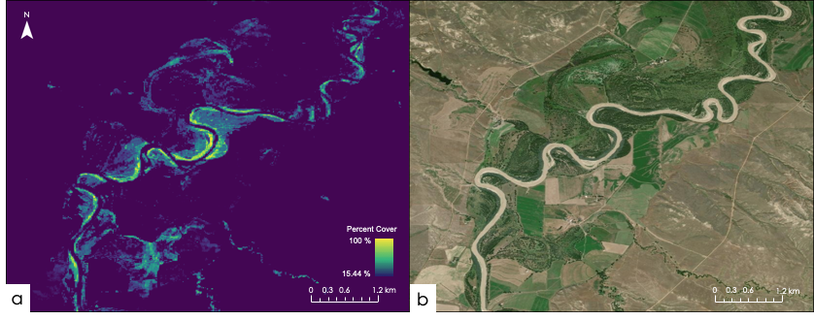

*Figure 2.* The results of the random forest model, calculated from Landsat 8 and Sentinel-2 (a) compared to ESRI’s Maxar (basemap) satellite imagery (b) as an example of the model's performance along the Powder River. Shown is just at small section of the Powder River in Powder River County. We created a threshold based on the RMSE = 15.44% cover to correct for areas where the model was not performing well. Dark blues represent 0% Russian olive cover while yellow represents 100% Russian olive cover.

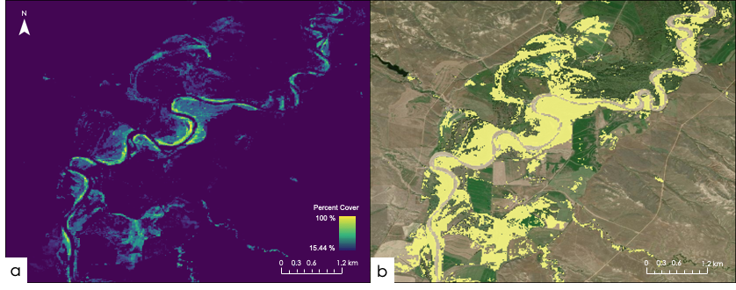

*Figure 3.* The results of the random forest model (a) compared to Russian olive presence/absence (b) plotted over ESRI’s Maxar (basemap), where any percent cover greater than RMSE = 15.44% cover is considered to be Russian olive presence.

Russian olive is most dominant in Custer County, Powder River County, and Sheridan County with 13.8%, 12.9%, and 11.8% coverage along the Powder River, respectively (Table 4; Figure 4). Over the entire study area, it was predicted that plots with 20-30% of Russian olive percent cover were the most frequent (Figure C1). While the scope of our study did not examine why Russian olive is more common in these counties, this could be due to higher rates of human development in these counties.

*Table 4. Area (acres) and percent coverage of Russian olive along the Powder River by county using a presence/absence classification.*

|  |  |  |
| --- | --- | --- |
| County | Area (acres) | Percent coverage |
| Campbell | 4,790 | 9.1% |
| Custer | 19,589 | 13.8% |
| Johnson | 27,662 | 9.0% |
| Natrona | 628 | 1.3% |
| Powder River | 23,316 | 12.9% |
| Prairie | 1,263 | 6.8% |
| Sheridan | 11,263 | 11.8% |

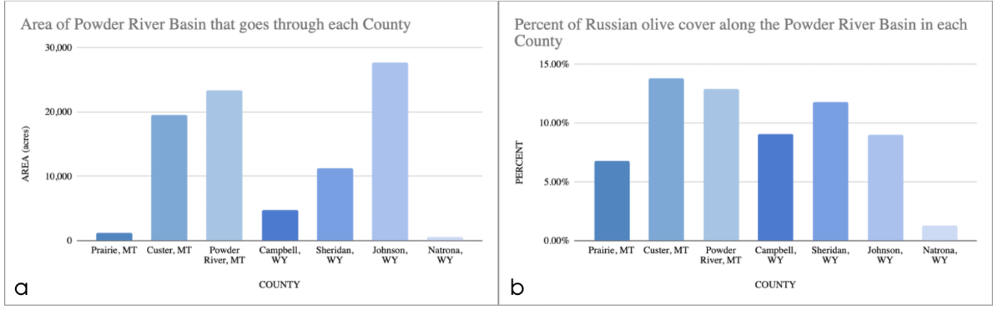

*Figure 4.* a) shows the total study area (in acres) that lies within each county, b) shows the percent cover of Russian olive within the study by county. The results are normalized by the size (acre) of each county.

Our partners were interested in understanding how much Russian olive was present within Powder River County in acres (Table 5). The extent of study area in Powder River County is 23,316 acres. A total of 30.34 acres in Powder River County contained Russian olive presence with 91-100% cover. As percent cover increases, the total acres invaded by Russian olive decreases, apart from the 21-30% range where Russian olive covers 7,997.80 acres within the study area in Powder River County. Approximately 21,000 acres of the study area in Powder River County contains less than 50% Russian olive cover, while approximately 2,230 acres of the study area contains greater than 50% Russian olive cover.

*Table 5. Total acres of Russian olive based on percent coverage ranges in Powder River County.*

|  |  |  |
| --- | --- | --- |
| Percent Cover | Pixel Count | Total Acres |
| 15.44-20%  21-30%  31-40%  41-50%  51-60%  61-70%  71-80%  81-90%  91-100% | 72223  80915  38188  21175  11218  6525  3197  1634  307 | 7138.67  7997.80  3774.58  2092.98  1108.81  644.94  316.00  161.51  30.34 |

*4.1.2 Random Forest Model and Canopy Height Model Case Study*

In addition to the results discussed, we ran a sub-model over the extent of available LiDAR data which included a canopy height model as a predictor variable in attempt to better distinguish Russian olive, since it is shorter than most other species along the Powder River (Figure D1). The model produced slightly higher error (RMSE = 19.454% and R2 = 56.12; Table 3) than our final model containing six variables (RMSE = 15.44% and R2 = 62.72). One of the flaws of including the CHM is that it only covered a small portion of the study area. Based on how our model ran with just the field data, collected in a small area, it is possible that a CHM that covers a larger portion of the study area might improve the results from the random forest model.

*4.1.3 Geomorphology*

Our qualitative analysis of stream geomorphology showed little change in the Powder River over time. The spatial resolution of our analysis may not have been suitable to detect subtle changes in the stream channel that occurred during our study period. We also may have detected more change in stream channel morphology if we could have extended the temporal coverage earlier than 1984. We had some success using the RivMAP package (Jon, 2021) following the methods detailed in Boothroyd et al. (2020). We were successful in extracting the active channel river mask from Google Earth Engine. However, we were unable to create visuals useful for our partners using the RivMAP package. It would be worthwhile to explore alternative packages similar to MATLAB’s RivMAP.

Due to the large size of our study area and the fact that most channel changes can only be seen at a relatively large scale, we chose to focus on a stretch of the river just north of Broadus, MT for our time series animation. This area had more channel morphology changes than the south of Broadus part of the river, along Gay Ranch. We visualized some change over the 34-year time period, but quantifying this change was outside the scope of this project.

***4.2 Future Work***

Future work could look into creating a habitat suitability map of Russian olive to provide information on target areas that may be at risk of Russian olive invasion to aid in invasive species management preparations. In a similar way, it would be useful to study how our model performs outside of the Powder River Basin. Other studies could also investigate presence of Russian olive in relation to cottonwood, which is present in the study area and high-resolution field data was previously collected for. Our partners are particularly interested in including tamarisk, another invasive species, as part of the detection model. Including tamarisk as part of the analysis was outside of the scope of this project. Based on the model’s success with 243 Russian olive presence points collected in the field, a model would likely run poorly with the number of tamarisks sampled. From what we learned, a separate model mapping tamarisk can successfully be created following our procedure. A tamarisk detection model used in conjunction with our Russian olive detection map would greatly support our partners efforts to learn more about local invasive species management. Additionally, the field data collected includes other woody invasive species, giving the opportunity for further exploration. To further improve the resolution of the Russian olive detection model, the model could be re-run with NIR re-sampled to 10-meter resolution. With NIR re-sampled, the resolution of our results would increase from 20 meters to 10 meters. This step also fell outside the timeframe of our project.

5. Conclusions

Our model successfully detected Russian olive within the Powder River riparian zone. The top predictor variables were tasseled cap brightness difference between the summer and spring and fall tasseled cap greenness. The tasseled cap indices and difference between tasseled cap indices of multi-seasonal imagery captures Russian olive phenology effectively and significantly increased the performance of our model. Russian olive has never been spatially mapped over a large area using remotely sensed data—our results show that it is feasible to use a random forest model, Sentinel-2 imagery, and GEE to map Russian olive. Our methodology is universal in that it can be applied to mapping Russian olive in regions outside of the Powder River. We believe our model would be successful outside of the Powder River Basin given the random forest model was developed using primarily spectral indices and is independent of any topographic variables.

6. Acknowledgments

Thank you to our collaborators at University of Northern Colorado, Dr. Sharon Bywater-Reyes and Dr. Scott Franklin and their students for collecting percent cover data for our project. Also, thank you to John Moody with the US Geological Survey for providing us with cross-section data of the Powder River and on-the-ground observations along with Glenn Gay from Gay Ranch. Thank you to Scott Cunningham, our Fellow with DEVELOP, and our primary science advisors, Dr. Anthony Vorster and Brian Woodward, with Colorado State University’s Natural Resource Ecology Lab.

This material contains modified Copernicus Sentinel data (2020), processed by ESA.

Any opinions, findings, and conclusions or recommendations expressed in this material are those of the author(s) and do not necessarily reflect the views of the National Aeronautics and Space Administration.

This material is based upon work supported by NASA through contract NNL16AA05C.

# 7. Glossary

**Earth observations** – Satellites and sensors that collect information about the Earth’s physical, chemical, and biological systems over space and time

**ETM+** – Enhanced Thematic Mapper Plus (Landsat 7 sensor)

**LiDAR** – Light Detection and Ranging, a remote sensing method

**MSI** – Multispectral Instrument (Sentinel-2 sensor)

**NAIP** – The National Agriculture Imagery Program

**NDMI** –Normalized Difference Moisture Index

**NDVI** – Normalized Difference Vegetation Index

**OLI** –Operational Land Imager (Landsat 8 sensor)

**SRTM** – Shuttle Radar Topography Mission

**TM** –Thematic Mapper (Landsat 5 sensor)

# 8. References

Ackerman, T. (2016). Powder River, Montana 2016 airborne lidar. National Center for Airborne Laser Mapping (NCALM), distribution by OpenTopography. <https://doi.org/10.5069/G93F4MJG>

Bergquist, E., Evangelista, P., Stohlgren, T. J., & Alley, N. (2007). Invasive species and coal bed methane development in the Powder River Basin, Wyoming. *Environmental Monitoring and Assessment*, *128*(1), 381-394. https://doi:10.1007/s10661-006-9321-7

Best, H., McNamara, J.P., & Liberty, L. (2018). Association of ice and river channel morphology determined using ground-penetrating radar in the Kuparuk River, Alaska. *Arctic, Antarctic, and Alpine Research 37*(2), 157-162. https://doi:10.1657/1523-0430(2005)037[0157:aoiarc]2.0.co;2

Boothroyd, R.J., Williams, R.D., Hoey, T.B., Barrett, B., & Prasojo, O.A. (2020). Applications of Google Earth Engine in fluvial geomorphology for detecting river channel change. *WIREs Water*, 2021; 8:e21496. <https://doi.org/10.1002/wat2.1496>

Bureau of Land Management. (2003). Final environmental impact statement and proposed plan amendment for the Powder River Basin oil and gas project. *Bureau of Land Management Environmental Impact Statement*. <http://purl.access.gpo.gov/GPO/LPS52158>

Clark, M.L., Miller, K.A., & Brooks, M.H. (2001). U.S. Geological Survey Monitoring of Powder River Basin Stream-Water Quantity and Quality: Water-Resources Investigations Report 01-4279. USGS, Cheyenne, Wyoming. <https://pubs.usgs.gov/wri/wri014279/html/report.htm>

Collette, L.K.D. & Pither, J. (2015). Russian olive (*Elaeagnus angustifolia*) biology and ecology and its potential to invade northern North American riparian ecosystems. I*nvasive Plant Science and Management 8*(1), 1-14. <https://doi.org/10.1614/IPSM-D-14-00037.1>

Combs, J. a& Potter, T. (2011). Russian Olive (*Elaeagnus angustifolia L.*) Distribution Mapping for the Upper Yellowstone River and Tributaries Using Feature Analysis Software, an Extension for ArcMap. USDA NRCS. Invasive Species Technical Note No. MT-31.

Crist, E.P., & Cicone, R.C. (1984). A physically-based transformation of Thematic Mapper data- the TM Tasseled Cap. *IEEE Transactions on Geoscience and Remote Sensing 22*, 256-352. https://doi:10.1109/tgrs.1984.350619

Crist, E.P., Laurin, R., & Cicone, R.C. (1986). Vegetation and soils information contained in transformed Thematic Mapper data. Proceedings of the IGARSS’ 86 Symposium, Zurich, Switzerland, ESA, Paris, pp. 1465–1470. <https://doi.org/10.1016/S0034-4257(01)00324-8>

Friedman, J.H. (2001). Greedy function approximation: A gradient boosting machine. *Annals of Statistics,* 1189-1232. <http://www.jstor.org/stable/2699986>

Gregory, S.V., Swanson, F.J., McKee, W.A., & Cummins, K. (1991). An ecosystem perspective of riparian zones. *BioScience, 41*(8), 540-551. https://doi:10.2307/1311607

Hamilton, R., Megown, K., Lachowski, H., & Campbell, R. (2006). Mapping Russian olive: Using remote sensing to map an invasive tree. FSAC-0087-RPT1. Salt Lake City, UT: US Forest Service, Remote Sensing Applications Center. 7p.

Jon. (2021). RivMAP - River Morphodynamics from Analysis of Planforms (<https://www.mathworks.com/matlabcentral/fileexchange/58264-rivmap-river-morphodynamics-from-analysis-of-planforms>), MATLAB Central File Exchange. Retrieved August 6, 2021.

Katz, G.L. & Shafroth, P.B. (2003). Biology, ecology, and management of *Elaeagnus angustifolia* L. (Russian olive) in western North America. *Wetlands, 23*(4), 763-777. [https://doi.org/10.1672/0277-5212(2003)023[0763:BEAMOE]2.0.CO;2](https://doi.org/10.1672/0277-5212(2003)023%5b0763:BEAMOE%5d2.0.CO;2)

Liaw, A. & Wiener, M. (2002). Classification and Regression by randomForest. *R News 2*(3), 18-22. <https://cogns.northwestern.edu/cbmg/LiawAndWiener2002.pdf>

Nagler, P.L., Glenn, E.P., Jarnevich, C.S., & Shafroth, P.B. (2011). Distribution and abundance of saltcedar and Russian olive in the Western United States. *Critical Reviews in Plant Sciences, 30*, 508-523. <https://doi.org/10.1080/07352689.2011.615689>

Naiman, R.J., Decamps, H., & Pollock, M. (1993). The role of riparian corridors in maintaining regional biodiversity. *Ecological Applications, 3*(2), 209-212. https://doi:10.2307/1941822

Ocampo, C. J., Sivapalan, M., & Oldham, C. (2006). Hydrological connectivity of upland-riparian zones in agricultural catchments: Implications for runoff generation and nitrate transport. *Journal of Hydrology, 331*(3–4), 643-658. <https://doi.org/10.1016/j.jhydrol.2006.06.010>

Pizzuto, J. E. (1994). Channel adjustments to changing discharges, Powder River, Montana. *Geological Society of America Bulletin*, *106*(11), 1494-1501. https://doi:10.1130/0016-7606(1994)106<1494:catcdp>2.3.co;2

Tabacchi, E., Lambs, L., Guilloy, H., Planty-Tabacchi, A.-M., Muller, E., & Décamps, H. (2000). Impacts of riparian vegetation on hydrological processes. *Hydrological Processes, 14*, 2959-2976. [http://dx.doi.org/10.1002/1099-1085(200011/12)14:16/17<2959::AIDHYP129>3.0.CO;2-B](http://dx.doi.org/10.1002/1099-1085(200011/12)14:16/17%3c2959::AIDHYP129%3e3.0.CO;2-B)

West, A. M., Evangelista, P.H., Jarnevich, C. S., Young, N.E., Stohlgren, T. J., Talbert, C., … & Anderson, R. (2016). Integrating remote sensing with species distribution models; mapping tamarisk invasions using the software for assisted habitat modeling (SAHM). *Journal of Visualized Experiments, 116*, e54578. h[ttps://doi.org/0.3791/54578](https://dx.doi.org/10.3791%2F54578)

West, N.M., Reinhold, A.M., Poole, G.C., & Espeland, E.K. (2020). Flood dynamics dictate distributions of *Elaeagnus angustifolia* L. (Russian olive) on a riverine floodplain. *Biological Invasions, 22*, 3493-3499. <https://doi.org/10.1007/s10530-020-02352-z>

Woodward, B., Evangelista, P., & Vorster, A. (2018a). Mapping progression and severity of a southern Colorado spruce beetle outbreak using calibrated image composites. *Forests, 9*(6), 336. <https://doi.org/10.3390/f9060336>

Woodward, B., Evangelista, P., Young, N., Vorster, A., West, A., Carroll, S., Girma, R., Hatcher, E.Z., Anderson, R., Vahsen, M., Vashisht, A., Mayer, T., Carver, D., and Jarnevich, C. (2018b). CO-RIP: A riparian vegetation and corridor extent dataset for Colorado River Basin streams and rivers. *ISPRS International Journal of Geo-Information 7*(10), 397. <https://doi.org/10.3390/ijgi7100397>

Xie, Y., Sha, Z., & Yu, M. (2008). Remote sensing imagery in vegetation mapping: a review. *Journal of Plant Ecology*, *1*(1), 9-23. <https://doi.org/10.1093/jpe/rtm005>

Zouhar, K. (2005). *Species: Elaeagnus angustifolia.* U.S. Department of Agriculture, U.S. Forest Service, Fire Effects Information System (FEIS). <https://www.fs.fed.us/database/feis/plants/tree/elaang/all.html>

# 9. Appendices

Appendix A: Sampling Procedure

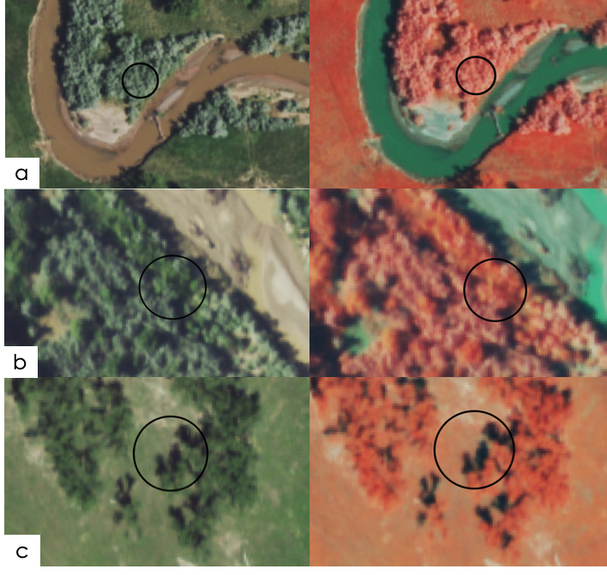

*Figure A1.* Depiction of different percentages of Russian olive cover along the Powder River study area using NAIP Mosaic true color 2019 imagery (left) and false color 2019 imagery (right) with a) 100% Russian olive cover, b) 25%, and c) 0%.

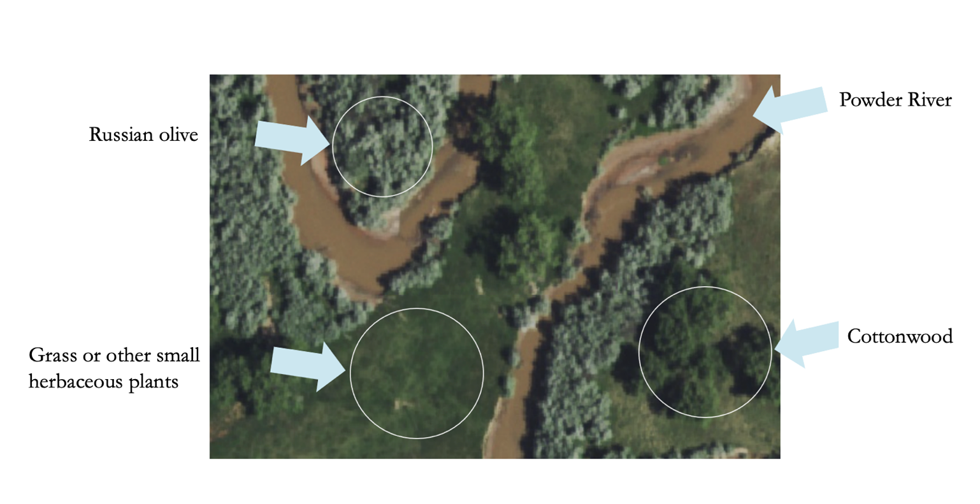*Figure A2.* Visual comparison of Russian olive to other vegetation using NAIP Mosaic true imagery (2019).

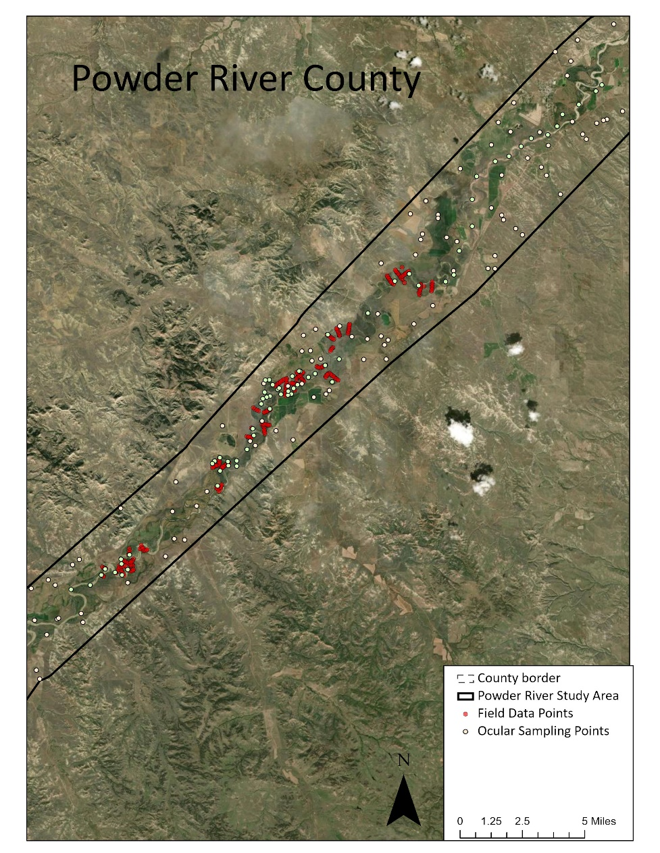

*Figure A3.* Map showing all of the field data collection points (red) and some of the ocularly sampled points (light yellow) in part of the Powder River County. All field data points are shown, but only part of the ocularly sampled points is shown, as they were collected across the entire study area spanning all seven counties. All data collection points were 10-meter radial plots.

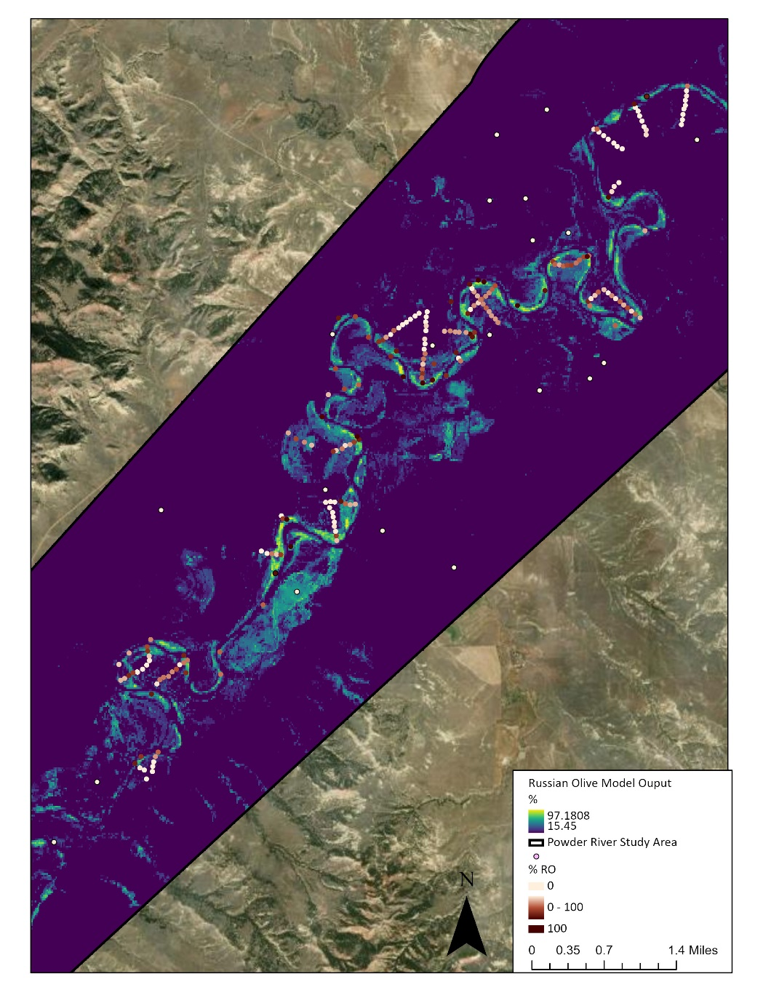

*Figure A4.* Map displaying field and ocular sampling data collection points over our random forest results.

Appendix B. Russian Olive Detection Maps

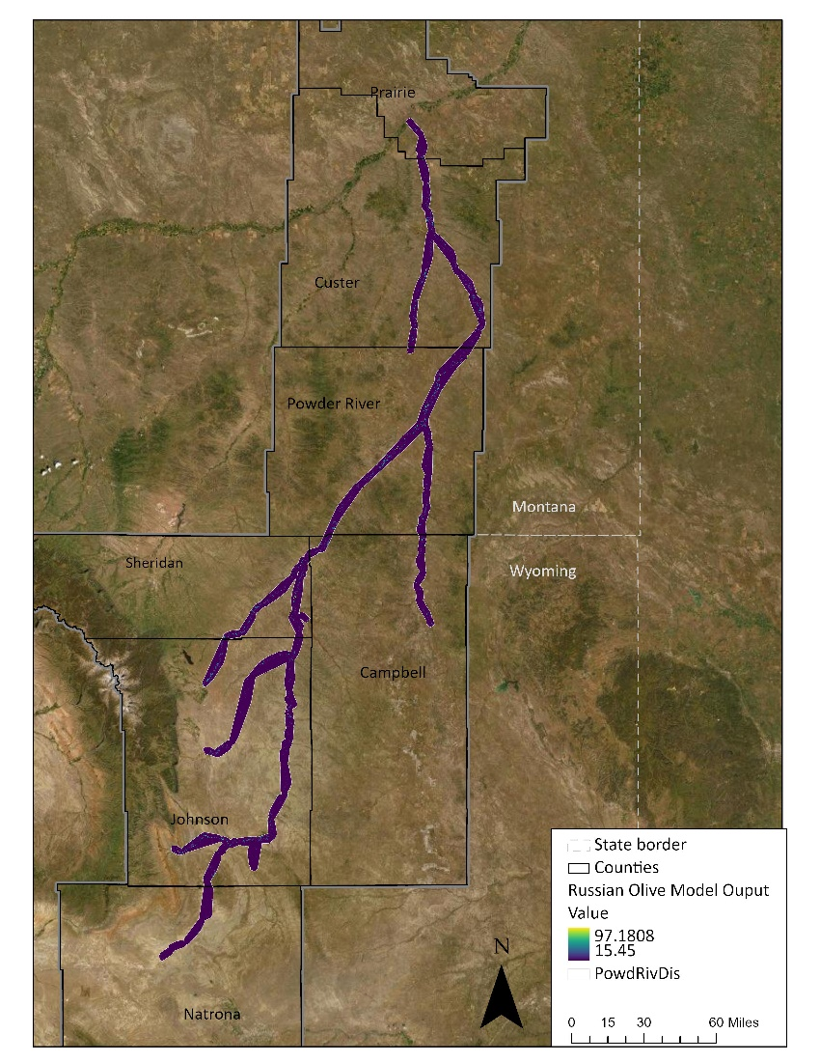

*Figure B1.* Russian olive detection map for the entire study area from our random forest model. A high-resolution PDF containing the results throughout the entire study area will be handed off to our partners for use.

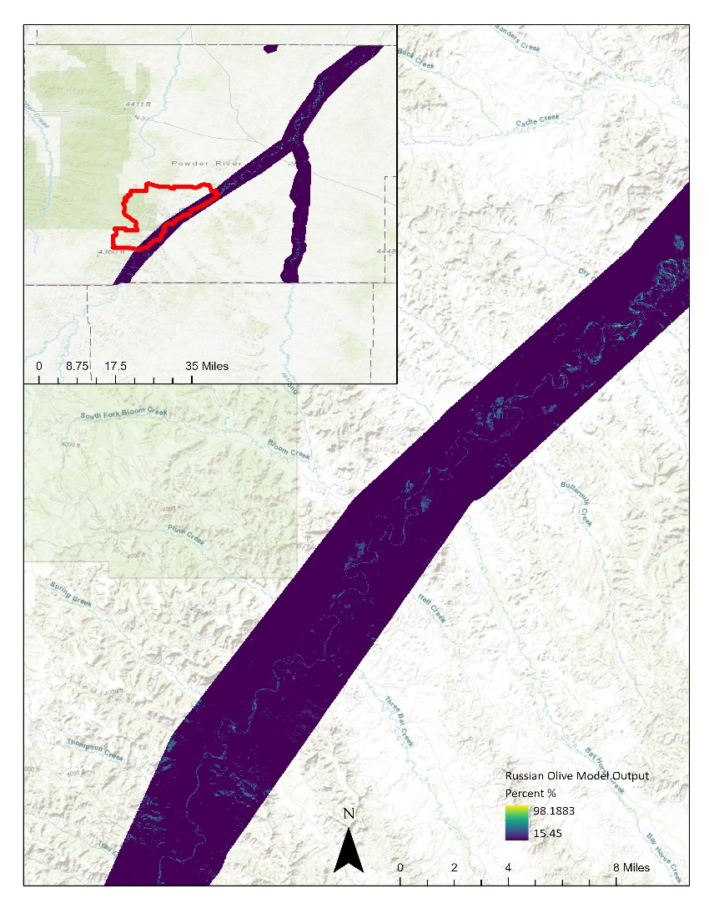

*Figure B2.* Russian olive detection map along the Gay Ranch in Powder River County, MT. Where dark blue is 0% Russian olive detection, and bright yellow is 100%, using a threshold of 15.45 so any detection of Russian olive below 15.45% is considered 0%.

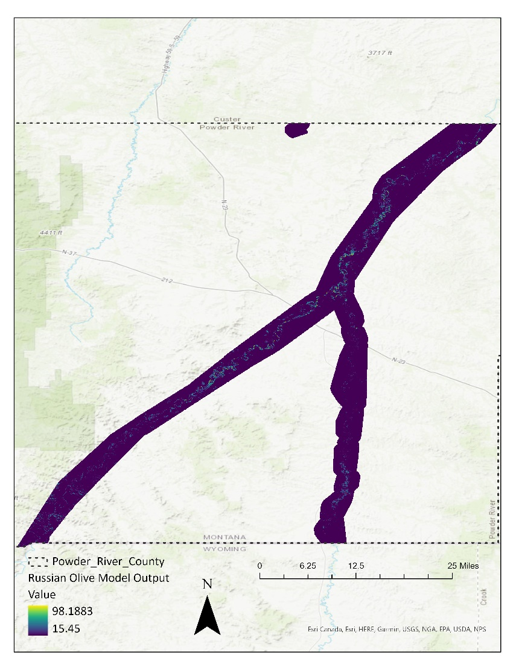

*Figure B3.* Russian olive detection map for Powder River County, MT. Where dark blue is 0% Russian olive detection, and bright yellow is 100%, using a threshold of 15.45 so any detection of Russian olive below 15.45% is considered 0%.

Appendix C. Model Summary Results

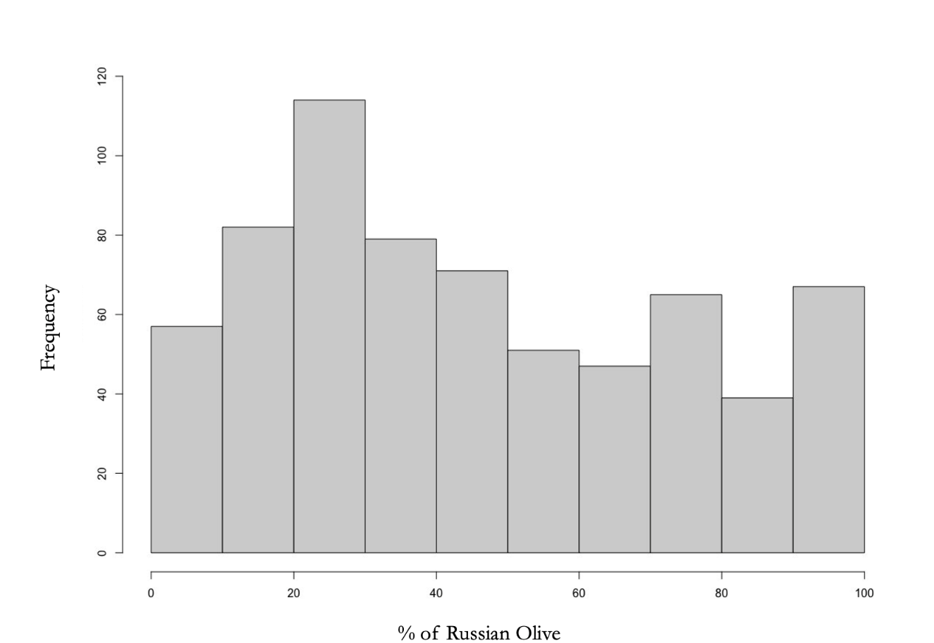

*Figure C1.* Frequency of percent cover of Russian olive across the entire Powder River Basin study area.

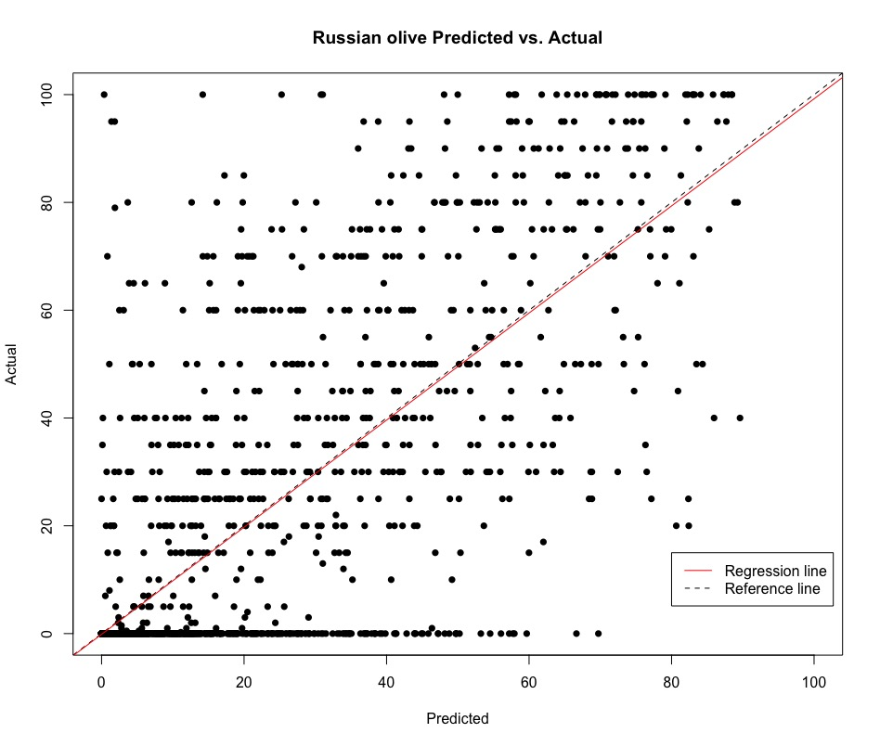

*Figure C2.* Actual vs predicted plot of the best-performing RFM with the top six predictor variables.

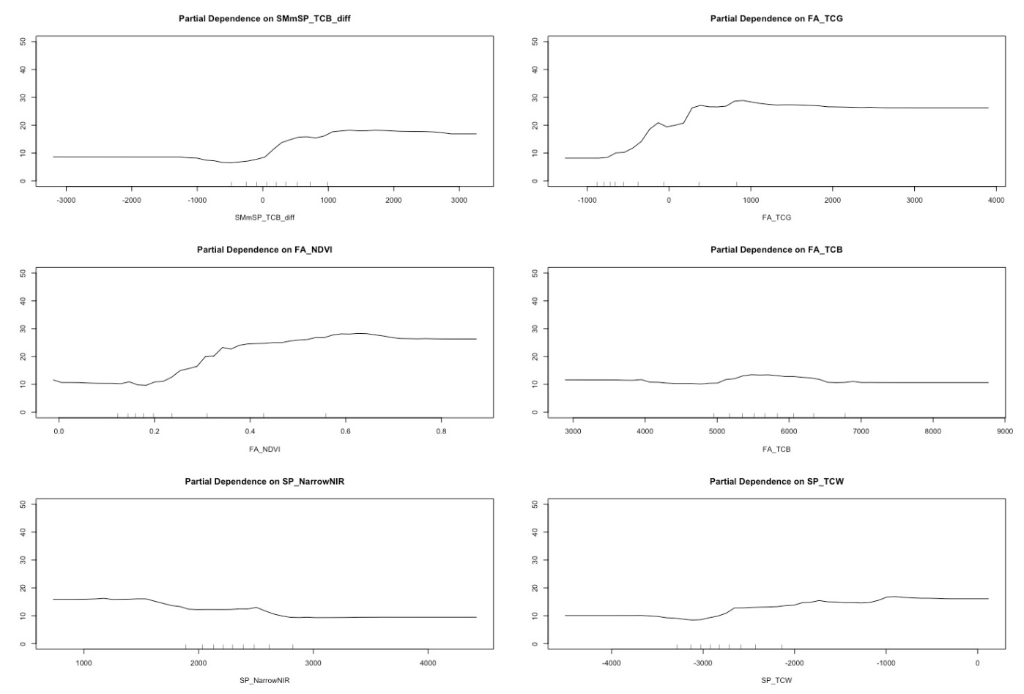

*Figure C3.* These figures present plots of partial dependence functions for the variables SMmSP_TCB_difference, FA_TCG, FA_NDVI, FA_TCB, SP_NarrowNIR, and SP_TCW. The plots show that all variables influence the model where regression is increasing and have no influence/less influence where regression is flat-lining.

Appendix D: Results Including Canopy Height Model

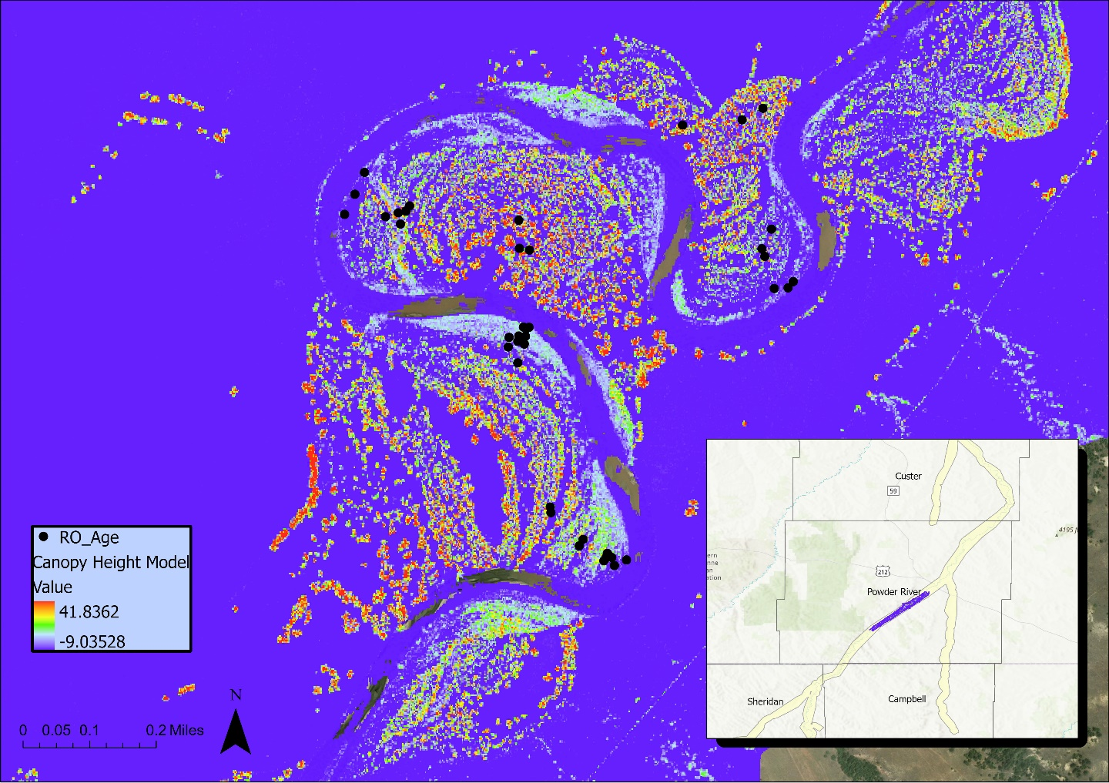

*Figure D1.* Canopy height model and Russian olive age data points (RO_Age).

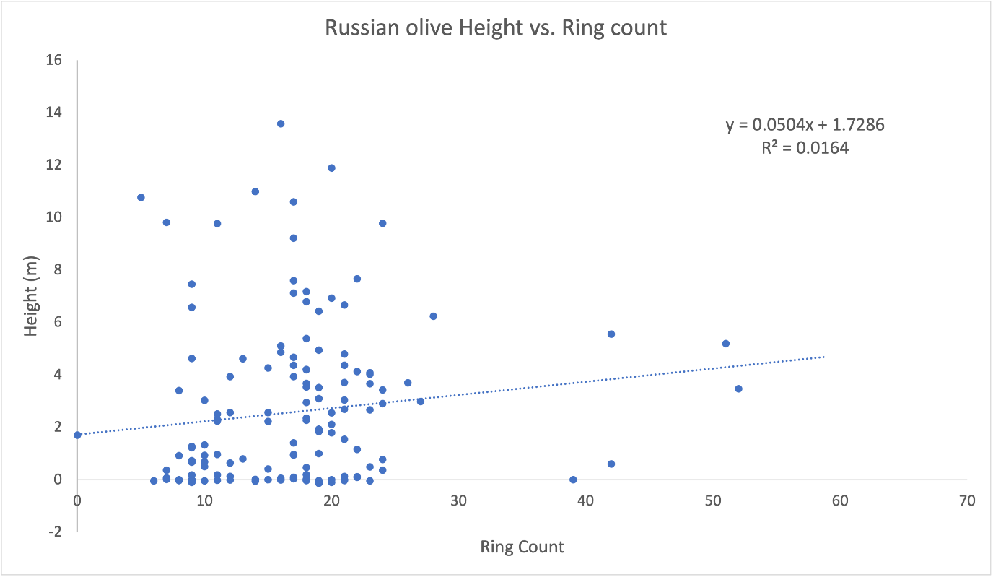

*Figure D2.* Russian olive height plotted against Russian olive ring count (proxy for age).