Peru Health and Air Quality
Land Use Change in the Rapidly Developing Peruvian Amazon and Implications on Zoonotic Disease Incidence

Technical Report
Final – August 12th, 2021

Elizabeth Stapleton (Project Lead)
Ariel Calle
Nataly Chacon
Nelson Huffaker
Oliver Nguyen

Advisors:
Dr. Marguerite Madden (Center for Geospatial Research, University of Georgia)
Dr. Sergio Bernardes (Center for Geospatial Research, University of Georgia)
Dr. Xiao Feng (Department of Geography, Florida State University)

1. Abstract
In the Madre de Dios region of the Peruvian Amazon, forests are being cleared for mining, timber harvesting, road construction, and hydroelectric dam development. These rapid land use changes are increasing human presence in previously sparsely populated areas, disrupting ecosystems and increasing the proximity of human settlement to zoonotic disease vectors. Dengue fever and leishmaniasis are two neglected tropical diseases which are prevalent in Madre de Dios and have been associated with urbanization and road construction. In partnership with the Peruvian Ministries of Health (MINSA) and the Environment (MINAM) and other in-country collaborators, our team examined Land Use Land Cover (LULC) correlations with reported dengue and leishmaniasis incidence in the Madre de Dios region to help partners understand the spatial relationship between land use change and zoonotic disease incidence. We created a LULC classification script using Google Earth Engine with Landsat 5 Thematic Mapper and Landsat 8 Operational Land Imager imagery to classify land cover in 2010, 2015, and 2020 and evaluate changes over this time period. We then used the quantified results of the LULC assessment in conjunction with reported disease cases to evaluate correlations between disease incidence and key land cover changes across Madre de Dios’s 11 districts. In the second term, the team will use these products to develop more detailed disease incidence risk maps and models. High risk areas will then be classified, using PeruSat-1 that allow for even higher resolution mapping at less than 3 meters. These products will allow the partners to understand hotspots of land cover change in Peru and the relationship with outbreaks to inform public health decision making and environmental policy.

Key Terms
land use, LULC, zoonotic diseases, health risk, Random Forest, GEE, deforestation

2. Introduction
2.1 Background Information
The Madre de Dios region, located in southeastern Peru, has become a hotspot for both deforestation and disease spread (Figure 1). This sparsely populated region is one of the most biodiverse in the Amazon (Scullion, 2014) but is under threat from rapidly changing land uses and urbanization. In addition to the completion of the Interoceanic Highway in 2012, gold mining is a major cause of deforestation (Caballero, 2018). Mining operations, which have increased dramatically since the 1980s, have not only accelerated deforestation but have also deposited mercury in the region’s waterways and impacted socioeconomic dynamics (Diringer et al., 2019).

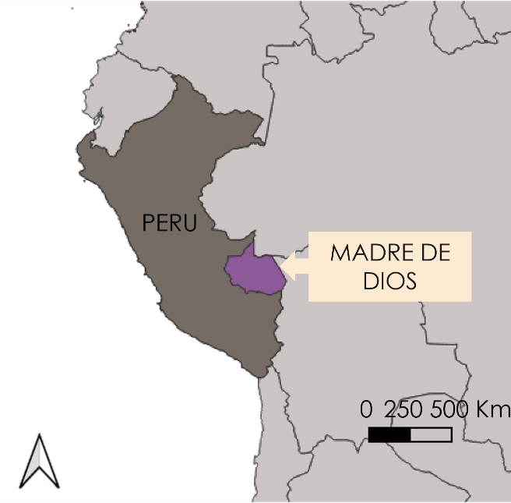
Figure 1. The Madre de Dios region in southeastern Peru

Road construction and associated deforestation and land cover changes are also linked to increased risk of zoonotic diseases throughout the region (Mastel et al., 2018, Cortez et al., 2018), raising concerns for human health. As deforestation rates continue to rise, the interactions between humans and zoonotic disease vectors increase, leading to more disease spread (Salmón-Mulanovich, 2016). These health concerns are compounded by the lasting effects from the Covid-19 pandemic, which has already stretched the region’s healthcare system thin (Arroyo, 2021). Our team compared land cover change with disease reports in Madre de Dios between 2010 and 2020 to help partners understand the spatial correlations between land cover change and zoonotic disease incidence.

Dengue fever and leishmaniasis are two zoonotic diseases of current concern to the Peruvian Ministry of Health (MINSA). Dengue fever incidence has risen dramatically over the last two decades due to rapid urbanization, which increases habitat for the disease’s vector, the Aedes aegypti mosquito (Castro et al., 2019). Based on one risk model of climatological factors, The Madre de Dios region was one of the 6 regions of highest dengue risk out of Peru’s 25 regions (Campbell et al., 2015). Leishmaniasis, which is transmitted by sand flies (Family: Psychodidae), tends to be associated with forest habitats and is a known concern in Madre de Dios (Zorrilla et al., 2017). As human development continues to encroach on forested areas, MINSA is concerned about increased incidence of the disease.

Although no past studies have used remote sensing and land cover classifications to consider zoonotic disease risk in Madre de Dios there are existing land cover classifications for the region, primarily focused on deforestation. MapBiomas is a land cover mapping initiative involving member organizations across Amazonian countries including Instituto del Bien Común (IBC) in Peru. MapBiomas used the Random Forest classifier in Google Earth Engine to create annual raster maps for 1985 through 2018. GeoBosques is a forest change monitoring platform supported by the Peru Ministry of the Environment (MINAM) (http://geobosques.minam.gob.pe). GeoBosques hosts forest loss maps and land use change maps generated from Landsat imagery; its most recent land use change maps are from 2016.

2.2 Project Partners & Objectives
Our team partnered with MINAM and MINSA to explore the application of remote sensing and satellite data to public health concerns related to land cover change. Both agencies were interested in understanding the spatial dynamics of land cover changes to better target agency resources to protect human and environmental health in the Peruvian Amazon. Several additional collaborating organizations also provided project support, including: The Lab for EcoHealth and Urban Ecology at Universidad Peruana Cayetano Heredia, Asociación para la Conservación de la Cuenca Amazónica (ACCA), Peruvian Service for Natural Protected Areas, The National Commission for Aerospace Research and Development (CONIDA), and Instituto del Bien Común (IBC).

For this project, MINAM was interested in understanding where and why land cover has changed to inform decisions around expansion and management of protected areas. They currently employ satellite data in their work through tools such as GeoBosques but have not considered this in conjunction with health data. MINSA tracks zoonotic disease across the country however they have not explored these data in conjunction with satellite data. MINSA was interested in exploring links between zoonotic disease and land cover change to better predict outbreaks and focus resources for prevention of infectious zoonotic diseases.

To support these partner goals, we had three main objectives. Our first objective was to use satellite data to create land use and land cover (LULC) maps of the Madre de Dios region between 2010 and 2020 in Google Earth Engine. Our second objective was to evaluate land cover changes over this period focusing on forest degradation and transitions to urban development and mining. Finally, our third objective was to explore spatial and temporal trends in zoonotic disease occurrence and evaluate correlations between land cover and zoonotic disease incidence in the region. Our results will also serve as preliminary inputs for a zoonotic disease risk model to be developed in a future DEVELOP term.

3. Methodology
3.1 Data Acquisition
3.1.1 Land Cover Mapping & Land Change Analysis
We used Google Earth Engine to produce LULC maps. Within this platform, we used publicly available satellite imagery collected by Landsat 5 Thematic Mapper (TM) data for the year 2010 and Landsat 8 Operational Land Imager (OLI) data for the years 2015 and 2020. Our partners provided us with the MapBiomas protocol for conducting Random Forest classification in Google Earth Engine and the most recent LULC maps created by GeoBosques which we used as the basis for developing our training sites.

Table 1. Earth observation products used.
Satellite | Sensor | Resolution | Years | Data Source
Landsat 5 Surface Reflectance Tier 1 | Thematic Mapper (TM) | 30 meters | 2010 | Google Earth Engine Image Collection
Landsat 8 Level 2, Collection 2, Tier 1 | Operational Land Imager (OLI) | 30 meters | 2015, 2020 | Google Earth Engine Image Collection

3.1.2 Disease Incidence Analysis
MINSA provided us with incidence reports for five different zoonotic diseases from over 8,000 surveillance units (health centers, hospitals, and other facilities) across the country. These data are reported on a weekly basis and include over two decades of data, from 2000 to present. These reports include not only which surveillance unit recorded the cases but also what district the cases originated within. In addition to disease reports, we needed district level population data and district boundaries to conduct our analysis. We used publicly available census data downloaded from the Peruvian National Institute of Statistics and Informatics from 2007 and 2017 to estimate district level populations. A shapefile with political boundaries for the Madre de Dios region’s 4 provinces and 11 districts was acquired from Esri through the ArcGIS Living Atlas.

3.2 Data Processing
3.2.1 Land Cover Mapping & Land Use Change Analysis
We identified our classes of interest based on a review of relevant scientific literature as well as from the two existing LULC classifications, MapBiomas and GeoBosques. We used both to identify the land cover classes, and the latter was used as the foundation for creating our training sites that would train the Random Forest algorithm. We decided on 8 classes, outlined in Table 2.

Table 2. Land cover classes and data sources
Classes | Data used | Raster Value
Forest | Landsat 5, Landsat 8, GeoBosques, MapBiomas, Google Earth Pro | 1
Secondary Vegetation | Landsat 5, Landsat 8, GeoBosques, MapBiomas, Google Earth Pro | 2
Pastures | Landsat 5, Landsat 8, GeoBosques, MapBiomas, Google Earth Pro | 3
Agriculture | Landsat 5, Landsat 8, GeoBosques, MapBiomas, Google Earth Pro | 4
Mining | Landsat 5, Landsat 8, GeoServidor Peru (SIDETEVA), Google Earth Pro | 5
Water | Landsat 5, Landsat 8, GeoBosques, MapBiomas, Google Earth Pro | 6
Wetlands | Landsat 5, Landsat 8, GeoBosques, MapBiomas, Google Earth Pro | 7
Urban Development | Landsat 5, Landsat 8, GeoBosques, MapBiomas, Google Earth Pro, Open Street Maps | 8

For each of the classes, we created training samples in QGIS by referencing the most recent pre-existing LULC classification by GeoBosques (2016) and the MapBiomas protocol. Documentation for these classifications outlined their scripted methods for running the Random Forest algorithm using a set of imported training data. These classifications served as precedents for selecting the bands and computing spectral indices to be fed into the classifier. Ultimately, we collected between 50 and 80 samples for each class. We used the same training data across all three years, which required temporal validation on Google Earth Pro to verify that each site was consistently the same across our study period. If a training site was the same land cover in 2020 as it was in 2015 and 2010, then it was accepted into the classifier. In Google Earth Engine, we spatially queried Landsat 5 TM and Landsat 8 OLI satellite imagery to our region of interest and to our study period (2010-2020). We applied filters and masks to the data in order to minimize and remove cloud noise and shadow interference and replace pixels with such interference with values based on nearest neighbors.

We calculated various spectral indices including the Normalized Difference Vegetation Index (NDVI, equation 1), Normalized Difference Water Index (NDWI, equation 2), as well as the Enhanced Vegetation Index (EVI, equation 3) to delineate our classes of interest. NDVI, NDWI, and EVI were particularly useful for parsing different types of vegetation from each other. The raster maps generated from these adjusted surface reflectance values allowed us to visualize the gain and loss to certain land cover classes (specifically mining, urban and forest), as well as what these classes transitioned to.

$NDVI=\frac{(NIR-R)}{(NIR+R)}=\frac{(Band 5 - Band 4)}{(Band 5+ Band 4)}$ (1)

$NDWI=\frac{(NIR-SWIR)}{(NIR+SWIR)}=\frac{(Band 5-Band 6)}{(Band 5+Band 6)}$ (2)

$EVI=G*\frac{\left(NIR-R\right)}{\left(NIR+C1*R-C2*B+L\right)}=2.5*\frac{(Band 5-Band 4)}{(Band 5+6*Band 4-7.5*Band 2+1)}$ (3)

Table 3. Terminology of spectral indices use for classification.
NIR | SWIR | R | B | L | C
Reflectance in near-infrared | Short-wave infrared | Reflectance in red range of spectrum | Reflectance in blue range of spectrum | Adjustment canopy background | Coefficients for atmospheric resistance

We used other ancillary datasets to identify difficult to distinguish mining areas, including the GeoServidor Peru Tool and SIDETEVA (Sistema de Detección Temprana y Vigilancia Ambiental), which provided shapefiles of the affected mining areas for 2017. We temporally validated these in Google Earth Pro as well to ensure that mining areas identified by SIDETEVA for 2017 were consistent for 2010, 2015, and 2020. We selected mining areas representative of diverse, heterogeneous landscapes since mining areas encapsulated an array of different land covers. Selected mining areas contained irregularly shaped patches of bare ground mixed with bodies of water of unusual or varying colors, complex and peculiar geological formations (rock and soil piles, ruts or pits), and extensive processing facilities.

3.2.2 Disease Incidence Analysis
We filtered the disease incidence data provided by MINSA to only include cases of the two zoonotic diseases of interest, dengue fever and leishmaniasis, which originated within the 11 districts within Madre de Dios. We then aggregated these reports for each district by year using R. Using census data from 2007 and 2017, we estimated district level populations for each year of the study period by linear interpolation. We used these population numbers to calculate disease incidence per 1000 residents for each district. We combined these data into csv tables in Excel which included total cases of each disease by district and population normalized cases of each disease by district, both annually as well as for the entire study period. We imported these tables into ArcGIS Pro and joined these data to a shapefile of district boundaries.
3.3 Data Analysis
3.3.1 Land Cover Mapping & Land Change Analysis
We imported the collected training data as assets into Google Earth Engine (GEE) and employed the Random Forest classifier to classify the rest of the Madre de Dios region. The algorithm for the Random Forest classifier is a highly accurate modeling function in GEE for processing extremely large datasets and thousands of input variables at once. This algorithm is also beneficial because features collected that are not useful or represent outliers are not used by the algorithm to split the data into the classes, so only optimal features are incorporated into the algorithm (Engelstad & Carver, 2020). After we classified the satellite imagery, we performed an accuracy assessment. We randomly split the data into two groups with 70% of the data used for training, and 30% used for testing using a script in GEE. We built the classification with the Random Forest algorithm by fitting the training data to a random subset of predictors in decision trees. Finally, as part of the accuracy assessment we examined the confusion matrix created with the testing dataset to evaluate the precision of the model.

We imported our final LULC maps from 2010, 2015, and 2020 into ArcGIS Pro to generate land change maps and quantify land cover changes over time. We used the raster calculator in ArcGIS Pro to subtract earlier land cover maps from later maps to produce three maps showing change, one for 2010-2015, one for 2015-2020, and one for the entire study period, 2010-2020. Before doing so, we reclassified each land cover value to large unique values which were selected to assure that the subtraction would produce a unique value for each specific transition type.
We used these land change maps to generate a separate simplified map for each of our key land cover changes of urbanization, mining expansion, and forest loss for 2010-2015, 2015-2020, and for 2010-2020. For each of these maps we reclassified the seven values which indicated changes to the key land cover class as 1 and all other values as 0. This produced maps which allowed us to visualize the areas that had transitioned to our key land covers and to quantify these areas for each based on the number of raster cells with value 1 within each district.
3.3.2 Disease Incidence Mapping and Analysis
As a preliminary spatial investigation into disease incidence reports across Madre de Dios, we used ArcGIS Pro to visualize the reports by district. We explored visualizing dengue and leishmaniasis incidences at the district level using quantile classification as well as a simple stretch. By visualizing these spatialized data, we were able to qualitatively compare the distributions of the two diseases with one another as well as through time. We also compared the distributions of the raw numbers with the population-normalized numbers.

To evaluate whether certain land cover types correlate with greater incidence of zoonotic disease, we used a modified version of the methods described by Bowden et al. (2014). This method delineates sub-areas with known populations, known numbers of reported disease cases, and known proportions of various land cover classes, then calculates a correlation coefficient between disease rate and each land cover class by sub-area across the entire study area. Because of our small sample size, we elected to use the Spearman’s rank correlation. This non-parametric test is less powerful than the parametric alternative (Pearson’s) but is more appropriate for small datasets like ours which may not follow a normal distribution or exhibit a linear relationship between variables.

We used the 11 administrative districts that make up the Madre de Dios region as sub-areas for this study (See Appendix A for a map of Madre de Dios’s 11 districts). We used total and normalized disease incidence reports from 2020 and our quantified LULC classification map from 2020 as inputs. For this analysis, we looked at three key land covers, 1) urban areas, 2) mines, and 3) forest. We quantified the area of each key land cover within each district; we calculated this area both as a raw number (square kilometers) and as a proportion of each district’s total area (percent). We used this district-level data to calculate correlation coefficients between each key land cover and the incidence of both dengue and leishmaniasis across the region.
We extended this method to consider the correlation between key land cover changes and disease incidence. For this portion of the analysis, we used the total and normalized disease incidence number for both dengue and leishmaniasis from 2010 to 2020 alongside the resulting map from our land change analysis from 2010-2020. From our land change analysis maps, we quantified the amount of new mining and urban areas that were added and the amount of forest that was removed for each district. We then calculated Spearman’s correlation coefficients between each key land cover change and disease incidence.

4. Results & Discussion
4.1.1 Land Cover Mapping
Our supervised classification algorithm was able to successfully classify the desired landcover classes for the region of Madre de Dios, particularly highlighting areas with mining and urbanization. Figure 2 shows three images of the La Pampa illegal mining area in Madre de Dios for 2010, 2015, and 2020. The large red area under the Madre de Dios river (blue) are the mining areas. The yellow thin strip of agriculture that cuts across the forested areas shows the Interoceanic Highway. In 2015 and 2020, the mining areas significantly increased above and below the highway, as well as along the Madre de Dios river. Overall, the region has been experiencing increases in mining and agriculture and decreases in forests.

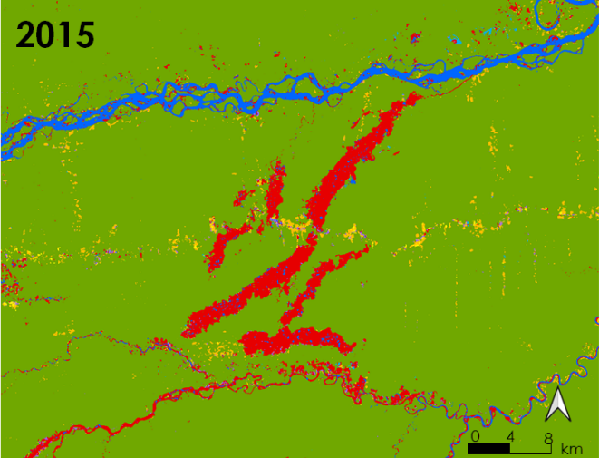
Figure 2. Resultant LULC classifications displaying mining areas in La Pampa, Peru (from Landsat 5 TM and Landsat 8 OLI, 2010-2020). Here, a significant increase in mining areas is discernable.

Figure 3 shows three images of the capital city of Madre de Dios, Puerto Maldonado, for 2010, 2015, and 2020. The purple center indicates urban areas in Puerto Maldonado. In 2010, there was a significant amount of agriculture and pastures near the city and along the Madre de Dios River. In 2015 and 2020, the amount of pasture and agriculture decreased, and urban areas slightly increased both north and south of the river. There is also a noticeable increase of mining areas near the river in 2015 and 2020.

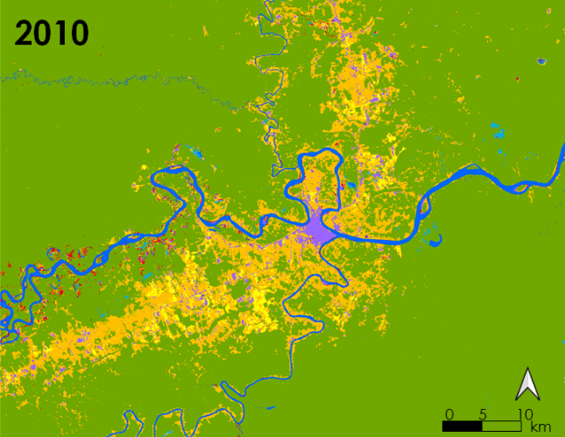
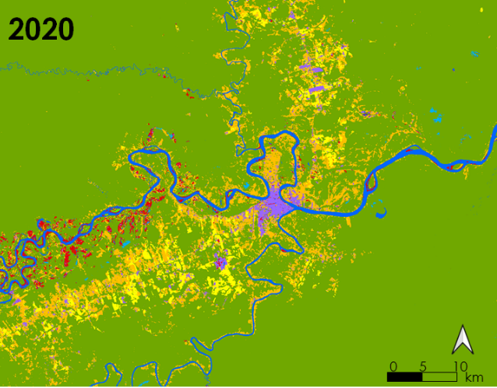
Figure 3. Resultant LULC classifications displaying heavily urban areas in Puerto Maldonado, Peru (from Landsat 5 TM and Landsat 8 OLI, 2010-2020).

Table 4. Accuracy assessment of LULC classifications
Validity of model: Confusion Matrix
Year | Score
2010 | 0.985
2015 | 0.970
2020 | 0.990

Table 4 shows the overall model’s accuracy assessment of the LULC classifications. The maximum value for the assessment is 1. Overall, the model has performed quite well for 2010, 2015, and 2020, with 2015 being the lowest score and 2020 being the highest score. To calculate accuracy, we used the scores from the confusion matrix as shown in equation 4, where TN is True Negative, TP is True Positive, FN is False Negative, and FP is False Positive.

$Accuracy=\frac{TN+TP}{TN+TP+FP+FN}$ (4)

When quantified by district, key land covers showed substantial variation. Forest cover was the dominant land cover in all districts, covering over 80% of every district and as much as 99% of Iñapari. In all three years, Tambopata, Iñapari, and Fitzcarrald consistently have the highest forest cover by both percentage and total area. Urban areas occupy less than 1% of all districts. Iberia and Las Piedras tend to have among the highest urban area across years by both total area and by percent. Tambopata, the district which contains Puerto Maldonado, has the greatest total urban area but, due to its large overall area, does not rank highly by percent. Across all years, Huepetuhe, Inambari and Madre de Dios has the greatest mining area by both total area and percent area. Unsurprisingly, these areas were greatest in 2020, at which point all three districts had greater than 200 square kilometers of mined area. (A full table of land cover quantification results for all three years can be found in Appendix B.)

4.1.2 Land Change Analysis
The magnitude of key land changes varied substantially by district, with certain districts experiencing more forest loss, mining expansion, and urbanization than others. Table 5 shows key changes by district from 2010 to 2020; Appendix C includes data for 2010-2015 and for 2015-2020. As can be seen in Table 5, while changes were sometimes independent of one another, it was common for high levels of one type of change to accompany high levels of other changes. For example, Inambari and Huepetuhe experienced high levels of all three land cover changes.

Table 5. 2010-2020 quantifications of key land changes by district; the three highest ranking districts for each land cover quantification are highlighted
District | Mining expansion (km²) | Mining expansion % | Forest loss (km²) | Forest loss % | Urbanization (km²) | Urbanization%
Fitzcarrald | 19.1 | 0.17 | 75.7 | 0.69 | 3.6 | 0.03
Huepetuhe | 103.9 | 6.60 | 99.4 | 6.32 | 9.4 | 0.60
Iberia | 7.6 | 0.29 | 42.0 | 1.58 | 7.5 | 0.28
Inambari | 252.4 | 5.04 | 403.1 | 8.05 | 43.2 | 0.86
Iñapari | 19.5 | 0.14 | 3.3 | 0.02 | 7.1 | 0.05
Laberinto | 24.6 | 0.89 | 110.6 | 4.01 | 9.7 | 0.35
Las Piedras | 15.4 | 0.19 | 99.6 | 1.25 | 22.6 | 0.28
Madre de Dios | 202.3 | 2.50 | 316.3 | 3.91 | 18.4 | 0.29
Manu | 61.8 | 0.69 | 235.9 | 2.63 | 11.6 | 0.13
Tahuamanu | 3.8 | 0.11 | 68.7 | 1.90 | 9.3 | 0.26
Tambopata | 55.4 | 0.26 | 113.9 | 0.54 | 20.0 | 0.09

Across the entire study period, from 2010 to 2020, the district of Inambari dominates all key land transitions when measured by either area or percent, ranking first in all transitions except mining expansion when measured by percent (ranked second). Between 2010 and 2020, Inambari lost 403 square kilometers of forest (8% of the district’s total area) and gained 252 square kilometers of mining area. Huepetuhe ranks in the top three districts for all transitions when measured by percent as well as for mining when measured by area. gaining over 100 square kilometers of new mining areas from 2010 to 2020 or nearly 7% of its total area. Trends in urbanization vary by measurement method, with Huepetuhe and Laberinto dominating by percent and Tambopata and Las Piedras dominating by total new urbanized area.
Across all districts, over 1500 square kilometers of forest were removed between 2010 and 2020. During this same period, 766 square kilometers of new mining areas developed, along with 163 square kilometers of expanded urban area. Both deforestation and mining appear to have accelerated since 2015, with greater land use changes happening between 2015 and 2020 than between 2010 and 2015. It should be noted that these change calculations do not reflect any areas that reverted from key land cover types to other uses during this time (such as a mining or urban area that was abandoned) and thus may overestimate total areas for these land cover types when compared to a simple subtraction of areas across years.

4.1.3 Disease Incidence Mapping and Analysis
Our preliminary explorations of disease incidence revealed substantial differences in the spatial distribution of dengue fever and leishmaniasis across the districts. Figure 4 shows districts classified by total number of dengue and leishmaniasis cases compared with the population normalized rates for each disease between 2010 and 2020. Without controlling for population, both diseases were clearly most prevalent in urban districts, most notably Tambopata which includes the region’s largest city of Puerto Maldonado. When population was controlled for, we saw that dengue continued to be more associated with urban areas while leishmaniasis prevalence was highest in the rural district of Manu.
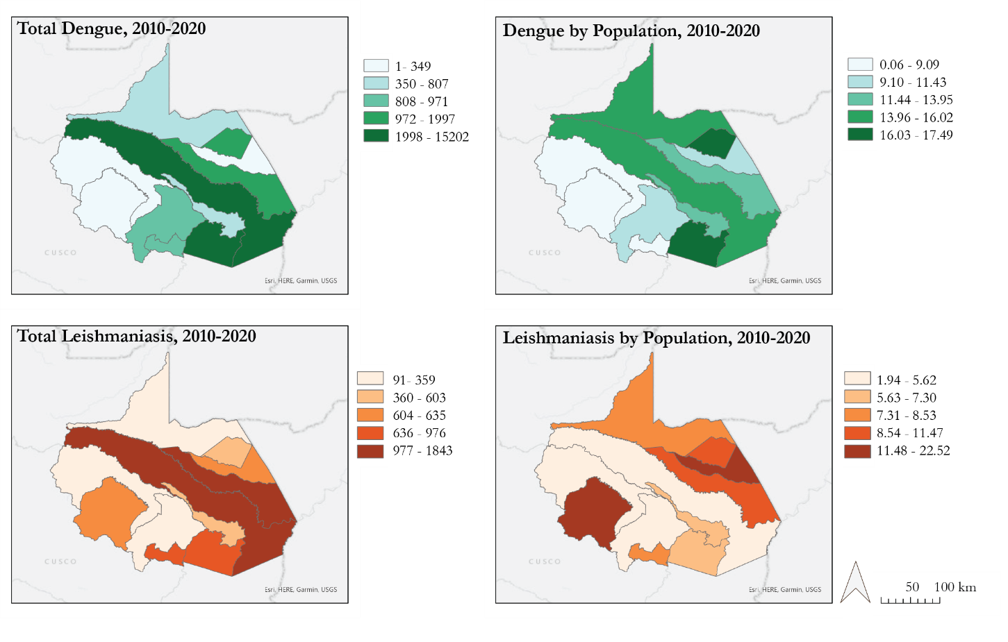Figure 4. Disease incidence maps for 2010-2020 comparing total cases of dengue and leishmaniasis by district with cases per 1000 residents; data is visualized using quantile classification to better allow comparison across years.

We see a steady increase in incidence of both diseases over the study period. In 2000, the first year of our dataset, there were only 21 reported cases of dengue across the entire region; this number began to grow around 2007 and in 2010 there were over 2000 reported cases. Although leishmaniasis incidence has been more consistent over the past 20 years, 9 of the 10 highest case load years have occurred since 2012. This spike in leishmaniasis coincides both spatially and temporally with the construction of the Interoceanic Highway in the northeastern portions of the region.
Results of the Spearman correlation indicate that there was a statistically significant positive association between total urban area and total dengue cases (0.66, p=0.031), total urban area and total leishmaniasis cases (0.73, p = 0.015), change in urban area and total dengue cases (0.71, p = 0.019), and change in urban area and total leishmaniasis cases (0.73, p = 0.015). (See Appendices D and E for full tables of correlation results.) While it is expected that places with greater urban area and thus higher populations will also have higher raw case numbers, the association of disease incidence with urban land transition itself is worth further investigation. These were the only correlations we found to be statistically significant. Because of our very low sample size and the use of a non-parametric test, it is possible that other correlations exist which our analysis did not have sufficient power to detect. These results suggest that the district level may not be a fine enough resolution at which to evaluate these associations, or that a larger spatial extent (i.e. additional districts from outside of Madre de Dios) would need to be considered in order to increase sample size.
4.2 Future Work
Our work will be continued during a second DEVELOP term. While we have been able to delineate land cover classifications and map past disease incidence, our partners are very interested in the ability to predict future outbreaks of zoonotic diseases. The second term of the project will use the maps produced during this term as inputs to generate risk models for dengue fever and leishmaniasis to further correlate disease incidence with land cover transitions. Additional environmental variables that are known to have a relationship with some of the diseases may also be incorporated into the risk models including humidity, elevation, seasonality, and precipitation. One example of an environmental correlation would be how dengue fever rarely occurs below an elevation of 1500 meters (Chowell et al., 2008). Higher resolution mapping using PeruSat-1 with a resolution of less than 3 meters may also be a future product, as this data is capable of delineating forest types such as primary, secondary, and montane forest from each other as well as various crops including Brazil nuts, palm oil and cocoa trees.

5. Conclusions
Our team has created a relatively fast cloud-based approach to classify a large important region in Peru by using Google Earth Engine and developed a preliminary strategy for comparing these results to disease incidence at the district level. Using the partners’ previous land classification maps and expertise in identifying important land classes, this method of using Random Forest classification will prove to be helpful in classifying newer and higher resolution satellite imagery for the next term of this project. By quantifying the amount of increases and decreases of certain land cover classes from our LULC maps and overlaying them with the disease incidences by district over 10 years, we found evidence that land transitions to urbanization may increase incidence of zoonotic diseases. The district of Tambopata experienced the highest coverage of urban area as well high number of cases for dengue. The districts of Inambari and Huepetuhe experienced the greatest transitions to mining and urbanization and the greatest loss of forest. These districts are where the Interoceanic Highway cuts through, which may indicate that districts with more road access are susceptible to more land cover changes especially mining, urban, agriculture. Districts that contain this highway also have the highest incidences of dengue. The highest cases for leishmaniasis occurred in more rural areas, such as the Manu district, which experienced high rates of deforestation. These outcomes support what past studies have suggested, that dengue incidence is typically higher in urbanized areas while leishmaniasis tends to occur when human populations settle near forested areas. Our results will help our partners gain a preliminary look at how land use change spatially relates to zoonotic disease incidences, and to focus their efforts on addressing health concerns in districts that are more at-risk.

6. Acknowledgments
We would like to recognize the valuable support of our partners: Tatiana Pequeño, William Augusto Llactayo Leon, Raul Tinoco, and Germán Marchan with MINAM; Cesar Munayco with MINSA; Ellen Delgado Florian, Armando Valdez-Vasquez, Camila Llarena Cayo, and Viviana Sanchez-Aizcorbe Hennings with The Lab for EcoHealth and Urban Ecology at Universidad Peruana Cayetano Heredia; Sidney Novoa, Milagros Becerra, and Judith Westveer with Asociación para la Conservación de la Cuenca Amazónica (ACCA); Jose Pasapera Gonzales with The National Commission for Aerospace Research and Development (CONIDA); and Kathrin Hopfgartner and Andrea Bravo with Instituto del Bien Común (IBC).

Any opinions, findings, and conclusions or recommendations expressed in this material are those of the author(s) and do not necessarily reflect the views of the National Aeronautics and Space Administration.

This material is based upon work supported by NASA through contract NNL16AA05C.

7. Glossary
Dengue fever – Mosquito-borne viral disease common in tropical regions which can be life-threatening.
Earth observations – Satellites and sensors that collect information about the Earth’s physical, chemical, and biological systems over space and time.
GeoBosques – The Peru Ministry of the Environment’s online platform for monitoring forest cover change.
Google Earth Engine – Web-based platform for geospatial analysis and visualization.
Leishmaniasis – Parasitic disease that is spread by the bite of phlebotomine sand flies. There are several types of leishmaniasis in people, the most common causes skin sores and can affect several internal organs.
MapBiomas – Online platform for monitoring land use change across the Amazon, developed by a multi-institutional collaboration.
NDVI – Normalized Difference Vegetation Index, a spectral index used to quantify vegetation from remote sensing imagery using a ratio of red to near infrared values.
NDWI – Normalized Difference Water Index, a spectral index similar to NDVI but calculated using short wave infrared wavelengths which are absorbed by water.
Spearman Rank Correlation - Non-parametric test for correlation between two variables appropriate for use when the assumptions of parametric tests cannot be met.
Zoonotic disease – Infectious disease transmissible to humans by an animal vector.

8. References
Arroyo, C. (15 January 2021). Dengue – An epidemic within a pandemic in Peru. Inter Press Service News Agency. Retrieved from: http://www.ipsnews.net/2021/01/dengue-epidemic-within-pandemic-peru/?utm_source=rss&utm_medium=rss&utm_campaign=dengue-epidemic-within-pandemic-peru

Bowden, S. E., Magori, K., & Drake, J.M. (2011). Regional differences in the association between land cover and West Nile Virus disease incidence in humans in the United States. The American Journal of Tropical Medicine and Hygiene, 84(2), 234-238. https://dx.doi.org/10.4269%2Fajtmh.2011.10-0134

Caballero Espejo J, Messinger M, Román-Dañobeytia F, Ascorra C, Fernandez LE, Silman M. Deforestation and Forest Degradation Due to Gold Mining in the Peruvian Amazon: A 34-Year Perspective. Remote Sensing. (2018); 10(12):1903. https://doi.org/10.3390/rs10121903

Campbell, K. M., Haldeman, K., Lehnig, C., Munayco, C. V., Halsey, E. S., Laguna-Torres, V. A., Morrison, A. C., Lin, C., & Scott, T. W. (2015). Weather regulates location, timing, and intensity of dengue virus transmission between humans and mosquitoes. PLoS Neglected Tropical Diseases, 9(7), 1–26. https://doi.org/10.1371/journal.pntd.0003957

Castro, M. C., Baeza, A., Codeço, C. T., Cucunubá, Z. M., Dal’Asta, A. P., De Leo, G. A., Dobson, A. P., Carrasco-Escobar, G., Lana, R. M., Lowe, R., Monteiro, A. M. V., Pascual, M., & Santos-Vega, M. (2019). Development, environmental degradation, and disease spread in the Brazilian Amazon. PLoS Biology, 17(11), 4–11. https://doi.org/10.1371/journal.pbio.3000526

Chowell, G., Torre, C. A., Munayco-Escate, C., Suárez-Ognio, L., López-Cruz, R., Hyman, J. M., & Castillo-Chavez, C. (2008). Spatial and temporal dynamics of dengue fever in Peru: 1994-2006. Epidemiology and Infection, 136(12), 1667–1677. https://doi.org/10.1017/S0950268808000290

Cortez, V., Canal, E., Dupont-Turkowsky, J. C., Quevedo, T., Albujar, C., Chang, T. C., Salmon-Mulanovich, G., Guezala-Villavicencio, M., Simons, M. P., Margolis, E., Schultz-Cherry, S., Pacheco, V. & Bausch, D. G. (2018). Identification of Leptospira and Bartonella among rodents collected across a habitat disturbance gradient along the Inter- Oceanic Highway in the southern Amazon Basin of Peru. PLoS ONE, 13(10), 1–17. https://doi.org/10.1371/journal.pone.0205068

Diringer, S. E., Berky, A. J., Marani, M., Ortiz, E. J., Karatum, O., Plata, D. L., Pan, W. K., & Hsu-Kim, H. (2019). Deforestation due to artisanal and small-scale gold mining exacerbates soil and mercury mobilization in Madre de Dios, Peru. Environmental Science & Technology. https://doi.org/10.1021/acs.est.9b06620

Engelstad, P., & Carver, D. (2020, May). Module 7: Image Classification. Introduction to Google Earth Engine. https://ecodata.nrel.colostate.edu/gdpe-gee-remote-sensing-lessons/module7.html.

MapBiomas Amazonia site. MapBiomas Amazonia Site. (2020, July 2). https://amazonia.mapbiomas.org/.

Mastel, M., Bussalleu, A., Paz-Soldán, V. A., Salmón-Mulanovich, G., Valdés-Velásquez, A., & Hartinger, S. M. (2018). Critical linkages between land use change and human health in the Amazon region: A scoping review. PLoS ONE, 13(6), 1–16. https://doi.org/10.1371/journal.pone.0196414

Salmón-Mulanovich, G., Powell, A.R., Hartinger-Peña, S.M., Schwartz, L ., Baush, D.G ., Paz-Soldán, V.A. (2016) Community perceptions of health and rodent-borne diseases along the Inter-Oceanic Highway in Madre de Dios, Peru. BMC Public Health, 16, 755. https://doi.org/10.1186/s12889-016-3420-3

Salmón-Mulanovich, G., Blazes, D. L., Guezala V, M. C., Rios, Z., Espinoza, A., Guevara, C., Lescano, A. G., Montgomery, J. M., Bausch, D. G., & Pan, W. K. (2018). Individual and Spatial Risk of Dengue Virus Infection in Puerto Maldonado, Peru. The American Journal of Tropical Medicine and Hygiene, 99(6), 1440–1450. https://doi.org/10.4269/ajtmh.17-1015

Scullion, J. J., Vogt, K. A., Sienkiewicz, A., Gmur, S. J., & Trujillo, C. (2014). Assessing the influence of land- cover change and conflicting land-use authorizations on ecosystem conversion on the forest frontier of Madre de Dios, Peru. Biological Conservation, 171, 247–258. https://doi.org/10.1016/j.biocon.2014.01.036

Zorilla, V., De Los Santos, M. B., Espada, L., Santos, R. del P., Fernandez, R., Urquia, A., Stoops, C. A., Ballard, S., Lescano, A. G., Vásquez, G. M., & Valdivia, H. O. (2017). Distribution and identification of sand flies naturally infected with Leishmania from the Southeastern Peruvian Amazon. PLoS Neglected Tropical Diseases, 11(11), 1–14. https://doi.org/10.1371/journal.pntd.0006029

9. Appendices

Appendix A: District Map of Madre de Dios

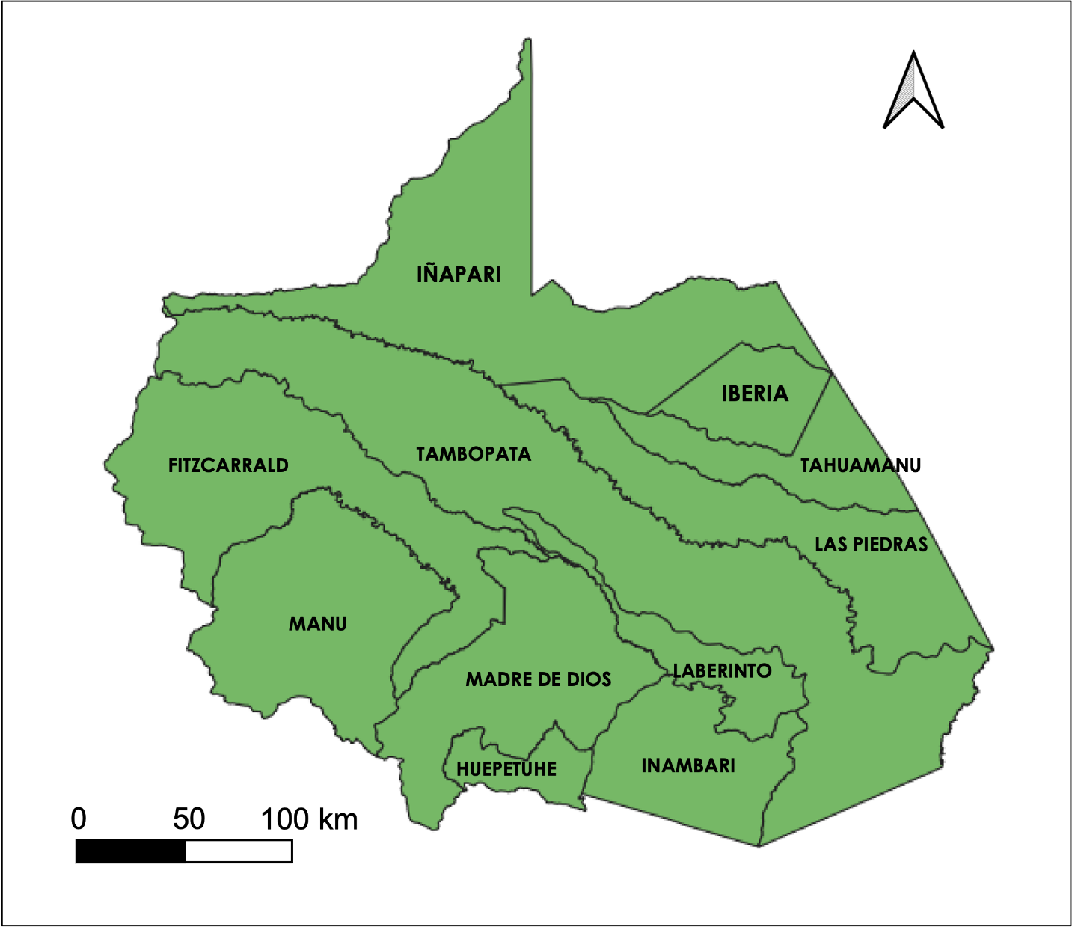
Figure A.1. District map of Madre de Dios. The Madre de Dios Region has three provinces: Manu, Tahuamanu and Tambopata. Each province is divided in districts. The Manu Province has 4 districts: Fitzcarrald, Huepetuhe, Madre de Dios and Manu. The Tahuamanu has 3 districts: Iberia, Iñapari and Tahuamanu. The Tambota province has 4 districts: Inambari, Laberinto, Las Piedras and Tambopata.

Appendix B: Land Cover Quantifications for 2010, 2015, and 2020

Table B.1. 2010 quantifications of key land use types by district, calculated as both raw area and as a percentage of the district’s total area; the three highest ranking districts for each land cover quantification are highlighted in gray and bolded.
District | Mining (km²) | Mining % | Forest (km²) | Forest % | Urban (km²) | Urban %
Fitzcarrald | 11.4 | 0.10 | 10828.6 | 98.83 | 0.2 | 0.00
Huepetuhe | 147.9 | 9.40 | 1366.3 | 86.85 | 2.8 | 0.18
Iberia | 7.6 | 0.29 | 2501.4 | 94.23 | 26.7 | 1.01
Inambari | 128.0 | 2.56 | 4467.0 | 93.18 | 7.3 | 0.15
Iñapari | 19.8 | 0.14 | 14048.6 | 99.20 | 14.6 | 0.10
Laberinto | 25.2 | 0.91 | 2550.2 | 92.38 | 8.4 | 0.31
Las Piedras | 8.5 | 0.11 | 7504.2 | 91.22 | 32.2 | 0.40
Madre de Dios | 126.3 | 1.56 | 7766.6 | 95.99 | 3.1 | 0.04
Manu | 38.7 | 0.43 | 8680.8 | 96.92 | 1.0 | 0.01
Tahuamanu | 2.2 | 0.06 | 3483.4 | 96.49 | 8.5 | 0.23
Tambopata | 40.7 | 0.19 | 20525.6 | 96.44 | 55.5 | 0.26

Table B.2. 2015 quantifications of key land use types by district, calculated as both raw area and as a percentage of the district’s total area; the three highest ranking districts for each land cover quantification are highlighted in gray and bolded.
District | Mining (km²) | Mining % | Forest (km²) | Forest % | Urban (km²) | Urban %
Fitzcarrald | 24.4 | 0.22 | 10826.0 | 98.81 | 4.8 | 0.04
Huepetuhe | 148.0 | 9.41 | 1360.4 | 86.47 | 14.2 | 0.90
Iberia | 9.4 | 0.36 | 2532.1 | 95.39 | 21.5 | 0.81
Inambari | 169.9 | 3.39 | 4614.6 | 92.14 | 14.0 | 0.28
Iñapari | 20.2 | 0.14 | 14071.4 | 99.36 | 13.1 | 0.09
Laberinto | 29.9 | 1.08 | 2545.1 | 92.19 | 6.1 | 0.22
Las Piedras | 14.7 | 0.18 | 7598.1 | 95.40 | 27.9 | 0.35
Madre de Dios | 179.0 | 2.21 | 7725.1 | 95.47 | 10.8 | 0.13
Manu | 78.9 | 0.88 | 8547.1 | 95.43 | 20.5 | 0.23
Tahuamanu | 5.3 | 0.15 | 3466.9 | 96.03 | 17.0 | 0.47
Tambopata | 60.5 | 0.28 | 20696.1 | 97.24 | 46.4 | 0.22

Table B.3. 2020 quantifications of key land use types by district, calculated as both raw area and as a percentage of the district’s total area; the three highest ranking districts for each land cover quantification are highlighted in gray and bolded.
District | Mining (km²) | Mining % | Forest (km²) | Forest % | Urban (km²) | Urban %
Fitzcarrald | 12.2 | 0.11 | 10813.5 | 98.70 | 3.6 | 0.03
Huepetuhe | 215.4 | 13.69 | 1299.1 | 82.58 | 9.6 | 0.61
Iberia | 2.2 | 0.08 | 2550.0 | 96.06 | 13.9 | 0.52
Inambari | 271.2 | 5.42 | 4367.2 | 87.20 | 44.9 | 0.90
Iñapari | 9.5 | 0.07 | 14075.2 | 99.38 | 10.5 | 0.07
Laberinto | 62.3 | 2.26 | 249.9 | 90.56 | 11.5 | 0.42
Las Piedras | 11.9 | 0.15 | 7573.1 | 95.08 | 30.1 | 0.38
Madre de Dios | 245.7 | 3.04 | 7548.9 | 93.30 | 18.7 | 0.23
Manu | 42.2 | 0.47 | 8586.7 | 95.87 | 12.2 | 0.14
Tahuamanu | 2.5 | 0.07 | 3470.6 | 96.13 | 11.9 | 0.33
Tambopata | 38.3 | 0.18 | 20698.4 | 97.25 | 37.7 | 0.18

Appendix C: Land Cover Transitions for 2010-2015 and 2015-2020
Table C.1. Land Cover Transitions from 2010-2015 by district; the three highest ranking districts for each land cover quantification are highlighted in gray and bolded.
District | Mining expansion (km²) | Mining expansion % | Forest loss (km²) | Forest loss % | Urbanization (km²) | Urbanization%
Fitzcarrald | 30.5 | 0.28 | 53.6 | 0.49 | 4.8 | 0.04
Huepetuhe | 62.3 | 3.96 | 48.3 | 3.01 | 13.7 | 0.87
Iberia | 13.3 | 0.50 | 36.4 | 1.37 | 13.4 | 0.51
Inambari | 161.5 | 3.22 | 169.8 | 3.39 | 12.7 | 0.25
Iñapari | 25.0 | 0.18 | 25.9 | 0.18 | 9.0 | 0.06
Laberinto | 37.0 | 1.34 | 60.1 | 2.18 | 4.5 | 0.16
Las Piedras | 17.2 | 0.22 | 62.3 | 0.78 | 19.0 | 0.24
Madre de Dios | 157.2 | 1.94 | 151.4 | 1.87 | 10.6 | 0.13
Manu | 84.3 | 0.94 | 241.8 | 2.70 | 19.9 | 0.22
Tahuamanu | 5.9 | 0.16 | 51.4 | 1.42 | 13.3 | 0.37
Tambopata | 67.2 | 0.32 | 79.6 | 0.37 | 23.8 | 0.11

Table C.2. Land Cover Transitions from 2015-2020 by district; the three highest ranking districts for each land cover quantification are highlighted in gray and bolded.
District | Mining expansion (km²) | Mining expansion % | Forest loss (km²) | Forest loss % | Urbanization (km²) | Urbanization%
Fitzcarrald | 22.5 | 0.21 | 61.2 | 0.56 | 3.3 | 0.03
Huepetuhe | 97.6 | 6.20 | 91.1 | 5.80 | 8.7 | 0.56
Iberia | 5.7 | 0.22 | 40.7 | 1.53 | 7.6 | 0.29
Inambari | 178.6 | 3.57 | 316.0 | 6.31 | 41.8 | 0.84
Iñapari | 12.5 | 0.09 | 30.4 | 0.22 | 7.4 | 0.05
Laberinto | 59.8 | 2.17 | 96.1 | 3.48 | 9.8 | 0.36
Las Piedras | 14.6 | 0.18 | 108.0 | 1.36 | 21.0 | 0.26
Madre de Dios | 184.4 | 2.28 | 280.3 | 3.47 | 17.6 | 0.22
Manu | 83.3 | 0.93 | 170.5 | 1.90 | 6.8 | 0.08
Tahuamanu | 4.2 | 0.12 | 48.8 | 1.35 | 8.3 | 0.23
Tambopata | 50.6 | 0.24 | 137.4 | 0.65 | 20.5 | 0.10

Appendix D: Spearman Correlation Results - Land Cover

Table D.1: Correlations between total dengue incidence and key land cover classes at the district resolution, 2020
(* indicates statistical significance at the 5% level)
 | Spearman (Rho) | p value
Mining (area) | 0.19 | 0.576
Mining (proportion) | 0.14 | 0.694
Urban (area) | 0.66 | 0.031*
Urban (proportion) | 0.14 | 0.694
Forest (area) | -0.09 | 0.797
Forest (proportion) | 0.11 | 0.755

Table D.2: Correlations between normalized dengue incidence and key land cover classes at the district resolution, 2020
(* indicates statistical significance at the 5% level)
 | Spearman (Rho) | p value
Mining (area) | 0.05 | 0.881
Mining (proportion) | -0.45 | 0.163
Urban (area) | 0.4 | 0.225
Urban (proportion) | -0.14 | 0.694
Forest (area) | 0.07 | 0.839
Forest (proportion) | 0.27 | 0.418

Table D.3: Correlations between total leishmaniasis incidence and key land cover classes at the district resolution, 2020
(* indicates statistical significance at the 5% level)
 | Spearman (Rho) | p value
Mining (area) | 0.14 | 0.694
Mining (proportion) | 0.2 | 0.558
Urban (area) | 0.73 | 0.015**
Urban (proportion) | 0.48 | 0.137
Forest (area) | 0.36 | 0.273
Forest (proportion) | 0.17 | 0.614

Table D.4: Correlations between normalized leishmaniasis incidence and key land cover classes at the district resolution, 2020
(* indicates statistical significance at the 5% level)
 | Spearman (Rho) | p value
Mining (area) | -0.48 | 0.137
Mining (proportion) | -0.3 | 0.371
Urban (area) | -0.17 | 0.614
Urban (proportion) | 0.14 | 0.694
Forest (area) | -0.37 | 0.261
Forest (proportion) | 0 | 0.99

Appendix E: Spearman Correlation Results - Land Change

Table E.1: Correlations between total dengue incidence and area of key land transitions at the district resolution, 2010-2020
(* indicates statistical significance at the 5% level)
 | Spearman (Rho) | p value
Mining Expansion (area) | 0.28 | 0.4
Mining Expansion (proportion) | 0.36 | 0.273
Urbanization (area) | 0.71 | 0.019*
Urbanization (proportion) | 0.45 | 0.163
Forest Loss (area) | 0.38 | 0.248
Forest Loss (proportion) | 0.11 | 0.755

Table E.2: Correlations between normalized dengue incidence and area of key land transitions at the district resolution, 2010-2020 (* indicates statistical significance at the 5% level)
 | Spearman (Rho) | p value
Mining Expansion (area) | 0.05 | 0.881
Mining Expansion (proportion) | 0.9 | 0.797
Urbanization (area) | 0.4 | 0.225
Urbanization (proportion) | 0.327 | 0.33
Forest Loss (area) | -0.05 | 0.881
Forest Loss (proportion) | 0.07 | 0.839

Table E.3: Correlations between total leishmaniasis incidence and area of key land transitions at the district resolution, 2010-2020 (* indicates statistical significance at the 5% level)
 | Spearman (Rho) | p value
Mining Expansion (area) | 0.14 | 0.694
Mining Expansion (proportion) | 0.2 | 0.558
Urbanization (area) | 0.73 | 0.015*
Urbanization (proportion) | 0.48 | 0.137
Forest Loss (area) | 0.36 | 0.273
Forest Loss (proportion) | 0.17 | 0.614

Table E.4: Correlations between normalized leishmaniasis incidence and area of key land transitions at the district resolution, 2010-2020 (* indicates statistical significance at the 5% level)
 | Spearman (Rho) | p value
Mining Expansion (area) | -0.48 | 0.137
Mining Expansion (proportion) | -0.3 | 0.371
Urbanization (area) | -0.17 | 0.614
Urbanization (proportion) | 0.14 | 0.694
Forest Loss (area) | -0.37 | 0.261
Forest Loss (proportion) | 0 | 0.99

