IAC-21,A5,1,5,x66702

24th IAA SYMPOSIUM ON HUMAN EXPLORATION OF THE SOLAR SYSTEM (A5)
Human Exploration of the Moon and Cislunar Space (1)
LUNAR SURFACE CONCEPT OF OPERATIONS FOR THE GLOBAL EXPLORATION ROADMAP LUNAR SURFACE EXPLORATION SCENARIO
Author: Mr. Markus Landgraf
ESA, The Netherlands, markus.landgraf@esa.int
Jennifer Reynolds
ESA, The Netherlands, Jennifer.reynolds@esa.int
Mr. Naoki Sato
JAXA, Japan, satoh.naoki1@jaxa.jp
Mrs. Kandyce Goodliff
NASA, United States, kandyce.e.goodliff@nasa.gov
Mr. Clark Esty
NASA, United States, charles.c.esty@nasa.gov
Mr. Martin Picard
CSA, Canada, martin.picard@canada.ca
Abstract
The International Space Exploration Coordination Group (ISECG) is a voluntary, non-binding coordination forum of 26 space agencies. Building on the 2018 Global Exploration Roadmap (GER) and on growing global interest in space exploration, ISECG’s GER Supplement (Aug 2020) captures the latest developments in lunar exploration planning in an updated Lunar Surface Exploration Scenario.
The updated Lunar Surface Exploration Scenario describes a phased approach to implementing infrastructure and exploration on the lunar surface to meet the goals and objectives defined by the ISECG. The updated scenario starts with Boots on the Moon, where space agencies focus on sending humans to the Moon beginning in 2024 and robotic exploration missions to support the 2024 goal and later phases. Next is Phase 2, Lunar Exploration—Expanding and Building, with an emphasis on completion of the proposed lunar surface objectives by exploring the lunar surface diversely and ultimately settling at the most beneficial site. Initial focus is on lunar surface exploration objectives pertaining to human landing and ascent, logistic cargo landers, and long-range traverses. The later focus is on lunar surface exploration objectives pertaining to long duration habitation, crew health and performance, and in-situ resource utilisation (ISRU). The third phase, Sustained Lunar Opportunities, envisages laying the foundation for a sustained and vibrant lunar presence in the coming decades through partnerships with international governments, academia and industry. During this phase, governments would shift their investment focus to further expand the frontier, including Mars exploration missions.
This paper will describe the concept of operations by phase that supported the development of the updated scenario, along with refinements to those concepts of operations since the release of the updated scenario. By phase, the paper will describe the scenario, give an overview of the applicable architecture elements, identify functional requirements/needs of those elements, and include a discussion of nominal operations and contingency scenarios.

- Introduction
In January 2018 the International Space Exploration Coordination Group (ISECG) issued its third edition of the Global Exploration Roadmap (GER) [1], a summary of strategies and plans for expanding human presence into the Solar System, with the presence on the surface of Mars as the long-term goal. The GER presents a shared international vision for human and robotic space exploration and is based on the coordinated programmes, initiatives and goals of the ISECG participating agencies. Since the release of the third edition of the GER, a large part of the ISECG community has set new national priorities, with a permanent presence in lunar orbit and surface as short and mid-term objectives at highest rank, enabling and preparing the next step towards Mars. These ambitious exploration plans, coupled with the interests of new agency participants recently joining ISECG, created the opportunity to elaborate a Supplement to the 2018 GER that extends and refines the emerged ISECG Lunar Surface Exploration Scenario, published in August 2020 [2]. This Supplement describes a phased approach to implementing infrastructure and exploration on the lunar surface to meet the goals and objectives defined by the ISECG.
Further refinement has continued for the Lunar Surface Exploration Scenario with a focus on potential concepts of operations for the various phases of the scenario. Within this paper describes a focus on the Phase 1 Boots on the Moon and Phase 2 Lunar Exploration – Expanding and Building, specifically Phase 2A Exploration and Mobility concepts of operations. The ISECG has emphasized nearer term missions and activities to understand potential collaboration opportunities while continuing to study future pathways. This paper will overview the lunar surface exploration objectives that drove the exploration scenario and an overview of the scenario itself. Then the paper delves into an overview of the Phase 1 and Phase 2 concept of operations.
- Lunar Surface Exploration Objectives
Prior to the formulation of the updated lunar surface exploration scenario, the ISECG created a set of lunar surface exploration objectives. These objectives leveraged the “ISECG Exploration Goals” and “Sustainability Principles” as published in the 2018 version of the GER [1], depicted in Figure 1, and referenced in Table 1 [3]. The objectives were also driven by preparation for future human exploration of Mars alongside future sustainable activities on the Moon leveraging in-situ resource utilisation (ISRU). For each objective, the ISECG created corresponding rationale, a mapping to each of the ISECG Exploration Goals, and performance measure targets to help understand when the objectives are achieved. Since the publication of the GER Supplement in August 2020, additional review has occurred, and updates have been added to a few of the objectives. Those updates are shown in blue font in Table 1.

Figure 1: ISECG Exploration Goals
Table 1. Lunar Surface Exploration Objectives (as published in Reference 3)
OBJECTIVE | ISECG GOALS (cf. Figure 1)
Demonstrate human landing/ascent capability to and from the lunar surface. | 
Demonstrate a range of cargo delivery capabilities on the
lunar surface for large surface elements and logistics.
Demonstrate Extra Vehicular Activity (EVA) capabilities on the lunar surface.
Demonstrate human long range traversing capability on the lunar surface.
Demonstrate reliability of human long duration habitation capability and operational procedures on the lunar surface.
Demonstrate crew health and performance sustainability to live and work on the lunar surface for a sufficient duration to validate Mars surface missions. | 
Demonstrate in-situ resource production and utilisation capability sufficient for crew transportation between lunar surface and Gateway and lunar surface utilisation needs.
Conduct effective global human/robotic cooperative science exploration to perform groundbreaking science.
Develop infrastructure (e.g. power and communication systems) necessary to achieve the objectives for sustained exploration.
Engage the public in general and the youth in particular with human/robotic lunar surface exploration by bringing the action to large audiences, making full use of the state-of-the-art technology and through new ways of communication. | 
Implement new commercial arrangements that stimulate economic prosperity and foster commercial opportunities.
Provide a large number of collaboration opportunities for international partners to contribute to the lunar surface scenario.

- Global Exploration Roadmap Lunar Surface Exploration Scenario Overview
As published in the GER Supplement [2], the updated Lunar Surface Exploration Scenario describes a phased approach to implementing infrastructure and exploration on the lunar surface to meet the goals and objectives defined by the ISECG. The updated scenario starts with Phase 1 Boots on the Moon, where space agencies focus on sending humans to the Moon beginning in 2024 and robotic exploration missions to support the 2024 goal and later phases. Next is Phase 2, Lunar Exploration—Expanding and Building, with an emphasis on completion of the proposed lunar surface objectives by exploring the lunar surface diversely and ultimately settling at the most beneficial site. Initial focus is on lunar surface exploration objectives pertaining to human landing and ascent, logistic cargo landers, and long-range traverses. These initial missions in Phase 2 are referred to as Phase 2A “Exploration and Mobility”. The later focus is on lunar surface exploration objectives pertaining to long duration habitation, crew health and performance, and in-situ resource utilisation (ISRU). These later missions in Phase 2 are referred to as Phase 2B “Mars forward demonstrations, Habitation, and ISRU”. The third phase, Sustained Lunar Opportunities, envisages laying the foundation for a sustained and vibrant lunar presence in the coming decades through partnerships with international governments, academia and industry. During this phase, governments would shift their investment focus to further expand the frontier, including Mars exploration missions.
Given Phase 1 and Phase 2A are nearer in time, the analysis provided in this paper has been focused on these phases. Therefore, Figures 2 and 3 are reprinted here from the GER Supplement [2] for convenience and reference.
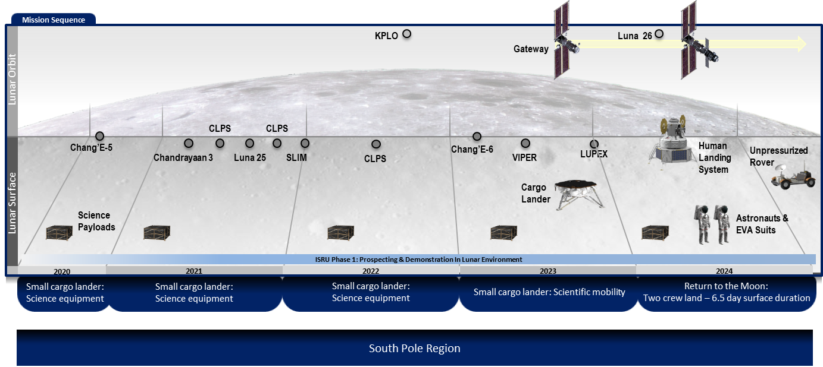
Figure 2: Phase 1 – Boots on the Moon
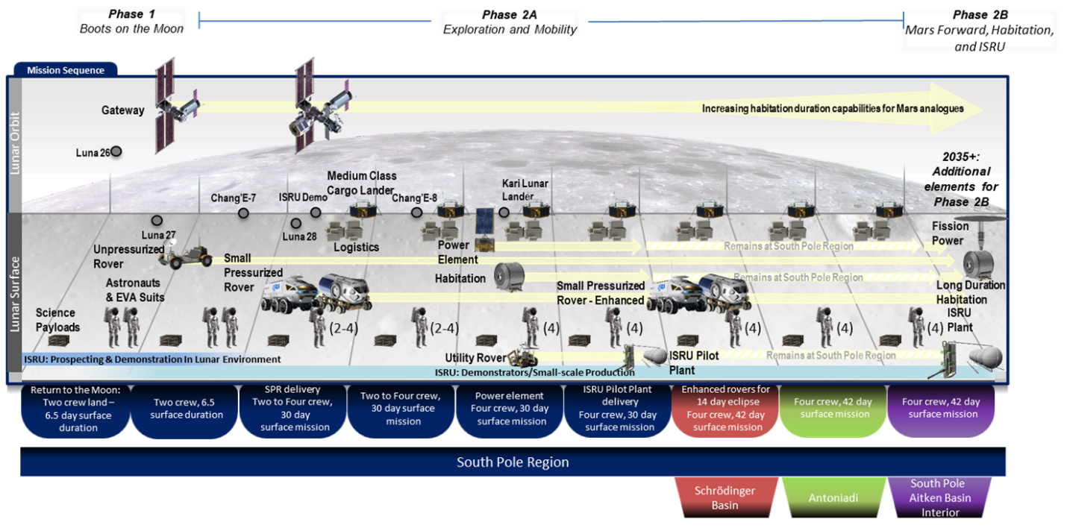
Figure 3: Phase 2 – Lunar Exploration – Expanding and Building
- Phase 1 – Boots on the Moon
Phase 1 combines robotic activities such as orbiters and landers and all activities leading up to landing humans on the Moon, with a goal of landing in 2024. Given the time frame for sending humans to the Moon, it is unlikely that there will be large infrastructure on the Moon to support initial missions. It is anticipated that initial capabilities will include small (cargo) landers—to support science and resource characterisation— as well as Gateway, a human lander, EVA hardware, and an unpressurised rover.
Prior to returning humans to the Moon in 2024, prospector and demonstrator missions are planned to be carried out by ISECG partner agencies. Missions leading up to the human landing are assumed to be all robotic precursor missions. The overall objective is to obtain relevant and necessary data on resources, regolith, the environment, and hardware operation under actual lunar surface conditions to inform future landing site selections and future ISRU architecture decisions. More details on these missions can be found in reference [3].
4.1 Overview of Elements
Several key elements are in development, near operational state, and existing today to support Phase 1 and the return to humans to the Moon. These are shown in Table 2 along with a description of their function.
Table 2: Key Elements of Phase 1 – Boots on the Moon
ELEMENT | FUNCTION
Crew Vehicle  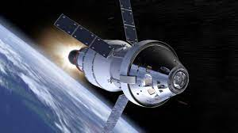 | Vehicle provides transportation for a crew of four between Earth and the lunar vicinity, including sustainment of the crew during space travel and providing safe reentry from deep space. As an example, NASA’s Orion spacecraft has a four-crew, 21-day capability.
Unpressurised Rover  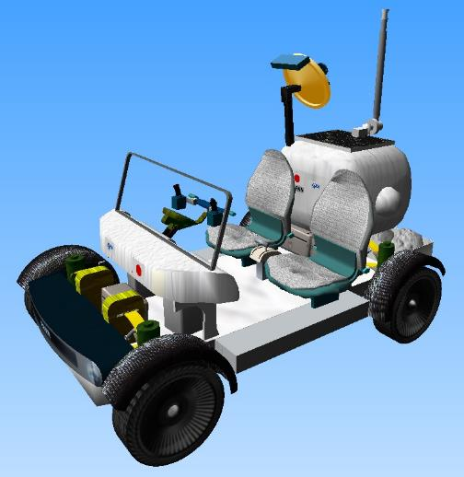 | Provides transportation on the lunar surface for two extra-vehicular activity (EVA)-suited crew with payload. The range of the unpressurised rover is targeted to be greater than 2 km for each excursion. The rover may be used during uncrewed periods through tele-operations. As an example, NASA’s Lunar Terrain Vehicle (LTV) is being developed to support two-crew expeditions on the lunar surface.
Human Lander | Initial capability will provide transportation for two crew between the lunar vicinity and the lunar surface, with an evolutionary goal of four crew, for up to an 8-day mission.
EVA Suits   | Dedicated suit system for use in deep space in microgravity locations or on the lunar surface to allow crewmembers to perform extra-vehicular activities (EVA) for up to 8 hours. EVA suits are planned to be used through a conventional airlock system and evolve to support suitport capability.
Small Landers / Robotic Precursors  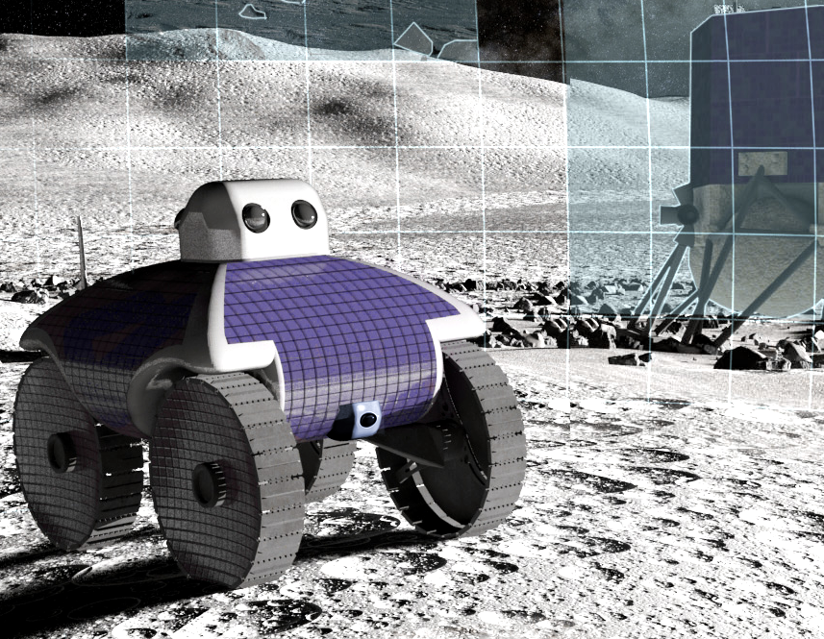 | Delivery of cargo to the lunar surface. Target range of cargo is 10s-100s of kg. Robotic precursors for science, utilisation and potential pathfinder for technology demonstrations. As an example, NASA’s Commercial Lunar Payload Services (CLPS) enables delivery of science and technology to the lunar surface.
Gateway  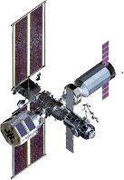 | Early Gateway modules will have the ability to serve as a communication relay for Phase 1 missions.
Ground Infrastructure | Phase 1 will leverage mission control at Johnson Space Center, launch and mission control from the other respective launch vehicles, the Deep Space Network (DSN) for tracking and communications, and the necessary infrastructure to readily pass the information between the control centers and receiving/transmitting stations.
Launch Vehicles | Available launch vehicles to support Phase 1 operations: Space Launch System (SLS), Ariane V and VI*, ULA Atlas V and Vulcan*, SpaceX Falcon 9 and Heavy, Blue Origin New Glenn*  * indicates vehicle is in development

4.2 Concept of Operations
The Concept of Operations (ConOps) referred within is based on NASA’s plans to land humans on the Moon with a goal of 2024. The ConOps will continue to be refined as the HLS vendor and NASA working together and progress towards flight. The robotic missions will not be covered in this paper. A subset of requirements for landing on the Moon include [4]:
- The initial HLS shall provide a habitable environment for two crew for an 8 earth day lunar sortie without pre-emplaced surface infrastructure. (HLS-R-0324)
- The initial HLS shall be capable of operating in continuous daylight conditions on the lunar surface. (HLS-R-0070)
- The HLS shall provide crew transfers to and from Lunar Orbit and a lunar landing site
- between 84°S and 90°S. (HLS-R-0306)
Figure 4 is a representation of the Phase 1 concept of operations for the crewed mission to the Moon. The crew will launch on SLS Block 1/Orion from Kennedy Space Center. SLS/Orion will launch into an elliptical orbit where the Interim Cryogenic Propulsion Stage (ICPS) will perform the Trans-Lunar Injection (TLI) burn to place Orion on a trajectory to intercept the Moon. On the outbound transfer, Orion will utilize a Lunar Gravity Assist and subsequently insert into the 9:2 Lunar Synodic Near Rectilinear Halo Orbit (NRHO) [5]. After inserting into NRHO, Orion will begin the Rendezvous, Proximity Operations, and Docking (RPOD) process with NASA’s Human Landing System (HLS). Upon soft capture and subsequent hard dock, the crew will perform operations (vehicle and suit checkouts, logistics transfer, etc.) to get ready for the surface mission. As the vehicle stack nears the NRHO departure location for the surface mission, two crew will transfer into HLS, finalize the necessary checkouts, and then perform undocking and the departure burn to conduct a lunar surface sortie of up to 8 days [4]. Note that the exact concept of operations to prepare for the surface mission is still TBD.
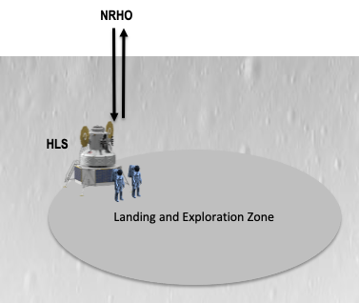
Figure 4: Phase 1 Concept of Operations for Human Landing on the Moon
During the descent phase, HLS will transfer to and insert into a Low Lunar Orbit (LLO) and likely need to loiter in LLO for navigation state updates. HLS then performs a Descent Orbit Insertion (DOI) to lower the vehicle’s perilune and then Powered Decent Initiation and subsequent braking burns to land on the lunar surface. Throughout descent to the lunar surface, the crew will don suits during the dynamic phases of flight. While the exact landing site has not been selected, the initial lunar landing will be targeting the South Pole region (84 to 90 degrees south latitude) with a landing accuracy of a 100 m of the intended landing site. Upon landing, the crew will work with Mission Control to safe the vehicle and begin operations to prepare for the surface stay. While the two crew are on the surface, HLS will enable the crew to live in the lander by providing life support, consumables, power, communications, enabling surface access for Extra Vehicular Activities (EVAs), and supporting EVAs. The total surface duration will be on the order of an NRHO orbit period (~6.5 days) as that drives the overall mission trajectories. The exact value will be directly impacted by the transfer durations between NRHO and LLO, the amount of LLO loiter time, and the location of the landing site – all of which are still openly being worked.
The number and duration of EVAs performed on the initial surface mission are dependent upon vehicle capabilities, surface stay duration, and additional activities aside from the EVA. Examples of these include pre and post EVA operations, meals, hygiene, and sleep. The requirements for the number of EVAs and their duration can be found in the HLS Appendix H solicitation information (add link). Given the scientific value that is provided through EVAs, the surface timeline will be consciously developed to maximize the amount of time that the crew can spend performing EVAs. For the initial surface mission, the crew will be constrained to the contingency walk back distance from the lander, with the exact distance driven by the local topography around the landing site. These EVAs are expected to include general scouting, geologic observations, sampling, and possible deployment of handheld and surface deployable payloads. Once the unpressurized rover is delivered to the surface, the exploration range around HLS will expand and enable the crew to cover greater distances on each EVA. Additionally, the unpressurized rover is being designed for telerobotic operations for relocation to different landing sites, along with the ability to continue various scientific operations.
Near the end of the surface mission, the crew will begin operations to prepare for ascent and the return transfer to NRHO. Once the desired ascent window opens, HLS will perform a powered ascent, likely another loiter in LLO, and then perform the Lunar Orbit Departure (LOD) to begin the transfer back to NRHO. Similar to the descent phases, the crew will be suited during the dynamic phases of flight. Once HLS inserts in NRHO, the vehicles will share the responsibility for this second RPOD where HLS will perform the rendezvous with Orion. At this stage, Orion will assume the active role and progress through the remaining proximity operations through docking. Once the vehicles have docked and the hatches are opened, the crew will begin preparations for their return to Earth.
Throughout the HLS surface mission, the two crew on orbit will engage in several activities. Potential options include performing on orbit science experiments, participating in public outreach events, communicating with and supporting the crew on the surface, among other potential activities.
Once the crew nears the NRHO departure locations for their return to Earth, the crew will transfer into Orion, finalize preparations for departure, and then undock. Once they are at a safe distance, the crew performs the NRHO departure burn to begin their journey home. The return transfer includes another lunar flyby and is constrained to be a 5-day transfer from NRHO departure to entry interface. The crew will then progress through entry, descent, and landing operations touching down in the Pacific Ocean off the coast of San Diego, California where ground support be ready for recovery.
- Phase 2 Lunar Exploration – Expanding and Building
Phase 2 follows the initial human landing on the Moon and moves toward a sustained lunar presence. The initial focus is on exploration and mobility (Phase 2A) followed by an emphasis of Mars forward demonstrations, Habitation, and ISRU (Phase 2B). The concept of operations described here focuses on Phase 2A, as it is nearer in time than Phase 2B. Additional work will be completed in the future to address Phase 2B. To further break down the concept of operations, Phase 2A was further divided into sub-phases, as described below:
- Mission 2A-a: One Pressurized Rover at the South Pole
- Mission 2A-b: One Pressurized Rover & Fixed Surface Habitat at the South Pole
- Mission 2A-c: Two Pressurized Rovers at the pole for the first mission and off the pole for the following missions
- Mission 2A-d: Uncrewed Mission.
Representative sub-phases are shown in Figure 5 are shown for 2A-a, 2A-b, and 2A-c. 2A-d is not shown in Figure 5 however is anticipated to be executed between every crewed mission.
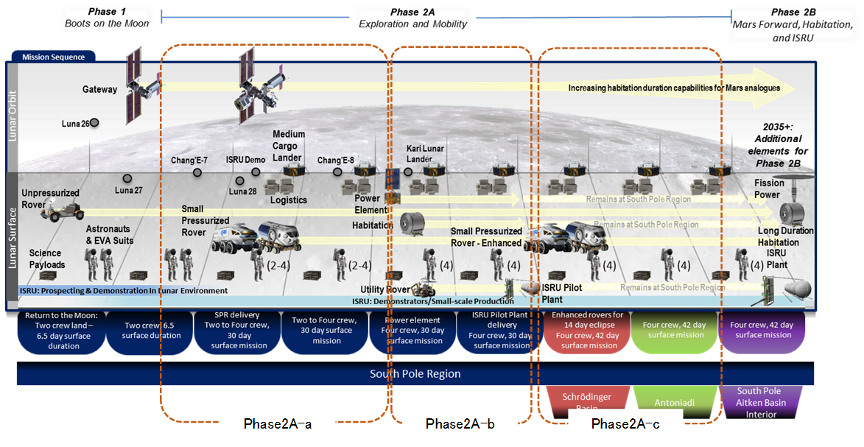
Figure 5: Phase 2A Representative Sub-phases
5.1 Overview of Elements
The architecture elements relevant for the description of the operational concept for Phase 2A are summarized in Table 3 below. Table 4 shows the surface architecture element interactions.
Table 3: Overview of Surface Architecture Elements Available in Phase 2A
Element | Availability | Acronym | Function
Human Landing System | Phase 1 | HLS | See Table 2
Extra-Vehicular Activity capability | Phase 1 | EVA | See Table 2
Small landers / Robotic precursors | Phase 1 | SCL | See Table 2
Unpressurized Rover | Phase 1 | UPR / LTV | See Table 2
Pressurized Rover  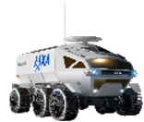 | Phase 2A | PR | Provide a mobile pressurized environment to support two crew over a 30-day mission on the surface of the Moon. EVAs and logistics will utilize the 2 suitports on the PR. PR is also capable of uncrewed operations during daylight periods to include traversing and completing utilization activities.
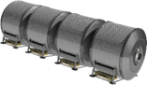  Fixed Surface Habitat | Phase 2A | FSH | Provide a pressurized environment to support two crew over a 30-day mission on the surface of the Moon and up to 4 crew over a 60-day mission with additional provisions.
Small Logistics Module   | Phase 2A | SLM | Provide pressurized transport of logistics from Earth to the lunar surface.
Medium-class Cargo Lander  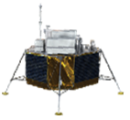 | Phase 2A | MCL | An uncrewed system allowing the deployment of logistic cargo or surface elements anywhere on the lunar surface in a manner that is safe for crew to work around. As an example, ESA’s European Large Logistics Lander (EL3) is being developed to deliver logistics and cargo to the lunar surface.
Communications Relay  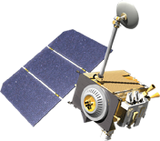 | Phase 2A | COM | Provide communications relay and navigation capabilities to support surface and in-space elements for the crewed and uncrewed operations. Examples of potential systems includes ESA’s Moonlight and NASA’s LunaNet.
Power  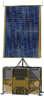 | Phase 2A | PWR | Capable of providing power generation, storage, and distribution to augment the surface elements along with supporting ISRU operations.
Utility Rover   | Phase 2A | RUR | Small to large rovers that support sample return, scientific activities, and/or ISRU.
ISRU Pilot Plant  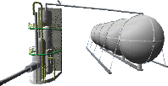 | Phase 2A | IPP | Provide a sub-scale version of the operational plant with identical technology, for proving the safe operations and reliability while providing about 1/100 of the amounts of O2 and or H2 needed for Phase 3.

Table 4: Operational interaction between architecture elements
Note: light green = some interaction, dark green = significant interaction, empty = no interaction
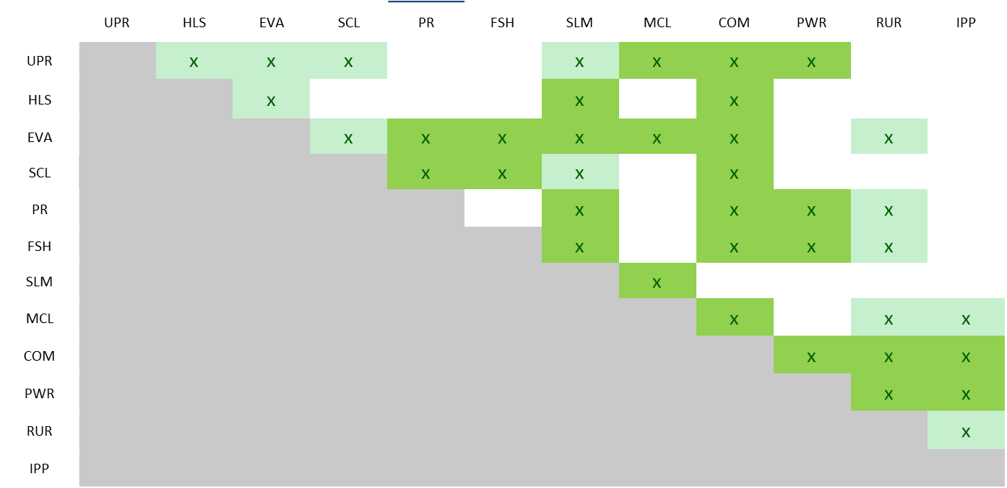
5.2 Operational approach – Trade-offs
The operational concept described in Section 5.3 depends on several choices in the operational approach. Since the surface architecture elements are in an early phase of definition, many of these choices are driven by uncertainties in the element design. In addition, there is a strong interaction between operational choices and system design so that an engineering trade of the operational approach appears an important step in the overall advancement of the exploration architecture outlined in the Global Exploration Roadmap. The operational interaction between the elements are shown in Table 4. Table 5 relays the trades themes, options, current approach (noted in green highlight), and the pros and cons associated with each option.
Table 5: Operational Trades
- Level of cooperation between the human exploration architecture and robotic precursors
 |  | Pros |  |  | Cons
High |  | - Option to integrate precursor missions into human operations  - Option to utilise material / equipment from precursor mission |  |  | - Operational risk due to requirement of collocation / surface rendezvous (e.g. landing in proximity or rendezvous with PR/UPR)  - Dependency between precursor and human mission
Medium |  | - Opportunities for engineering data benefits (e.g. analysis of long-term exposure to lunar environment of robotic equipment) |  |  | - Operational risk due to collocation / surface rendezvous
Low |  | - Option to recover failures of precursor mission with human interaction |  |  | - Operational risk due to collocation / surface rendezvous
None |  | - No requirement of crew time  - Demonstration of autonomy for precursors  - More flexibility of choice for precursor landing site  - No constraints of choice for human landing site  - No operational risk due to requirement of collocation |  |  | - Risk of non-recoverable failure of low-reliability precursor mission
- EVA support mode of the crewed elements (HLS, PR, FSH)
 |  |  |  | Pros |  | Cons
HLS | Airlock |  |  | - Dust mitigation |  | - Extra dry and wet mass
HLS | Suitport |  |  | - Dust mitigation++ |  | - Extra dry and wet mass
HLS | Depress |  |  | - Savings in dry and wet mass |  | - Dust exposure
HLS | Combination |  |  |  |  | - Complexity, extra mass
FSH | Airlock |  |  | - Dust mitigation |  | - Complexity, mass
FSH | Suitport |  |  | - Dust mitigation++ |  | - Seal risk
FSH | Depress |  |  | - Mass savings |  | - Dust exposure
FSH | Combination |  |  | - Dust mitigation++ |  | - Operational complexity
PR | Airlock |  |  | - Dust mitigation |  | - Complexity, mass
PR | Suitport |  |  | - Dust mitigation++ |  | - Seal risk
PR | Depress |  |  | - Mass savings |  | - Dust exposure
PR | Combination |  |  | - Dust mitigation++ |  | - Operational complexity
- Mode of unloading of the medium cargo lander
 |  |  | Pros |  | Cons
Crew in suits |  |  | - No mass impact on cargo lander |  | - High risk for crew
Robotic aid |  |  | - High operational flexibility (can be used for other tasks) |  | - Reliability requirements on robotics  - High mass impact on cargo lander
Mechanical aid |  |  | - Moderate operational flexibility  - Low risk for crew |  | - Moderate mass impact on cargo lander
Without crew |  |  | - Option to decouple cargo lander and human operations / timeline |  | - Requires additional transportation system and robotic aid  - Highest mass impact on cargo lander
Function of UPR |  |  | - Increased operational flexibility  - Low risk for crew |  | - Complex interface between UPR and cargo lander
Function of HLS |  |  |  |  | - Complex interface between HLS and cargo lander  - Requires collocation / surface rendezvous  - No credible transportation solution
- Crew interaction with medium cargo lander
 |  |  | Pros |  | Cons
Crew access to deck |  |  | - Operational flexibility  - Recovery from mechanical failure modes |  | - Increased, yet low crew risk in unlikely contingency case
No crew access to deck |  |  | - No crew training requirements for contingency scenario |  | - Increased, yet low mission risk
- Communication link capabilities
 |  |  | Pros |  | Cons
Gateway only |  |  | - Simpler architecture for telecommunications |  | - Lower availability of service  - Slightly power reliability of service (no dissimilar redundancy)
Gateway + additional relay |  |  | - Improved availability and reliability of service  - More partnership opportunities  - Potential starting point for lunar service economy
- Communication relay service coverage
 |  |  | Pros |  | Cons
All locations |  |  | - Robustness with respect to future change of plans  - Independence from ground station network for Moon orbit-surface communication |  | - Lowest availability for a given set of satellites
Far side only |  |  | - Increased availability for a given set of satellites |  | - Reliance on Earth-Moon via ground stations for near side
Only focused areas |  |  | - Potentially highest service availability |  | - No feasible orbit solution e.g. ”hovering at low altitude over south pole”
- Habitation function distribution
 |  |  | Pros |  | Cons
Only PR and FSH, HLS only for transfer operations (nominal and abort) |  |  | - Clear function separation between PR, FSH, and HLS  - Lower complexity of HLS design  - Lowest crew risk |  | - Unused potential habitation volume on lunar surface
Mainly PR and FSH, HLS as backup |  |  | - Increased operational flexibility |  | - Increased crew risk in case of abort (coordination between crew already inside HLS and crew outside)
Share between PR, FSH, and HLS |  |  | - Highest operational flexibility |  | - Increased crew risk in case of abort (coordination between crew already inside HLS and crew outside)
- Powerplant function
 |  |  | Pros |  | Cons
Provision of power during night |  |  | - Additional recovery mode for contingencies during night |  | - Significant design requirements for power station if solar  - Lower power availability for same mass power plant during day
No provision of power during night |  |  | - Higher performance of power plant optimised for day operations |  | - Slightly higher risk for night operations
- Operational interface between ISRU Pilot Plant and Power plant
 |  |  | Pros |  | Cons
No interface |  |  | - No interface complexity |  | - ISRU PP needs dedicated power generation
Only power -> ISRU |  |  | - ISRU PP design can be optimised on reactor and feed stock delivery  - Relatively simple interface  - Higher output of ISRU PP is more representative of the operational ISRU plant |  | - Still needs collocation / surface rendezvous + connection mechanism / rover support
Only ISRU products -> power |  |  | - Some mass saving for ISRU PP |  | - ISRU PP needs dedicated power generation
Power <-> ISRU reactants |  |  | - Some mass saving for ISRU PP  - Optimised ISU PP |  | - Complex interface
- Envisioned EVA frequency
 |  |  | Pros |  | Cons
FSH - Few long |  |  | - Fewer pre-breath, suit-up, EVA, ingress cycles |  | - Potential for fatigue
FSH - Many short |  |  |  |  | - Fewer pre-breath, suit-up, EVA, ingress cycles  - More resource consumption due to habitat de- and re-pressurisation
PR - Few long |  |  |  |  | - Potential for fatigue
PR - Many short |  |  | - Opportunities for switching equipment

5.3 Concept of Operations
Ground rules and assumptions have been identified for each of the sub-phases of Phase 2A. Some are comment across all sub-phases whereas others are specific to that sub-phase. Ground rules are described in Table 3, including comment to all crewed sub-phases and specific sub-phases, and assumptions are captured in Table 4.
Table 3: Ground Rules
Common to all crewed sub-phases | Crew of four is transferred by SLS/Orion between the Earth and the Gateway
Common to all crewed sub-phases | The HLS will support the crew during landing and post-landing until successful transition to the surface assets has been completed as well as prior to ascent
Common to all crewed sub-phases | Gateway normally functions in the NRHO. (Communication relay function from Lunar surface to the Earth and Staging point)
Common to all crewed sub-phases | Logistics necessary for the mission are already transferred to the landing point at least 48 hours of operation with the crew prior to additional logistics transfer by the crew
Mission 2A-a (One Pressurized Rover) | Crew of two will descend to the lunar surface, while another crew of two remains at the Gateway during lunar surface mission
Mission 2A-a (One Pressurized Rover) | The crew will stay on the lunar surface for approximately 32 days
Mission 2A-b (One Pressurized Rover & Fixed Surface Habitat) | Crew of four will remain at the Gateway for 30 days prior to landing on the lunar surface
Mission 2A-b (One Pressurized Rover & Fixed Surface Habitat) | Crew of four will descend to the lunar surface
Mission 2A-b (One Pressurized Rover & Fixed Surface Habitat) | Two crewmembers live in and operate out of the Pressurized Rover, and two crewmember live in and operate out of the Surface Habitat. The crew will swap vehicles during the surface mission
Mission 2A-b (One Pressurized Rover & Fixed Surface Habitat) | The crew will stay on the lunar surface for approximately 32 days
Mission 2A-c (Two Pressurized Rover off the pole) | Crew of four will remain at the Gateway for 30 days prior to landing on the lunar surface
Mission 2A-c (Two Pressurized Rover off the pole) | Crew of four will descend to the lunar surface
Mission 2A-c (Two Pressurized Rover off the pole) | Two crewmembers live in each Pressurized Rover
Mission 2A-c (Two Pressurized Rover off the pole) | The crew will stay on the lunar surface for approximately 42 days
Mission 2A-d (Uncrewed Mission) | Uncrewed operations (e.g. autonomous or teleoperations) will continue throughout the year to perform science, exploration, logistics, maintenance, repairs, assembly and improvements

Table 4: Assumptions
Common to all sub-phases | Each surface element has own power generation system for keep alive and communication system to the Earth
Common to all sub-phases | Phasing in of mission critical reliance on communication or navigation satellite in the vicinity of the Moon, initial reliance on the Gateway (i.e. Short black out occurs almost once a 7 days). As capabilities are available, this assumption will be reevaluated and updated.
Common to all sub-phases | There is no night survival during crewed mission for South Pole missions
Common to all sub-phases | Up to three days following touchdown are allocated for crew adaptation to the lunar surface gravity environment
Common to all sub-phases | The surface habitat, pressurized rover, unpressurized rover, as well as cargo landers have accommodations that allow payloads to be raised, secured, and lowered
Common to all sub-phases | The cargo landers provide enough power and communications for the small pressurized logistics carriers and air tank quiescent operations until crew retrieval
Common to all sub-phases | Crew landing will nominally occur at beginning of favourable solar illumination periods (enhances crew visibility operations as well as ensuring full power charge of assets)
Common to all sub-phases | No EVAs from PR on days when EVAs are occurring from the Surface Habitat
Common to all sub-phases | Crew off-duty day every 7th day. First off-duty day is Surface Day 4 (last day before HLS egress, during acclimation)
Common to all sub-phases | Both dual and single person EVAs can be conducted from the PR via suitports
Common to all sub-phases | Each PR has only two suitports

5.3.1 Concept of Operations for Phase 2A-a
During Phase 2A-a, one Pressurized Rover (PR) and one unpressurised rover (shown as the Lunar Terrain Vehicle (LTV)) is utilized for the lunar surface exploration. LTV is basically for the contingency return capability if the PR is failed or stuck. The HLS will not be used for habitation. An overview of the concept of operation is shown in Figure 6 and described in Table 5.
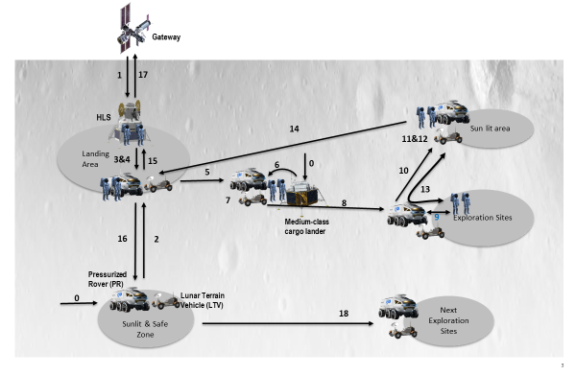
Figure 6: Phase 2A-a Concept of Operations
Table 5: Phase 2A-a Operation Description
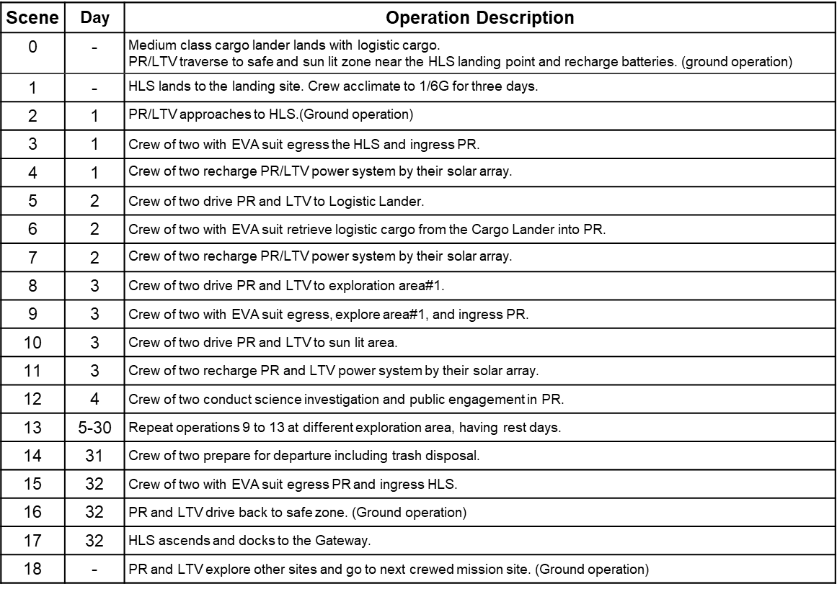

As the preparation for the mission, the batteries of the PR and LTV will be fully recharged and checked out from the ground operation in the sunlit & safe zone near the landing area.
The crew will be launched on SLS Block 1B/Orion from Kennedy Space Center. SLS/Orion will launch to Low Earth Orbit (LEO) where the Exploration Upper Stage (EUS) will perform the Trans-Lunar Injection (TLI) burn to place Orion on a trajectory to intercept the Moon. On the outbound transfer, Orion will utilize a Lunar Gravity Assist and subsequently insert into the NRHO. After inserting into NRHO, Orion will begin the RPOD process with Gateway. Upon soft capture and subsequent hard dock, the crew will transfer to the Gateway and stay 30 days (TBD) and perform operations (HLS checkout and suit checkouts, logistics transfer, etc.) to get ready for the surface mission. As the Gateway and vehicle stack nears the NRHO departure location for the surface mission, two crew will transfer into HLS, finalize the necessary checkouts, and then perform undocking and the departure burn to conduct a lunar surface mission of up to 30 days. Note that the exact concept of operations to prepare for the surface mission is still TBD.
During the descent phase, HLS will transfer to and insert into a Low Lunar Orbit (LLO) and likely need to loiter in LLO for navigation state updates. HLS then performs a Descent Orbit Insertion (DOI) to lower the vehicle’s perilune and then Powered Decent Initiation and subsequent braking burns to land on the lunar surface. Throughout descent to the lunar surface, the crew will don suits during the flight. While the exact landing site has not been selected, the lunar landing area in this phase will be targeting the South Pole region (84 to 90 degrees south latitude) with a landing accuracy of a 100 m of the intended landing site. Upon landing, the two crew will work with Mission Control to safe the HLS. Before starting actual exploration, two crew will stay in the HLS for TBD days for acclimation to 1/6G. During this acclimation the PR and LTV approach to the HLS by the ground operation.
After the acclimation, the two crew with EVA suit egress the HLS and ingress PR and then recharge PR/LTV power system by their solar array on the first day of surface operation.
On the second day, two crew drive the PR to Logistic Lander and don EVA suits and retrieve logistic cargo from the Cargo Lander into the PR. LTV will follow the PR by ground operation. Then two crew recharge PR/LTV power system by their solar array at the end of second day.
From the 3rd day, two crew drive PR and LTV to exploration area#1, egress with the EVA suit, explore area#1, and ingress PR. In the end of the day, two crew drive the PR and LTV to sun lit area for recharging the batteries. On the 4th day, because crew will not be able to perform EVA, two crew conduct science investigation and public engagement within the PR.
Repeat the operations of 3rd and 4th day for the different exploration areas, having rest days. Near the end of the surface mission, two crew prepare for departure including trash packing into PLC and disposal After that, two crew with EVA suit egress PR and ingress HLS. The PR and LTV drive back to and stay at sunlit and safe zone by the HLS ascend. Then the PR and LTV explore other sites and go to next crewed mission site. (Ground operation)
Once the desire ascent window opens, HLS will perform a powered ascent, likely another loiter in LLO, and then perform the Lunar Orbit Departure (LOD) to begin the transfer back to NRHO. Similar to the descent phases, the crew will be suited during the dynamic phases of flight. After the HLS inserts into the NRHO, the HLS will perform the RPOD operation to dock to the Gateway. Once the HLS docked to the Gateway and the hatches are opened, the crew will transfer to the Gateway and begin preparations for their return to Earth.
Once the crew nears the NRHO departure locations for their return to Earth, the crew will transfer into Orion, finalize preparations for departure, and then undock. Once they are at a safe distance, the crew performs the NRHO departure burn to begin their journey home. The return transfer includes another lunar flyby and is constrained to be a 5 day transfer from NRHO departure to entry interface. The crew will then progress through entry, descent, and landing operations touching down in the Pacific Ocean off the coast of San Diego, California where ground support be ready for recovery.
It is important to study the contingency operation concept to derive the necessary functions to secure the crew safety during such contingency cases.
The studied contingency cases are summarized on the Table 6. The below table is the current study results of the operation concept for the contingency cases which could be considered to occur during phase 2A-a. Because these are the representative cases, we need to investigate the other contingency cases in detail to complete these studies in future.
Table 6: Studied Contingency Cases for Phase 2A-a
Contingency Case | Description
Contingency-1 | Either ECLSS (including exceeded contamination and pressure loss) or TCS function of the PR is totally lost. Fail to extinguish fire is included.  (Note: Mission will be continued if only one string of ECLSS/TCS functions lost.)
Contingency-2 | One string of power functions of the PR is lost.
Contingency-3 | PR immobilized (due to failures in driving system).
Contingency-4 | PR stuck (no failure in the system).
Contingency-5 | Incapacitated crewmember during EVA.

5.3.2 Concept of Operations for Phase 2A-b
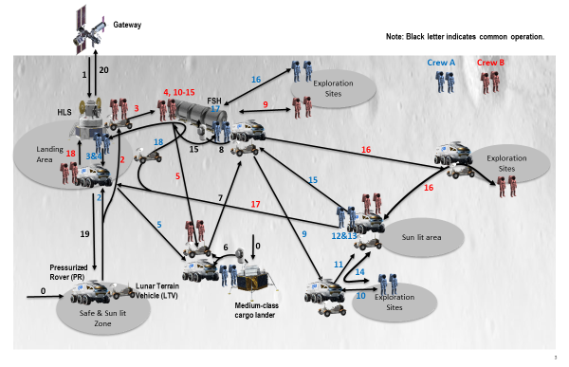
During the Phase 2A-b one Pressurized Rover (PR) with one Lunar Terrain Vehicle (LTV) and Fixed Surface Habitat (FSH) are used together for the lunar surface exploration. The LTV is basically used for the contingency return capability if the PR is failed or stuck. The HLS will not be used for habitation. Two crew will stay in the PR and other two crew will stay in the FSH. In the middle of the mission duration, crew will switch the habitation locations. An overview of the concept of operation is shown in Figure 7 and described in Table 7.
Figure 7: Phase 2A-b Concept of Operations
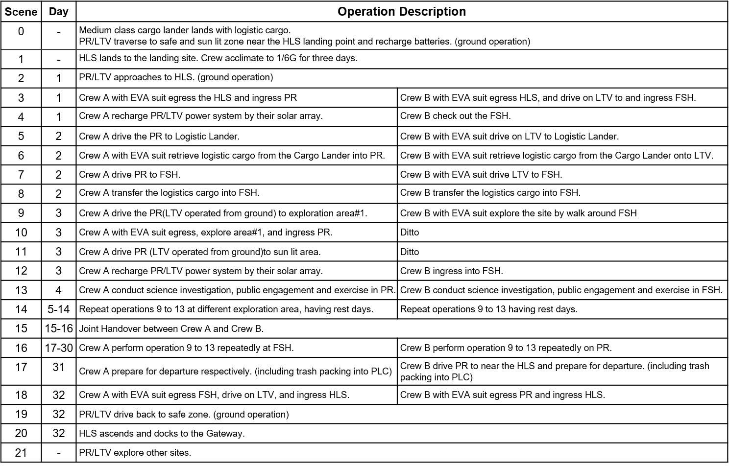
Table 7: Phase 2A-b Operation Description

The concept of operation from the crew launch to crew landing on lunar surface and preparation operation are identical to the Phase 2A-a.
After the acclimation in the HLS, the two crew (Crew A) with EVA suit egress the HLS and ingress the PR and then recharge the PR power system by their solar array on the first day of surface operation. LTV is also recharged the batteries from the ground operation.
The other two crew (Crew B) with EVA suit egress the HLS and drive the LTV to the FSH. Then the Crew B ingress and checkout the FSH.
On the second day, Crew A drive the PR to the Cargo Lander. Then Crew A don EVA suit and retrieve logistic cargos from the Cargo Lander into the PR. In parallel, Crew B with EVA suit drive the LTV to the Cargo Lander and retrieve logistic cargos from the Cargo Lander onto the LTV. After the retrieval operation, Crew A and Crew B drive the PR and the LTV respectively to the FSH. Then, Crew A and Crew B collaboratively transfer the cargos into the FSH.
From the 3rd day, actual exploration operation starts. The Crew A drive the PR to exploration area#1, egress with the EVA suit, explore area#1, and ingress PR. In the end of the day, two crew drive the PR to sun lit area for recharging the batteries. The LTV will follow the PR by the ground operation. On the other hand, Crew A stay in the FSH and go for the exploration around the FSH by EVA suit. On the 4th day, because crew will not be able to perform EVA every day, Crew A and Crew B conduct science investigation and public engagement within the PR and FSH respectively.
Repeat the operations of 3rd and 4th day for the different exploration areas, having rest days during about the first two weeks.
After around the first two weeks, Crew A transfer to the FSH and Crew B transfer to the PR switching their roles. Crew A and Crew B conduct the similar operations to the first two weeks vice versa for the rest of mission duration.
Near the end of the surface mission, Crew A and Crew B prepare for departure including trash packing into PLC and disposal. After that, Crew A and Crew B with EVA suit egress the FSH and the PR respectively and ingress HLS. The PR and LTV are driven back to and stay at sunlit/safe zone until the HLS ascend. Then the PR and LTV explore other sites and go to next crewed mission site. (Ground operation)
The studied contingency cases are summarized on the Table 8. The below is the current study results of the operation concept for the contingency cases which could be considered to occur during phase 2A-b. Because these are the representative cases, we need to investigate the other contingency cases in detail to complete these studies in future.
Table 8: Studied Contingency Cases for Phase 2A-b
Contingency Case | Description
Contingency-1 | Either ECLSS (including exceeded contamination and pressure loss) or TCS function of the PR is totally lost. Fail to extinguish fire is included.  (Note: Mission will be continued if only one string of ECLSS/TCS functions lost.)
Contingency-2 | One string of power functions of the PR is lost.
Contingency-3 | PR immobilized (due to failures in driving system).
Contingency-4 | PR stuck (no failure in the system).
Contingency-5 | Incapacitated crewmember during EVA.
Contingency-6 | SH totally lost habitation function.

5.3.3 Concept of Operations for Phase 2A-c
During the Phase 2A-c, we use two Pressurized Rovers (PRs) with one Lunar Terrain Vehicle (LTV) for the lunar surface exploration mainly to exploration sites other than South Pole e.g., Schrodinger Basin and Antoniadi. The LTV is basically used for the contingency return capability if the PR is failed or stuck. The HLS will not be used for habitation. Each crew of two will stay in one PR respectively. The mission duration is assumed to be around 42 days. An overview of the concept of operation is shown in Figure 8 and described in Table 9.
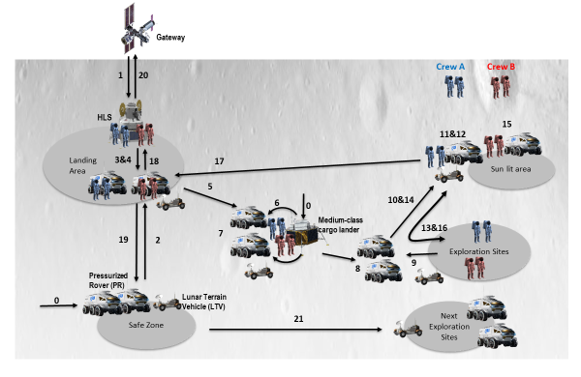
Figure 8: Phase 2A-c Concept of Operations
Table 9: Phase 2A-c Operation Description

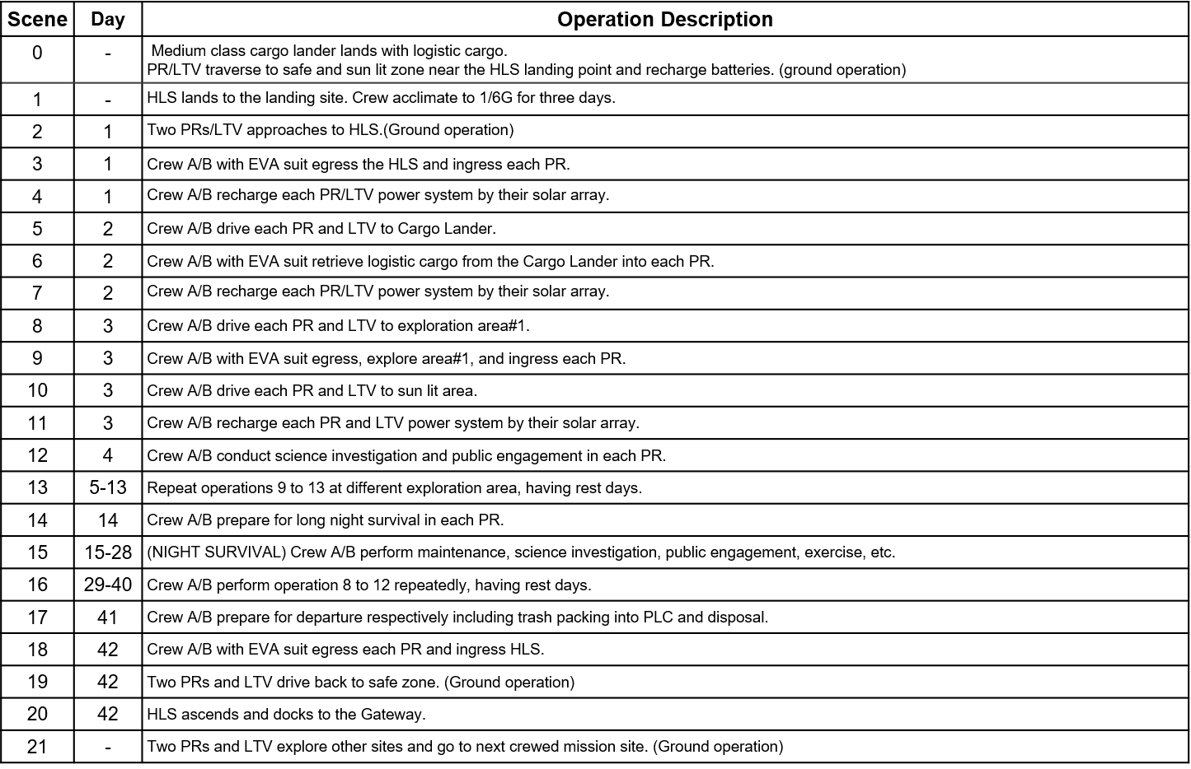
The concept of operation from the crew launch to crew landing on lunar surface and preparation operation are identical to the Phase 2A-a and b.
After the acclimation in the HLS, the two crew (Crew A) with EVA suit egress the HLS and ingress the PR and then recharge the PR power system by their solar array on the first day of surface operation. The other two crew (Crew B) do the same. The LTV is also recharged the batteries from the ground operation.
On the second day, Crew A and Crew B drive the PR respectively to the Cargo Lander. Then Crew A and Crew B don EVA suit and retrieve logistic cargos from the Cargo Lander into the PR. After that, Crew A and Crew B recharge the batteries.
From the 3rd day, actual exploration operation starts. The Crew A and Crew B drive the PR to exploration area#1, egress with the EVA suit, explore area#1, and ingress PR. In the end of the day, two crew drive the PR to sun lit area for recharging the batteries. Because the PR can be used for the contingency, the distance from the Lander can be 100 km or more which could benefit to achieve more science return in one mission. The LTV will follow the PRs by the ground operation. On the 4th day, because crew will not be able to perform EVA every day, Crew A and Crew B conduct science investigation and public engagement within the PR and SH respectively.
Repeat the operations of 3rd and 4th day for the different exploration areas, having rest days during about the first two weeks.
After around the first two weeks, Crew A and Crew B prepare for the night survival mainly fully recharging the batteries. During the night survival, Crew A and Crew B stay within the PR. and conduct science investigation, public engagement, and maintenance activities.
After the night survival, Crew A and Crew B go for the exploration with the similar concept of operation to the first two weeks.
Near the end of the surface mission, Crew A and Crew B prepare for departure including trash packing into PLC and disposal. After that, Crew A and Crew B with EVA suit egress the PR respectively and ingress HLS. The two PRs and LTV are driven back to and stay at sunlit/safe zone until the HLS ascend. Then the two PRs and LTV explore other sites and go to next crewed mission site. (Ground operation)
The concept of operation after the HLS ascends is similar to the phase 2A-a.
The studied contingency cases are summarized on the Table 10. The below is the current study results of the operation concept for the contingency cases which could be considered to occur during phase 2A-c. Because these are the representative cases, we need to investigate the other contingency cases in detail to complete these studies in future.
Table 10: Studied Contingency Cases for Phase 2A-c
Contingency Case | Description
Contingency-1 | Either ECLSS (including exceeded contamination and pressure loss) or TCS function of the PR is totally lost. Fail to extinguish fire is included.  (Note: Mission will be continued if only one string of ECLSS/TCS functions lost.)
Contingency-2 | One string of power functions of the PR is lost.
Contingency-3 | PR immobilized (due to failures in driving system).
Contingency-4 | PR stuck (no failure in the system).
Contingency-5 | Incapacitated crewmember during EVA.
Contingency-6 | SH totally lost habitation function.

5.3.4 Concept of Operations for Phase 2A-d
Phase 2A-d is defined as an uncrewed mission in between crewed missions. In this phase, the Pressurized Rover(s) (PRs) are utilized with uncrewed mode by the operation from the ground. The Lunar Terrain Vehicle (LTV) may be used within the limited life. An overview of the concept of operation is shown in Figure 9 and described in Table 11.
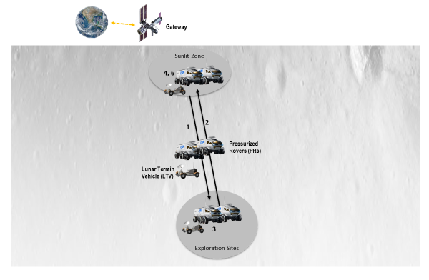
Figure 10: Phase 2A-d Concept of Operations
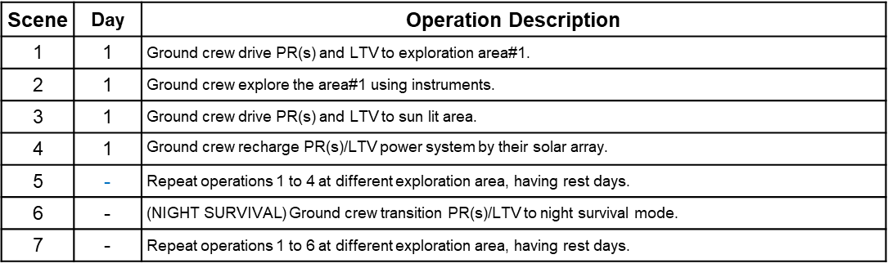
Table 11: Phase 2A-d Operation Description
5.4 Functional Allocations to Elements
Based on the studies described in the above sections, functional allocation to each element is derived as shown in Table 11.

Table 11: Functional Allocations to Elements
Element | functions | interface functions
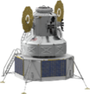  Human Landing System (HLS) | - Comm relay b/w GW and EVA suit  - Navigation  - Guidance  - Control (Thrust & Attitude)  - Power generation storage, & control  - ECLSS and Habitation  - Thermal Control  - Suitport or Airlock | - Comm with GW, PR, FSH, LTV & EVA suit  - Mechanical I/F EVA suit  - Comm (receive) Nav. Data from Nav system (TBD)
Fixed Surface Habitat (FSH) | - Comm relay b/w GW and EVA  - Power generation, storage, & control  - ECLSS and Habitation  - Thermal Control  - Suitport or Airlock  - Support science investigation  - Support public engagement  - Exercise equipment | - Comm with GW, HLS, & EVA suit  - Mechanical I/F EVA suit
Pressurized rover (PR) | - Comm relay b/w GW and EVA suit  - Navigation  - Guidance  - Driving (inc. remote ops from ground & neutral mode)  - Power generation, storage, & control  - ECLSS and Habitation  - Thermal Control  - Suitport or airlock  - Support science investigation  - Support public engagement  - Exercise equipment  - Stow winch+anchor (TBD)  - Support to attach incapacitated EVA crew to suitpot | - Comm with GW, LTV & EVA suit  - Mechanical I/F EVA suit  - Comm (receive) Nav. Data from Nav system (TBD)
  lunar terrain vehicle (LTV) | - Comm relay b/w GW and EVA suit  - Navigation  - Guidance  - Driving (inc. remote ops from ground & tow mode)  - Power generation, storage, & control  - Thermal Control | - Comm with PR, & EVA suit  - Mechanical I/F EVA suit  - Comm (receive) Nav. Data from Nav system (TBD)
  EVA suit | - Comm with HLS, PR, FSH, LTV & EVA suit  - ECLSS  - Power storage/control  - Thermal Control  - Function to support to be attached to suitport for incapacitated crew | - Comm with HLS, PR, FSH, LTV & EVA  - Mechanical I/F with HLS, FSH, PR, and LTV
medium-class cargo lander | - Comm with GW (in case of landing to far side)  - Navigation  - Guidance  - Control (Thrust & Attitude)  - Power generation, storage, & control  - Thermal Control  - Support mechanism to aid cargo transfer | - Comm with GW  - Comm (receive) Nav. Data from Nav system (TBD)

- Findings
Through the studies above, several topics need to be further discussed and are recommended forward work for the ISECG as the lunar surface exploration scenario is continued to be refined.
- Several additional functions were derived from contingency operation scenario investigation such as:
  - For Pressurized Rover (PR)
    - Stow winch+anchor (TBD)
    - Support to attach incapacitated EVA crew to suitport
    - Neutral mode
  - For EVA suit
    - Function to support to be attached to suitport for incapacitated crew
  - For LTV
    - Tow mode
- Global navigation system around the moon will be beneficial and relevant element may have interface with the navigation system.
- “Support mechanism to aid cargo transfer” should be furnished on Medium-size cargo lander and FSH (TBD).
- It should be decided that the LTV be operated from the ground or the PR when the LTV follows the crewed PR. (Comm function between the PR and LTV may be necessary.)

- References
[1] ISECG Global Exploration Roadmap (GER, 3rd edition), January 2018, https://www.globalspaceexploration.org/wordpress/wp-content/isecg/GER_2018_small_mobile.pdf (accessed 9.12.21).
[2] ISECG Global Exploration Map Supplement, August 2020, https://www.globalspaceexploration.org/wp-content/uploads/2020/08/GER_2020_supplement.pdf (accessed 9.12.21).
[3] S. De Mey, J. Guidi, M. Bamsey, J. Blouvac, K. Goodliff, M. Haese, M. Landgraf, C. Lange., S. Pirrotta, N. Sato, An Updated Reference Lunar Surface Exploration Scenario for the Global Exploration Roadmap (GER): The Growing Global Effort and Momentum going Forward to the Moon and Mars, GLEX-2021,1,1,2,x62343, 2021.
[4] Next Space Technologies for Exploration Partnerships -2 (NextSTEP-2) Broad Agency Announcement Appendix H: Human Landing System Integrated Lander https://beta.sam.gov/opp/f3f8689858d6fc2c7f91e6533235f6e7/view
[5] Lee, D. E. (2019). White Paper: gateway destination orbit model: a continuous 15 year NRHO reference trajectory. Technical Report. Document ID: 20190030294, National Aeronautics and Space Administration, NASA Johnson Space Center, Houston, TX.

