Colorado Ecological Forecasting
Monitoring Post-fire Cheatgrass (Bromus tectorum) Distribution to Inform Management Planning


Technical Report
Final – August 12th, 2021

Christopher Tsz Hin Choi (Project Lead)
Alix Bakke
Alex Posen
Monika Rock
Nikole Vannest

Advisors:
Peder Engelstad, Colorado State University, Natural Resources Ecology Laboratory (Science Advisor)
Nicholas Young, Colorado State University, Natural Resource Ecology Laboratory (Science Advisor)
Dr. Tony Vorster, Colorado State University, Natural Resource Ecology Laboratory (Science Advisor)
Brian Woodward, Colorado State University, Natural Resource Ecology Laboratory (Science Advisor)
Dr. Paul Evangelista, Colorado State University, Natural Resource Ecology Laboratory (Science Advisor)
Dr. Catherine Jarnevich, Colorado State University, Natural Resource Ecology Laboratory (Science Advisor)

1. Abstract
Cheatgrass (Bromus tectorum) is a species of concern across the western United States as it has the potential to outcompete native plant species, reduce biodiversity, and diminish nutrient availability for ungulates. Furthermore, because cheatgrass can quickly dominate disturbed landscapes it has the potential to exacerbate wildfire risk by increasing fuel loads. In 2020, the Cameron Peak fire burned more than 200,000 acres on the Arapaho and Roosevelt National Forests in Colorado. These issues are of imminent concern for our partners at the Forest Service (USFS), as they are tasked with wildfire risk and invasive species mitigation. Disturbances such as wildfires can substantially increase the rate and extent of cheatgrass spread. Current cheatgrass mitigation methods rely on field crews to physically locate cheatgrass on the landscape, which takes time, money, and extensive manpower. Here, we developed two Random Forest models within the Software for Assisted Habitat Modeling (SAHM) using remote sensing predictors derived from Sentinel-2 MultiSpectral Instrument (MSI) and Shuttle Radar Topography Mission (SRTM). The first model identified suitable cheatgrass habitat while the other detected cheatgrass presence during the 2021 growing season. Topographic variables were found to be the most important in driving the habitat suitability model. Cheatgrass detection was also found to be possible within a short timespan with limited imagery surrounding a phenological shift of the plant. Maps produced from these models provide natural resource managers the ability to implement early detection and rapid response to prevent the spread of cheatgrass to new locations.

Key Terms
remote sensing, invasive species, Sentinel-2 MSI, Random Forest, Google Earth Engine, Software for Assisted Habitat Modelling, Cameron Peak Fire

2. Introduction
2.1 Background Information
Considered the most successful plant invasion in North America, cheatgrass (Bromus tectorum) is problematic both on national and local scales (Nagy et al., 2020). Cheatgrass was introduced to the United States in the mid-late 19th century and now covers over 101 million acres in the Western US (Mealor et al., 2013). In the Rocky Mountain region, cheatgrass is a growing concern to land managers because of its ability to outcompete native vegetation, distribution throughout ungulate wintering habitat, and effects on wildfire.

The ability of cheatgrasses to create monocultures can lead to a decrease in long-term nutrient availability for wintering ungulates (Kohl et al., 2012). Cheatgrass establishment can cause positive feedback loops that increase the frequency, intensity, and the size of wildfires (Kerns et al., 2020). Adaptations such as prioritizing seed production over root development, the ability to establish quickly in disturbed areas, and favoring elevated nitrogen levels contribute to the ability of cheatgrass to outcompete native grasses, especially in post-fire landscapes (Kerns et al., 2020; Peeler & Smithwick, 2018; Vasquez et al., 2008; West et al., 2017).

Physical, cultural, biocontrol, and chemical methods have all been documented to control the spread of cheatgrass invasions, often in combination to achieve the desired management goal (USDA, 2014). To effectively treat cheatgrass invasions land managers need to know the size and density of cheatgrass patches. Manual field data collection of cheatgrass presence is cumbersome and expensive. Remote sensing has the potential to detect large areas of land without the need for extensive field data and provides a cost-effective method of detection (West et al., 2017).

Remote sensing satellite systems offer frequent coverage at moderate spatial resolution. Satellite systems such as Landsat 8 Operational Land Imager (OLI) and Sentinel-2 MultiSpectral Instrument (MSI), Level-2A provide data products across a range of spectral bands. These data products can be used to derive various spectral indices which can be used to identify vegetation patterns and vegetation health. This is particularly useful for areas that are remote and hard to access. For Example, West et al. (2017) built a successful habitat suitability model and cheatgrass detection map for a post-fire region utilizing open-source software and spectral indices from Landsat 8.

2.3 Project Partners & Objectives
The Cameron Peak Fire (CPF) burned 208,913 acres across the Colorado Front Range in 2020 and was the largest wildfire in Colorado’s recorded history (USDA Forest Service, 2020). Land managers have become concerned about the potential spread of cheatgrass into large post-fire montane regions, especially in the face of climate change lengthening dry seasons and extending drought periods in the western US (Prevéy & Seasted, 2015). The United States Forest Service (USFS) Arapaho and Roosevelt National Forests wants to ascertain the size and extent of cheatgrass invasions in a post-Cameron Peak Fire landscape. To support USFS management actions we investigated the use of remote sensing to (1) create a cheatgrass habitat suitability model and (2) detect and map cheatgrass within the predicted area of suitable cheatgrass habitat. These data may provide critical information to gauge the scope of cheatgrass extent and help inform a plan of action to mitigate cheatgrass spread in the CPF.

Three hypotheses were developed that addressed our project objectives; (1) topographic variables are important indicators within a cheatgrass habitat suitability analysis, (2) disturbed areas, including previous burned areas, will have more cheatgrass cover, (3) regions near trails and roads are more likely to have cheatgrass.

2.4 Study Area
The study area for this project is a minimum convex polygon with a 150 m buffer derived from 136 cheatgrass field sample points within or near the CPF burned area (Figure 1). The study area encompasses 469.34 km² and has an elevation ranging from 1,735m to 3,298m. The lower montane portion of the study area (up to 2,400m) is dominated by ponderosa pine (Pinus ponderosa) and Douglas fir (Psuedotsuga menziesii) on moister, north facing slopes with an understory consisting of grasses, junipers, and pines (Kaufmann et al., 2006; Rocca et al., 2014). Historically, vegetation in the Colorado Central Rockies has experienced low to medium intensity fires every 10-30 years, however with widespread anthropogenic fire suppression throughout the 20th century, a buildup of fuels has led to more high severity fires, which kills mature trees (Kaufmann et al., 2006). In recent decades, burn treatments have been utilized to reduce fuel buildup, as seen in the study area, which has experienced 182 prescribed burn forest treatments from 1993 to 2019 (Swayze et al., 2021).
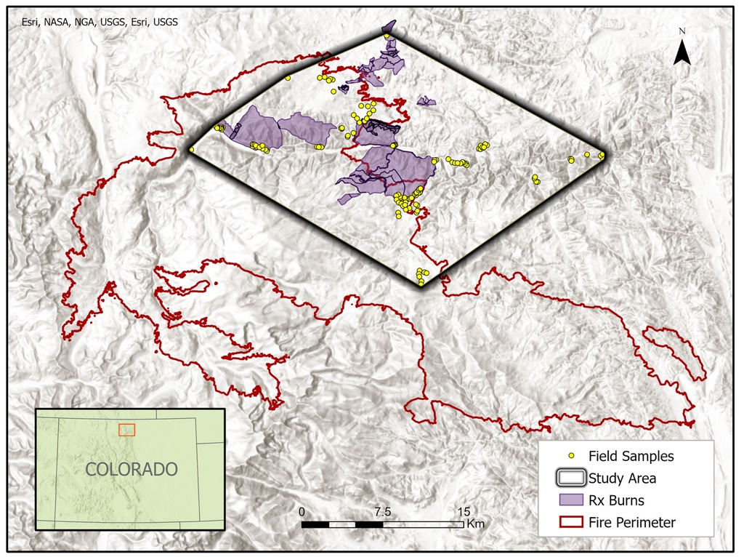
Figure 1. The study area in relation to the Cameron Peak fire in northern Colorado.

3. Methodology
3.1 Data Acquisition
A total of 136 vegetation field samples were collected by the USFS between June 16th and June 28th, 2021, across the study area. Field plots were created through a mixture of chance encounters with cheatgrass (116 points) and random sampling (20 points) at a minimum distance of 100m apart to increase the range of environments being sampled. At each site, 20-meter diameter radial vegetation plots were laid out to assess the percent coverage of cheatgrass, perennial forbs, perennial grasses, bare ground, and rock.

Predictor variables for the habitat suitability model were derived from a range of sources, primarily from Google Earth Engine (GEE; Table 1). The categories of variables were topography, climate, distance to dispersal corridors, and burn-related (Table 1). Topographic variables were derived from the Shuttle Radar Topography Mission (SRTM) Data Version 4 digital elevation model (Farr et al., 2007). Link et al. (1990) found that high slope angles and dryer south facing slopes were more suitable cheatgrass habitat due to reduced competition with native species. Climate variables were derived from the PRISM Monthly Spatial Climate Dataset AN81m (PRISM) and gridMET datasets (Abatzoglou, 2013; Daly et al., 2015). It was found that wet winters and springs allowed for increased cheatgrass seed germinations and dry summers suppressed native vegetation growth (Prevéy & Seastedt, 2015). Distance to dispersal corridors, which included roads and trails, were calculated using the US Census Bureau 2019 TIGER/Lines Shapefiles. This variable considered the effect of cheatgrass seeds being dispersed anthropogenically. To measure the disturbance caused by the CPF, burn severity was calculated using Sentinel-2 imagery; areas within the study area that were not burned in the CPF were given a value of 0 (unburned). Other burn-related variables regarding past prescribed burns administered across the study area were obtained from the NASA DEVELOP Front Range Disasters Team (2021).

Table 1
Initial predictor variables processed for cheatgrass habitat suitability model. Source: which satellite the band is derived from, Native Resolution: the original resolution of the images captured, Image Date: which dates images derive from, Access/Processing: which software was used to extract and process the data.

Predictor Variable | Source | Native Resolution | Image Date | Access/Processing | Included in final model (Yes/No)
Elevation | Shuttle Radar and Topography Mission (SRTM) | 30m | Feb 2000 | GEE | Yes
Northness | SRTM | 30m | Feb 2000 | GEE | Yes
Eastness | SRTM | 30m | Feb 2000 | GEE | No
Slope Northness | SRTM | 30m | Feb 2000 | GEE | No
Slope Eastness | SRTM | 30m | Feb 2000 | GEE | No
Topographic Diversity (TD) | SRTM | 30m | Feb 2000 | GEE | Yes
Continuous Heat Insolation Load Index (CHILI) | SRTM | 30m | Feb 2000 | GEE | No
Multi-Scale Topographic Position Index (mTPI) | SRTM | 30m | Feb 2000 | GEE | Yes
Landform | SRTM | 30m | Feb 2000 | GEE | Yes
Temperature (Maximum Yearly) | PRISM | 4km | 1980 – 2021 | GEE | No
Temperature (Minimum Yearly) | PRISM | 4km | 1980 – 2021 | GEE | No
Temperature (Average Yearly) | PRISM | 4km | 1980 – 2021 | GEE | No
Precipitation (Average Yearly) | PRISM | 4km | 1980 – 2021 | GEE | Yes
Differenced Normalized Burn Ratio (dNBR) | Sentinel-2 | 10m | Feb 2019, Feb 2021 | GEE | Yes
Relative Differenced Normalized Burn Ratio (RdNBR) | Sentinel-2 | 10m | Feb 2019, Feb 2021 | GEE | No
Relativized Burn Ratio (RBR) | Sentinel-2 | 10m | Feb 2019, Feb 2021 | GEE | No
Previously Burned Areas (Prescribed Burn and Wildfire Areas) | NASA DEVELOP, Colorado Front Range Disasters CO Spring 2021 | N/A | 1970 – 2020 | ArcGIS Pro, GEE | No
Years Since Last Prescribed Burn | NASA DEVELOP, Colorado Front Range Disasters CO Spring 2021 | N/A | 1970 – 2020 | ArcGIS Pro, GEE | No
Distance to Road/Trail (Euclidean) | TIGER/Line Shapefiles United States Census Bureau, Colorado Parks & Wildlife | N/A | 2019 | ArcGIS Pro | No
For detection modeling, differenced vegetation, tasseled cap, and wetness indices derived from Sentinel-2 imagery were used in a cheatgrass detection model (Figure A1). Cloud masking was performed using Sentinel-2's cloud and cirrus bitmasks. Water masking was performed using the LANDFIRE EVC (Existing Vegetation Cover) v1.4.0 water band (LANDFIRE, 2019). Only images with less than 20% cloud cover were considered for creating differenced indices.

3.2 Data Processing
Field sampled points were separated into cheatgrass and non-cheatgrass sample points. In the suitability model, any field data points with recorded cheatgrass presence were described as cheatgrass. For the detection model, a minimum of 40% cheatgrass coverage per plot was used as a threshold for a plot to be considered cheatgrass (85 out of 136 points) based on West et al. (2017). The cheatgrass detection model takes advantage of cheatgrass’ distinct spring boot-stage (also known as green-up) and early summer senescence lifecycle, which occurs much earlier than most native species. Peak greenness of cheatgrass was observed on June 10th, 2021, across the study area. Sentinel-2 imagery was used to derive the greenness of pre-June 10th (pre-boot stage) and June 10th onwards (boot-stage imagery). Differenced greenness, wetness, and tasseled cap indices were calculated from these images to identify cheatgrass (Table 2; Table B1).

Table 2
Predictor variables differenced for detection modeling. All variables were sourced from Sentinel-2, had a 10m resolution and were processed using GEE. Equation: raster math of bands used to derive predictor variable indices ( ª equation for MSAVI2 derived from Jiang et al. 2007, ^{b} coefficients for deriving Tasseled Cap indices referenced from Lastovicka et al., 2020).

Predictor Variable | Equation | Included in final model (Yes/No)
Normalized Difference Vegetation Index (NDVI) | $$\frac{NIR-RED}{NIR+RED}$$ | Yes
Modified Soil Adjusted Vegetation Index 2 (MSAVI) ª | $$2*NIR+1- √({2*NIR+1)}^{2}-8*(NIR-RED)$$ | No
Enhanced Vegetation Index (EVI) | $$2.5*\frac{NIR-RED}{\left(NIR+6*RED-7.5*BLUE\right)+1}$$ | Yes
Normalized Differenced Wetness Index (NDWI) | $$\frac{NIR-SWIR}{NIR+SWIR}$$ | No
Tasseled Cap Brightness (TCB) ^{b} | $$0.3037(BLUE)+0.2793(GREEN)+0.4743(RED)+0.5585(NIR)+0.5082(SWIR1)+0.183(SWIR2)$$ | Yes
Tasseled Cap Greenness (TCG) ^{b} | $$-0.2848(BLUE)- 0.2435(GREEN)-0.5436(RED)+0.7243(NIR)+0.0840(SWIR1)-0.1800(SWIR2)$$ | Yes
Tasseled Cap Wetness (TCW) ^{b} | $$0.1509(BLUE)+0.1973(GREEN)+0.3279(RED)+0.3406(NIR)-0.7112(SWIR1)-0.4572(SWIR2)$$ | Yes

3.3 Data Analysis
Suitability and detection modeling were performed using Software for Assisted Habitat Modeling (SAHM), an open-source modeling package within VisTrails version 2.2.3 (Morisette et. al., 2013). Within the SAHM software, BoostedRegressionTree (BRT), Generalized Linear Model (GLM), Multivariate Adaptive Regression Spline (MARS), and Random Forest (RF) are the models available. Unfortunately, MARS significantly slowed model runs and would often crash, so it was dropped early on. In order to increase model fitness, we (1) altered BRT model parameters LearningRate and TreeComplexity to 0.01 and 1 respectively, and (2) altered the number of trees (nTrees) to 500 and 1000 trees in RF for the habitat suitability model and the detection model, respectively. Ultimately, RF was chosen for further analysis because of its statistical accuracy and ecologically making the most sense; this is also in line with other studies (West et. al., 2017).

Northness and topographic diversity being the biggest drivers of habitat suitability (Figure 2), many predictors were dropped from further analysis. Years since the last prescribed burn, previously burned areas, and slope eastness were also not included in the final model runs as these variables did not significantly affect the results of the model. Euclidean distance from roads and trails as dispersal corridor predictor variables were considered, but ultimately dropped from the predictor variable list because these bound the model more than would be expected on the landscape. All other variables were highly correlated (≥0.7) and dropped from the model.

Similarly, the detection model used BRT, GLM, and RF within SAHM for initial modeling and RF was chosen because of its statistical accuracy and complete variable retention. In the detection model, field data points with 40% cheatgrass cover and higher were considered cheatgrass presence based on West et. al.’s (2017) study. The final detection model was run with spectral indices that were differenced between two dates in order to highlight the change in phenology between boot and senescence stages. May 6th, 2021, proved to be the most significant date to initialize the differenced indices (Figure 2). Tasseled cap wetness (TCW; May 6th – June 20th) was the most predictive vegetation index. Modified soil adjusted vegetation index 2 (MSAVI2) and normalized differenced wetness index (NDWI) were highly correlated with other variables and dropped from the analysis. The detection model also relied on the RF Habitat Suitability Results to create a ‘mask’ and narrow down our study area further by removing regions of unsuitable habitat. We used a minimum presence point threshold for the suitability model (39%) to define a binary suitable and unsuitable landscape.

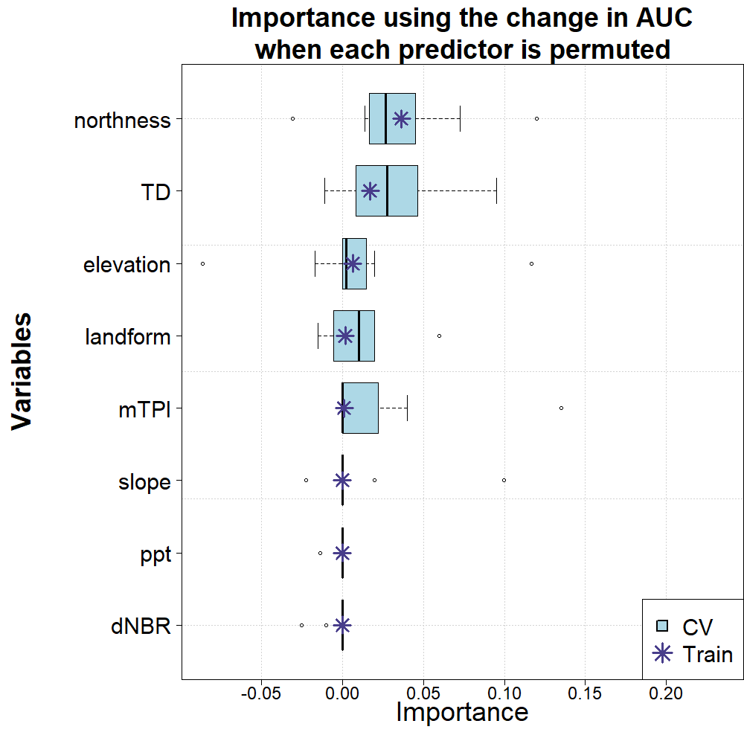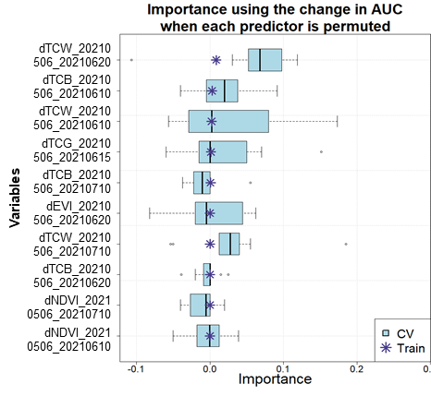
B
A
Figure 2: Top indices utilized by the habitat suitability model (A) and the detection model (B) as described on the y-axis, with level of importance on the x-axis.

4. Results & Discussion
4.1 Analysis of Results
A well fit habitat suitability model suggests that remote sensing can identify preferred cheatgrass growing conditions within the study area (Table 1; Figure 3). Aligning with known cheatgrass phenology, the predictor variables of most importance were northness and topographic diversity for this model (Figure 2). When including dispersal corridors in the suitability model, results supported the final hypothesis predicting regions near trails and roads being more likely to have cheatgrass. However, we found they bound the model too much, were highly correlated with elevation, and ultimately, were dropped from the final model. The resulting detection model masked by suitable habitat was well fit, suggesting that cheatgrass can be detected within a short time frame using vegetation indices (Table 2; Figure 4). Cheatgrass’s boot stage was critical in our model’s detection, resulting in the best fit when May 6th was differenced with later dates. Although cheatgrass phenology was captured within a few months by differencing vegetation indices, it is important to acknowledge that more images throughout a larger time frame could improve the detection model.

Table 3.
The mean of statistical metrics from cross-validated data: Area Under the Curve (AUC), Differenced AUC (training – cross validation), Specificity, Sensitivity, True Skills Statistic (TSS), and Percent Correctly Classified were all used to evaluate model fitness.
Model | AUC | dAUC | Specificity | Sensitivity | TSS | % Correctly Classified
Habitat Suitability | 0.97 | <0.01 | 0.83 | 0.97 | 0.81 | 92.6
Detection | 0.81 | <0.01 | 0.60 | 0.87 | 0.47 | 76.9

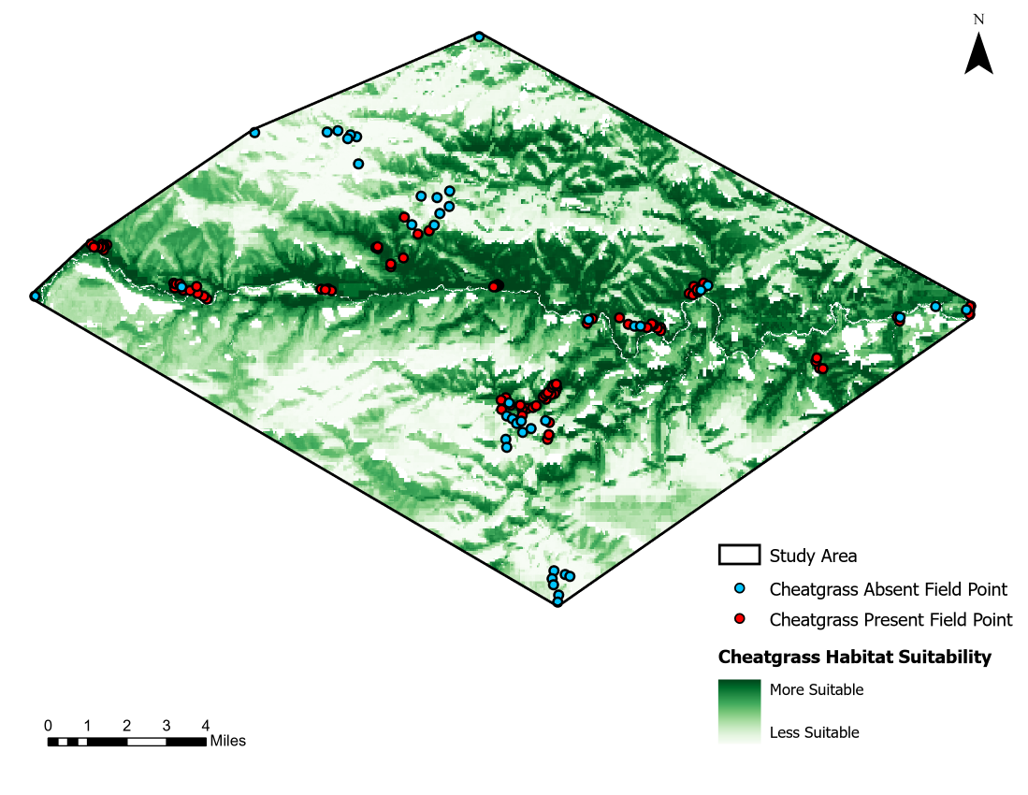
Figure 3. SAHM RF output depicting habitat suitability of cheatgrass within the study area. Light to dark green depicts less to more suitable cheatgrass habitat. The blue and red points indicate cheatgrass absence and presence in the field data.

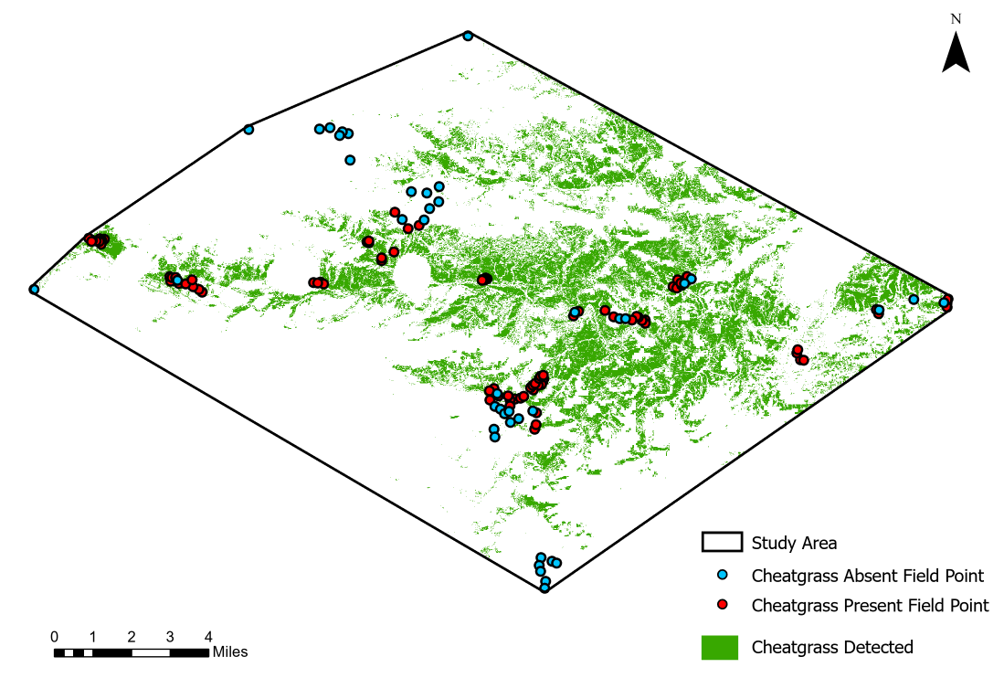
Figure 4. SAHM RF output depicting detection of cheatgrass within the study area convex polygon. Green depicts cheatgrass detection of 70% or more within a pixel. The blue and red points indicate cheatgrass absence and presence in the field data.

Topographic diversity being a key driver of the habitat suitability model indicates cheatgrass prefers less diverse niches, this is consistent with what is known about cheatgrass phenology and has interesting implications for preserving species richness in lower montane landscapes. Cheatgrass detection was more abundant in the eastern region of our study area at lower elevations and areas along roads and rivers. Thresholding the detection model to 70% cheatgrass probability and above, 74.1% of cheatgrass field presence points were captured in the detection model. This threshold was chosen as it maximized the inclusion of cheatgrass presence points without the results being too inclusive and potentially not useful for our partners.

Surprisingly, wildfire and burn areas were not important predictor variables in our suitability model, but this may be due to the scale of our study area not being large enough to detect differences in burned and unburned areas. When comparing areas burned by the CPF, prescribed burns within the CPF, and past prescribed burns (both in and outside of the CPF), a higher percentage of cheatgrass was detected in areas with past prescribed burns (Table 4). Although, this may be due to the location of the prescribed burns, being closer to the Poudre River and Highway 14 corridor, and the distribution of our field data.

Table 4
Statistical analyses extracting detected cheatgrass presence and absence in areas of previously prescribed burns (RX Burns), the Cameron Peak Fire (CPF), and overlapping areas of both RX Burns and CPF (RX Burns & CPF).
Burn Type | Cheatgrass Detected (%) | Cheatgrass Absent (%)
RX Burns | 23 | 77
CPF | 8 | 92
RX Burns & CPF | 18 | 82

4.2 Limitations
While this project had a number of strengths, including well fit habitat suitability and detection models, it was not without limitations. First, field sampling restrictions based on time and space resulted in a limited snapshot of species distribution and abundance (Jarnevich et al., 2015). For example, because of the lack of accessibility to our study area, most of our field sample points were collected near roads and trails (by chance encounter) close to anthropogenic corridors and potentially limited sampling variety. Second, was the limitation of spatial resolution from the satellite imagery used, which ranged from 10m to 4km and could have led to preferences within our models to only detect larger cheatgrass cover. Third, imagery for the detection model due to weather conditions was a continuous challenge. These weather conditions included snow cover throughout the study area observed in April, cloud cover diminishing image quality throughout the month of May, and unusual rain in early June that promoted a second boot stage of vegetation. Fourth, cheatgrass cover below 40% was not feasibly detected with remote sensing and could lead to large swaths of lower cheatgrass cover going undetected and not presented in our findings. Last was the challenge of modeling within a varied and diverse landscape of our study area. Since there were broad topographic differences throughout the region, extrapolated areas are likely to be more uncertain.

4.3 Future Work
Referencing the results of the detection analysis, further sampling using remote sensing to support field samples to increase and diversify the training data for modeling. Areas to focus sampling could include areas further away from roads and other anthropogenic dispersal corridors as well as points within a wider topographic range. Increasing and diversifying the training data could improve the robustness of models in this study and more confidently model other areas of the CPF burn area.

The effects of the CPF are still recent and progressively revealing themselves. There is still much to be understood about the effects of cheatgrass distribution in large, disturbed areas. From our results, we found that northness and topographic diversity were important predictors of cheatgrass habitat suitability. Other modeling approaches could explore the effects of these variables in a targeted manner by modeling isolated topographic ranges (i.e., modeling high elevation vs modeling low elevation areas). Overall, the cheatgrass invasion of large fires in Colorado, such as the CPF, is still relatively unknown. A comparative analysis of areas that were not studied in the CPF, or with other large fires in the region – such as the East Troublesome Fire, would be beneficial in evaluating these effects.

5. Conclusions
The concern of cheatgrass spread throughout the western United States has been exacerbated by disturbances such as wildfire. These concerns were expressed by the USFS when the largest fire in Colorado’s recorded history, the CPF, burned in 2020. The purpose of the project was to develop a cheatgrass habitat suitability model and a cheatgrass detection model within and around the CPF. By building these models within SAHM, we have created a reusable framework for our partners, or future researchers, to build from given expanded study areas or additional field data.

Overall, we were able to develop well fitted suitability and detection models by identifying important variables within the study area, and tweaking model parameters when necessary. In support of our first hypothesis, stating topographic variables are important indicators within a cheatgrass habitat suitability model, results indicated that northness, topographic diversity, and elevation were the main drivers for this model. Surprisingly, our findings on previously burned areas being a less influential variable did not support the hypothesis that disturbed areas, including previously burned areas, would have more cheatgrass cover. For the detection model, tasseled-cap indices utilized May 6th as the initial differenced date were found to be the best suited vegetation detectors to capture the phenology of cheatgrass.

Additionally, our study provides a framework for detecting cheatgrass in a short period of time, even when satellite imagery is limited, by differencing vegetation indices. Using this method, the study captured cheatgrass’ unique phenology by detecting the plant’s early season green-up. This may be useful for land managers, especially after large disturbances like the CPF, because it allows them to distinguish cheatgrass on the landscape quickly after the disturbance.

5. Acknowledgements
Project Partner(s):
- Tom Bates (USDA, US Forest Service, Arapaho and Roosevelt National Forests and Pawnee National Grassland)

Special Thanks:
- Dr. Paul Evangelista (Colorado State University, Natural Resource Ecology Laboratory)
- Dr. Catherine Jarnevich (USGS, Fort Collins Science Center)
- Dr. Anthony Vorster (Colorado State University, Natural Resource Ecology Laboratory)
- Peder Engelstad (Colorado State University, Natural Resource Ecology Laboratory)
- Nicholas Young (Colorado State University, Natural Resource Ecology Laboratory)
- Brian Woodward (Colorado State University, Natural Resource Ecology Laboratory)
- Scott Cunningham (NASA DEVELOP National Program)

This material contains modified Copernicus Sentinel data (2021), processed by ESA. Any opinions, findings, and conclusions or recommendations expressed in this material are those of the author(s) and do not necessarily reflect the views of the National Aeronautics and Space Administration. This material is based upon work supported by NASA through contract NNL16AA05C.

7. Glossary
AIC – Akaike Information Criterion; scores covariates based on how well they fit the data (inside of GLM).
AUC – Area Under the [ROC] Curve; A value depicting the probability a model will rank a randomly chosen presence observation higher than a randomly chosen absence observation.
BRT – Boosted Regression Tree; utilizes recursive binary splits to evaluate response predictors (regression trees) while also combing many smaller, simpler models to improve prediction (boosting).
dAUC – differenced Area Under the [ROC] Curve; The difference between the training curve and cross validated curves, a fit model has a difference of ≤ 0.05.
Earth observations – Satellites and sensors that collect information about the Earth’s physical, chemical, and biological systems over space and time.
GLM – Generalized Linear Model; a basic linear regression adapted to our presence-absence data that begins with a null model and calculates the AIC score for each variable that may be included in the model. The AIC scores covariates based on how well they fit the data, and GLM uses stepwise procedure to choose first single covariates with the highest scores, then two-covariate models, then three, and so on. The result is a combination of covariates that provides the highest overall AIC score.
MODIS – Moderate resolution Imaging Spectroradiometer.
RF – Random Forest; a general-purpose classification and regression model that combines multiple randomized decision trees and aggregates their predictions by averaging.
ROC – Receiver Operating Characteristic Curve; Used to display the performance of a model.
SAHM – Software for Assisted Habitat Suitability, a package within VisTrails that was created to expedite habitat suitability analysis and help maintain a record of various inputs, pre- and post-processing steps, and modeling options.
Sensitivity – A model’s ability to predict a true positive using the training data.
Specificity – A model’s ability to predict a true negative using the training data.
TSS – True Skill Statistic; A summary statistic that considers specificity and sensitivity to measure the accuracy of a model’s predictions.
VisTrails – An open-source scientific workflow that supports data exploration and visualization.

8. References
Abatzoglou J. T. (2013). Development of gridded surface meteorological data for ecological applications and modelling. International Journal of Climatology, 33(1), 121-131. https://doi.org/10.1002/joc.3413
Daly, C., J.I. Smith, & K.V. Olson. (2015). Mapping atmospheric moisture climatologies across the conterminous United States. PloS ONE, 10(10), e0141140. https://doi.org/10.1371/journal.pone.0141140.

Farr, T.G., Rosen, P.A., Caro, E., Crippen, R., Duren, R., Hensley, S., Kobrick, M., Paller, M., Rodriguez, E., Roth, L., Seal, D., Shaffer, S., Shimada, J., Umland, J., Werner, M., Oskin, M., Burbank, D., & Alsdorf, D.E. (2007). The Shuttle Radar Topography Mission. Reviews of Geophysics, 45(2), RG2004. https://doi.org/10.1029/2005RG000183.

Jarnevich, C. S., Stohlgren, T. J., Kumar, S., Morisette, J. T., & Holcombe, T. R. (2015). Caveats for correlative species distribution modeling. Ecological Informatics, 29, 6-15. https://doi.org/10.1016/j.ecoinf.2015.06.007

Jiang, Z., Huete, A.R., Li, J., & J. Qi. (2007). Interpretation of the modified soil-adjusted vegetation index isolines in red-NIR reflectance space. Journal of Applied Remote Sensing, 1(1), 013503. https://doi.org/10.1117/1.2709702

Kaufmann, M.R., Veblen, T.T., & Romme, W.H. (2006). Historical fire regimes in ponderosa pine forests of the Colorado Front Range, and recommendations for ecological restoration and fuels management. Front Range Fuels Treatment Partnership Roundtable, findings of the Ecology Workgroup. https://www.fs.usda.gov/treesearch/pubs/61131

Kerns, B. K., Tortorelli, C., Day, M. A., Nietupski, T., Barros, A. M.G., Kim, J. B., Krawchuk, M. A. (2020). Invasive grasses: A new perfect storm for forested ecosystems? Forest Ecology and Management, 463(1), 117985. https://doi.org/10.1016/j.foreco.2020.117985

Kohl, M.T., Hebblewhite, M., Cleveland, S.M. & Callaway, R.M. (2012). Forage value of invasive species to the diet of Rocky Mountain Elk. Rangelands, 34, 24–28.

LANDFIRE, 2019, Existing Vegetation Type Layer, LANDFIRE 1.1.0, U.S. Department of the Interior, Geological Survey, and U.S. Department of Agriculture. Accessed August 2021.

Lastovicka J, Svec P, Paluba D, Kobliuk N, Svoboda J, Hladky R, Stych P. (2020). Sentinel-2 data in an evaluation of the impact of the disturbances on forest vegetation. Remote Sensing, 12(12), 1914. https://doi.org/10.3390/rs12121914

Link, S. O., Gee, G. W., Downs, J. L. (1990). The effects of water stress on phenological and ecophysiological characteristics of cheatgrass and Sandberg’s bluegrass. Journal of Range Management, 43, 506- 513. https://doi.org/10.2307/4002354

Mealor, B., Mealor, R., Kelly, W., Bergman, D., Burnett, S., Decker, T., Flowers, B., Herget, M., Noseworthy, C., Richards, J., Susan Brown, C., George Beck, K., Fernandez-Gimenez, M., Frasier, M., Munis, M., Lupis, S., Roath, R., Coghenour, M., Verdone, M., Brumbaugh, M. (2013). Cheatgrass ManageMent handbook Managing an invasive annual grass in the Rocky Mountain region.

Morisette, J. T., Jarnevich, C. S., Holcombe, T. R., Talbert, C. B., Ignizio, D., Talbert, M. K., ... & Young, N. E. (2013). VisTrails SAHM: visualization and workflow management for species habitat modeling. Ecography, 36(2), 129-135. 10.1111/j.1600-0587.2012.07815.x

Nagy, R. C., Fusco, E. J., Balch, J. K., Finn, J. T., Mahood, A., Allen, J. M., & Bradley, B. A. (2020). A synthesis of the effects of cheatgrass invasion on US Great Basin carbon storage. Journal of Applied Ecology, 58(2), 327–337. https://doi.org/10.1111/1365-2664.13770

Peeler, J. L., Smithwick, E. A. H. (2018). Exploring invasibility with species distribution modeling: How does fire promote cheatgrass (Bromus tectorum) invasion within lower montane forests? Diversity and Distributions, 24, 1308– 1320. https://doi.org/10.1111/ddi.12765

Prevéy, J. S., & Seastedt, T. R. (2015). Effects of precipitation change and neighboring plants on population dynamics of Bromus tectorum. Oecologia, 179(3), 765-775. https://doi.org/10.1007/s00442-015-3398-z

Rocca, M. E., Brown, P. M., MacDonald, L. H., & Carrico, C. M. (2014). Climate change impacts on fire regimes and key ecosystem services in Rocky Mountain forests. Forest Ecology and Management, 327, 290–305. https://doi.org/10.1016/j.foreco.2014.04.005
Soil Survey Staff, Natural Resources Conservation Service, United States Department of Agriculture. Web Soil Survey. Available online at the following link: http://websoilsurvey.sc.egov.usda.gov/. Accessed [06/26/2021].

Swayze, N., Choi, C.T.H., Knowlton, G., & Kilsauskaite, J. (2021). Colorado Front Range Disasters. Understanding the Impact of Forest Management on the Cameron Peak and CalWood Fire. Unpublished manuscript. NASA DEVELOP.

United States Department of Agriculture (USDA) Forest Service. 2014. Field Guide For Managing Cheatgrass in the Southwest. TP-R3-16-04 https://www.fs.usda.gov/Internet/FSE_DOCUMENTS/stelprdb5410110.pdf
USDA Forest Service. (2020). Inciweb: Incident Information System. https://inciweb.nwcg.gov/incident/6964/.

Vasquez, E., Sheley, R., & Svejcar, T. (2008). Nitrogen enhances the competitive ability of cheatgrass (Bromus tectorum) relative to native grasses. Invasive Plant Science and Management, 1(3), 287-295. https://doi.org/10.1614/IPSM-08-062.1

West, A. M., Evangelista, P. H., Jarnevich, C. S., Kumar, S., Swallow, A., Luizza, M. W., & Chignell, S. M. (2017). Using multi-date satellite imagery to monitor invasive grass species distribution in post- wildfire landscapes: An iterative, adaptable approach that employs open-source data and software. International Journal of Applied Earth Observation and Geoinformation, 59, 135- 146. https://doi.org/10.1016/j.jag.2017.03.009.

9. Appendices
Appendix A

Figure A1. NDVI time series of cheatgrass field sample points from early April to early August. NDVI values were derived from Sentinel-2 imagery, Cheatgrass points were split into cheatgrass presence points (>40% cheatgrass cover) and cheatgrass absence points (<20% cheatgrass cover). Missing observations were a result of cloud masking on Sentinel-2 imagery.

Appendix B
Table B1
Dates used for differencing to generate differenced index predictor variables for detection modeling.
Dates
05/06/2021
06/10/2021
06/15/2021
06/20/2021
07/10/2021

