Emulation of Core Flight System Applications for Flight Software Development and Validation
Cody Wheeler  Marshall Space Flight Center  Mail Stop EV43  Huntsville, AL 35812  Cody.A.Wheeler@nasa.gov | Peter Berg  Marshall Space Flight Center  Mail Stop EV43  Huntsville, AL 35812  Peter.Berg@nasa.gov | Mason Ricks  Qualis Corporation  Marshall Space Flight Center  Mail Stop EV43  Huntsville, AL 35812  Mason.P.Ricks@nasa.gov
Ashley Jinright  Jacobs Space Exploration Group  Marshall Space Flight Center  Mail Stop EV43  Huntsville, AL 35812  Ashley.M.Jinright@nasa.gov | Chandler Millar  Marshall Space Flight Center  Mail Stop EV43  Huntsville, AL 35812  chadmillar@live.com | Tristan Lane  Marshall Space Flight Center  Mail Stop EV43  Huntsville, AL 35812  Tristan.Lane@nasa.gov

Abstract—The Mars Sample Return (MSR) campaign is an unprecedented attempt in the return of Martian samples back to Earth. The ascent from the surface will be performed by the Mars Ascent Vehicle (MAV), a critical element in the mission that National Aeronautics and Space Administration (NASA) Marshall Space Flight Center (MSFC) is developing. To this end, innovations in flight software development, verification, and validation are occurring. The MAV flight computer will run Core Flight System (cFS), an open-source software environment developed by NASA Goddard Space Flight Center (GSFC). NASA Marshall’s MAV Mission and Fault Management (M&FM) Team has implemented an emulation of two applications of this architecture: Limit Checker and Stored Command. Using an emulation of the functionalities of these applications allows for rapid prototyping of table-based algorithms. Further, M&FM is leveraging an in-house, low-fidelity but high-throughput State Analysis Model (SAM), an integrated MATLAB Stateflow Plant and Software model. This model is run in parallel with the cFS emulation for full flyout testing of the M&FM algorithms, verification of intent of these algorithms, and for future auto-generation of application-ingestible M&FM tables. The tables can then be delivered to the MAV Flight Software (FSW) team in a seamless process, reducing the cost of traditional FSW development and the risk of starting M&FM FSW development at later points in the NASA program life cycle.

Table of Contents
1. Introduction 1
2. Historical Efforts 2
3. State Analysis Modeling 3
4. Core Flight System Emulation 5
5. Comparison with State Analysis Model Results 7
6. Auto-Generation and Delivery to MAV FSW 7
7. Forward Work and Conclusions 8
Appendix 9
Acknowledgements 9
References 9
Biography 10

1. Introduction
NASA, and humanity as a whole, has a long history of crewed and non-crewed spacecraft launching from Earth’s surface. NASA also boasts a number of very successful missions that involved landing on other celestial bodies, namely the moon and Mars. However, one thing humanity has not yet done is return samples from the Martian surface to Earth. To this end, NASA is partnering with the European Space Agency (ESA) to execute the Mars Sample Return (MSR) campaign. This campaign contains a variety of moving parts, including the ESA-developed Earth Return Orbiter (ERO) and the Jet Propulsion Lab (JPL)-developed Sample Retrieval Lander (SRL), beginning with the Mars 2020 Perseverance Rover. Other MSR concepts are detailed by NASA on the Mars Exploration Program webpage [1].
The focus of this paper is on a different but equally critical asset: Marshall Space Flight Center’s (MSFC) Mars Ascent Vehicle (MAV). The MAV is a two-stage solid rocket vehicle with the first stage primary flight computer running a Core Flight System (cFS) software environment. The algorithms governing the mission flight software are being developed by the Mission and Fault Management (M&FM) team of MSFC’s Integrated Systems Health Management and Automation branch. While M&FM has significant experience in analysis, design, and development of launch vehicle mission and fault management capabilities and software algorithms, the cFS environment is mostly novel to M&FM personnel.
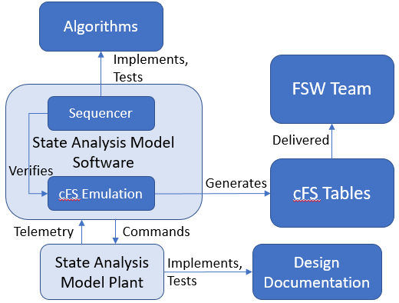
M&FM has rich experience with developing mission management and fault management algorithms for the Space Launch System (SLS). These algorithms and their delivery to the Flight Software (FSW) team is a well-defined process. M&FM has also developed in-house simulations, namely the State Analysis Model (SAM), for testing of the algorithms before formal testing, reducing risk and cost. However, given the many differences between the MAV mission, the SLS mission, and the Artemis program, a new process is warranted. Thus, M&FM is utilizing historical efforts and lessons learned from NASA Lunar Atmosphere Dust and Environment Explorer (LADEE), with heritage from Lunar Reconnaissance Orbiter (LRO) and other cFS-based missions, to develop the mission and fault management algorithms. The M&FM team implements these algorithms in a SAM, converts these to a cFS-like format, and then autogenerates them to a cFS-ingestible table format. The M&FM team also provides rigorous testing with a subsequent delivery to the MAV FSW team of the cFS tables, further reducing risk and cost compared to implementation and testing in more traditional and costly environments. The current as-recommended process for future development is portrayed in Figure 1.
Figure 1. MAV M&FM - FSW Process

2. Historical Efforts
Space Launch System Mission and Fault Management Delivery Process
For the Space Launch System Program, the Mission & Fault Management team is responsible for defining the nominal and off-nominal functional behaviors of the integrated launch vehicle. The then-uncharted territory of utilizing a Systems Modeling Language (SysML)-based tool to feed the Flight Software design began to be explored around a decade ago, in the Constellation Program M&FM, and continues today in the SLS Program M&FM.
The process includes developing an agreement with the prime contractor for the delivery of design documentation with the generation of draft, low-detail versions and then building upon each updated set of documents per program milestones with increased complexity and design specifics. The SysML model is built using a process similar to the delivery of design documentation in that the initial deliveries to FSW are nominal, state transition plans that lay the foundation for the follow-on deliveries that include the more detailed designs that reflect full subsystem functionality. FSW receives each M&FM Model delivery via a well-defined release process to use as a guide in writing the code that ultimately resides on the SLS flight computers. The release process was rigorously defined due to the number of people supporting the effort as well as the steps needing to be completed in a specific chronological order. Lastly, while the SLS launch vehicle is human-rated, it was not required to address the full human rating process for the Artemis I mission since that first test flight is non-crewed. The full human rating process, including abort capabilities and assessments, will be performed for the Artemis II mission. The M&FM MAV team is utilizing aspects of this SLS process and is evolving it given the less complicated nature of the program and the absence of a need to human-rate the vehicle. The size of the program, though, doesn’t diminish the need for sound M&FM software.
Core Flight System
Around 2008, NASA’s Goddard Space Flight Center (GSFC) “was tasked two large in-house missions with concurrent development schedules.” To keep the schedule and minimize cost, they realized that similarity in large portions of the flight software could be leveraged, thus conceiving the idea for the core Flight System, designed with “reusability and flexibility in mind” [2].
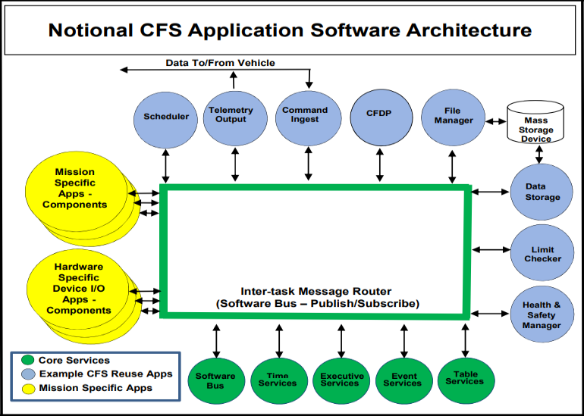
The open-source Government Off-The-Shelf (GOTS) Core Flight System was selected by the MAV Flight Software Team through a detailed trade study. cFS has a robust legacy of use on numerous NASA and commercial spaceflight missions [3], including Lunar Reconnaissance Orbiter and the Lunar Atmosphere and Dust Environment Explorer. cFS provides a modular, table-based approach to spacecraft FSW, allowing developers to use existing applications or develop mission-specific applications to connect to an overall data bus, as shown in Figure 2 [2].
Figure 2. Notional cFS Application Software Architecture
For MF&M purposes, existing built-in cFS applications, namely Limit Checker (LC) and Stored Command (SC), can be utilized to achieve a majority of the needed M&FM functions. These applications are described in the paragraphs that follow.
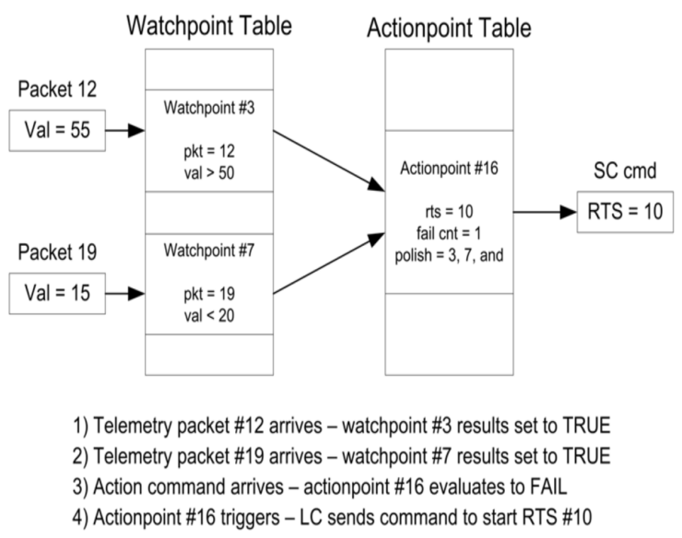
LC works by evaluating packets on the Spacecraft Bus (SB) application and applying a threshold check on a single packet. This information is evaluated on Watchpoints (WP) in the Watchpoint Definition Table (WDT) and is shown in Figure 3 [4, 5]. The results of the WDT are then combined in logical expressions with persistency or fail count checks applied in the Actionpoint Definition Table (ADT). Once an Actionpoint (AP) is evaluated as true, meets the persistence criteria, and is Enabled and Active, the cFS then initiates a Relative Time Sequence (RTS). RTSs, operated from the Stored Command application, are tables that can contain a variety of things, including commands to spacecraft components and other cFS applications, starting or stopping other RTSs, and enabling or disabling other APs, among other things [6].
Figure 3. LC Monitoring Process Example Diagram
This table-based approach provides for a highly flexible software and M&FM capability, which has proven very useful for satellites and scientific spacecraft. Unfortunately, this flexibility comes at the cost of verification and the clarity of algorithms. Because it is documented as tables and not within the structure of typical Model-Based Systems Engineering (MBSE) tools like MagicDraw, new concepts and novel innovations were needed in the LRO and LADEE missions to document the M&FM design [7].
For LRO, Fault Management Engineers created a Microsoft Excel Workbook with a spreadsheet for WPs, APs, and tracking of RTSes, but the generation of the cFS WDT, ADT, and RTS tables was still a manual process. LADEE Fault Management engineers expanded this capability to use MATLAB scripts to autogenerate the cFS tables used in flight from the Excel spreadsheet.
The MAV M&FM team is building on the strong heritage of cFS Limit Checker and Stored Command by expanding the innovation developed on LRO and LADEE to improve on the table-based M&FM approach, as discussed in Section 4. Part of this capability’s evolution stems from the State Analysis Modeling performed on the SLS FSW algorithms development, described in Sections 3 and 5.

3. State Analysis Modeling
As discussed in Section 2, MSFC M&FM has performed algorithm development for the SLS program. M&FM also uses in-house tools to support algorithm testing and validation. One such tool is known as the State Analysis Model and is a fast-executing but low-fidelity, closed-loop simulation consisting of Plant and Software components.
Stateflow Plant
The Plant model represents the physical system under control and is comprised of individual reference models of program-specific subsystems, such as Propulsion or Avionics. These models show the physical interaction of each component within said subsystem and how they work together to create a complete system or vehicle. These models can also show interactions between systems. This modeling of component and system interactions allows for fault propagation analysis and generation of data that could support Safety and Mission Assurance work such as hazard analysis or Probabilistic Risk Assessments. This development and simulation is done by use of MATLAB Simulink Stateflow, a graphical language suite of state transition diagrams and flow charts, among other features. For the Plant models, though, only state transition charts are used, with the flow charts being resigned to the Software model as described in Section 3.
The Plant reference models are developed using all available and relevant information (e.g., schematics, vendor documentation, concept of operations, Failure Modes and Effects Analysis). While many facets/components of a system can be represented with a state or multiple states, the SAM modeling effort is mostly concerned with states that can aide in the design and testing of the M&FM algorithms. To this end, physical components, such as valves, solenoids, connectors, and sensors, are the main concern, with less algorithm-related components as typically being ignored, such as filters, storage tanks, and generally components that are static or immobile.
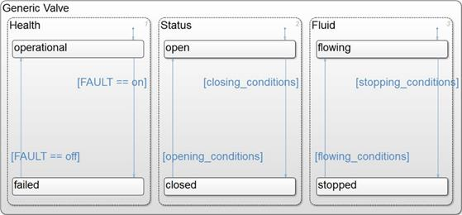
An example of a generic valve modeled in Stateflow is given in Figure 4. There can be multiple levels to a component, with groupings usually by traits and in a specific order. Typical models could include both health and status states for most components, but there are other implementations that achieve the same result. In Figure 4, the “Status” state maintains the functionality of the component, like a valve being “open” or “closed,” whereas the “Health” state informs the Status state if a fault has been injected, which could affect component operability. The conditional lines between these states detail the conditions that lead to a superstate, such as Status, transitioning between its “open” and “closed” substates. It could be thought the closing_conditions as related to the substate of Health. Perhaps a specific valve defaults to a closed status, and in the absence of a fault and the presence of a mechanical actuating force, the valve may open. However, if the valve Health is “failed,” or if the actuating force is removed, then the valve Status will fail safe state or return to “closed.”
Figure 4. Generic Valve Modeled in Simulink Stateflow
Additional states can also be added depending on the systems, like a “Fluid” state showing if something is flowing or not. Other faults can be injected as well on these sorts of states, such as forcing a temperature sensor to read a high value or a turbine being forced to underspin. The nature of fault injections, the failure conditions that they cause, and the downstream effects that are realized leads to the need for fault management software.
Due to the fast pace of the early stages of the MAV program, design documentation changes frequently. Luckily, a strength of the SAM is the ability to update models quickly. When new design and capability information is made available, the SAM team can rapidly make any necessary modifications. To this end, one of the benefits of the relatively small size of the MAV Program compared to the Artemis Program is the ability to quickly communicate with lead engineers and subsystem leads across the program to receive feedback on questions that may arise. Another advantage of MAV SAM model development is the ability to leverage other SAM models, such as from SLS. While subsystems cannot be used verbatim across multiple projects, certain components can be quickly duplicated and modified to fit a new project, like the MAV. This was specifically done for the Thrust Vector Control system using existing SLS Exploration Upper Stage models, taking components and using them as a base for the MAV TVC subsystem. As previously mentioned, new documentation allows for constant evolution of the model, increasing functionality and capabilities to keep the SAM as accurate as possible. More information on Plant modeling in a State Analysis Model and processes can be found in [9].
Stateflow Software
The Software side of State Analysis Modeling drives the Plant. While the Plant represents how the vehicle will respond to various inputs and commands, the software model controls those inputs and interprets the behavior of the vehicle. It simulates real-time events, albeit in faster-than-real-time performance, and implements the Flight Software algorithms to systematically respond to feedback from the Plant and determine what commands should be sent back to the Plant. The algorithms are represented in the software as a flow through a series of nodes where Plant feedback or states are checked for conformance with an algorithm’s expectation. If the desired feedback or state is not yet present, the flow will be directed down a path that either sends a command to the Plant that should lead to the desired state, or it will leave the algorithm and check again on the next timestep iteration.
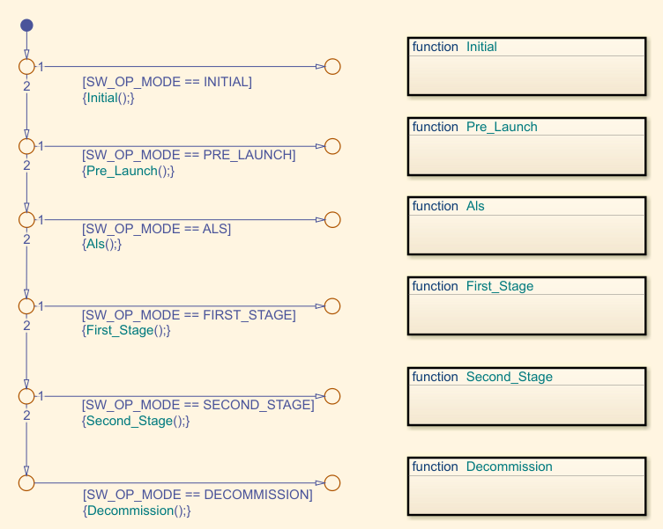
One example of a sequence of operations detailed in an algorithm could be, for example, sending a command, waiting for the Plant to receive said command and update its behavior, and finishing with the reception of updated telemetry from an actuated Plant system. In this case, ideally, the next time the flow reaches that same decision node, the desired feedback or state will be present, meaning that the feedback from the Plant indicates that its current state is caught up to that point in the algorithm and the flow can move on to the next part. However, if (1) the Plant is slow to respond, (2) there is command latency in the Avionics, (3) a fault is present in the relevant component in the Plant, or (4) some other mechanism has caused slow or reduced operation of the Plant component, the algorithm may not receive an expected updated telemetry in an appropriate amount of time, and a fault management algorithm may be initiated. The below Figure 5 and Figure 6 portray a part of the Stateflow software as well as the algorithm from which it originated.
Figure 5. Stateflow Software Example
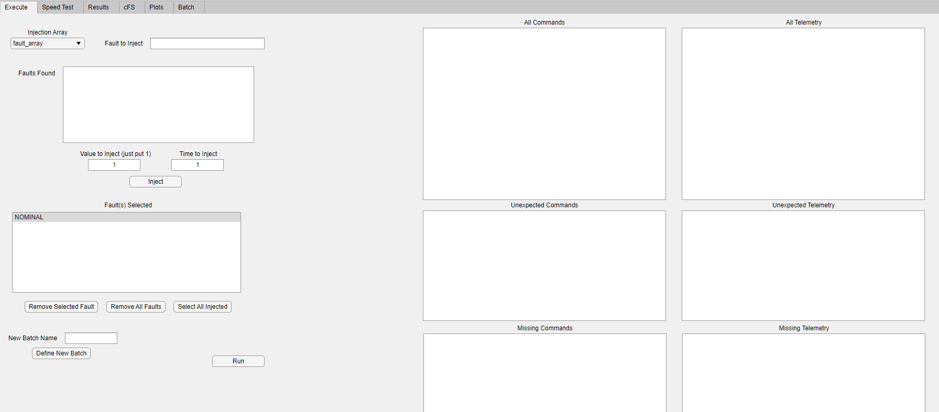
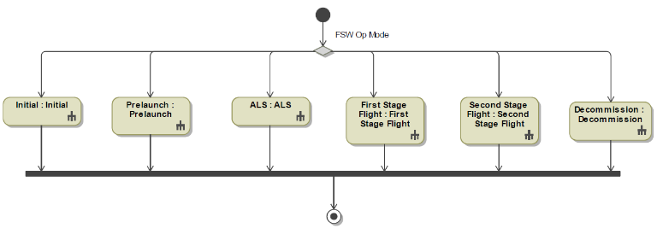
The flow starts at the top of the Stateflow image at the small blue filled-in circle. It then follows the arrows and attempts to follow paths from juncture points in numerical order if there are multiple options. The SW_OP_MODE variable is set as INITIAL before entering this flow diagram, and the square brackets function as IF conditional statements. Therefore, when the flow gets to the first path off of the first juncture point, and the algorithm checks if the value of SW_OP_MODE equals INITIAL, the conditional is evaluated as TRUE and the flow continues to the remainder of the statement, {Initial();}, which tells the flow to enter the “Initial” function. The flow will move through that function, and at the end of it, SW_OP_MODE is set to PRE_LAUNCH, which will cause the flow in Figure 5 to move to the next juncture. This process is repeated until the program moves through all the operation modes. These conditionals are a good example of how this flow-based portion of Stateflow can be utilized for the Mission and Fault Management algorithm design as it is intended to read like the SysML algorithms but is fully executable, integrating with the Plant models and testing the operation of the algorithms. More information on Software modeling in a State Analysis Model and processes can be found in [9].
Figure 7. SAM Graphical User Interface
Figure 6. Algorithm Example
Integrated Stateflow Software and Plant Simulation and Results
The MATLAB Simulink environment provides for the closed-loop Plant-Software simulation. The pre- and post-processing of the inputs and outputs for the simulation is performed via a Graphical User Interface (GUI) as shown in Figure 7, designed using MATLAB App Designer. The free reign given by App Designer facilitates a variety of user-designed capabilities, such as fault injection. Faults can be introduced as many at a time and at any simulation time the user would like. Opposite of the fault panes, the telemetry and command panes are displayed. When a simulation is run, the “All Telemetry” and “All Commands” panes are populated with the data collected. The primary goal of the simulation is to see how the system reacts when a fault is injected into the system. When a fault is introduced, if there is any effect on the system, unexpected and/or missing telemetry/commands will populate in their respective panes within the GUI. This is beneficial to identify vulnerabilities in particular areas of the Plant model, such as single point failures that may cause a loss of mission. Another benefit of the simulation is to test new algorithm changes, and to see how the system reacts. It’s critical that the alterations made to both the plant and the software match the schematics and the intent of the algorithms. When a simulation has finished running, a report can be generated capturing all of the data collected, and subsequent analysis can be performed.

4. Core Flight System Emulation
The traditional process for SLS FSW algorithm development that includes testing internally in in-house simulations (SAM), hand-coding FSW code, and higher-fidelity Hardware-in-the-Loop simulations. While this has been successful for SLS FSW development and verification, the MAV M&FM team has been working towards a slightly different process that includes auto-generation of cFS application-ingestible “Safing” tables and RTSs from the SAM environment.
Emulation “Black Box”
As stated in the previous section, the MSFC M&FM team possesses historical and present-day experience with State Analysis Modeling techniques, namely state-based Plant models and flow-based Software models. The MSFC M&FM team has chosen to emulate a number of key cFS applications to be run as the “Software,” in loop with the traditional state-based Plant models. These applications namely include Limit Checker and Stored Command, as described in Section 2, with some capabilities of Command Ingest (CI) as well. The operational processes implemented require external Excel spreadsheets, MATLAB scripts, and the reference model itself.
The simulation requires at least two Excel workbooks, one for Limit Checker and one for Stored Command emulation. For Limit Checker, we consider this the Safing table, an Excel workbook that contains tabs for the WPs and APs. Each tab has all the information necessary to construct the Limit Checker tables within the cFS emulator. Additionally, enough information is present for the real cFS Limit Checker data tables, which will be discussed in Section 6 Auto-Generation and Delivery to FSW. The second Excel workbook contains the data for the Relative Time Sequences. Additionally, another Excel workbook can be utilized for Absolute Time Sequences (ATSs) if they are being used. ATSs are currently not intended for the MAV mission, but the capability is present.
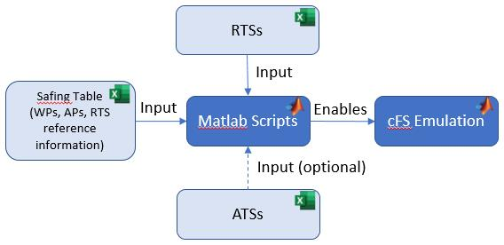
Being external to the MATLAB environment, the Excel sheets promote rapid prototyping of the LC tables by allowing ease of content editing, reviewing, and verification of the tables. Additionally, the user can create tables for a variety of missions without the need to alter the emulation model itself, like a “black box.” This capability will be expanded in the future and is detailed in Section 7 Forward Work. The separation of the tables across different Excel workbooks provides a barrier between the data in the Safing table and the data for the RTSs, paralleling the delineating between the LC and SC applications. A tab in the Safing table, though, contains all the RTS names and numbers, as well as which tab in the RTS table it belongs to. This bridges the gap between the two sheets and allows the LC and SC emulations to interact. Each RTS is housed in a separate tab of the RTS spreadsheet. Doing so helps simplify the code needed for the emulation by allowing each tab to be recognized as a single RTS, instead of trying to differentiate between one RTS and another within a single spreadsheet tab.
Figure 8. cFS Emulation Excel Layout
The data from the Excel files is read in by a startup script within MATLAB. This script functions as an intermediary handler between the Excel tables and the cFS emulation. The script mediates the conversion of data and the population of data arrays to ensure the data received from the Excel sheets is compatible with the cFS emulation. Functions within the script read the data from the Safing table to pair the variables and constants with their respective values. During this period, logic from the tables is converted into logics useable by the state conditionals within the cFS emulation. The startup script is also responsible for building the WP, AP, RTS, and ATS tables from the data contained in the Excel spreadsheets. It is this transformation from external to internal tables that permits the use of the Excel sheets for table prototyping. Once the tables are internalized, the script adds the RTS, ATS, and Safing tables into the Stateflow model, and the cFS emulation can now be executed in the simulation. This process of updating the model array information is repeated when a new prototype iteration is ready to be tested.
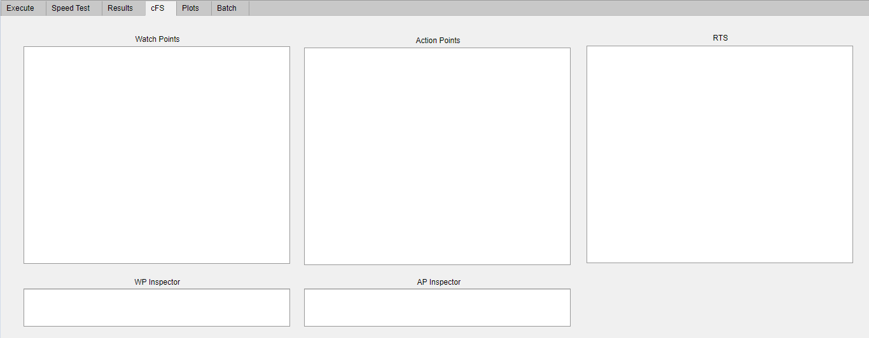
In addition to LC and SC, a third application that was deemed functionally useful for the emulation was Command Ingest. While the LC-activated commands can be executed using the current table prototype, they are limited to internal activation based on telemetry from the Plant. The emulation of external commands from Earth-based ground control was found to be advantageous and was accomplished using Command Ingest. This took form as another partition within the cFS reference model. It uses an additional external Excel sheet that contains the time that each command is to be sent, as well the RTS associated with that command. CI allows the user to simulate the sending of external commands, such as those sent from ground control, that are sent when ground control deems necessary during an actual mission, as opposed to relying on WP/AP activation. CI also plays a key role in managing the execution of commands received via Absolute Time Sequences, which may or may not be used for MAV, but the emulated infrastructure is present. Figure 8 below shows how the Excel spreadsheets relate to the cFS emulation. Figure 9 shows how the cFS data is outputted to the GUI for user analysis.
Figure 9. cFS Emulation Results Pane

5. Comparison with State Analysis Model Results
Stateflow Plant and Sequencer Simulation in Parallel with cFS Tables
As stated in earlier sections, previous SAM efforts on SLS included flow-based Software models and state-based Plant models for the simulation. MSFC M&FM’s emulation of key cFS applications provides for a similar, parallel simulation to be run in concert with the state-based Plant but excludes the flow-based Software. The capability to run both types of simulations and compare the data provides an enormous, early program phase validation of algorithm intent, table design, and FSW implementation.
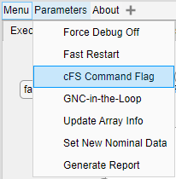
The cFS emulation is always running in the background of the model, running the Safing tables and RTSs based on the received telemetry from the Plant, but the commands generated are not sent to the Plant unless authorized to do so by the user. By use of a “Switch” component in Simulink and a check box in the GUI shown in Figure 10, a user can specify which Software model, the flow-based Sequencer or the cFS emulation, is in charge of sending commands to the plant. Running both of the Software models in parallel with both sending commands to the Plant model and them both being accepted and acted upon would be infeasible. For example, the Sequencer might send a command to fire the pyrotechnic valves at some arbitrary time x. Based on its stored tables, the cFS emulation might determine to send the same command, but at time x + 3 seconds. For a given single valve, this incongruity might not have serious consequence on the mission, but other components are liable to have different time-based interactions and different downstream failures.
Figure 10. GUI cFS Command Flag
To this end, a Sequencer-based simulation is run, immediately followed by a cFS emulation-based simulation. The results of the two can then be compared. If the Sequencer and its results have been verified to match the intent of the algorithms, and then the cFS emulation is introduced and produces different results, then it is likely that the loaded Safing tables and RTSs do not fully match the intent of the algorithms. These Excel-based tables are easy to manipulate, can be altered and re-loaded into the cFS emulation, with another simulation run and the results subsequently analyzed. This is a strong capability that allows the M&FM team to test and internally verify the to-be-delivered tables, buying down risk and reducing cost of expanded testing suites in more expensive Hardware in the Loop simulations.

6. Auto-Generation and Delivery to MAV FSW
MATLAB Scripting to Application-Ingestible Formatting
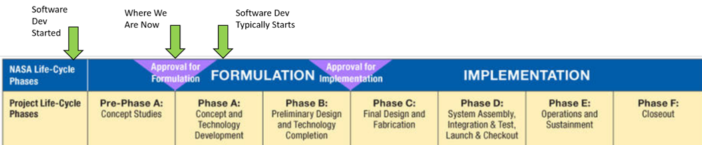
Once the Excel versions of the Safing tables and RTS tables are complete and tested, with validation of intent by comparison with the flow-based Sequencer, the Excel spreadsheets need to be converted to a format that can be easily ingested by the LC and SC applications. As stated in Section 2, LADEE-heritage scripts are largely used for generation of the WDT and ADT, with only minor alterations needed. After initial conversations with the FSW team, though, it was pertinent to confirm the version of the LC and SC apps that were used for LADEE, compared to what is currently intended to be used for MAV, and if there were any changes between the versions. This capability of auto-generating the Safing tables has been expanded to include RTS table generation as well. This required a new script, and interaction with FSW occurred to ensure the RTS tables matched the format the application expected.
Figure 11. NASA Life Cycle Phases, MAV FSW
Delivery to FSW
The M&FM and FSW teams have coordinated to develop a process for the delivery of these application-ingestible tables. This process has been iterative, improving after each meeting to ensure each team is providing/receiving the expected information in the correct format. Presently, the M&FM team provides the WDT, ADT, and the RTS tables (one for each RTS). On the other hand, M&FM is to receive from the FSW team the Message IDs (MIDs) and Offsets of data items, with potential for command checksums as well. These items are then incorporated back into the SAM and the Safing tables for acceptable re-generation and delivery back to the FSW team.
It’s particularly important to note, as evident in the below Figure 11, that oftentimes in programs FSW development doesn’t begin until NASA program life cycle Phase A. However, for MAV, the FSW team was able to utilize work from a Technology Investment Program, allowing for a rapid-implementation of a MAV-specific software suite much earlier than typical [10]. Additionally, M&FM algorithm and software development historically doesn’t start until after Preliminary Design Review (PDR), which occurs near the end of Phase B. For larger missions that are deemed as Agency critical, such as SLS, the algorithm development began in Phase A. However, for smaller historical missions, such as LADEE and LRO, the “M&FM design” (not called that on these programs) didn’t really begin until Phase C. Recent small programs are making a concerted effort to start development as early as possible, and this cFS emulation and early delivery to FSW is a direct result. For MAV, starting earlier and testing in an integrated manner with the SAM provides the benefit of a robust infrastructure and delivery process, enabling rapid changes in the M&FM design as the program and vehicle mature. This process will continue to be refined as the program progresses, yielding a potential overall reduction in cost and risk. More information on the NASA Project Life Cycle can be found in [11] and [12].

7. Forward Work and Conclusions
The process and intentions detailed in the above sections show current capabilities of M&FM’s cFS emulation for implementing and validating the mission management and fault management algorithms (Safing tables and RTSs). There also exist other facets of the simulation that are planned for capability expansion in the future, including supporting development of higher-fidelity test cases, expanding the cFS emulation to be more of a “black box,” and consideration for incorporation of the real cFS applications.
A large portion of M&FM’s effort since the initial development of the SLS algorithms has been analysis of data from System Integration Lab (SIL) or Hardware in the Loop test cases, and this experience is anticipated to be leveraged for the MAV SIL testing. The M&FM team is expecting to develop recommendations for test cases, notably failure scenarios that could provide unexpected vehicle behavior that have been identified by the SAM team, and their detailed success criteria, and provide these to the SIL facilitators.
Second, the majority of the current emulation and simulation was implemented as a proof of concept and architecture for future development, given the expectation that the vehicle design will change as the concepts mature. In the future, this cFS emulation is anticipated to be expanded to be more representative of a “black box,” a structure that can be utilized as-is for any other cFS-based SAM simulation. To that end, this “black box” capability would also help with application to future EV43 projects to refine the process, just as the original algorithm development process originated on Constellation has been altered and refined through the SLS life cycle to best suit the needs of the M&FM and FSW teams.
One question that arises with M&FM’s emulation of particular cFS applications is “Why are you not bringing in the real open-source LC and SC applications for development and testing of the tables before delivery to the FSW team?” Bringing in the real cFS applications, while it would provide an increase in fidelity of the overall simulation, would likely reduce the speed of the simulation, the main purposes of which are rapid development and rapid simulation. Additionally, by keeping the emulation as an in-house reference model we can tailor it to our needs, while also trying to maintain it as a “black box.” Further, the real cFS applications provide for many more back-end computations and tracking of the Safing tables, but they may be much more than are needed for M&FM logic testing, which mostly resides in the functional realm. These extra back-end data are to be tested in the FSW cFS architecture upon delivery of the Safing tables and RTS tables. In the future, the M&FM team tentatively plans to incorporate these real applications of LC and SC. This would provide further verification of the cFS emulation implementation and further validation of the algorithm implementation in an application-ingestible format.
As described throughout this paper, a number of conclusions can be drawn regarding software development: different space missions may constitute different processes, low-fidelity state modeling has supported algorithm testing in the past and will continue to be utilized for MAV, and emulation of cFS applications can reduce the cost of Flight Software development and buy down risk early on. The MAV M&FM team plans to implement the above Forward Work and continue to refine the process and delivery to FSW to ensure the most mature mission management and fault management software for launch.
Appendix
ADT | Actionpoint Definition Table
AP | Actionpoint
ATS | Absolute Time Sequence
cFS | Core Flight System
CI | Command Ingest
ERO | Earth Return Orbiter
ESA | European Space Agency
FSW | Flight Software
GOTS | Government Off-The-Shelf
GSFC | Goddard Space Flight Center
GUI | Graphical User Interface
JPL | Jet Propulsion Laboratory
LADEE | Lunar Atmosphere Dust and Environment Explorer
LC | Limit Checker
LRO | Lunar Reconnaissance Orbiter
MAV | Mars Ascent Vehicle
MBSE | Model-Based Systems Engineering
MID | Message ID
MSFC | Marshall Space Flight Center
MSR | Mars Sample Return
M&FM | Mission and Fault Management
NASA | National Aeronautics and Space Administration
PDR | Preliminary Design Review
RTS | Relative Time Sequence
SAM | State Analysis Model
SB | Spacecraft Bus
SC | Stored Command
SIL | System Integration LAB
SLS | Space Launch System
SRL | Sample Retrieval Lander
SysML | Systems Modeling Language
WDT | Watchpoint Definition Table
WP | Watchpoint

Acknowledgements
The authors thank the entire MAV team, namely S. Justice and the rest of the MAV FSW team, D. Yaghoubi of the Integrated Analysis team, and S. Maynor.

References
[1] National Aeronautics and Space Administration, Feb. 2020, “Concepts for Mars Sample Return,” National Aeronautics and Space Administration, Mars Exploration Program. [Online]. Available: https://mars.nasa.gov/mars-exploration/missions/mars-sample-return/
[2] Lorraine Prokop, Ph.D., “NASA’s Core Flight Software - a Reusable Real-Time Framework,” November 2014. Available: https://ntrs.nasa.gov/api/citations/20140017040/downloads/20140017040.pdf
[3] McComas, David, “NASA/GSFC’s Flight Software Core Flight System”, Flight Software Workshop, http://flightsoftware.jhuapl.edu/files/2012/FSW12_McComas.pdf, 2012.
[4] cFS Limit Checker Application User’s Guide, version 1.1, NASA Goddard Space Flight Center Flight Software Systems Branch, Greenbelt, MD, USA, 2017.
[5] H. Cannon, A. Bajwa, P. Berg, and A. Crocker, “LADEE Preparations for Contingency Operations for the Lunar Orbit Insertion Maneuver,” presented at 2015 IEEE Aerospace Conference, Big Sky, MT, March 7-14, 2015, 10.1109/AERO.2015.7119199.
[6] cFS Stored Command Application User’s Guide, version 1.1, NASA Goddard Space Flight Center Flight Software Systems Branch, Greenbelt, MD, USA, 2014.
[7] A. R. Bajwa and P. P. Berg, “Modeling Spacecraft Modes for Nominal and Off-nominal Operations,” presented at the Infotech AIAA Aerospace 2011, St. Louis, MO, March 29-31, 2011, Paper AIAA 2011-1444.
[8] A. M. Turing, “Computing Machinery and Intelligence,” in Mind, Volume 59, Issue 236, Oct. 1950. Available: https://doi.org/10.1093/mind/LIX.236.433.
[9] L. C. Trevino, P. Berg, S. Johnson, and D. England, “Modeling in the State Flow Environment to Support Launch Vehicle Verification Testing For Mission and Fault Management Algorithms in the NASA Space Launch System,” presented at the AIAA SPACE 2016, Long Beach, CA, USA, 13-16 September 2016, Paper AIAA 2016-5223.
[10] Stefanie Justice, “Early Software Design and Development Efforts for the Mars Ascent Vehicle,” June 7, 2021.
[11] NASA Systems Engineering Handbook, National Aeronautics and Space Administration. Washington, DC, USA, 2016, pp. 17-42.
[12] NASA Procedural Requirements 7120.5F, National Aeronautics and Space Administration. Washington, DC, USA, 2021.

Biography

Cody Wheeler is an Aerospace Engineer and has worked at NASA MSFC for 3 years. He has been a member of the MAV team since January 2020. For MAV, Cody is the lead of the State Analysis Team and the lead of the M&FM team. In addition to MAV, Cody also supports the Space Launch System Program on the State Analysis Team and the Human Landing System Program as a Functional Analysis modeler. Cody received a B.S. in Mechanical Engineering from Auburn University in 2018 and a B.S. in Computer Science from Auburn University in 2018.

Peter P. Berg is an Aerospace Engineer and the Team Lead of the Integrated Systems Health Management and Automation Branch Analysis Team at NASA MSFC. He served as Flight Software System Engineer, Fault Management Engineer, Simulation Engineer, and as the System Engineer flight controller for LADEE at Ames Research Center. Presently, he works with the Mission and Fault Management Team for the Space Launch System, Human Landing System, Mars Ascent Vehicle, and Solar Cruiser. He is a member of the NASA Engineering and Safety Center's Software Discipline Team where he participated in the Toyota Unintended Acceleration Assessment as well as Commercial Crew Avionics Fault Tolerance Assessment. Peter has received both the NASA Exceptional Public Achievement and NASA Exceptional Engineering Achievement Medals. Peter has a B.S. in Aerospace Engineering from Embry-Riddle Aeronautical University with Minors in both Mathematics and Physics.

Mason Ricks received a B.S. in Mechanical Engineering from the University of South Florida in 2019 and started working at NASA MSFC in the Fall of 2019 as contractor support. He has been a member of the MAV team since January 2020 as a Stateflow modeler for TVC and Separation Systems, as well as GUI development. Apart from MAV, he has also supported the Space Launch System on the Vehicle Management End-to-End Testbed (VMET) team as an analyst.

Ashley Jinright received a B.S. in Mechanical Engineering from Auburn University in 2014. She has worked at NASA MSFC since spring 2020 and has been a member of the MAV team since December of that year. In addition to MAV, Ashley has also supported the Main Propulsion System team for the Space Launch System as an analyst.

Chandler Millar interned on the MAV M&FM team in the summer of 2021, namely providing support to the cFS emulation implementation of the M&FM algorithms. He is pursuing a B.S. in Mechanical Engineering with a minor in Entrepreneurship from the University of Utah.

Tristan Lane received a B.S in Mechanical Engineering with an Aerospace concentration from the University of Alabama in Huntsville in 2008. She has worked at NASA MSFC for 15 years, first as a part-time student employee working through a cooperative agreement with UAH throughout her college career, and then as a professional after graduation. She was initially hired by Teledyne Brown Engineering supporting Vehicle Management algorithm development for the Constellation Program, and then after 3 years was hired as a NASA Civil Servant within the same organization. She held the Avionics Lead role for Mission & Fault Management for 8 years, along with the Team Lead role for the branch. Tristan currently is the Manager for the M&FM Branch at MSFC.

The term "Plant" that is used for State Analysis Modeling is in reference to R. E. Kalman's plant, which is "the physical object being controlled.
The SAM implementation is what Turing was describing when he said “there are many kinds of machine which can profitably be thought of as being discrete state machines” [8].
“Safing table” nomenclature is specified in [6], with further heritage from LRO.

