Integrated Crewed Mars Mission Analysis, Part II: The Trajectory Strikes Back
Andrew C. Owens, Christopher A. Jones,¹ William M. Cirillo, Jordan J. Klovstad,¹ Emily L. Judd,¹ Patrick R. Chai,¹ Raymond G. Merrill¹, and Akshay Prasad¹
NASA Langley Research Center, Hampton, VA, 23681, USA
Jason Cho and Chel Stromgren
Binera, Inc., Rockville, MD, 20850, USA
Crewed missions to Mars present a challenging problem involving strong interactions between a variety of spacecraft systems. Design and architecture decisions made by one system can have powerful implications for another. Siloed subsystem development and optimization efforts are unlikely to generate optimal results for the integrated system and may lead to counterproductive investments at the mission and system level. Mismatched assumptions between different subsystems can also negatively impact the final result. Integrated systems analysis, trade studies, and sensitivity analysis are a critical element of successful Mars mission design. Previous work examined the linkages between Environmental Control and Life Support System (ECLSS) loop closure, food water content, spares Probability of Sufficiency (POS), and other factors by performing an integrated mass and cost assessment of a variety of Mars habitat and transportation system designs. This paper expands upon that work by evaluating the impact of mission duration, trajectory, and propulsion technology alongside key habitat variables. Transportation system and trajectory design decisions have enormous impacts on overall system mass, and the impacts of those decisions are themselves sensitive to the mass of the habitat that is being transported. This paper examines a variety of mission cases and evaluates total departure mass for each case. An estimate of relative costs for specific cases is also provided. The results are discussed, with an emphasis on the sensitivity of mass, cost, and other figures of merit to key parameters. Interactions and dependencies between various decisions, particularly those that relate to technology investments, are also highlighted. Overall, the various elements, systems, and subsystems required to support human spaceflight should not be optimized and evaluated in isolation, but instead should be analyzed as part of an integrated system. This paper demonstrates how integrated analysis can improve system understanding and lead to more optimal and effective crewed exploration systems.
- Nomenclature
BPA = Brine Processor Assembly
C&DH = Command and Data Handling
C&T = Communications and Tracking
CCAA = Common Cabin Air Assembly
CDRA = Carbon Dioxide Removal Assembly
CTB = Crew Transfer Bag
d = day
ECLSS = Environmental Control and Life Support System
EPS = Electrical Power System
EVA = Extravehicular Activity
ISS = International Space Station
N2 = Nitrogen
NEP = Nuclear Electric Propulsion
NORS = Nitrogen / Oxygen Recharge System
O2 = Oxygen
OGA = Oxygen Generation Assembly
PCEC = Project Cost Estimating Capability
POS = Probability of Sufficiency
PPA = Plasma Pyrolysis Assembly
RCS = Reaction Control System
SEP = Solar Electric Propulsion
t = metric ton
TCCS = Trace Contaminant Control System
UPA = Urine Processor Assembly
WHC = Waste and Hygiene Compartment
WPA = Water Processor Assembly
- Introduction
Crewed missions to Mars present one of the most challenging problems in human spaceflight. Strong interactions between a variety of spacecraft systems and decisions mean that design and architecture decisions made by one system can have powerful implications for another. Siloed subsystem development and optimization efforts are unlikely to generate optimal results for the integrated system, and in fact may lead to counterproductive investments at the mission and system level. Integrated systems analysis, trade studies, and sensitivity analysis are critical for successful Mars mission design.
Previous work [1] examined the mass and cost impacts of changes in Environmental Control and Life Support System (ECLSS) loop closure, food water content, Probability of Sufficiency (POS), number of Extravehicular Activities (EVAs), mission opportunity, and testing for a single reference mission and transportation system – specifically, a 1,000 d conjunction-class mission using a hybrid Solar Electric Propulsion (SEP) and chemical transportation system (SEP/Chem). This paper expands on that work by introducing two additional dimensions to the trade study: total mission duration and transportation system architecture. Mission duration and transportation system design decisions have enormous impacts on overall system mass and cost, and the magnitude of those impacts are driven in part by the mass of the habitat that is being transported. Habitat mass is itself driven by mission duration and ECLSS system architecture. Overall mission cost, which includes development and production costs for the habitat and transportation system as well as launch costs, is driven by ECLSS architecture and sizing, transportation system architecture and sizing, and overall mass.
Arney et al. [2] examined the impact of duration on Mars mission architectures from the perspective of benefit, cost, and risk, using quantitative and qualitative methods. Their analysis found that lower-duration missions impacted risk by reducing crew health risk, but with high uncertainty. From a cost perspective, they found that shorter missions tended to reduce habitat costs and mass, but that the increased performance requirements on the transportation system tended to result in greater increases in cost and mass for the transportation system. The net result is that shorter-duration missions tended to have higher cost and mass than longer-duration missions. This analysis does not examine changes in risk or benefit, but instead focuses on mass and cost evaluation, using more detailed quantitative models than were applied by Arney et al. [2], in order to further explore and understand this relationship.
The cases examined in this paper are notional, and the purpose of this analysis is to explore the tradespace of potential mission options for sending humans to Mars and understand the relationships between key mission drivers. This analysis does not examine all of the many factors that influence mission decisions, nor does it examine all metrics that should be considered during mission planning. It does, however, provide an integrated understanding of the relationships between ECLSS, transportation system, and mission duration decisions and their impacts on mass and cost, adding new dimensions and analysis capabilities to previous work as part of ongoing efforts to enable more holistic, integrated, and quantitative crewed mission analysis.
The remainder of the paper is organized as follows. Section III defines the cases examined in this trade study and the methodology used to assess them. Section IV presents results, which are then discussed in Section V. Section VI presents conclusions and future work.
- Methodology
This paper examines combinations of 5 different ECLSS architectures, 2 transportation architectures, and 6 mission durations. The same models are used for habitat logistics and maintenance, trajectory design, and cost analysis as were used in previous work [1], with some additions. The modeling approach and case definitions are described below.
ECLSS architectures are defined in Table 1. Moving from left to right, each case iteratively increases loop closure by adding new regenerative ECLSS technologies. The Open Loop case has only baseline ECLSS systems, consisting of the Carbon Dioxide Removal Assembly (CDRA), Common Cabin Air Assembly (CCAA), Trace Contaminant Control System (TCCS), Waste and Hygiene Compartment (WHC), Oxygen (O2) / Nitrogen (N2) supply and distribution, O2 compressor, pressure control and relief, and air circulation and ventilation. Every case also includes non-ECLSS systems, consisting of airlock gas recovery, atmospheric constituent monitoring, active thermal control, Electrical Power System (EPS), Communications and Tracking (C&T), Command and Data Handling (C&DH), attitude and rate determination, and emergency equipment. The following four cases gradually add additional regenerative ECLSS technologies. The second case (Up to UPA) adds the Oxygen Generation Assembly (OGA), Water Processor Assembly (WPA), and Urine Processor Assembly (UPA), and the following three cases (Up to BPA, Up to Sabatier, and Up to PPA) add the Brine Processor Assembly (BPA), Sabatier, and Plasma Pyrolysis Assembly (PPA), respectively.
Table 1: Summary of ECLSS architectures.
 |  | ECLSS Architecture
 |  | Open Loop | Up to UPA | Up to BPA | Up to Sabatier | Up to PPA
Technology | Baseline ECLSS
Technology | OGA
Technology | WPA
Technology | UPA
Technology | BPA
Technology | Sabatier
Technology | PPA
Food Hydration |  | 50% | 50% | 50% | 35% | 25%

Previous analysis [1] demonstrated the important linkage between food water content and ECLSS loop closure. Specifically, levels of loop closure beyond the Up to BPA are not beneficial to Mars missions unless food hydration levels (i.e. the percent water by mass in the food) are reduced. Douglas et al. [3] performed an initial analysis to identify potential strategies for reducing food water content, though they note that the feasibility of the resulting food supply architectures from the perspective of nutrition and palatability are still unknown and will require testing. For the purposes of this paper, it is assumed that food hydration levels can be reduced as needed. The food hydration levels for Up to Sabatier and Up to PPA cases are 35% and 25%, respectively, and these values are selected because they minimize the mass for the associated ECLSS architectures.
Requirements for consumables, gasses, and liquids are allocated for 4 crew for the overall mission duration, using the model described by Ewert and Stromgren [4], and the analysis assumes that a two-person EVA is conducted every 90 days. Spares and maintenance requirements are calculated using the model described by Owens [5]. Spares are allocated to achieve a POS of 0.99, and all components are assumed to undergo 15 years of uncertainty reduction testing, using the test models described by Owens et al. [6]. All in-space segments of the mission assume that gasses are stored in integral tanks in the habitat, and only Crew Transfer Bag (CTB) liners – as opposed to full CTBs – are used to store logistics and spares on the habitat, in order to save mass. Launch mass is higher due to the increased overhead associated with launching full CTBs and N2/O2 Recharge System (NORS) tanks to transport logistics into orbit; this higher launch mass is accounted for in launch cost estimation.
Two transportation system architectures are examined: a hybrid Nuclear Electric Propulsion (NEP) and chemical architecture (NEP/Chem), and SEP/Chem. The SEP/Chem architecture is modeled using the same approach applied in previous work [1], which is described in greater detail by Chai et al. [7], assuming a 400 kW low-thrust Xenon SEP with a 675 kW solar array. NEP/Chem systems are modeled using the approach described by Chai et al. [8] and Chai et al. [9], assuming a 1.8 MW reactor. The NEP/Chem system is sized for shorter-duration missions, while the
SEP/Chem system is sized for longer-duration missions, and therefore care should be taken when making direct comparisons between results for the two options in this paper. Transportation system power level is an important factor that remained fixed for each transportation system in this analysis; variations in power level will be examined in future work.
Habitat and transportation development and production costs were estimated using industry-standard parametric cost estimating tools. Habitat and SEP/Chem element costs were modeled at the component level using PRICE H. NEP/Chem development and procurement costs were estimated at the subsystem level using the NASA-developed Project Cost Estimating Capability (PCEC), with the exception of the nuclear reactor. The reactor cost estimate was based on a series of cost estimating relationships developed by Meisl [10], and then integrated with the PCEC system model. Launch costs were modeled using the same parametric cost estimating approach used in previous work [1], based on the model described by Jones et al. [11].
In summary, the cases examined in this paper consist of all combinations of the following:
- ECLSS Architectures: Open Loop, Up to UPA, Up to BPA, Up to Sabatier, and Up to PPA
- Transportation Architectures: NEP/Chem and SEP/Chem
- Mission Durations: 750 d, 800 d, 850 d, 900 d, 950 d, and 1,000 d
Mass and launch cost analysis is performed for all missions. Habitat and transportation system development and production cost analysis is performed only for all combinations of the Open Loop and Up to PPA ECLSS architectures, NEP/Chem and SEP/Chem architectures, and 900 d and 1,000 d mission durations.
- Results
The following sections present the results of this analysis. When the SEP/Chem architecture was used, trajectory optimization did not find solutions for mission durations below 900 d. That is, under the assumed power levels, habitat masses, and parametric transportation system sizing relationships, mission durations of 850 d or lower are not feasible using SEP/Chem. As a result, no results are presented for those transportation system and duration combinations.

Mass Results
Figure 1 shows the total Earth departure mass as a function of mission duration, transportation architecture, and ECLSS architecture. Stacked bars for each case show the contributions of key categories, including the dry mass of the habitat itself, water, gasses (i.e. O2 and N2), food, non-food consumables (i.e. all other ECLSS consumables that are not food or spares/maintenance), spares and maintenance items, the propulsion system dry mass, Xenon (i.e. NEP or SEP propellant), chemical propellant, and Reaction Control System (RCS) propellant. The total Earth departure mass in these cases ranges from just over 110 t to just under 1,200 t, with the largest mass by far corresponding to the 750 d missions. In order to facilitate a better understanding of results for longer missions, Figure 2 shows a zoomed-in view of the same data, focusing on the range of mission durations at and above 900 d, for which total Earth departure mass ranges from just over 110 t to just under 280 t. These two figures show the impact of the different parameters examined here on total mass as well as how different elements of the habitat, transportation system, and logistics contribute to that mass. In general, the transportation system tends to account for the majority of Earth departure mass, and that mass grows exponentially as shorter mission durations are pursued, due to the increased energy requirements of the trajectories associated with those shorter durations.
Figure 3 shows the total habitat mass, transportation system mass, and total Earth departure mass for each case. A color gradient is used to highlight relative differences between values in each individual table, with red indicating higher values and blue indicating lower values. In order to facilitate easier comparison between options, Figure 4 uses the same format to show the change in mass for each case relative to the SEP/Chem, Up to PPA, 1,000 d case (i.e. the bottom right corner in each table). These charts show that habitat mass decreases as ECLSS loop closure increases and as mission duration decreases. Transportation system mass also decreases as ECLSS loop closure increases but exhibits a much larger increase as mission duration decreases. In addition, NEP/Chem systems are generally more massive than SEP/Chem systems. The net effect is that total Earth departure mass decreases with higher ECLSS loop closure, but increases from lower mission durations, with duration tending to have a stronger effect than loop closure.
These results also highlight a trend identified in previous work [1]: the largest impact on mass comes from transitioning from open loop to a system with OGA, WPA, and UPA (i.e. the Up to UPA case). This first step of adding regenerative ECLSS reduces the habitat mass by approximately 18 t for a 1,000 d mission, which results in a reduction in total Earth departure mass of 26 to 30 t, depending on transportation system architecture. For shorter missions, the habitat mass reduction provided by this first step is reduced, but the impact on total mass is magnified. For the 750 d mission using NEP/Chem, adding OGA, WPA, and UPA reduces habitat mass by approximately 13 t, but reduces total Earth departure mass by over 132 t.
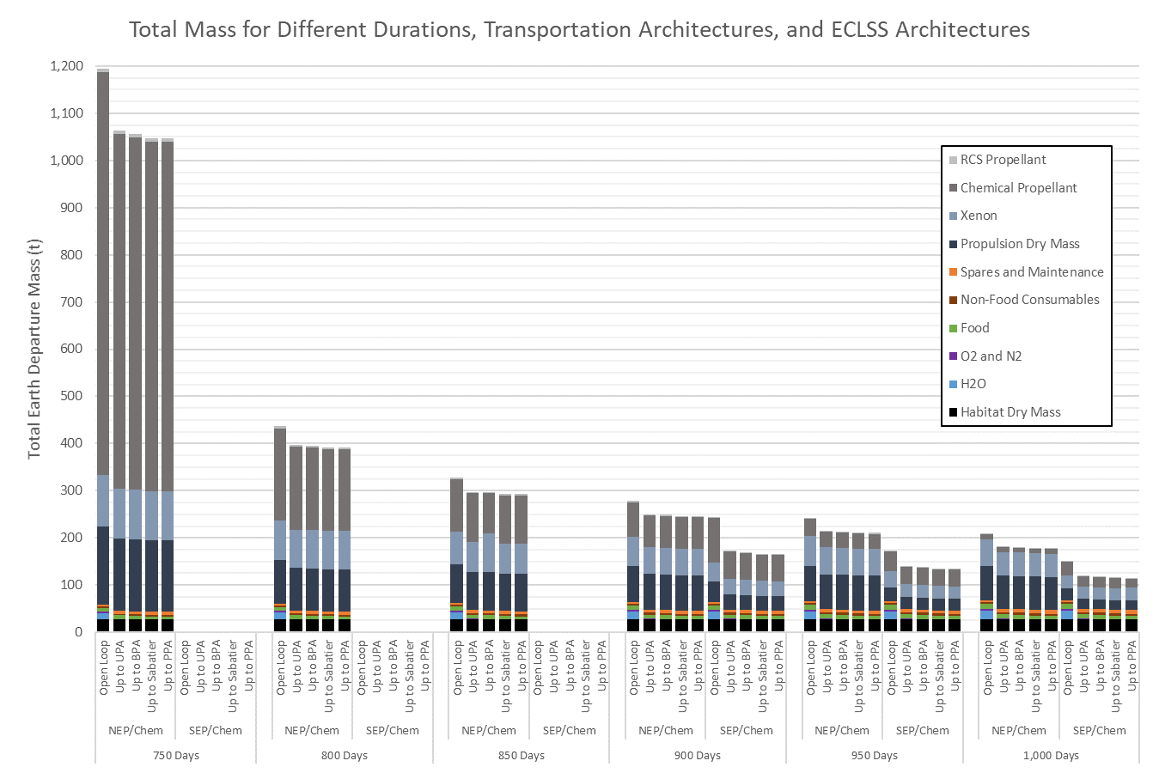
Figure 1: Total Earth departure mass as a function of mission duration, transportation architecture, and ECLSS architecture. Sections of the stacked bars for each case show contributions from major categories in habitat and transportation system mass. No results are presented for SEP/Chem options at $≤$850 d because no feasible trajectories were found for those cases.

In this trade study, food water content was reduced as necessary to take advantage of the mass reduction opportunities offered by higher loop closure technologies. As a result, in contrast to the results for a fixed level of food hydration [1], in this trade study each additional ECLSS technology provided additional mass reduction. While the additional mass reduction provided by higher levels of loop closure are small relative to the very large mass reduction enabled by the addition of OGA, WPA, and UPA, they still represent hundreds or thousands of kilograms of habitat mass reduction, and thousands of kilograms of total Earth departure mass reduction.
Overall, these results show the very large mass impacts that ECLSS architecture, transportation architecture, and mission duration decisions have on mass. Taken together, these decisions result in a change in Earth departure mass of more than 1,080 t—over a million kilograms. Put another way, the tradespace of options examined here covers an entire order of magnitude, from 114 t to 1,195 t.
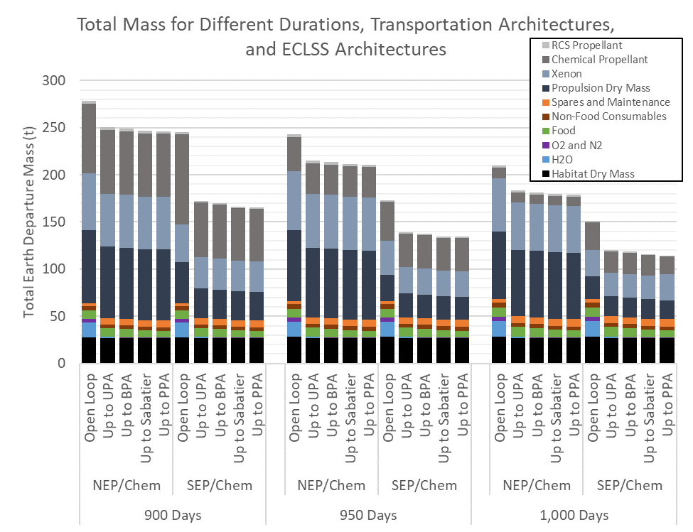
Figure 2: Zoomed-in view of total Earth departure mass as a function of mission duration, transportation system architecture, and ECLSS architecture, focusing on mission durations at or above 900 d. Stacked bars for each case show contributions from major categories in habitat and transportation system mass.

Cost Results
Launch costs were estimated for all cases, but, due to schedule limitations, development and production cost estimates were limited to the Open Loop and Up to PPA ECLSS cases for 900 d and 1,000 d missions. Future work will execute a more comprehensive cost evaluation and comparison. Figure 5 shows the percent change in launch cost for each case relative to a 1,000 d SEP/Chem mission using regenerative ECLSS up to PPA, which was the case with the lowest launch cost. As expected, the highest launch costs are associated with the missions with the highest mass—namely shorter duration missions with low levels of ECLSS loop closure. In many instances, however, additional levels of loop closure beyond the Up to UPA case do not result in further reduction in launch costs. This is due in part to the discrete nature of the launch cost model; if the reduction in mass between two cases is not sufficient to reduce the number of launches required to transport all required materials to orbit, the launch cost is the same. However, the range of results again highlights the importance of these decisions on mission planning. The launch costs associated with the most massive mission (Open Loop, NEP/Chem, 750 d) are over seven times higher than those associated with the lowest-mass mission (Up to PPA, SEP/Chem, 1,000 d).
Figure 6 shows the percent change in total cost, including habitat and transportation system development and procurement, for the Open Loop and Up to PPA cases at 900 d and 1,000 d using both transportation system architectures. Figure 7 shows more detail, indicating the percent changes in habitat, transportation system, and launch costs, as well as total costs, using the same format as Figure 5. These results show that increased loop closure—i.e. moving from an Open Loop system to a regenerative system up to PPA—leads to an approximately 16% increase in habitat cost for both mission durations. The habitat cost for 900 d is slightly lower than the cost for 1,000 d, primarily due to the fact that fewer spares are requried for the shorter mission, but the difference is less than half a percentage point. The NEP/Chem transportation system tends to be more expensive than the SEP/Chem system under the assumptions examined here, and transportation system cost is reduced by increasing ECLSS loop closure (which reduces the mass of the habitat that the transportation system must push) and moving to longer mission durations (which tends to reduce trajectory energy requirements). As described above, launch costs are also reduced by increasing ECLSS loop closure and moving to longer mission durations.
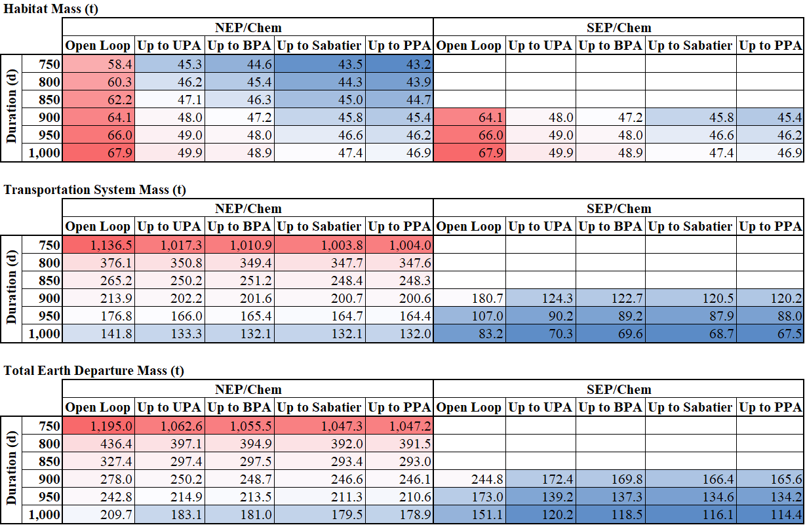
Figure 3: Habitat mass (top), transportation system mass (middle), and total mass (bottom). Color gradient represents relative values, with red indicating higher values and blue indicating lower values. No results are presented for SEP/Chem options at $≤$850 d because no feasible trajectories were found for those cases.
As shown in Figure 6, increased ECLSS loop closure has different effects on when different transportation systems are considered. For the NEP/Chem case, moving from Open Loop to the Up to PPA case at a given duration resulted in a net increase in total cost of a few percentage points. This indicates that, under the modeling assumptions used here, the transportation development/production cost savings and launch cost savings enabled by reduced logistics are outweighed by the cost of the increased ECLSS loop closure (from Open Loop to PPA) required to provide those logistics reductions. This result does not mean that increased loop closure should not be pursued at all. Previous analysis [1] has shown that local minima may exist in the range of ECLSS architecture options, where partial loop closure (e.g. Up to BPA or Up to Sabatier) provide lower total costs than the Open Loop case. Future work will perform a more comprehensive cost evaluation examining these intermediate points and how they are impacted by changes in mission duration and transportation architecture.
For the SEP/Chem case, moving from Open Loop to Up to PPA reduced total cost. At 1,000 d, the Open Loop ECLSS architecture resulted in a 3% increase in cost over the Up to PPA architecture. The 900 d Up to PPA case had 15% higher cost than the 1,000 day case with the same ECLSS architecture, while reducing duration to 900 d and switching to Open Loop ECLSS results in a 27% cost increase.
Cost modeling involves relatively high uncertianty compared to other engineering models, and in this analysis two different cost models (PRICE H and PCEC) were used to examine the SEP/Chem and NEP/Chem development costs. However, the results of those cost estimates are consistent with previous internal analyses. As with the mass modeling results shown in the previous section, these results indicate the high cost impacts of ECLSS architecture, transportation architecture, and duration decisions, even on the subset of options here. Even when only examining durations down to 900 d, changes in these variables results in a 96% cost increase—that is, mission cost is nearly doubled by a change in ECLSS architecture, transportation architecture, and a 100 day reduction in mission duration.
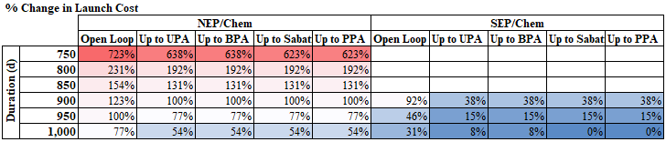
Figure 5: Percent change in launch cost, measured relative to the launch cost of the Up to PPA, SEP/Chem, 1,000 d case. Color gradient represents relative values, with red indicating higher values and blue indicating lower values. No results are presented for SEP/Chem options at $≤$850 d because no feasible trajectories were found for those cases.
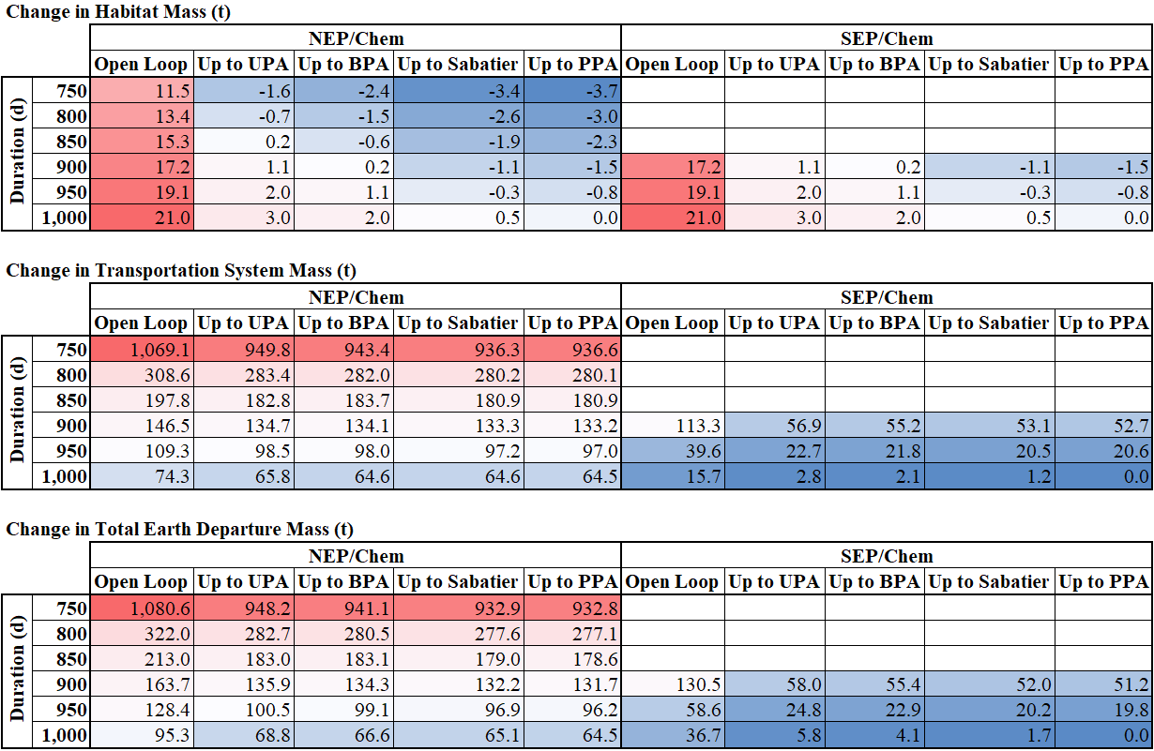
Figure 4: Change in habitat mass (top), transportation system mass (middle), and total mass (bottom) relative to the mass of the Up to PPA, SEP/Chem, 1,000 d case. Color gradient represents relative values, with red indicating higher values and blue indicating lower values. No results are presented for SEP/Chem options at $≤$850 d because no feasible trajectories were found for those cases.
- Discussion
Decisions related to ECLSS architecture, transportation architecture, and mission duration have a large impact on total mission mass and cost, and these impacts are coupled. In general, reductions in mission duration incur exponential increases in mass, and though the detailed cost analysis presented above only examined two duration points, the fact that cost estimating relationships are often driven by mass indicates that it is likely that the same holds true for cost. This result is not surprising, as Mars mission durations are driven by orbital mechanics, which lead to specific durations associated with local minima in transit energy requirements and high energy costs—and therefore mass and system costs—associated with moving away from those minima. Even though shorter Mars mission durations reduce habitat mass and cost, the larger transportation system mass and cost increases associated with these shorter durations tend to result in a net increase in mass and cost.
Under the assumptions examined here, NEP/Chem architectures tend to be more massive and more expensive than comparable SEP/Chem. However, NEP/Chem system are able to achieve shorter mission durations than SEP/Chem systems, and these capability differences should be considered when comparing mass and cost. In addition, the specific NEP/Chem and SEP/Chem power levels examined in this paper were tuned to short and long missions, respectively. Future work will examine variations in power levels and other factors in order to explore more details of transportation system architecture impacts in conjunction with other factors.
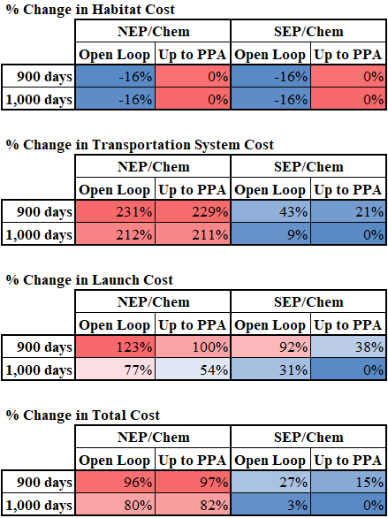
Figure 7: Percent change in habitat cost (top), transportation system cost (2nd from top, launch cost (2nd from bottom), and total cost (bottom). In all cases, changes are measured relative of the Up to PPA, SEP/Chem, 1,000 d case. Color gradient represents relative values, with red indicating higher values and blue indicating lower values.

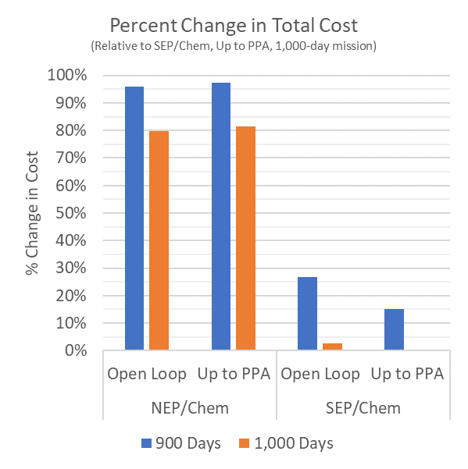
Figure 6: Percent change in cost for a subset of cases, all measured relative to the cost of a 1,000 d mission with SEP/Chem and ECLSS up to PPA.

Increased loop closure reduces habitat mass but results in increased habitat cost. Lower habitat mass reduces transportation system and launch cost. In some cases, the increase in habitat cost is larger than the decrease in other costs and results in a net cost increase, but in other cases the net effect is a reduction in cost—as has been shown before, system optimization based on mass and system optimization based on cost may result in different answers [1]. Future work will perform a more comprehensive cost analysis to characterize intermediate points between the two boundary cases (Open Loop and Up to PPA) examined here in order to identify local minima and provide a clearer view of trends. Increasing loop closure provides diminishing returns, but when food hydration levels are reduced each additional loop closure technology does continue to reduce mass.
One key factor that was not examined in detail in this analysis is risk, both in terms of mission risk and programmatic risk. All cases examined above assumed a POS of 0.99, and therefore have the same risk of insufficient spares (i.e. spares allocations are increased as needed to account for increased parts counts and system complexity). However, the operational complexity of a nuclear reactor vs. solar arrays, or of a high-loop-closure ECLSS vs. a simpler system, as well as the associated impact on probability of loss of crew or loss of mission, must also be considered. The complexity of system build-up on orbit should also be considered. Increased mass results in an increased number of launches, which increases cost as well as risk. Each additional launch increases the probability of loss of vehicle on launch, as well as increases the number of docking and transfer events required to execute the mission. At a certain point, the number of launches may increase to the point that it is more likely than not that at least one of those launches will fail, and as a result campaigns may need to plan to have spare mission elements and logistics to recover from a potential failure. In addition, while many of these technologies (e.g. OGA, WPA, and UPA) have already been developed and demonstrated on the International Space Station (ISS) for over a decade, some are new technologies that have not been demonstrated in a spaceflight environment. New technologies represent programmatic risk, in that they may not be developed within schedule and budget projections or their performance, mass, reliability, or other characteristics may be different than what was planned. The uncertainties surrounding new technology development are a key consideration during mission planning. The potential for increased mission or programmatic risk from new technologies is not, by itself, a reason not to pursue those new technologies—it is simply a factor to be considered in the decision process.
This analysis focused on the impacts of different decisions on a single mission. However, particularly for new technology development or new system design/development/testing, the value of some investment decisions may be applicable to multiple missions or a wider range of future activities. The “payback period” for investments in a new technology may span multiple missions or campaigns. Excluding a particular technology from a development plan because it does not provide immediate cost reductions in its first application may miss opportunities to achieve long-term cost reduction. In addition, new technologies may provide other benefits that are not captured in the mass and cost metrics evaluated above. A holistic view—both in terms of the decisions, factors, and metrics considered during the decision process as well as the overall scope of application cases being examined—will enable more informed decision-making than a siloed, short-term view.
Historical experience shows that space missions tend to seek mass reductions wherever they can be found, especially as launch deadlines approach. The realities of implementation often do not fully achieve the goals of conceptual planning. Unexpected interactions, details, or other factors may end up having different effects, with larger or smaller magnitudes than expected, that drive mass, performance, risk, cost, or other factors away from their planned levels. Launch vehicle or propulsion system capabilities may shrink and system and subsystem mass estimates may grow as system designs evolve and become more detailed. Flexibility is a valuable commodity. Even with recent reductions in the average launch cost per unit mass [12], mass remains a valuable and limited resource for human spaceflight missions, especially missions to Mars. This analysis showed very large mass reductions associated with moving from shorter to longer mission durations, as well as moving from Open Loop to basic water and oxygen recycling using OGA, WPA, and UPA (i.e. the Up to UPA ECLSS architecture). The mass reductions associated with higher levels of loop closure, for example, tend to be small in comparison. However, they still enable hundreds or thousands of kilograms of mass reduction and can enable cost reductions. Budget and schedule limitations dictate that programs typically cannot fully develop all of the technologies that may be under consideration. However, the value of flexibility should be considered as part of decision-making. It is always possible to fly a mission without including every technology that has been developed; it is not possible to fly a mission using technology that has not been developed.
Models are imperfect abstractions and incomplete representations of reality, but they are informative and valuable if developed and implemented properly and utilized with awareness of their limitations. Space mission design is a complex, multidisciplinary activity involving many coupled factors that sometimes interact in nonintuitive ways. Moreover, even when the specific trends or directionality of interactions are intuitive—such as increased duration and increased loop closure leading to lower total mass—models provide insights into the magnitudes of these relationships. In addition, system models can be expanded, adapted, and adjusted as new information becomes available or new questions are asked. There are no crystal balls, but integrated models such as the one described here enable informed decision-making via quantitative and qualitative assessments and sensitivity analysis.
- Conclusion and Future Work
ECLSS architecture, transportation system architecture, and mission duration are major decisions impacting crewed Mars mission mass and cost. This paper has presented the results of an examination of 45 combinations of these decisions in order to understand the relationships between various decisions and the trends and magnitudes of their impacts on mass and cost. These three decisions alone can have a very large impact on mass, with the extremes representing a difference of over a million kilograms of Earth departure mass, as well as on cost. These results again highlight the importance of metrics and an integrated view. The minimum-mass system is not always the minimum-cost system. In general, the various elements, systems, and subsystems required for human spaceflight should not be evaluated and optimized in isolation. Instead, they should be assessed as part of an integrated system.
As discussed above, this model currently examines a small subset of the full range of decisions and factors that would need to be considered to have a truly holistic view of a mission, and results here should not be considered final. Future work will expand the scope of the model to incorporate additional factors based on lessons learned during these analyses. More comprehensive cost modeling will be implemented, covering all of the cases examined in the mass analysis above. Expanded analysis will look at potential payback periods of different investments over a multi-mission campaign, rather than a single mission. In addition, variations in NEP and SEP power levels and their impacts on mission mass and cost will be examined. The risk implications of different decisions will also be examined in more detail. Iterative model development and analysis to identify and understand key trends and identify and implement model improvements based on those observations will lead to an improved understanding of the mission design challenge and enable more informed decisions.

References
[1] Owens, A., Jones, C. A., Cirillo, W., Klovstad, J., Judd, E., Chai, P., Merrill, R. G., Piontek, N., Stromgren, C., and Cho, J. Integrated Trajectory, Habitat, and Logistics Analysis and Trade Study for Human Mars Missions. Presented at the ASCEND 2020, Virtual Event, 2020. AIAA 2020-4034.
[2] Arney, D. C., Earle, K. D., Cirillo, W., Jones, C. A., Klovstad, J., Grande, M., and Stromgren, C. The Impact of Mission Duration on a Mars Orbital Mission. Presented at the AIAA SPACE and Astronautics Forum and Exposition, Orlando, FL, 2017. AIAA 2017-5284.
[3] Douglas, G. L., Johnson, M., and Broyan, J. Space Food System Water Content: Considerations for ECLSS Water System Closure. Presented at the 50th International Conference on Environmental Systems, 2021. ICES-2021-130.
[4] Ewert, M. K., and Stromgren, C. Astronaut Mass Balance for Long Duration Missions. Presented at the 49th International Conference on Environmental Systems, Boston, MA, 2019. ICES-2019-126.
[5] Owens, A. Multiobjective Optimization of Crewed Spacecraft Supportability Strategies. Doctoral Thesis. Massachusetts Institute of Technology, Cambridge, MA, 2019.
[6] Owens, A., Cirillo, W. M., Piontek, N., Stromgren, C., and Cho, J. Analysis and Optimization of Test Plans for Advanced Exploration Systems Reliability and Supportability. Presented at the 50th International Conference on Environmental Systems, 2021. ICES-2021-199.
[7] Chai, P., Qu, M., Merrill, R. G., and Pfrang, K. G. Hybrid Transportation System Integrated Trajectory Design and Optimization for Mars Landing Site Accessibility. Presented at the AIAA Propulsion and Energy 2019 Forum, Indianapolis, IN, 2019. AIAA 2019-3961.
[8] Chai, P., Qu, M., and Saputra, B. Human Mars Mission In-Space Transportation Sensitivity for Nuclear Electric / Chemical Hybrid Propulsion. Presented at the AIAA Propulsion and Energy 2021 Forum, VIRTUAL EVENT, 2021. AIAA 2021-3237.
[9] Chai, P., McBrayer, K. T., McCrea, A. C., Merrill, R. G., Prasad, A., and Qu, M. Crewed Mars Mission Mode Options for Nuclear Electric/Chemical Hybrid Transportation Systems. Presented at the ASCEND 2021, 2021. Submitted for publication.
[10] Meisl, C. J. Cost Estimating Relationships for Nuclear Power and Propulsion. Publication NAS3-25808. Rockwell International Corporation, Rocketdyne Division, Cleveland, OH, 1992.
[11] Jones, C. A., Clark, M., Pensado, A., Ivanco, M. L., Reeves, D., Judd, E., and Klovstad, J. Cost Breakeven Analysis of Lunar ISRU for Human Lunar Surface Architectures. Presented at the 70th International Astronautical Congress, Washington, DC, 2019. IAC-19-D4.5.15.
[12] Grande, M. L., Carrier, M., Cirillo, W., Earle, K. D., Jones, C. A., Judd, E., Klovstad, J. J., Owens, A. C., Reeves, D., and Stafford, M. Mega-Drivers to Inform NASA Space Technology Strategic Planning. Presented at the 2018 AIAA SPACE and Astronautics Forum and Exposition, Orlando, FL, 2018. AIAA 2018-5137.

Aerospace Engineer, Space Mission Analysis Branch, 1 N. Dryden St. MS 462, AIAA Member
Senior Researcher, Space Mission Analysis Branch, 1 N. Dryden St. MS 462
Aerospace Engineer, 77 S. Washington St., AIAA Member
Vice President / Chief Scientist, 77 S. Washington St., AIAA Member

