Protecting Crew and Surface Systems with a Long-Duration Lunar Safe Haven
Melanie L. Grande, Robert W. Moses, and Patrick A. Cosgrove
NASA Langley Research Center, Hampton, VA 23681, USA
Robert P. Mueller
NASA Kennedy Space Center, FL, 32899, USA
Tracie J. Prater, Alex Blanchard
NASA Marshall Space Flight Center, Huntsville, AL 35808, USA
NASA’s Artemis program will send astronauts to the lunar surface for extended mission durations throughout the 2030s, with a focus on sustainability and extensibility for Mars exploration. However, NASA must place more emphasis on protecting both the crew and the exploration surface systems if they hope to achieve long-duration sustainability on the lunar surface. It is now reasonable with excavation, construction, and autonomy technologies to achieve a significant level of protection that was not viable with architectures to date. The Lunar Safe Haven (LSH) was proposed to protect astronauts, electronics, and other surface exploration systems from the hazards of the lunar environment, including radiation, micrometeoroid strikes, lunar dust, thermal extremes, and vacuum. During the study, Level Zero Requirements were developed for the LSH, and a decision analysis framework was baselined to evaluate concepts. The LSH Study also performed a comprehensive trade study, during which numerous alternatives for establishing and maintaining a safe haven shelter on the lunar surface were identified. This paper reviews the products developed during the study and presents the final recommendations.
- Nomenclature
ABC = Artemis Base Camp
A-PUFFER = Autonomous Pop-Up Flat Folding Explorer Robot
ARMADAS = Automated Reconfigurable Mission Adaptive Digital Assembly Systems
LANCE = Lunar Attachment Node for Excavation
LDRS = Location Determination Reference System
LIDAR = Light Detection and Ranging
LSH = Lunar Safe Haven
LSMS = Lightweight Surface Manipulation System
MMPACT = Moon to Mars Planetary Autonomous Construction Technologies
RASSOR = Regolith Advanced Surface Systems Operations Robot
SLAM = Simultaneous Localization and Mapping
STMD = Space Technology Mission Directorate
TRL = Technology Readiness Level
WS = Whipple Shield
VSAT = Vertical Solar Array Technologies
- Introduction
NASA’s Artemis program will send astronauts to the lunar surface for extended mission durations throughout the 2030s, with a focus on sustainability and extensibility for Mars exploration, as described in NASA’s “Artemis Plan” [1]. However, NASA must place more emphasis on protecting both the crew and the exploration surface systems if they hope to achieve long-duration sustainability. For example, NASA’s current habitation development does not go far enough to protect astronauts from background radiation, especially if the crew is simulating longer mission durations in preparation for Mars [2]. Development of a “safe haven” shelter on the surface is therefore paramount to continuously protect Artemis astronauts and exploration systems from radiation and other hazards of the lunar environment. This “safe haven” need not be pressurized, but it must provide adequate protection for the crew and systems during long-duration crewed surface missions.
The proposed Lunar Safe Haven (LSH) is a game changing concept that can protect crew and equipment for long durations on the Moon by repositioning abundant regolith resources using lunar surface equipment and construction techniques that are well understood on Earth. The LSH is proposed for Artemis lunar exploration but is also extensible for Mars. It is known through past analyses of radiation shielding materials that regolith offers excellent shielding properties at thicknesses of 3 to 7 m, reducing the radiation dose that astronauts and equipment would receive while on the lunar or Martian surfaces [2]. Additionally, such regolith protective layers would provide ample shielding from micrometeorite strikes. For crew safety, this could be an extremely valuable approach for sustained lunar operations. For equipment, this shielding could extend the lifetime and reduce radiation-hardening/tolerance and thermal control requirements. Such shielding would not be possible without using in situ regolith since costs and other constraints would otherwise be prohibitive. Past studies suggested completely burying habitats in regolith; however, the LSH presents an alternative: completely covering the habitats but not exposing the habitat skin itself to regolith. Instead, a structure would be built around and over the habitat, and regolith would be piled around and on top (see Figure 5). This removes the potential challenge of exposing the habitat materials to regolith and also preserves access to the external structures of the habitat in case maintenance is needed. Furthermore, the LSH concept takes advantage of significant, recent advancements in surface excavation, construction, assembly, and autonomy technologies. The LSH concept is therefore game-changing because it is able to achieve substantial protection for crew and equipment at a level that has not been viable with architectures to date.
The LSH Seedling Study was a one-year effort funded by the NASA Space Technology Mission Directorate (STMD) Game Changing Developments (GCD) program to perform a comprehensive trade study for identifying the best approaches for implementing an LSH shelter. The LSH Study team examined NASA activities in site preparation, excavation, surface construction, assembly, surface mobility, autonomy, advanced manufacturing, and in situ resource utilization (ISRU). The study defined high-level requirements, which emphasize synergy with NASA’s “Artemis Plan” [1]. Guided by these Level Zero Requirements, the study then baselined a decision analysis framework. The study identified numerous concept alternatives for the LSH shelter, establishment systems, and maintenance systems. The concept alternatives were evaluated using decision attributes to inform the down-select and ultimately provide a consensus on the recommendation for designing, establishing, and maintaining a safe haven shelter. Additionally, initial recommendations on development pathways are offered for further maturing, demonstrating, and validating the necessary LSH systems.
- Level Zero Requirements
The Level Zero Requirements were the first focus of the LSH Study. They were developed to be synergistic with the “Artemis Plan,” NASA Human Exploration and Operations Mission Directorate (HEOMD) ground rules and assumptions for future lunar exploration, and known lunar surface hazards. Based on the priorities of the study stakeholders, they were also developed to place an emphasis on ISRU. These requirements were the first step to bound the trade space. They include:

- The Lunar Safe Haven (LSH) shall shield crew, electronics (such as computers providing command and control of autonomous systems), and other exploration and habitation systems that require radiation shielding as defined by HEOMD for at least 10 years without exceeding the proxy dose limits for crew and electronics.
- The LSH shall protect crew, electronics, and other exploration and habitation systems that require protection as defined by HEOMD from the hazards of the lunar environment—including but not limited to micrometeoroid impacts, thermal loads, seismic activity, electrical charging, dust, vacuum, and the sun—for at least 10 years.
- The LSH shall protect crew, electronics, and other exploration and habitation systems that require protection as defined by HEOMD from the impacts and damage from other external assets that could cause collisions or ejecta for at least 10 years.
- The LSH shall not negatively impact the crew performance, habitability, and safety requirements derived from NASA-3001 for crew—as defined in Human Systems Integration (HIS) requirements documents of the lunar exploration systems to be used by HEOMD—and for proximal Extravehicular Activity (EVA).
- The LSH shall not negatively impact functionality nor negatively impact deployment and placement of heritage exploration habitation systems selected by HEOMD that require protection and shielding.
- The LSH shall utilize in situ re-sources- including both natural and repurposed resources.
- The LSH shall identify and define the surface equipment concepts necessary to emplace, assemble, and/or construct the safe haven shelter.
- The technologies included in the LSH concept shall be ready to be deployed and operational on the lunar surface by 2026 (TBR), according to HEOMD.
- The LSH shall be compatible with NASA's lunar lander systems to be selected by HEOMD.
- Functional Decomposition
The next step was to complete a functional decomposition of the LSH concept that responds to the Level Zero Requirements. A functional decomposition describes the functions that systems in the concept are responsible for performing, within the scope of the study. The list is separated by the three LSH system groups—physical shelter, establishment systems, and maintenance systems—and includes functions that must be performed by the LSH systems and functions that might be performed, depending on the concept design. Here, there is a spectrum of options for emplacement, deployment, assembly, construction, and manufacturing. A Class I structure would be emplaced on the surface after being fully assembled on Earth. Class II and Class III structures require increasing levels of assembly and construction [3]. The LSH trade space can encompass any of these three levels of classification. It is important to note that the functions listed are not written as requirements, but they strongly suggest that system-level requirements should be written for a given concept in response to the Level Zero Requirements.

Physical Shelter
The functions of the LSH shelter must be to:
- Store the crew and some amount of electronics and other exploration and habitation systems, including:
  - Allow shipping and receiving (in and out)
- Protect from radiation for at least 10 years without exceeding the proxy dose limits for crew and electronics, including: [Mapped to L-0 Req. 1]
  - Protection of crew
  - Protection of some amount of electronics and other exploration systems
- Protect from the hazards of the lunar environment—including but not limited to micrometeoroid impacts, thermal loads, seismic activity, electrical charging, dust, vacuum, and sunlight—for at least 10 years, including: [Mapped to L-0 Req. 2]
  - Protection of crew
  - Protection of some amount of electronics and other exploration systems
- Protect from the impacts and damage from other external assets that could cause collisions or ejecta for at least 10 years, including: [Mapped to L-0 Req. 3]
  - Protection of crew
  - Protection of some amount of electronics and other exploration systems

In addition, options for the shelter might include:
- Provide a protected area for servicing systems
- Manage/remove lunar dust within (or under the footprint of) the shelter, including:
  - Coarsely remove dust
  - Finely remove dust

Establishment Systems
According to Level Zero Requirement 7, the LSH shall identify the concepts needed to emplace, assemble, and/or construct the LSH shelter on the lunar surface. However, there is a trade space of possible alternatives for emplacement, assembly, construction, and/or manufacturing. Collectively, the systems that were identified in this trade space are known as the “LSH establishment systems”. These establishment systems will generally perform different specific functions to satisfy the Level Zero Requirement, so the study’s functional decomposition includes a range of possible functions. Therefore, the list below represents functions of the establishment systems that might be included to satisfy Level Zero Requirement 7.

The functions of the LSH establishment systems might be to:
- Transport LSH systems from lander off-loading site to the establishment site
- Deploy Location Determination Reference Systems
  - Reverse-Ephemeris Satellite Suite
  - Ground Beacons
- Survey the installment location
  - Image and characterize the site (topography, geology)
  - Perform resource assessment, mapping, and analysis
  - Identify mining locations
  - Identify shelter location
- Prepare the site for installment of the LSH shelter, including:
  - Remove rocks
  - Grade (level) the site
    - Excavate high areas (and trench for subsurface structures)
    - Dump regolith in depressions to create a level site and rough grade at the site
  - Rough compact the site and stabilize the surface of the compacted area
  - Verify compaction and grading
  - Transfer bulk regolith
  - Stockpile construction feedstock
- Emplace, assemble, and/or construct the LSH shelter, including:
  - Transport LSH shelter components from landing site to construction site
  - Deploy LSH systems/components
  - Process construction materials
  - Construct/assemble shelter foundation
  - Construct/assemble shelter structural elements
  - Construct/assemble shelter walls or other shielding material
  - Deploy/place service cables where needed, such as through walls with length available both “inside” (underneath/in shadow of) and “outside” of the final shelter footprint
  - Install equipment and connect (external) services (e.g., power, communications, etc.)
- Receive distributed power from the Artemis Base Camp (ABC) surface power source, OR generate power independently, including:
  - Connect to and accept power from the surface power source
  - Do power conditioning appropriate for a given system
  - Distribute the received power to LSH systems
- Communicate and provide sufficient command and data handling with other surface systems, including:
  - Send and receive data to/from LSH and other ABC systems on the lunar surface
  - Manage algorithms for autonomy
  - Distribute commands among agents
  - Connect to and accept internet from the ABC elements
- Manage/remove lunar dust for individual LSH systems (not ABC systems inside the shelter), including:
  - Coarsely remove dust
  - Finely remove dust
- Manage thermal control for individual LSH systems (not ABC systems inside the shelter)

Maintenance Systems
According to Level Zero Requirements 1-3, the LSH shelter shall operate for at least 10 years. However, there is a trade space of possible alternatives for maintaining successful operation over a long duration. Collectively, the systems that were identified in this trade space are known as the “LSH maintenance systems”. These maintenance systems will generally perform different specific functions to satisfy the Level Zero Requirements, so the study’s functional decomposition includes a range of possible functions. Therefore, the list below represents the functions of the maintenance systems that might be included to satisfy the Level Zero Requirements 1-3.

The functions of the LSH maintenance systems might be to:
- Maintain successful operation of the LSH, including:
  - Identify and respond to anomalies during the establishment of the shelter
  - Inspect and verify that the establishment of the shelter has completed successfully, and confirm operational readiness
  - Provide continuous health monitoring and fault identification the LSH operations
  - Provide appropriate audits to verify operational readiness during LSH operations
  - Identify and respond to anomalies during operations lasting up to 10 years
  - Perform maintenance and repairs of LSH systems
  - Support tool changes during repairs and operations
- Manage waste and trash, including waste from construction, maintenance, and operations (i.e., logistics wrappers and general trash).
- Monitor the lunar environment to provide information on space weather conditions, radiation, seismic activity, and other conditions relevant to protection of crew and surface systems.
- Receive distributed power from the Artemis surface power source
  - Connect to and accept power from the surface power source
  - Do power conditioning appropriate for a given system
  - Distribute the received power to LSH systems
- Communicate and provide sufficient command and data handling with other surface systems, including:
  - Manage algorithms for autonomy
  - Distribute commands among agents
  - Send and receive data to/from LSH and other ABC systems
  - Connect to and accept internet from the ABC elements
- Manage/remove lunar dust for individual LSH systems (not ABC systems inside the shelter), including:
  - Coarsely remove dust
  - Finely remove dust
- Manage thermal control for individual LSH systems (not ABC systems inside the shelter)
- Concept Generation
A main product of the LSH study was an extensive trade tree of possible alternatives in the areas of physical shelter design, establishment systems, and maintenance systems. The functional decomposition was a key product outlining the scope of the concept generation activities to create this trade tree. The team participated in multiple rounds of brainstorming sessions to begin the concept generation process. Next, the alternatives were pared down, and eventually, a list of complete LSH concepts was selected for further design and evaluation. Section V.A describes the concept generation methodology, while Section V.B presents the alternatives in the broad LSH trade space. Section V.C presents a summary of the selected LSH concepts that were evaluated.

Methodology
The concept generation methodology for the LSH study was based on the use of a morphological matrix, but there are two variations of this matrix to consider. In a morphological matrix based on a functional decomposition, the rows each contain a function, and the columns each contain an alternative means to achieve the function [4]. This type of matrix was used to enumerate alternatives for both the LSH establishment and maintenance systems. The functions from the previous functional decomposition activity were used in this step. However, if a functional decomposition does not work well for the system in question, it is because it is more accurately defined using a set of physical design parameters. In a variation of the morphological matrix based on the physical architecture, the rows each contain a physical parameter, and the columns each contain an alternative setting for that parameter [4]. This type of matrix was used to enumerate alternatives for the LSH physical shelter. Using a morphological matrix, a complete design would include at least one alternative from every row. Alternatives can be mixed and matched from each column to create different designs. For the LSH, a complete concept design includes at least one alternative from every row in all three of the matrices for the physical shelter, establishment systems, and maintenance systems.
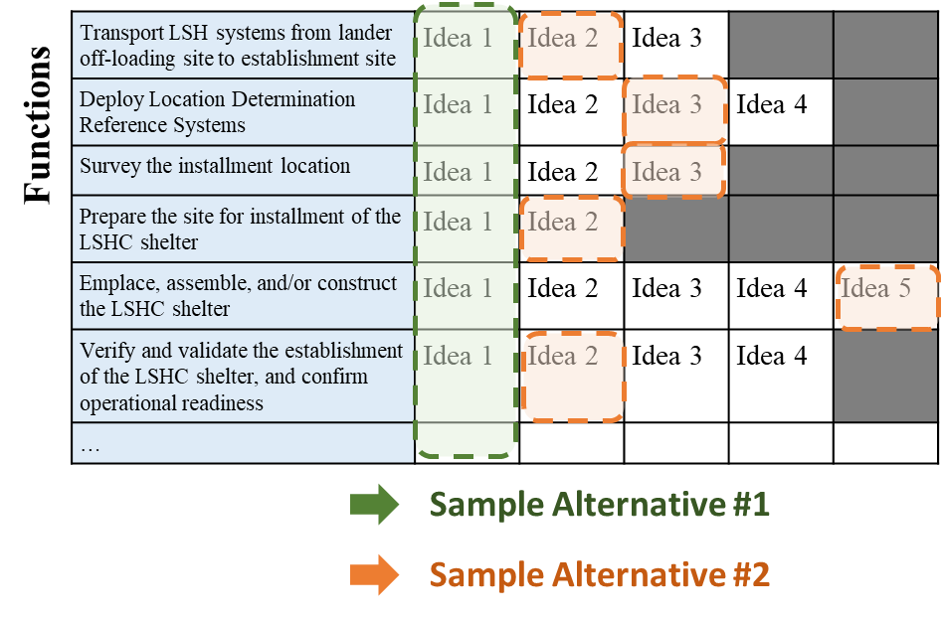
Figure 1. Sample LSH morphological matrix using functional decomposition. Two sample, complete concept alternatives are shown using mix and matched alternatives from each row.
The team went through multiple rounds of concept generation, beginning with several sessions of brainstorming. After brainstorming, the alternatives were reduced because the trade space was so broad that a full factorial set of combinations from the matrices would have resulted in billions of possible LSH concepts. Due to the limited duration of the LSH study, a small subset of concepts had to be selected for further consideration. This required the lists of alternatives to be pared down. A set of common features across all concepts were identified to further reduce the options, and ultimately, a more limited number of concept combinations was identified.

Generated Alternatives
As previously stated, the LSH trade space encompasses the design of a protective shelter and also the site preparation, excavation, construction, assembly, and maintenance systems to establish a sustainable shelter on the lunar surface. The several rounds of brainstorming by the team resulted in a very large number of alternatives. A representative look at the alternatives is presented in Figure 2–4.
A list of common features was identified to further reduce the alternatives for evaluation, and these features would be set constant across all the LSH concepts. These common features included:
Physical Shelter:
- Shelter Shape: Level with grade; single story; 2 ingress/egress points
- Dust Mitigation: “Mudroom” antechamber should incorporate dust mitigation techniques such as piezoelectric, plasma lofting, or an electrostatic dust shield
- Thermal Control: Thick layer of regolith shielding causes more controlled thermal environment. Sunshades can also be added to ingress/egress points (doorways).

Establishment Systems:
- Site Survey: CLPS missions and orbiting satellites should be leveraged to perform site surveying ahead of LSH mission
- Resource Mapping: Data should be transferred back to Earth for science team assessment of resource availability and site selections. Additional resource mapping—such as soil sampling—is possible via CLPS missions prior to LSH mission.
- Site Preparation: Small rovers can be used for soil analysis, resource assessment, and site mapping
- Verification of establishment operations: sensors and imaging equipment should be built into the establishment systems; combination of autonomy and human input to complete verification

Maintenance Systems:
- Maintenance operations: LSH maintenance will be performed mostly using autonomous robotics, which will continuously monitor operations, identify faults/degradations, and perform necessary repairs to maintain operational readiness of the shelter
- Environmental monitoring: On the lunar surface in/on/near the LSH shelter, a suite of sensors forms a consolidated environmental monitoring station, including: mass spectrometer, seismometer, radiation monitors, and an instrument to monitor dust accumulation.

Miscellaneous:
- Surface Guidance & Navigation: combination of ground beacons (active markers), fiducials (passive markers), on-board sensors, and satellites (not explicitly part of LSH concept) would combine to provide guidance and navigation
  - Ground beacons and fiducials must be placed during LSH site preparation operations
- Power: LSH systems must drive to and connect to the ABC surface power source, such as via wireless charging. LSH systems must also be designed with sufficient onboard power storage to complete appropriate tasks around the LSH site.
- Communication: There will be network communication connected to the ABC, and all LSH systems will have surface-to-surface communication capability and appropriate communication protocols for autonomous robotics
- Thermal control: LSH systems should use a combination of active and passive thermal control, such as heaters, radiators, and MLI

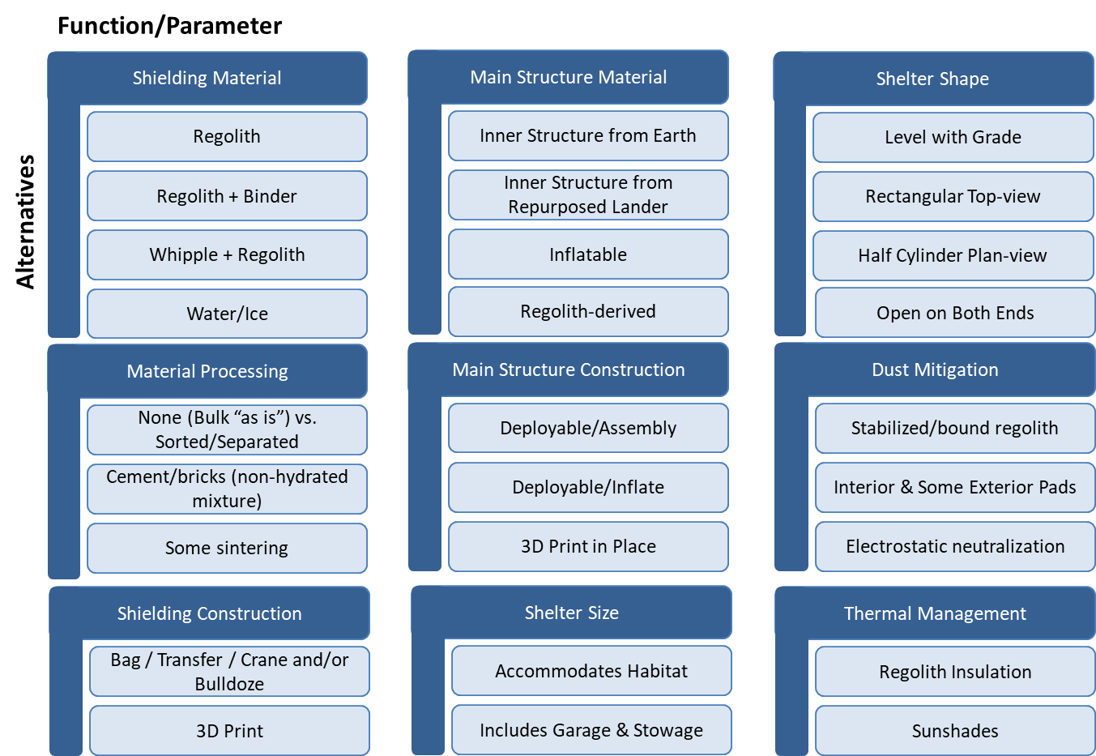
Figure 2. Trade tree for physical shelter design. Note: initial reduction in alternatives was already performed by team.
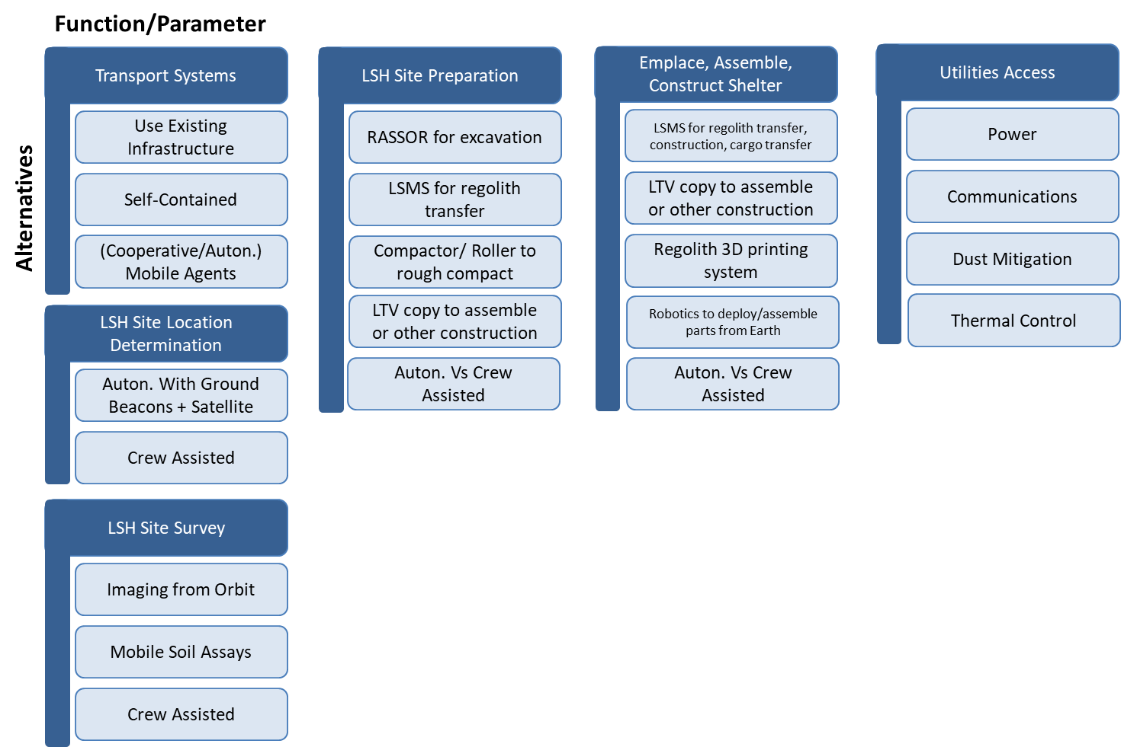
Figure 3. Trade tree for establishment systems. Note: initial reduction in alternatives was already performed by team.

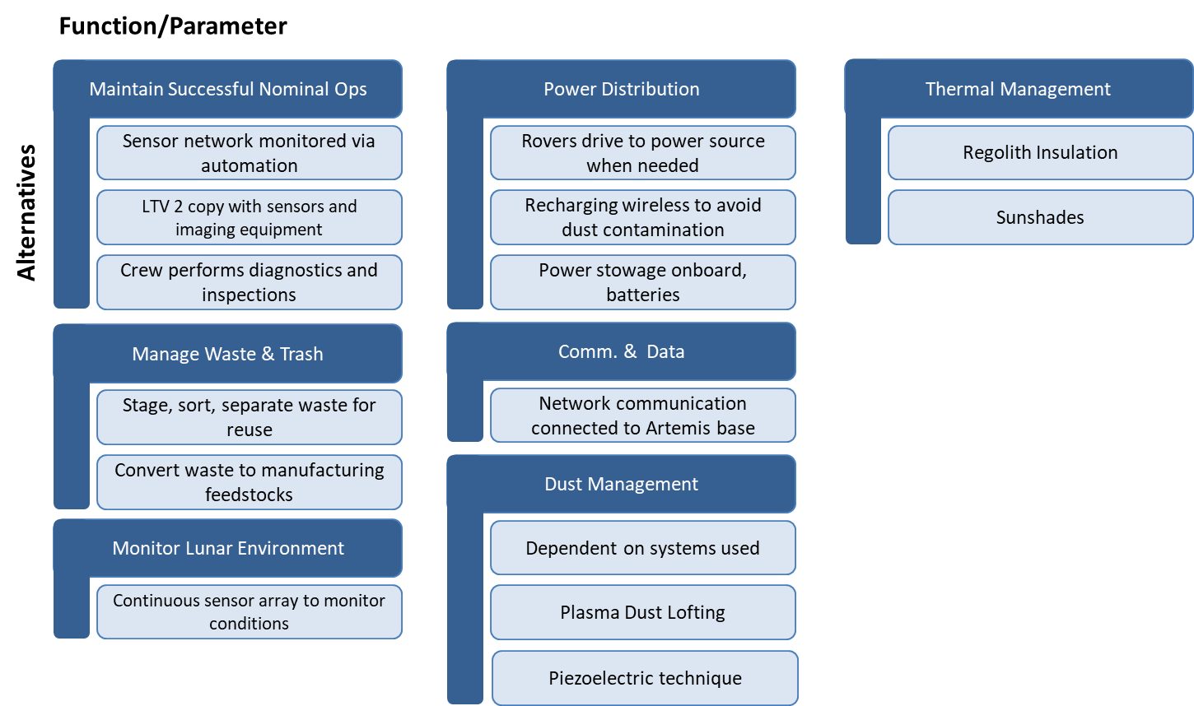
Figure 4. Trade tree for maintenance systems. Note: initial reduction in alternatives was already performed by team.

Summary of Concept Alternatives
The team generated and moved forward with 15 concepts to design in more detail. One of these concepts was the Baseline, which was created as an example solution that reasonably responds to the highest-priority stakeholder objectives. This Baseline is meant to serve as a basis for comparison against other concept alternatives. For every other concept, only one key aspect was adjusted from the Baseline. This allowed the team to highlight the impact of certain changes to the Baseline when evaluating decision attributes. This method allowed the team to group concepts into subsets, including: shelter structure and construction method alternatives, shelter size and dimensions alternatives, establishment systems alternatives, and maintenance and autonomy alternatives. The following subsections will summarize each subset of the 15 selected concepts.

Baseline Concept 1.1A
The physical shelter of Concept 1.1A is based on two key aspects: a simple metallic structure which is delivered to the lunar surface, and bulk regolith as overburden to provide radiation and micrometeorite protection. The delivered structure can be deployed and/or assembled on the lunar surface after being unloaded from the lunar lander and transported to the LSH site at Artemis Base Camp, such as via the Lightweight Surface Manipulation System (LSMS) crane [5] on a mobility platform. The structure could be a parabolic dome in compression, as seen in the cut-away view in Figure 5. There are various options for how to assemble this metallic structure and how to cover it so that regolith can be piled on top. For example, a flexible material could be delivered to the surface and stretched over the metallic structure.
Regolith is a readily available resource on the lunar surface and can be used to pile onto the shelter for effective protection from radiation, micrometeoroids, and thermal extremes. Regolith does not require any processing to be effective, as past studies have shown [2]. Based on the results of the environmental effects modeling by Moses et al. and replicated by the LSH team, the LSH threshold for the protective regolith layer was 3 m and the goal was 7 m. Utilizing regolith as a protection material greatly reduces the delivery mass to surface needed. A final consideration is that although high hydrogen-content materials like polyethylene or water are more effective shielding materials per mass, they are less dense than lunar regolith and would require a thicker shielding layer for the same level of protection. Based on this study’s stakeholder objectives, regolith is therefore the best possible choice for radiation shielding.
To pile this large amount of regolith and at the necessary height, the natural angle of repose of lunar regolith must be considered, which the team determined to be approximately 55 degrees [6]. The angle of repose results in a large footprint and a variance of thickness from the bottom to the top of the structure. Another consideration is the maximum ground slope tolerance of any establishment systems that might be transporting regolith, such as the Lunar Attachment Node for Construction and Excavation (LANCE) bulldozer [8]. Therefore, it might be necessary to stabilize the loose regolith with additional material such as geo-mats, which are erosion control netting made from a material such as high-density polyethylene. This would decrease the overall footprint, allowing the outer regolith layer to be built more vertically than could be achieved if the regolith was allowed to assume its natural angle of repose. These solutions are not shown in Figure 5, and indeed the concept rendering may show a higher angle of regolith than can actually be achieved, but such solutions should be considered further in future work.

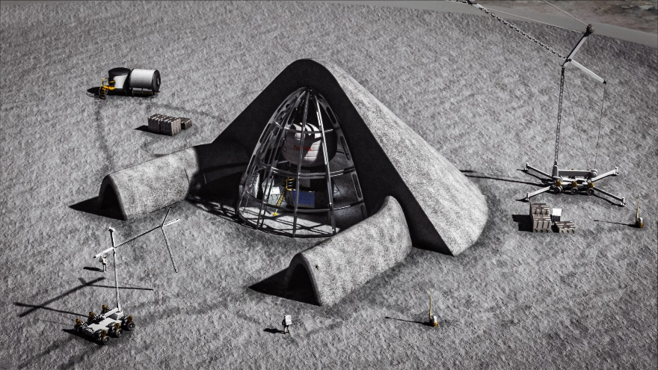
Figure 5. Artist’s rendition of LSH Baseline Concept 1.1A: Metallic structure with regolith overburden to protect surface habitat – Cutaway view. Structure shown is notional and for illustration purposes.
The LSH establishment systems are responsible for site mapping, site preparation, excavation, assembly, construction, and mobility functions. Before beginning establishment of any surface systems, preliminary surveying must be completed, and this could be accomplished with a combination of satellite observation for coarse surveying and surface rovers for finer details. Further resource and construction site mapping could be accomplished by a fleet of small, lightweight rovers equipped with cameras, Light Detection and Ranging (LiDAR), and ground-penetrating radar. These rovers could function semi-autonomously, conducting detailed sweeps of regions of interest identified by human operators.
After selecting a site based on results from these surveys, the immediate next step would be to install a Location Determination Reference System (LDRS). An LDRS enables guidance and navigation on the surface, and in the LSH Baseline concept, the LDRS would include a combination of fiducials and beacons mounted on deployable towers. In particular, autonomous and semi-autonomous agents require the LDRS to function reliably. Because the Baseline is designed to use semi-autonomous agents for establishment and maintenance, it is important to deploy the LDRS as early as possible. One of the larger construction systems could be used to install the LDRS, such as the LSMS if attached to a mobile platform. One option for the mobile platform is the Chariot chassis, which has already been developed and demonstrated by NASA and which is able to support a variety of attachments, tools, and cargo [7].
Finally, with the LDRS available for use, the remaining assembly and construction agents can be used:
- Regolith Advanced Surface Systems Operations Robot (RASSOR): Capable of moving regolith and small rocks around [9]
- LANCE: A bulldozer blade attachment to Chariot, used for pushing large amounts of regolith [8]
- A compactor, possibly also attached to Chariot, for stabilizing the ground (Note: a compactor for the lunar surface does not exist to date and would require a new development effort)
- LSMS on Chariot: The same vehicle used for LDRS installation can also be used to move rocks too large for LANCE or RASSOR
These systems would all work in tandem to remove rocks and loose regolith and to compact and stabilize the ground at the construction site. In addition to preparing the area that will be used for the shelter itself, they could also prepare roads around the construction site. Once site preparation is complete, these same systems move on to deployment, construction, and/or assembly tasks for the shelter, such as:
- LSMS on Chariot could lift truss segments into place
- A fleet of smaller, mobile robots would perform assembly tasks such as attaching truss segments and would also inspect progress in real-time. For example, NASA’s Automated Reconfigurable Mission Adaptive Digital Assembly Systems (ARMADAS) [10] or Autonomous Pop-Up Flat Folding Explorer Robot (A-PUFFER) [11]
- RASSOR, LANCE, and LSMS could work together to pile up regolith shielding material
The Baseline concept uses semi-autonomous agents at all stages. Operators give high-level commands, and the agents are then capable of autonomously performing the necessary low-level tasks, like navigation, path planning, and determining the status of the current task. In some situations, human operators would step in to provide manual tele-operation, but this should only happen in unexpected circumstances, like loss of LDRS. The benefit of this system is that it reduces the workload for operators, while simultaneously providing greater situational awareness. Additionally, it demonstrates and validates autonomy for future Mars missions where increased latency means autonomy is the only feasible option for establishing infrastructure for crewed missions.
Once the LSH has been established, routine maintenance would need to be performed. There is a variety of equipment options that can be used to perform this maintenance. Of the options, the equipment may either be semi-autonomous, fully autonomous, or human-operated, but the Baseline focuses on semi-autonomous systems. The use of embedded sensors or inspection robots can be used for monitoring the health of the LSH. A small inspection robot, such as those developed by NASA’s A-PUFFER project can be used to perform audits and system analysis to identify faults and anomalies of the LSH [11].
Table 1 gives a rough estimate of the mass for each of the establishment systems as well as maintenance systems. For most concepts other than the baseline, the same elements would be present with exceptions noted in each subsequent section. The rows highlighted in yellow represent the elements unique to this specific concept. At the time of this report, an estimate for the metallic truss structure was not available, though this is a critical piece of the total mass delivery required to the lunar surface. Future work is required to improve the mass estimate for the structure as well as the other systems.
Estimating the power required to excavate and pile up regolith using these systems was beyond the scope of this study but is identified as a key aspect of feasibility for future work. It is known from other studies that excavation and regolith dumping functions have a reasonably low power requirement, generally less than 200 W [12]. Piling up loose regolith and even compacting it in place require significantly less power than other concepts like filling sandbags or sintering. There are several power generation technologies that have a high Technology Readiness Level (TRL) which could be employed on the lunar surface at the Artemis Base Camp. Surface power generation technologies—e.g., Vertical Solar Array Technologies (VSAT) [13]—should be evaluated to determine if they can provide sufficient resources for the excavation and construction operations and if they are at a sufficient TRL for inclusion in near-term surface operations. The autonomous positioning of a solar tower on the surface is low TRL and should be studied further.
Table 1. Notional mass and TRL estimates for the establishment and maintenance systems of Baseline Concept 1.1A. Does not include certain out-of-scope systems such as power generation or cargo off-loading.
System | Quantity | Notional Mass Estimate (kg) | Current TRL  Estimate - Hardware | Current TRL  Estimate - Software
LSMS | 1 | 650 (Estimated) | 4-5 | 3
RASSOR | 1 | 66 [7] | 6 | 3
LANCE (Attachment) | 1 | 160 [8] | 6 | 3
Compactor (Attachment) | 1 | 400 (Estimated) | 6 | 3
Chariot Chassis | 2 | 1,000 [7] | 6 | 3
Survey Rover (e.g., A-PUFFER) | 3 | 15 (Estimated) | 4-5 | 3-4
Command + Monitoring Suite | 1 | 50 (Estimated) | 8 | 3-4
Deployable LDRS Truss | 4-6 | 20 (Estimated) | 5-6 | 3-4
Truss assembly robot (e.g., ARMADAS) | 5 | 12 (Estimated) | 4-5 | 3-4
Metallic truss structure | 1 | TBD | High | n/a
Geo-mat material | 1 | TBD | High | n/a

Concept Alternatives 1.1B-2.4: Shelter Structure and Construction Method Alternatives
In Concept Alternatives 1.1-2.4, the shelter structure and construction methods were varied. Concept 1.1B was a variation to the Baseline but eschewed the concept of a regolith dome in favor of a cylinder. The inner support structure—delivered from Earth similarly to the Baseline—would be constructed of a cylinder-shaped frame surrounding the habitat, all of which would be surrounded by a regolith protective layer. This concept was proposed for two primary reasons. First, the incident angle of most MM strikes is lower than 40 degrees from the horizon, though GCR is present from all angles. This means that tall, vertical walls may provide sufficient protection from MM strikes. The walls would also provide GCR protection from most angles, although not from directly above. Secondly, this structural concept may significantly reduce risk during the construction of the shelter. Since Concept 1.1B is based on a vertical cylinder, it has a natural geometrical advantage for structural stability, and the stability can much more easily be managed using well-known Earth construction techniques, like the Deadman anchor. Removing the need to place pieces above the shelter also mitigates the risk of pieces falling and damaging the habitat. Although it’s possible to leave off the roof, additional protection could be achieved with several options for the shelter’s roof. For example, on top of the cylinder there could be a high-strength net or tank used to support multiple bean bags filled with polyethylene or polypropylene pellets/products.
In another variation to the Baseline, Concept 1.2 used regolith-filled sandbags, rather than attempting to pile bulk regolith. A notional rendering of this concept is shown in Figure 6. Terrestrially, sandbags have been employed with great success, and they might be equally employed as a durable construction method on the Moon. One potential advantage of using the regolith sandbags is that the sandbags themselves might provide structural support, resulting in potentially reduced structures mass and volume delivered to the lunar surface. The study looked at sandbag material options as well as options for packing the material. Vectran was chosen as a promising material for durability on the lunar surface, and a cassette was discussed to spool the sandbag material, which could be cut to length on the lunar surface. Further, the study considered the idea to use high aspect ratio sandbags cut to various lengths, so that the bags could interlock and provide additional structural stability. However, this concept needed to balance the added mass of the sandbags and the sandbag filling system, in addition to the significant system design and development need for a sandbag filling system that does not exist to date.
In Concept 1.3, a Whipple Shield (WS) was evaluated as a protective layer since WS is commonly used for effective MM protection. The reference design for the evaluation was based on the WS structure used on portions of the International Space Station, an approximately 11.5 cm-thick structure that consists of an aluminum layer, multi-layer insulation (MLI), Nextel, Kevlar, and aluminum layers as well as open spaces in between, where the energy of the smaller particle fragments can be diffused. Unfortunately, the WS protection from radiation was deemed grossly insufficient as the sole method for radiation protection for crew when compared to regolith. Concept 1.3 was therefore removed from further consideration during the LSH study.

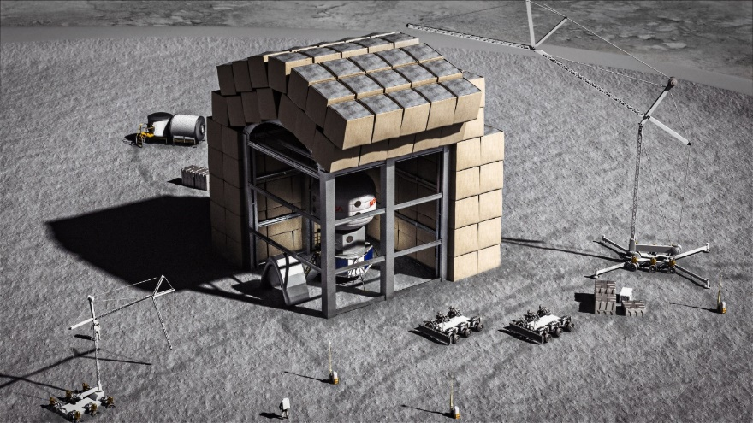
Figure 6. Artist’s rendition of LSH Concept 1.2: regolith-filled sandbags for radiation protection – Cutaway view.
Concept 2.1 would reuse materials from lunar landers already present on the surface. With this concept, additional reforming and repurposing of materials may be necessary to fix the materials to the shelter structure. If repurposing and reforming the materials is not a viable option, the landers could be designed initially with repurposing in mind. This concept assumes that permission will be granted to scavenge from the landers and that there will be sufficient material from the landers to use for LSH. It should be noted that an appropriate system to scavenge, reform, and repurpose such materials does not exist to date, and a new development activity would be needed to enable this concept. This poses a significant barrier for a concept intended to support Artemis exploration plans within the 2020s.
In Concept 2.2, inflatable beams would be delivered from Earth. This concept would utilize an inflatable structure that can be stowed very compactly and deployed once on the surface. To inflate the structure, an expandable foam or gas would be used. An expandable foam would be an ideal method of inflating the structure to reduce the amount of upkeep necessary. The expandable foam material must also be delivered from Earth. It is possible that inflatable beams could represent a mass savings compared to a metallic structure; however, the total mass considering the foam or gas and inflation systems must be further explored. Additionally, the risk of structural failure with inflatable beams and the expected difficulty repairing leaks—or worse, large-scale rupture—adds substantial risk to this concept.
LSH Concept 2.3 was based on the idea to perform 3D printing of the structure on the surface using a regolith concrete. A notional rendering of this concept is shown in Figure 7. The material that is 3D printed would be comprised of a binder, which is delivered from Earth or mined on the surface, and a filler material, which is lunar regolith. A notional concrete additive manufacturing system was discussed that would 3D print two structural shells, and the shells would then be filled with bulk regolith by a system such as LSMS to obtain the thick regolith protective layer necessary for radiation protection. The feasibility of this concept relies predominantly on whether there are suitable binders that can be mixed with lunar regolith to form concrete. After trading multiple options, the LSH team selected elemental sulfur as a binder because it is well-studied and is not limited by the need for water [14-16]. Additionally, sulfur has the potential to be sourced from the lunar surface, if ISRU processing systems were in place to collect and process basalt on the lunar surface, which is rich in FeS. Sulfur concrete is not without its own challenges, but it was determined to be the best choice for this initial trade study.
The use of in situ regolith for the shelter structure was intended to greatly reduce the amount of delivery mass to the surface; however, the total mass and volume of the binder required grows immensely high with such a large structure as the LSH. Potential for ISRU mining systems to extract the binder might reduce the delivery mass burden, but additional analysis of the investment and delivery costs of those ISRU systems is needed. An alternative to using a concrete with a binder, however, is regolith sintering.
Concept 2.4 was a variation of 2.3, wherein sintered regolith was used to build structural shells. Sintering is the process of using heat and/or compression to turn a powdered material into a solid, though without melting. Sintering represents a distinct advantage compared to 3D printing with regolith cement because it does not need a binder, and there are multiple sintering technology options being researched, such as in NASA’s Moon to Mars Planetary Autonomous Construction Technologies (MMPACT) project [17]. However, sintering represents its own challenges, such as high-power requirements and the low TRL of such systems.
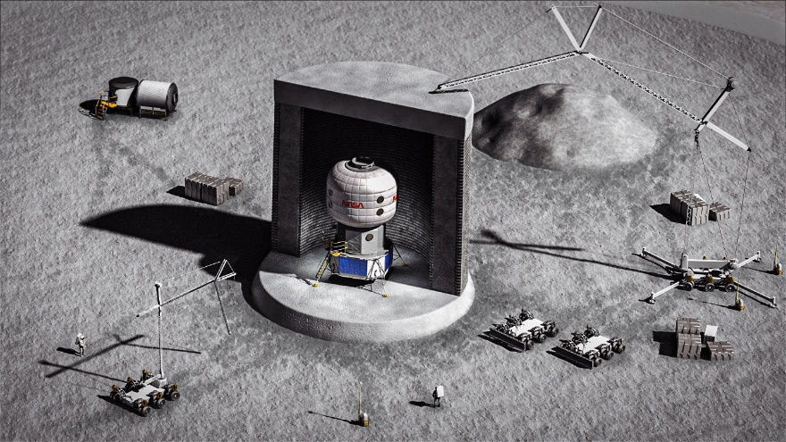
Figure 7. Artist’s rendition of LSH Concept 2.3: 3D printed regolith cement structure surrounding surface habitat – Cutaway view.

Concept Alternatives 3.1-3.2: Establishment Systems Alternatives
The Baseline concept considers numerous Establishment Systems that would be used for the LSH. Concept 3.1 proposes to utilize one or more copies of the Lunar Terrain Vehicle (LTV) as the main chassis for the establishment systems, since the LTV will likely already be developed for the Artemis Base Camp according to NASA’s Artemis Plan [1]. The benefit of this concept is based on the assumption that there would already be contract mechanisms in place to procure the crew LTV for the ABC, and it’s possible that copies of the crew LTV could be procured, potentially even for a reduced cost since minimal development would be needed. Similar to the LANCE concept proposed by Mueller et al. [9], various attachments could be produced for the LTV to perform the establishment functions required. Additional work is needed to verify that the LTV is suitable for supporting the establishment system attachments; however, this does rely on additional detail on the LTV design. Because excavation functions are largely constrained by the mass of the system to enact a force on the regolith, the LTV and attachment total mass will be a major parameter to consider.
The LSH Concept 3.2 proposes to utilize a loader and dump truck combination instead of the RASSOR and LANCE systems for regolith excavation and transfer. The RASSOR is an example of a continuous excavation system. There are also discrete excavation systems that have been developed, too, such as the “Glenn Digger”, a front loader developed by NASA Glenn Research Center (GRC) [18], or the “Backhoe”, a back loader designed by van Susante and Dreyer [19]. An example dump truck-style system for regolith transfer is the “Cratos Scraper” also developed at GRC [20], which could be an alternative to the LANCE bulldozer attachment on the Chariot chassis from the Baseline. There are also other options, such as those described in Just et al.’s review of existing regolith excavation techniques [12]. Using these example systems, it must also be considered that the system may need to be scaled up to an appropriate size for the LSH operations, which will require the transfer and piling up of 3 m (threshold) to 7 m (goal) of regolith on the shelter. Ultimately, Concept 3.2 could represent a potential reduction in mass from the Baseline. However, the small mass savings must be traded against potential challenges with discrete excavators, compared to continuous excavation systems like RASSOR (i.e., construction time, power required).

Concept Alternatives 4.1-4.3: Maintenance and Autonomy Alternatives
For maintenance of the LSH, the Baseline uses a combination of semi-autonomous robotics and embedded sensors to perform inspection and diagnostics. Semi-autonomous systems would require some amount of operator time, such as giving commands and analyzing data, and this could be performed by either remote operators or crew. However, Concept 4.1 considers the alternative where crew involvement would be increased, and crew would perform regular inspection of all systems. One possibility for this concept is a hybrid approach: all mobile systems would still be equipped with the relevant sensor packages (cameras, LiDAR, etc.) used for inspection, but crew members could perform spot inspections by disconnecting these sensor packages and using them in handheld mode. One benefit of this method is that it is more robust to failure or degradation of the mobile agents and robust to unexpected situations for which the autonomous systems are not prepared. Another benefit to removing autonomous inspection might be potential savings of technology development costs, but further work would have to perform a cost estimate to validate this. Autonomous systems and robotics have seen significant advancements in recent years, so they are now more prepared to respond to surface operations like those proposed in the LSH concept and would require less development than they might have several years ago. The potential development cost savings would also be largely offset by the high cost of crew time needed in this concept. Also, there would be increased risk of not observing degradations in LSH systems’ performance due to either limited crew resources or human error.
Instead of increasing crew involvement, alternatives exist that change the degree of autonomy for the maintenance and establishment systems. Compared to the semi-autonomous systems in the Baseline, Concept 4.2 would use fully autonomous systems. This concept uses largely the same hardware as the Baseline, but more intelligent and autonomous software would be installed on all of the mobile agents. With full autonomy, operators would only need to give very high-level commands. To accomplish this, each mobile agent would need to be equipped with a complex sensor package, and potentially additional LDRS beacons would need to be installed to provide higher resolution and reliability for navigation. For high-level planning and monitoring of progress, the system would need to use technology like Simultaneous Localization and Mapping (SLAM) to build a detailed map of the work area, including locations of mobile agents, progress on tasks, and up-to-date terrain as it is changed. This would be very valuable to crew and operators as well. Rather than looking through the limited lens of a few cameras, they would be able to see a complete overview of the entire system.
In Concept 4.3, the systems are equipped with a lower level of autonomy than the baseline. Operators would give specific, low-level commands to individual agents. The major benefit of this lower level of autonomy is savings in technology development investment. Most of the fully autonomous systems described previously would require significant research and development before being ready for operational deployment. On the other hand, manual tele-operation in space is already used. However, there are many drawbacks. More manual operation would require increased training of operators and more time and effort of the operators during the mission, and it would reduce situational awareness. Furthermore, this concept is not very extensible to Mars. Manual tele-operation may be practical with the ~1 second of communication delay to the Moon; however, it becomes completely infeasible to establish infrastructure to support crew missions with the several minute communication delay to Mars without a higher level of autonomy.

Concept Alternatives 5.1-5.2: Alternatives for Shelter Size and Dimensions
Shelter size and dimensions were the final parameters considered in the LSH concept alternatives. The Baseline considered a shelter size that had the ability to only house the surface habitat. Concept 5.1 expands the space to not only house the FSH but also other equipment. For example, this size of shelter could accommodate multiple pressurized rovers, with room for crew to pass by on either side. This extra space would allow the mission to evolve, as more elements are brought in that need to be protected. This shelter size is useful to aid in preserving equipment from the harsh lunar environment. While the total mass delivered to the surface would increase and the production and delivery costs would also increase, the methodology to build the shelter would be nearly identical, with no impact to the establishment or maintenance systems required.
In Concept 5.2, multiple smaller shelters are added to the concept along with the main shelter from the Baseline. Similar to Concept 5.1, not only the FSH but also other surface equipment could be protected from the lunar conditions. An additional benefit is the redundancy that is introduced when multiple shelters are present.
- Methodology for Evaluation of LSH Concept Alternatives
All concept alternatives generated in the previous activity were candidates for selection to satisfy the goal of the LSH study. To perform the down-select, a formal decision analysis methodology was implemented to appropriately consider stakeholder goals, objectives, and priorities [21]. First, stakeholder goals were decomposed into objectives, which are in turn decomposed into quantifiable attributes. Later, the attributes were assigned swing weights that represent stakeholder priorities. This overall process is reflected in Figure 6. The decision analysis framework created for the study was used to evaluate each of the LSH concept alternatives.

Objectives
Objectives are derived based on an understanding of the stakeholder’s goals and desires. Objectives define what stakeholders hope to achieve to meet the overall goal. For the LSH Study, the Level Zero Requirements and the functional decomposition contributed to the definition of objectives. The objectives encompassed benefit, cost, and risk and were sorted into three categories: Environmental, Operational, and Programmatic. The objectives for the LSH are provided in Table 2.
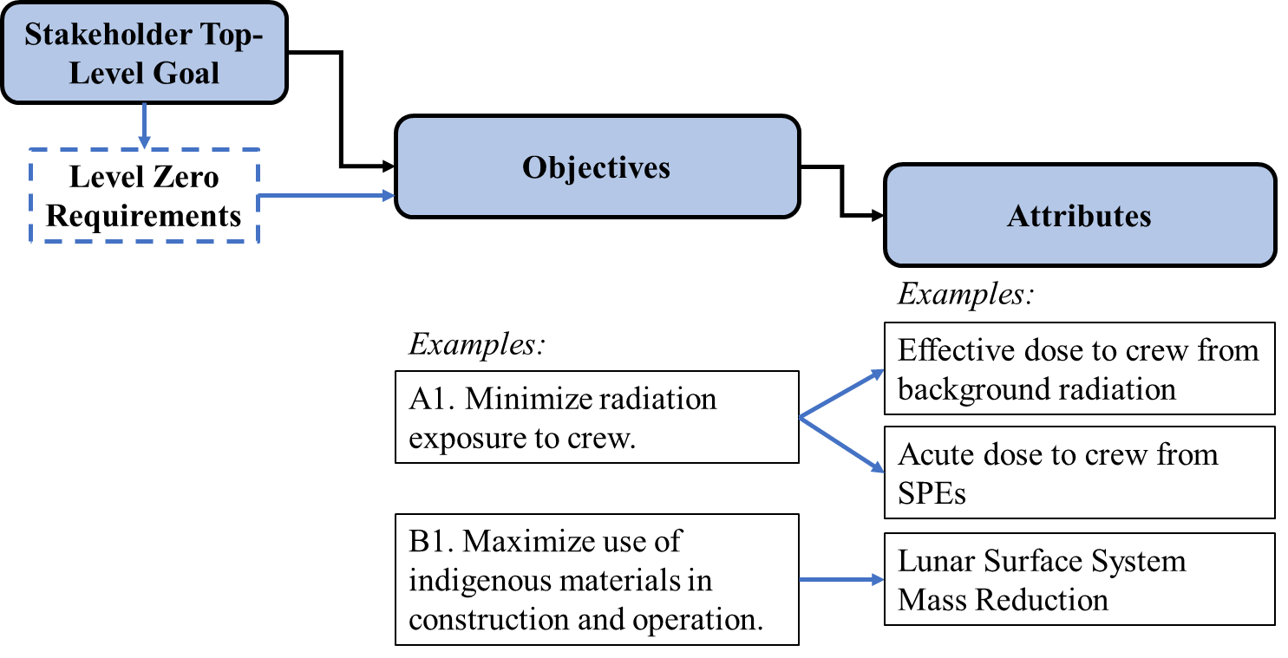
Figure 8. Overview of decision analysis methodology implemented by LSH Seedling Study, including the decomposition from the stakeholder top-level goal to objectives to attributes, with examples.

Decision Attributes
Next, the objectives are decomposed into quantifiable metrics, called attributes. Attributes measure the trade-offs between achieving relatively more or less of a given objective. One or more attributes were defined for each objective, including with measurement guidance for later when the concepts would be evaluated. Table 2 provides the list of LSH attributes.
The attributes include both metrics that can be quantified using known models as well as more subjective metrics. For example, “evolvability” and “long term utility” had to be subjectively evaluated by the team. It is often the case that stakeholder-expressed benefits and risks can only be expressed subjectively or on contrived scales, and it is important to include these attributes also.
Table 2. LSH Decision Attributes
Objective Category | LSH Objectives | LSH Attributes
Environmental | A1. Minimize radiation exposure to crew. | Effective dose to crew from background radiation
 |  | Acute dose to crew during SPEs
 | A2. Maximize energy absorption capability of the shelter from impacts for crew and other exploration systems, including impacts from micrometeoroids, the movements of external assets (e.g., mobility systems), and any resulting ejecta. | Micrometeorite (MM) Impact Protection Probability
 |  | Sensitivity of Damage Detection
 |  | Protection against impact from external assets
 | A3. Minimize accumulation of dust (fine and coarse) on LSH establishment and operations systems. | Architectural Dust Mitigation
Operational | B1. Maximize use of indigenous materials in construction and operation. | Lunar Surface System Mass Reduction
 | B2. Minimize need for crew involvement during establishment and sustained operations of the LSH. | Maintenance Need
 |  | Training Need
 |  | Degree of Autonomy
 |  | Crew Situational Awareness
 |  | Spatial Involvement
 | B3. Maximize evolvability of the LSH establishment and operations concept. | Evolvability Composite Score
 | B4. Balance resiliency and robustness of LSH concept as a whole. | Fault/Degradation Identification
 |  | Resiliency
 |  | Complexity
 | B5. Maximizes available storage for exploration systems, science equipment, consumables, and contingency spares. | Long Term Utility
 |  | Space Management
Programmatic | C1. Minimize investment costs. | Total Lunar Safe Haven System Investment
 |  | Technology Maturation Investment
 | C2. Maximize Mars extensibility. | Regolith as a Shielding Material
 |  | Autonomous Emplacement

So that all of the attributes could eventually be combined into a final score, each of the attributes were evaluated on the same scale. This required that the team convert attributes that had different units and that could otherwise be evaluated using separate quantitative tools. This scale also provided a guide for how to evaluate subjective attributes. The team chose to use an interval scale from -2 to +2. The scale for most attributes was centered on the Baseline Concept 1.1A, at a score of 0, and then each other concept was evaluated in comparison to the Baseline. Concepts that achieved the attribute relatively better than the Baseline were given a score of +1 or +2, and those achieving the attribute relatively worse were given a score of -1 or -2. The ideal score—i.e., the maximum that could be achieved by a concept—was +2. The choice of interval scale is generally dependent on the study and is an experience-based judgement of how much granularity is possible and valuable for distinguishing concepts. The -2 to +2 scale was determined by the team to be sufficient for the study’s purposes with those factors in mind.
In the final step with the decision attributes, all attributes were combined into an overall weighted score using swing weights. Parnell’s book Trade-Off Analytics [4] describes how swing weights are used in decision analysis as an alternative to weights based solely on importance, which are commonly criticized for the possibility for an analyst to alter the results to suit their own preferences. Alternatively, swing weights incorporate the importance of each attribute to the stakeholder (i.e., the stakeholder priorities) as well as the impact of the range of the attribute. In other words, the “impact of the range” considers how the range of scores that will be accepted will change the way the attribute should influence the decision [4].
The methodology to define swing weights is adapted from the Handbook of Decision Analysis [22]. Input was required from the stakeholders, who were represented by the LSH Steering Team. Table 3 provides the final swing weights. The decision analysis framework was then complete, including the definition of objectives, decision attributes, and swing weights. Each of the 15 selected LSH concepts were evaluated using the decision analysis framework. The full table of results is provided in Table 4.

Table 3. LSH Swing Weights used to create overall weighted score
 | Importance of the Attribute to the Decision
 | “Mission Critical” (1) |  |  | “Enabling” (2) |  |  | “Enhancing” (3)
Impact of the Range of the Attribute | Attribute | Matrix Weight | Swing Weight | Attribute | Matrix Weight | Swing Weight | Attribute | Matrix Weight | Swing Weight
Large Impact | Technology Maturation Investment | 100 | 0.10 | Lunar Surface System Mass Reduction | 90 | 0.09 | Evolvability Composite Score | 60 | 0.06
 | Total Lunar Safe Haven Architecture Investment | 100 | 0.10 | Resiliency | 90 | 0.09 | Complexity | 60 | 0.06
Medium Impact |  |  |  | Fault/Degradation Identification | 70 | 0.07 | Maintenance Need | 40 | 0.04
 |  |  |  | Crew Situational Awareness | 70 | 0.07 | Training Need | 40 | 0.04
 |  |  |  |  |  |  | Degree of Autonomy | 40 | 0.04
 |  |  |  |  |  |  | Long Term Utility | 40 | 0.04
Small Impact | Effective dose to crew from background | 80 | 0.08 | Autonomous Emplacement | 50 | 0.05 | Space Management | 30 | 0.03
 |  |  |  |  |  |  | Regolith as a Shielding Material | 30 | 0.03

Key Takeaways and Recommendations
The attributes allowed the team to both think through and quantify the benefits, costs, and risks that together represent value to stakeholders. They also helped the team understand how concepts have both advantages and disadvantages, and that there are many ways that all the concepts can provide value to NASA stakeholders. Finally, the attributes were helpful because they enabled an overall score (whether weighted or unweighted sum) to be calculated to compare concepts. From Table 4, the Steering Team highlighted several concepts that received the highest overall scores:
- Baseline Concept 1.1A: Bulk Regolith Protection and Metallic Structure Delivered from Earth
- Concept 1.1B: Bulk Regolith Protection over Tall, Cylindrical Shelter Structure
- Concept 2.4 Sintered Regolith Structure
- Concept 3.1: LTV Copies
- Concept 4.2: Higher level of autonomy, less human operation
Most of the LSH concepts reflected significant value for NASA stakeholders, but a concept needed to be down-selected for recommendation. Ultimately, the Steering Team decided to choose a concept that leverages the highest number of existing or high-TRL systems to support Artemis lunar operations in the late 2020s or early 2030s. Out of the highest-scoring concepts, the Steering Team further down-selected to those that had a low “Technology Maturation Investment” required—i.e., a high score for this attribute. This decision removed Concepts 2.4 and 4.2 from the shortened list, but these two were included in recommendations for future development pathways.
After further discussion of the evaluations, stakeholder priorities, and rankings, the final down-select was determined. The LSH Seedling Study recommends the Baseline Concept 1.1A because it is both high-value and leverages mostly existing, high-TRL systems. Replacement of the Chariot chassis with cargo versions of the LTV (LSH Concept 2.4) is a concept that might add value and should be evaluated more closely in future work. In summary, the Baseline Concept utilizes a metallic structure delivered from Earth and assembled on the lunar surface. The simple structure would be covered in bulk regolith. Establishment and maintenance systems that already exist and are mostly TRL 4 would be used, including LSMS, RASSOR, Chariot, LANCE, and A-PUFFER. Additionally, all the robotic

Table 4. Decision Attributes Results for the 15 Evaluated LSH Concepts
 | Concept Alternative #: |  | 1.1A | 1.1B | 1.2 | 2.1 | 2.2 | 2.3 | 2.4 | 3.1 | 3.2 | 4.1 | 4.2 | 4.3 | 5.1 | 5.2
 | Descriptive Concept Name: | Swing Weight | Baseline – Bulk Regolith + Metallic/Composite Structure Delivered from Earth ("Twinkie") | “Round Cake” Delivered from Earth | Regolith Sandbags | Scavenged from Landers | Inflatable Beams | 3D Printed Cement Structure | Sintered Regolith Structure | LTV Copies and Attachments | Loader and Dump Truck Combo | Crew inspection | Higher Level of Autonomy | Lower Level of Autonomy | One Big Shelter | Multiple Smaller Garages |  | "Ideal"
Category | Attribute | Value | Value | Value | Value | Value | Value | Value | Value | Value | Value | Value | Value | Value | Value | Value |  | Value
A. Environmental | Effective dose to crew from background | 0.08 | 2 | 2 | 0 | 2 | 0 | 0 | 0 | 2 | 2 | 2 | 2 | 2 | 2 | 2 |  | 2
 | Acute dose to crew during SPEs | 0 | 2 | 2 | 2 | 2 | 2 | 2 | 2 | 2 | 2 | 2 | 2 | 2 | 2 | 2 |  | 2
 | Micrometeoroid (MM) Impact Protection Probability | 0 | 2 | 2 | 1 | 2 | 2 | 2 | 2 | 2 | 2 | 2 | 2 | 2 | 2 | 2 |  | 2
 | Sensitivity of Damage Detection Systems | 0 | -1 | -1 | -1 | -1 | -1 | -1 | -1 | -1 | -1 | -1 | -1 | -1 | -1 | -1 |  | 2
 | Protection against impact from external assets | 0 | 1 | 1 | 1 | 1 | 1 | 1 | 1 | 1 | 1 | 1 | 1 | 1 | 1 | 1 |  | 2
 | Architectural Dust Mitigation | 0 | -1 | -1 | -1 | -1 | -1 | -1 | -1 | -1 | -1 | -1 | -1 | -1 | -1 | -1 |  | 2
B. Operational | Lunar Surface System Mass Reduction | 0.09 | 0 | 1 | -1 | 1 | -1 | -2 | 0 | 1 | 0 | 0 | -1 | 0 | -1 | -2 |  | 2
 | Maintenance Need | 0.04 | 0 | 0 | 0 | 0 | 0 | 0 | 0 | 0 | 0 | -1 | 2 | -1 | 0 | -1 |  | 2
 | Training Need | 0.04 | 0 | 0 | 0 | -2 | -1 | 0 | 0 | 0 | 0 | -1 | 1 | -1 | 0 | 0 |  | 2
 | Degree of Autonomy | 0.04 | 0 | 0 | 0 | 0 | 0 | 0 | 0 | 0 | 0 | -2 | 2 | -1 | 0 | 0 |  | 2
 | Crew Situational Awareness | 0.07 | 0 | 0 | 0 | 0 | 0 | 0 | 0 | 0 | 0 | -2 | 2 | -1 | 0 | 0 |  | 2
 | Evolvability Composite Score | 0.06 | 0 | 1 | -3 | 2 | -3 | -3 | 6 | 1 | 0 | -1 | -1 | 0 | 1 | 3 |  | 6
 | Fault/Degradation Identification | 0.07 | 0 | 0 | 0 | 0 | 0 | 0 | 0 | 0 | 0 | -1 | 2 | -1 | 0 | 0 |  | 2
 | Resiliency | 0.09 | 0 | 0 | 0 | 0 | 0 | 0 | 0 | 1 | 0 | 1 | -1 | 1 | 0 | 1 |  | 2
 | Complexity | 0.06 | 1 | 0 | -1 | -2 | 0 | -1 | -1 | 1 | 1 | -1 | -1 | 1 | 0 | -1 |  | 2
 | Long Term Utility | 0.04 | 1 | 1 | 1 | 1 | 1 | 1 | 2 | 1 | 1 | 0 | 2 | 1 | 1 | 2 |  | 2
 | Space Management | 0.03 | 0 | -1 | 0 | 0 | 0 | 0 | 0 | 0 | 0 | 0 | 0 | 0 | 1 | 2 |  | 2
C. Programmatic | Total Lunar Safe Haven Architecture Investment | 0.10 | 0 | 0 | -1 | 2 | 0 | -2 | 2 | 2 | 0 | 0 | 0 | 0 | -1 | -2 |  | 2
 | Technology Maturation Investment | 0.10 | 0 | 0 | -1 | -2 | -1 | -1 | -1 | 1 | -1 | 1 | -2 | 1 | 0 | 0 |  | 2
 | Regolith as a Shielding Material | 0.03 | 2 | 2 | 2 | 2 | 2 | 1 | 1 | 2 | 2 | 2 | 2 | 2 | 2 | 2 |  | 2
 | Autonomous Emplacement | 0.05 | 1 | 1 | 1 | 1 | 1 | 1 | 1 | 1 | 1 | 0 | 2 | 0 | 1 | 1 |  | 2
 | SUM: |  | 10 | 10 | -1 | 8 | 1 | -3 | 13 | 16 | 9 | 0 | 14 | 6 | 9 | 10 |  | 46
 | WEIGHTED SUM: |  | 0.37 | 0.44 | -0.39 | 0.32 | -0.26 | -0.61 | 0.57 | 0.92 | 0.27 | -0.08 | 0.38 | 0.25 | 0.21 | 0.20 |  | 2.24
 | WEIGHTED SUM - Environmental: |  | 0.16 | 0.16 | 0.00 | 0.16 | 0.00 | 0.00 | 0.00 | 0.16 | 0.16 | 0.16 | 0.16 | 0.16 | 0.16 | 0.16 |  | 0.16
 | WEIGHTED SUM - Operational: |  | 0.10 | 0.16 | -0.30 | 0.05 | -0.27 | -0.39 | 0.39 | 0.38 | 0.10 | -0.40 | 0.26 | -0.07 | 0.04 | 0.13 |  | 1.52
 | WEIGHTED SUM - Programmatic: |  | 0.11 | 0.11 | -0.09 | 0.11 | 0.01 | -0.22 | 0.18 | 0.35 | -0.05 | 0.10 | -0.10 | 0.10 | -0.05 | -0.15 |  | 0.57
 | Concept Rankings from ST Survey: (based on concept groupings) |  | 1 | 2 | 1 | 4 | 3 | 2 | 1 | 2 | 3 | 2 | 1 | 3 | 1 | 3

systems would use a low- to mid-level of autonomy, which relies on some human interaction while also beginning to demonstrate and validate autonomous capabilities on the lunar surface, capabilities which are extensible to Mars.
The recommendation for a LSH represents a reasonably achievable concept but is still a significant step forward in capabilities for surface excavation, construction, and maintenance over long durations. There are many challenges associated with construction on another planetary surface, and NASA could build up to the full-scale LSH over a period of time. Several preliminary steps could be planned to aid the development of the full-scale shelter, while also providing smaller-scale shelter for near-term missions. Initial demonstrations and technology validation would buy down risk for the full-scale LSH as NASA proceeds through progressively more advanced generations. Suggested future work is to infuse the right scale and features of the shelter based on “companion systems” made available on the lunar surface during the Artemis Program—such as the cargo lunar lander, per Level Zero Requirement 9 stated above. Therefore, the development plan for LSH depends heavily on NASA’s capability development Roadmaps for Power and for Autonomous Systems & Robotics.
Another recommendation is to allow the LSH concept to evolve over time. Based on the evaluation results, two main evolvability pathways were identified: surface construction and autonomy. For example, the construction techniques could evolve to include regolith sintering. Sintering is a high-scoring LSH concept that maximizes use of ISRU, reduces the mass delivered from Earth, and is evolvable to many mission scenarios (evolving from Class II to Class III structures [3]). However, sintering is currently low-TRL, so continued technology investment and demonstrations are needed, and there are remaining challenges also includes power availability. This makes evolving to include sintering in the future a viable option for LSH.
The second evolvability pathway is advancing the degree of autonomy employed by the establishment and maintenance systems. The Baseline and Concept 4.2 showed how increasingly advanced degrees of autonomy have very high value. Both of these were amongst the top-scoring concepts. However, starting with lower capability levels in autonomy can be acceptable with a pathway to advancing the capability over time through continued technology investment, demonstrations, and validation on the surface.
Both the recommendation of the LSH concept as well as the decision analysis framework are important outcomes of this seedling study. The down-selected concept and decision analysis framework can be used by NASA and others to provide a path forward for future technology investments and promote synergy with existing and proposed programs. It can also be used to compare and evaluate future concepts like the LSH.
- Conclusion
The Lunar Safe Haven Seedling Study presented a game-changing concept that offers a potential remedy for crew health hazards including background Galactic Cosmic Rays (GCR) and acute Solar Particle Events (SPEs) radiation effects that mission architectures have been unable to provide to date [2]. Over the course of the one-year study, the team developed Level Zero Requirements, baselined a decision analysis framework, and identified an expansive trade tree of alternatives for designing, establishing, and maintaining a safe haven shelter on the lunar surface. These alternatives included existing and in-development systems as well as revolutionary ideas. Though the study could not evaluate every possible alternative, a large number (15) of representative concepts were evaluated using a decision analysis methodology. During this process, concepts were separated out for those that were high-TRL and low-TRL, and each was given a score for the amount of Technology Maturation Investment that would be required to bring the system to a launch-ready state for Artemis exploration. The Technology Maturation Investment was a prioritized decision attribute when making the final down-select. As an outcome to this study, the final recommended concept and decision analysis framework are both valuable tools that NASA and others can use to assess and compare future ideas.
Finally, the study concluded that lunar surface excavation, construction, and ISRU capabilities and current and planned equipment concepts suggest that implementing the radiation shielding—for both GCR and SPEs—necessary for long crew stays on the Moon and Mars is reasonably achievable. The study has considered the TRLs and capabilities required for the LSH concepts proposed, and it has identified recommendations and requirements for future mission planning. These recommendations should influence NASA’s capability development Roadmaps for Assembly, ISRU Construction, Power, and Autonomous Systems & Robotics. Although construction on the Moon can seem daunting, especially at scale, NASA is in a position today to commit to pushing these technologies forward so that they can establish reasonably achievable, sustainable infrastructure on the Moon within the 2020s.

- Optional Supporting Materials

References
- National Aeronautics and Space Administration, “Artemis Plan: NASA’s Lunar Exploration Program Overview”, September 2020, URL: https://www.nasa.gov/sites/default/files/atoms/files/artemis_plan-20200921.pdf [retrieved 23 Mar. 2021].
- Moses, R. W., Bushnell, D., Komar, D. R., Choi, S., Litchford, R., Chang-Diaz, F., and Carter, M., “Maintaining Human Health for Humans-Mars”, 2018 AIAA SPACE and Astronautics Forum and Exposition, AIAA 2018-5360, AIAA, Orlando, FL, 2018, URL: https://arc.aiaa.org/doi/10.2514/6.2018-5360
- Moses, R. W., and Mueller, R. P., “Requirements Development Framework for Lunar In Situ Surface Construction of Infrastructure”, 17th Biennial International Conference on Engineering, Science, Construction, and Operations in Challenging Environments, ASCE, 2021, URL: https://ascelibrary.org/doi/abs/10.1061/9780784483374.106
- Parnell, G. S., editor, Trade-Off Analytics: Creating and Exploring the System Tradespace, John Wiley and Sons, Hoboken, New Jersey, 2016.
- Dorsey, J. T., Jones, T. C., Doggett, W. R., Brady, J. S., Berry, F. C., Ganoe, G. G., Anderson, E. J., King, B. D., and Mercer, C. D., “Recent Developments in the Design, Capabilities and Autonomous Operations of a Lightweight Surface Manipulation System and Test-bed”, AIAA SPACE 2011 Conference and Exposition, AIAA, Long Beach, California, 2011, URL: https://arc.aiaa.org/doi/pdf/10.2514/6.2011-7266
- Heiken, G. H., Vaniman, D. T., and French, B. M., editors, Lunar Sourcebook, Cambridge University Press, 1991, URL: https://www.lpi.usra.edu/publications/books/lunar_sourcebook/
- “Space Exploration Vehicle”, Wikipedia, Retrieved 01 September 2021, URL: https://en.wikipedia.org/wiki/Space_Exploration_Vehicle
- Mueller, R. P., Wilkinson, R. A., Gallo, C. A., Nick, A. J., Schuler, J. M., and King, R. H., “Lightweight Bulldozer Attachment for Construction and Excavation on the Lunar Surface”, AIAA SPACE 2009 Conference and Exposition, AIAA, Pasadena, California, 2009, URL: https://arc.aiaa.org/doi/pdf/10.2514/6.2009-6466
- Mueller, R. P., Smith, J. D., Schuler, J. M., Nick, A. J., Gelino, N. J., Leucht, K. W.; Townsend, I. I.; and Dokos, A. G., “Design of an Excavation Robot: Regolith Advanced Surface Systems Operations Robot (RASSOR) 2.0”, 15th Biennial ASCE Conference on Engineering, Science, Construction, and Operations in Challenging Environments, ASCE, 2016, URL: https://ntrs.nasa.gov/api/citations/20210011366/downloads/ASCE%202016%20RASSOR%202%20Final%20%206_8_2016.pdf
- NASA, “Automated Reconfigurable Mission Adaptive Digital Assembly Systems (ARMADAS)”, 2020, URL: https://www.nasa.gov/directorates/spacetech/game_changing_development/projects/armadas
- NASA, “Autonomous Pop-Up Flat Folding Explorer Robot (A-PUFFER)”, 2020, URL: https://www.nasa.gov/directorates/spacetech/game_changing_development/projects/A-PUFFER
- Just, G. H., Smith, K., Joy, K. H., and Roy, M. J., “Parametric review of existing regolith excavation techniques for lunar In Situ Resource Utilisation (ISRU) and recommendations for future excavation experiments”, Planetary and Space Science, Elsevier, 2020, URL: https://www.sciencedirect.com/science/article/pii/S003206331930162X
- Taylor, “Langley Research Center Lunar Surface Opportunities and VSAT Overview”, Presentation to the Lunar Surface Innovation Consortium (LSIC), Powerpoint, 28 October 2020, URL: https://lsic.jhuapl.edu/uploadedDocs/presentations/587-Taylor_LSSI%20Talk.pdf
- Grugel, R. N., "Integrity Of Sulfur Concrete Subjected To Simulated Lunar Temperature Cycles", Advances In Space Research, vol 50, no. 9, 2012, pp. 1294-1299, Elsevier BV, URL: https://doi.org/10.1016/j.asr.2012.06.027. Accessed 29 Sept 2021.
- Grugel, R. N., and Toutanji, H., "Sulfur “Concrete” For Lunar Applications – Sublimation Concerns", Advances In Space Research, vol 41, no. 1, 2008, pp. 103-112, Elsevier BV, URL: https://doi.org/10.1016/j.asr.2007.08.018. Accessed 29 Sept 2021.
- Toutanji, H. A. et al., "Performance Of Lunar Sulfur Concrete In Lunar Environments". Construction And Building Materials, vol 29, 2012, pp. 444-448, Elsevier BV, URL: https://doi.org/10.1016/j.conbuildmat.2011.10.041. Accessed 29 Sept 2021.
- Clinton, R. G., Edmunson, J., Fiske, M., Effinger, M., Ballard, J., and Jensen, E., “The NASA MMPACT Project – Autonomous Construction of Infrastructure on the Lunar Surface”, Presentation to the Lunar Surface Innovation Consortium (LSIC) Excavation and Construction Working Group Monthly, Powerpoint, 30 April 2021, URL: https://lsic.jhuapl.edu/uploadedDocs/focus-files/817-E&C%20Monthly%20Meeting%20-%202021%2004%20April_Presentation%20-%20MMPACT.pdf
- Bauman, S., Newman, P., Izadnegahdar, A., Johnson, K., and Abel, P., “A Basic Robotic Excavator (the “Glenn Digger”): Description, Design, and Initial Operation”, NASA/TM—2016-218961, 2016.
- Van Susante, P. J., and Dreyer, C. B. “Lunar and Planetary Excavation Prototype Development and Testing at the Colorado School of Mines”. 12th Biennial International Conference on Engineering, Construction, and Operations in Challenging Environments; and Fourth NASA/ARO/ASCE Workshop on Granular Materials in Lunar and Martian Exploration. 2010. https://ascelibrary.org/doi/pdf/10.1061/41096%28366%29109
- Caruso, J. J., Spina, D. C., Greer, L. C., John, W. T., Michele, C., Krasowski, M. J., and Prokop, N. F., “Excavation on the Moon: Regolith Collection for Oxygen Production and Outpost Site Preparation”, AIAA-2008-808, 46th AIAA Aerospace Sciences Meeting and Exhibit, AIAA, Reno, Nevada, 2008, https://arc.aiaa.org/doi/pdf/10.2514/6.2008-808
- NASA, NASA Systems Engineering Handbook, NASA SP-2016-6105 Rev2, 2016, pp. 160-170.
- Parnell, G. S., Bresnick, T. A., Tani, S. N., and Johnson, E. R., Handbook of Decision Analysis, John Wiley and Sons, Hoboken New Jersey, 2013.

Aerospace Engineer, Space Mission Analysis Branch, Systems Analysis and Concepts Directorate, AIAA Member.
Aerospace Engineer, Atmospheric Flight & Entry Systems Branch, Engineering Directorate, AIAA Associate Fellow.
Project Management Engineer, Space Technology & Exploration Directorate, AIAA Member.
Senior Technologist, Swamp Works, Exploration Systems and Development Office, AIAA Member.
Materials Engineer, Materials Engineering Support Office, AIAA Senior Member.
Materials Engineer, Materials Engineering Support Office.

