**NASA Space Launch System Completes Key Hot Fire Test and Begins Vehicle Integration**

John Honeycutt[1] and Joseph C. Cianciola[2]

*NASA Marshall Space Flight Center, Huntsville, Alabama, 35812, USA*

John Blevins[3]

*NASA Marshall Space Flight Center, Huntsville, Alabama, 35812, USA*

**NASA and its commercial and international partners are on the way back to the Moon. Significant progress towards that goal was made in 2021, including on the agency’s Space Launch System (SLS) rocket – a key part of the Artemis initiative. The SLS core stage for the Artemis I mission – the first launch of SLS and an uncrewed Orion capsule – completed its Green Run test series in early 2021 and was successfully mated with the SLS twin solid rocket boosters on the mobile launcher at Kennedy Space Center (KSC). The launch vehicle stage adapter, interim cryogenic propulsion stage, and the Orion stage adapter structural test article and Orion spacecraft mass simulator were also stacked. The flight Orion spacecraft and Orion stage adapter are being prepared for stacking and launch, targeted for late 2021 following a wet dress rehearsal at Launch Complex 39B. SLS hardware for Artemis II, which will be the first flight of crew on Orion and SLS, is also in work. Work progressed on core stage components, booster segments, and other hardware for Artemis III and future missions. This paper will detail the progress made.**

1. **Introduction**

Humanity will soon return to the Moon as NASA and its commercial and international partners are preparing to land the first woman and first person of color as part of the Artemis initiative. NASA’s Space Launch System (SLS) rocket is one of the key parts to achieving that goal and establishing a permanent presence on and around the Moon.

The rocket, along with the Orion spacecraft, has transitioned from development to operations, while other systems needed for the initiative are in development. Three flights of SLS Block 1 and Orion will lay the groundwork for the first human landing on the Moon in over 50 years. Following Artemis III, SLS Block 1B missions will deliver more infrastructure to lunar orbit. While performing important scientific research on the surface and in lunar orbit, Artemis astronauts will test technologies that will help enable NASA’s human spaceflight program to reach its horizon goal: humans on Mars.

Before NASA can send humans back to the Moon and on to Mars, though, the agency first needs to perform a test flight of SLS, Orion, and ground processing and launch at Kennedy Space Center – a mission called Artemis I. At the time of this writing, the Artemis I SLS rocket is stacked with the core stage mated between the solid rocket boosters and the launch vehicle stage adapter (LVSA, built by prime contractor Teledyne Brown), interim cryogenic propulsion stage (ICPS, built by United Launch Alliance), and the Orion stage adapter (OSA) structural test article stacked on top of the core stage (Fig. 1). The Orion spacecraft and flight OSA are prepared and are in the Vehicle Assembly Building (VAB), awaiting stacking and integration.

**Fig. 1 The Artemis I SLS is seen with the OSA structural test article and the Orion mass simulator mated to the SLS stack on the mobile launcher at NASA’s Kennedy Space Center.**

Artemis I will launch SLS for the first time. The mission will send an uncrewed Orion capsule (built by prime contractor Lockheed Martin) beyond the Moon (Fig. 2). The mission will test SLS’s ascent capabilities and the capsule’s systems in the extreme conditions of deep space. Launch is targeted to take place from KSC at the end of 2021, assuming no significant issues are encountered during integration of the vehicle for the first time. Jacobs is prime contractor the rocket’s assembly and integration. During and after vehicle building and integration, multiple tests have, are, and will occur to fully understand the vehicle, refine computer models and flight software, and improve processes. Mission simulations are also underway to prepare engineers, flight controllers, leadership, and public affairs teams for nominal and off-nominal mission scenarios.

In addition to work for the first flight of SLS, hardware and components for the next three Artemis missions are in different stages of manufacturing, assembling, and testing at NASA and industry partner locations around the United States. Work has also started on components for missions beyond Artemis IV.

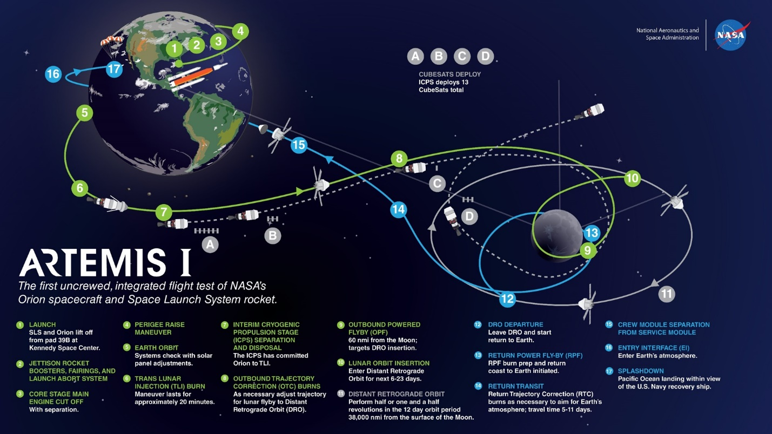  
**Fig. 2 The Artemis I test flight, lasting several weeks, will give NASA the opportunity to thoroughly test all systems in deep space prior to commencing crewed lunar missions.**

1. **SLS Design and Architecture**

SLS will be used for decades to come to launch NASA’s most ambitious crewed and can be used for flagship robotic missions. The rocket provides more mass, volume, and departure energy than currently existing commercial launchers. SLS uses heritage technologies and hardware initially developed for the Space Shuttle Program to optimize the opportunity for safe and successful missions. These technologies and hardware components have been upgraded to reflect contemporary manufacturing methods, streamline production and adapt existing hardware to SLS requirements and environments. The SLS evolvable platform, starting with Block 1, enables improvements in performance throughout the rocket’s life (Fig. 3).

At the heart of any rocket is the propulsion system. SLS uses a 2.5-stage configuration with RS-25 liquid-propellant engines that served as the Space Shuttle Main Engines (SSMEs, built by prime contractor Aerojet Rocketdyne) and shuttle’s twin solid rocket boosters (SRBs, built by prime contractor Northrop Grumman). Upgrades to both propulsion systems were needed to launch SLS and its vital missions. During the Space Shuttle Program, three SSMEs were mounted on the base of the orbiter, which flew on the side of the external tank. For SLS, a fourth engine was added, and they have been moved to the base of the core stage – directly between the SRBs. Due to the new thermal environment, the engines were also upgraded with new insulation and new engine controllers. The SRBs each used four propellant segments during the Space Shuttle Program, but for SLS they will use five propellant segments. New avionics and insulation were also added to the boosters.

The core stage is a new design (manufactured by Boeing). In addition to housing the four RS-25s and their liquid hydrogen (LH2) and liquid oxygen (LOX) tanks, it is the backbone for the rocket as it serves at the attach point for the SRBs, the home of the rocket’s flight computers, and the base for the integrated spacecraft and payload element. The stage holds approximately 537,000 gallons of LH2 and 196,000 gallons of LOX. This base architecture will be used for all six variants of SLS (Fig. 3).

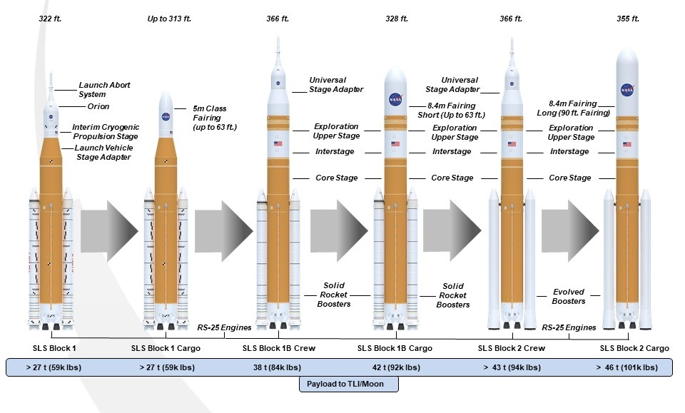

**Fig. 3 Primary components and performance of the planned SLS variants.**

SLS Block 1 stands 322.4 feet tall and weighs 5.75 million pounds fueled in crew configuration (with Orion), which will be used on Artemis I. The vehicle has a maximum thrust of 8.8 million pounds with the SRBs providing approximately 7.2 million pounds and the remaining 1.6 million pounds coming from the RS-25s. During the first two minutes of flight, the SRBs provide 75 percent of the thrust. Approximately 416,000 pounds of thrust come from each RS-25 at sea level; the engines produce more than 512,000 pounds of thrust once they reach vacuum conditions. The engines operate for the entire roughly 480-second core stage operation. Using the ICPS, SLS Block 1 is capable of sending more than 59,535 pounds of payload to trans-lunar injection (TLI). The ICPS provides the upper stage propulsion for Block 1. It is powered by a single Aerojet Rocketdyne RL10 LH2/LOX engine with 24,750 pounds thrust. The stage is extended version of the United Launch Alliance (ULA) Delta IV Cryogenic Second Stage. The Artemis I crew configuration is shown below (Fig. 4).

Block 1B will succeed Block 1 and is 366 feet tall and will weigh six million pounds fueled. The ICPS will be replaced with the Exploration Upper Stage (EUS) with four RL10s. The EUS is designed by Boeing. The new stage will produce 97,360 pounds thrust, increasing the payload to TLI capability of the rocket. Heritage RS-25s performing at 109 percent thrust will be replaced with new-production engines operating at 111 percent rated power level (RPL), which also contributes slightly more thrust while lowering engine cost by approximately 30 percent. In the crewed Orion configuration, Block 1B will be able to send more than 83,766 pounds in the crew configuration and more than 92,594 pounds in the cargo configuration into TLI. The 8.4 m-diameter payload fairing is available in varying lengths. A 62.7-foot (19.1 m) shroud will provide an available payload volume of 21,930 cubic feet. A 10 m-diameter fairing is also under consideration.

SLS Block 2 will stand 366 feet tall, weigh 7.4 million pounds fueled, and have a maximum thrust of 9.5 million pounds. The current SRBs will replaced with evolved boosters, increasing thrust from 3.6 million pounds each to 3.9 million pounds. The EUS will be the upper stage. TLI payload capability increases to more than 94,799 pounds in crew configuration, while the cargo configuration has a TLI payload capability of more than 101,413 pounds. Block 2 will retain the 8.4 m diameter payload fairing availability, and the 10 m fairing concept being studied.

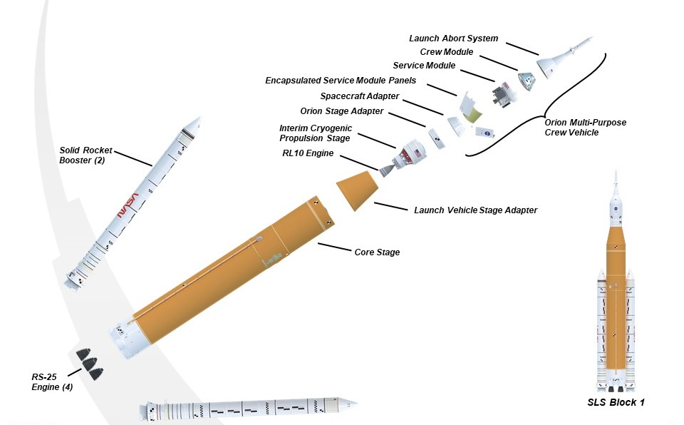

**Fig. 4 Expanded view of the Artemis I Block 1 vehicle.**

1. **SLS Progress**

Many important milestones were reached by the NASA-industry team over the past year in preparation for the Artemis I launch, as well as the assembly and development of hardware for the next missions and versions of the SLS rocket. This section will detail the progress made.

1. **Artemis I**

Stacking and integration operations on the mobile launcher began in late 2020 and made significant progress in 2021. The SRBs began stacking on the mobile launcher in the VAB at KSC in November 2020. The process was completed in March 2021. Stacking involved first placing the aft skirt assembly, which includes the aft segment, on the hold-down bolts on the mobile launcher. The four additional propellant segments of each booster were then carefully positioned, aligned, and pinned before the forward nose assemblies were mated. Following stacking, teams conducted push-pull tests on the boosters to more thoroughly understand their dynamics.

Approximately two minutes into flight, the SRBs will complete their mission and separate from SLS. Separation involves the firing of eight booster separation motors (BSMs) on each booster. These BSMs use solid propellant and each has a thrust of 20,000 pounds.

Next to be stacked was the core stage. The central section to the SLS vehicle was transported from Stennis Space Center (SSC) to KSC in April, following a successful Green Run test series. Once it arrived at KSC, the Artemis I core stage was moved into the transfer aisle of the VAB where it underwent further refurbishment from the hot fire test prior to lift and mate with the SRBs on the mobile launcher. Primarily, this involved touch-up and repair of thermal protection.

The LVSA was stacked on June 22. The adapter connects the core stage to the integrated upper stage-spacecraft element. It also protects part of the ICPS – including its RL10 engine – during ascent. The adapter is built in two primary segments: an upper cone and a lower cone. Once they are individually complete, they are joined and undergo non-destructive evaluation (NDE) to ensure structural integrity. The adapter is built using friction stir welding performed by advanced robotic tooling at NASA’s Marshall Space Flight Center (MSFC). Following welding and NDE, thermal insulating foam is applied to the adapter to ensure the cryogenic propellants in the ICPS are kept cold and that the avionics and RL10 engine maintain proper temperature during ascent through the atmosphere. While the same spray-on foam insulation (SOFI) is applied robotically to the core stage, it’s manually applied to the LVSA.

The ICPS was stacked on July 5, following loading of its hypergolic propellants earlier this year. The hypergolics will be used on the stage’s reaction control system. The LH2 and LOX for the stage’s RL10 engine will be loaded at the launch pad.

The OSA structural test article (STA) and Orion mass simulator (MSO) were stacked on the ICPS for a series of tests that will be detailed later in this paper (Fig. 5). Following the tests, they will be de-stacked, and the flight OSA will be mated in October. The OSA, like the LVSA, is manufactured at MSFC, using friction-stir welding before undergoing non-destructive evaluation. Prior to its move to the VAB and stacking, it was processed at KSC, where it was loaded with 10 CubeSat secondary payloads. Nine of the payloads were loaded into their dispensers when they were ready, while the tenth, BioSentinel, was the last to be loaded before the OSA move to the VAB. BioSentinel is a biological experiment and remained in cold storage until it was time to be loaded.

**Fig. 5 The Orion mass simulator was stacked on the Artemis I rocket for modal testing on SLS prior to the Artemis I launch.**

Artemis I originally had 13 6U CubeSats manifested, with universities providing several of the payloads. These university labs, as well as some NASA projects providing Artemis I CubeSat payloads, were adversely affected by the COVID-19 pandemic. In order to give the payload developers additional time to ready their CubeSats, NASA’s Exploration Systems Development (ESD) decided to use the OSA STA temporarily in the stack for modal vehicle tests while the small satellites are simultaneously being installed in the flight OSA in a parallel processing flow. Ultimately, at the time of this writing,10 payloads were able to make the deadline for installation into commercial off-the-shelf (COTS) dispensers and battery charging. The Outstanding MOon exploration Technologies demonstrated by NAno Semi-Hard Impactor (OMOTENASHI) CubeSat from the Japanese Space Agency (JAXA) can be seen in Fig. 6 as its team prepares it for the Artemis I launch.

The flight OSA, Orion capsule and European Service Module to join SLS on the mobile launcher are set to be mated to SLS. Prior to stacking, Orion’s Launch Abort System (LAS) was integrated with the crew and service modules in KSC’s Launch Abort System Facility (LASF). Orion is scheduled to be moved from the LASF to the VAB in October, where it will be stacked and integrated with SLS. Following checkouts, the integrated rocket-spacecraft will roll out to the launch pad for a series of tests, including the vital Wet Dress Rehearsal (WDR). A projected launch date will be announced after WDR and return of the vehicle to the VAB for final checkouts.

While stacking operations have been underway, teams have been conducting a series of tests, checkouts, and software loads of individual elements as well as integrated systems.

On August 6, the core stage was powered on for the first time since being stacked on the mobile launcher. The power-up enabled engineers to perform a checkout of the systems. While the stage was powered, the flight software was loaded onto the three onboard computers and the avionics systems. The software was developed at MSFC and thoroughly tested in the center’s Software Integration Laboratory/Software Integration and Test Facility. Software was also loaded onto the engine controllers on the RS-25 engines and the avionics units in the forward skirts of the SRBs.

In addition to software loading, teams have been and are in the process of performing multiple tests on the rocket. The Integrated Modal Test was a five-day test series where the SLS stack with the MSO and OSA STA were subjected to vibrations at different frequencies and locations to understand the natural frequencies of the rocket. The test series used seven hydraulic shakers placed on the rocket and mobile launcher to create the vibrations. A mobile hammer on a dolly was moved on the mobile launcher, and a specifically calibrated hammer was used on specific locations near the navigation units. The data are used to verify models and refine flight software so when SLS is in flight, the vehicle’s guidance systems respond to the right movements, safely guiding the rocket to space.

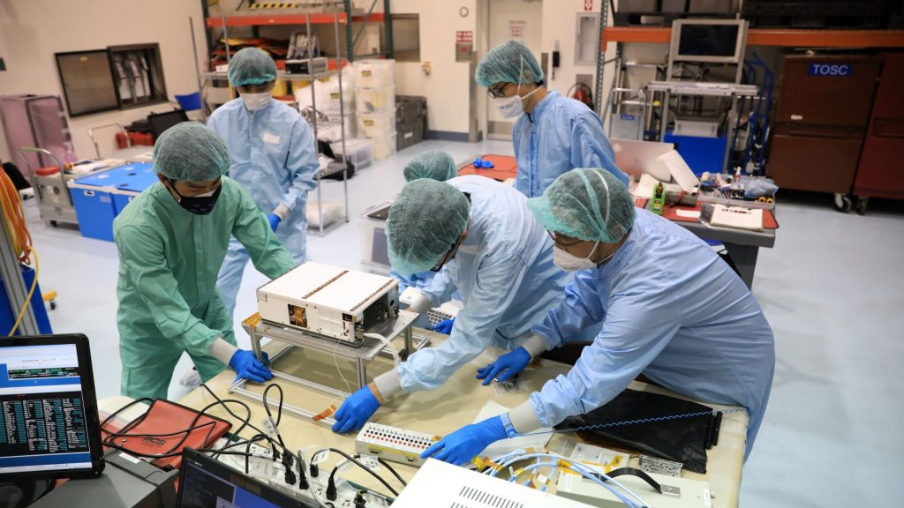

**Fig. 6 The OMOTENASHI (Outstanding MOon exploration Technologies demonstrated by NAno Semi-Hard Impactor) team prepares its secondary payload for a ride on NASA’s Space Launch System rocket during the Artemis I mission. If successful, OMOTENASHI will be the smallest spacecraft ever to land on the lunar surface and will mark Japan as the fourth nation to successfully land a craft on the Moon.**

Engineers at MSFC performed final checks and began loading the flight software onto flight computers. The flight software load occurred during multiple events during which computers and systems for the SRBs, core stage, RS-25s, ICPS, and other components were powered. During power-up, systems were evaluated for health and how they communicate with other systems and ground teams at KSC, JSC, and MSFC.

Teams are also preparing for launch by conducting countdown and mission simulations. These activities include teams at KSC, the SLS Engineering Support Center (SESC) at MSFC, the Flight Operations Directorate at Johnson Space Center (JSC), and several contractor locations and are critical to pre-launch and launch success. The simulations provide the teams practice with the procedures and enable refinement of the communication pathways, as the SESC will be monitoring data and camera views of the rocket to support the KSC Launch Control Center (LCC). The SESC also supported the Green Run test series, collecting and storing data for analysis.

As previously mentioned, the Artemis I core stage underwent a series of tests at SSC called Green Run. This series culminated with a successful hot fire test of the four RS-25 engines for the Artemis I flight that were installed on the core stage in 2019. They were tested as an integrated unit with the core stage during the Green Run test series in 2020 and 2021. The eight-part Green Run test series began in February 2020, and on January 28, 2021 the first hot-fire test of all four engines and the core stage was conducted. Despite shutting down earlier than planned, the test resulted in useful data for engineers. On March 18, a full-duration hot-fire test was successfully conducted at SSC, and the Green Run test series was complete.

The hot-fire test was the final test of Green Run, which included a number of tests and first-time events to ensure smooth integration and operation of the core stage:

* Test 1: Apply forces simulating launch to the unpowered, suspended core stage to verify vehicle models needed for the operation of the rocket’s guidance, navigation, and control systems
* Test 2: Turn on and check out the avionics on the core stage to ensure the computers and software boot up as expected
* Test 3: Simulate potential issues to test systems that shut down other systems if there’s a problem to verify that the vehicle will detect and protect itself and systems in the event of a failure or anomaly
* Test 4: Test main propulsion components that connect to the engines to ensure the commands are performed as expected and the valves and other hardware respond as expected
* Test 5: Test thrust vector controls and check out all of the related hydraulic systems, verifying that the RS-25 engines can steer the rocket
* Test 6: Simulate launch countdown to validate timeline and sequence of events
* Test 7: Load and drain more the more than 700,000 gallons of LH2 and LOX from the stage
* Test 8: Fire all four RS-25s for up to eight minutes

**  
Fig. 7 The 212-foot SLS core stage is transported to the VAB in April.**

The stage was removed from the B-2 test stand following the successful hot fire test and was loaded on the Pegasus barge and transported to KSC. April 27 was arrival day for the stage at KSC, where it was unloaded and transported to the VAB on April 29 (Fig. 7). NASA’s Exploration Ground Systems (EGS) and integration contractor Jacobs took the lead, and the core stage then underwent refurbishment in the VAB’s transfer aisle before being mated. Mating itself is a complex process that involves transitioning the 188,000 pound stage from its horizontal position to the vertical position. Once vertical, the cranes lift it into the VAB’s High Bay 3 and precisely lower it in between the twin SRBs. The SLS Program provided a full-scale “pathfinder,” or mockup hardware, for crews in the VAB as well as transportation crews and other location to practice with prior to handling the Artemis I core stage.

1. **Artemis II**

For Artemis II, SLS will launch Orion and its first crew to the vicinity of the Moon, where the crew will test and evaluate Orion’s performance and systems. SLS hardware for the mission is well underway at NASA and industry facilities around the country. In fact, several elements of the Block 1 vehicle for Artemis II are complete.

The SRB motor segments are completed and are in storage at Northrop Grumman’s facility in Utah. Along with the motor segments, the booster forward skirts are being outfitted with instrumentation and thermal protection systems. The aft skirts, thrust vector control systems, and booster separation motors are also in various stages of assembly.

Major components for the Artemis II core stage have been manufactured at Michoud. On May 18, the LOX tank and intertank completed the multi-day mating operations, completing the first part of the major forward join (Fig. 8). The forward skirt mated to the LOX tank May 24, forming the forward join. Teams have started applying the thermal protection system to the LH2 tank, as part of its preparation. The engine section has been mated with the boattail. The RS-25 engines for Artemis II are complete and are awaiting shipment to Michoud.

Michoud was affected by Hurricane Ida on August 29, but no substantial damage was done to the SLS hardware. Roofs of numerous building at the facility were damaged. Clean-up and repair operations are underway.

**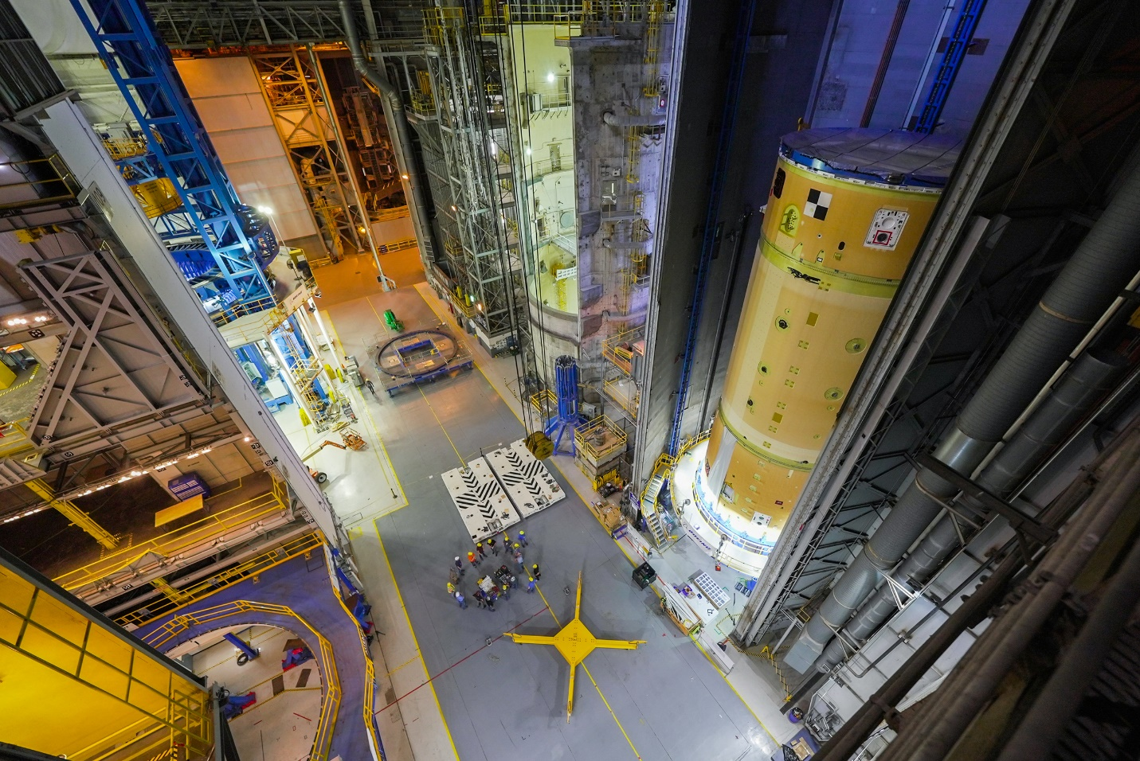  
Fig. 8 The Artemis II core stage forward skirt, liquid oxygen tank, and intertank are joined at NASA’s Michoud Assembly Facility.**

The LVSA has completed welding at MSFC’s Advanced Weld Facility and teams are currently applying thermal protection. Welding is also complete on the OSA, and non-destructive evaluation is underway on the diaphragm that protects the crew module from gases generated during launch. Unlike Artemis I, the Artemis II OSA will not have secondary payloads aboard.

The ICPS was shipped from ULA’s Decatur, Alabama, manufacturing facility to the company’s location at Cape Canaveral, arriving on July 28 (Fig. 9). The stage is undergoing final outfitting before being delivered to NASA.

**Fig. 9 The Artemis II ICPS arrives at ULA’s facilities in Florida July 28.**

1. **Artemis III and Beyond**

Components for Artemis III and Block 1B vehicles are also in manufacturing, assembly, and testing.

Hardware for the Artemis III core stage is being manufactured at Michoud. The LH2 tank is structurally complete and is being analyzed for any defects, and the LOX tank is in early manufacturing. The engine section is also structurally complete and being outfitted with its thrust beam and engine gimbal assemblies. The intertank and forward skirt are also making progress. The RS-25s are in processing, with one engine and all four engine controllers complete. Vertical welding for the LVSA and OSA is completed. Non-destructive evaluation is underway on the LVSA and has already been completed on the OSA. Refurbishment of heritage SRB forward assemblies and aft assemblies is underway at KSC, and the 10 motor segments have been cast at Northrop Grumman’s facilities in Utah. Early production of the ICPS has begun, and its RL10 engine is complete.

The first of the new-production RS-25 engines, to be flown on the Artemis V and future missions, have begun manufacturing. Prime contractor Aerojet Rocketdyne has started stacking and brazing of exhaust nozzles and their regenerative cooling tubes. Powerheads, main combustion chambers, and turbomachinery are also in various phases of manufacturing (Fig. 10).

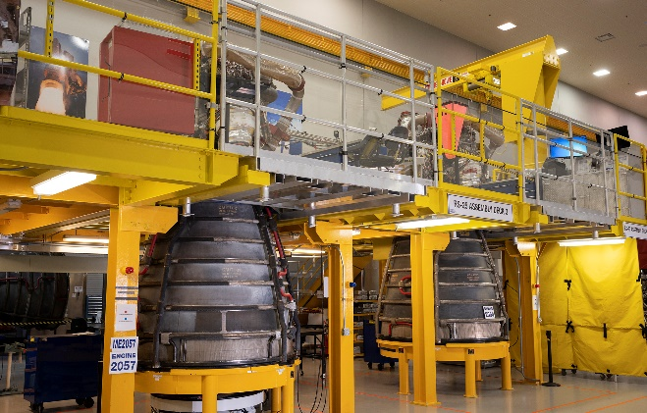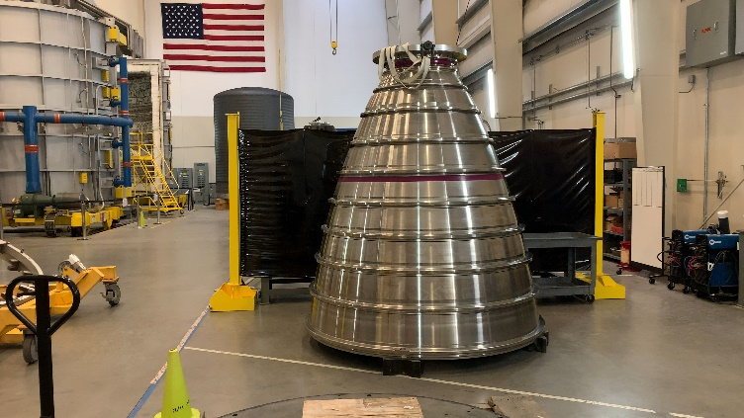  
**Fig. 10 Two RS-25 engines for the Artemis III mission undergo inspection at SSC, left, and an RS-25 nozzle from the new production line for Artemis V and beyond, right.**

SRB motor cases for Artemis IV are being refurbished now, with the first segment scheduled to be cast with propellant in November 2021. Following the eighth flight of SLS, the program will run out of shuttle-heritage booster cases. Beginning with the ninth flight, composite motor cases, new nozzle hardware, propellant, forward and aft structures, nose cap and frustrum structures, avionics, and electronic thrust vector control systems for the evolved boosters will be introduced. The evolved boosters will define SLS’s Block 2 (Fig. 11).

**Fig. 11 Manufacturing for the evolved boosters is underway including the aft cylinder and aft dome, left, and the forward cylinder tang end ring, right.**

Core stage components for Artemis IV have started construction at Michoud, including the forward skirt and engine section. Weld confidence articles for the EUS are being produced, and the EUS LH2 STA is scheduled to begin manufacture in late 2021. Design work on the new payload adapter (PLA) is continuing. Universal stage adapter (USA) panels for Block 1B have been manufactured.

1. **Missions Beyond Artemis**

While SLS is capable of launch humans on the most ambitious exploration missions ever undertaken, it is also a prime candidate to launch robotic and satellite missions into deep space. SLS has more payload capacity and volume than any currently available commercial rocket and can reduce transit time to deep space destinations by years. The capability also decreases the need for spacecraft miniaturization and complicated deployment processes. These benefits mean scientists and mission planners can have complex, robust spacecraft that return enhanced science from their deep space destinations sooner and with less risk than would be possible with the multi-planet slingshot maneuvers required of less powerful launch vehicles.

1. **Test Programs**

In addition to building and preparing flight hardware, NASA and its partners conducted and concluded multiple tests of various systems.

NASA and Aerojet Rocketdyne kicked off the latest series of RS-25 single engine tests in support of SLS in January 2021. The seven hot-fire tests in the A-1 test stand at SSC will evaluate new engine components and reduce risk during engine operation. A variety of conditions will be used to verify the engine’s capabilities. The data will then be used to improve production of new engines and components using advanced manufacturing techniques such as additive manufacturing (Fig. 12).

**  
Fig. 12 An RS-25 rocket engine is tested at SSC in August.**

SRB upgrades and evolutions have been supported by multiple hot-fire tests in Utah and at MSFC. Some of the tests provided data to help qualify the current SLS SRBs. Other tests evaluate new propellant ingredients from new vendors to help build the supplier base while reducing costs and improving booster performance. New solvents and other materials for preparation of the boosters and for use in the boosters are also under evaluation in this test program. The Booster Obsolescence and Life Extension (BOLE) contract modification will also be developing test programs that will supply critical data needed in building and using new booster segments when the supply of Space Shuttle Program segments has been depleted (Fig. 13).

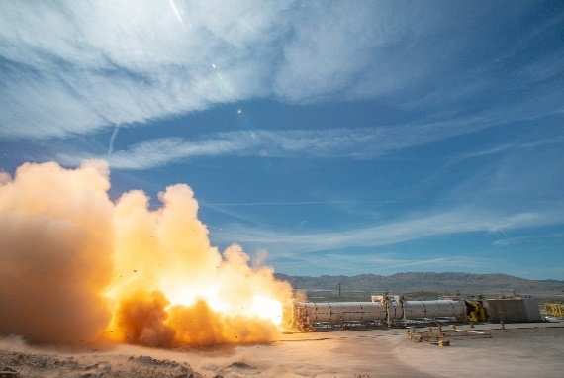

**Fig. 13 A subscale solid rocket motor test, left, at MSFC supports the evolved boosters, while a full-scale SRB test Utah, right, evaluates potential new materials and processes for missions beyond Artemis III.**

1. **Summary and Conclusions**

NASA and its industry partners made significant progress on SLS rockets for Artemis I and future missions during the last year. The Artemis I rocket is stacked with the SRBs, core stage, LVSA, ICPS, and OSA at KSC’s VAB. The Orion spacecraft will be stacked and integrated in coming weeks. Software for the rocket’s computers, engines, and boosters have been loaded onto flight computers and avionics systems, and the secondary payloads for the mission are integrated. Multiple test programs, including the Green Run test series and the Integrated Modal Tests have been completed that help verify and refine the vehicle’s behavior and computers. Once Orion has been mated and integrated, the stack will be transported to launch complex 39B for the wet dress rehearsal. The activity is the final major test before launch and will test the teams, systems, and countdown and tanking and de-tanking procedures. Once complete, SLS and its payloads will roll back to the VAB where teams from EGS and Jacobs will perform the final checks and closeouts before launch of the Artemis I mission.

While Artemis I is in final preparations for launch, hardware and components for Artemis II, III, IV, and V continue to be manufactured and processed. This ensures the launch vehicles for the next missions are ready to support NASA’s continued Artemis missions.

SLS is not simply one rocket or one version of a rocket. It is platform which will serve as a backbone for NASA and the nation’s most ambitious human and robotic exploration mission for decades to come. With SLS, the history and science books will be re-written because of the discovery the vehicle and its unmatched capabilities will enable.

1. Manager, Space Launch System Program.
2. Deputy Manager, Space Launch System Program.
3. Chief Engineer, Space Launch System Program, AIAA Associate Fellow, #101797.