Jordan Lindsey  The Aerospace Corporation  2525 Bay Area Blvd, Houston, TX 77058  jordan.lindsey@aero.org | John Swatkowski  The Aerospace Corporation  2525 Bay Area Blvd, Houston, TX 77058  john.swatkowski@aero.org
Machine Learning for Extravehicular Mobility Unit (EMU) Glove Inspections
This document has been reviewed for Proprietary, SBU, and Export Control (ITAR/EAR) and has been determined to be non-sensitive. It has been released to the public via the NASA Scientific and Technical Information (STI) Process (Document ID 20210022286).

Abstract: The Extravehicular Mobility Unit (EMU) Glove Machine Learning Inspection project utilizes machine learning to expedite the inspection, analysis, and recommendation for continued use of space suit gloves after spacewalks. Today, ISS EMU glove photos are individually reviewed by a team of experts to determine the conditions of space suit gloves. For this project, the Microsoft Azure platform is used to perform Automated Machine Learning (AutoML) to detect issues with tagged images from previous Extravehicular Activities (EVAs) to build a predictive model. The model analyzes a test image and deems the glove GO or NO-GO for additional EVAs. The goal for this ML project is to decrease the time spent reviewing images by ground personnel and crewmembers in high frequency EVA locations such as the Moon and Mars. For destinations such as the Moon and Mars, the goal is to increase crew autonomy in determining glove conditions with limited support from Earth. This paper will outline the results to date and future work needed to expand the capability for in-situ recommendations.
Contents
2 INTRODUCTION 1
2.1 ISS EVA Operational Environment 2
2.2 Post-EVA Glove photo analysis 3
3 METHODOLOGY 4
3.1 Gathering Images 4
3.2 MICROSOFT AZURE setup 4
3.3 Preliminary Results 5
3.3.1 RTV Wear Labels 5
3.3.2 RTV Trim Labels 5
3.3.3 Vectran Damage Labels 6
3.3.4 Thumb view of Vectran damage 6
3.3.5 Visible Vectran Damage Labels 7
3.3.6 Class III Damage 7
4 Conclusion 7
5 Future Work 8
6 References 8

INTRODUCTION
The process to determine the ability for repeated use of EMU gloves in subsequent spacewalks relies on human operators to photograph, inspect and analyze the worn gloves. With the prevalence of machine learning algorithms used for detection in non-aerospace fields such as radiology for cancer diagnosis and routine inspection of various critical infrastructure, this technology can be similarly applied to the time intensive task of EMU glove inspections. This project’s goal is to examine automation of the human-centric process for EMU glove inspections by utilizing existing photos to train an AutoML algorithm to detect various modalities of damage in gloves and recommend a GO/NO-GO decision for continued glove use. Additionally, this project lays the groundwork to support NASA’s Artemis Program operations by providing a real-time glove reuse recommendation to support increased frequency of EVAs on Moon and Mars missions.
There is a long history of spacewalks occurring in different regions of space from the limited EVAs of the Gemini Program, the lunar surface EVAs of the Apollo Program, and the microgravity EVAs of the Space Shuttle and International Space Station (ISS) Programs. Each of these programs saw changes and improvements in glove design, durability, and dexterity. For this project, we focused on the EVA gloves used for construction and maintenance of the ISS. For ISS operations, EVA glove design has remained relatively stable, allowing for a dataset of images to be collected and applied to a AutoML process for image analysis. To understand the wear and deterioration of EMU gloves, the following section will illuminate the harshness of the environment and severity of possible consequences from the damage sustained through use.

ISS EVA Operational Environment
ISS utilizes the astronaut-worn EMU to perform spacewalks for maintenance, repair, and upgrades to the ISS. EVA operations deteriorate the EVA gloves; this deterioration can lead to spacewalk termination, or in the worst case, loss of the crew. Part of the process for preventing failure of the glove material is to conduct post-EVA visual inspections of EMU glove photos by ground personal. Visual recognition via machine learning provides a means to reduce the overhead of ground personnel manually inspecting photos for damage.
The ISS Low Earth Orbit (LEO) microgravity requires crewmembers to use their hands to translate to and from worksites on the exterior of the ISS. To aid in translation, hundreds of EVA handrails made of aluminum are installed on the ISS modules and trusses.
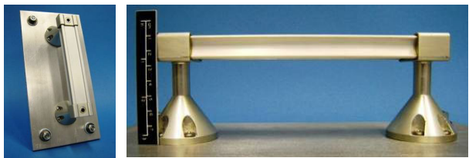
Figure 1 ISS handrail design, called dog bone cross section.
Over the ISS operational life, these handrails have been struck by micrometeoroid and orbital debris (MMOD) that leave behind small impact craters and or pass completely through the handrail, leaving sharp edges that the crew encounter during EVA. The sharp edges can result in snags and cuts in the EMU gloves, which can lead to punctures of the space suit’s inner bladder layer, causing oxygen leakage and resulting in a termination of the EVA or a potential loss of life.
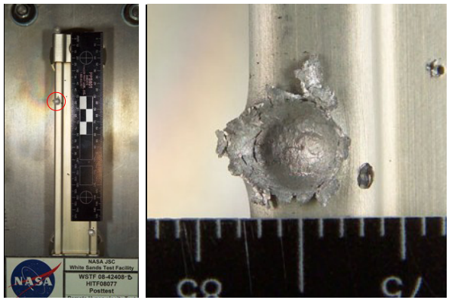
Figure 2 MMOD testing producing a raised lip and sharp edge that could cut the EMU Outer TMG layer. Credit (Ryn2009)
Spacewalk EMU Gloves have a total of 3 layers: an inner bladder, a restraint layer, and a thermal micrometeoroid garment (TMG) layer as shown in Figure 3. Puncturing the EVA glove inner most layer is not always instantaneous and can occur from sharp edges or degradation of the glove materials during an EVA. These degradations are the result of multiple EVAs of contact with abrasive surfaces. To prevent degradation leading to a penetration of the inner most glove layer, the bladder, the crewmember performs two types of glove inspections. First inspection, during the EVA, the crewmember conducts an inspection every 90 minutes, after major translations, and after hand-intensive tasks. Second, post-EVA, crewmembers take a series of photos of each glove in specific orientations, which are then reviewed by experts on Earth to determine whether the EMU gloves are GO or NO-GO for subsequent EVAs. This paper will focus on the second type of glove inspection.

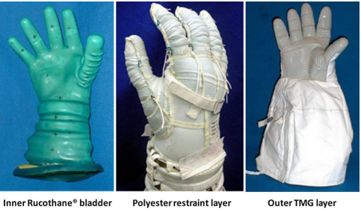
Figure 3 The 3-part EMU Glove assembly. The outer TMG layer with RTV is the focus of this paper. Credit: (Shockey, Piascik, Jensen, Hewes, & Sutter, 2013)
The focus of the post-EVA inspection is to identify deterioration in the outer TMG layer that may propagate into the inner layers thereby resulting in a glove not being suitable for future EVAs. The Outer TMG layer is composed of 3 types of material to provide maximum protection, thermal comfort, and cut resistance. The palm area of the TMG is a Vectran yarn; a loose knit fabric that facilitates hand and finger movement. The palm and fingers are covered in a room temperature vulcanized silicone rubber (RTV). The Vectran is lightly coated with RTV that permeates between the knitted yarn to aid in the adhesion of the RTV pads to the TMG. Thee RTV pads are closely analyzed to determine if wearing or peeling has taken place. The next area of interest is the detection and labeling of Vectran damage. Damage to the Vectran cloth results in a NO-GO condition and could lead to a potentially catastrophic depressurization condition for the EMU and crewmember wearing it.

Post-EVA Glove photo analysis
The use of image recognition software offers the possibility of quickly and repeatedly analyzing image datasets, resulting in reduced the turnaround time for recommending GO/NO-GOs for future EVA use. In contrast, the standard process in place today, with ground personnel inspecting and approving images, can take up to 5 days to complete. To understand the length of time taken to make a final recommendation of GO or NO-GO for a pair of EMU gloves, requires a review of the post-EVA human-centric glove analysis process. The steps of the human-centric process are: 1) The crew takes EMU glove photos aboard ISS in specific orientations as depicted in the Post-EVA Glove photos procedure on board; 2) The crew transfers the photos to a laptop; 3) The Flight Operations Team downlinks photos to Mission Control Center (MCC); 4) The Flight Operations Team relocates the imagery to an internal NASA photo database (Imagery Online (IO)); 5) The EMU glove contractor team performs an analysis of the images looking for any damage or areas of concern; 6) The NASA glove review team reviews the images with the contractor in detail, enlarging and scanning for any damage; 7) The glove review team makes a GO/NO-GO recommendation for each pair of gloves; 8) The recommendation is reported to the Flight Operations team, documenting any areas of concern or rationale for GO/NO-GO decision. The expert panel takes all images for a given pair of gloves into account to build a recommendation.
As shown in the process overview, the workflow is dependent upon the ground team for ISS operations. On average, there are 10 US EVAs per year typically spread throughout the year with weeks between EVA excursions. For Artemis missions to the Lunar surface, and missions further into the solar system, the frequency of EVAs will increase, possibly even to the point of occurring on back-to-back days. With the increase in frequency of EVAs, and restrictions on communication bandwidth back to Earth, dependency on the ground team will need to be reduced or eliminated to give the crew enough autonomy required for success at the planned operations tempo.

METHODOLOGY
For this analysis, the team chose to focus on US EVAs conducted in the construction and maintenance of the ISS up to and including US EVA 77, completed on September 12, 2021. This EVA marks the 244th US EVA in the construction, maintenance, and upgrade of the ISS. For many of those EVAs, there are notes from the glove review team indicating whether deterioration of the outer TMG layer had occurred and whether the glove was recommended as GO/NO-GO. In the case of the machine learning algorithm, each glove image is reviewed and tagged based on any defects visible. If the image shown is free from defect, “RTV Wear,” “RTV Trim,” paint, threads, and Vectran damage, the image is labeled GO. For the progressive analysis with each Azure model iteration, there were fewer and fewer images that were labeled only GO. Each human labeling scan added more images to tag categories other than Vectran damage and NO-GO. It is assumed in the analysis that Vectran damage and NO-GO are mutually inclusive

Gathering Images
To build the first model, images had to be added to the Microsoft Azure platform. This started with a query of the Imagery Online (IO) database for images of EMU gloves. As part of their EVA training, each member of the crew is instructed to start the series of photos by taking a picture of his or her unique identifier on the inside of the glove. The ground team uses next unique identifier photo to indicate that member’s specific photos will follow. In IO, various metadata fields are used to identify photos as “Inspection”, “Extravehicular Mobility Units”, “Gloves” which make it easier to locate all the photos associated with this task. Using these metadata, approximately 3100 images of EMU gloves were gathered. Those images were downloaded to a local computer to then be separated between GO or NO-GO.
With the aid of the quick status reports from the post-EVA glove analysis reviews, the team identified and tagged gloves from various ISS Increments (i.e. INC-065) that were deemed NO-GO by the review panel. Those identified NO-GO images were separated from the image dataset of total glove images. The remaining images were reviewed to find and delete any that were not related to this analysis. This included images of EMUs and crew identifiers inside the gloves. It was assumed all gloves not removed were GO gloves. Combined, the GO and NO-GO photos were reduced to a set of approximately 2800 images. The image dataset was then split into training and test datasets. The ratio of training images to test image data was 90% / 10%, respectively. This initial training dataset was used for iteration 1 of our model with the following model parameters: 18-hour training time, with the use of single tags on images. Despite the arbitrary selection of 18-hours as the training time, this training time remained constant throughout all model iterations to reduce the number of variables.
To help bolster the dataset of damaged gloves, Adobe ACDSEE photo editing software was used to augment the original photos by rotating them in 90-degree increments. This resulted in a 3:1 growth in the damaged dataset. Even with the growth, there remained an imbalance in the training set of nearly 6:1 (GO Gloves to NO-GO gloves). To offset this imbalance, additional photos were added of damaged TMG from Class III (non-space rated; training) units used in Neutral Buoyancy Laboratory (NBL) training events. An example of the excessive wear on Class III gloves is shown in Figure 4. A primary difference in the Class III gloves vs the flight gloves is the damage of the Class III gloves outer TMG layer far exceeds the minimal threshold for labeling a glove NO-GO.
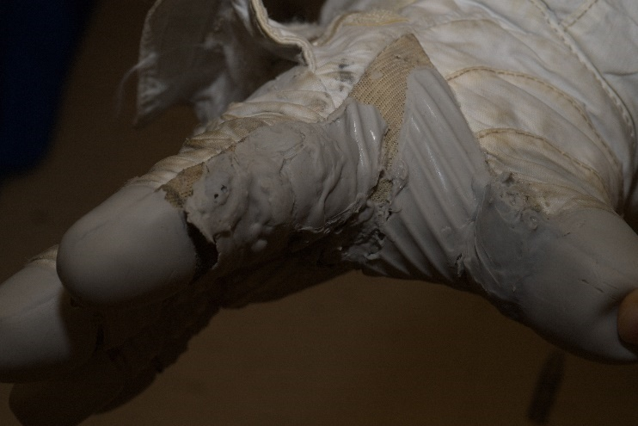
Figure 4 Class III Outer TMG Layer used for NBL training events.

MICROSOFT AZURE setup
The initial setup for tagging images in Microsoft Azure was to allow for a binary classification of the glove photos. Either the images were decidedly GO or NO-GO and tagged as such. Starting with iteration 3 of the model, additional tags were added to the photos to provide classification of the type of deterioration on the glove alongside the gloves original binary classification of GO and NO-GO. By iteration 5, all photos were tagged as GO or NO-GO and, when applicable, included a combination of the following tags: “RTV Trim,” “Vectran Damage,” “RTV wear,” paint, threads, or Mylar. Table 2 shows how additional tags were applied over each model iteration. As every photo was tagged GO or NO-GO, the total values shown in Table 2 are inclusive of the types of damage tags.
Model Iteration | Precision | Recall | AP
1 | 99.6 | 99.6 | 99.7
2 | 99.2 | 99.5 | 99.4
3 | 98.5 | 98.4 | 99.0
4 | 97.9 | 97.3 | 99.5
5 | 98.1 | 97.0 | 98.4
6 | 98.0 | 97.9 | 99.2
7 | 96.2 | 96.0 | 98.8
8 | 97.3 | 95.5 | 99.2
9 | 93.9 | 88.6 | 96.7

Table 1 Data table with Model parameters (Precision, Recall & AP) per iteration.

Image Tag | 1 | 2 | 3 | 4 | 5 | 6 | 7 | 8 | 9
GO | 2598 | 2598 | 2598 | 2598 | 2598 | 2685 | 2685 | 2696 | 2183
NO-GO | 128 | 424 | 427 | 427 | 420 | 425 | 424 | 424 | 974
Vectran Damage | N/A | N/A | N/A | N/A | N/A | 68 | 79 | 556 | 691
RTV Trim | N/A | N/A | 77 | 77 | 117 | 106 | 106 | 401 | 658
RTV wear | N/A | N/A | N/A | N/A | N/A | 180 | 180 | 328 | 854
Paint | N/A | N/A | N/A | N/A | N/A | 105 | 105 | 819 | 1528
Threads | N/A | N/A | N/A | N/A | N/A | N/A | N/A | 839 | 928
Mylar | N/A | N/A | N/A | N/A | N/A | N/A | N/A | 134 | 183
Table 2 Data table showing image count per tag and iteration.

Preliminary Results
To show changes in the classification probabilities between iterations, four photos were chosen and tested against each iteration of the model. Beginning with Table 7, the probabilities of a particular classification tag being applied to the test image are shown. As additional tags were added to the original binary classification of GO/NO-GO, the probability of a classification being of that original binary classification decreased for some of the test photos. While still correctly classifying the image, the model’s probability of GO vs NO-GO had gone from 90% NO-GO to approximately 50%. GO classification probabilities also had changed increasing from ~1% to about 10%. While the percentage points difference between the two is significant, as that difference decreases, it will eventually lead to a point where the model outcome is no longer trustworthy. Currently, there is no known threshold for where trust in the model’s output no longer exists.

RTV Wear Labels
In Figure 7, there are two types of RTV deterioration present, “RTV Wear” and “Trimmable RTV shearing”. At the base of the index finger RTV pad, “RTV Wear” is visible. This is where the RTV pad is worn away during EVA. This type of damage is common and is not justification to tag a glove as NO-GO. However, if there are threads protruding through the RTV pad, or the entire RTV is worn away, and Vectran is exposed, a deeper investigation and review occurs. Wear with or without protruding threads was tagged “RTV Wear” in later iterations of the model.

RTV Trim Labels
There is a potential for the RTV to wear in such a way that an entire layer of RTV peels away from an underlying RTV layer. While the damage itself can produce foreign object debris (FOD) if the peeled layer were to be liberated during an EVA, this type of damage can be corrected post EVA by trimming away the flap. Figure 7 depicts RTV layers peeling that can be trimmed. Deterioration of the RTV in a shear layered pattern is not absolute justification for a NO-GO. After trimming, if the subsequent layer of RTV is still intact and not showing underlying Vectran, threads, or mylar, the review panel will recommend the EVA gloves as GO. Trimmable RTV damage resembles NO-GO RTV damage and may be a potential area for some model iterations incorrectly identifying or having reduced confidence via probability in the classification of the image. Results shown in Table 1 illustrate an increase in the model’s ability to predict “RTV Wear,” coinciding with an increased dataset of that condition in that training iteration, while slightly reducing the ability to predict “RTV Trim.” Some images previously tagged as “RTV Trim” only were reviewed and found to have cases of “RTV Wear”, potentially leading to “cross talk”, reducing the “network connections” between layers.
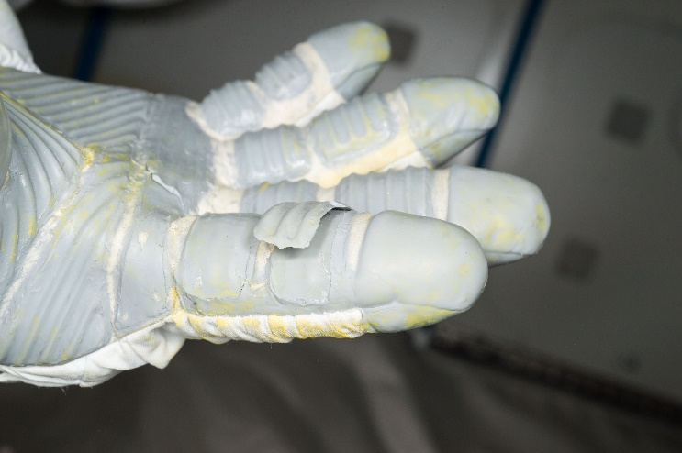
Figure 7 RTV detached from the adjacent layer of RTV. This damage would result in a recommended "RTV Trim" scenario. Also visible is yellow paint on the glove.
** During these model iterations NO-GO and Vectran Damage were a combined tag.
Iteration/Tag | 1 | 5 | 8 | 9
GO | 0.1 | 0.0 | 0 | 0
NO-GO | 99.9 | 99.9 | 99.9 | 99
RTV Wear | N/A | N/A | 65.6 | 85.8
RTV Trim | N/A | 98.4 | 95.9 | 91
Vectran Damage | N/A** | N/A** | 0 | 0.1
Table 3 Iteration vs tag probability for test image shown in Figure 7.

Vectran Damage Labels
The most concerning type of damage is to the Vectran layer. In this modality, the crew has encountered something sharp enough to go through the RTV layer and damage the cut-resistant Vectran layer. Shown in Figure 8, near the center of the photo, Vectran threads have been pulled up, indicating there has been a snag-and-pull motion that caused the damage . Figure 8 is also indicative of the type of photograph crew would take to indicate an area of concern for the ground team to observe. In this case, the free end of a Vectran thread has been pulled through the weave. This thread could lead to a widening of the exposed area where the RTV is missing, exposing the polyester restraint layer to possible damage.
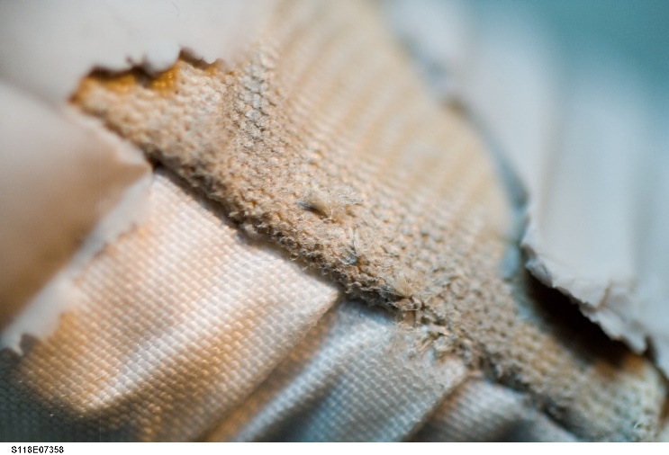
Figure 8 Close up view of Vectran damage in thumb area with RTV coating missing.
Iteration/Tag | 1 | 5 | 8 | 9
GO | 0 | 0.0 | 0 | 1.5
NO-GO | 99.9 | 99.7 | 99.3 | 91.6
RTV Wear | N/A | N/A | 0 | 5.3
RTV Trim | N/A | 0 | 0.2 | 0
Vectran Damage | N/A** | N/A** | 81.6 | 57.1
Table 4 Iteration vs tag probability for test image shown in Figure 8.

Thumb view of Vectran damage
Another version of Vectran damage is the case seen when an astronaut presses and slides his or her gloved hand along a sharp-edged surface. Figure 9 shows the case of a slicing motion of the Vectran yarn fibers, allowing a gap to open near the thumb seam. This is a known high-wear area for the gloves and has had various mitigation strategies implemented since the issue in the photo was detected.
The results for each tag are shown in Table 3 below. For the image seen in Figure 9, model iteration 1 resulted in a tie in the classification of whether the glove was GO or NO-GO. While model iteration 5 tagged the same image as “NO-GO” but without a “Vectran Damage” tag resulting in a significant increase to the probability, and correct classification as a NO-GO condition. However, iteration 8’s assessment of the same image in Figure 9, with tags for both “Vectran Damage” and NO-GO, did not correctly predict Vectran damage and the probability of a correct classification of NO-GO decreased.
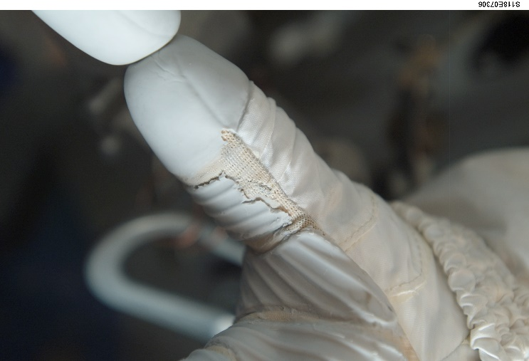
Figure 9 Image showing Vectran damage on thumb. This is considered "Vectran Damage" and a "NO-GO" condition.
Iteration/Tag | 1 | 5 | 8 | 9
GO | 63.3 | 7.9 | 2.8 | 1.9
NO-GO | 62.4 | 95.6 | 48.6 | 92.7
RTV Wear | N/A | N/A | 0.1 | 3.5
RTV Trim | N/A | 0 | 1.5 | 0.6
Vectran Damage | N/A** | N/A** | 0 | 69.5
Table 5 Iteration vs tag probability for test image shown in Figure 9.

Visible Vectran Damage Labels
The buildup and construction of the EVA glove can lead to contact areas on the surface of the glove where the loading is amplified with certain hand movements, such as gripping and rotating the body’s position via wrist flexion. Areas on the polyester restraint layer, shown in Figure 3, such as the keyhole brackets (blue aluminum object) used to adjust the restraint layer for comfort and mobility are areas that increase wear on the Vectran layer. Figure 10 is an example of this resulting damage to the Vectran layer.
As shown in Table 6, the results between iteration 8 and 9 are very distinct and indicate a feature of the training data used. While the class 3 images were added in iteration 8, the increase in images with tags associated with NO-GO, “RTV Wear,” and Paint increased. This could account for the incorrect labeling probabilities shown in Table 6. Additional data to support this hypothesis is shown when the same image is flipped 180 degrees along the horizontal axis and is analyzed with iteration 9. The analyzed flipped image yields probabilities for NO-GO equal to 94.2%, Vectran damage equal to 35.5%, and RTV wear equal to 46.7%.
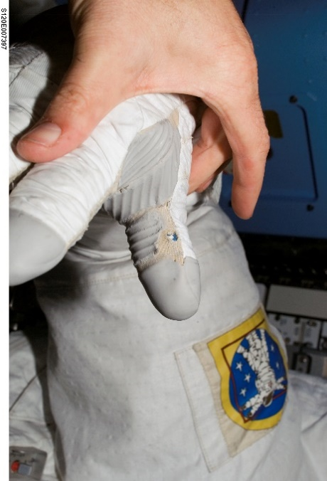
Figure 10 Visible Vectran damage to thumb area. Blue adjustment keyhole bracket visible in image.
Iteration/Tag | 1 | 5 | 8 | 9
GO | 0.1 | 99.9 | 42.1 | 83.7
NO-GO | 99.9 | 0 | 52.9 | 11.9
RTV Wear | N/A | N/A | 1.9 | 44.5
RTV Trim | N/A | 0 | 1.3 | 3.2
Vectran Damage | N/A** | N/A** | 13.7 | 4.9
Table 6 Iteration vs tag probability for test image shown in Figure 10.

Class III Damage
The Class III images used to help increase the dataset, see Figure 4, are representative of the current EMU glove design, but greatly exceed the damage allowable for use on a space-based EVA. It was mentioned that the Class III glove images were used to bolster the dataset, but they most likely led to a reduction in the models ability to predict particular tags because the differences in the amount of wear between Class I and Class III are extensive.

Conclusion
This paper has shown that using AutoML with the Microsoft Azure platform can produce a model capable of classifying GO, NO-GO and types of damage to EMU gloves. However, as shown in figure 10, adding tags to delineate types of damage negatively impacted the probabilities of the GO/NO-GO classification resulting in some misclassifications. While the current model did not detect all issues with high enough confidence to prevent the possible use of NO-GO EMU gloves, the use of AutoML has shown it is possible to train an image classification model into providing recommendation system for static images in the analysis of EMU gloves post-EVA. Further refinement of tags and number of damaged gloves is needed to improve the classification ability of the model

Future Work
Future work on the project is multifaceted. To start, the team will continue to explore the use of static images to update and improve the prediction model to provide a recommendation for GO/NO-GO. The first item to aid in classification of images will be to remove the Class III images from the training set and replace them with Class I damaged glove photos. Second will be to balance the dataset. This should help to align what the model predicts. These two updates will be worked in parallel with the Glove Expert Panel to validate the prediction of the model against their independent assessment of an upcoming, scheduled US EVA.
A follow-up task would be to use high definition video available to the ISS crew, adapt the model and lessons learned with static images and begin working a version to use real time video to make classifications. Since video has not been used previously to determine the condition and continued use for a pair of EMU gloves, there would need to be a series of tests with known conditions on the ground for the expert panel to review in order to build a training set of video data for the model. The method for proving a consistent recommendation from static images and video will need to be coordinated with the expert panel. The end goal for this machine learning project is to have the autonomous capability for the Artemis program to provide astronauts with a near real time recommendation of GO/NO-GO for continued use; allowing the crew to adapt to the autonomy that will be needed for Mars and deep space exploration.
Finally, a process must be developed in conjunction with the expert panel to identify and agree upon the probability threshold for a given image to recommend a set of EMU gloves are GO or NO-GO. Using previous analogs as a starting point, the various threshold must include the cases where a human is not required for further analysis, but specifically address what must be done for areas where the classification is not clear. This paper has shown that using AutoML with the Microsoft Azure platform can produce a model capable of classifying GO, NO-GO and types of damage to EMU gloves. However, as shown in figure 10, adding tags to delineate types of damage negatively impacted the probabilities of the GO/NO-GO classification resulting in some misclassifications. While the current model did not detect all issues with high enough confidence to prevent the possible use of NO-GO EMU gloves, the use of AutoML has shown it is possible to train an image classification model to provide a recommendation system for static images in the analysis of EMU gloves post-EVA. A further refinement of tags and an additional number of damaged gloves are needed to improve the classification ability of the model.

References
[1] Graziosi, D., Stein, J., Ross , A., & Kosmo, J. (2001). Phase VI Advanced EVA Glove Development and Certification for the International Space Station. SAE Technical Paper Series.
Hyde, J. L., Christiansen, E. L., & Lear, D. M. (2019). Observations of MMOD Impact Damage to the ISS.
Shockey, D. A., Piascik, R. S., Jensen, B. J., Hewes, L. S., & Sutter, J. K. (2013). Textile Damage in Astronaut Gloves. Journal of Failure Analysis and Prevention, 748-756.

Biography

Jordan Lindsey received a M.S. in Aerospace Engineering from the University of Cincinnati. He has been with the EVA Office at JSC for 3 years. Previously he served in EVA Operations and astronaut instruction for 10 years.


John Swatkowski received a M.S. in Astronautical Engineering from the University of Southern California. He is currently the Deputy Chief Engineer for EVA. Previously he had been supporting the EVA Office in system engineering for ISS and lunar exploration.

(Hyde, Christiansen, & Lear, 2019)
(Shockey, Piascik, Jensen, Hewes, & Sutter, 2013)
(Shockey, Piascik, Jensen, Hewes, & Sutter, 2013)
(Shockey, Piascik, Jensen, Hewes, & Sutter, 2013)
(Shockey, Piascik, Jensen, Hewes, & Sutter, 2013)

