Regenerative ECLSS and Logistics Analysis for Sustained Lunar Surface Missions
Chel Stromgren, Callie Burke, and Jason Cho  Binera, Inc.  77 S. Washington St.  Rockville, MD 20850  chel.stromgren@nasa.gov  callan.burke@nasa.gov jason.m.cho@nasa.gov | William Cirillo and Andrew Owens  NASA Langley Research Center  1 NASA Drive  Hampton, VA 23666  william.m.cirillo@nasa.gov  andrew.c.owens@nasa.gov  David Howard  NASA Marshall Space Flight Center  Martin Rd SW, Huntsville, AL 35808  david.f.howard@nasa.gov

Abstract— As NASA develops concepts for sustained crew missions to the lunar surface, a crucial component of mission planning will be evaluating the required amount of logistics to support the crew, surface systems, and science operations. This amount could be substantial. Because NASA plans to conduct these missions on an annual basis, the complexity and cost of logistics delivery will likely drive campaign sustainability. Logistics quantity is partially a function of the regenerative Environmental Control and Life Support System (ECLSS) capability in habitable elements on the surface. The regenerative ECLSS recycles human waste to produce water and oxygen, reducing the consumables needed for a mission. Thus, an ECLSS with increased regenerative capability will require less logistics. However, an ECLSS with enhanced regenerative abilities will also increase the initial delivery mass of elements and require extra maintenance items and spares. This paper analyzes the tradeoff between initial delivery masses of different regenerative ECLSS options and the amount of logistics resupply required for each option.
Sustained lunar surface missions will involve crews of two to four astronauts living on the surface for periods of 30 days or longer. Astronauts will live in some combination of a surface habitat and/or a pressurized rover. To conduct the study, the authors created the Lunar Surface Integrated ECLSS Analysis Tool to model different configurations of rover and habitat with different ECLSS options. The tool can simulate ECLSS operations in the integrated architecture, including potential commodity transfers between the habitat and the rover. In this paper, the authors describe the use of the tool to evaluate different possible ECLSS configurations and their corresponding logistics requirements. The authors then complete a sensitivity analysis that compares logistics requirements for annual resupply and the initial delivery mass over increasing regenerative ECLSS capabilities. Finally, the authors recommend ECLSS architecture options that potentially improve the balance between logistics requirements and ECLSS system mass.
Table of Contents
1. Introduction 1
2. Lunar Surface Logistics Requirements and ECLSS Options 2
3. Analysis 4
4. Results 5
5. Recommendation 8
Appendix A. ECLSS Case Results – Logistics Breakdown 9
References 10
Biography 10
1. Introduction
In the coming years, the National Aeronautics of Space Administration (NASA) plans to send humans back to the moon. NASA is currently developing concepts for sustained crew missions to the lunar surface. These missions will consist of two to four crew living on the surface for 30 days or longer in a Surface Habitat (SH) and/or a Pressurized Rover (PR). An important component of mission planning will be evaluating the amount of logistics required to support these missions.
Logistics requirements will determine the capacity and cadence of required resupply landers, launch vehicles, and resupply costs. The amount of these logistics will be substantial to support the longer mission durations, thus the cost and complexity of delivering this yearly resupply will likely drive campaign sustainability.
Water and gas requirements, including carrier overhead, potentially make up a large portion of the logistics mass and are a direct function of the degree of performance provided by the regenerative Environmental Control and Life Support System (ECLSS) in the SH and the PR. The regenerative ECLSS recycles human waste to produce water and oxygen, reducing the consumables needed for a mission. Therefore, an ECLSS with higher regenerative capability (i.e., “closure”) will require less gas and water to be delivered to the surface. This increased level of closure, however, comes at a cost. An ECLSS with improved regenerative capabilities will increase the initial delivery mass of elements and will require extra maintenance items and spares.
To help plan for the most efficient and sustainable lunar campaign, this effort analyzes the tradeoff between the initial delivery masses of different regenerative ECLSS options and the amount of logistics required for each option. The team developed a sensitivity analysis based on potential mission parameters for a sustained lunar surface mission. It assumes that annual lunar surface missions will consist of four crew living in a Surface Habitat (SH) and/or Pressurized Rover (PR) for 30 days.
First, the paper lays out potential ECLSS architecture options for the long-duration lunar surface mission. It then specifies the mission parameters for the reference sustained lunar mission that drive logistics mass, such as mission duration, crew size, and Extravehicular Activity (EVA) cadence. The paper then describes the process and analysis tool. Finally, the paper details the results of this study and a recommended ECLSS architecture to both minimize the tradeoff between ECLSS delivery mass and annual logistics resupply.
2. Lunar Surface Logistics Requirements and ECLSS Options
Lunar Surface Logistics Requirements
Logistics payloads must include everything needed to support four crew living on the surface for 30 days. Thus, annual logistics resupplies sent to the lunar surface will consist of the following:
Crew Consumables – This includes all solid goods, gases, and liquids used by the crew that are not related to specific science or research activities. It can also include gas for non-crew activities, such as leakages or cabin repressurizations. Crew consumables are determined by using metabolic rates and historical usage rates of disposable items (e.g., clothing, towels, etc.). This study includes the mass of the following consumables:
- Food
- Clothing
- Waste Collection
- Wipes/Gloves
- Towels
- Hygiene Supplies
- Health Care Consumables
- Operational Supplies
- Recreation and Personal Items
- Water
- Oxygen
- Nitrogen
EVA Consumables and Spares – EVA Consumables include water and gases required to recharge the EVA systems, as well as Maximum Absorbency Garments (MAGs) and drink bags. EVA Spares include any parts required for resizing or maintenance on the systems. EVA Consumables are estimated based on EVA cadence. EVA Spares are included in logistics as a single static mass based on analysis from the EVA team.
Carriers – This includes all the pressurized carriers, bags, and tanks used to safely package and transport the logistics items. Cargo Transfer Bags (CTBs) are used to package solid logistics. Water is carried in Iodine Compatible Water Containers (CWC-Is). High Pressurized Gas Carriers (HPGCs) are used to transport oxygen and nitrogen. CTBs and CWC-Is packed into Small Pressurized Logistics Carriers (SPLCs) for transport to and on the lunar surface. Carrier mass is calculated by using carrier mass and volume capacities and average packaging densities of goods.
Surface System Spares & Maintenance – Maintenance items include planned replacement hardware for system components. Spares are included for unplanned system failures. These masses are determined based on ECLSS configuration using the method described in Owens, et al. [1].
Science and Utilization – Science and utilization logistics are mission-dependent and can vary widely. For the purposes of this study, no science or utilization mass was included in the total logistics resupply mass.
ECLSS Architecture Options
Surface Habitat—The ECLSS community is exploring a wide range of ECLSS architecture options for the SH. In this study, the team assumed the following options could be implemented (in addition to the base ECLSS sub-systems required to support the crew):
Airlock Gas Recovery (A/L Recovery) – Airlock Gas Recovery “saves” the atmosphere from the SH Airlock as it is being depressurized for EVA operations. This study assumes a system with the capability to recover 90% of the airlock atmosphere.
Oxygen Generation Assembly (OGA) – The OGA produces metabolic oxygen from water.
High Pressure Oxygen Compressor (HP O₂) – The HP O₂ Compressor purifies and pressurizes oxygen produced by the OGA and stores for future use. High pressure oxygen is required for recharge of EVA Primary Life Support System (PLSS).
Water Processor Assembly (WPA) – The WPA purifies condensate and wastewater, as well as urine distillate from the Combined Urine Processor Assembly (UPA) / Brine Processor Assembly (BPA), into potable water.
Combined Urine Processor Assembly (UPA) / Brine Processor Assembly (BPA) – The UPA and BPA purify urine and flush water from the Waste Management System into distillate which is then fed into the WPA.
Carbon Dioxide Reduction Assembly (SABATIER) – The Sabatier recovers waste CO₂ gas collected from the cabin atmosphere and H₂ from the OGA. The Sabatier process recycles these two gases to produce grey water.
Pressurized Rover—Because of power and volume restrictions, it is assumed that the PR ECLSS capabilities will be limited to the required base sub-systems. No regenerative ECLSS options within the PR were considered as part of the study. However, the team did consider options for the interactions between the PR and the SH. The two elements are intended to operate together on the lunar surface as part of Artemis Base Camp. A key component of this study was an assessment of how the ECLSS in the two distinct elements could potentially operate as an integrated system to maximize efficiency. With these options, water, oxygen, and waste products would be transferred between the two elements, leveraging regenerative ECLS Systems within the SH to recover waste products from the PR and then resupplying the PR with consumables. The following options, detailed in Figure 1, were assessed:
Water & Oxygen Transfers from the SH to the PR – This option allows the SH to supply water and oxygen to the PR. This allows water and oxygen produced from regenerative systems to be used in the PR. Without this option, oxygen and water would be delivered to the PR from Earth.
Wastewater Transfer from the PR to the SH – This option allows for the collection of wastewater in the PR. Wastewater can then be transferred to the SH for recovery in the SH regenerative ECLSS, if present.

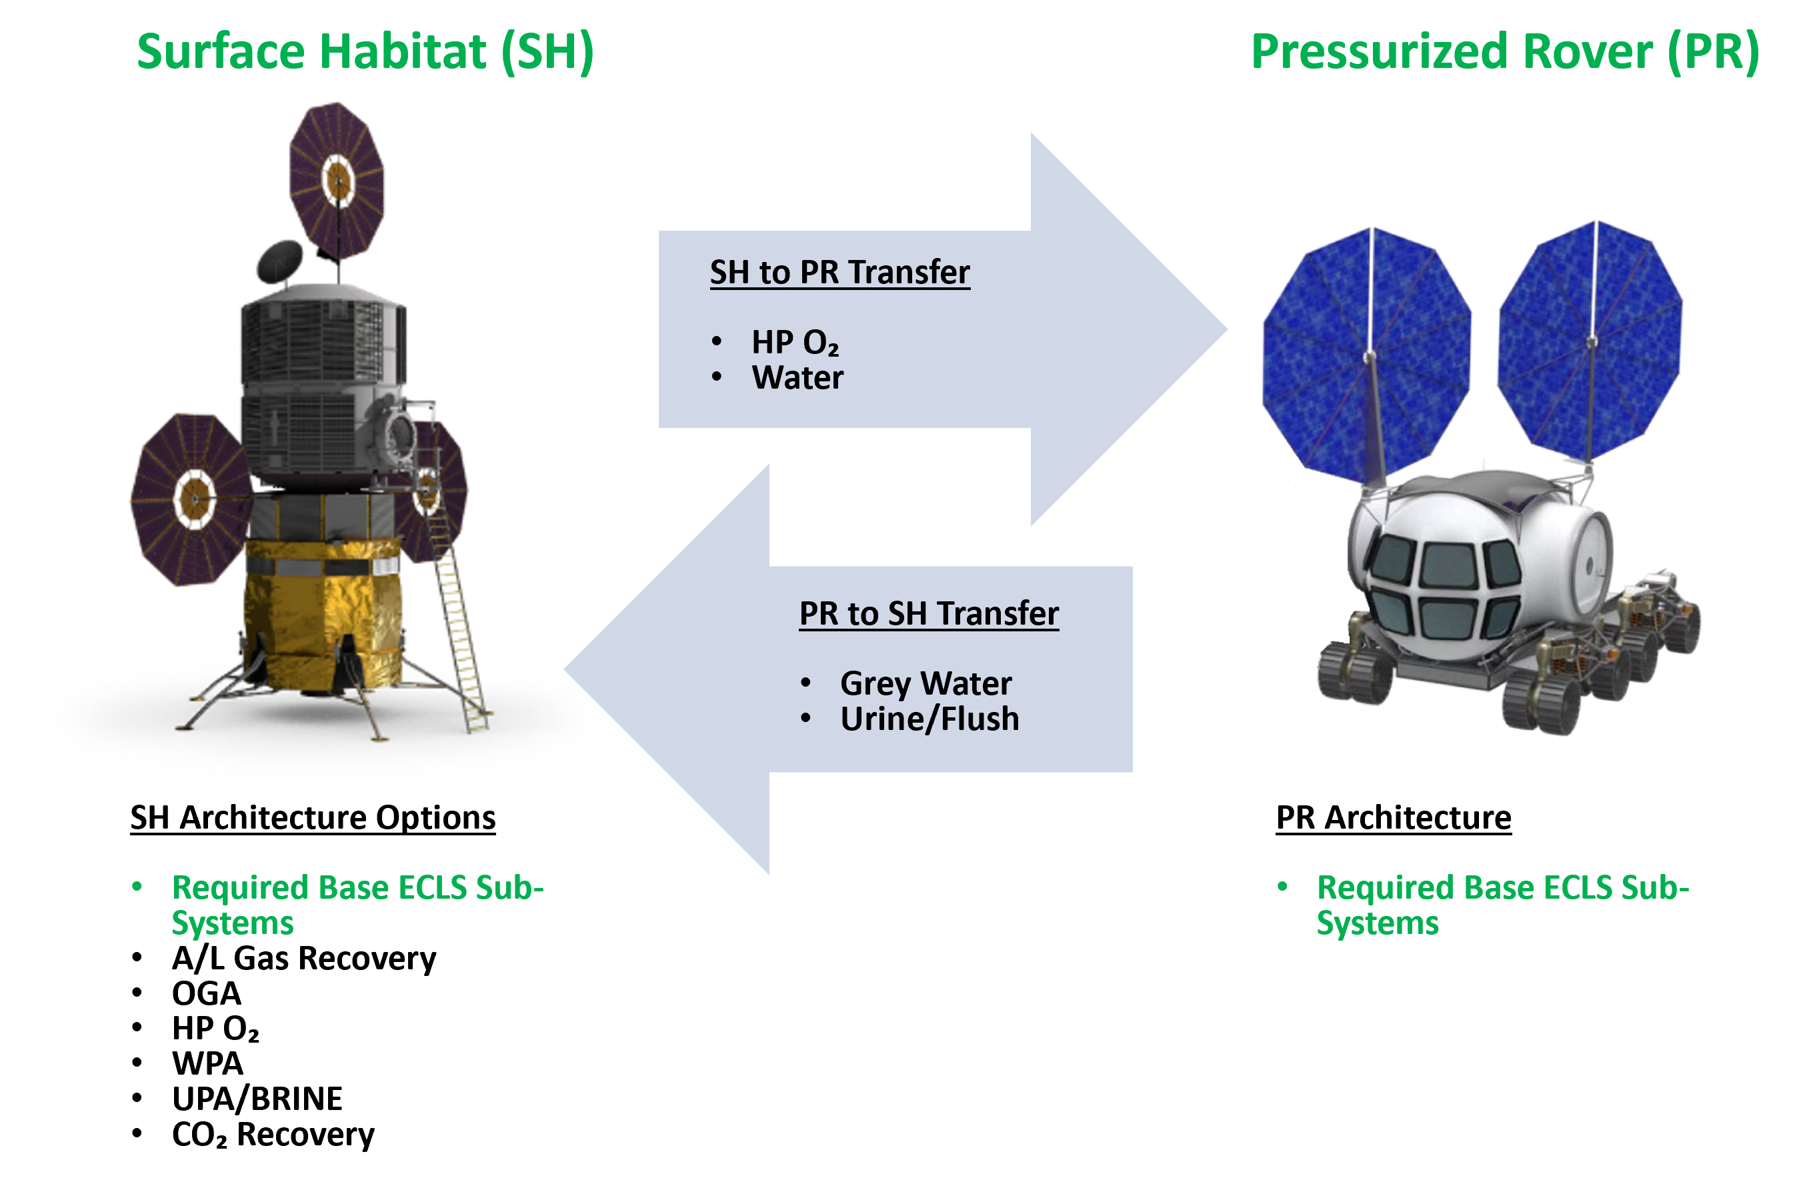
Figure 1. Lunar Surface ECLSS Architecture Options

Assumed Systems Masses
To determine the tradeoff between initial delivery mass and logistics resupply mass, the team estimated masses for each ECLS Sub-System option. Predicted masses are derived from current and projected ISS systems, adapted for use on the lunar surface, and include the mass of critical spares that would be delivered with each sub-system to ensure a reasonable level of availability. Table 1 lists the assumed and projected masses for each ECLS Sub-System that was evaluated for this study.
Table 1: Assumed ECLS Sub-System Masses
OPTION | Predicted Mass (kg)
Airlock Gas Recovery | 139
Oxygen Generator Assembly | 467
HP O₂ Compressor | 120
Water Processing (WPA) | 528
Modified Urine Processing w/ Brine (UPA/BPA) | 357
CO₂ Reduction (Sabatier) | 210
Water/O₂ Transfer SH --> PR* | 50
Grey Water/Urine Transfer PR --> SH* | 50
* Estimates based on preliminary design for transfer hardware
3. Analysis
Mission Parameters and Assumptions
The team created the Lunar Surface Integrated ECLSS Analysis Tool to assess the logistics needs for a crewed mission to the moon. The tool takes in mission parameter inputs such as crew size, mission duration, EVA cadence, and ECLSS configuration and calculates the total delivered logistics mass required to support the mission. Masses are estimated for crew consumables, system spares and maintenance, water, and gases. The tool also determines the number and mass of the carriers required to deliver those logistics. The tool can simulate missions occurring in either the SH, the PR, or both elements operating together, including commodity transfers between the two.
Logistics resupply requirements are calculated for a four crew, 30-day mission on the surface. During this mission, two crew will operate from the SH and two crew will operate in the PR. The crews will swap between the SH and the PR once at the mid-point of the mission with an additional overlap of four hours in the SH each week.
Table 2: Assumed Mission Parameters
Parameter | Input
# of Crew | 4 crewmembers  (2 in SH, 2 in PR)
# of Days | 30 days (crews swap between the SH and PR at the mission’s midpoint)
SH EVAs | 16 hours of EVA per crew per week; using an Airlock
PR EVAs | 24 hours of EVA per crew per week; using a Suitport

EVA—EVA assumptions can have a significant impact on logistics requirements. The EVAs from the SH are assumed to occur through an airlock. Nominal EVAs from the PR are assumed to occur through suitports integrated into the elements. However, the vehicle can still support contingency entry into the element via cabin depressurization.
Logistics Delivery—While logistics for initial missions may be delivered with the PR and SH, all logistics for outyear missions are assumed to be delivered via pre-deployed robotic landers. Logistics resupply masses will be restricted by the mass capacities of the robotic landers. Additional landers will result in added costs.
Sensitivity Analysis
Using the Lunar Surface Integrated ECLSS Analysis Tool, the team modeled 16 distinct cases for the integrated regenerative ECLSS capability. The cases begin with an Open Loop ECLSS and no gas or water transfers between the SH and the PR. Each subsequent case adds regenerative ECLSS capability options and finally includes different transfer options between the two spacecraft. Table 3 outlines the matrix of cases that the team evaluated.
For each case, the team calculated the total Logistics resupply mass required for the 30-day mission, as well as a detailed breakdown of the logistics mass.

Table 3: ECLSS Options Matrix Case Numbers
 | Transfer Options
Regenerative ECLSS Options | No Transfer | Water/Gas Transfer from SH to PR | Water/Gas Transfer from SH to PR + Wastewater Transfer from PR to SH
OPEN LOOP (Base ECLSS Sub-systems) | 1
+ A/L GAS RECOVERY | 2
+ OGA | 3
+ OGA + HP O₂ COMP | 4 | 9
+ OGA + HP O₂ COMP + A/L GAS RECOVERY | 5 | 10
+ OGA + HP O₂ COMP + A/L GAS RECOVERY +WPA | 6 | 11 | 14
+ OGA + HP O₂ COMP + A/L GAS RECOVERY +WPA + UPA/BRINE | 7 | 12 | 15
+ OGA + HP O₂ COMP + A/L GAS RECOVERY +WPA + UPA/BRINE + SABATIER | 8 | 13 | 16

4. Results
Since crew size and mission duration stayed the same throughout the cases, dry goods (and the Cargo Transfer Bags that they are packed in) remained constant. A total mass of 630 kg for dry goods packed into CTBs was used. That mass was added to the calculated gas and water mass for each case. Carrier mass was then included to determine the total required resupply mass for each case.
Figure 2 shows the results of the sensitivity analysis for all assessed cases. The horizontal axis indicates the system and critical spares mass that would be added to the total ECLSS mass beyond the open loop with no transfer case (case #1). The vertical axis indicates the total annual resupply mass required to support the mission, including carriers. Figure 3 shows the same results grouped by regenerative ECLSS capability. Table 4 shows the results for each case. (See Appendix A for a more detailed breakdown).

1
2
3
4
5v
6v
7v
8v
9v
10
11
12
13
14
15
16
- No Transfer
- Water/Gas Transfer from SH to PR
- Water/Gas Transfer from SH to PR + Waste Transfer from PR to SH
Figure 2: Annual Outyear Logistics vs Added ECLSS Mass
Table 4. ECLSS Case Results
Case | Description | Transfer | Total Initial Mass (kg) | Total Recurring Mass (kg)
1 | OPEN LOOP | None | 225 | 2,635
2 | + A/L GAS RECOVERY | None | 349 | 2,494
3 | + OGA | None | 833 | 2,607
4 | + OGA + HP O₂ COMP | None | 939 | 2,554
5 | + OGA + HP O₂ COMP + A/L GAS | None | 1,063 | 2,355
6 | + OGA + HP O₂ COMP + A/L GAS + WPA | None | 1,852 | 2,206
7 | + OGA + HP O₂ COMP + A/L GAS + WPA + UPA + BRINE | None | 2,359 | 2,125
8 | + OGA + HP O₂ COMP + A/L GAS + WPA + UPA + BRINE + SABATIER | None | 2,641 | 2,087
9 | + OGA + HP O₂ COMP | Water/Gas to PR | 981 | 2,459
10 | + OGA + HP O₂ COMP + A/L GAS | Water/Gas to PR | 1,105 | 2,259
11 | + OGA + HP O₂ COMP + A/L GAS + WPA | Water/Gas to PR | 1,894 | 2,110
12 | + OGA + HP O₂ COMP + A/L GAS + WPA + UPA + BRINE | Water/Gas to PR | 2,401 | 2,030
13 | + OGA + HP O₂ COMP + A/L GAS + WPA + UPA + BRINE + SABATIER | Water/Gas to PR | 2,683 | 1,989
14 | + OGA + HP O₂ COMP + A/L GAS + WPA | Water/Gas to ROVER + Grey Water/Urine to SH | 1,936 | 1,966
15 | + OGA + HP O₂ COMP + A/L GAS + WPA + UPA + BRINE | Water/Gas to ROVER + Grey Water/Urine to SH | 2,443 | 1,651
16 | + OGA + HP O₂ COMP + A/L GAS + WPA + UPA + BRINE + SABATIER | Water/Gas to ROVER + Grey Water/Urine to SH | 2,725 | 1,609

Open Loop
+ A/L Gas Recovery
+ OGA
+ OGA & HP O₂
+ A/L Gas Recovery & OGA & HP O₂
+ A/L Gas Recovery & OGA & HP O₂ & WPA
+ A/L Gas Recovery & OGA & HP O₂ & WPA & UPA/Brine
+ A/L Gas Recovery & OGA & HP O₂ & WPA & UPA/Brine & Sabatier
- No Transfer
- Water/Gas Transfer from SH to PR
- Water/Gas Transfer from SH to PR + Waste Transfer from PR to SH
Figure 3. Annual Outyear Logistics vs Added ECLSS Mass – Grouped by Regenerative ECLSS Capability

The results of the sensitivity analysis demonstrate the possibility for the regenerative ECLSS to reduce the annual required logistics resupply mass for sustained lunar missions. However, the potential reduction in resupply mass must be balanced against the increase in initial systems and spares mass.
Initial systems and spares mass is not directly comparable to resupply mass. This is because increases in initial mass are a single, one-time penalty, while the reductions in recurring mass are realized for every mission. The total mass of the SH may also be an important parameter for the architecture, as it is the largest potential element that must be delivered to the surface. Therefore, any increase in systems mass may be critical. Nevertheless, a comparison of changes in initial and resupply mass does allow for an assessment of the relative benefit of implementing different ECLSS options.
The Airlock Gas Recovery System (case #2) requires a small increase in initial mass but provides a significant decrease in annual resupply mass. This is a function of the high EVA cadence expected for lunar surface missions. The OGA (case #3) provides some reduction in resupply mass but requires a significant investment in initial system mass. However, when combined with the HP O₂ Compressor (case #4), the system can reduce resupply mass. Again, this is a function of the high EVA cadence and the PLSS recharge requirements. The value of including the OGA and the HP O₂ Compressor increases with the implementation of water and gas transfer from the SH to the PR (case #9). This transfer allows oxygen to provide for both elements without the need for high overhead oxygen resupply from Earth.
One effective option for the surface ECLSS architecture is case #10, which includes Airlock Gas Recovery, OGA, HP O₂, and water/gas transfer from SH to PR. This option increases the initial systems mass by approximately 880 kg, as compared to the full open loop case, but reduces annual resupply mass by approximately 376 kg.
Adding true regenerative/recycling ECLSS sub-systems requires substantial investments in sub-system and spares mass. However, these sub-systems potentially yield even greater reductions in annual resupply mass. Significant reduction in resupply mass can only be achieved if the regenerative ECLSS can be leveraged to reprocess waste streams from both the SH and PR via waste and commodity transfers.
Adding a WPA to the system, along with waste and commodity transfer (case #14), increases the initial systems and spares mass by 1,711 kg as compared to the open loop case. This configuration reduces the annual resupply mass by 669 kg per mission.
Including the UPA/Brine Recovery System as well, along with waste and commodity transfer (case #15), increases the initial systems and spares mass by 2,218 kg as compared to the open loop case. This configuration reduces the annual resupply mass by 984 kg per mission.
Finally, including the Carbon Dioxide Reduction System in the SH (case #16) increases the initial systems and spares mass by 2,500 kg as compared to the open loop case. This configuration reduces the annual resupply mass by 1,026 kg per mission. Gains from implementing carbon dioxide reduction are limited, as carbon dioxide for only half the crew can be recovered. Capture and transfer of carbon dioxide from the PR was not considered to be a viable option.
5. Recommendation
This study is not meant to imply that systems mass and logistics resupply mass are the only factors driving ECLSS design decisions. Budget availability, transportation system limitations, crew time requirements, and spares testing and reliability could have an impact on the ultimate configuration.
However, the results of this study show that some level of regenerative ECLSS in the SH can reduce annual resupply requirements with comparatively small investments in initial system and spares mass. Airlock Gas Recovery, OGA, and HP Oxygen Compression are strong candidates for inclusion in the SH. These three capabilities provide for substantial reduction in logistics resupply.
If commodity and waste transfer between the PR and SH is viable, then it is reasonable to consider regenerative options, such as the WPA and UPA/Brine systems, as long as the additional systems mass, volume, and crew time can be accommodated in the SH. These capabilities result in large reductions in resupply mass but require proportionally larger increase in initial mass

Appendix A. ECLSS Case Results – Logistics Breakdown

Case | Description | Transfer | Total Logistics + Carrier Mass | Total Initial System Mass | Total Spares Mass (Initial) | Total Spares Mass (Recurring) | Total Initial Delivery Mass | Total Recurring Resupply Mass
1 | OPEN LOOP | None | 2,600.6 | 0.0 | 0.0 | 34.3 | 0.0 | 2,634.8
2 | + A/L GAS RECOVERY | None | 2,459.6 | 115.6 | 233.0 | 34.3 | 348.7 | 2,493.8
3 | + OGA | None | 2,563.9 | 458.0 | 374.9 | 42.8 | 832.9 | 2,606.6
4 | + OGA + HP O₂ COMP | None | 2,511.5 | 550.0 | 388.8 | 42.8 | 938.8 | 2,554.2
5 | + OGA + HP O₂ COMP + RECOVERY | None | 2,312.4 | 665.6 | 397.7 | 42.8 | 1,063.3 | 2,355.1
6 | + OGA + HP O₂ COMP + RECOVERY +WPA | None | 2,154.6 | 1,183.6 | 668.2 | 51.0 | 1,851.9 | 2,205.6
7 | + OGA + HP O₂ COMP + RECOVERY +WPA + UPA + BRINE | None | 2,067.6 | 1,533.6 | 825.6 | 57.5 | 2,359.2 | 2,125.1
8 | + OGA + HP O₂ COMP + RECOVERY +WPA + UPA + BRINE + SABATIER | None | 2,029.6 | 1,738.6 | 902.5 | 57.5 | 2,641.2 | 2,087.1
9 | + OGA + HP O₂ COMP | Water/Gas to PR | 2,416.7 | 592.0 | 388.8 | 42.8 | 980.8 | 2,459.5
10 | + OGA + HP O₂ COMP + RECOVERY | Water/Gas to PR | 2,216.4 | 707.6 | 397.7 | 42.8 | 1,105.3 | 2,259.2
11 | + OGA + HP O₂ COMP + RECOVERY +WPA | Water/Gas to PR | 2,058.6 | 1,225.6 | 668.2 | 51.0 | 1,893.9 | 2,109.6
12 | + OGA + HP O₂ COMP + RECOVERY +WPA + UPA + BRINE | Water/Gas to PR | 1,972.9 | 1,575.6 | 825.6 | 57.5 | 2,401.2 | 2,030.4
13 | + OGA + HP O₂ COMP + RECOVERY +WPA + UPA + BRINE + SABATIER | Water/Gas to PR | 1,931.0 | 1,780.6 | 902.5 | 57.5 | 2,683.2 | 1,988.5
14 | + OGA + HP O₂ COMP + RECOVERY +WPA | Water/Gas to PR + Grey Water/Urine to SH | 1,914.8 | 1,267.6 | 668.2 | 51.0 | 1,935.9 | 1,965.8
15 | + OGA + HP O₂ COMP + RECOVERY +WPA + UPA + BRINE | Water/Gas to PR + Grey Water/Urine to SH | 1,593.0 | 1,617.6 | 825.6 | 57.5 | 2,443.2 | 1,650.5
16 | + OGA + HP O₂ COMP + RECOVERY +WPA + UPA + BRINE + SABATIER | Water/Gas to PR + Grey Water/Urine to SH | 1,551.2 | 1,822.6 | 902.5 | 57.5 | 2,725.2 | 1,608.7

References
[1] Owens, A., de Weck, O., Mattfeld, B., Stromgren, C., and Cirillo, W. Comparison of Spares Logistics Analysis Techniques for Long Duration Human Spaceflight. Presented at the 45th International Conference on Environmental Systems, Bellevue, WA, 2015. ICES-2015-268.
[2] Ewert, M. K., and Stromgren, C. Astronaut Mass Balance for Long Duration Missions. Presented at the 49th International Conference on Environmental Systems, Boston, MA, 2019. ICES-2019-126.
[2] National Aeronautics and Space Administration, “Exploration Planning Logistics Document,” HEOMD-402.
[3] Owens, A., Jones, C., Cirillo, W., Klovstad, J., Judd, E., Chai, P., Merrill, R., Piontek, N., Stromgren, C., and Cho, J. Integrated Trajectory, Habitat, and Logistics Analysis and Trade Study for Human Mars Missions. Presented at the AIAA ASCEND Conference, Virtual, 2020.
[4] Stromgren, C., Cho, J., Owens, A., and Cirillo, W. Integrated ECLSS Metrics to Support NASA Technology and System Development Activities. Presented at the 50th International Conference on Environmental Systems, Lisbon, Portugal, 2020. ICES-2020-313.

Biography

Chel Stromgren currently serves as the Chief Scientist of Binera, Inc. Risk Analytics Division. In this role, Mr. Stromgren leads the development of probability and risk-based strategic models and strategic analysis of complex system development. Mr. Stromgren has supported NASA in the analysis of Space Shuttle and International Space Station operations in the post-Columbia environment and has led the development of strategic campaign models for the lunar exploration initiatives. He holds a Bachelor of Science degree in Marine Engineering and Naval Architecture from the Webb Institute and a Master of Science degree in Systems Management from the Massachusetts Institute of Technology.


Callie Burke is a Senior Analyst at Binera, Inc. where she has worked since 2018. She has supported multiple projects for NASA’s Human Spaceflight and Exploration Team including volumetric analyses for lunar landing designs and research related to long-duration exploration missions. She holds a Bachelor of Arts in Diplomacy and World Affairs from Occidental College and a Master of Arts in Law and Diplomacy from The Fletcher School at Tufts University.


Jason Cho received a B.S (2019) in Aerospace Engineering from The University of Maryland and currently serves as an Aerospace Engineer at Binera, Inc. Mr. Cho supports NASA in the analysis of campaign and probabilistic modeling for lunar and deep space exploration efforts.

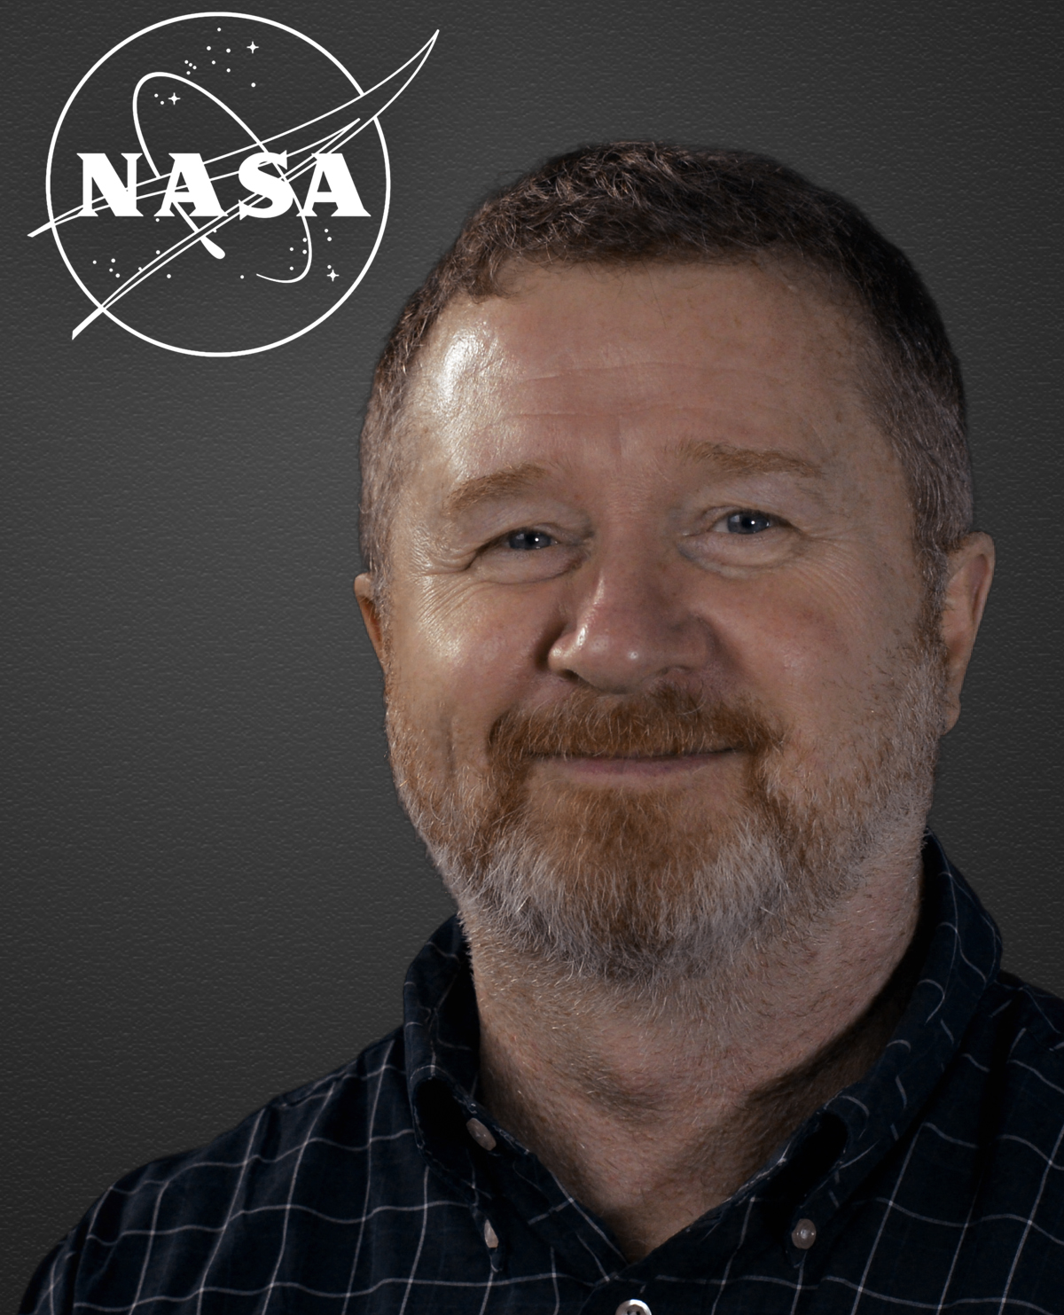
William Cirillo currently serves as a Senior Researcher at NASA Langley Research Center in Hampton, Virginia, where he has worked for the past 20 years in Human Space Flight Systems Analysis. This has included studies of Space Shuttle, International Space Station, and Human Exploration beyond low Earth orbit. In 2005, Mr. Cirillo served at NASA Headquarters as a core member of the Exploration Systems Architecture Study where he was responsible for studying the use of Ares I/Orion in meeting future ISS crew and logistics transportation needs. Mr. Cirillo currently leads a team of analysts in assessing the manifesting of assembly and logistics flights human exploration beyond low Earth orbit at a strategic and tactical level.


Andrew Owens is an Aerospace Engineer
in the Space Mission Analysis Branch
(SMAB) at NASA Langley Research
Center in Hampton, VA. His work focuses
on supportability, reliability, test
planning, logistics, and risk assessment
for human spaceflight, and on integrated
systems analysis, optimization, and tradespace exploration
to inform system and mission design. Dr. Owens received a
BS in Mechanical Engineering (2012) from Rice University,
as well as an SM in Aeronautics and Astronautics (2014)
and a PhD in Space Systems (2019) from MIT.

