Towards erecting straighter lightweight towers on the Moon using deployable guy wires
Alex S. Miller  Massachusetts Institute of Technology, 77 Mass. Ave, Cambridge, MA 02139  asmiller@mit.edu | Joshua Rohrbaugh  Massachusetts Institute of Technology, 77 Mass. Ave, Cambridge, MA 02139  jrohrbau@mit.edu | Emma K. Rutherford  Massachusetts Institute of Technology, 77 Mass. Ave, Cambridge, MA 02139  emmakr@mit.edu
Natasha Stamler  Massachusetts Institute of Technology, 77 Mass. Ave, Cambridge, MA 02139  stamlern@mit.edu | Benjamin Martell  Massachusetts Institute of Technology, 77 Mass. Ave, Cambridge, MA 02139  martellb@mit.edu | George Lordos  Massachusetts Institute of Technology, 77 Mass. Ave, Cambridge, MA 02139  glordos@mit.edu
Juan M. Fernandez  NASA Langley Research Center  Structural Dynamics Branch  Hampton, VA 23681  juan.m.fernandez@nasa.gov | Matthew K. Chamberlain  NASA Langley Research Center  Structural Dynamics Branch  Hampton, VA 23681  matthew.k.chamberlain@nasa.gov | Jeffrey A. Hoffman  Massachusetts Institute of Technology, 77 Mass. Ave, Cambridge, MA 02139  jhoffma1@mit.edu

Abstract— This paper reports our static stability test findings for a simple guy wire system to correct the natural lateral deflections of an 8.5m tall, compact deployable composite tower intended to support exploration of lunar permanently shadowed regions by nearby robotic assets. Deployable composite booms with microgravity flight heritage are currently being investigated at NASA Langley Research Center (LaRC) and Massachusetts Institute of Technology (MIT)’s Space Resources Workshop for their potential to be vertically deployed in the lunar gravity field, in support of NASA’s Artemis campaign. These applications include vertical solar arrays and the provision of elevated lines-of-sight to science or engineering payloads on landers and rovers, in support of nearby or distant crewed or robotic assets exploring scientifically interesting and hard to reach areas. Useful elevated payloads include radio repeaters, remote sensing and imaging, navigation and power beaming systems. However, while these lightweight booms have an excellent height to mass ratio, they typically exhibit slight axial curvature upon deployment resulting in appreciable lateral dead-load deflection of the tip mass relative to the tower base. This static deflection increases with tower height and tip mass, not only constraining the value delivered by the tower but also endangering its integrity. To develop a competitive, lightweight deployable composite boom tower, a capability to correct static deflections during and after deployment may be required. This paper presents a pathfinder deployable guy wire stability system for the MIT / LaRC self-erecting composite boom lunar tower that provides real time measurements, maintains tension passively, and can serve as a reconfigurable platform to test new guy wire components, configurations and control algorithms. Using a validated, calibrated photogrammetry system, the natural lateral deflection of the boom tip relative to the boom base at different deployed heights in Earth’s gravity field was recorded. With real-time tension measurements it was found that guy wires can significantly reduce the tip deflection of a deployable composite boom under dead load. Specifically, we found that (1) control capability is greatest where it is needed most, i.e. for the lever arm closest to being opposite the direction of deflection, and (2) for a tower height of at least 8.5 m and arm length of at least 60 cm, a solution of differential tension in all three arms exists and, in principle, provides sufficient control capability to correct or significantly reduce boom deflections. We also found that natural deflections occur almost entirely out-of-plane of the seams of the boom cross-section, which was expected, and that the natural boom tip lateral deflection under dead load upon deployment was ~5% of boom deployed length, unexpectedly exceeding the manufacturing acceptance specification of 1%. Ongoing and future collaborative work between LaRC and MIT includes the further investigation of the unexpected lateral deflection, testing of alternative guy wire system designs at higher tensions and higher deployed heights, as well as trade studies of costs and benefits of an optimized integrated guy wire system compared to other types of static stability solutions.

Table of Contents
1. Introduction and Background 1
2. Methods 3
3. Results 12
4. Conclusions and Discussion 14
5. Limitations and Future Work 15
Acknowledgements 15
References 16
Biography 17

1. Introduction and Background
As part of the Artemis program, NASA intends to return humans to the surface of the Moon. However, before humans land on the Moon once again, rigorous exploration must be performed autonomously to reduce risks for manned missions. The Permanently Shadowed Regions (PSRs) near the lunar poles, which have remained dark for billions of years, are of special interest due to their likelihood to contain water or other hydrogen-rich deposits that could support a mission on the surface (Kleinhenz and Paz, 2020; Li et al., 2018). The extreme cold, complete darkness and uncertain terrain of PSRs present substantial logistical challenges to both humans and machines operating inside these regions. One of these challenges is the lack of a line-of-sight to nearby landers situated in sunlight outside crater rims. The Multifunctional Expandable Lunar Lightweight and Tall Tower (MELLTT) was a proof-of-concept technology development by MIT in response to the NASA 2020 BIG Idea Challenge, where NASA’s Deployable Composite Boom (DCB) project loaned a boom to MIT for experimentation (Amy at al., 2020; Lordos et al., 2021).
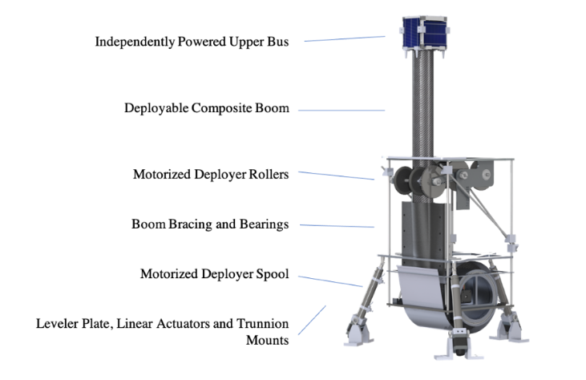
Figure 1. Multifunctional Expandable Lunar Lightweight and Tall Tower (MELLTT) developed at MIT in collaboration with LaRC’s Deployable Composite Booms team can self-level in the lunar gravity field and is envisioned to elevate a CubeSat payload package of up to 3U to a height of up to 16.5 meters above the lander deck.
Figure 1 shows MELLTT as built and demonstrated by the MIT team to an initial height of 2m. A new collaborative effort between NASA LaRC and MIT under a 3-year Space Act Agreement will advance technologies to support improved versions of the lunar tower. The Self-Erectable Lunar Tower for Instruments (SELTI) is a technology under development at NASA in collaboration with MIT. SELTI will take advantage of the relatively weak lunar gravity and lack of atmosphere to deploy science and engineering payloads at elevations up to 16.5m above the lander deck. Elevated payloads can include radio relay, navigation beacons, multispectral and stereoscopic imaging, scanning LiDAR and lasers, lenses or mirrors for beamed or reflected power. The line-of-sight provided by a lunar tower is a key enabler for small, distributed payloads and autonomous robots to explore and operate in and around PSRs. A number of networked applications for SELTI have been explored at MIT by Johanson et al (2020).
To meet its Artemis goals of building a lunar Base Camp and Gateway to Mars, NASA established the Commercial Lunar Payload Services (CLPS) program in 2018, which encourages the U.S. commercial space industry to develop new technologies to deliver payloads to the lunar surface. In 2022, the first CLPS deliveries will begin with two companies delivering 16 instruments to the lunar surface to pave the way for human explorers (Warner, 2020). A low-cost CLPS-compatible version of SELTI is currently being pursued by LaRC and MIT with the objective of advancing and demonstrating key technologies needed in future towers to support lunar surface operations and exploration.
The NASA Space Technology Mission Directorate (STMD) Deployable Composite Booms (DCB) project is a collaboration between NASA LaRC and the German Aerospace Center (DLR) to advance compact deployable composite boom technology (Fernandez et al. 2019, Richter et al. 2019). A 13m collapsible tubular mast (CTM) boom on loan to MIT from LaRC is shown in Figure 2.
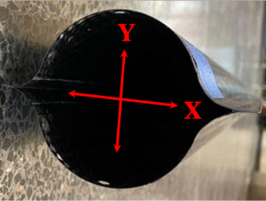
(a)
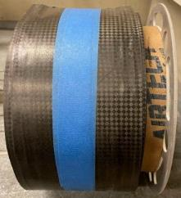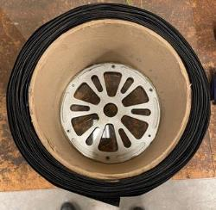
(b) (c)
Figure 2. CTM boom (a) in its deployed state, showing its two omega-shaped shells connected in the X-axis direction, and in its stowed state, showing its (b) outer carbon fiber plain-weave and (c) thin layers when the boom is collapsed and rolled.
The thin-ply carbon fiber/epoxy plain-weave and unidirectional ply technology reduces boom wall thickness and enables small bending radii that result in compact rolling stowage of the booms (Fernandez, 2017, Fernandez, 2019). The two omega-shaped thin shells form a closed cross-section, yielding large stiffness in its deployed state, providing high dimensional stability (Lee and Fernandez, 2019). Additionally, incorporating a CTM boom into a low-cost technology demonstration flight is feasible for a near-term CLPS flight since similar booms are being flight qualified under the NASA Advanced Composite Solar Sail System (ACS3) project to launch at the end of 2022 (Wilkie et al., 2021). The structural properties of the DCB boom and its manufacturing process are described in detail by Fernandez et al (2019) and Stohlman et al. (2021).
Realistic deployed booms are expected to exhibit a non-zero axial curvature for one or more of the following reasons: manufacturing errors, long-term stowage creep/relaxation, and thermally- induced deformations. If, upon deployment, the boom shape has or acquires an axial curvature (bow) resulting in a lateral deflection of the elevated platform, the risk of buckling increases and the tower’s value can be limited. If the deflection is such that the center of gravity of the tip mass is shifted significantly outside the load-bearing tower profile, the tower’s integrity may be endangered. Guy wires are a typical solution to this problem for tall masts in Earth applications.
While guy wire systems on Earth are well developed, space deployable structures present unique challenges that make them a topic of active research. Autonomously deployable towers with guy wires delivered by small landers such as CLPS must have self-deployable guy wire arms and active tensioning, especially if guy wire support is needed throughout deployment. In addition, most space systems have volume constraints that cause the guy wires to be much closer to the tower compared to Earth systems, causing a reduction in controllability and an increase in corresponding additional compressive force. Furthermore, space guy wire systems will have a more costly tradeoff between mass and stiffness in the support arms and other rigid structures.
Photogrammetry uses the known position and angle of multiple cameras to form highly accurate 3D visualizations of space. Some photogrammetry systems use specific targets to track rigid bodies in space. Photogrammetry can thus be used to measure small displacements of the boom by placing target markers at various locations along its height. The locations of markers with respect to each other can then be analyzed to characterize bending and variation in boom deflection.
Photogrammetry has the potential to yield more insights into the mechanics of the lunar tower than accelerometers or gyroscopes due to its ability to track multiple points along the boom at the same time. Photogrammetry was used to characterize the dynamic behavior of the Roll-Out Solar Arrays (ROSA) that use deployable slit-tube composite booms at the International Space Station (ISS) in 2017 (Chamberlain et al., 2019). Researchers at NASA LaRC and DLR have used photogrammetry to characterize the 13 m long CTM boom structure under evaluation in this paper both in a vertical configuration in a one Earth-gravity (1-g) field (Stohlman et al. 2021), and more recently in a horizontal configuration on a zero-gravity (0-g) parabolic flight.
2. Methods
Guy wire and rigging systems on cell towers, cranes, and sailboats serve as major sources of inspiration for this concept. Such rigging systems have been a staple of Earth-bound lightweight tower construction. Guy wires are often used in cell and radio antenna towers, such as in Fig. 3 (a), to reduce shear loads on the central structure and prevent a stress concentration at the base. When guy wires are employed around a central truss structure, the central truss becomes a quasi-tensegrity structure.
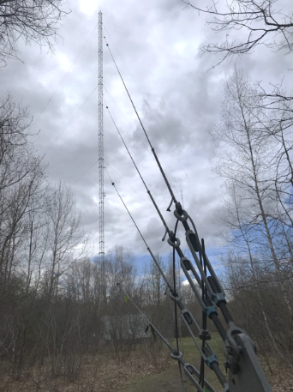
(a)

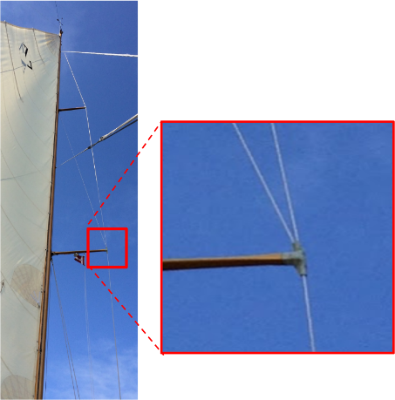
(b)
Figure 3. Sources of inspiration: (a) Guy wires supporting a radio tower in Newton, MA. (b) Rigging arrangement on MIT’s classic sailing yacht, Mashnee, a recently restored 1902 Buzzards Bay 30 designed by renowned naval architect Nathaniel Greene Herreshoff, MIT Class of 1870. Photo credits: (a) Alex Miller (b) George Lordos.

Rigging systems on sailboats, such as in Fig. 3 (b), are designed to sustain dynamic loads and are rapidly reconfigurable for different wind conditions and sail structures. Sailboat guy wire systems often feature multiple mid-mast spreaders, dynamically moving pulleys and compliant structural elements. Deployable tensegrity designs for space applications, such as Chen et al, (2009) necessitate a higher number of structural elements compared to a single piece deployable, adding complexity and mass. Deployable terrestrial military applications also exist, such as Rolatube (“Rollable Composite Masts,” 2020), however these are meant for manual deployment and are not designed for the space environment.
Design of experiment to assess feasibility of an active solution to the static deflection challenge
Given a boom cross-section diameter d, the delivered value of a lunar tower is a function of height h, elevated payload tip mass m, and tower robustness (i.e. resistance to buckling). In idealized form, this value function assumes an as-deployed boom with zero axial curvature, i.e. a perfect column. However, assuming a more realistic non-zero axial curvature, i.e. an imperfect column, the higher h is, the greater the lateral deflection at the tip relative to the fixed cross-section of the boom d at the base and the less the tip mass m the tower can robustly and safely bear. Further, given boom cross-section d and tip mass m, there will be a critical height h_{lim} above which buckling failure should be expected. All other things being equal, the higher m is, and the higher the curvature of the boom, the lower h_{lim} will be.
Hence, lateral deflection caused by boom curvature limits tower value by enforcing an undesirable trade between tower height h and payload mass m, i.e. a trade between the two key drivers of the value function of the lunar tower. To preserve the engineering and science value of a realistic lightweight lunar tower, it is essential to address the boom curvature / static deflection challenge up front as a key step in the system architecting of the tower.
From the above, given a tip payload mass m and a non-zero axial curvature, the deployed height h is constrained by h < h_{lim}, compromising value delivery relative to the ideal maximum. In this situation, there are generally three families of approaches to protect the delivered value of a realistic tower which exhibits non-zero axial curvature:
- Use a boom with a larger cross-section d’ that would be capable of coping (quasi-statically) with the maximum expected boom tip mass center of gravity offsets, at the cost of added size, weight and power (SWaP) for the deployer system.
- Provide a capability to control and correct static curvatures / deflections during and after deployment, at the cost of added SWaP and complexity.
- Use a different boom material and/or design that may exhibit lower natural or induced post-deployment axial curvature, at the cost of added boom mass and longer development time due to the missed opportunity to use booms that have flight heritage.
The experiment we describe in this work tested for the functional existence of at least one instance of the second family of solutions, i.e. an active capability to correct deflections of a naturally curved boom. Using a validated photogrammetry system, the control capability of a simple three-wire rigging system (i.e. guy wires) at different tension levels was demonstrated. In this first experiment, a scalable composite boom with high technology readiness level (TRL) was tested up to an initial height of 8.5 m with a tip mass of 0.25kg. The main objective of the experiment was to investigate whether a simple three-wire guy wire system with differential tension control for each wire had sufficient control capability to correct natural boom deflections and restore the center of gravity of the tip mass to be within the bounds of the perimeter of the tower base.
Guy wire simulation and initial trade studies
The team conducted initial simulations of guy wire systems in the tnxTower nonlinear finite element analysis (FEA) software package (tnxTower 8.0.5, 2020). This program was created specifically for communication towers and allows for rapid iteration in comparison with general purpose FEA tools. We observed that for a hypothetical 30-m-tall monopole steel tower with a 5 kg tip payload, guy wires yielded a significant improvement of up to 43% in static tilt performance, and further improvements in seismic load compared to a tower without guy wires. Furthermore, the large variance in guy wire performance across modeled configurations of “3-at-the-top,” “3-at-midpoint,” and “3-at-the-top and 3-at-midpoint”, as shown in Figure 4, warranted further research.
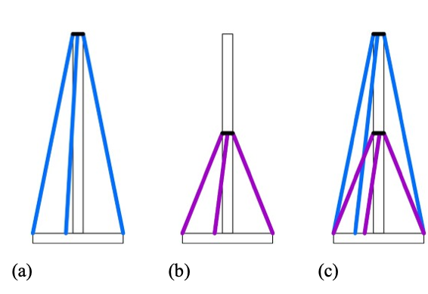
Figure 4. Three proposed guy wire configurations: (a) “3-at-the top”, (b) “3-at-midpoint”, and (c) “3-at-the-top and 3-at-midpoint.”
The “3-at-midpoint” configuration outperformed “3-at-the-top,” and “3-at-the-top and 3-at-midpoint” tower in dead load conditions, but since these simulations were conducted assuming a much larger steel tower than SELTI the variance between configurations is more significant than the finding itself. Due to the relative simplicity of the “3-at-the-top” configuration, we decided to test the “3-at-the-top” configuration in this paper, and to evaluate other configurations in future research.
While FEA simulations allow for rapid case studies, their limitations motivate practical experimentation. Tower-specific FEA packages such as tnxTower, which can only model homogeneous construction materials like steel underestimate the potential for local buckling in SELTI’s thin-walled composite laminate structure. General purpose FEA packages such as Abaqus and Ansys require an ultrafine mesh due to the thinness of the boom, causing long run-times that impede parametric studies and sensitivity analysis, especially when simulation boundary conditions, which greatly affect results, depend greatly on physical system implementation.
Guy wires in practice: from requirements to working design

To assess the feasibility and utility of guy wire rigging systems for DCB-based lunar towers, a test platform was conceptualized, designed and built to evaluate guy wire systems in static tests.
Table 1. Requirements for guy wire testing platform
Requirement | Description
GW 001: Configurable | System supports testing of multiple configurations, including guy wires at the top, guy wires on a mid-boom spreader arm, and pulleys that link multiple guy wire configurations.
GW 002: Measurable | Guy wire system supports measurement of guy wire tension in real time.
GW 003: Actuation | System can be tensioned using both hand tightening and precision motor control
GW 004: Passive Locking | Tensioned guy wires can passively lock in tensioned position without any expended power.
GW 005: Deployable | Guy wire system folds into a small package and deploys into a usable position and size.

To meet the requirements listed in Table 1, the SELTI team designed a modular, deployable three-arm structure anchored to the deployer-leveler interface plate. Each arm deploys from a vertical stowed position using a linear actuator with potentiometer feedback. After unfolding, the guy wire system may be tensioned with a 270 KV brushless motor controlled by an ODrive motor controller with feedback from an 8192-count-per-revolution encoder. The ODrive system has cascaded position, velocity and current control proportional-integral-derivative (PID) loops, allowing for the guy wire system to be controlled in different regimes during different phases of operation. Guy wire tension can be controlled by both actuating the brushless spool motor and also adjusting the angle of the spreader arms. During deployment, the guy wire deployment arms have a ratchet and pawl that maintain tension on the arm, and allow that tension to be passively sustained after deployment; to facilitate retraction, a simple linear actuator releases the spring-loaded pawl and thus the tension on the guy wires. The tension of the guy wires is measured in real time with load cells integrated into each guy wire arm.
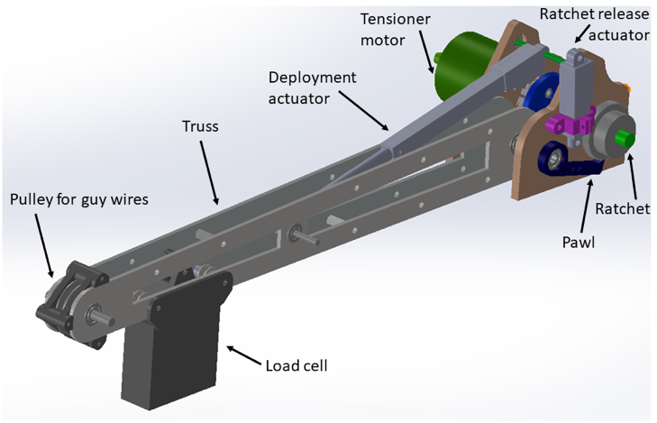
(a)
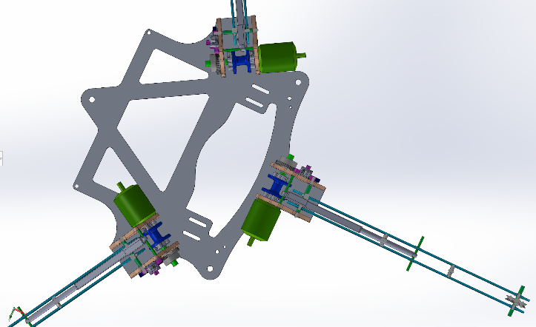(b)
Figure 5. (a) Guy wire arm system components. (b) Guy wire arms on deployer-leveler interface plate, top view.

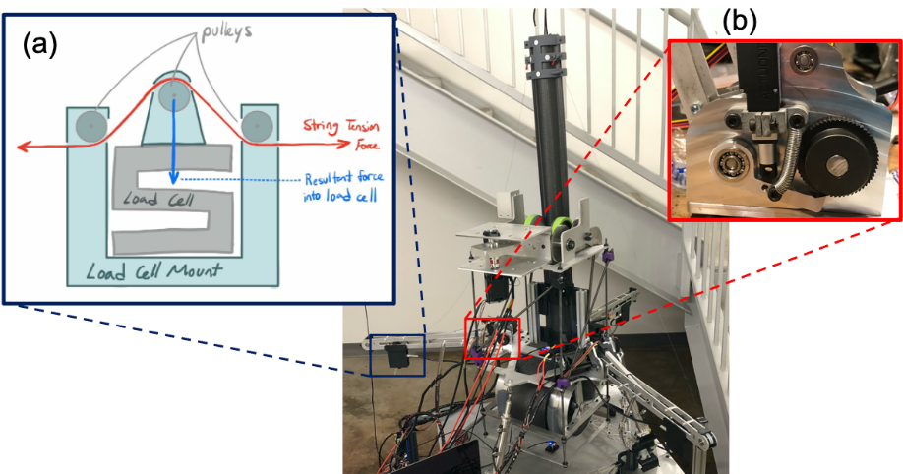
System components are labeled in Figure 5 and the general arrangement of the three-arm guy wire system, together with detail of the load cell design and the ratchet and pawl subsystem, are shown in Figure 6.
Figure 6. Guy wire system arrangement and details. Three guy wire arms spaced 120º apart are mounted to the deployer / leveler platform, with guy wires secured at the tip, next to the photogrammetry targets (white circles); (a) detail of load cell design; (b) ratchet and pawl for passive tensioning.
The guy wires were Spectra PowerPro 30-lb-test fishing line due to its low stretch in comparison to monofilament, and linear stiffness that reduces knotting and provides for high spooling consistency. The guy wires run from a spool attached to the brushless motor across a load cell, then the pulley at the end of the spreader arm, and are ultimately anchored to a fixed attachment directly under the SELTI upper platform payload deck. Custom-machined components for the modular guy wire structure were made out of computer numerical control (CNC) milled and waterjet aluminum for a balance of minimum weight and maximum stiffness. Stiffness was a priority in the system design as it will greatly ease control algorithm development during later stages of this project. In addition to the structural stiffness, all 33 joints employ press-fit ball bearings, allowing the arm system to be treated as a rigid body.
Photogrammetry for characterizing static boom behavior
To measure the deflection of the boom under static dead load a commercial-off-the-shelf (COTS) photogrammetry system was purchased. The system was a Optitrack V120: Trio unit. This model consists of three infrared light cameras in line with each other with built-in LED 850 nm infrared (IR) light rings. System specifications are as follows. Resolution: 640 px x 480 px. Frame Rate: 30, 60, 120 frames per second. Accuracy: Sub-millimeter. Latency: 8.333 ms. Standard M12 latency (Horizontal field of view (FOV): 57.5°, Focal Length: 3.5 mm, F-number: 2.0).
Four retro-reflective circular targets of 1.25 cm in diameter arranged in a diamond pattern and spaced 5 cm apart were placed at the tip of the boom and 1.28 meters below, as shown in Figure 6. Each diamond was set to be a rigid body since it is assumed that very little bending occurs within the small length of the markers. The centroid location of each diamond of markers was tracked by the cameras.
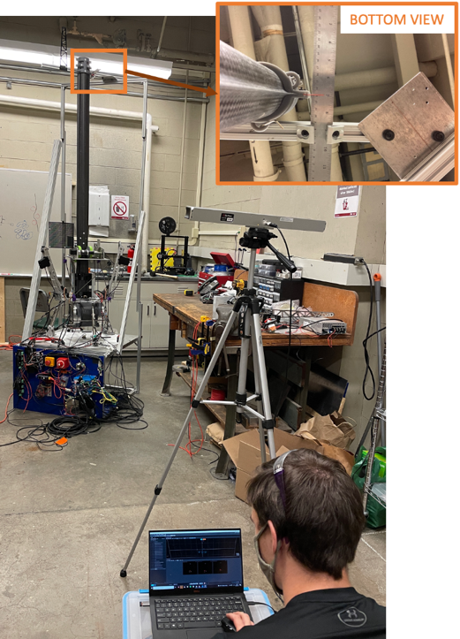
Figure 7. Setup for photogrammetry validation. A fixed pi-shaped frame provided a physical reference to measure the resting position of the top of the tower using a ruler. The photogrammetry ground plane reference square was also attached to this fixed frame. The tower was deflected by a small distance and the deflection measured using both the ruler and the photogrammetry system.
Photogrammetry accuracy
The accuracy of the photogrammetry system was validated before proceeding with experimental testing of the guy wire configurations. First, a fixed rigid frame was constructed next to the boom for consistent measurements, as shown in Figure 7. Then, the photogrammetry system was calibrated by affixing a physical “ground plane” reference square to the frame structure. Finally, measurements were taken of the tower position using both a ruler and the photogrammetry system before and after inducing a small deflection in the boom. By comparing the results of the ruler and photogrammetry as per Figure 8, it was shown that the photogrammetry system was consistent with conventional measuring tools and accurate to the nearest millimeter.

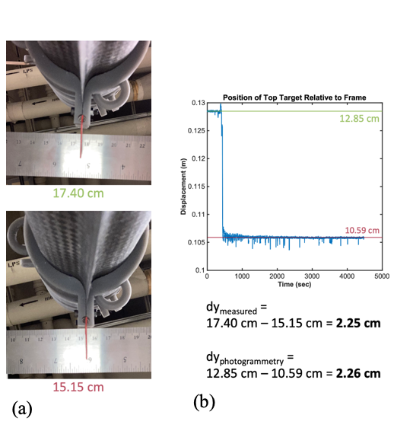
Figure 8. Data processing for photogrammetry validation. In (a) photos were taken of the red indicator on the ruler before and after manually repositioning the boom. In (b) this measured change in position was compared to the change in position measured using the photogrammetry setup. The photogrammetry system was validated to be accurate to the nearest millimeter.
Static test setup and procedure
To evaluate the efficacy of guy wires for decreasing boom off-nominal offsets and reducing the likelihood of boom buckling, a test that uses photogrammetry was designed to measure the position of the boom with a range of guy wire tensions at several boom heights. The test of the SELTI guy wire system was conducted in the MIT Stata Center stairwell 3. Since this test was focused on reducing the static deflection of the boom with guy wires and not on automatic control or deployment, all operations were manually actuated including the guy wire spreader arm deployment and the guy wire tensioning. The aforementioned photogrammetry system was used to record natural boom tip positions and static deflections under the following permutations of conditions:
Deployed Height—4.2 m, 6.2 m, 8.5 m.
Guy wires tensioned— none, one arm at a time (#1, #2, #3), or all three arms together.
Tension loads—3.9 N, 5.9 N, 7.8 N, 10.8 N or differential with tensions between 5.9N to 19.6N per wire.
The above conditions were constrained by safety considerations. The maximum deployed height was limited by the geometry of the stairwell used at MIT and the tension loads were conservatively sized to maintain a safety margin for this first experiment with the boom loaned to MIT by NASA. Future tests will build on the findings of this first experiment to deploy to higher elevations and utilize alternative configurations and/or higher tensions while maintaining safety margins.
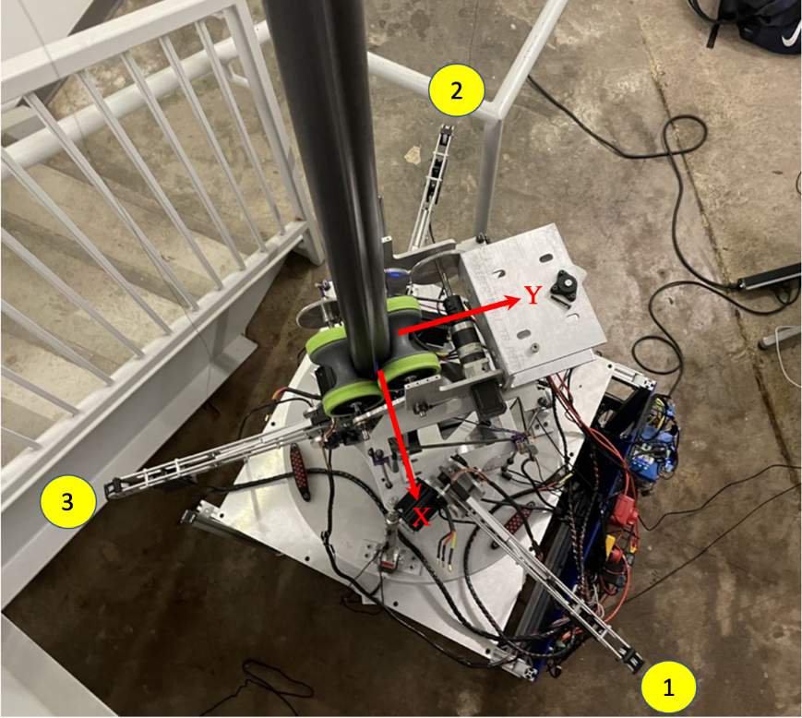
The positioning and identification of the three guy wire arms relative to the boom and to the X and Y axes is shown in Figure 9.
Figure 9. Boom deployer, from above, showing the orientation of the three guy wire arms relative to the orientation of the cross-section of the boom in the X and Y planes. Arms are 120º apart and are labeled in the photo. The boom is pulled out of the spool between two green rollers, and once deployed it can be stabilized with the three arms that provide tension to the guy wires.
At each height, 4.2 m, 6.2 m and 8.5 m, the static deflection in response to each of the guy wire tension configurations was recorded using the photogrammetry system. The boom tip positions and lateral deflection relative to the boom base are shown below in Tables 1, 2 and 3 respectively. In a few cases, higher tensions were also tested when they did not appear to be any risk of the boom buckling, as are denoted in the tables below, and one test was omitted because it was judged that it would bend the boom further towards its starting, natural deflection. The last test at each height involved tensioning all three guy wires using differential tensions to attempt to center and stabilize the boom.

Table 2. Boom tip static lateral deflections at 4.2 m deployed height per experimental configuration.

Wire #1 Tension (N) | Wire #2 Tension (N) | Wire #3 Tension (N) | Deployed Height (m) | X position of tip of boom (m) | Y position of tip of boom (m) | Lateral deflection relative to tower base (m)
0 | 0 | 0 | 4.2 | -0.043 | 0.204 | 0.208
3.9 | 0 | 0 | 4.2 | -0.037 | 0.222 | 0.225
7.9 | 0 | 0 | 4.2 | -0.027 | 0.243 | 0.244
0 | 3.9 | 0 | 4.2 | -0.048 | 0.218 | 0.223
0 | 7.9 | 0 | 4.2 | -0.056 | 0.220 | 0.227
0 | 0 | 3.9 | 4.2 | -0.040 | 0.180 | 0.184
0 | 0 | 7.9 | 4.2 | -0.038 | 0.151 | 0.156
3.9 | 3.9 | 3.9 | 4.2 | -0.044 | 0.206 | 0.211
7.9 | 7.9 | 7.9 | 4.2 | -0.041 | 0.218 | 0.222
8.3 | 8.3 | 19.6 | 4.2 | -0.038 | 0.143 | 0.133
5.7 | 7.5 | 15.7 | 4.2 | -0.040 | 0.143 | 0.148
6.7 | 7.9 | 19.6 | 4.2 | -0.039 | 0.128 | 0.148

Table 3. Boom tip static lateral deflections at 6.2 m deployed height per experimental configuration.

Wire #1 Tension (N) | Wire #2 Tension (N) | Wire #3 Tension (N) | Deployed Height (m) | X position of tip of boom (m) | Y position of tip of boom (m) | Lateral deflection relative to tower base (m)
0 | 0 | 0 | 6.2 | -0.021 | 0.278 | 0.279
3.9 | 0 | 0 | 6.2 | -0.011 | 0.323 | 0.324
5.9 | 0 | 0 | 6.2 | -0.004 | 0.348 | 0.348
0 | 3.9 | 0 | 6.2 | -0.029 | 0.298 | 0.299
0 | 5.9 | 0 | 6.2 | -0.035 | 0.306 | 0.308
0 | 0 | 3.9 | 6.2 | -0.015 | 0.227 | 0.228
0 | 0 | 5.9 | 6.2 | -0.013 | 0.1976 | 0.198
0 | 0 | 7.9 | 6.2 | -0.012 | 0.175 | 0.176
3.9 | 3.9 | 3.9 | 6.2 | -0.019 | 0.275 | 0.275
7.9 | 7.9 | 7.9 | 6.2 | -0.021 | 0.281 | 0.282
7.7 | 9.6 | 18.8 | 6.2 | -0.014 | 0.139 | 0.140

Table 4. Boom tip static lateral deflections at 8.5 m deployed height per experimental configuration.

Wire #1 Tension (N) | Wire #2 Tension (N) | Wire #3 Tension (N) | Deployed Height (m) | X position of tip of boom (m) | Y position of tip of boom (m) | Lateral deflection relative to tower base (m)
0 | 0 | 0 | 8.5 | -0.035 | 0.322 | 0.324
3.9 | 0 | 0 | 8.5 | -0.021 | 0.368 | 0.369
0 | 3.9 | 0 | 8.5 | -0.051 | 0.353 | 0.357
0 | 3.9 | 0 | 8.5 | -0.077 | 0.362 | 0.369
0 | 0 | 3.9 | 8.5 | -0.024 | 0.273 | 0.274
0 | 0 | 7.9 | 8.5 | -0.013 | 0.189 | 0.189
0 | 0 | 10.8 | 8.5 | -0.004 | 0.119 | 0.120
3.9 | 3.9 | 3.9 | 8.5 | -0.034 | 0.319 | 0.320
7.9 | 7.9 | 7.9 | 8.5 | -0.033 | 0.323 | 0.325
6.4 | 9.0 | 17.0 | 8.5 | -0.018 | 0.131 | 0.133

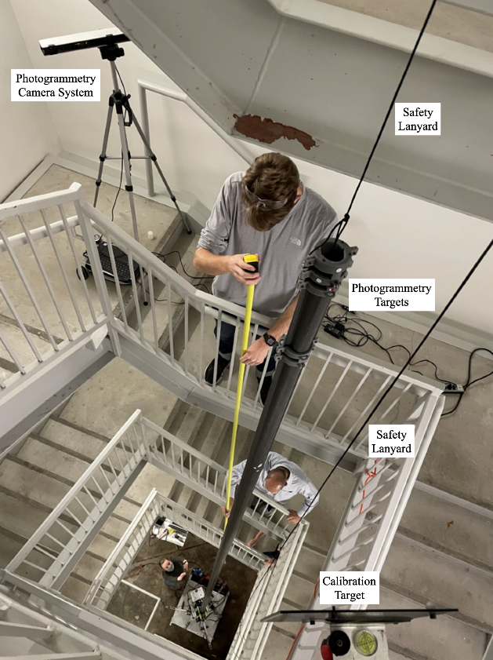
Figure 10. The boom is deployed to 8.5 m in the stairwell to allow easy access at all points during deployment. The tip of the boom is attached to a safety lanyard, which is in case of emergency buckling scenarios, and was monitored but not tensioned throughout the test. In the top left of the figure, the photogrammetry camera system is positioned so that both the photogrammetry targets at the top of the boom and the calibration target (bottom right) are in its view.
During all testing, the top of the boom was belayed using a safety harness. Unlike a gravity offload, this belay was never under tension during the test, and instead was there as an emergency safety net in case of boom buckling. This belay was attended throughout the duration of the test but was never used to catch a buckling event.
To maintain a consistent reference for the position of the boom across each of the test heights, the coordinate system of the photogrammetry camera was calibrated using a calibration square of known dimensions. In addition, the base

of the tower was leveled using multiple two-axis levels to ensure straight deployment. At each height, the position of the calibration square was measured relative to two plumb-bob wires that were hung from 12 meters above the floor of the test area. These plumb wires acted as a reference position of the square across different heights and relative to the base of the tower. Figure 10 shows the arrangement of the equipment prior to the 8.5 m tests.
3. Results
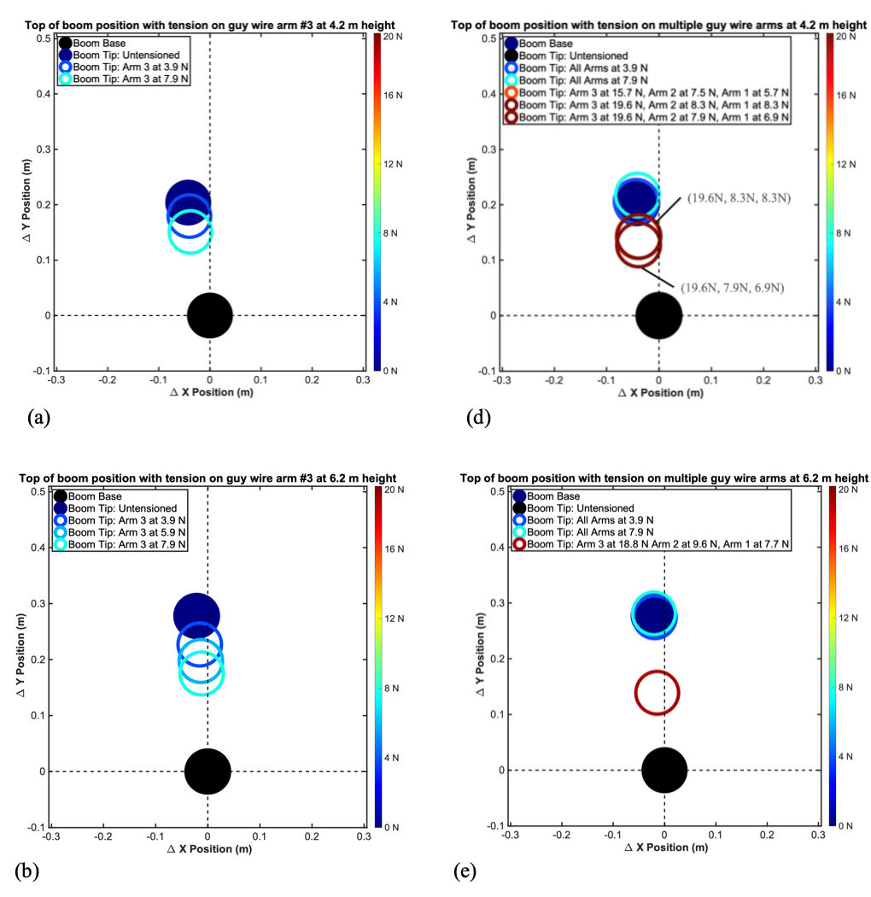
As height increases, natural lateral deflection increases. As expected, nearly all natural deflection takes place in the Y-axis. In Figure 11 (a), (b), (c) the individual wire control capability for the arm opposite the direction of deflection is demonstrated.

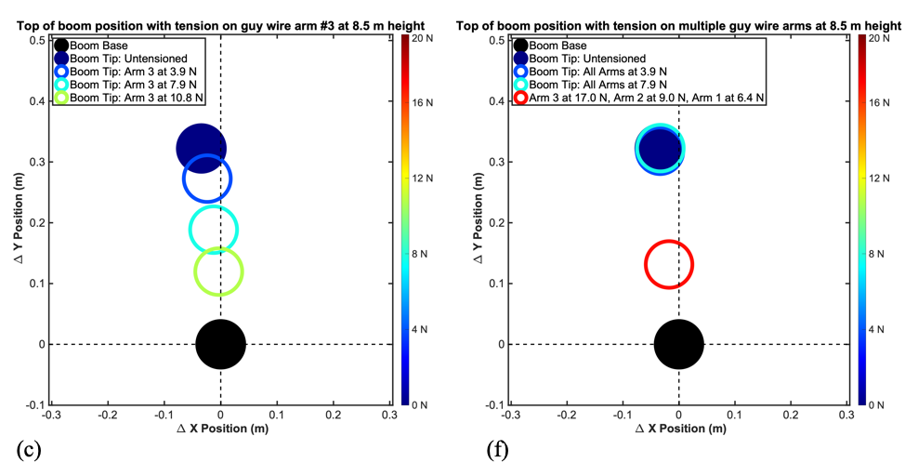
Figure 11. Static deflection photogrammetry test results for single-arm experiments, diagrams (a), (b), (c) on the left and for three-arm experiments, diagrams (d), (e), (f), on the right. The X-axis was aligned with the flat bonded regions (webs) connecting the two omega-shaped shells of the boom, shown earlier in Fig. 2.
In (c), where an additional level of tension to arm #3 (10.8N) was applied, an additional reduction in deflection was observed. In (d), (e) and especially in (f), utilizing the available control capability with differential tension in all three wires, it was possible to correct part of the deflection and bring the center of the tip mass closer to the boom base. In the two three-arm tests shown in Fig. 11 (d), where the high-leverage arm #3 was at 19.6N for both (maroon color), we observed that the tension in the opposing arms #1 and #2 affected the deflection, with slightly higher tension in arms #1 and #2 resulting in a slightly larger deflection, as expected. Finally, when equal tension is applied to all three wires, there is little change in deflection, indicating that the tower was likely naturally bowed rather than leaning. Future experiments will test alternative guy wire system configurations and higher tensions.
The static deflection test of the SELTI deployable guy wire system indicates that a simple guy wire system for a deployable composite boom tower of 8.5 m height, with arm length of 60 cm and maximum tension forces limited to below 20 N has at least partial control capability to position the top of the boom, reducing static lateral deflections compared to the untensioned control position of the top of the boom. Furthermore, as shown in Fig. 12, the test indicates that control capability provided by the guy wire system is greatest where it is needed most, i.e. in-plane along the Y axis, where the natural deflections are observed to be an order of magnitude greater than out-of-plane (X axis).

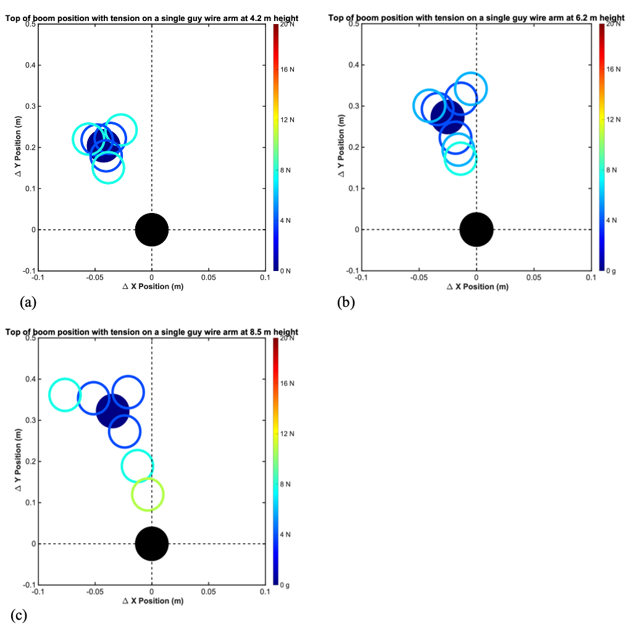
Figure 12. Static deflection photogrammetry test results showing all three single-arm experiments in the same diagram for each height (a) 4.2 m, (b) 6.2 m and (c) 8.5 m. The X-axis scale was zoomed in to clearly show the much smaller out-of-plane deflections (X axis) relative to the large in-plane deflections (Y axis)
- Conclusions and Discussion
Experiments with a simple guy wire system confirmed that tension-adjustable guy wire rigging is capable of controlling the position of the payload mass over several possible boom heights. We observed that adding tension on the arm closest to the opposite direction of deflection provides the most significant correction of the boom deflection towards the ideal centered position. However, under the range of single-arm tension loads used (3.9 – 10.8 N), the boom tip offsets could not be completely removed at any of the tested heights.
It was observed that for given levels of tension, absolute and relative correction capability is increased as height increases. This is evident by a comparison of the effectiveness of the 7.9N tension level applied via arm 3 at the 4.2 m, 6.2 m and 8.5 m heights. The resulting correction was 25%, 37% and 41% respectively, as can be seen from Fig. 11 (a), (b), (c) and Tables 2, 3 and 4. Even though the angle of attack gets smaller as tower height increases, due to the fixed arm length and orientation, the moment arm also increases and tension is effective.
It was observed that for all tests, the natural lateral offsets under 1-g (self-weight) were of the order of 5% of deployed height, which is significantly greater than the 1% manufactured tolerance. Potential explanations include long-term stowage creep, as this boom has remained spooled almost continuously for about 22 months from its date of manufacturing. This is consistent with the finding that the deflections under dead load occur almost entirely in the in-plane Y-axis in the direction of rolling the boom. Also, a very small misalignment of the boom exit angle from the deployer with respect to the gravity vector could lead to an unwanted additional boom root moment and lateral tip deflection. Further testing under controlled conditions with different booms will be needed to better understand the reasons for the significant deflections.
In conclusion, we find that control capability is greatest for the lever arm opposite the direction of deflection, and that for a deployable-boom-composite-based tower height of at least 8.5 m with an arm length of at least 60 cm, a simple guy wire system using the opposing arm alone with tension limited to 11N or less has sufficient control capability to reduce boom deflections by 63%. Using three arms under differential tension, with the highest tension limited to 17N and the opposing tensions at 9N and 6.4N respectively, the tested guy wire system has sufficient control capability to reduce boom deflections by 59 %.

- Limitations and Future Work
A limitation of this investigation is that while static testing confirmed that guy wires can be used to reduce the deflection of the tip payload, the photogrammetry approach measured only the position of the top of the boom, not the curvature across the boom’s length. Thus, for some high-tension configurations, with low tip deflections, the total boom curvature may be very high. Specifically, for the 8.5 m test at 10.8 N tension on arm #3, it was visually confirmed that the boom showed a slight bow. That is, the lateral deflection at the top of the boom was mostly corrected, but potentially introduced bowing or curvature in the direction of the applied tension. Future work on more diverse rigging configurations will assess not only the tip deflection, but also the curvature over the length of the boom. This will support the investigation towards an optimal guy wire configuration that balances complexity and mass with rigging system performance.
Additional ongoing and future collaborative work at LaRC and MIT includes the further investigation of the unexpected magnitude of the natural lateral deflection under dead load as well as testing of alternative guy wire system designs at higher tensions and higher deployed heights. Given the results observed in the three-arm tests shown in Fig 11(d), there may be opportunities to further reduce boom deflections by increasing tension in arm #3 and/or reducing tension in arms #1 and #2 in future experiments. Follow-on experiments are expected to inform trade studies of costs and benefits of an optimized guy wire system over other types of static stability solutions. Future work will also include additional development work on an automated guy wire tension controller.
Even though the scope of this paper is limited to static testing, dynamic characteristics of the boom system are of interest to ensure a safe deployment, and protect system payloads from dynamic events such as moonquakes or landing or near-by assets. Future work on dynamics will investigate how the tower and rigging system responds at different frequencies, and how rigging can be used to mitigate dynamic instabilities and to adjust the systems natural resonant frequencies. Dynamics studies will require new modeling development, since the behavior of ropes is highly chaotic during dynamic events; additionally, modeling dynamic stability of the tower system during deployment routine is difficult because the deployed section is changing length with time.
Acknowledgements
This research is sponsored by the 2020 BIG Idea Challenge, a collaboration between the Space Technology Mission Directorate’s (STMD) Game Changing Development (GCDP) program and the Office of STEM Engagement’s Space Grant Consortium and managed by the National Institute of Aerospace. The STMD/GCDP Deployable Composite Booms project that mentored and loaned the 13 m boom test article to the MIT team is greatly acknowledged. Thank you to the MIT Department of Aeronautics and Astronautics for space and facilities, including Dan Hastings and Anthony Zolnik, as well as MIT Laboratory for Manufacturing and Productivity (LMP) for access to machining facilities. Alex Miller is generously funded by the Fannie and John Hertz Foundation Fellowship. Emma Rutherford and Joshua Rohrbaugh are supported by the MIT Undergraduate Research Opportunities Program (UROP). Natasha Stamler was supported by the NASA Internships, Fellowships, and Scholarships (NIFS) Program at NASA LaRC. Thank you tnxTower for giving us free access to their tower program modeling program.

Thank you also to past and current MELLTT team members and mentors: Caleb Amy, Marc-André Bégin, Becca Browder, Manwei Chan, Charles Dawson, Paula do Vale Pereira, Travis J. Hank, Eric Hinterman, Cormac O’Neill, Vineet J. Padia, Jessica Todd, Nieky Wang, Dava J. Newman, and Olivier L. de Weck. Thank you to Mike Brown, Marianna Lordou, and Palak Patel for testing support.

References
C. Amy, M. Bégin, B. Browder, M. Chan, C. Dawson, P. do Vale Pereira, T. J. Hank, E. Hinterman, G. Lordos, B. Martell, A. Miller, C. O’Neill, V. J. Padia, N. Stamler, J. Todd, N. Wang, D. J. Newman, O. L. de Weck, & J. A. Hoffman, (2020). “Autonomously Deployable Tower Infrastructure for Exploration and Communication in Lunar Permanently Shadowed Regions.” ASCEND 2020. https://doi.org/10.2514/6.2020-4109

M. Chamberlain, S. Kiefer, J. Banik, (2019). “Photogrammetry-Based Analysis of the On-orbit Structural Dynamics of the Roll-out Solar Array.” AIAA SciTech 2019, San Diego, CA.

M. Chen, R. Goyal, M. Majji, and R. E. Skelton, (2009). “Deployable Tensegrity Lunar Tower”, https://arxiv.org/pdf/2009.12958.pdf

J. M. Fernandez, S. A. Krizan and E. R. Dyke, (2019), "Thin-shell composite booms for solar sails: Design, manufacturing, and qualification," 5th International Symposium on Solar Sails, Aachen, Germany.

J. M. Fernandez, (2017). "Advanced deployable shell-based composite booms for small satellite applications including solar sails", 4th International Symposium of Solar Sailing, Kyoto, Japan.

J. M. Fernandez, J. Salazar, J., M. Hamillage, A. Gomez-Delrio, K. Kwok, (2019). “Large Deformation Bending Relaxation of Thin-Ply Composite Laminates”, 22nd International Conference on Composite Materials (ICCM22), Melbourne, Australia.

R. Johanson, D. Jang, E. Kononov, M. Luu, S. Morgan, J. Todd, M. Blevins, M. Contreras, D. Erkel, A. Garcia, J. Holland, A. Kharsansky, B. Martell, A. Mitchell, T. Roberts, J. Schultz, A. Sentis, J. Rockaway, & J. A. Hoffman, (2020). “What could we do with a 20-meter tower on the Lunar South Pole? Applications of the Multifunctional Expandable Lunar Lightweight, Tall Tower (MELLTT).” ASCEND 2020, Virtual. https://doi.org/10.2514/6.2020-4108

J. E. ​​Kleinhenz and A. Paz, (2020). “Case Studies for Lunar ISRU Systems Utilizing Polar Water.” ASCEND 2020. https://doi.org/10.2514/6.2020-4042

A. J. Lee & J. M. Fernandez, (2019). “Inducing bistability in Collapsible Tubular Mast booms with thin-ply composite shells.” Composite Structures 225:111166.
https://doi.org/10.1016/j.compstruct.2019.111166

S. Li, P. G. Lucey, R. E. Milliken, P. O. Hayne, E. Fisher, J.-P. Williams, D. M. Hurley, and R. C. Elphic, (2018). “Direct evidence of surface exposed water ice in the lunar polar regions.” PNAS 115(36): 8907-8912. http://www.pnas.org/cgi/doi/10.1073/pnas.1802345115

G. Lordos, C. Amy, B. Browder, M. Chan, C. Dawson, P. do Vale Pereira, S. Dolan, T. Hank, E. Hinterman, B. Martell, K. McDonough, A. Miller, C. O’Neill, N. Stamler, J. Todd, Z. Wadia, N. Wang, D. Newman, O. de Weck, and J. Hoffman, (2021). “MELLTT: Multifunctional Expandable Lunar Lightweight & Tall Tower.” in BIG Idea Forum 2020, Virtual. http://bigidea.nianet.org/wp-content/uploads/2020-BIG-Idea-Technical-Paper_MIT.pdf

“Rollable Composite Masts”, (2020). ​​Rolatube Technology. Retrieved from https://www.rolatube.com/ lightest-mast-systems/. Accessed October 11, 2021.

M. Richter, M. Straubel, J. M. Fernandez, O. R. Stohlman and W. K. Wilkie, (2019). "Compact deployment control mechanism for the deployable backbone structure of a 500-m2-class solar sail," in 5th International Symposium of Solar Sailing, Aachen, Germany, 2019.

O. R. Stohlman, M. E. Zander, & J. M. Fernandez, (2021). “Characterization and modeling of large collapsible tubular mast boom.” AIAA Scitech 2021 Forum. https://doi.org/10.2514/6.2021-0903

C. Warner. (January 22, 2020). “First Commercial Moon Delivery Assignments to Advance Artemis.” NASA. https://www.nasa.gov/feature/first-commercial-moon-delivery-assignments-to-advance-artemis (Accessed October 7, 2021).

W. K. Wilkie, J. M. Fernandez, O. R. Stohlman, N. R. Schneider, G. D. Dean, J. H. Kang, J. E. Warren, S. M. Cook, P. L. Brown, T. C. Denkins, S. D. Horner, E. D. Tapio, M. Straubel, & M. Richter, (2021). “An Overview of the NASA Advanced Composite Solar Sail (ACS3) Technology Demonstration Project.” AIAA SciTech 2021 Forum. https://doi.org/10.2514/6.2021-1260

Biography
Alex Miller is a graduate researcher at Massachusetts Institute of Technology in the AeroAstro department with a B.S in Physics and in Electrical Engineering and Computer Science from MIT. Alex has interned with teams at NASA’s Jet Propulsion Laboratory, X (formerly Google [X]), Microsoft Research, and DeepMind. Alex’s graduate work is generously funded by the Fannie and John Hertz Foundation Fellowship.

Joshua Rohrbaugh is a junior at the Massachusetts Institute of Technology studying Mechanical Engineering. He worked with the composite boom team to integrate the guy wire system with the deployer system. His interests include aerospace, transportation, and robotics.

Emma Rutherford is a junior at the Massachusetts Institute of Technology studying Mechanical Engineering and Physics. She worked with the composite boom team to improve the mechanisms for deployment and retraction, allowing for testing at greater heights. Her past research has focused on computational fluid dynamics of aerosols, and she is currently pursuing work in robotics.

Natasha Stamler is a senior at the Massachusetts Institute of Technology studying Mechanical Engineering and Urban Planning. She has interned at the NASA Langley Research Center and the NASA Goddard Institute for Space Studies. Natasha is supported by a John Mather Nobel Scholarship from the National Space Grant Foundation.

Benjamin Martell is a PhD student in the Department of Aeronautics and Astronautics at MIT. He received his SM in AeroAstro from MIT and his BS in Mechanical Engineering from the University of Rochester. He is currently researching methods for ISRU on Mars using non-thermal plasma, and is interested in developing technology to help explore the universe and solve complex problems. He has experience with researching electrostatics, fluids, plasmas, and space systems.
George Lordos is a PhD candidate at Massachusetts Institute of Technology in the Department of Aeronautics and Astronautics, the founder of MIT’s Space Resources Workshop and a member of AIAA’s Space Resources Technical Committee. He received a B.A. in Philosophy, Politics and Economics from the University of Oxford in 1991, a MBA from MIT’s Sloan School of Management in 2000 and a Masters in Engineering and Management from MIT’s System Design and Management Program in 2018. George is researching the industrial ecology of human settlements on the Moon and Mars and previously had a 25-year professional career as a technical project manager, strategy consultant, system architect, company director and entrepreneur.
Dr. Juan M. (Johnny) Fernandez serves as the flexible composite technology lead at NASA Langley Research Center. He holds a BSc in Aeronautical Engineering from the Technical University of Madrid, Spain, a MSc in Space Technology and a PhD in Space Engineering from the University of Surrey, UK. He is the Principal Investigator for the NASA Deployable Composite Booms (DCB) project and Principal Technologist for the Advanced Composites-Based Solar Sail System (ACS3) flight demonstration. He chairs the AIAA High Strain Composites section of the larger AIAA Spacecraft Structures Technical Committee. He holds several patents on composite boom designs and fabrication methods. He manages a NASA STTR subtopic for small businesses and research institutions on thin-ply composite technology.

Dr. Matthew K. Chamberlain is a research aerospace engineer in the Structural Dynamics Branch at NASA Langley Research Center. His research focuses on the design, analysis, and testing of lightweight spacecraft structures such as deployable booms, solar arrays, and solar sails. He received his BS in mechanical engineering from Carnegie Mellon University and both his MS and PhD in mechanical engineering from Georgia Institute of Technology. Prior to joining NASA in 2013, he worked for Dynamic Concepts, Inc in Huntsville, AL.

Dr. Jeffrey A. Hoffman is a Professor of the Practice of Aeronautics and Astronautics at MIT since 2002, and co-director of MIT’s Human Systems Lab since 2015. He is interested in the future of human spaceflight and in the use of the International Space Station as a testbed for future aerospace technology, especially in: human-machine interactions, EVA, flight operations and conducting laboratory research in space. From 1978-1997 he served as a NASA astronaut (five flights) and from 1997 – 2001 as NASA’s European representative.

