Delay/Disruption Tolerant Networking
Project Introduction
Communicating from Earth to any spacecraft is a complex challenge, largely due to the extreme distances involved. When data are transmitted and received across thousands and even millions of miles, the delay and potential for disruption or data loss is significant. Delay/Disruption Tolerant Networking (DTN) is NASA’s solution to reliable internetworking for space missions.
For previous missions from low-Earth orbit to deep space, NASA has used point-to-point (direct) or single relay links to communicate with spacecraft; this method operates much like the phone system by directly connecting two communication nodes. While this approach has been successful for previous missions, future exploration concepts will introduce more complex communication scenarios with data transfer between many nodes. Future data transmission will need to operate like the Internet here on Earth – involving multiple hops via relay spacecraft and other intermediate nodes, creating the foundation for a Solar System Internet (SSI).
The SSI will take advantage of the DTN protocol suite to offer networked end-to-end communications even in scenarios where the Internet Protocol (IP) suite does not work well. The DTN protocol suite can operate in tandem with the IP suite or it can operate independently.
DTN is based upon an automatic store-and-forward approach. If the link to the next node in the communications path is available, the data is forwarded without interruption; however, if the link to the next node is not immediately available, DTN nodes can store data to be forwarded later. This store-and-forward approach enables DTN to operate in scenarios where IP networks cannot—for example, in scenarios involving long delays or disruptions—and also optimizes available bandwidth.
The DTN suite also contains network management, security, routing, and quality-of-service capabilities, which are similar to the capabilities provided by the terrestrial Internet suite.
The Consultative Committee for Space Data Systems (CCSDS) and the Internet Engineering Task Force (IETF) are standardizing DTN, and all of the DTN standards will be open international standards supported by open-source software. Several DTN implementations developed by NASA exist and are publicly available, including the following examples:
- Interplanetary Overlay Network (ION) implementation (http://sourceforge.net/projects/ion-dtn/)
- core Flight System (cFS) Bundle Protocol (BP) application (https://software.nasa.gov/software/GSC-18331-1) and the cFS BP Library (https://software.nasa.gov/software/GSC-18318-1)
- DTN Marshall Enterprise (DTNME) (https://github.com/nasa/dtnme)
Anticipated Benefits
- DTN enables Science and Exploration
  - Increases science data return through interoperability and more efficient link utilization
  - Enables communications between and through constellations and swarms of smallsats
  - Enables missions that would either be impossible or too difficult/costly
  - Facilitates science across distributed platforms
    - Monitoring of phenomena by multiple spacecraft
    - Delivery of data from distributed instruments to a central processing node
    - Communication between diverse space assets across heterogeneous links
  - Promotes data relay through Gateway or planned Lunar assets
    - Exchange of data with each other and Earth
    - Exchange of data between assets on Earth and on Lunar surface without direct view of Earth
    - Increased coverage and capacity
- DTN increases autonomy
  - Reduces of operational complexity
  - Enables responsive mission operations
  - Increases scalability
- DTN decreases life cycle cost
  - Enables reuse
  - Increases interoperability
  - Facilitates streamlined operations and more efficient use of personnel
Primary Work Locations and Key Partners
Org Performing Work | Role | Type | Location
Johnson Space Center (JSC) | Lead Organization | NASA Center | Houston, TX
Glenn Research Center (GRC) | Supporting Org | NASA Center | Cleveland, OH
Goddard Space Flight Center (GSFC) | Supporting Org | NASA Center | Greenbelt, MD
Jet Propulsion Laboratory (JPL) | Supporting Org | NASA Center | Pasadena, CA
Johns Hopkins University Applied Physics Laboratory (JHU/APL) | Supporting Org | R&D Center | Laurel, MD
Marshall Space Flight Center (MSFC) | Supporting Org | NASA Center | Huntsville, AL
The MITRE Corporation | Supporting Org | Industry | McLean, VA

Primary US Work Locations
- Alabama
- Ohio
- Texas
- California
- Maryland
- Virginia

Organizational Responsibility
- Responsible Mission Directorate: HEOMD
- Lead Center/Facility: JSC
- Responsible Program: SCaN
Project Management
- Program Director: Badri A Younes
- Program Manager: Jason W Mitchell
- Project Manager: Brenda E Lyons
- Principal Investigator: n/a
Project Duration
- Start Date: Oct 2019
- End Date: Dec 2031
TRL
- Start: 6
- Current:7
- End: 9
Technology Areas (per https://techport.nasa.gov/view/taxonomy)
- TX05 Communications, Navigation, and Orbital Debris Tracking and Characterization Systems
  - TX05.3 Internetworking
    - TX05.3.1 Disruption Tolerant Networking
Target Destinations
- Earth
- The Moon
- Others inside the Solar System
Supported Mission Type
- Planned Mission (Pull)

PROJECT LIBRARY
- SMD DTN White Paper from IAC 2019 (https://www.nasa.gov/sites/default/files/atoms/files/the_benefits_of_dtn_for_future_nasa_science_missions.pdf)
- DTN waypoint graphic
  - 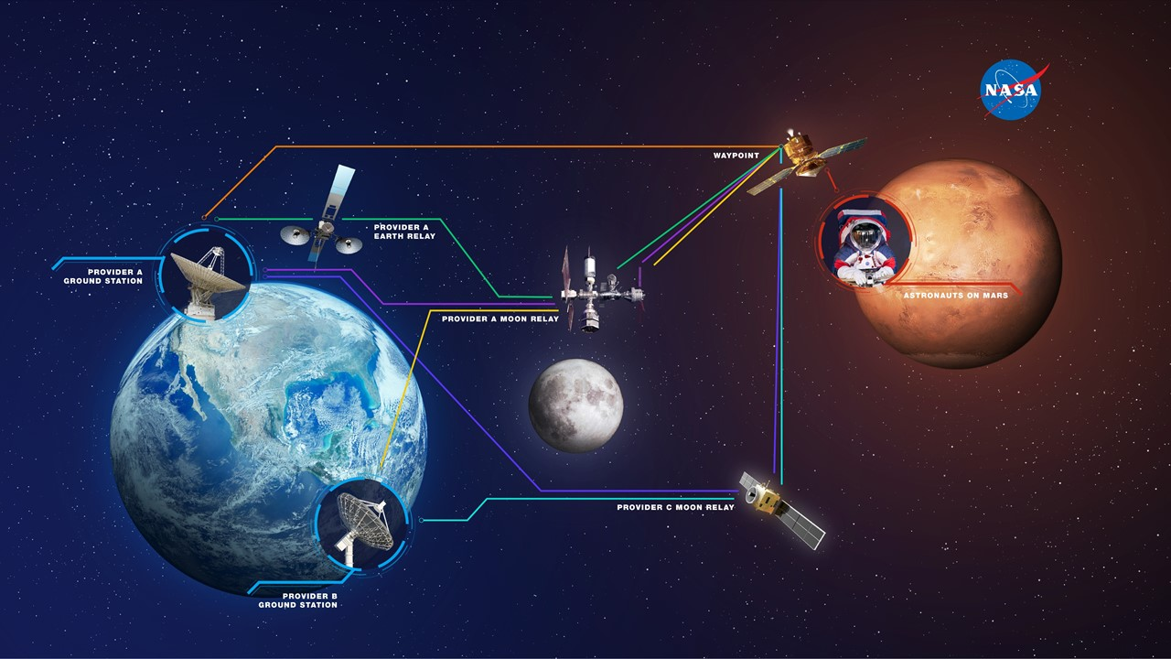
- DTN Optical Comm animation (see animation on https://www.nasa.gov/directorates/heo/scan/engineering/technology/disruption_tolerant_networking)
- DTN Phasing graphic
  - 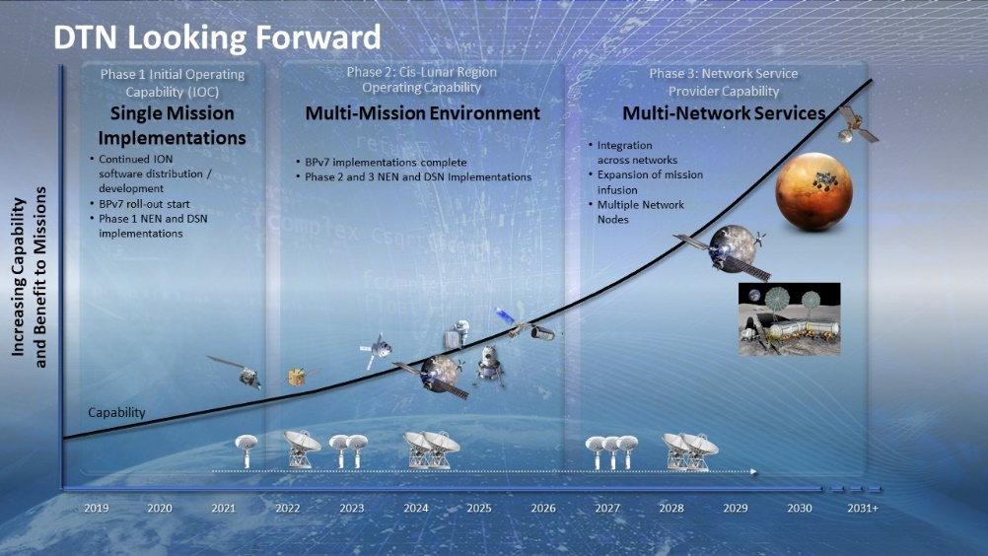
- Protocol stack graphic
